Bitcoin Regression Analysis
Introduction:
In 2008, an unknown programmer using the pseudo name of Satoshi Nakamoto wrote a document called Bitcoin: A Peer-to-Peer Electronic Cash System. Bitcoin (BTC) is a decentralized digital crypto-currency system, meaning the transfer of funds are operated independently of a central bank through the internet. Most notably, these transactions occur with anonymity.
How does it work? Bitcoins can be bought and sold in exchange of Dollars or Euros or other currencies. Bitcoins are kept in the digital wallet in the computer or mobile device. We can purchase anything in exchange of Bitcoin and there is a growing list of business entities accepting it. The Bitcoin network is secured by individuals called miners. Miners are rewarded newly generated Bitcoins for verify the transactions. After transactions are verified, they are recorded in a public transparent ledger. Bitcoin generated a whole new platform for innovation. The software is completely open source which can be reviewed by anyone.
While Bitcoin may sound too good to be true, it is not risk-free. It is very hard to predict the future price of Bitcoin. Crypto-currency is on the radar of many governments worldwide and regulations are sure to be around the corner. Some countries ban it altogether. Bitcoins are a rival to government issued and regulated currency and are sometimes associated with black market transactions, money laundering, illegal activities and tax evasion. Anonymity is one of the reasons Bitcoin has gained such popularity and seen its large financial returns. That is what happens when it goes from $0.05 to $20,000 in eight years. Millionaires get minted! The Bitcoin price has been highly unpredictable but has proven to be one of the best speculations ever with multiple years having returns in excess of 5,000% each. It is possible that the value of this currency will go down as governments regulate it. The uncertainty of what regulation is going to do to this currency is also a reason for it to remain volatile and a risky investment. For that reason, you wonder, what will happen to Bitcoin in the long term? Will it last or will it die out as quickly as it skyrocketed?
Bitcoin has shown significant market capitalization growth in last few years. It is important to understand what drives the fluctuations of the Bitcoin exchange price and to what extent they are predictable. The graphical representation in Exhibit 1(a) resemble the blue print of a roller coaster more than a financial asset.

Data Description: Exhibit 1(b) uses the actual historical data for analysis, obtained from blockchain website (https://blockchain.info/stats), comprised of 13 integer variables and 1715 observations from August 2009 to May 2018. Each of the 13 variables are downloaded at a time in excel sheet The dataset has no missing values.
The main objective of this project is to fit a linear regression for Bitcoin market price (USD). Since a Bitcoin dataset is a time series dataset and this project is a regression analysis, the date column will not be considered for regression analysis.
Before diving into the regression models, it can be useful to determine how the independent variables such as (Day, Week, Total Transaction Fees, Number of Transactions, Output Value, Estimated Transaction Value, Miners Revenue, Cost per Transaction, Difficulty, Hash Rate, Trade Volume) are correlated to the dependent variable (Price in USD) and each other. A correlation matrix plot shown in Exhibit 2 provides a quick overview of 12 numeric variables correlation in the Bitcoin data frame. At the intersection of each row and column pair, the diagonal (with color navy blue) is always 1 shows the perfect correlation between a variable and itself. Exhibit 2 also depicts that the variables: miner’s revenue, estimated transaction value, difficulty, cost per transaction, and hash rate are highly correlated i.e. (>=.75) to variable price.

Analysis: Now it’s time to run the regression models and do the analysis. By running the first additive model having all independent variables, assuming that error terms (or "residuals") have a mean of zero and constant variance, the output shows how close the data are to the fitted regression line. In other words, the coefficient of multiple determination i.e. R squared from first model is equal to .9947, indicating that 99.47% of variability in Bitcoin price ($) is explained by the fitted model. This result was an absolutely over fitting the model and variances explained error (or "residuals") were not constant. Result is explained in Exhibit 3. In other words, the variance of the error terms must be constant, and they must have a mean of zero. If this isn't the case, the model may not be valid. This process is called diagnostic(s) test.
Since dataset has 11 independent variables against dependent variable (Bitcoin market price), we have two options. First option is to perform Principal Components Regression (PCR), which is a dimensionality reduction technique on a high dimensional dataset and then fit a linear regression model to a smaller set of variables (discussed later in detail*). The other option is to perform an Akaike Information Criterion (AIC) using step function to estimates the quality of each model, relative to each of the other models. In other words, AIC provides a means for initial quality model selection to kick start our core analysis.
After performing PCR, trial models were not showing the good / ideal model, i.e. R square equal to 99.15% and because the variance was again not constant, the model may not be valid. Next, we tried with transformation which is the good ways to improve the model but all kind of transformations trials failed when the residuals were not constant. In other words, if the residuals increase or decrease with the fitted values in a pattern, the errors may not have constant variance. Thus, the model may not be true. Plots are explained in Exhibit 4.
Akaike information criterion (AIC) was tried which provides the quality model by choosing with lowest AIC. According to this step( ) function, suggested variables are Day, Week, Transaction fees, no. of transactions, Output value, estimated transaction value, Miners revenue, Cost per transaction, Difficulty, Hash rate with lowest AIC value. Thus rerun the model and check for the residuals test using Breusch-Pagan test for non-constant variance and Shapiro Wilk, a test for normality. According to model, residuals indicate heteroscedasticity (non-constant variances) and the data are still deviated from the normal. Thus, again the model is not valid. Plots are explained in Exhibit 5.
Exhibit 4 and 5 explains that we should not use the regression models that produced such results. So, what to do? There's no single answer, but there are several options are knows for transformations. Data transformation definitely requires a "trial and error" approach. In building the model, we try a transformation and then check to see if the transformation eliminated the problems with the model. If it doesn't help, we try another transformation and so on.
In our situation, polynomial transformation and percentage change could take place. Polynomial regression models are useful when there is reason to believe the relationship between two variables is curvilinear. In Exhibit 5, there is a curvilinear relationship between the variables which appears to be quadratic. Hence, it fits a polynomial regression model of order 2. But unfortunately, transformations could not make much impact on the residuals data. Finally arrived no where but back to square one.
Since in the early years 2009-2016, there were not a lot of price fluctuations in the Bitcoin market price. Hence, bifurcating this dataset from mid 2016 onwards was a smart move for this regression analysis to reflect the current high-volume trading state of the Bitcoin marketplace. The graphical representation in Exhibit 7 would resemble the Bitcoin Price Fireworks from 2017 - 2018. We have a marathon from correlations to the ideal regression model with an updated dataset, lets have a look!!
We rerun all steps one by one with an updated dataset from mid June 2016 till May 2018. First, most of the variables are highly correlated to the Bitcoin market price, explains in Exhibit 7. Next, kick start with full additive model having all 11 independent variables plugged in, where R^2 is 99.66% of variability in Bitcoin price($). This is explained by the fitted model, which indicates over fitting as earlier with some insignificant variables. After checking the residuals, no big surprises!! Residuals indicate heteroscedasticity that means variances were still not constant and the data deviates from normality. (likewise both Breusch-Pagan test and Shapiro Wilk test fails!!)

Running step ( ) function to get a model with the lowest AIC did not do much impact on residuals. We found, weighted least squares regression might be useful and an efficient method that makes good use of small bitcoin dataset after bifurcation. The main advantage of weighted least squares over other methods is an ability to handle regression situations in which the data points are of varying quality. If the standard deviation of the random errors in the data is not constant across all levels of the explanatory variables, using weighted least squares with weights that are inversely proportional to the variance at each level of the explanatory variables yields the most precise parameter estimates possible. But after applying weighted least square regression too, the residuals don’t seem to be constant.
Next, we could think of using the logarithmic transformed variables to percentage changes. But why? Before going further, let’s take a ride of what is it? A typical use of a logarithmic transformation variable is to pull outlying data from a positively skewed distribution closer to the bulk of the data in a quest to have the variable be normally distributed. In regression analysis the logs of variables are routinely taken, not necessarily for achieving a normal distribution of the predictors and/or the dependent variable but for interpretability. The standard interpretation of coefficients in a regression analysis is that a one unit change in the independent variable results in the respective regression coefficient change in the expected value of the dependent variable while all the predictors are held constant. Now, interpreting a log transformed variable can be done in a same manner. However such coefficients are routinely interpreted in terms of percent change. Since the dataset was not logarithmic scaled therefore logarithmic transformations are required to move further.
Next, both the dependent variable and independent variable(s) are log-transformed. This relationship is commonly referred to as elastic in econometrics. In a regression setting, we’d interpret the elasticity as the percent change in Y (dependent variable), while X (the independent variable) increases by one percent.
Since from Exhibit 8, after weighted average, we observed that transaction fee BTC, miner revenue seem having curvilinear relationship which appears to be quadratic. Therefore, polynomial transformation is needed for those independent variables i.e transaction fee BTC, miner revenue, resultant to the good model. Yes!! Finally multiple R squared is equals to 30.61% with all independent variables being significant and residuals 'seems to be constant'. According to Breusch Pegan test, p-value > 0.05, therefore we can assume the data has constant variance and W = .98 which is close to 1 proving the data pass the test of normality according to Shapiro Wilk test, explained in Exhibit 10. Final Model equation and its interpretation as follows:
Bitcoin market price (%) = -21.89 - 29.68(transaction fee) - 26.05 (transaction fee ^2) + 0.0000014 ( no of transaction) - 360.6 (hash rate) +65.87 (miner revenue %) - 25.76 (miner revenue (%) ^ 2 + 1.4 ^ -11(difficulty) . Fewer interpretation for instance,
- A unit change in transaction fee will result in the change in Bitcoin market price(%) by -29.68 minus twice of 26.05 of transaction fees. It will go up in quadratic, when transaction fee go down, holding other variables constant.
- A unit change in Miner revenue will result in a change in Bitcoin price(%) by 65.87 minus twice of 27.76 times miner revenue, holding other variables constant.
- A unit change in 'no of transaction', will result in the increase in Bitcoin market price(%) by 0.0000014, holding other variables constant and so on..
Multiple R squared is equal to .3061, that means 30.61% explains the variability in Bitcoin price(%) is explained by the this model, recalling that our dependent variable (Price) is in % change, therefore R square 30.61% is consider to be a good multiple coefficient determination.
Once the final model is arrived, next is to investigate about outliers and influential observations, if any. In regression, we assume that there are no influential observations which can have a significant impact on model otherwise, observation with high leverage will affect the intercept and slope of a model significantly. Exhibit 11 shows that in the Bitcoin model, observation 1335 is an influential outlier however since it has a low leverage ( less hat value according to the bubble chart), removing probably will not change the model by much therefore we would like to keep it in the model.
Conclusion: From our final model, we concluded that the predictors such as Transaction fees, no. of transactions, Cost per transaction, Hash rate, Miners revenue and Difficulty explained the fluctuations in the Bitcoin market price.
Future project could be to take it even further to explore time series analysis, after a truly extraordinary run over the last eight years, where will Bitcoin be a decade from now? Final graphical plots and tables are given below that explains that the model has been following the trend of actual data, except for a few spikes. Next graph is the forecast of 2018 Bitcoin market price ($) with a positive trend in dotted line.
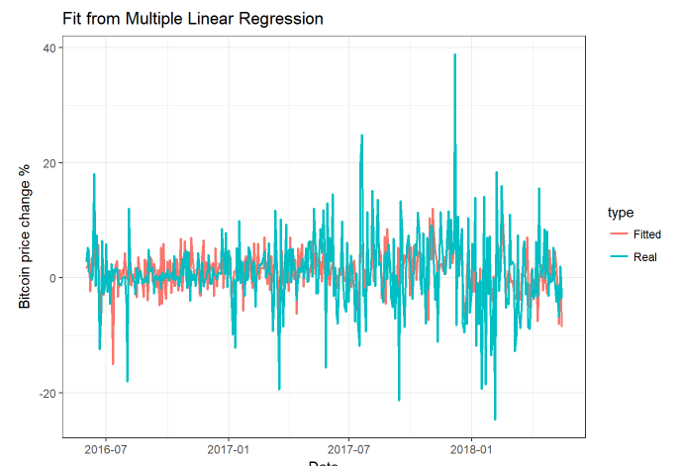 | 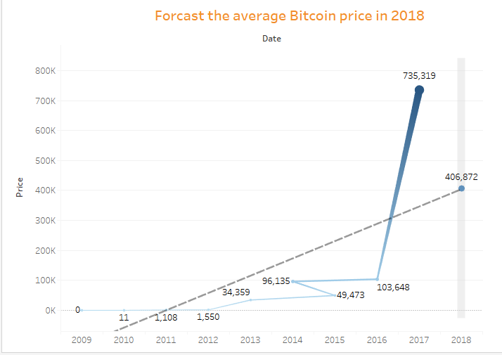

Discussion: Now before closure, I would like to discuss few more topics which have been untouched before. Principal Components Regression (PCR) can easily perform dimensionality reduction on a high dimensional dataset and then fit a linear regression model to a smaller set of variables. This can help in reducing the model complexity, which is always a plus. However, if we need a lot of principal components to explain most of the variability in the data, say roughly as many principal components as the number of variables in the dataset, then PCR might not perform that well in that scenario. It might even be worse than plain vanilla linear regression.
The bitcoin dataset has 11 independent variables. Trying out dimensionality reduction technique for Performing Principal Components may be a good option. By using PCR, we found that 3 principal components are enough to explain 87% of the variance of data. In this case, we might be better off running PCR on with these 3 components instead of running a linear model on all the 11 variables, explained in Exhibit 6. PCR tends to perform well when the first principal components are enough to explain most of the variation in the predictors. Therefore, the most important variable on the PCR direction is Cost_Per_Transaction with a loading of -0.4342, followed by the Miners_Revenue (-0.4164) and estimated_transaction_value (-0.3858). Besides these, hash rate, trade volume, difficulty, and transaction fees also seem important.
After running the model suggested by PCR, it could not help much because of normality test and constant error test fails as per Shapiro Wilk test and Breusch-Pagan test respectively. Further, trying out by using percentage transformations and poly transformations on those variables (advice by PCA) also couldn't help much either.
On the other hand, even after so much tried different methods with original Bitcoin dataset, we couldn't reach to the ideal regression model. In that situation, bifurcating the dataset from mid 2016 onwards was the smart move before arriving to the conclusion. Bitcoin cryptocurrency was created in 2009 but it became extremely popular in 2017. Though data was cleaned and numeric value for greater easy in regression however, it is expected that linear regression will be a difficult part due to not potential trends and fluctuations before 2017. In other words, there were few hundreds in price hike of Bitcoin from 2013 till 2017 and even before 2013, the price hike was negligible. Therefore we decided to bifurcate the data from 2016 onwards for our further analysis.
More than time series as future project for predicting Bitcoin price, can be forecast with deep learning algorithms such as by the neural network model using 2-layers long short term memory as well as Gated Recurrent Unit architecture of the Recurrent neural network.
Appendix
Exhibit 1(a)
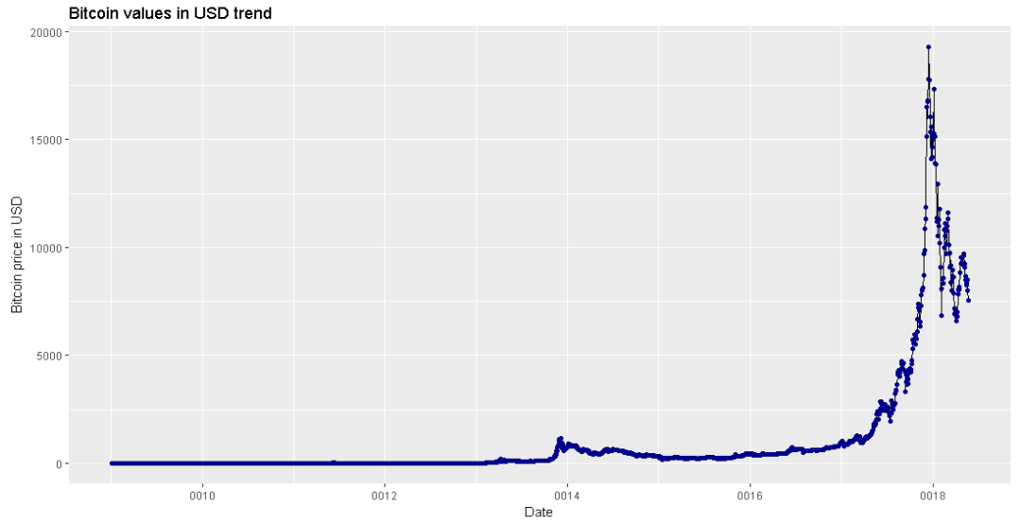
Exhibit 1(b)
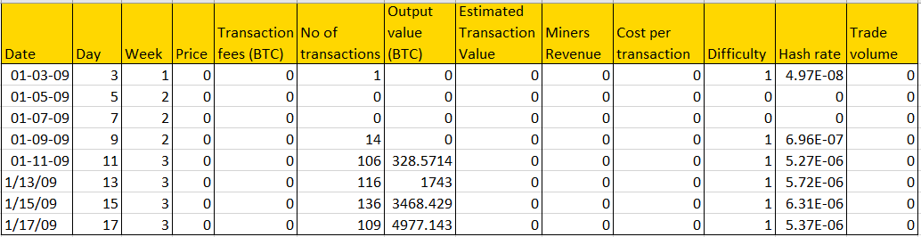

Exhibit 2
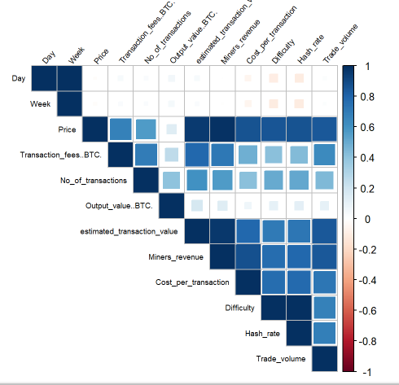

Exhibit 3 - First Additive Model - FAILS!!
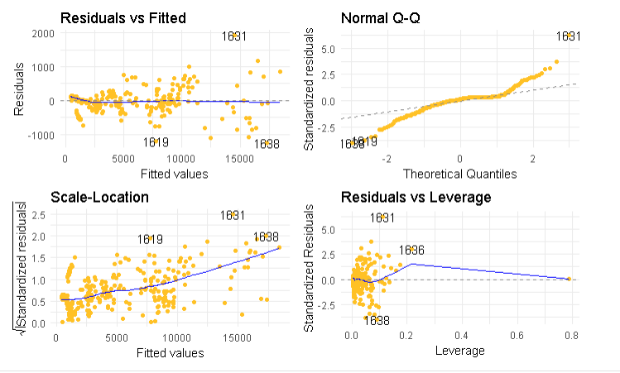 | 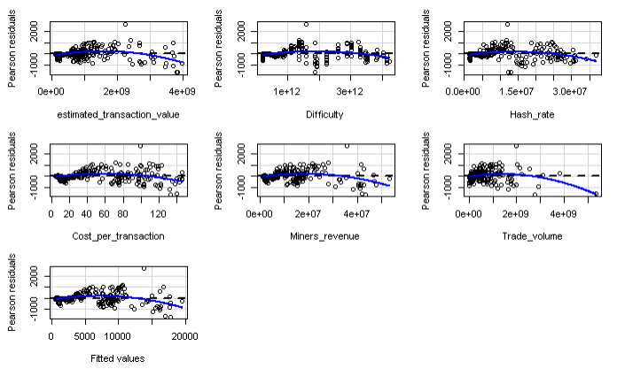
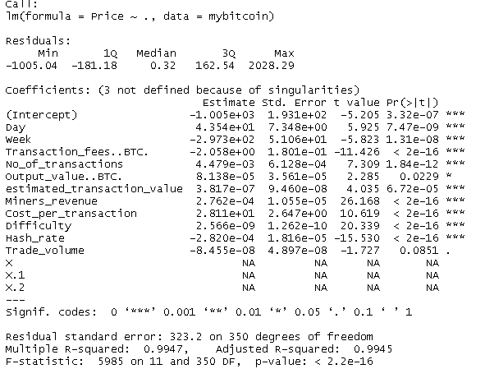 | 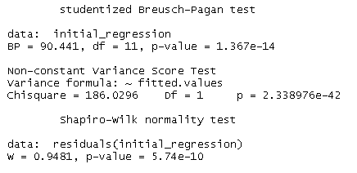

Exhibit 4 - PCR models after transformations - FAILS!
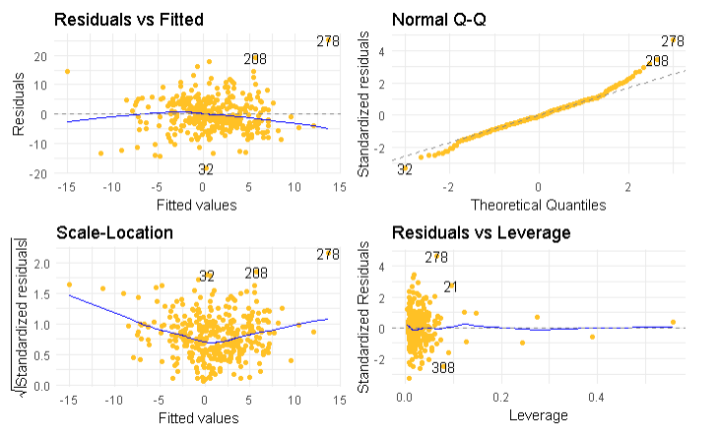 | 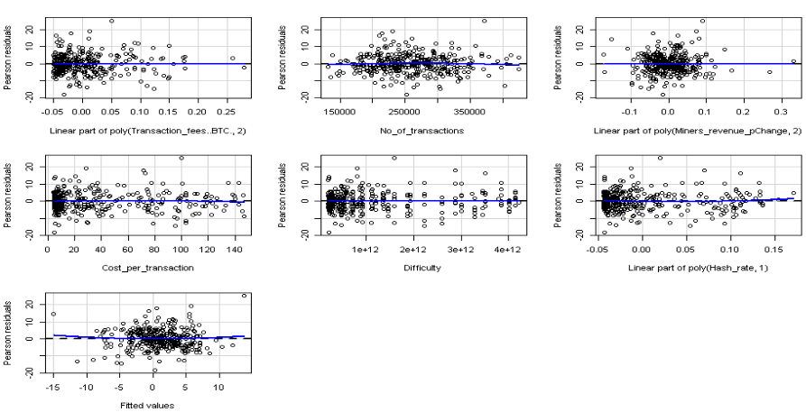
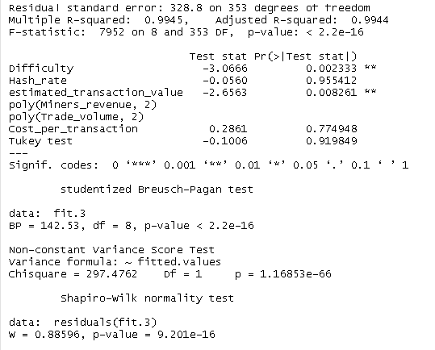

Exhibit 5 - AIC models before and after transformations Fails !! :(
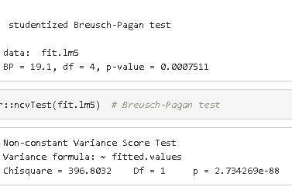 | 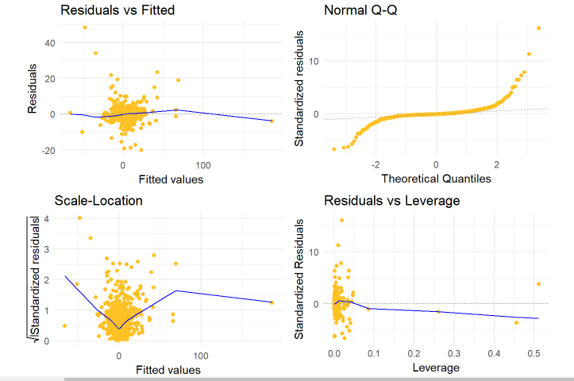
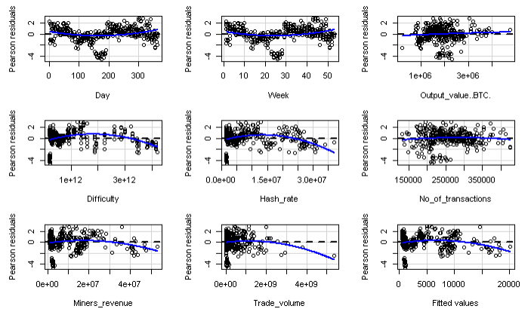

Exhibit 6 - PCR detail under discussion*
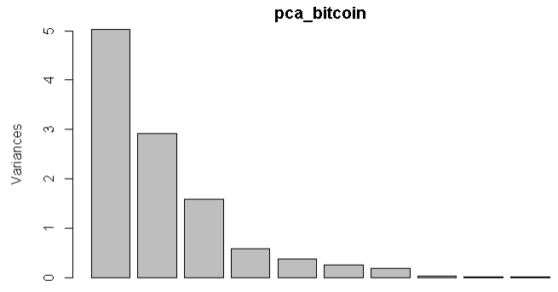 | 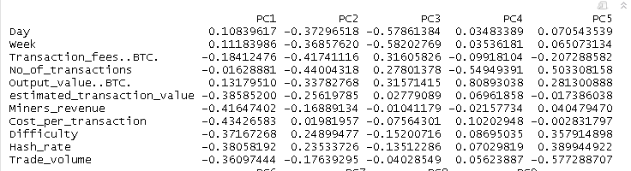
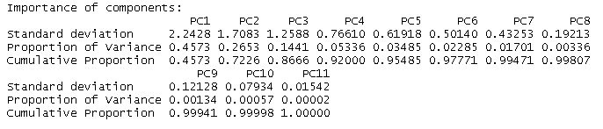

Exhibit 7- Plots for dataset from mid 2016 onwards
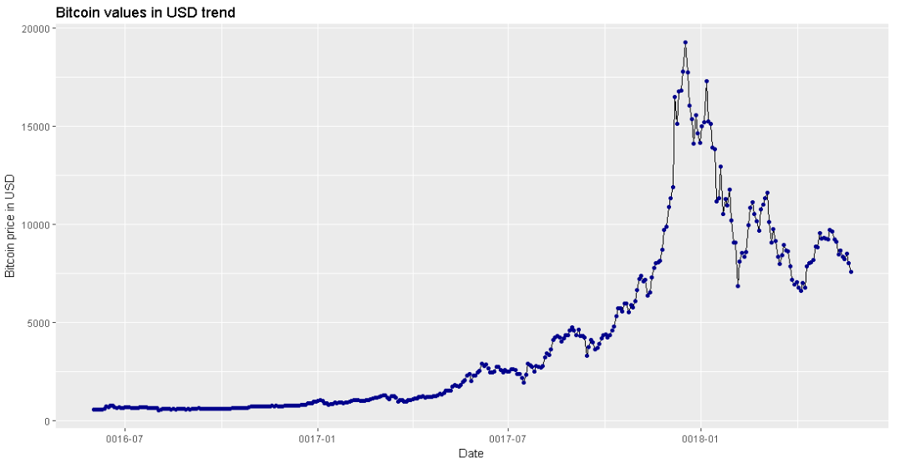 | 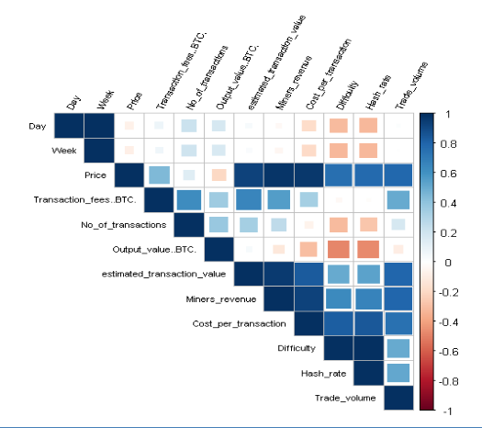

Exhibit 8 - before and after Polynomial transformation
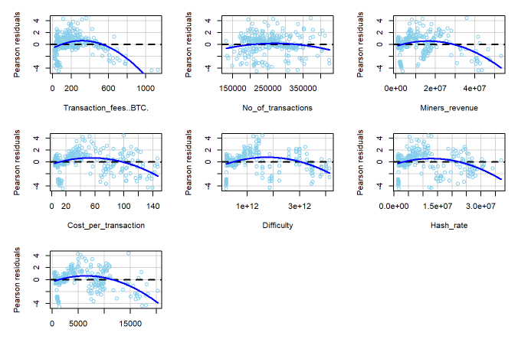 | 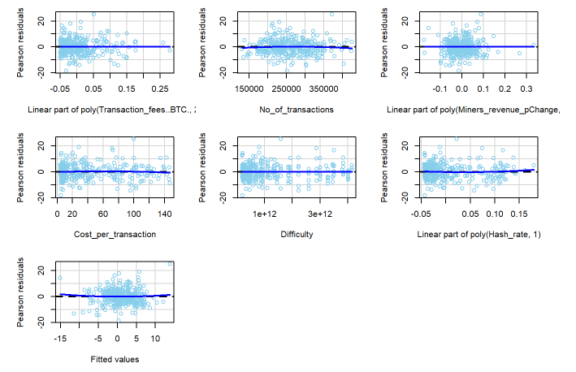

Exhibit- 9 Forecast of average Bitcoin Price in the year 2018

Exhibit- 10 - Final Model looks good !!
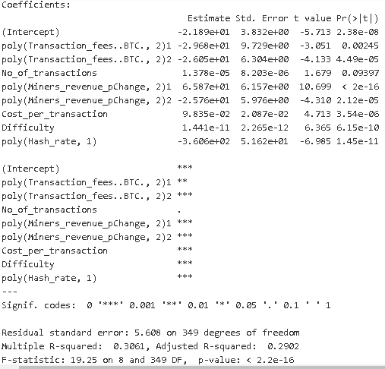 | 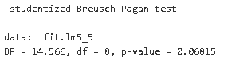  p-value > 0.05, we can assume the data has constant variance.  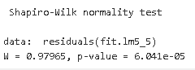  W=.98 which is close to 1, data are normal.
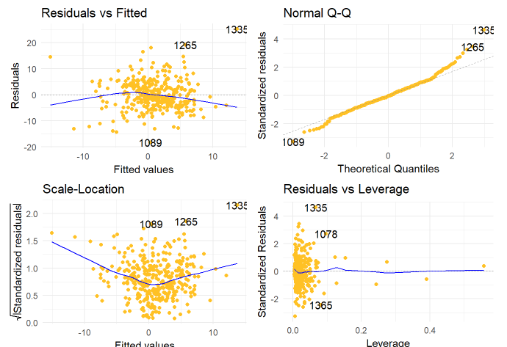 | 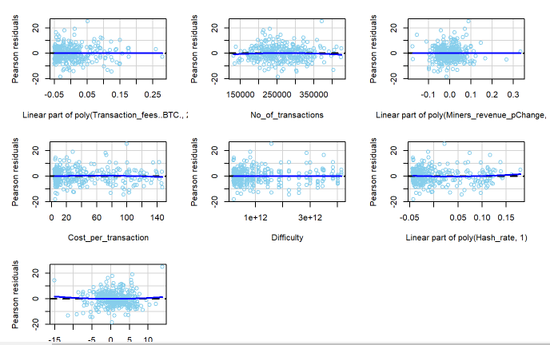

Exhibit-11 Outliers plot, Bubble plot, Influence index and Diagnostic Plot!!
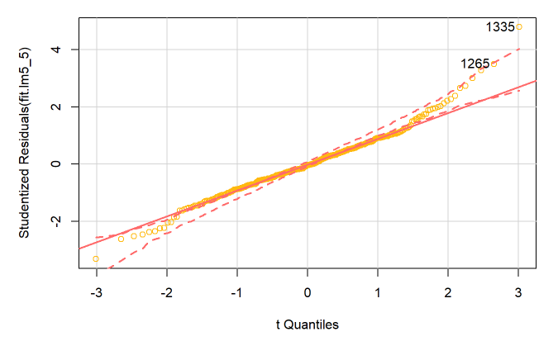 | 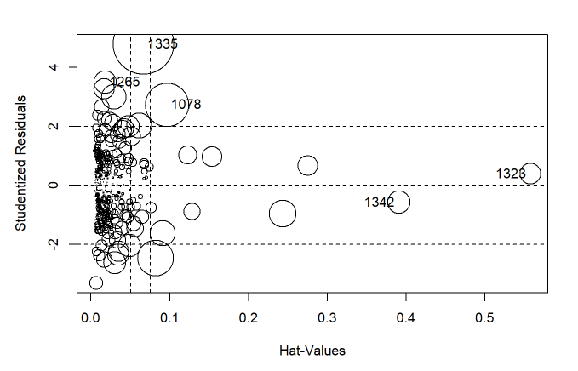
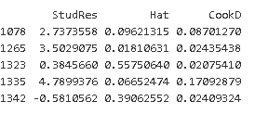 | 