Retrieve the total number of orders placed.

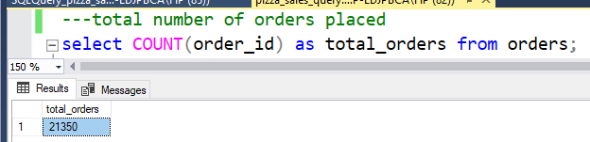

Calculate the total revenue generated from pizza sales.

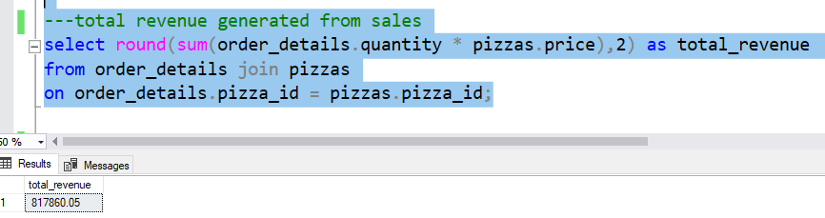

Identify the highest-priced pizza.

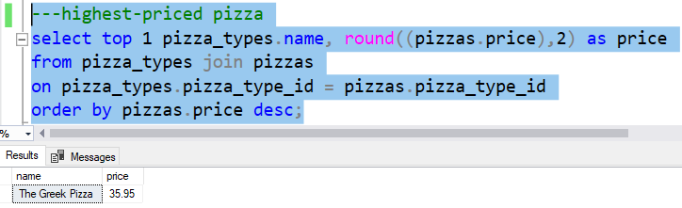

Identify the most common pizza size ordered.

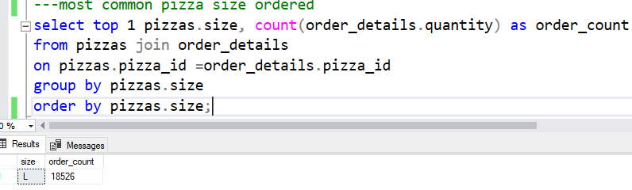

List the top 5 most ordered pizza types along with their quantities.

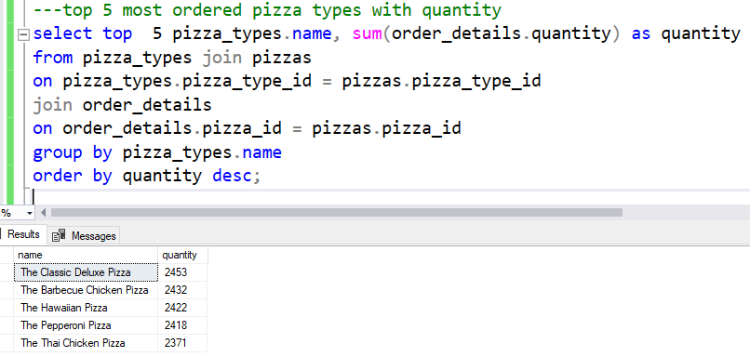

Join the necessary tables to find the total quantity of each pizza category ordered.

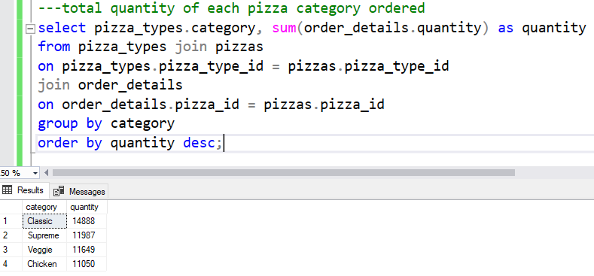

Join relevant tables to find the category-wise distribution of pizzas.

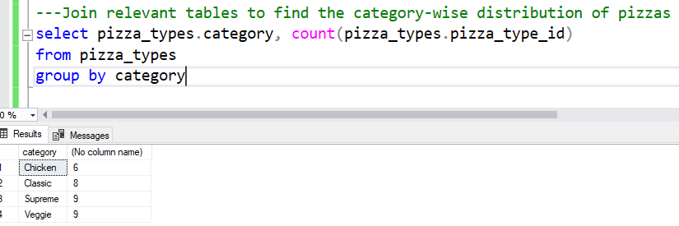

Group the orders by date and calculate the average number of pizzas ordered per day.

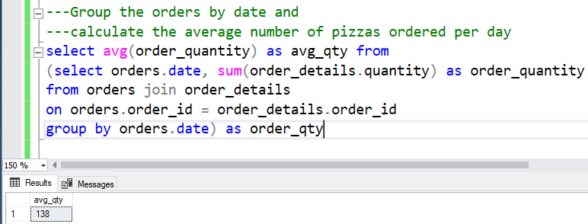

Determine the top 3 most ordered pizza types based on revenue.

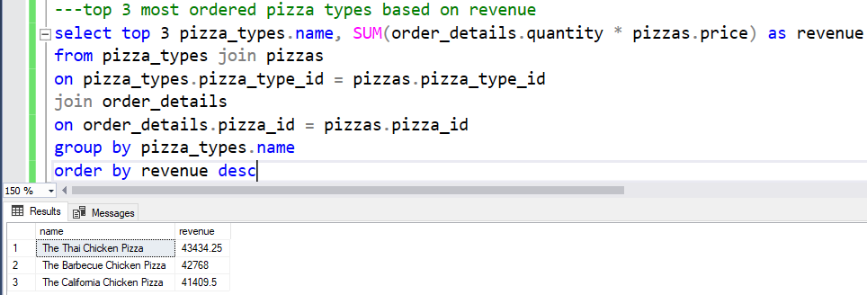

Calculate the percentage contribution of each pizza type to total revenue.

