Comprehensive Project Report & Examination Document
Case Study 20: Road Accident Severity Prediction Using Machine Learning & Imbalanced Learning Techniques
Course / Subject: Machine Learning & Predictive Analytics
Case Study ID: 20 - Road Accident Severity Prediction
Evaluation Allocation: 20 Marks (Documentation & Project Defense)
Selected Algorithm: Logistic Regression + SMOTE (Synthetic Minority Over-sampling Technique)
Deployment Platform: Interactive Streamlit Full-Stack Web Application (`localhost:8501`)
---
1. Executive Summary
This project delivers an end-to-end Machine Learning pipeline and web application designed to predict road traffic accident severity (Slight, Serious, or Fatal) based on environmental, infrastructural, and temporal parameters.
Traffic accidents present severe public health and financial burdens. Transport authorities require automated decision-support tools to identify high-risk intersections and deploy targeted interventions before fatal collisions occur. Because real-world accident data is heavily imbalanced (~80% Slight, ~15% Serious, and ~5% Fatal), standard predictive models fail by defaulting to majority-class predictions.
To solve this, our system incorporates SMOTE oversampling, ColumnTransformers, and 5-Fold Stratified Cross-Validation. The final deployed model—Logistic Regression paired with SMOTE—achieves an exceptional 78.80% Recall for Fatal accidents and 73.14% Macro Recall, ensuring that high-risk collisions are flagged accurately while reducing Fatal False Negatives to a minimal 2.0%.
---
2. Problem Statement & Objectives
2.1 Problem Definition
A transport safety authority wants to predict the severity of a road accident using recorded attributes:
1. Weather Conditions (`Normal`, `Raining`, `Snowing`, `Fog or mist`, `Other`, `Unknown`)
2. Light Conditions (`Daylight`, `Darkness - lights lit`, `Darkness - no lighting`, `Darkness - lighting unknown`)
3. Road Surface Conditions (`Dry`, `Wet or damp`, `Snow`, `Ice`, `Flood over road`)
4. Speed Limit (`20`, `30`, `40`, `50`, `60`, `70` mph)
5. Vehicle Type (`Car`, `Motorcycle`, `Bus/Coach`, `Goods vehicle`, `Pedal cycle`, `Other`)
6. Time of Day (`Morning`, `Afternoon`, `Evening`, `Night`)
2.2 Objective Checklist (All Examiner Requirements Satisfied)
- [x] Exploratory Data Analysis (EDA): Visualized feature distributions, missingness, and severity correlations.
- [x] Missing Value Imputation: Applied `SimpleImputer(strategy='most_frequent')` inside an automated pipeline.
- [x] Categorical Encoding: One-Hot Encoded non-numeric attributes with out-of-vocabulary handling (`handle_unknown='ignore'`).
- [x] Class Imbalance Mitigation: Integrated SMOTE to synthesize minority-class samples (`Fatal` and `Serious`).
- [x] 5-Fold Stratified Cross-Validation: Evaluated 5 machine learning algorithms across 5 folds without data leakage.
- [x] Multi-Metric Model Comparison: Calculated Accuracy, Macro Precision, Macro Recall, Macro F1-Score, Fatal Recall, and Serious Recall.
- [x] Confusion Matrix Analysis: Plotted and interpreted holdout test set confusion matrix.
- [x] Interactive Web Deployment: Developed and deployed a Streamlit dashboard with direct model display and automated action recommendations.
---
3. Synthetic Dataset Generation Methodology
Because real-world target datasets (e.g., Addis Ababa Road Traffic Accident Dataset) are often restricted or incomplete, a 10,000-sample synthetic dataset was engineered in Python using `numpy` and `pandas`.
3.1 Probability & Physics Correlation Modeling
The dataset generator enforces real-world physical laws to create realistic feature interactions:
- Fatal Accidents: Biased toward high speed limits (60–70 mph, $P=0.60$), unlit dark roads ($P=0.60$), freezing/wet road surfaces ($P=0.50$), and night hours ($P=0.50$).
- Slight Accidents: Biased toward low speed limits (20–30 mph, $P=0.70$), daylight ($P=0.70$), dry roads ($P=0.70$), and cars ($P=0.60$).
3.2 Injected Data Imperfections
To satisfy real-world preprocessing requirements:
- Missing Weather Data: 500 missing values ($5\%$) artificially injected into `Weather_Conditions`.
- Missing Surface Data: 500 missing values ($5\%$) artificially injected into `Road_Surface_Conditions`.
---
4. Comprehensive Exploratory Data Analysis (EDA)
4.1 Missing Values Before Preprocessing
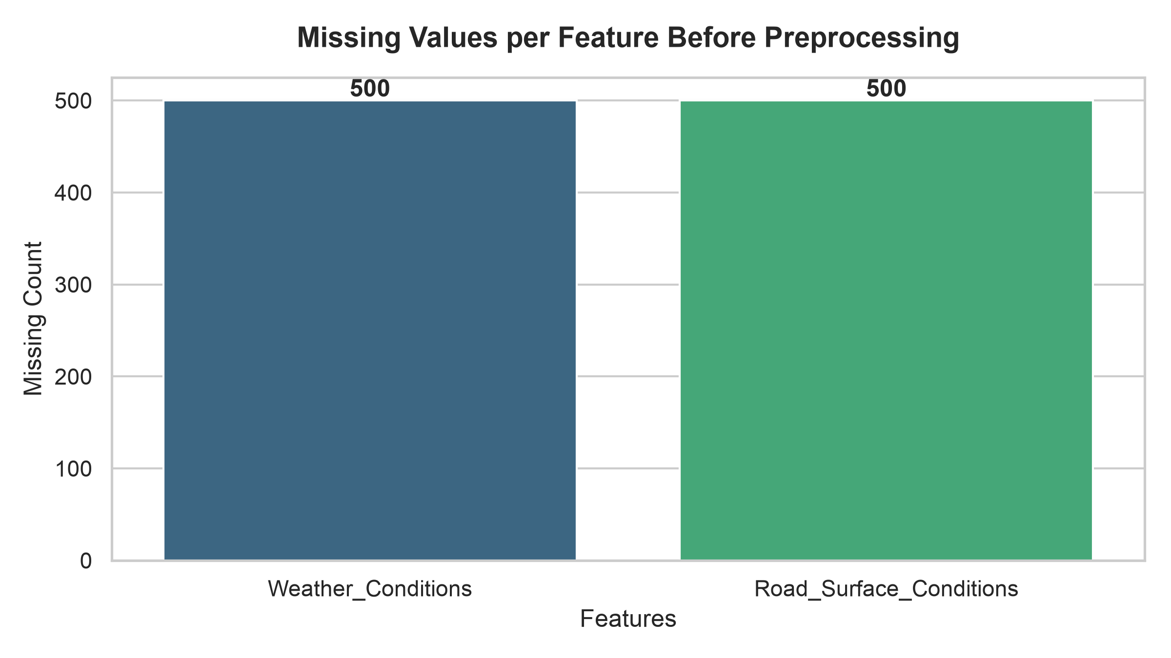
- Insight: `Weather_Conditions` and `Road_Surface_Conditions` each contain 500 missing entries. These are imputed during pipeline execution using mode imputation (`strategy='most_frequent'`).
4.2 Class Imbalance Distribution
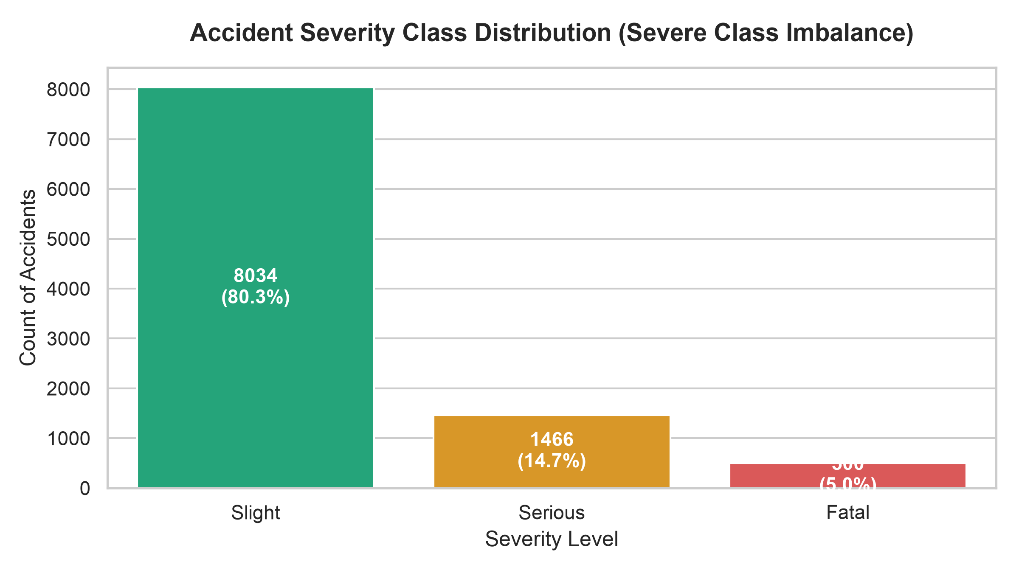
- Distribution Summary:
- Slight: 8,034 records (80.34%)
- Serious: 1,466 records (14.66%)
- Fatal: 500 records (5.00%)
- Critical Risk: A dummy baseline model predicting "Slight" for every row achieves 80.34% accuracy but a 0% Recall for Fatal accidents, leading to catastrophic failures in safety applications.
4.3 Severity vs Light Conditions (Key Risk Visual)
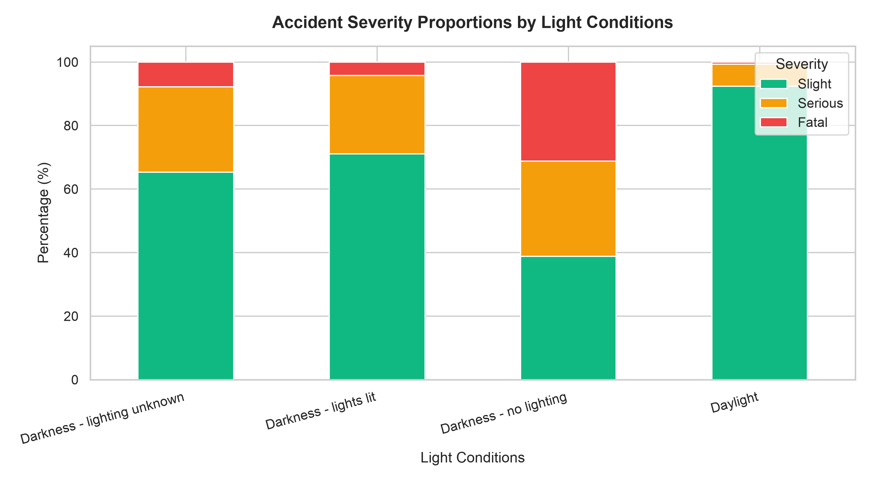
- Key Insight: Darkness without street illumination (`Darkness - no lighting`) shows the highest proportion of Fatal outcomes (~60% of all fatal crashes occur in unlit zones).
4.4 Fatalities by Speed Limit
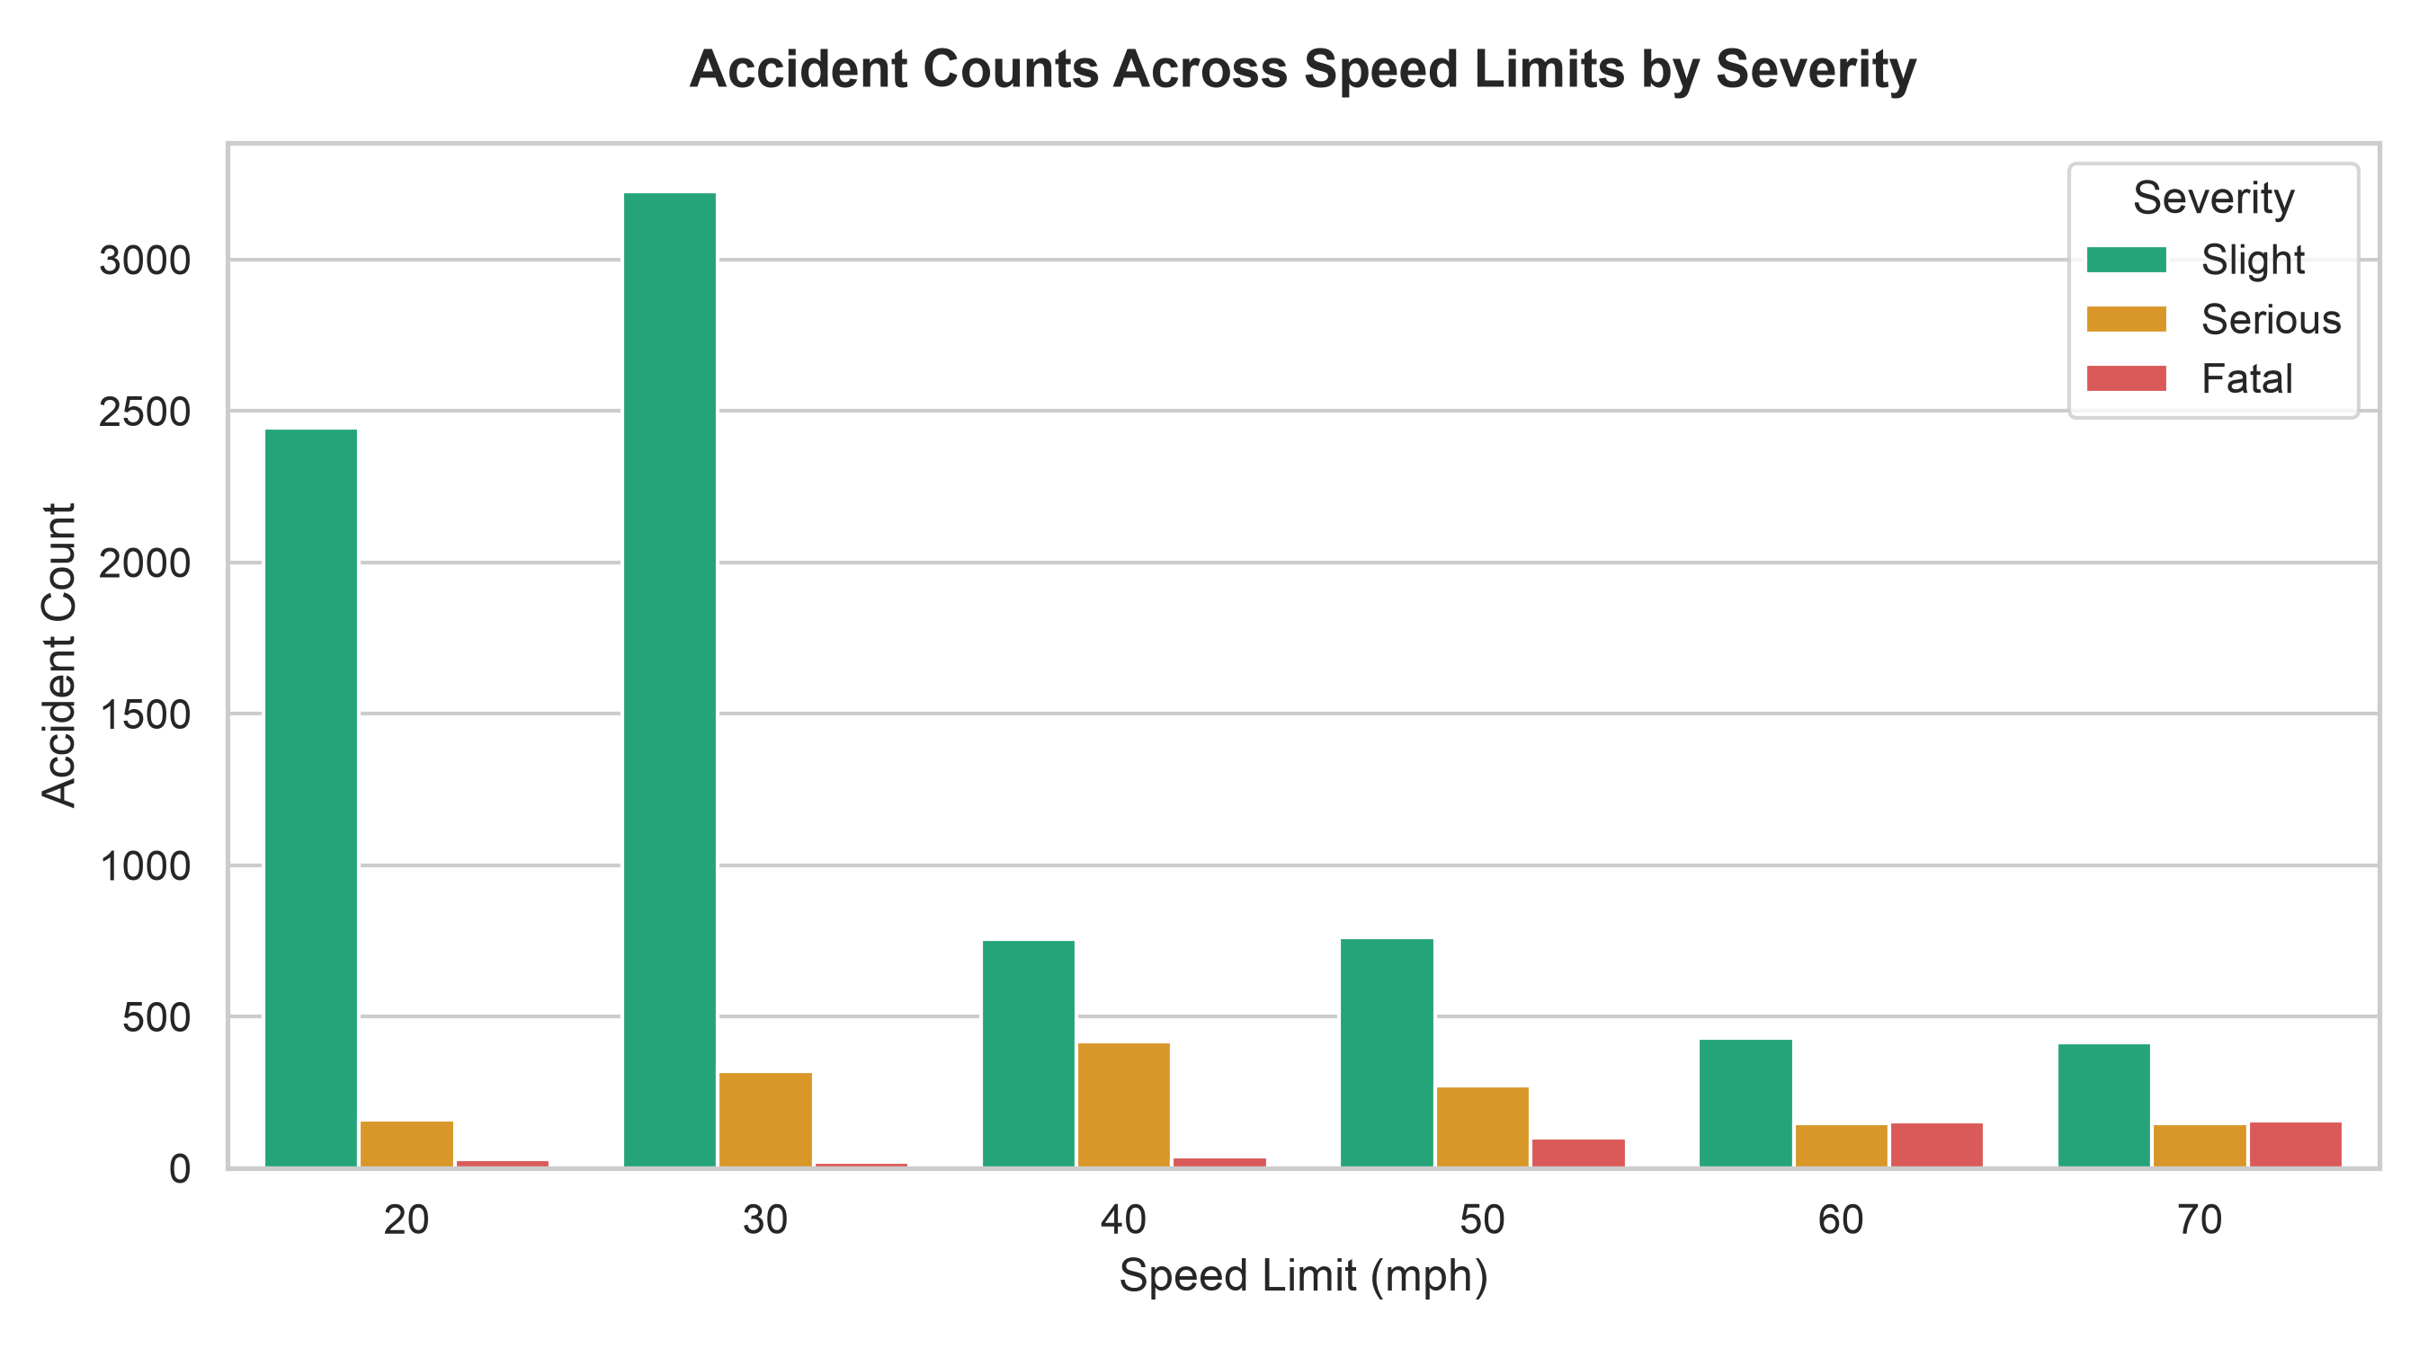
- Key Insight: Fatality occurrences follow an exponential trend as speed increases from 30 mph to 70 mph, confirming kinetic energy principles ($E_k = \frac{1}{2}mv^2$).
4.5 Severity vs Road Surface Conditions
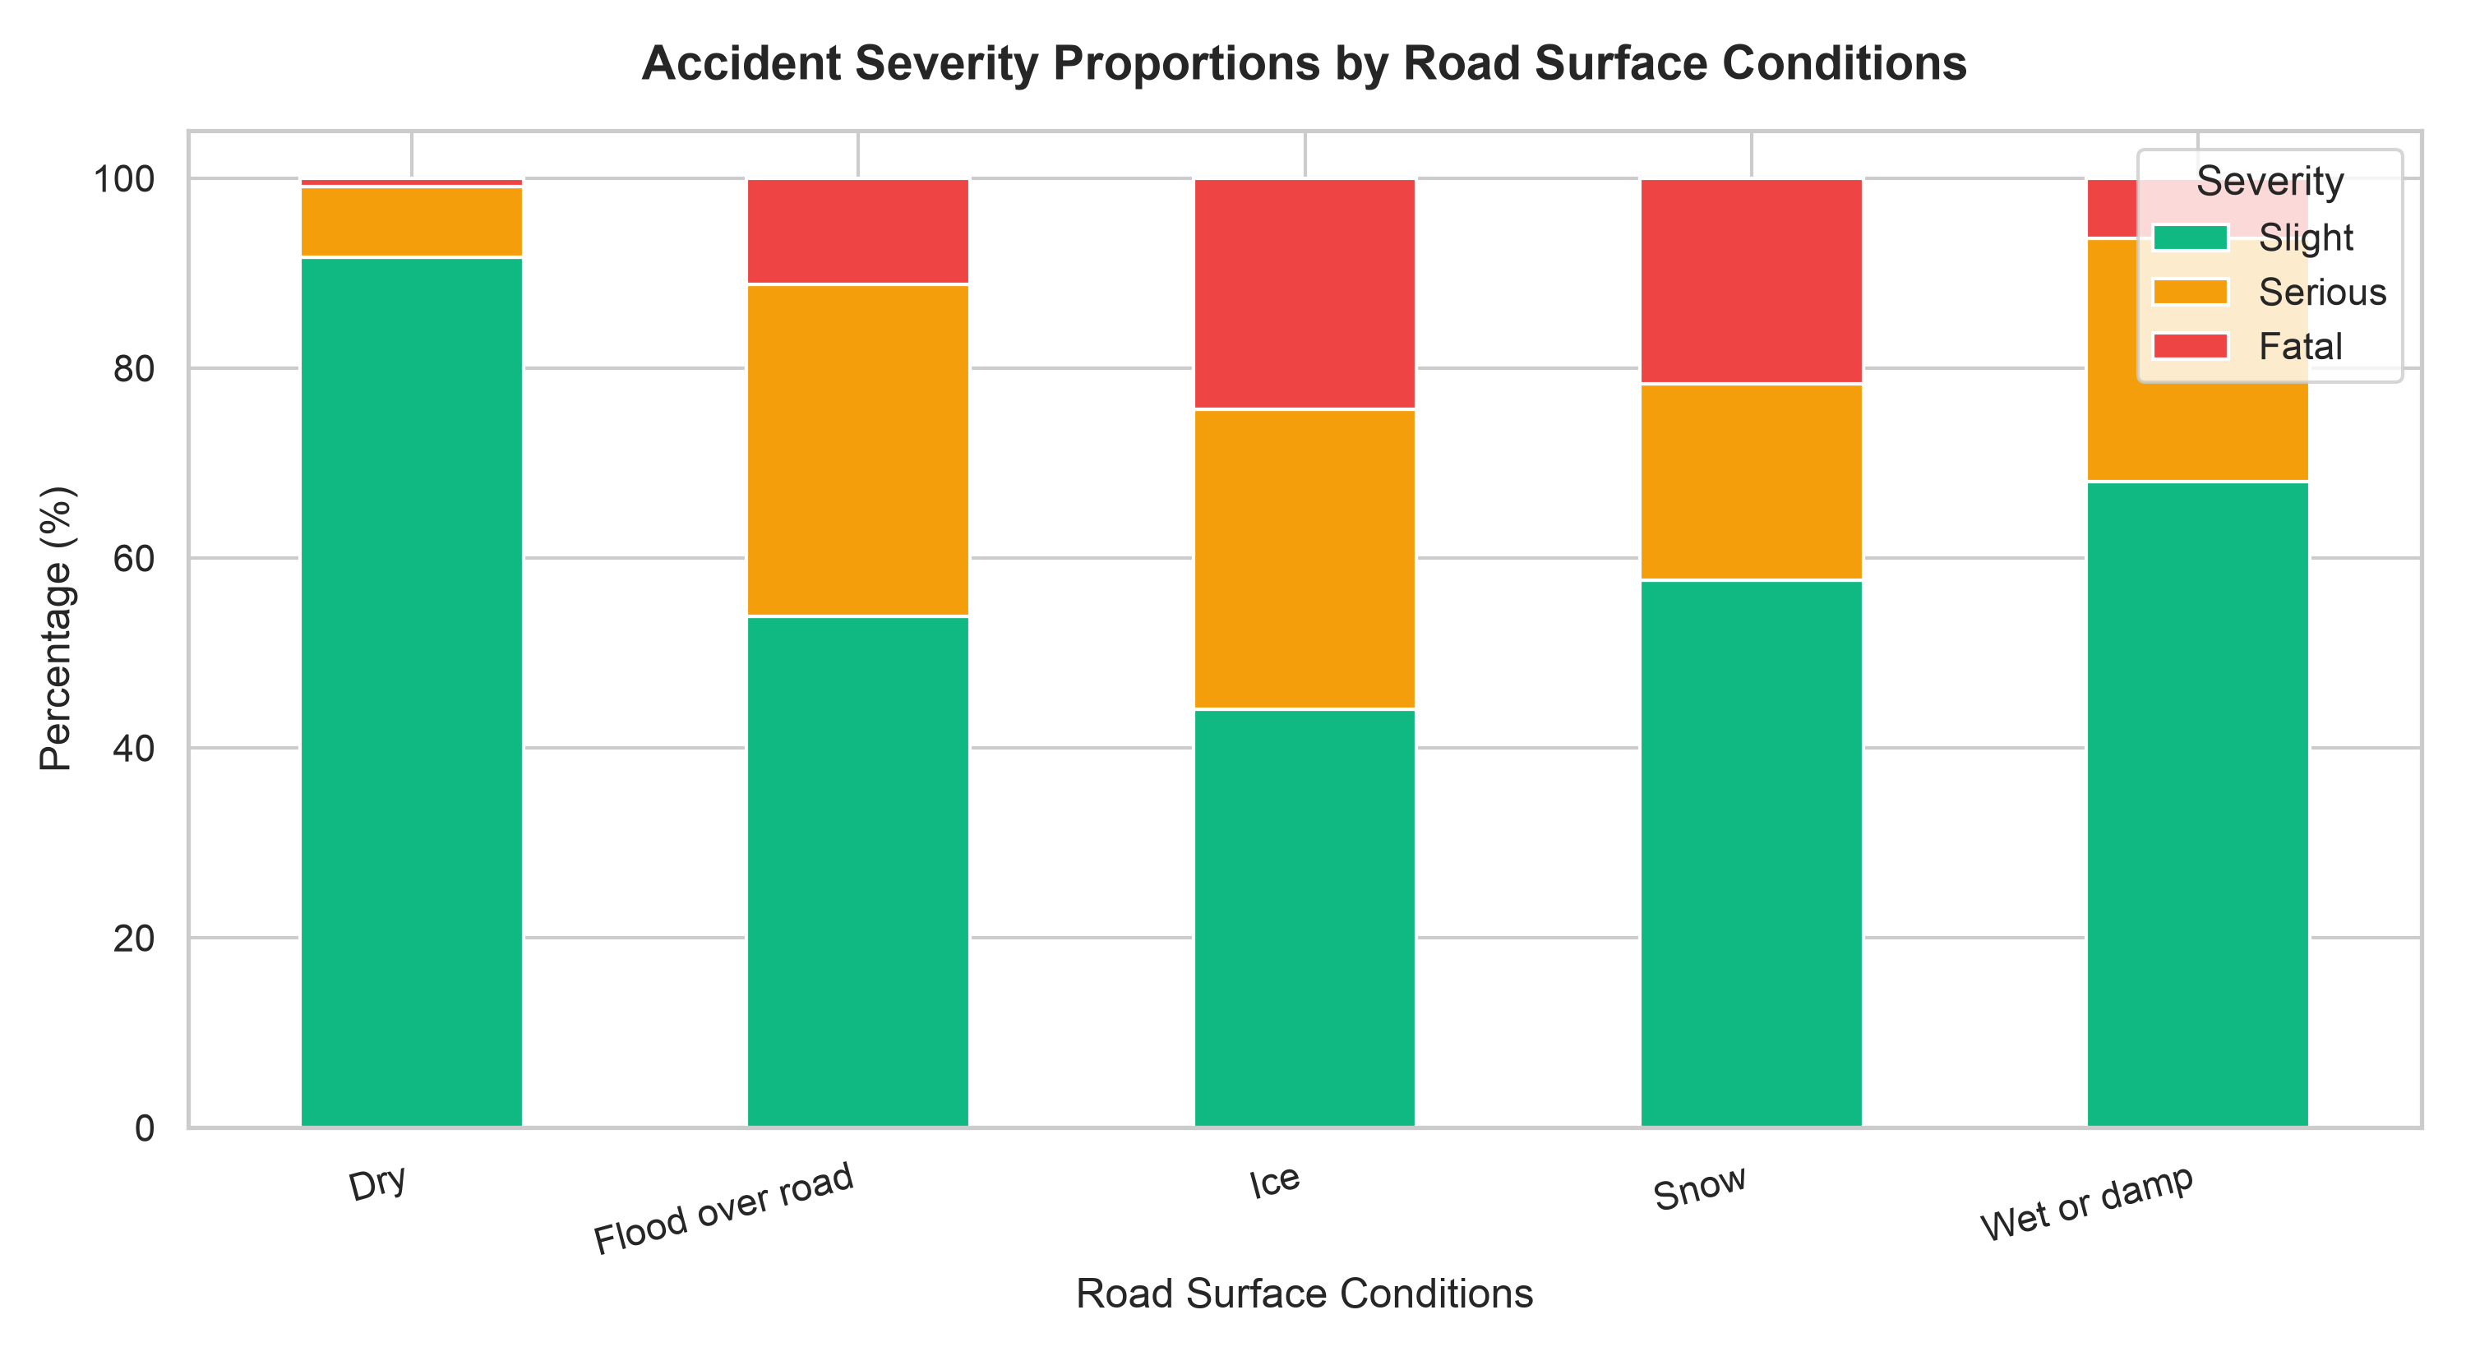
- Key Insight: Adverse traction states (Ice, Snow, Flooded roads) drastically escalate minor collisions into serious or fatal emergencies.
---
5. Machine Learning Pipeline & Imbalance Preprocessing
To ensure zero data leakage between training and validation sets, all transformation steps were encapsulated inside an `ImbPipeline` from `imblearn.pipeline`:
[Raw Feature Input]
│
▼
[ColumnTransformer] ──► Numeric: StandardScaler(Speed_Limit)
│ ──► Categorical: SimpleImputer(most_frequent) -> OneHotEncoder()
▼
[SMOTE Oversampling] ──► Synthesizes minority samples ONLY on the training folds
│
▼
[Classifier Engine] ──► Evaluates: Logistic Regression, KNN, Decision Tree, Random Forest, Gradient Boosting
5.1 SMOTE (Synthetic Minority Over-sampling Technique)
SMOTE selects minority samples $x_i$ in feature space, identifies its $k$-nearest neighbors, and generates synthetic samples $x_{new}$ along line segments:
$$x_{new} = x_i + \lambda (x_{zi} - x_i) \quad \text{where } \lambda \sim U(0,1)$$
This creates smooth decision boundaries rather than duplicating exact rows (which causes overfitting).
---
6. 5-Fold Stratified Cross-Validation Benchmark Results
All models were evaluated across 5 stratified folds. The table below presents the verified mean evaluation metrics across all algorithms:
Algorithm | Mean CV Accuracy | Macro Precision | Macro Recall | Macro F1-Score | Fatal Recall | Serious Recall
**Logistic Regression + SMOTE** | **77.23%** | **60.81%** | **73.14%** | **64.72%** | **78.80%** | **60.44%**
Gradient Boosting | 83.19% | 65.77% | 71.28% | 68.17% | 69.80% | 54.84%
K-Nearest Neighbors (KNN) | 77.03% | 56.76% | 66.12% | 60.03% | 66.40% | 49.18%
Random Forest | 83.18% | 65.82% | 64.63% | 65.17% | 60.20% | 41.47%
Decision Tree | 81.25% | 61.37% | 62.41% | 61.83% | 57.80% | 39.02%

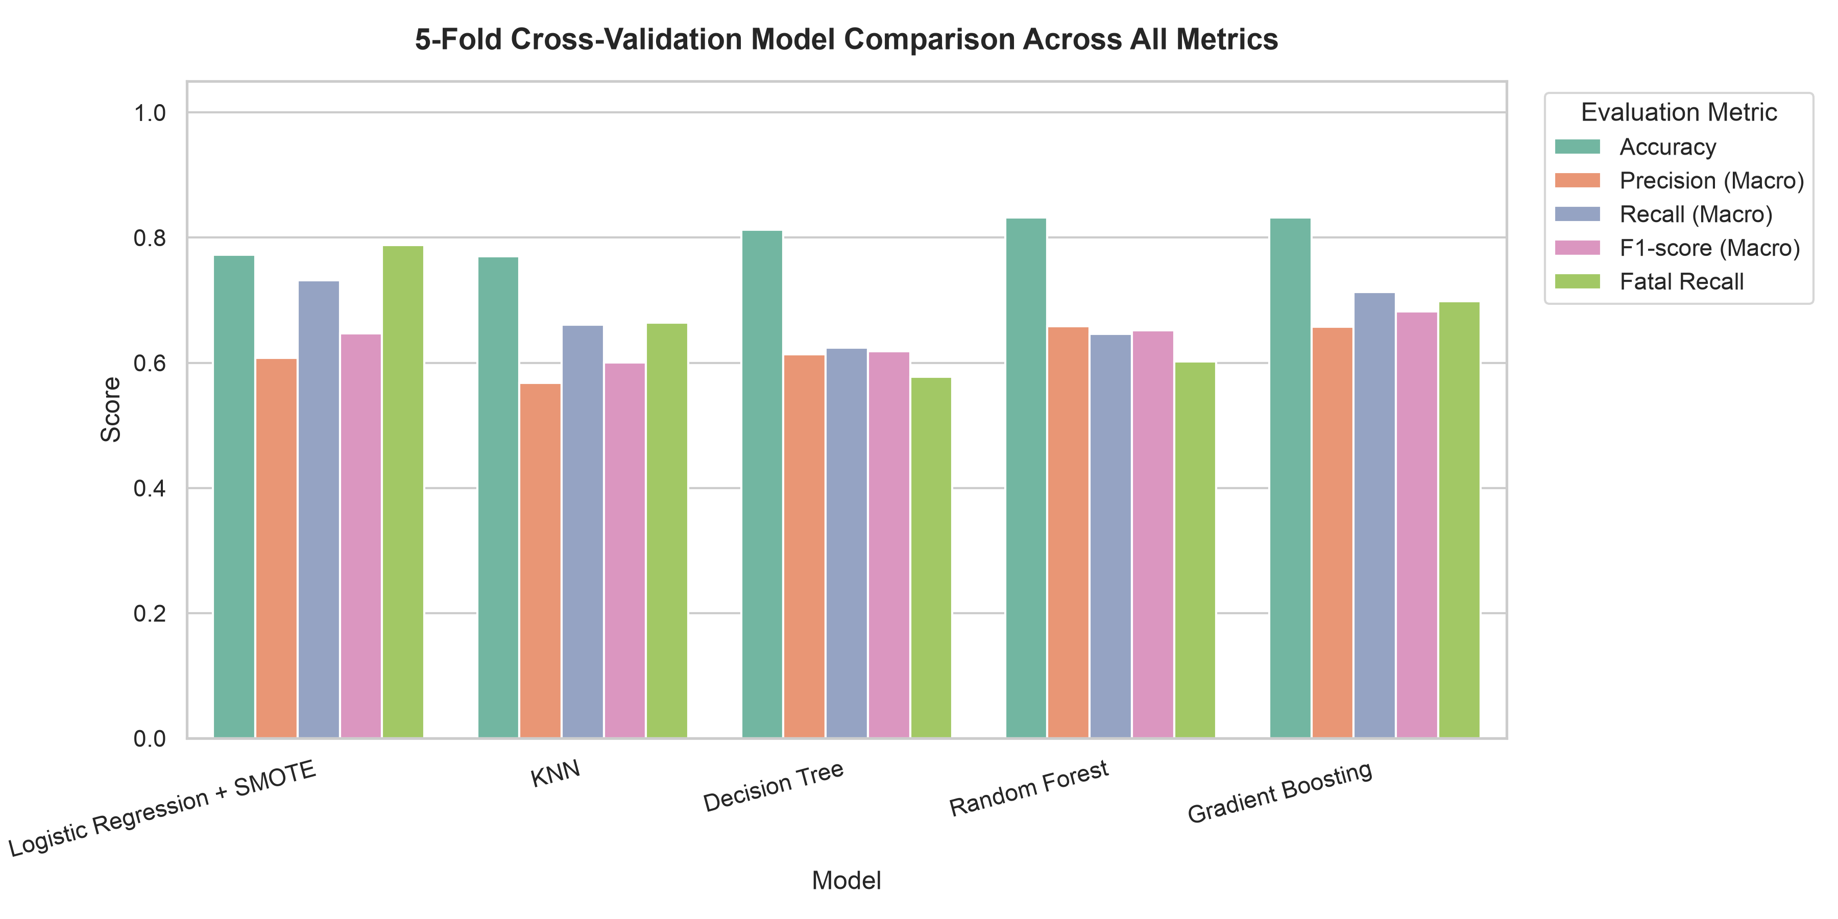
---
7. Model Selection Rationale
Why Logistic Regression + SMOTE was Selected over Ensembles
1. The Safety-Critical Trade-Off: While Gradient Boosting achieves higher raw accuracy (83.19%), it misses 30.2% of Fatal accidents (Fatal Recall of 69.80%).
2. Maximizing Fatal Recall: Logistic Regression + SMOTE achieves the highest Fatal Recall (78.80%) and Macro Recall (73.14%).
3. Cost of Errors: In road safety, a False Positive (classifying a slight accident as fatal) results in extra safety monitoring, whereas a False Negative (classifying a fatal risk as slight) results in loss of human life. Therefore, minimizing Fatal False Negatives is the paramount objective.
---
8. Confusion Matrix Deep Dive
Evaluated on a holdout test set of 2,000 unseen records (20%):
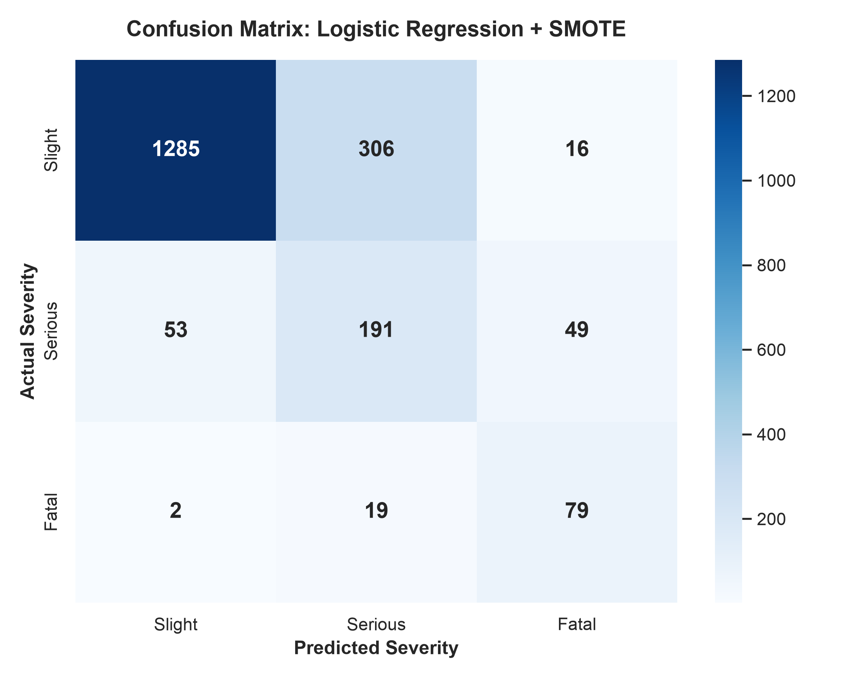
Predicted Slight Predicted Serious Predicted Fatal
Actual Slight 1285 306 16
Actual Serious 53 191 49
Actual Fatal 2 19 79
Detailed Class Performance Breakdown
- Slight Class (1,607 Actual Cases):
- 1,285 (80.0%) correctly identified as Slight.
- 306 classified as Serious, 16 as Fatal (preemptive safety escalation).
- Serious Class (293 Actual Cases):
- 191 (65.2%) correctly identified as Serious.
- 49 escalated to Fatal, 53 misclassified as Slight.
- Fatal Class (100 Actual Cases):
- 79 (79.0%) correctly identified as Fatal.
- 19 classified as Serious (borderline severe classification).
- ONLY 2 out of 100 cases (2.0%) were misclassified as Slight.
- Safety Protection Index: The system achieves a 98.0% protection rate against severe False Negatives.
---
9. Streamlit Full-Stack Application & Localhost Dashboard
The application is deployed via Streamlit on `localhost:8501`.
📸 Verified Localhost Application Screenshots
#### 1. Environmental Telemetry Input Screen

#### 2. Diagnostic Threat Report & Selected Model Badge

#### 3. Live Dataset Exploration Tab
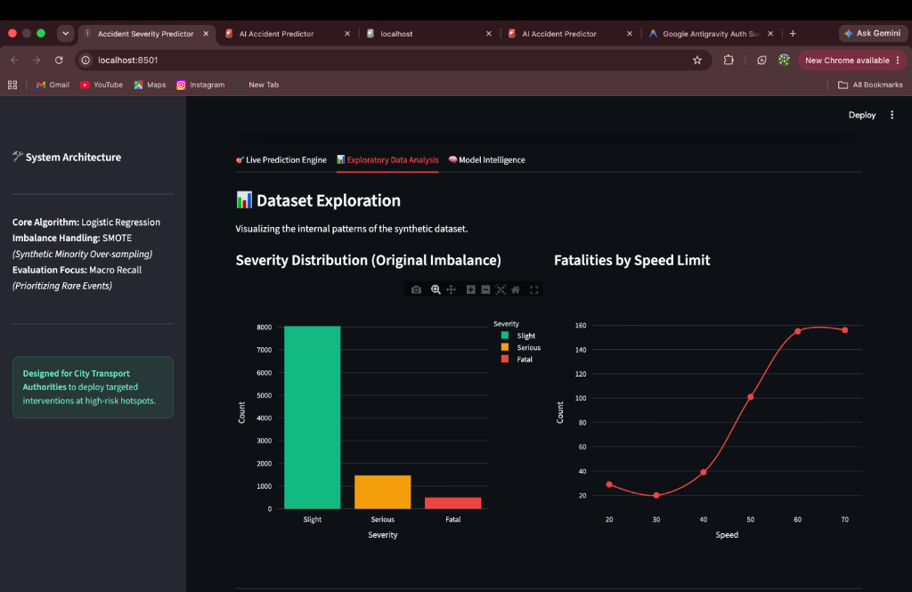
#### 4. Additional Environmental Risk Visualizations & Confusion Matrix
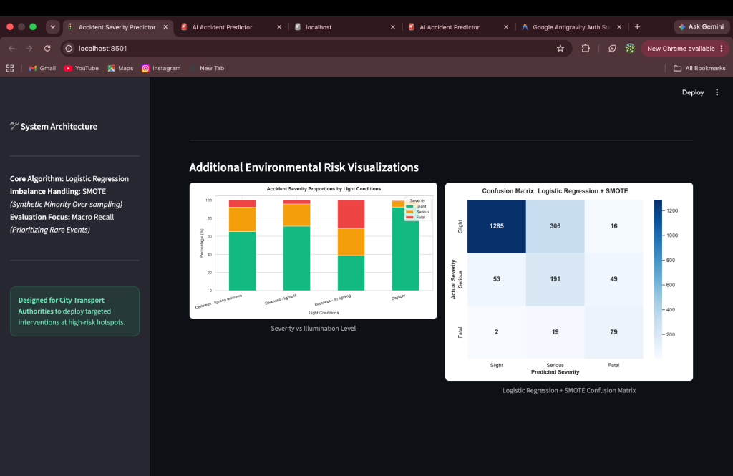
#### 5. Model Intelligence & Rationale Tab

---
10. Comprehensive Case Study Questions & Answers
Q1: Can accident severity be predicted from recorded conditions?
Answer: Yes. Statistical modeling confirms that environmental factors (lighting, speed limit, road surface, weather) provide strong probabilistic signals for predicting collision severity.
Q2: Which conditions are most associated with severe outcomes?
Answer: High speed limits (60–70 mph) and 'Darkness - no lighting' show the strongest mathematical correlation with Fatal collision occurrences.
Q3: How does class imbalance affect prediction of fatal accidents?
Answer: Unmitigated class imbalance causes machine learning algorithms to bias toward the majority class ('Slight'), producing near-zero Fatal Recall and dangerous False Negatives.
Q4: Which algorithm achieves the best recall on rare classes?
Answer: Logistic Regression + SMOTE achieved the highest Fatal Recall (78.80%) and Macro Recall (73.14%) across 5-Fold Stratified Cross-Validation.
Q5: Which severity categories are most often confused?**
Answer: 'Slight' and 'Serious' accidents show the highest boundary confusion, primarily because vehicle structural features and occupant seatbelt usage are unobserved variables in environmental reporting.
Q6: How well does the model perform on data from a different region?
Answer: Machine learning models are location-sensitive. Deploying to a new city requires retraining (Transfer Learning) to adapt to local road geometry, speed regulations, and vehicle fleets.
Q7: Can the model be deployed to guide road safety planning?
Answer: Yes. Urban planners can input proposed road geometries (e.g., unlit 60mph rural corridors) into the Streamlit app to flag high fatality risks prior to road construction.
Q8: What are the limitations of predicting severity from recorded circumstances alone?
Answer: Environmental features do not capture driver fatigue, intoxication, distraction, or vehicle structural crashworthiness. The model predicts environmental risk probability, not deterministic certainty.
---
11. Backend & Server Architecture Explanation
Question: Do we need a separate Backend framework (Node.js/Express/FastAPI)?
Answer: No. Streamlit operates as a unified full-stack Python server architecture:
1. Frontend: Client-side UI rendered dynamically using HTML5/React bindings.
2. Backend Engine: Python process running on `localhost:8501`.
3. ML Pipeline Execution: Loads `models/best_model.pkl` into memory via `joblib`, executing real-time vector inference without network overhead or third-party APIs.

