MediTrack
Electronic Medical Record for a Multi-Speciality Hospital Group

UML Package
Use case · class · sequence · activity · deployment diagrams – internally consistent, with the prescription module loosely coupled from billing

Case study | Case Study no. 1 – MediTrack (Aarogya Healthcare)
Course | Software Engineering & Project Management – B.Tech CSE 2025-29, Semester III
Institution | School of Future Tech, ITM Skills University
Team / roll numbers | [ to be filled in by the team ]
Version / date | 1.0 – October 2026

1. Overview and modelling approach
This package contains the five diagrams required by the case study. They model the same system from five viewpoints and use the same names for the same things (for example the class *PrescriptionService* is the participant in the sequence diagram and is deployed on the application servers in the deployment diagram). Section 8 proves this with a cross-reference matrix.
Figure | Diagram | Question it answers | Main requirements covered
UML-1 | Use case | Who uses the system and for what? | FR-01 to FR-12
UML-2 | Class | What are the main concepts and how are they related? How are prescribing and billing decoupled? | FR-01 to FR-09, FR-11, NFR-02, NFR-08
UML-3 | Sequence – prescribe drug with allergy check | In what order do objects collaborate to prescribe safely? | FR-03, FR-05, FR-06, NFR-02
UML-4 | Activity (swim-lanes) | What is the end-to-end workflow and who does each step? | FR-01 to FR-09
UML-5 | Deployment | Where does each part run, and how is it kept available and safe? | FR-12, NFR-01, NFR-03, NFR-05, NFR-06

The user interface is already built, so no screens are drawn. Boundary behaviour is captured by use cases and by the API calls shown in the sequence diagram.

2. Use case diagram
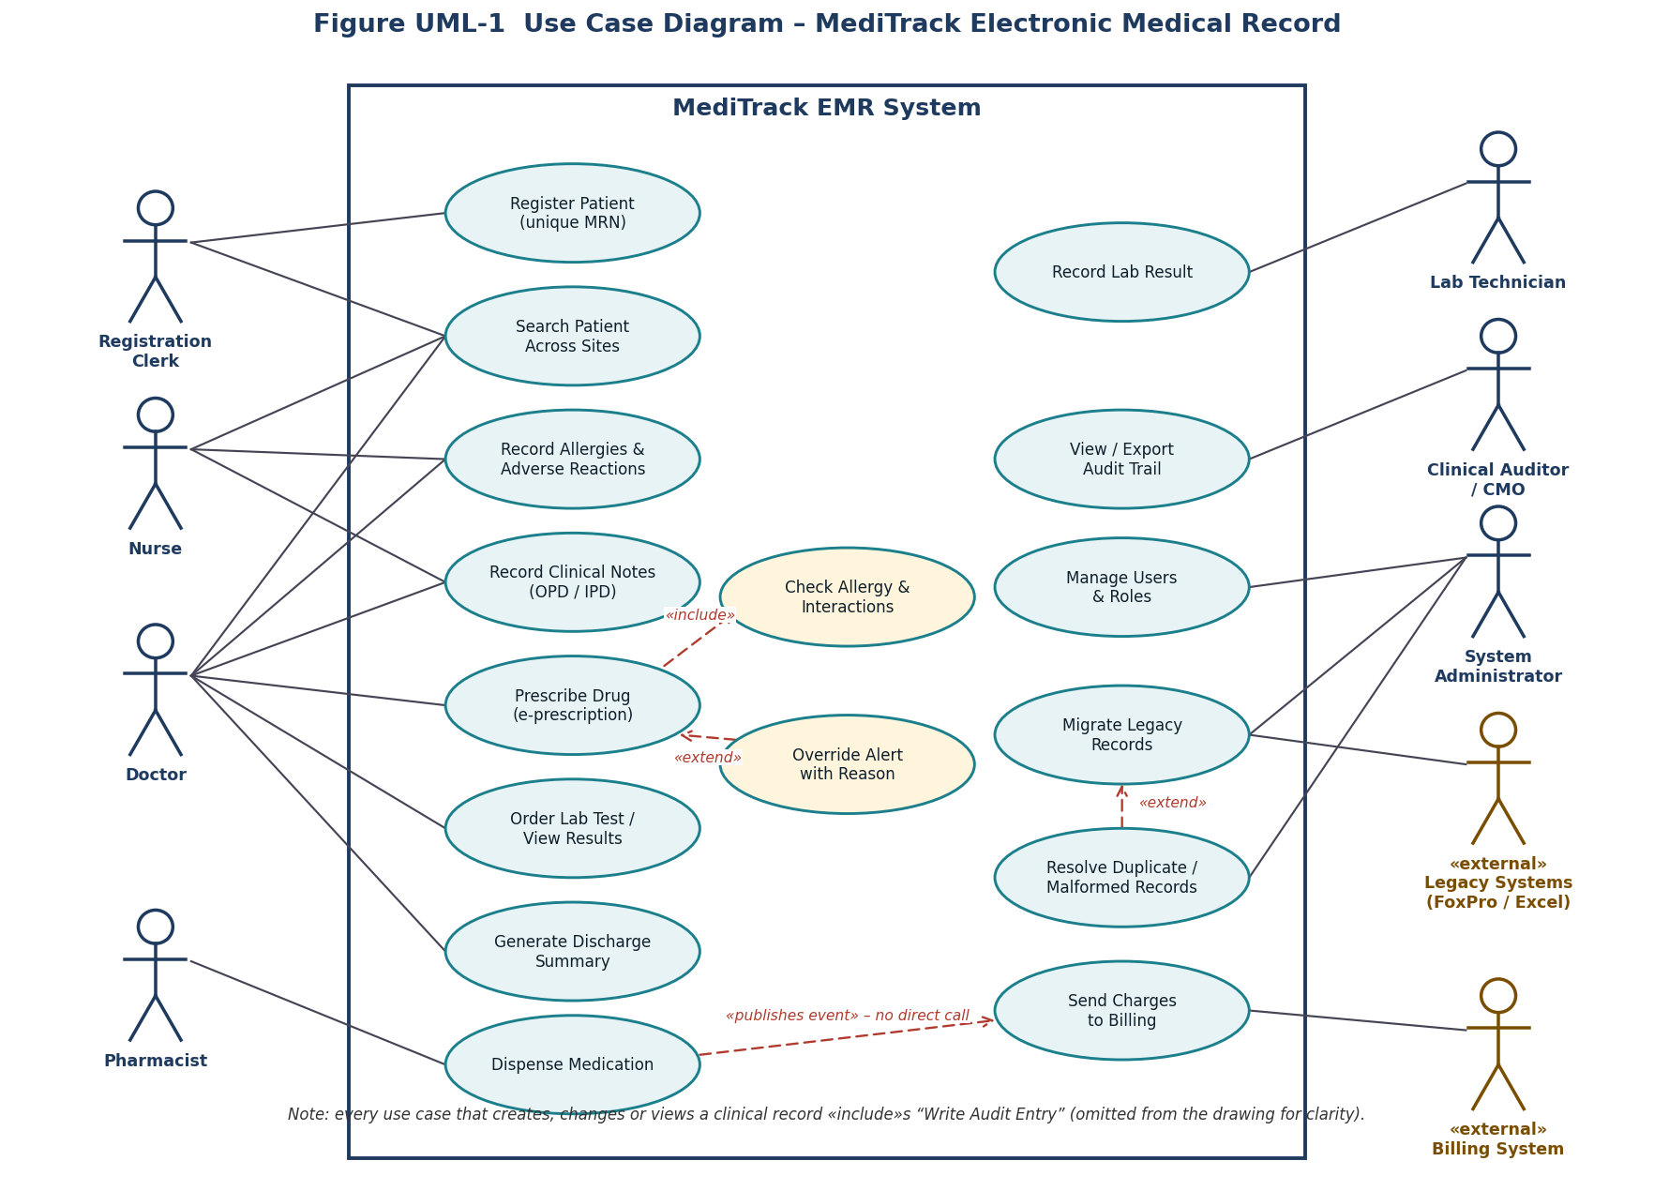
Figure UML-1 Use case diagram
Seven human actors and two external systems interact with the system boundary. «include» shows mandatory behaviour (every prescription is checked); «extend» shows optional behaviour (an alert may be overridden; a malformed record may be resolved). Billing receives an event; it does not call back into the prescribing use case.

Use case specification – Prescribe Drug
Item | Description
Primary actor | Doctor
Preconditions | Doctor is authenticated with the DOCTOR role; patient found; allergy status of the patient is KNOWN or NKDA (otherwise the use case first routes to ‘Record Allergies’).
Main flow | 1 Doctor selects patient. 2 System shows allergies and active medications. 3 Doctor enters drug, dose, route, frequency, duration. 4 System validates every numeric field against formulary limits (BVA, TC-009 to TC-012). 5 System runs ‘Check Allergy & Interactions’ (included). 6 Result is OK. 7 Doctor signs; system writes an audit entry, queues the prescription for the pharmacy and publishes *PrescriptionIssued*.
Alternative flows | 5a Result WARN: system shows reason; doctor changes the drug or overrides with a reason (extend). 5b Result BLOCK: system shows reason; doctor changes the drug or overrides with a reason and a second clinician’s co-sign. 4a Field outside range: entry rejected with message.
Postconditions | Prescription is SIGNED and immutable; audit entry exists; Pharmacy can see it; Billing is notified asynchronously.
Requirements | FR-03, FR-05, FR-06, NFR-02

3. Class diagram
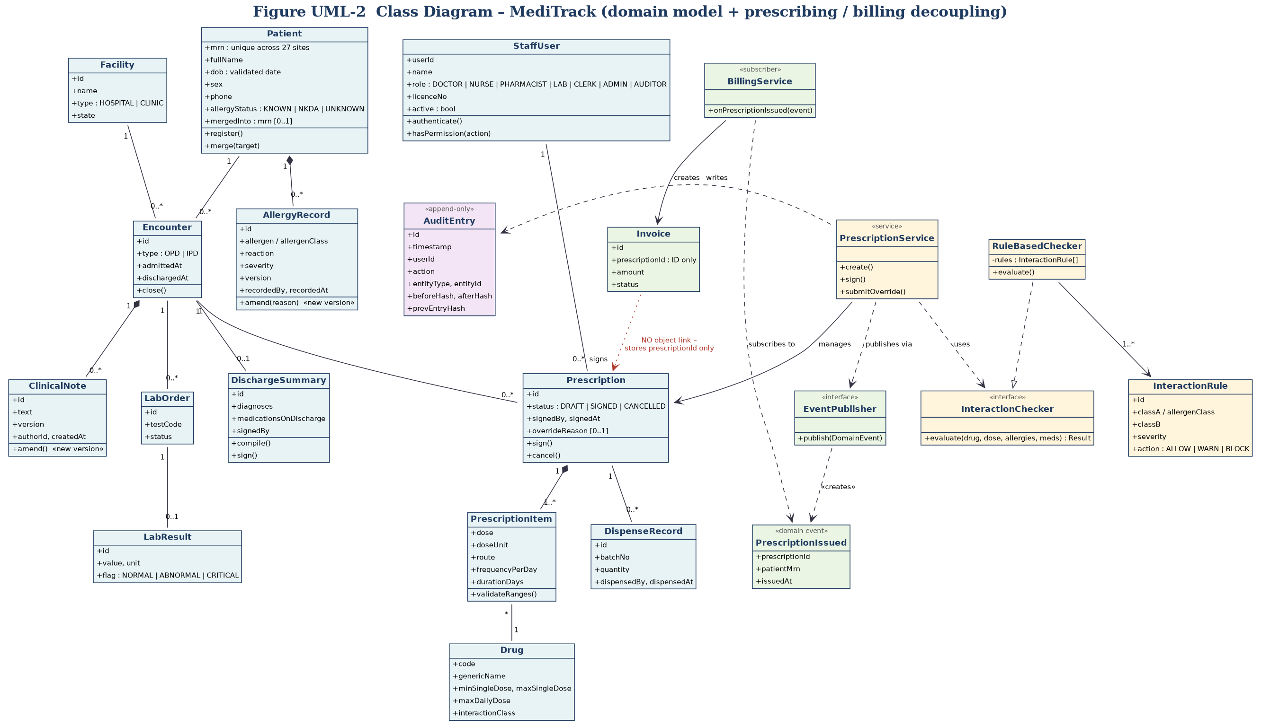
Figure UML-2 Class diagram (blue = clinical domain, yellow = prescribing / safety module, green = billing module, purple = audit)

Key design decisions
- Versioning, not overwriting: *AllergyRecord* and *ClinicalNote* are amended by creating a new version, so nothing is silently edited (FR-04, NFR-02).
- Allergy status on the patient: *Patient.allergyStatus* (KNOWN / NKDA / UNKNOWN) makes ‘we do not know’ an explicit, blockable state – the root cause of the 310 incidents.
- Strategy pattern for safety rules: *PrescriptionService* depends on the interface *InteractionChecker*; *RuleBasedChecker* implements it using data-driven *InteractionRule* objects, so rules change without code changes (NFR-08).
- Append-only audit: *AuditEntry* holds hashes of the previous entry and of before / after state, making tampering detectable.
- Loose coupling to Billing: see section 7.

4. Sequence diagram – prescribe drug with allergy check
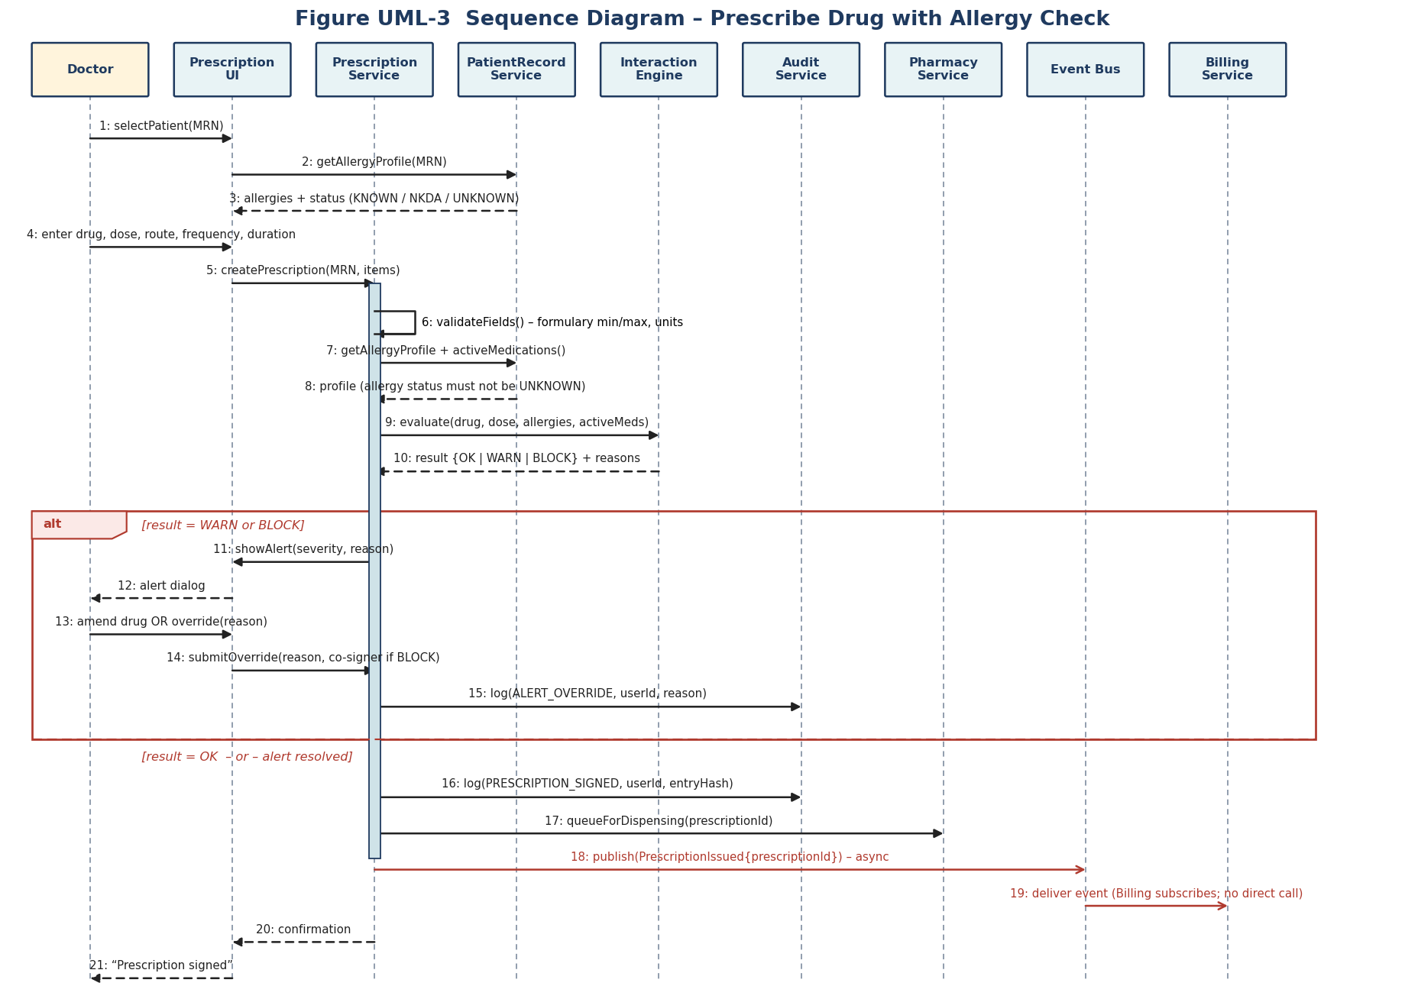
Figure UML-3 Sequence diagram
Messages 1–5 gather the patient’s allergy profile and the prescription. Message 6 validates numeric fields. Messages 7–10 fetch allergies and active medications and ask the *InteractionEngine* for OK, WARN or BLOCK. The alt fragment handles WARN / BLOCK: the doctor must change the drug or override with a reason (and a co-signer for BLOCK), and the override is audited (message 15). Messages 16–21 sign, audit, queue for the pharmacy and publish the event. Messages 18–19 are asynchronous: the prescribing service only talks to the event bus, never to Billing.

5. Activity diagram – encounter from registration to discharge
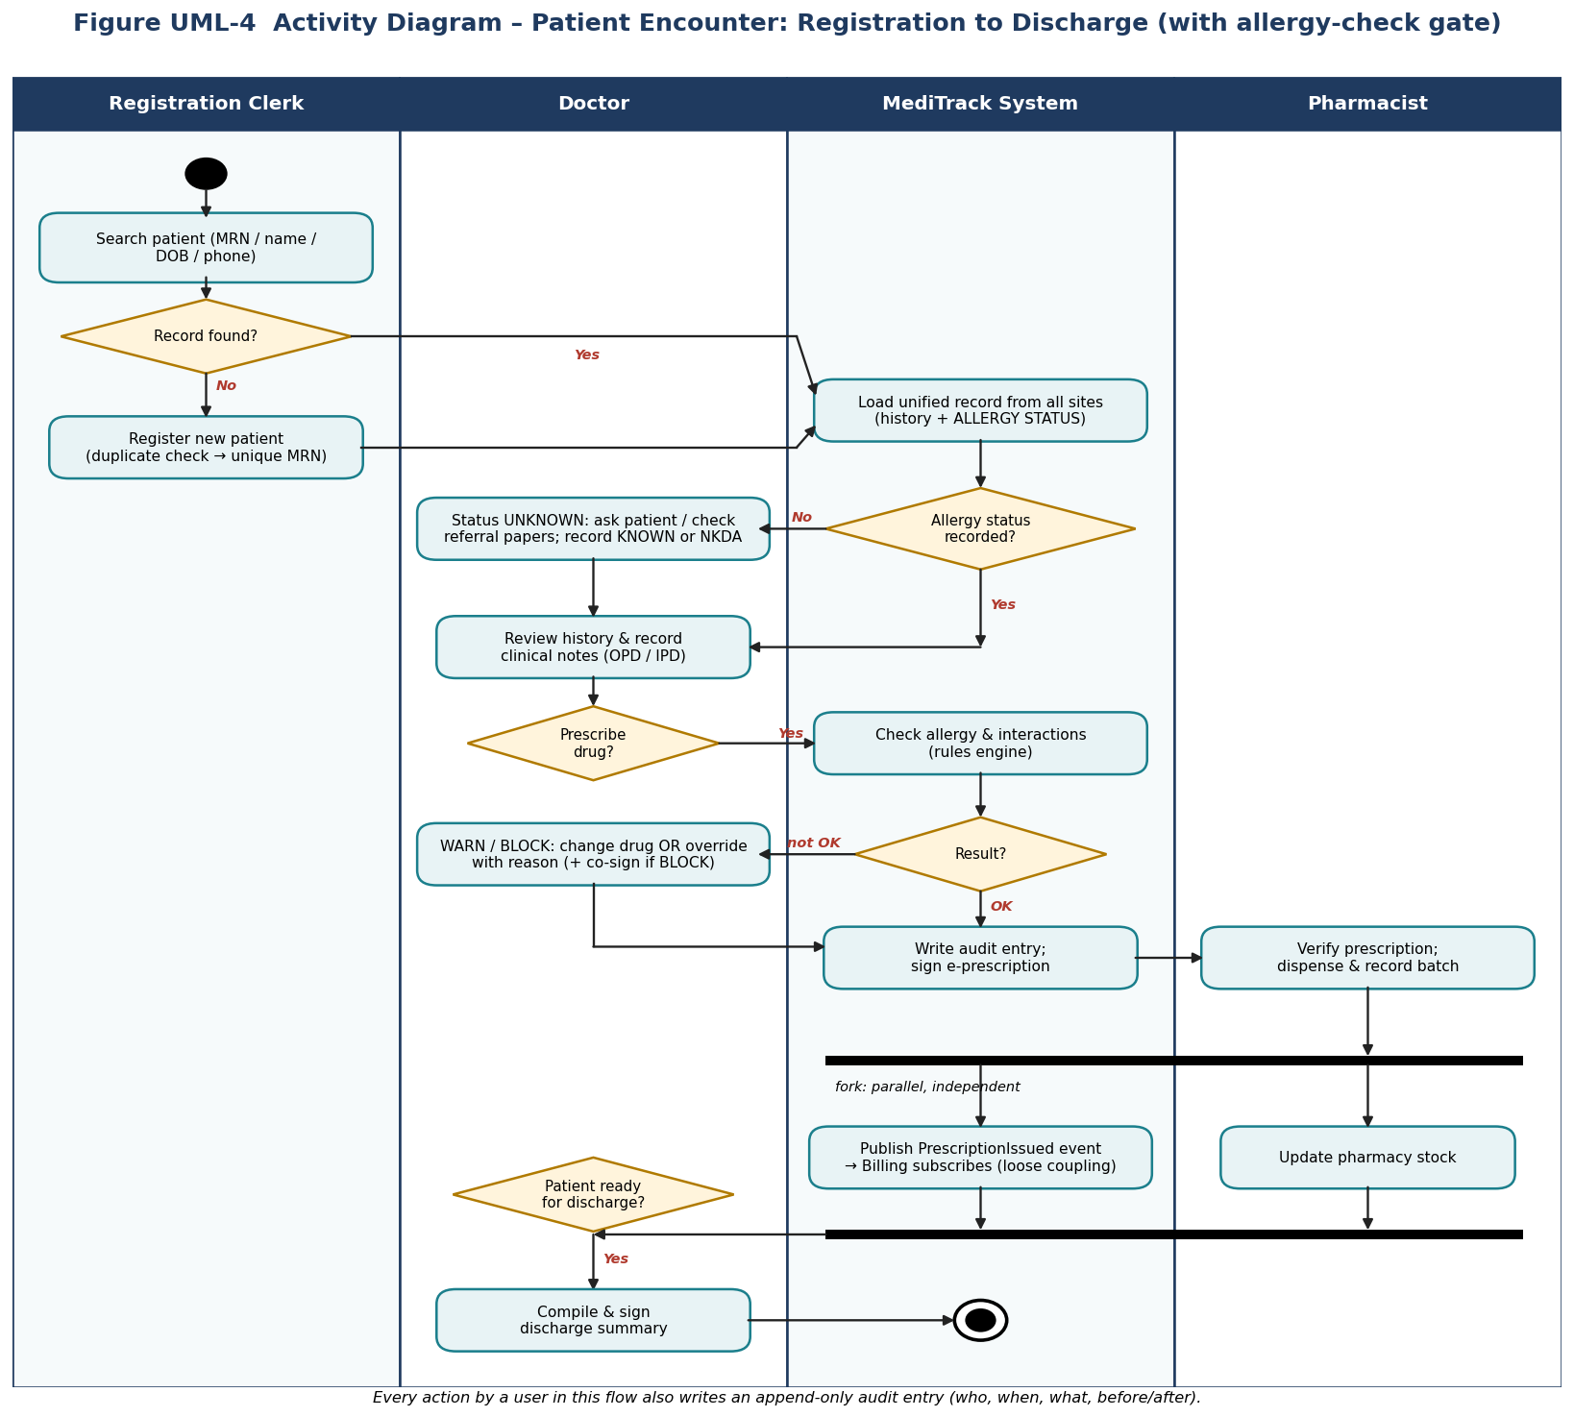
Figure UML-4 Activity diagram with swim-lanes
The allergy-status decision (‘recorded?’) is a gate before any prescribing: if the status is UNKNOWN the flow loops back to the doctor to ask the patient or read the referral papers. The fork after dispensing shows that billing notification and pharmacy stock update are independent and parallel.

6. Deployment diagram
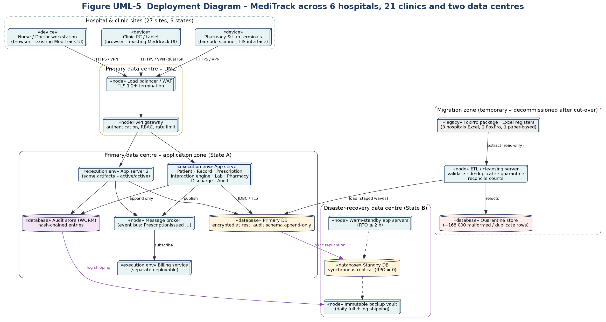
Figure UML-5 Deployment diagram
Design element | Requirement it supports
Load balancer / WAF, TLS termination, API gateway with RBAC | NFR-01 Security; FR-10
Two active/active application servers | NFR-03 Availability (MTTR ≤ 2 h), NFR-05 Performance, NFR-07 Scalability
Synchronous standby database in a second state; immutable backup vault | NFR-06 Durability (RPO = 0), NFR-03 (RTO ≤ 2 h), CMO’s ‘never lose a record’
WORM audit store with hash chain | NFR-02 Auditability
Temporary migration zone with ETL, quarantine store, read-only legacy extract | FR-12; risk R1 (migration) – decommissioned after cut-over
Billing service deployed separately and fed by a message broker | Loose coupling; a Billing outage cannot stop prescribing

7. How the prescription module is kept loosely coupled from billing
Mechanism | What it means | Where it is visible
Event-driven integration | *PrescriptionService* publishes a *PrescriptionIssued* event; it does not know who listens. | UML-2 (EventPublisher, PrescriptionIssued); UML-3 messages 18–19; UML-4 fork
Dependency inversion | The prescribing module depends on the abstraction *EventPublisher*, never on *BillingService*. Compile-time dependencies from Prescription → Billing: zero. | UML-2
Reference by ID only | *Invoice* stores *prescriptionId* but holds no object link to *Prescription*; no shared tables. | UML-2 (red dotted line)
Separate deployable and queue | Billing runs as its own service behind a broker; if it is down, events wait in the queue and prescribing continues. | UML-5
Independent testing and release | Prescribing tests use a stub *EventPublisher*; Billing can be released without re-testing the allergy engine – important for the regulated safety gate. | Test Plan; CI/CD pipeline in the Project Plan

Result: a change in billing rules, a billing bug or a billing outage cannot alter, delay or block the safety-critical prescribing path, and the safety-critical code can be verified without Billing.

8. Internal consistency check
Use case (UML-1) | Class(es) (UML-2) | Sequence / activity (UML-3, UML-4) | Deployed on (UML-5) | Req.
Register Patient | Patient | UML-4: ‘Register new patient’ | App server – Patient service; Primary DB | FR-01
Search Patient Across Sites | Patient, Encounter | UML-4: ‘Search patient’, ‘Load unified record’ | App server; API gateway | FR-02
Record Allergies | AllergyRecord, Patient.allergyStatus | UML-3 msgs 2–3, 8; UML-4 allergy-status gate | App server – Record service | FR-03
Record Clinical Notes | Encounter, ClinicalNote | UML-4: ‘Review history & record notes’ | App server; Primary DB | FR-04
Prescribe Drug | Prescription, PrescriptionItem, Drug, PrescriptionService | UML-3 msgs 4–6, 16–21 | App server – Prescription service | FR-05
Check Allergy & Interactions / Override | InteractionChecker, RuleBasedChecker, InteractionRule | UML-3 msgs 7–15; UML-4 ‘Check allergy & interactions’ | App server – Interaction engine | FR-06
Order Lab Test / Record Lab Result | LabOrder, LabResult | (lab flow – same Record service pattern) | App server – Lab service; lab terminals | FR-07
Dispense Medication | DispenseRecord | UML-3 msg 17; UML-4 pharmacist lane | App server – Pharmacy service; pharmacy terminals | FR-08
Generate Discharge Summary | DischargeSummary | UML-4 final activities | App server | FR-09
Manage Users & Roles | StaffUser | UML-3 (authorisation of every call) | API gateway; App server | FR-10
View / Export Audit Trail | AuditEntry | UML-3 msgs 15–16 write entries | Audit store (WORM) | FR-11
Migrate Legacy Records / Resolve Duplicates | Patient (alias, mergedInto) | – | Migration zone: ETL, quarantine store | FR-12
Send Charges to Billing | BillingService, Invoice, PrescriptionIssued | UML-3 msgs 18–19; UML-4 fork | Billing service; message broker | (interface)

Consistency rules checked
- Every use case in UML-1 appears in the matrix above and has at least one class, one flow and one deployment node.
- Every class used in the sequence diagram exists in UML-2 or is a service that maps to a deployed component in UML-5.
- Names are identical across diagrams (PrescriptionService, InteractionEngine / InteractionChecker, AuditService / AuditEntry, EventBus / EventPublisher).
- The allergy-status gate (UML-4) corresponds to rules DT-01 to DT-04 of the decision table and to message 8 of UML-3.
- The decoupling shown in UML-2 (ID-only reference) is the same decoupling shown in UML-3 (async event) and UML-5 (separate deployable).

