EV Customer Prioritization Technical Report
  - Technical report revision | MSBA265 Applied Analytics | Fall 2026
  - Nu Quynh Chau Nguyen | October 27 2026

1 Executive summary
This project builds a decision support prototype for an illustrative EV dealership that can review only K customer profiles. It estimates the supplied Will_Buy_EV label, ranks profiles, and exports an exact K shortlist with profile context. Staff can then prepare an editable Customer Conversation Guide for each selected profile. A staff member decides whether and how to follow up.
Logistic Regression was selected from three fixed candidates using validation Lift at 10% capacity. The saved final pipeline was refitted on 568,365 training and validation records, then evaluated on 100,300 holdout records. Its top 10,030 profiles contain 7,902 Yes labels, giving Precision@K of 78.78%, Lift@K of 4.511, and coverage of 45.11% of all holdout Yes labels. The Decision Tree was close on validation; the evidence supports this baseline choice within this experiment rather than an optimal model claim.
The recommendation is to use the local prototype for demonstration and structured review, then test permitted real data before any campaign. These are synthetic profiles and labels. The result does not estimate confirmed purchases, additional sales caused by outreach, or revenue.

2 Business context and objective
The intended user is a sales or customer relationship manager with limited review capacity. The project question is: Which K profiles are most likely to have a Yes label in the approved dataset? A ranked list fits this decision better than assigning every profile a Yes or No label at a fixed threshold.
Success means a reproducible shortlist with higher Yes-label concentration than label-independent selection, correct profile attachment, and usable exports. K is chosen by the user; 10% is the fixed comparison capacity for model selection. Conversation guides support staff preparation with consistent needs questions. There is no partner dealership, observed campaign, or measured guide impact in the evidence.
Report guide | Data and preparation: page 3 | Method and pipeline: page 4 | Training diagnostics: page 5 | Evaluation: pages 6 and 7 | Reproduction: page 8 | Recommendation: page 9 | Sources and feedback response: page 10

3 Individual project ownership
The project choice reflects an applied analytics focus: connect a measurable ranking question to a tool someone can inspect and use. I am responsible for framing the question, understanding the fields and preparation decisions, explaining the model and evaluation, checking the application, and communicating the limitations and recommendation. I must be able to explain the submitted code and results.
AI assistance supported code and document drafting. Responsibility for reviewing the evidence, reproducing the workflow, and addressing instructor feedback remains with me. Automated checks support technical review; independent peer replication and the separately signed course form remain part of the submission handoff.

4 Topic and industry context
The main topic is supervised binary classification. Each labeled row provides predictor values and a Yes or No outcome, so a classifier can learn an association between profile information and the supplied label. Its continuous score supports prioritization at different capacities. Unsupervised grouping would answer a different question about similarity; the dataset has no text or channel histories to support NLP or campaign analytics as the primary method.
Logistic modeling has a long history. Berkson applied the logistic function to biological response modeling in 1944, and Cox developed regression analysis of binary sequences in 1958 [3,4]. The present project uses the same general probability link with modern preprocessing and numerical optimization. These historical sources explain the method lineage, not the validity of this dataset.
Response modeling also appears in customer targeting. Moro, Cortez, and Rita examined bank telemarketing using predictive models and lift [5]. That example supports the logic of ranking people for limited review capacity. It does not establish that contacting the top ranked EV profiles produces additional sales.

Why the EV setting is useful
The U.S. Department of Energy identifies daily driving and charging options as practical consumer considerations [2]. The dataset includes commute, home charging, nearby charging, car ownership, and range anxiety fields, which can support questions during a consultation. Recorded profile facts should help staff confirm needs rather than infer preferences or financial suitability from demographics.
Potential value is a shorter, reviewable worklist with a consistent ranking rule. The costs include data preparation, staff review, permitted contact information, validation, and maintenance. The project has no evidence to quantify cost savings or return on investment. Its immediate value is a reproducible class prototype and an explicit evaluation framework.

5 Data and preparation
The professor approved Kaggle Playground Series Season 6 Episode 9, Predicting Electric Vehicle Purchases [1]. Files were obtained through the Kaggle API. One row is a synthetic customer profile. The labeled file contains an identifier, 13 predictors, and Will_Buy_EV; No maps to 0 and Yes to 1. There are 116,779 Yes labels (17.4645%) and 551,886 No labels. The identifier supports traceability and joins, and is excluded from predictors.
File | Rows | Columns | Role
train.csv | 668,665 | 15 | Labeled development and evaluation
test.csv | 286,571 | 14 | Unlabeled scoring and demonstration
sample_submission.csv | 286,571 | 2 | Competition output template
Table 1. Source file roles from the file summary and data manifest. The unlabeled competition test file cannot measure predictive performance; its row count is not an additional evaluation sample.

Field meanings and transformations
Six numeric predictors are Age, Annual_Income_USD, Daily_Commute_km, Number_of_Cars_Owned, Charging_Stations_Near_Home, and Charging_Stations_Near_Work. Seven categorical predictors are Environmental_Concern_Level, Gender, City_Type, Current_Car_Type, Home_Charging_Possible, Subsidy_Available, and Range_Anxiety_Level. Concern codes 1 to 5 are treated as nominal categories because their survey anchors and equal spacing are unverified.
Checks found zero missing or blank cells, duplicate IDs, duplicate full rows, repeated predictor profiles, non-finite numeric values, or checked domain violations in train and test. No source rows or predictor values were removed or changed. Preparation uses lossless integer storage where appropriate and the reversible target mapping.
IQR flags identify 3,678 income values, 41 commute values, and 13,489 car counts in labeled data. These were retained because an unusual value is not proof of an error. Two unlabeled test commute values exceed the observed training maximum of 98.7 km; scoring preserves them and warns about extrapolation.
Split | Records | Yes labels | Purpose
Training | 468,065 | 81,745 | Fit candidate preprocessing and models
Validation | 100,300 | 17,517 | Choose among fixed candidates
Holdout | 100,300 | 17,517 | Evaluate the final saved pipeline
Table 2. Stratified 70/15/15 membership. Seed 42 makes the initial 70/30 split; seed 43 divides the remaining 30%. Membership is saved by ID. Yes prevalence is about 17.46% in each split.
Full-data descriptive exploration preceded splitting. Fitted transformations and candidate selection respect split boundaries, but the holdout is an internal evaluation rather than a completely untouched external population. Purchase timeframe, country, income definition, charging radius, and concern survey anchors remain unspecified.

6 Method and implementation
The implemented flow validates profiles, applies the saved pipeline, predicts a Yes-label score, and returns the first K IDs with their profile context. A separate rule-based generator then creates a Customer Conversation Guide with five sections: opening, needs questions, discussion points, concerns, and an appointment or test-drive next step. Deterministic templates use recorded transport and charging facts, without demographic inference, an LLM, an API call, or another model. Staff review and edit the guide; generation does not change scores or ranking.
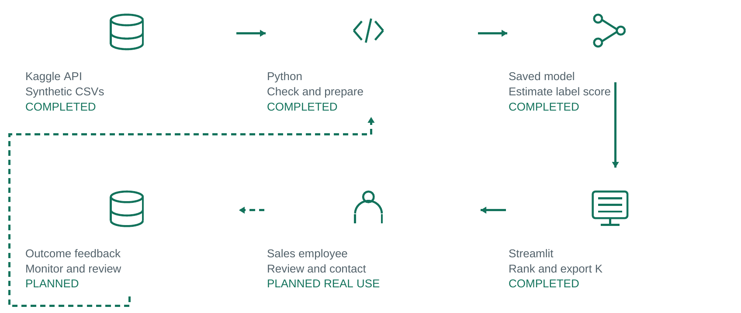
Figure 1. Data to action pipeline adapted from the archived P1 figure. The first four technical stages are completed; Streamlit delivery also includes editable conversation guides. Staff contact, outcome collection, and feedback remain planned. Dashed arrows mark planned feedback. All icons are original drawings; no customer contacts or live outcomes have been collected.

Candidate choices and fixed settings
Candidate | Fixed setting | Reason for comparison
Dummy baseline | strategy = prior | Same probability for all profiles; tests whether predictors add useful ranking.
Logistic Regression | C = 1; L2; lbfgs; tol = 0.0001; max_iter = 1000 | Simple regularized score with a standard solver; main interpretable baseline.
Decision Tree | max_depth = 6; min_samples_leaf = 200 | Nonlinear comparison with bounded depth and less reliance on tiny leaves.
Table 3. Prespecified candidates in ev_project/modeling.py. These settings are baseline constraints, not the result of exhaustive tuning or evidence of an optimum. No class weighting or resampling was applied; the baseline retains the supplied class proportions and evaluates capacity directly.
A ColumnTransformer standardizes numeric fields for Logistic Regression and one-hot encodes categories with handle_unknown="ignore" [6,8]. Scaling places numeric inputs on comparable scales for regularization and optimization. The Tree and Dummy use unscaled numeric values. Preprocessing is fitted on training only during comparison; validation and holdout receive transform only. Shared schema validation still rejects unsupported category inputs before scoring.
Validation selects the highest Lift@10%, with ROC AUC and then simpler candidate as tie rules. The selected pipeline is cloned and refitted on the 85% training plus validation data. The exact refitted pipeline receives the final holdout evaluation and is saved together with its preprocessing.

Training loss and numerical convergence
Logistic Regression computes a linear score from the transformed predictors and maps it through the logistic function to a probability. Training minimizes binary log loss plus an L2 coefficient penalty [6]. Log loss becomes large when a model confidently assigns a low probability to the observed class. The penalty discourages very large coefficients; C=1 controls its inverse strength. The intercept is not penalized.
For n equally weighted training records, the fitted objective can be written as mean binary log loss plus the sum of squared coefficients divided by 2Cn. Thus the plotted unpenalized log loss and the optimizer objective are related but distinct. Validation log loss is measured for diagnosis; it is not the quantity used to select this project model.
The lbfgs solver uses gradients and a limited memory approximation to curvature, with a line search checking proposed steps [6,7]. It evaluates the full training objective; one iteration can include multiple function evaluations. C=1 and tolerance 0.0001 retain standard baseline values. The max_iter=1000 safety cap gives the solver room to converge; it does not require 1000 updates. These settings were fixed rather than tuned on holdout.
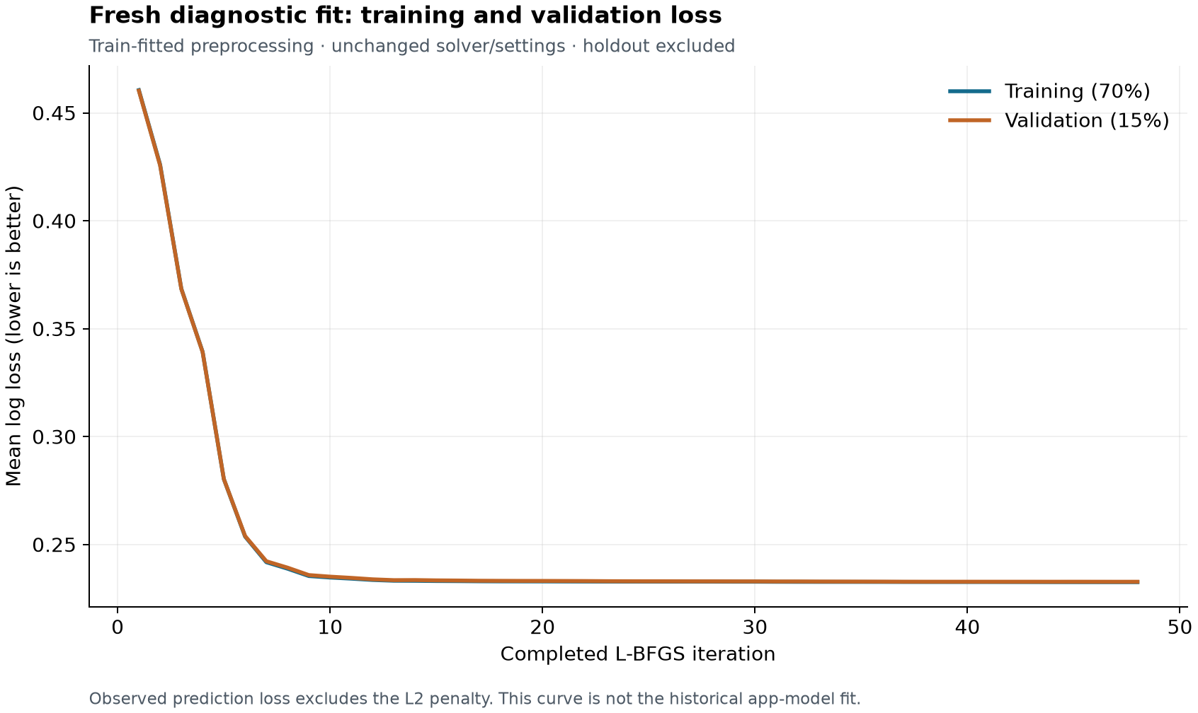
Figure 2. Fresh diagnostic fit on 468,065 training rows, with 100,300 validation rows used only for measurement. The public fit callback records mean unpenalized log loss after each completed iteration. Holdout is excluded, and validation does not control stopping. This curve is not the historical application model fit.
The diagnostic completed 48 iterations in 2.70 seconds, including preprocessing and callback scoring, without a ConvergenceWarning. Training loss fell from 0.4606 at iteration 1 to 0.2326; validation loss fell from 0.4603 to 0.2327. Both curves flatten with a small observed train-validation gap. The public estimator does not expose which convergence criterion ended the run.
The saved application model reports 47 actual iterations for its separate 568,365-row final fit. Its original elapsed training duration and per-iteration history were not stored. The new diagnostic run does not reconstruct that historical fit. A convergence warning is treated as a failed fit in the training code; a small final loss change alone would not establish good ranking or real-world performance.

7 Evaluation and findings

Metrics fit a limited capacity decision
Precision@K is the number of Yes labels among the first K ranked profiles divided by K. Recall@K is that count divided by all Yes labels in the evaluation set. Lift@K divides Precision@K by the set prevalence. Lift=1 is expected under random selection; higher lift indicates greater concentration of supplied Yes labels. K uses the ceiling of the contact fraction times the split size.
ROC AUC measures ordering across thresholds, and average precision summarizes precision and recall for the positive label. Brier score evaluates squared probability error. Accuracy and classification errors at 0.5 are supporting diagnostics because a fixed threshold does not enforce staff capacity. With 82.54% No labels overall, high accuracy alone could hide failure to identify Yes profiles.
Validation candidate | Precision at 10% | Lift at 10% | ROC AUC | Brier
Dummy baseline | 17.69% | 1.013 | 0.5000 | 0.14414
Logistic Regression | 79.10% | 4.529 | 0.9382 | 0.07347
Decision Tree | 78.76% | 4.510 | 0.9367 | 0.07347
Table 4. Validation n=100,300 and K=10,030. Source: validation_metrics.csv. Logistic Regression ranks first under the stated rule. Its shortlist has only 34 more Yes labels than the Tree; the small gap does not establish broad superiority.
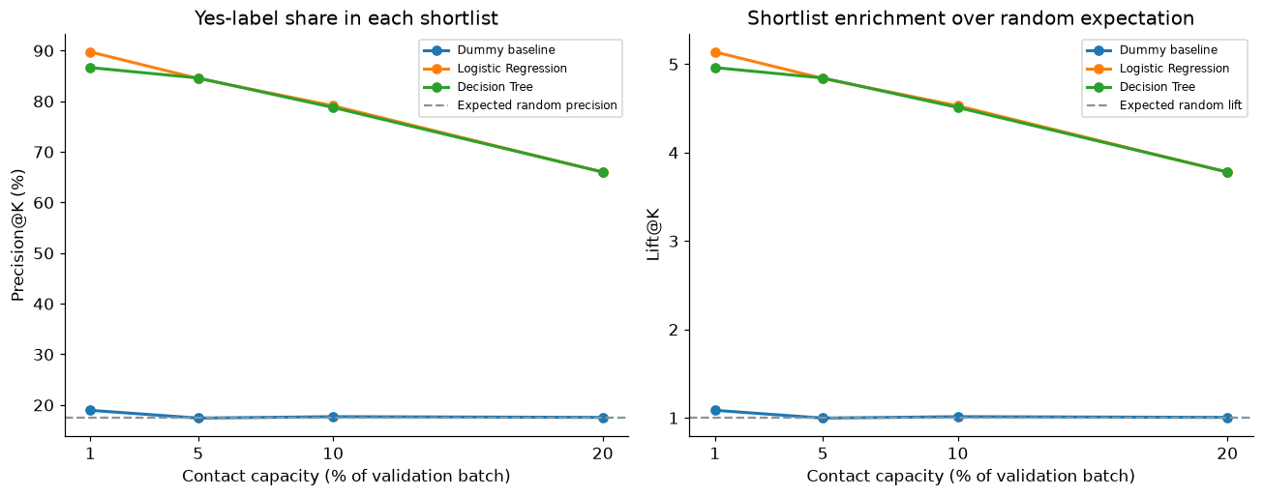
Figure 3. Validation capacity sensitivity from validation_ranking.csv. The two feature based models remain close at the tested capacities and both exceed the constant-score baseline. Smaller shortlists have a higher Yes-label share but review fewer profiles.
The Dummy baseline assigns the same probability to everyone. Tied scores use a seeded ID hash independent of the label and upload order, so its 17.69% shortlist precision is a realized near-random comparison, not meaningful feature-based prioritization. No confidence interval or repeated-split comparison was performed; model-selection uncertainty remains.

Final holdout results and errors
The final saved Logistic Regression pipeline has holdout ROC AUC 0.938872, average precision 0.740682, and Brier score 0.073400. At the primary capacity, 7,902 of the first 10,030 profiles have a Yes label. The remaining 2,128 have a No label, and 9,615 Yes profiles fall outside the shortlist. This makes the benefit and capacity tradeoff explicit.
Capacity | K | Precision at K | Recall at K | Lift at K
1% | 1,003 | 90.13% | 5.16% | 5.161
5% | 5,015 | 84.67% | 24.24% | 4.848
10% | 10,030 | 78.78% | 45.11% | 4.511
20% | 20,060 | 66.19% | 75.79% | 3.790
Table 5. Final holdout ranking sensitivity, n=100,300 with 17,517 Yes labels. Source: holdout_ranking.csv. Doubling capacity from 10% to 20% covers more Yes profiles but reduces shortlist concentration. Capacity should reflect review resources and the consequences of missed or unnecessary reviews.
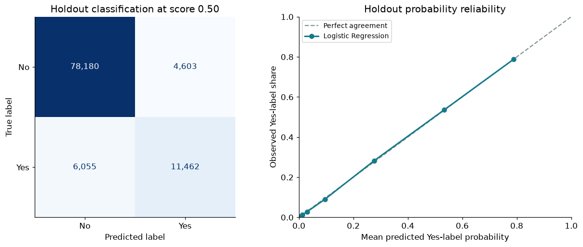
Figure 4. Supporting holdout diagnostics. At threshold 0.5, 4,603 No profiles are classified Yes and 6,055 Yes profiles are classified No. The binned probability curve is near the diagonal in this synthetic split. The threshold produces 16,065 positive classifications, so it is not the 10,030-profile shortlist rule.
The probability diagnostic supports checking within-source reliability, but neither its appearance nor the Brier score validates probabilities in a dealership population. The holdout was excluded from fitting and model selection; using its results to repeatedly alter settings would weaken that evaluation boundary. Future tuning should use development data and reserve fresh evaluation data.
Results are label associations in one synthetic source. Precision@K and Lift@K assess ranking, not the wording or sales impact of conversation guides. The analysis provides no causal estimate of what a call or script changes. Guide quality needs staff review, and appointment or sales effects require a separate pilot. Treating 78.78% as a conversion forecast would change the measured outcome.

8 Advanced component and reproducibility
The completed reproducibility component is a persisted preprocessing and model pipeline. models/model_bundle.joblib stores the fitted Pipeline with schema version and metadata. models/model_metadata.json records features, fixed settings, selection rule, source hashes, split counts, training versions, and evaluation. The app loads this fixed local artifact rather than retraining when a user uploads a CSV.

Saved model load and test evidence
During the original artifact save, the pipeline was reloaded and probabilities on the first 100 holdout records were compared with the in-memory final pipeline. The check used zero relative and absolute tolerance. The application test suite also checks that the saved application bundle is the evaluated pipeline, selects the positive class by label, and preserves ID alignment.
On October 27, a read-only check loaded the current saved model and scored all 500 demo profiles at K=25. All IDs were unique, probabilities were finite and within [0, 1], and the shortlist had exactly 25 rows. Reloaded probabilities, ID order, and shortlist were identical, with maximum absolute score difference 0.0. The 53 passing automated checks cover model boundaries, validation, exact K, ID alignment, rule branches, guide wording without demographic inference, edit retention and reset, and export refresh. These checks support implementation; independent peer reproduction remains pending.
from ev_project.scoring import load_bundle, score_profiles
import pandas as pd
bundle = load_bundle("models/model_bundle.joblib")
profiles = pd.read_csv("data/demo/customer_profiles_demo.csv",
dtype={"id": "string"})
ranked, shortlist, warnings = score_profiles(profiles, bundle, 25)
assert len(shortlist) == 25
assert shortlist["id"].is_unique
Demonstration 1. Minimal load and score example using the included 500-profile unlabeled demo. This calls the same scoring function as the app. Load only the trusted project artifact; joblib loading requires compatible dependencies and can execute code [9].

Reproduction sequence and outputs
Use the project README to obtain the complete repository, create a Python 3.12 or 3.13 environment, and install requirements.txt. The recorded training environment is Python 3.13.9 with scikit-learn 1.9.1, pandas 2.2.3, NumPy 2.3.5, and joblib 1.6.0. Matching the training environment is the preferred path for loading and reproduction [9].
For full analysis, an authorized reviewer obtains the three competition CSVs using their own Kaggle credentials, runs ev_project/run_eda.py and ev_project/run_modeling.py, and checks reports, split membership, metadata, and the saved bundle. ev_project/train_models.py is a direct training alternative. The two notebooks and HTML reports provide analysis and reading copies. Raw data and credentials are not included in the public handoff.
Run python -m unittest discover -s tests, then python -m streamlit run app.py. The app ranks up to 300,000 profiles. Bulk guide CSV generation supports K up to 1,000 to bound memory; individual guide viewing and .txt downloads remain available for larger shortlists. Staff edits stay in session memory, so export them before leaving or changing the uploaded file. The guide CSV contains all 13 profile fields, rank, ID, score, script, and edit status. Prepare it again after editing a script. The saved model is unchanged, with no retraining or automatic contact. Independent peer replication remains pending.

9 Recommendation limitations and next steps
Use the saved Logistic Regression pipeline as the current demonstration model and the exact K ranking as the product behavior. Preserve the fixed comparison and holdout records. Staff can inspect the capacity tradeoff, review profile context, edit the corresponding conversation guide, and export a worklist. Any real campaign should begin with permitted data and an evaluation plan agreed with the business owner.

Limits that affect use
Synthetic labels do not validate real purchase behavior, time to purchase, contact response, revenue, or incremental benefit. One internal stratified split gives no estimate of population or time drift. The close Tree comparison and lack of repeated-split uncertainty mean model choice could change under another valid experiment. Unknown field definitions constrain interpretation even when the data have no missing cells.
Gender, age, income, and related variables raise fairness and suitability questions. Subgroup errors, shortlist representation, and the effect of removing demographic predictors have not been evaluated. Staff should confirm budget and preferences directly. A real deployment requires a review of predictor relevance, permitted use, contact consent, and subgroup outcomes before choosing a production policy.
The app checks known input rules and warns about values outside observed numeric ranges. Those checks cannot establish calibration in a new population. Conversation rules do not create offers or prices, promise savings, or determine eligibility. Their questions use recorded transport and charging facts; staff must confirm the facts and the customer's needs. Guide content and edits need separate review, while measuring predictive or campaign performance requires newly verified outcomes.

Work needed before real use
First, complete independent peer reproduction and incorporate specific instructor feedback. Next, evaluate subgroup and demographic-feature choices on development data, quantify uncertainty with appropriate resampling, and assess calibration and ranking on fresh permitted data. Review guide factual consistency, question relevance, and staff editing needs in a pilot. Record profile selection, contact, verified outcomes, and costs before claiming campaign value; an experimental comparison is needed to estimate the effect of outreach or the guide.
Extension | Current status | Evidence required for completion
FastAPI | Planned | Shared input rules, scoring endpoint, valid and invalid request tests, run instructions.
Docker | Planned | Reproducible build, launch, dependencies and artifact included, scores match the local pipeline.
MLOps | Planned | Versioned input reference, quality and drift checks, shifted-input alert test, investigation rules.
Table 6. Planned extensions from the archived P1 plan. They are not implemented evidence in this report. A monitoring feature can flag input change; measuring prediction quality additionally needs verified outcomes.

10 References and appendices
[1] Kaggle. Predicting Electric Vehicle Purchases. Playground Series Season 6 Episode 9. Synthetic competition data. Source
[2] U.S. Department of Energy. Alternative Fuels Data Center. Electric Vehicles for Consumers. Source
[3] Berkson, J. (1944). Application of the Logistic Function to Bio-Assay. Journal of the American Statistical Association, 39(227), 357-365. Source
[4] Cox, D. R. (1958). The Regression Analysis of Binary Sequences. Journal of the Royal Statistical Society Series B, 20(2), 215-232. Source
[5] Moro, S., Cortez, P., and Rita, P. (2014). A data-driven approach to predict the success of bank telemarketing. Decision Support Systems, 62, 22-31. Source
[6] Scikit-learn 1.9.1 documentation. LogisticRegression and user guide. Parameters and regularized objective. Source
[7] SciPy documentation. Minimize using L-BFGS-B. Numerical iteration and stopping criteria. Source
[8] Scikit-learn documentation. Common pitfalls and recommended practices. Preprocessing and leakage. Source
[9] Scikit-learn documentation. Model persistence. Dependency compatibility and trusted loading. Source
[10] Solis, S. MSBA265 Final Project Instructions. Professor supplied FInal-Project.docx. Part 5 report outline and reproducibility guidance.
External software and EV guidance checked October 27 2026. Historical references are retained from P1. Project visuals are original analysis figures or the original P1 pipeline; no outside logos are used.

Appendix A Evidence map
Data: docs/reports/data_manifest.json and docs/reports/tables. Model experiment: docs/reports/modeling/methodology.json, split_summary.csv, validation_metrics.csv, validation_ranking.csv, holdout_metrics.csv, holdout_ranking.csv, and holdout_confusion_matrix.csv. Artifact: models/model_bundle.joblib and model_metadata.json. Runnable source: notebooks and ev_project. Input, model, and app checks: tests. Conversation rules and exports: ev_project/conversation_guide.py. Checks: tests/test_conversation_guide.py and tests/test_app.py.
New evidence: docs/reports/modeling/training_diagnostics.json, training_diagnostics.csv, lbfgs_loss_history.csv, figures/lbfgs_loss_history.png, and saved_model_score_reload_evidence.json. These records identify versions, source and split hashes, measurement scope, reload equality, and byte-identical historical application artifacts.

Appendix B Response to project guidance
The October 26 general instructor direction was applied by making the project-specific training choices explicit: what was fitted, why each fixed candidate and setting was used, how preprocessing and splits work, how loss and numerical stopping differ from ranking success, and how the saved model is loaded and tested. The measured optimization chart documents a fresh diagnostic run rather than inventing a historical training curve.
This revision expands the archived P1 proposal into the ten-section paper, adds interpreted training and evaluation evidence, retains an icon pipeline with completed and planned steps, and is paired with a stakeholder deck in plain business language. This response addresses general project guidance. Individual review feedback and the resulting revisions will be tracked separately when received. Independent peer replication and the signed form remain separate handoff tasks.
The October 27 feature update adds a staff-editable five-section Customer Conversation Guide after ranking, with session-only edits and selected-text or batch-CSV export. It uses deterministic rules and the existing profile facts; the fitted model and reported ranking results are unchanged. The guide supports preparation, and its business impact remains a question for pilot evaluation.
Project repository: EV Customer Prioritization

