

__________________________________________________________________________________________________________

Matric Number: 1190507

Name: NUR AZILA BINTI MUHAMMAD

Faculty: FACULTY OF SCIENCE AND TECHNOLOGY

Semester: SEMESTER 1 SESSION 2021/2022

Date: 07 February 2022

**ANSWER SHEET**

# Course Code: SKJ4113

# Course Name: INFORMATION SYSTEMS DEVELOPMENT

# Lecturer’s Name: ASSOCIATE PROF. DR. MOHD ZALISHAM JALI

|  |  |  |  |  |  |  |  |  |  |  |  |  |  |  |  |  |  |  |  |  |  |  |  |  |  |  |  |  |  |  |  |  |  |  |  |  |  |  |  |  |  |  |  |  |  |  |  |  |  |  |  |  |  |  |  |
| --- | --- | --- | --- | --- | --- | --- | --- | --- | --- | --- | --- | --- | --- | --- | --- | --- | --- | --- | --- | --- | --- | --- | --- | --- | --- | --- | --- | --- | --- | --- | --- | --- | --- | --- | --- | --- | --- | --- | --- | --- | --- | --- | --- | --- | --- | --- | --- | --- | --- | --- | --- | --- | --- | --- | --- |
| **INSTRUCTIONS TO CANDIDATES**   1. Write your answer clearly. 2. Write your matric number, course code and course's name in the space provided. 3. Begin answering every question on new page. 4. Tie every answer sheet that you have used to this booklet. 5. Write every question number that you have attempted and the number of answer sheet used in answering sequence in the space provided on the right side of this booklet. | |  |  |  |  | | --- | --- | --- | --- | | Answers | | For Examiner’s Use | | | Marks/ Grades | | | Question Number | Number of Pages | Full | Obtained | | 1 | 1 |  |  | | 2 | 2 |  |  | | 3 | 1 |  |  | | 4 | 1 |  |  | |  |  |  |  | |  |  |  |  | |  |  |  |  | |  |  |  |  | |  |  |  |  | |  |  |  |  | | Total | |  |  | |

Question Number: 1

Write your answer on this page only

**Entity Relationship Diagram (*ERD*)**

3 types of persons: 1. Employees (*data_hired*) -> two or more

2. Volunteers (*skill*)

3. Donors (*donates*) -> one or more items, an item may have no or more donors

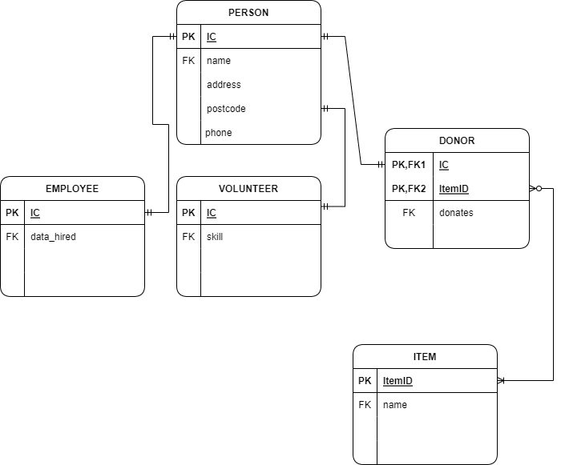

Question Number: 2

Write your answer on this page only

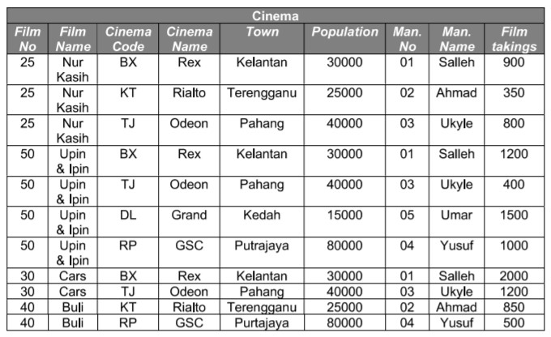

**Third Normal Form (*3NF*)**

|  |  |
| --- | --- |
| Film | |
| Film No | Film Name |
| 25 | Nur Kasih |
| 25 | Nur Kasih |
| 25 | Nur Kasih |
| 50 | Upin & Ipin |
| 50 | Upin & Ipin |
| 50 | Upin & Ipin |
| 50 | Upin & Ipin |
| 30 | Cars |
| 30 | Cars |
| 40 | Buli |
| 40 | Buli |

|  |  |  |
| --- | --- | --- |
| MAN | | |
| Man. No | Man. Name | Film takings |
| 01 | Salleh | 900 |
| 02 | Ahmad | 350 |
| 03 | Ukyle | 800 |
| 01 | Salleh | 1200 |
| 03 | Ukyle | 400 |
| 05 | Umar | 1500 |
| 04 | Yusuf | 1000 |
| 01 | Salleh | 2000 |
| 03 | Ukyle | 1200 |
| 02 | Ahmad | 850 |
| 04 | Yusuf | 500 |

|  |  |  |  |
| --- | --- | --- | --- |
| Cinema | | | |
| Film No | Man. No | Cinema Code | Cinema Name |
| 25 | 01 | BX | Rex |
| 25 | 02 | KT | Rialto |
| 25 | 03 | TJ | Odeon |
| 50 | 01 | BX | Rex |
| 50 | 03 | TJ | Odeon |
| 50 | 05 | DL | Grand |
| 50 | 04 | RP | GSC |
| 30 | 01 | BX | Rex |
| 30 | 03 | TJ | Odeon |
| 40 | 02 | KT | Rialto |
| 40 | 04 | RP | GSC |

|  |  |  |
| --- | --- | --- |
| Town & Population | | |
| Cinema Code | Town | Population |
| BX | Kelantan | 30000 |
| KT | Terengganu | 25000 |
| TJ | Pahang | 40000 |
| BX | Kelantan | 30000 |
| TJ | Pahang | 40000 |
| DL | Kedah | 15000 |
| RP | Putrajaya | 80000 |
| BX | Kelantan | 30000 |
| TJ | Pahang | 40000 |
| KT | Terengganu | 25000 |
| RP | Putrajaya | 80000 |

Question Number: 3

Write your answer on this page only

Vets – maintain records of treatment sessions, maintain detailed animal records, prepared and dispatched breakdown of treatment

Receptionist – enters new animal details (if), remind owners about account needs payment, record all payments, checks the payments, updates the ledgers, records updated balance, reminds to owners with outstanding balance

Patients – Bring the animals, make a payment

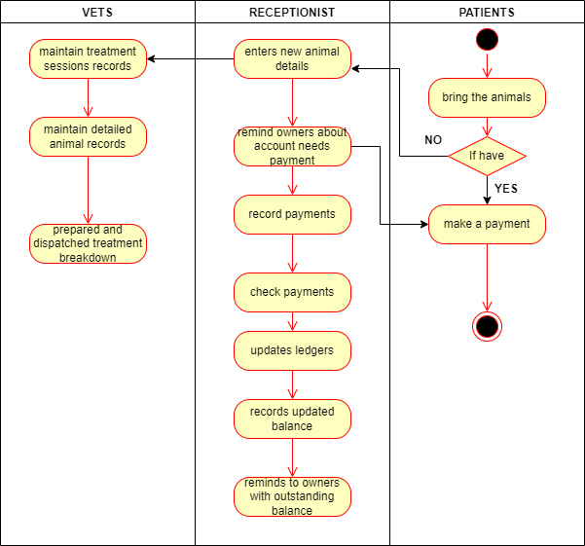

Question Number: 4

Write your answer on this page only

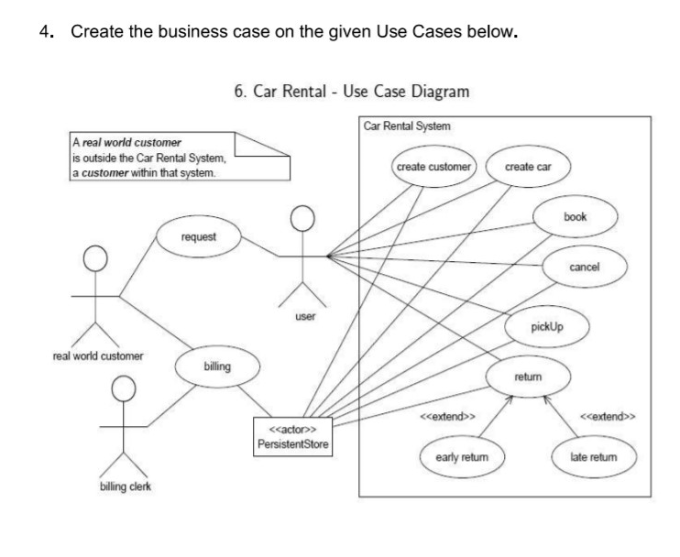

|  |  |
| --- | --- |
| Project Name | Car Rental System |
| Project Manager | PersistentStore |
| Contribution Strategy | To ease user or customer to go to everywhere by car (rent). |
| Actors/Persons Involved | 1. Real World Customer  2. User  3. Billing Clerk |
| Activities | 1. Real World Customer will request to the user and send bill to Billing Clerk  2. Billing Clerk will manage the bills  3. User can book, cancel, pickup and return (early or late)  4. PersistentStore will create customer, create car and manage the rental process. |
| Timescales | 1 year |
| Costs | RM50,000 |
| Benefits | 1. Ease user to go anywhere  2. Help workers to find jobs |
| Risks | This project may be having unconsistent payments every month |