Indoor Localization Using WLAN Fingerprinting: Comparative Study of Machine Learning Models
Phase 2: Final Group Report

Nur Afiqah
University of Doha for Science and Technology, College of Computing and IT, 60306981@udst.edu.qa
Raneem Alhamaydah
University of Doha for Science and Technology, College of Computing and IT, 60300390@udst.edu.qa
Jawaher Al-Aji
University of Doha for Science and Technology, College of Computing and IT, 60303883@udst.edu.qa

Abstract: Indoor localization is challenging in environments where GPS signals are weak or unavailable. This project presents a comparative study of machine learning models for indoor localization using WLAN fingerprinting and the UJIIndoorLoc dataset. A shared preprocessing pipeline was applied, including duplicate removal, treatment of undetected signals, feature scaling, and feature reduction. The study covers both classification and regression tasks, where classification predicts building-floor location and regression estimates longitude and latitude coordinates. Simple and advanced models were developed and compared to evaluate their performance. The results show that WLAN fingerprinting, combined with suitable preprocessing and model selection, can provide accurate and practical indoor localization for real-world applications such as navigation, asset tracking, and facility management.
Additional Keywords and Phrases: indoor localization, WLAN fingerprinting, WiFi fingerprinting, RSSI, UJIIndoorLoc, machine learning, classification, regression, convolutional neural network, K-nearest neighbors, indoor positioning
Disclaimer: In accordance with the project guidelines, the authors of this report acknowledge the use of AI tools during the development of this project. AI assistance was utilized for the structure and insights for the report to follow the ACM template and ensure smooth workflow to enhance readability. Machine learning development, data preprocessing logic and model interpretations remain the original work and responsibility of the group members.
- Introduction
  - Background
Indoor Localization remains a significant challenge when it comes to navigation, as tools like Global Positioning System (GPS) signals are often weak or unavailable inside complex structures. This could be due to physical barriers like walls or objects, signal attenuations or possible structure changes. To address this issue, WiFi Fingerprinting could be used [1, 2].
WIFI Fingerprinting is a technique that relies on Received Signal Strength (RSSI) readings gathered from multiple surrounding Access Points (AP) to create a unique “fingerprint” or “signature” for specific indoor locations. By mapping these signal patterns, machine learning models can be trained to determine a user’s location within a building without the need for specialized hardware [3].
WLAN fingerprinting offers a much more efficient alternative, as it is far more resilient to signal attenuation and can quickly adapt to the frequent dynamic changes found in indoor environments. Interestingly, while physical barriers usually hinder GPS, fingerprinting turns these obstacles into an advantage; it uses the unique signal variations caused by walls and furniture to create distinct "fingerprints" for specific areas. This technology holds potential for location tracking from improving emergency response and asset tracking to enhancing the everyday user experience in massive facilities like airports and shopping malls [2, 3].

  - Project Objectives
The goal of this project is to build a reliable indoor positioning system by using the Indoor Localization Dataset, UJIIndoorLoc [4, 5]. To achieve this, the project is broken down into several steps:
- Data Preprocessing: Cleaning the dataset, handling missing values, normalizing the 520 Wireless Access Point (WAP) features and feature selection to ensure smooth flow and improved accuracy of models [5, 6].
- Modeling: This project aims to address two main tasks: Classification and Regression. This project will include six models in four categories (simple regression and classification, advanced regression and classification). Classification aims to predict Building ID and Floor by its fingerprint whereas regression aims to predict user’s location based on coordinates (longitude and latitude)[4, 5].
- Optimization and evaluation: refining these models into hyperparameter tuning and cross validation, while measuring success metrics like Accuracy, F1 Score, RMSE, MAE, etc.
- Interpretation: Analysis of how these results would assist stakeholders like facility managers or end users
- DATA PREPARATION
  - Shared Preprocessing Pipeline
The UJIIndoorLoc dataset was prepared using one shared preprocessing pipeline so that all team members could train and compare their models on the same cleaned data. The dataset contains WiFi fingerprint measurements from 520 Wireless Access Points (WAPs), along with Building ID, Floor, Longitude, and Latitude labels [4, 5].
Because the project includes both classification and regression tasks, the preprocessing stage was designed to support both tasks consistently. The pipeline included exploratory analysis, duplicate removal, handling undetected signals, feature scaling, and removal of non-informative features.
  - Exploratory Data Analysis (EDA)
The dataset was first explored to understand its structure and main challenges. The training set contains 19,937 samples and the validation set contains 1,111 samples, with 520 WAP signal features in each record. This makes the dataset high-dimensional and sparse [5].
The class distribution plots show that the samples are not perfectly balanced across buildings and floors. Building 2 contains the largest number of samples, while Floor 4 has far fewer samples than the other floors. The combined building-floor class distribution (Figure 3) also shows that some classes appear much more frequently than others.

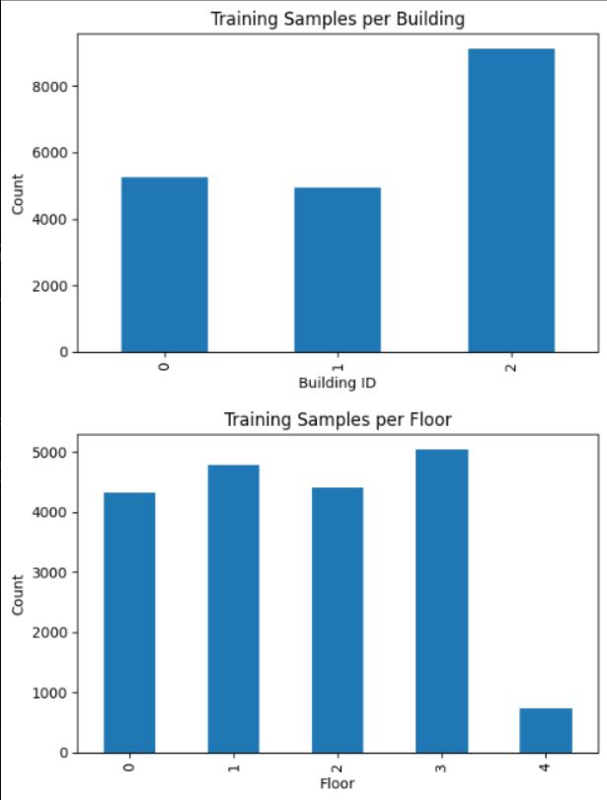
Figure 1: Distribution of data per Building.


Figure 2: Distribution of data per Floor.
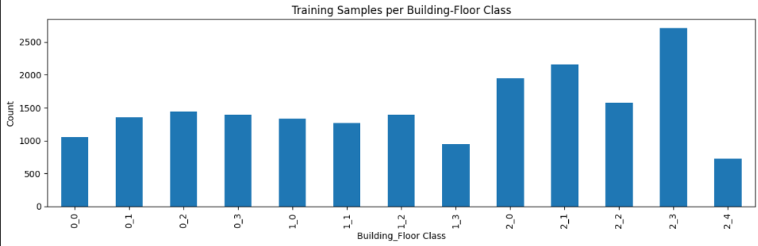
Figure 3: Distribution of data per Building-Floor Class
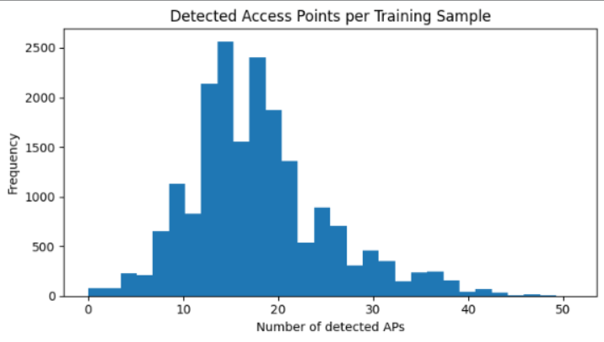
Figure 4: Histogram showing the number of detected APs per location

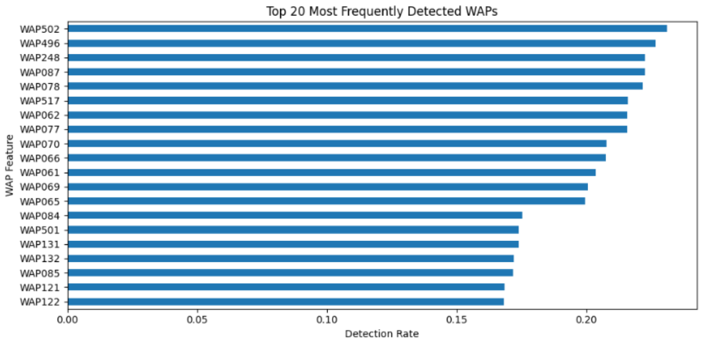
Figure 5: Count plot of the top 20 most frequently detected WAPs

Figure 4 shows that most fingerprints contain only a limited number of visible WAPs. This confirms that the dataset is sparse and that each indoor location is represented by only a subset of the total access points. The top detected WAP plot (Figure 5) also shows that even the most frequently observed access points appear in only a fraction of the data, meaning localization depends on the overall fingerprint pattern rather than one dominant feature.
The coordinate scatter plots reveal clear spatial structure in the data. When grouped by building, the coordinates form distinct clusters, which supports the regression task. When grouped by floor, some overlap appears, suggesting that floor-level separation may be more difficult in certain areas.

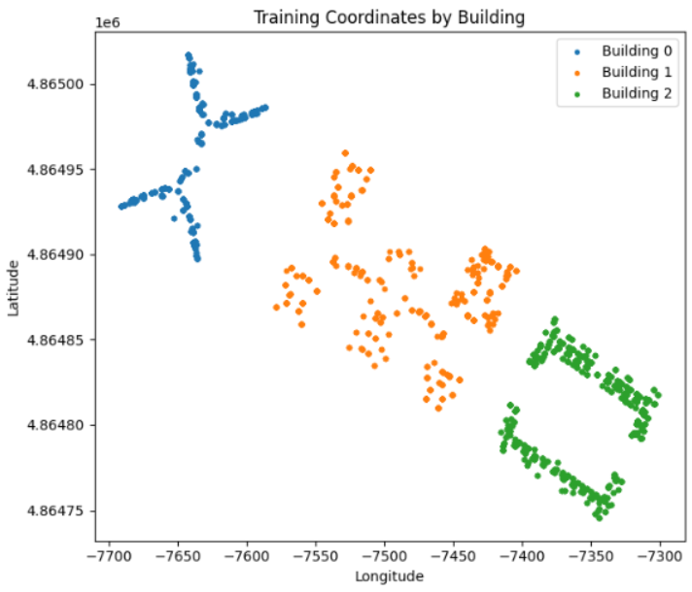
Figure 6: Scatter plot showing the coordinates by Building

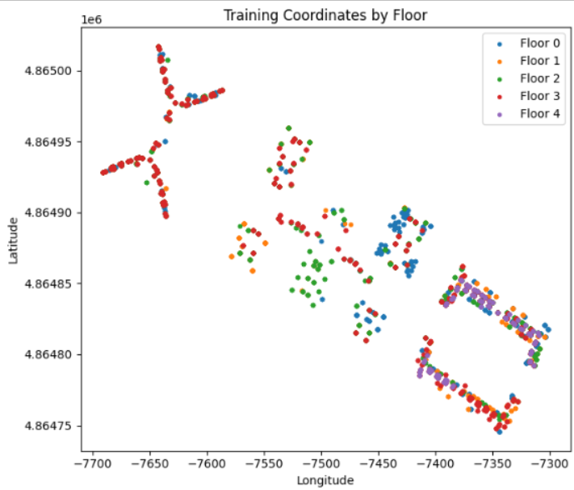
Figure 7: Scatter plot showing the coordinates by Floor
  - Data Cleaning
The first cleaning step was to retain only the WAP features as model inputs, since these represent the actual WiFi fingerprints. Metadata fields were excluded from the shared modeling pipeline.
The training set was then checked for duplicate rows. After removing exact duplicates, the number of training samples decreased from 19,937 to 19,300, meaning that 637 duplicate rows were removed. The validation set was left unchanged for fair final evaluation.
Another important cleaning step involved handling the value 100 in the RSSI columns. In this dataset, 100 does not represent a strong signal; instead, it indicates that the corresponding access point was not detected. Therefore, all 100 values were converted to -110 dBm so that signal absence would be represented more realistically [5].
  - Normalization and Feature Scaling
After cleaning, the retained WAP features were standardized using StandardScaler. This made the feature values comparable across access points and improved the training process for the machine learning models [6].
The scaler was fitted only on the training data and then applied to the validation data. This prevented data leakage and ensured that all models used the same feature scale during training and testing [6].
  - Feature Reduction
Feature reduction was applied by removing WAP columns that were never detected in the training set. These features had no variation and did not contribute useful information for localization.
As a result, the number of WAP features was reduced from 520 to 465. This helped reduce noise and computational cost while keeping the most relevant signal information for both classification and regression tasks.
- MODEL DEVELOPMENT
  - Member 1: Nur Afiqah
    - Advanced Classification
For the advanced classification task, a 1D Convolutional Neural Network (CNN) was implemented to predict the indoor location by using the Building-Floor combination. The model consists of two convolutional blocks followed by max-pooling and dropout layers to prevent overfitting. The output layer, on the other hand, uses a Softmax function to classify the input signal into 13 unique Building-Floor locations identified in the dataset [7].
The input features were reshaped into a 3D tensor format (19300, 465, 1), where 19300 represents the number of samples, 465 represents the filtered WAP, and 1 represents the signal strength channel. The dataset had to be altered to match the properties of CNN, which uses dimensions in their prediction. The code of the CNN model is provided in the appendix section (Appendix A.4).
The result of the model shows an accuracy of 99.5% on both the training and validation sets. While this high model performance indicates that the model successfully captures data, there might also be a chance that the model is overfitting. Thus, to ensure that the model does not have high accuracy due to overfitting, Dropout (0.2 and 0.3) was applied, and the validation loss was monitored to ensure it remained consistent with the training loss. The plot is shown in figure 1 below.
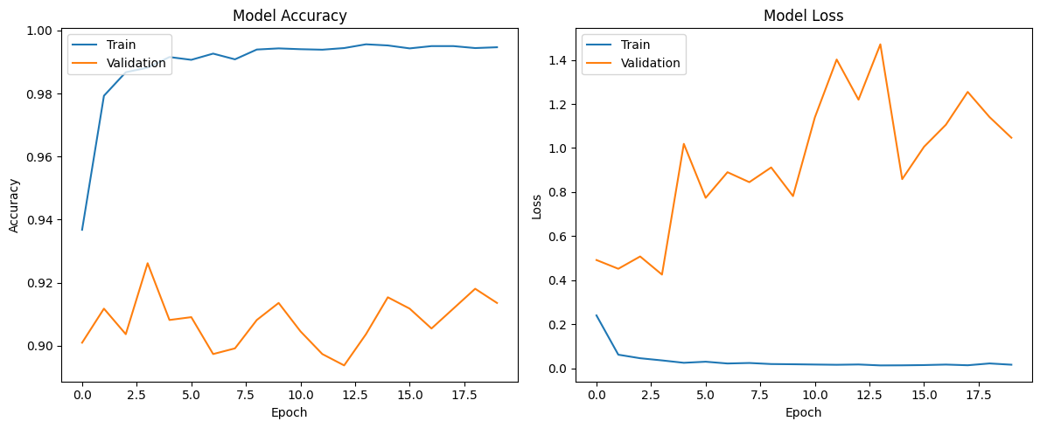Figure 1: A line graph showing the accuracy of the train vs validation sets based on epoch
    - Basic Regression
As mentioned in the previous section, the regression problem’s objective is to predict the user’s location by its Longitude and Latitude. Thus, one of the basic regression models this project will use is the K-Nearest Neighbor (KNN), as coordinates are usually continuous. This makes KNN one of the suitable models as they are able to find similar features from a pre-mapped radio map [3, 8].
Before modeling, all RSSI values were standardized by using the StandardScaler, as mentioned in the previous section. WAPs that provided no information (in this case, all WAPs with a value of 100) were dropped, leaving 465 relevant features to calculate the Euclidean distance between points [5, 6].
The performance was measured using Mean Squared Error (MSE) and Mean Absolute Error (MAE). The KNN model achieved an MAE of approximately 8m meters, indicating a generally accurate distance estimation. However, the RMSE for this model is high, about 15 meters, which suggests the presence of outliers, likely due to signal interference or fingerprints in other locations that are too similar to the target fingerprint. This issue could be resolved by removing outliers or hyperparameter tuning.

  - Member 2: Raneem Alhamaydah
    - Basic Classification
For the simple classification task, a Linear Support Vector Machine (Linear SVM) was implemented to predict the indoor location by using the Building-Floor combination. The model was trained on the standardized RSSI fingerprint features after preprocessing, where each sample was represented by the retained WAP signal values. This model was selected as a simple baseline because it performs well on high-dimensional data and provides a strong reference point for comparing more complex models [9].
The input to the model consisted of 465 filtered WAP features, which were obtained after removing non-informative access points and standardizing the retained RSSI values using StandardScaler. The target labels were created by combining the Building ID and Floor into a single class label, resulting in 13 unique Building-Floor classes [6, 9]. The code of the Linear SVM model is provided in the appendix section (Appendix 5).
The performance of the model was evaluated using Accuracy, Precision, Recall, and F1-score on the validation set. The model achieved an accuracy of 0.8515 with a macro F1-score of 0.8222. In addition, the Building Accuracy and Floor Accuracy were reported separately to better interpret the model’s performance in terms of coarse and fine indoor localization. The confusion matrix is shown in Figure 2 below, where most predictions are concentrated along the diagonal, indicating that the model was able to correctly classify a large portion of the validation samples.
Figure 2 Confusion matrix of the Linear SVM model for Building-Floor classification on the validation set.

    - Advanced Regression
For the advanced regression task, a Deep Neural Network (DNN) was implemented to predict the user’s location by estimating the Longitude and Latitude coordinates directly from the WiFi fingerprint. Unlike the classification task, which predicts discrete building-floor classes, the regression model aims to learn a continuous mapping between RSSI measurements and the user’s exact position in the indoor environment [10, 11].
The model was trained using the 465 standardized WAP features as input, while the output layer predicted two continuous values corresponding to Longitude and Latitude. To improve training stability, the regression targets were also scaled before training and then transformed back to their original values during evaluation. The model architecture consisted of multiple dense layers with ReLU activation, along with batch normalization and dropout to improve generalization and reduce overfitting [10, 11]. The code of the regression model is provided in the appendix section (Appendix 7).
The performance of the model was measured using Mean Absolute Error (MAE) and Root Mean Squared Error (RMSE). The model achieved an MAE of 7.0791 and an RMSE of 11.3116 on the validation set. In addition, the mean Euclidean coordinate error was computed to provide a more interpretable measure of location prediction quality. The predicted and actual coordinate distributions are shown in Figure 3 below. The figure shows that the predicted points generally follow the same spatial structure as the actual coordinates, indicating that the model was able to capture meaningful location patterns from the WLAN fingerprints.
Figure 3. Actual and predicted indoor coordinates produced by the deep neural network regression model on the validation set.

  - Member 3: Jawaher Al-Aji
    - Basic Classification
A Logistic Regression model was used to predict the indoor location by using the Building-Floor label as a whole for the basic classification task. After preprocessing, the model was trained on the standardised RSSI fingerprint features, with each sample represented by the retained WAP signal values. Logistic Regression was chosen as a straightforward baseline model due to its efficiency, interpretability, and strong performance on multi-class classification tasks [13].
The model's input was 465 filtered WAP features. These were obtained by removing access points that didn't give useful information and standardizing the RSSI values that were kept using StandardScaler [6]. We made the target labels by putting the Building ID and Floor together into one class label. This made 13 different Building-Floor classes [5]. The code of the Logistic Regression model is provided in the appendix section (Appendix A.6)
The accuracy and F1-score were used for evaluating the performance of the model, which reached 0.8848 in accuracy with 0.8746 macro F1-score [15]. Furthermore, the confusion matrix is given below in Figure 4, which illustrates that the majority of predictions have been clustered around the diagonal, implying that a large proportion of validation samples was classified correctly by the model [16].
Figure 4: Confusion matrix of the Logistic Regression model for Building-Floor classification on the validation set.
    - Advanced Regression
The algorithm employed for the regression problem was the Gradient Boosting Regression model. Such a solution enables predicting user's location by forecasting their longitude and latitude coordinates based on the WiFi fingerprint. Unlike the classification problem, where the prediction was performed using the information about building-floor classes, in regression, the goal was to discover the relationship between WiFi fingerprint and user's indoor location coordinates [14].
The inputs of the model included standardized 465 WAPs features [6], whereas the target output consisted of the user's longitude and latitude values. For such complex problems where the relation between inputs and target variables is non-linear, gradient boosting was selected as a more advanced approach than linear regression algorithms [14]. The source code of the regression model is provided in Appendix A.8.
Two main metrics were considered to test the performance of the Gradient Boosting Regression model – Mean Absolute Error (MAE) and Root Mean Squared Error. Based on the analysis of the validation sample, the MAE equals 20.1359, and RMSE equals 29.6016. It should be mentioned that the algorithm performed relatively well but still demonstrated lower results than other regression models.
- COMPARATIVE ANALYSIS OF RESULTS
The comparative results show clear differences between the simple and advanced models used in this project. For the classification task, the advanced 1D CNN produced the strongest overall performance, reaching 99.5% accuracy on both the training and validation sets. Among the simple classification models, Logistic Regression performed better than Linear SVM, achieving an accuracy of 0.8848 and a macro F1-score of 0.8746, compared with 0.8515 accuracy and 0.8222 macro F1-score for Linear SVM. This indicates that all three classification models were effective in predicting the Building-Floor classes, but the CNN was able to extract more complex patterns from the RSSI fingerprints and therefore achieved the highest predictive power [7, 9, 13, 15].
A similar pattern can be observed in the regression task, although the difference between models is more nuanced. The Deep Neural Network gave the best regression performance, with an MAE of 7.0791 and an RMSE of 11.3116, showing that it was able to estimate indoor coordinates more precisely than the other regression models. The KNN regressor also performed reasonably well, with an MAE of about 8 meters and an RMSE of about 15 meters, which suggests that fingerprint similarity can provide a useful baseline for coordinate prediction. In contrast, the Gradient Boosting Regressor showed the weakest performance, with an MAE of 20.1359 and an RMSE of 29.6016, meaning that its coordinate predictions were less accurate and less stable across the validation samples [8, 10, 11, 14].
These findings suggest that advanced deep learning models were more successful because indoor WiFi fingerprinting contains complex and non-linear relationships between RSSI values and location. The CNN was better suited for classification because it could learn local signal patterns across the WAP features, while the DNN was better suited for regression because it could model continuous spatial relationships between the fingerprint and the longitude-latitude coordinates. On the other hand, the simpler models still provided useful and competitive results, especially Logistic Regression and KNN, which performed well while being easier to train, explain, and implement [7, 10, 11, 13].
Overall, the comparison shows that model choice depends on the task and the level of complexity required. For Building-Floor classification, the CNN is the most accurate option, while Logistic Regression offers a strong simpler alternative. For coordinate regression, the DNN achieved the best balance between error reduction and spatial prediction quality, whereas KNN remained a practical baseline. The weaker performance of Gradient Boosting also highlights that not all advanced models are automatically better; performance depends on how well the model matches the structure of the WiFi fingerprint data. Therefore, the results confirm that advanced neural approaches are the most effective for this dataset, but simpler machine learning methods still remain valuable when interpretability and lower computational cost are important [7, 8, 10, 11, 13, 14].
- APPLIED ANALYSIS AND INTERPRETATION
  - Real World Implications
From the above results of the study, it is clear that a WiFi fingerprint with a combination of machine learning algorithms can be used effectively to achieve reliable indoor localization with the help of minimal resources. Such a model can be employed to localize people or things in big indoor spaces, such as in airports, hospitals, shopping malls, and universities, among others [2, 3].
Additionally, the indoor localization system can assist in improving the efficiency of the emergency response process since the location of people can be determined using this technique. Indoor localization systems can also be useful in managing assets and monitoring the activities of people working in an organization [2, 3]. From the above discussion, it is evident that more advanced models such as neural networks and gradient boosting techniques can be effective in capturing non-linearities in WiFi signal data [10, 11, 13].
Overall, the findings prove that indoor WiFi fingerprint localization is both feasible and scalable [2, 3].
  - Stakeholder Relevance
Indoor localization technology development will have various advantages for various stakeholders. Facility management will be able to manage their resources effectively due to the ability to track their equipment using indoor localization technology. Maintenance staff will be able to access equipment fast through indoor localization, thus making it easy for them to provide their services effectively [2, 3].
On the other hand, the indoor localization technology can be advantageous to the users in terms of easy navigation within large facilities. Indoor localization technology will make it easy for users to access large buildings, including universities, hospitals, or any large buildings that require navigation to reach certain destinations. In addition, the emergency services would also benefit from indoor localization technology because they will be able to act on emergencies fast after being provided with accurate locations of victims requiring help [2, 3].
Furthermore, technology firms that engage in research and development will benefit significantly from the results of the research project. They can take advantage of the model used in the project to develop indoor localization technology in the future. Moreover, such firms will be able to integrate indoor localization technology with IoT applications and smart buildings [2, 3].
- CONCLUSION
The current project examines machine learning techniques used for indoor localization based on WiFi fingerprinting technique. Based on UJIIndoorLoc data set, both regression and classification problems were applied for building-floor identification and indoor coordinate prediction [5]. A common pre-processing procedure was performed for all considered models to guarantee unbiased results.
As follows from the obtained results, complex machine learning models were more efficient in comparison with simple models. Thus, it could be stated that Convolutional Neural Network and Deep Neural Networks were the most efficient in solving the problem, demonstrating the necessity of identifying non-linear dependencies between variables in WiFi fingerprint data. In turn, simple models like Logistic Regression and Linear SVM produced efficient results but consumed less computational resources and could be easily interpreted by researchers [9, 13].
While Gradient Boosting regression model was not highly efficient in comparison with the rest of the advanced models, it also demonstrated good performance and the ability of ensemble machine learning algorithms to work with high dimensional data of WiFi fingerprint type [14].
Other issues that came out from this project included the high number of features (high dimensional), sparse data signals, and imbalanced classes among the data [5]. Some areas of improvements include the optimization of hyperparameters, feature engineering, and dimensionality reduction as well as the application of more complex Deep Learning models.
Indoor positioning based on WiFi fingerprints is a viable and scalable solution in the case of smart buildings and emergency response systems [2, 3]. The findings of the current project clearly show how machine learning can be used to solve indoor positioning problems.
REFERENCES
[1] Xuxin Lin, Jianwen Gan, Chaohao Jiang, Shuai Xue, and Yanyan Liang. 2023. Wi-Fi-based indoor localization and navigation: A robot-aided hybrid deep learning approach. Sensors 23, 14 (2023), 6320. https://doi.org/10.3390/s23146320
[2] Jiang Xiao, Zimu Zhou, Youwen Yi, and Lionel M. Ni. 2016. A survey on wireless indoor localization from the device perspective. ACM Computing Surveys 49, 2, Article 25 (June 2016), 31 pages. https://doi.org/10.1145/2933232
[3] Shixiong Xia, Yi Liu, Guan Yuan, Mingjun Zhu, and Zhaohui Wang. 2017. Indoor fingerprint positioning based on Wi-Fi: An overview. ISPRS International Journal of Geo-Information 6, 5 (2017), 135. https://doi.org/10.3390/ijgi6050135
[4] Joaquín Torres-Sospedra, Raul Montoliu, Adolfo Martínez-Usó, Joan P. Avariento, Tomás J. Arnau, Mauri Benedito-Bordonau, and Joaquín Huerta. 2014. UJIIndoorLoc: A new multi-building and multi-floor database for WLAN fingerprint-based indoor localization problems. In 2014 International Conference on Indoor Positioning and Indoor Navigation (IPIN). IEEE, 261–270. https://doi.org/10.1109/IPIN.2014.7275492
[5] Joaquín Torres-Sospedra, Raul Montoliu, Adolfo Martínez-Usó, Tomàs Arnau, and Joan Avariento. 2014. UJIIndoorLoc [Dataset]. UCI Machine Learning Repository. https://doi.org/10.24432/C5MS59
[6] scikit-learn developers. 2026. StandardScaler. scikit-learn documentation. Retrieved April 4, 2026 from https://scikit-learn.org/stable/modules/generated/sklearn.preprocessing.StandardScaler.html
[7] Xudong Song, Xiaochen Fan, Xiangjian He, Chaocan Xiang, Qianwen Ye, Xiang Huang, Gengfa Fang, Liming Luke Chen, Jing Qin, and Zumin Wang. 2019. CNNLoc: Deep-learning based indoor localization with WiFi fingerprinting. In 2019 IEEE SmartWorld, Ubiquitous Intelligence & Computing, Advanced & Trusted Computing, Scalable Computing & Communications, Cloud & Big Data Computing, Internet of People and Smart City Innovation (SmartWorld/SCALCOM/UIC/ATC/CBDCom/IOP/SCI). IEEE, 589–595. https://doi.org/10.1109/SmartWorld-UIC-ATC-SCALCOM-IOP-SCI.2019.00139
[8] Jongtaek Oh and Jisoo Kim. 2018. Adaptive K-nearest neighbour algorithm for WiFi fingerprint positioning. ICT Express 4, 2 (2018), 91–94. https://doi.org/10.1016/j.icte.2018.04.004
[9] Corinna Cortes and Vladimir Vapnik. 1995. Support-vector networks. Machine Learning 20, 3 (1995), 273–297. https://doi.org/10.1007/BF00994018
[10] Jaehoon Cha and Enggee Lim. 2022. A hierarchical auxiliary deep neural network architecture for large-scale indoor localization based on Wi-Fi fingerprinting. Applied Soft Computing 120 (2022), 108624. https://doi.org/10.1016/j.asoc.2022.108624
[11] Xu Feng, Khuong An Nguyen, and Zhiyuan Luo. 2021. A survey of deep learning approaches for WiFi-based indoor positioning. Journal of Information and Telecommunication 6, 2 (2021), 163–216. https://doi.org/10.1080/24751839.2021.1975425
[12] UCI Machine Learning Repository. UCI Machine Learning Repository. archive.ics.uci.edu. Retrieved from https://archive.ics.uci.edu/dataset/310/ujiindoorloc
[13] scikit-learn developers. 2026. LogisticRegression. scikit-learn documentation.
https://scikit-learn.org/stable/modules/generated/sklearn.linear_model.LogisticRegression.html

[14] scikit-learn developers. 2026. GradientBoostingRegressor. scikit-learn documentation.
https://scikit-learn.org/stable/modules/generated/sklearn.ensemble.GradientBoostingRegressor.html

[15] scikit-learn developers. 2026. f1_score. scikit-learn documentation.
https://scikit-learn.org/stable/modules/generated/sklearn.metrics.f1_score.html

[16] scikit-learn developers. 2026. confusion_matrix. scikit-learn documentation.
https://scikit-learn.org/stable/modules/generated/sklearn.metrics.confusion_matrix.html

A APPENDICES
The appendices below summarize the shared preprocessing, exploratory analysis, and data export code contributed to the project.
A.1 Shared Preprocessing Code
This code was used to clean the dataset, prepare the classification and regression targets, remove non-informative features, and standardize the retained WAP features.

import os
import zipfile
import random
import numpy as np
import pandas as pd
import joblib

from sklearn.preprocessing import StandardScaler, LabelEncoder

SEED = 42
random.seed(SEED)
np.random.seed(SEED)

train_df = pd.read_csv(train_path)
val_df = pd.read_csv(val_path)

wap_cols = [c for c in train_df.columns if c.startswith("WAP")]

train_before = len(train_df)
train_df = train_df.drop_duplicates().reset_index(drop=True)
train_after = len(train_df)

detected_mask = (train_df[wap_cols] != 100).any(axis=0)
kept_wap_cols = detected_mask[detected_mask].index.tolist()

X_train_raw = train_df[kept_wap_cols].copy()
X_val_raw = val_df[kept_wap_cols].copy()

X_train_raw = X_train_raw.replace(100, -110)
X_val_raw = X_val_raw.replace(100, -110)

y_class_train_str = train_df["BUILDINGID"].astype(str) + "_" + train_df["FLOOR"].astype(str)
y_class_val_str = val_df["BUILDINGID"].astype(str) + "_" + val_df["FLOOR"].astype(str)

label_encoder = LabelEncoder()
y_class_train = label_encoder.fit_transform(y_class_train_str)
y_class_val = label_encoder.transform(y_class_val_str)

y_reg_train = train_df[["LONGITUDE", "LATITUDE"]].copy()
y_reg_val = val_df[["LONGITUDE", "LATITUDE"]].copy()

scaler = StandardScaler()
X_train_scaled = scaler.fit_transform(X_train_raw)
X_val_scaled = scaler.transform(X_val_raw)

X_train_scaled_df = pd.DataFrame(X_train_scaled, columns=kept_wap_cols)
X_val_scaled_df = pd.DataFrame(X_val_scaled, columns=kept_wap_cols)

A.2 EDA and Visualization Code
This code was used to generate the main preprocessing and exploratory analysis figures included in the report.

import matplotlib.pyplot as plt

plt.figure(figsize=(6,4))
train_df["BUILDINGID"].value_counts().sort_index().plot(kind="bar")
plt.title("Training Samples per Building")
plt.xlabel("Building ID")
plt.ylabel("Count")
plt.tight_layout()
plt.show()

plt.figure(figsize=(6,4))
train_df["FLOOR"].value_counts().sort_index().plot(kind="bar")
plt.title("Training Samples per Floor")
plt.xlabel("Floor")
plt.ylabel("Count")
plt.tight_layout()
plt.show()

train_detected_ap_count = (X_train_raw > -110).sum(axis=1)

plt.figure(figsize=(7,4))
plt.hist(train_detected_ap_count, bins=30)
plt.title("Detected Access Points per Training Sample")
plt.xlabel("Number of detected APs")
plt.ylabel("Frequency")
plt.tight_layout()
plt.show()

plt.figure(figsize=(7,6))
for b in sorted(train_df["BUILDINGID"].unique()):
subset = train_df[train_df["BUILDINGID"] == b]
plt.scatter(subset["LONGITUDE"], subset["LATITUDE"], label=f"Building {b}", s=8)

plt.title("Training Coordinates by Building")
plt.xlabel("Longitude")
plt.ylabel("Latitude")
plt.legend()
plt.tight_layout()
plt.show()
A.3 Basic Regressor Model: KNN
This code is used to implement a basic regressor in this project, the K-Nearest Neighbor, which looks for similar data points to the target.

from sklearn.neighbors import KNeighborsRegressor
from sklearn.metrics import mean_squared_error, mean_absolute_error

y_train_reg = y_reg_train.values
y_val_reg = y_reg_val.values

knn_regressor = KNeighborsRegressor(n_neighbors=7)
knn_regressor.fit(X_train_scaled, y_train_reg)

y_pred_knn = knn_regressor.predict(X_val_scaled)

mae_knn = mean_absolute_error(y_val_reg, y_pred_knn)
rmse_knn = np.sqrt(mean_squared_error(y_val_reg, y_pred_knn))

print(f"Baseline k-NN Regression Results:")
print(f"Mean Absolute Error (MAE): {mae_knn:.2f} meters")
print(f"Root Mean Squared Error (RMSE): {rmse_knn:.2f} meters")
A.4 Advanced Classification Model: Convolutional Neural Network (CNN)
CNNs are used to find patterns that exist across features or time steps. While they are often used in images, their ability to scan the data makes it suitable for datasets. We used a k value of 7 for this project.

from sklearn.preprocessing import LabelEncoder
import tensorflow as tf
from tensorflow.keras import layers, models
le = LabelEncoder()

train_labels = train_df['BUILDINGID'].astype(str) + "_" + train_df['FLOOR'].astype(str)
val_labels = val_df['BUILDINGID'].astype(str) + "_" + val_df['FLOOR'].astype(str)

y_train_class = le.fit_transform(train_labels)
y_val_class = le.transform(val_labels)

num_classes = len(le.classes_)

X_train_cnn = X_train_scaled.reshape(X_train_scaled.shape[0], X_train_scaled.shape[1], 1)
X_val_cnn = X_val_scaled.reshape(X_val_scaled.shape[0], X_val_scaled.shape[1], 1)

cnn_model = models.Sequential([

layers.Conv1D(64, kernel_size=3, activation='relu', input_shape=(465, 1)),
layers.MaxPooling1D(pool_size=2),
layers.Dropout(0.2), # Prevents overfitting to noisy signals

layers.Conv1D(128, kernel_size=3, activation='relu'),
layers.MaxPooling1D(pool_size=2),
layers.Flatten(), # Flattens the 2D patterns into a 1D vector

layers.Dense(128, activation='relu'),
layers.Dropout(0.3),

layers.Dense(num_classes, activation='softmax')
])

cnn_model.compile(optimizer='adam',
loss='sparse_categorical_crossentropy',
metrics=['accuracy'])

cnn_model.summary()

history = cnn_model.fit(X_train_cnn, y_train_class,
epochs=20,
batch_size=32,
validation_data=(X_val_cnn, y_val_class))
A.5 Basic Classification 1:
This code trains and evaluates the Linear SVM used for the simple classification task.

from sklearn.svm import LinearSVC
from sklearn.metrics import (
accuracy_score, precision_score, recall_score, f1_score,
classification_report, confusion_matrix
)
import numpy as np
import matplotlib.pyplot as plt

simple_clf = LinearSVC(
C=1.0,
class_weight="balanced",
max_iter=5000,
random_state=42
)

simple_clf.fit(X_train, y_class_train)

y_class_pred = simple_clf.predict(X_val)

acc = accuracy_score(y_class_val, y_class_pred)
prec = precision_score(y_class_val, y_class_pred, average="macro", zero_division=0)
rec = recall_score(y_class_val, y_class_pred, average="macro", zero_division=0)
f1 = f1_score(y_class_val, y_class_pred, average="macro", zero_division=0)

print("Simple Classification (Linear SVM)")
print(f"Accuracy: {acc:.4f}")
print(f"Precision: {prec:.4f}")
print(f"Recall: {rec:.4f}")
print(f"F1-score: {f1:.4f}")

true_labels = label_encoder.inverse_transform(y_class_val)
pred_labels = label_encoder.inverse_transform(y_class_pred)

true_building = np.array([int(x.split("_")[0]) for x in true_labels])
pred_building = np.array([int(x.split("_")[0]) for x in pred_labels])

true_floor = np.array([int(x.split("_")[1]) for x in true_labels])
pred_floor = np.array([int(x.split("_")[1]) for x in pred_labels])

building_acc = accuracy_score(true_building, pred_building)
floor_acc = accuracy_score(true_floor, pred_floor)

print(f"Building Accuracy: {building_acc:.4f}")
print(f"Floor Accuracy: {floor_acc:.4f}")

print("\nClassification Report:")
print(classification_report(y_class_val, y_class_pred, zero_division=0))

cm = confusion_matrix(y_class_val, y_class_pred)

plt.figure(figsize=(8,6))
plt.imshow(cm, interpolation="nearest")
plt.title("Confusion Matrix - Simple Classification (Linear SVM)")
plt.xlabel("Predicted Label")
plt.ylabel("True Label")
plt.colorbar()
plt.tight_layout()
plt.show()
A.6 Basic Classification 2: Logistic Regression
This code trains and evaluates the Logistic Regression model used for the basic classification task.

from sklearn.linear_model import LogisticRegression
from sklearn.metrics import accuracy_score, f1_score, classification_report, confusion_matrix
import matplotlib.pyplot as plt

log_reg = LogisticRegression(max_iter=2000, random_state=42)
log_reg.fit(X_train_scaled, y_class_train)
y_pred_log = log_reg.predict(X_val_scaled)

log_acc = accuracy_score(y_class_val, y_pred_log)
log_f1 = f1_score(y_class_val, y_pred_log, average='macro')

print("Logistic Regression Classification Results:")
print(f"Accuracy: {log_acc:.4f}")
print(f"F1-score: {log_f1:.4f}")

print("\nClassification Report:")
print(classification_report(y_class_val, y_pred_log))

cm = confusion_matrix(y_class_val, y_pred_log)

plt.figure(figsize=(8,6))
plt.imshow(cm, interpolation="nearest")
plt.title("Confusion Matrix - Logistic Regression")
plt.xlabel("Predicted Label")
plt.ylabel("True Label")
plt.colorbar()
plt.tight_layout()
plt.show()
A.7 Advanced Regression 1:
This code trains and evaluates the Deep Neural Network used for the advanced regression task.

import tensorflow as tf
import numpy as np
import matplotlib.pyplot as plt
from sklearn.preprocessing import StandardScaler
from sklearn.metrics import mean_absolute_error, mean_squared_error

y_scaler = StandardScaler()
y_reg_train_scaled = y_scaler.fit_transform(y_reg_train)
y_reg_val_scaled = y_scaler.transform(y_reg_val)

reg_model = tf.keras.Sequential([
tf.keras.layers.Input(shape=(X_train.shape[1],)),

tf.keras.layers.Dense(256, activation="relu"),
tf.keras.layers.BatchNormalization(),
tf.keras.layers.Dropout(0.3),

tf.keras.layers.Dense(128, activation="relu"),
tf.keras.layers.BatchNormalization(),
tf.keras.layers.Dropout(0.2),

tf.keras.layers.Dense(64, activation="relu"),
tf.keras.layers.Dense(2)
])

reg_model.compile(
optimizer=tf.keras.optimizers.Adam(learning_rate=1e-3),
loss="mse",
metrics=["mae"]
)

reg_callbacks = [
tf.keras.callbacks.EarlyStopping(
monitor="val_loss",
patience=10,
restore_best_weights=True
),
tf.keras.callbacks.ReduceLROnPlateau(
monitor="val_loss",
factor=0.5,
patience=5,
min_lr=1e-6
)
]

history_reg = reg_model.fit(
X_train,
y_reg_train_scaled,
validation_data=(X_val, y_reg_val_scaled),
epochs=80,
batch_size=128,
callbacks=reg_callbacks,
verbose=1
)

plt.figure(figsize=(7,4))
plt.plot(history_reg.history["loss"], label="Train Loss")
plt.plot(history_reg.history["val_loss"], label="Validation Loss")
plt.title("Advanced Regression Loss")
plt.xlabel("Epoch")
plt.ylabel("MSE Loss")
plt.legend()
plt.tight_layout()
plt.show()

plt.figure(figsize=(7,4))
plt.plot(history_reg.history["mae"], label="Train MAE")
plt.plot(history_reg.history["val_mae"], label="Validation MAE")
plt.title("Advanced Regression MAE")
plt.xlabel("Epoch")
plt.ylabel("MAE")
plt.legend()
plt.tight_layout()
plt.show()

y_reg_pred_scaled = reg_model.predict(X_val, verbose=0)
y_reg_pred = y_scaler.inverse_transform(y_reg_pred_scaled)

mae = mean_absolute_error(y_reg_val, y_reg_pred)
rmse = np.sqrt(mean_squared_error(y_reg_val, y_reg_pred))
coord_error = np.linalg.norm(y_reg_val - y_reg_pred, axis=1)

print("Advanced Regression (Deep Neural Network)")
print(f"MAE: {mae:.4f}")
print(f"RMSE: {rmse:.4f}")
print(f"Mean Euclidean Coordinate Error: {coord_error.mean():.4f}")

print("\nPer-target MAE:")
print("Longitude MAE:", mean_absolute_error(y_reg_val[:, 0], y_reg_pred[:, 0]))
print("Latitude MAE: ", mean_absolute_error(y_reg_val[:, 1], y_reg_pred[:, 1]))

plt.figure(figsize=(7,6))
plt.scatter(y_reg_val[:, 0], y_reg_val[:, 1], s=10, label="Actual")
plt.scatter(y_reg_pred[:, 0], y_reg_pred[:, 1], s=10, label="Predicted")
plt.title("Actual vs Predicted Coordinates")
plt.xlabel("Longitude")
plt.ylabel("Latitude")
plt.legend()
plt.tight_layout()
plt.show()
A.8 Advanced Regression 2:
This code trains and evaluates the Gradient Boosting Regressor used for the advanced regression task.

from sklearn.ensemble import GradientBoostingRegressor
from sklearn.multioutput import MultiOutputRegressor
from sklearn.metrics import mean_absolute_error, mean_squared_error
import numpy as np

gbr = MultiOutputRegressor(
GradientBoostingRegressor(
n_estimators=200,
learning_rate=0.05,
max_depth=3,
random_state=42
)
)

gbr.fit(X_train_scaled, y_reg_train)

y_pred_gbr = gbr.predict(X_val_scaled)

gbr_mae = mean_absolute_error(y_reg_val, y_pred_gbr)
gbr_rmse = np.sqrt(mean_squared_error(y_reg_val, y_pred_gbr))

print("Gradient Boosting Regressor Results:")
print(f"MAE: {gbr_mae:.4f}")
print(f"RMSE: {gbr_rmse:.4f}")

