Task 1

<!DOCTYPE html>

<html>

<head>

<title>Task 1</title>

</head>

<body>

<table border="1">

<tr>

<td>Name</td>

<td>Nur Fatini binti Mohd Ali</td>

<td><img src="myphoto.jpg" alt="My Photo" width="100" heigth="100"></td>

</tr>

<tr>

<td>Date of birth</td>

<td colspan="2">19/05/2000</td>

</tr>

<tr>

<td>Religion</td>

<td colspan="2">Islam</td>

</tr>

<tr>

<td>Race</td>

<td colspan="2">Malay</td>

</tr>

<tr>

<td rowspan="4">Address</td>

<td>Street</td>

<td>Jalan Gong Badak</td>

</tr>

<tr>

<td>Town</td>

<td>Wakaf Sukai</td>

</tr>

<tr>

<td>District</td>

<td>Kuala Nerus</td>

</tr>

<tr>

<td>State</td>

<td>Terengganu</td>

</tr>

<tr>

<td rowspan="3">Contact</td>

<td>Mobile Phone</td>

<td>011 29341326</td>

</tr>

<tr>

<td>Social Media</td>

<td>Facebook</td>

</tr>

<tr>

<td>Website</td>

<td>None</td>

</tr>

<tr>

<td>Course and Institution</td>

<td colspan="2">Information Technology, University Tun Hussein Onn</td>

</tr>

<tr>

<td>Programming skills</td>

<td colspan="2">SQL, Problem solving</td>

</tr>

<tr>

<td>Hobbies</td>

<td colspan="2">Reading</td>

</tr>

<tr>

<td>2025 Wishlist</td>

<td colspan="2">Graduate</td>

</tr>

</table>

</body>

</html>

1. <https://github.com/NurFatiniMohdAli/Lab_2_>
2. <https://nurfatinimohdali.github.io/Lab_2_/task_1.html>

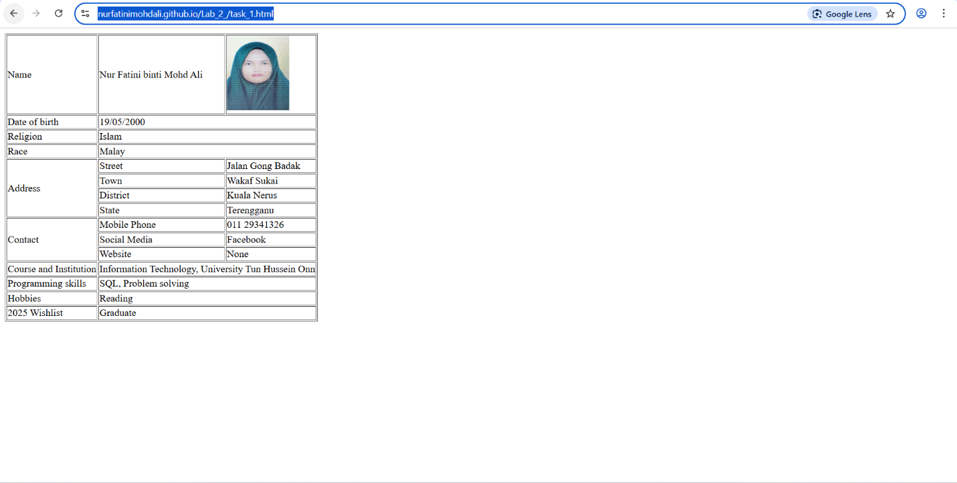

Task 2

1. J

<!DOCTYPE html>

<html lang="en">

<head>

    <meta charset="UTF-8">

    <title>Conference Registration Form</title>

</head>

<body>

    <h1>Conference Registration Form</h1>

    <form action="#" method="post">

        <label for="fullname">Full Name:</label><br>

        <input type="text" id="fullname" name="fullname" placeholder="Enter your full name" required><br><br>

        <label for="email">Email Address:</label><br>

        <input type="email" id="email" name="email" placeholder="Enter your email address" required><br><br>

        <label for="age">Age:</label><br>

        <input type="number" id="age" name="age" min="18" max="99" value="18" required><br><br>

        <label>Gender:</label><br>

        <input type="radio" id="male" name="gender" value="Male">

        <label for="male">Male</label><br>

        <input type="radio" id="female" name="gender" value="Female">

        <label for="female">Female</label><br><br>

        <label for="country">Country of Residence:</label><br>

        <select id="country" name="country">

            <option value="Malaysia">Malaysia</option>

            <option value="Singapore">Singapore</option>

            <option value="Other">Other</option>

        </select><br><br>

        <label>Areas of Interest:</label><br>

        <input type="checkbox" id="software" name="interest" value="Software Development">

        <label for="software">Software Development</label><br>

        <input type="checkbox" id="data" name="interest" value="Data Science">

        <label for="data">Data Science</label><br>

        <input type="checkbox" id="cyber" name="interest" value="Cybersecurity">

        <label for="cyber">Cybersecurity</label><br>

        <input type="checkbox" id="ai" name="interest" value="Artificial Intelligence">

        <label for="ai">Artificial Intelligence</label><br><br>

        <label>Experience Level:</label><br>

        <input type="radio" id="beginner" name="experience" value="Beginner">

        <label for="beginner">Beginner</label><br>

        <input type="radio" id="intermediate" name="experience" value="Intermediate">

        <label for="intermediate">Intermediate</label><br>

        <input type="radio" id="advanced" name="experience" value="Advanced">

        <label for="advanced">Advanced</label><br><br>

        <label for="comments">Comments or Questions:</label><br>

        <textarea id="comments" name="comments" rows="4" cols="40" placeholder="Any comments or questions?"></textarea><br><br>

        <input type="submit" value="Register">

        <input type="reset" value="Reset">

    </form>

</body>

</html>

1. J
2. J