Part 1: Reading Information From A Script

1. How many tables have been created using the CREATE TABLE statement?

**10 tables**

1. How many columns are created for the history table?

**6 columns**

1. What statement is used to enforce the constraint that the category column of the items table must have a value?

**NOT NULL,**

1. What is the name of the foreign key constraint between the customers and customer addresses tables?

**customer_address_customer_fk**

1. What are the lowest and highest values that can be stored in the commission_rate column for the sales_representative table?

**Lowest value: -99**

**Highest value: 99**

1. What are the lowest and highest values that can be stored in the price column for the price_history table?

**Lowest value: -9999999.99**

**Highest value: 9999999.99**

1. What are the 3 columns that make up the primary key for the price_history table?
   1. **itm_number**
   2. **start_date**
   3. **start_time**

Part 2:

**Modifying a column**

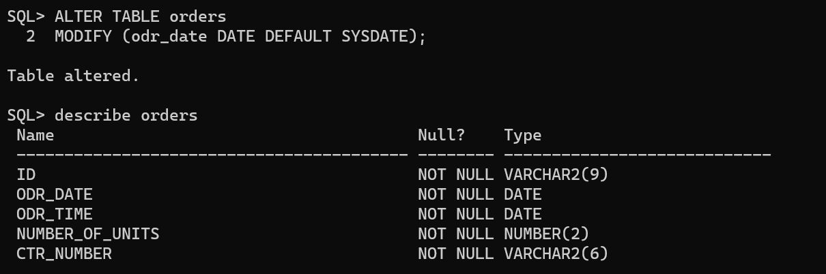

**Adding a check constraint**

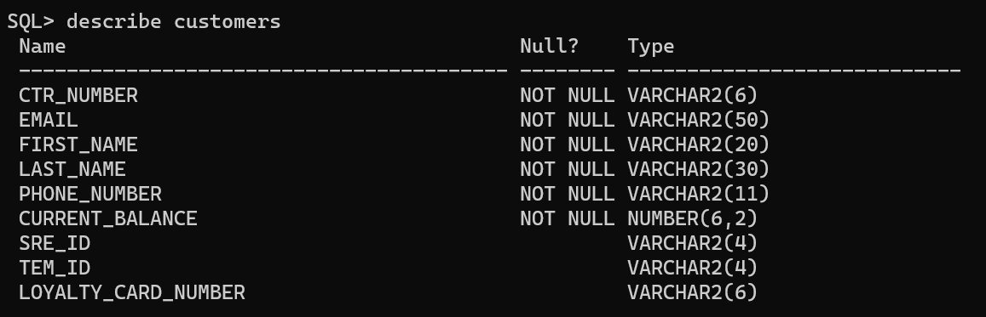

**Adding a column**

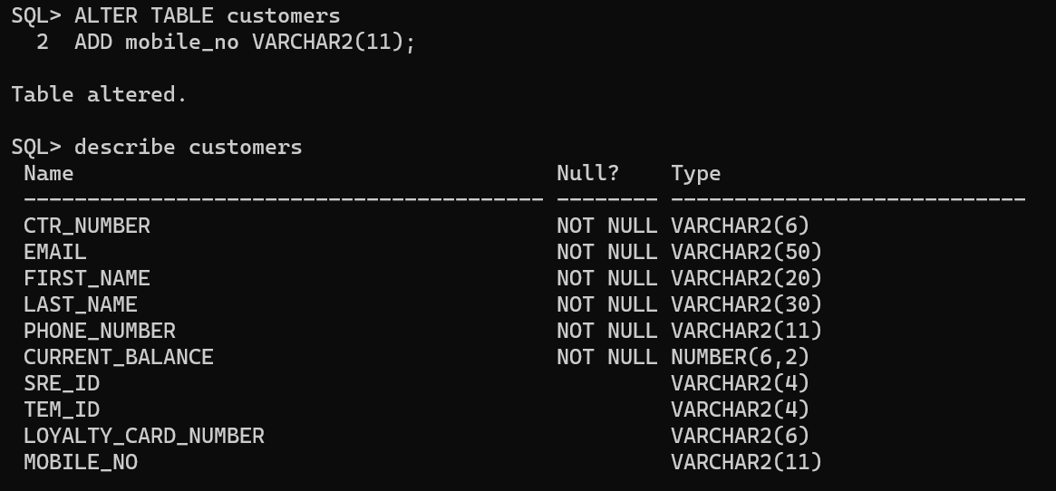

**Dropping a column**

