Assignment 5 Soft
SE-2413
Nurislam Temirgali

Smart Home Automation System

1. Introduction
This project is a simulation of a Smart Home Automation System built using Java.
The main goal of this project is to demonstrate the use of Design Patterns such as Decorator and Facade, while also showing how multiple devices in a house can be controlled through both remote and voice-based interfaces.
Additional features include user authentication, door control, modes (Party, Night, Leave Home), and interactive device operations like lights, music, and thermostat

2. Objectives
- To implement the Decorator Pattern for extending device features dynamically (e.g., energy saving, voice control, remote access).
- To use the Facade Pattern for simplifying complex subsystem interactions (lights, music, thermostat, cameras).
- To simulate a realistic user experience with login, door system, and two control modes (Remote and Voice).
- To practice object-oriented programming principles — encapsulation, abstraction, and modularity

3. System Overview

Main Features
- User Login System – allows multiple users with stored credentials.
- Door System – simulates opening, closing, and locking of the main home door.
- Home Modes –
  - Party Mode: turns on lights and music, adjusts thermostat.
  - Night Mode: turns off lights, sets eco temperature, activates camera.
  - Leave Home: shuts down all systems and locks the door.
- Remote Control Interface – provides a text-based menu for choosing actions.
- Voice Control Interface – allows typed commands like light on, music off, thermostat 25, party mode, etc.
- Decorator Extensions – adds features to devices dynamically (EnergySaving, VoiceControl, RemoteAccess).
- Facade Controller – central class (HomeAutomationFacade) that manages all devices at once.

4. Design Patterns Used

a) Decorator Pattern
Used to dynamically add features to base device classes without modifying their source code.
Examples:
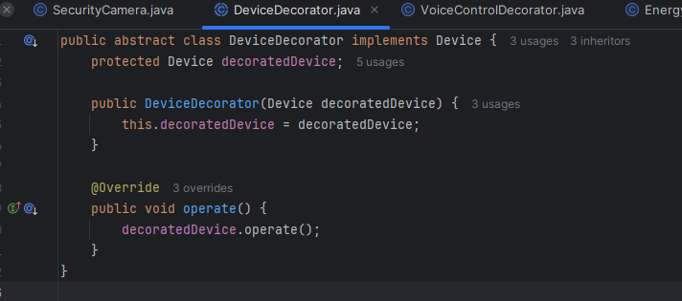
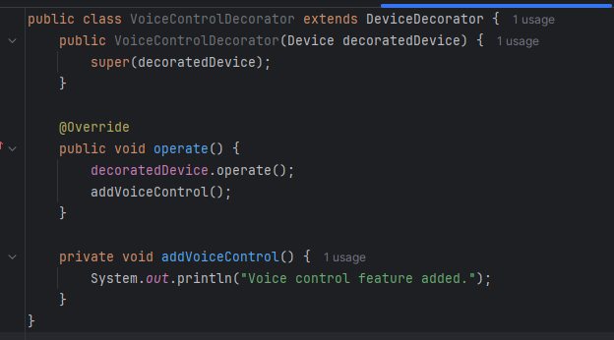
Explanation:
- The EnergySavingDecorator adds power efficiency to the light.
- The VoiceControlDecorator then adds the ability to control it via voice commands.
- The base Light class remains unchanged — this demonstrates Open/Closed Principle.

b) Facade Pattern
Used to simplify complex subsystem operations by providing a single interface (HomeAutomationFacade).
Example:
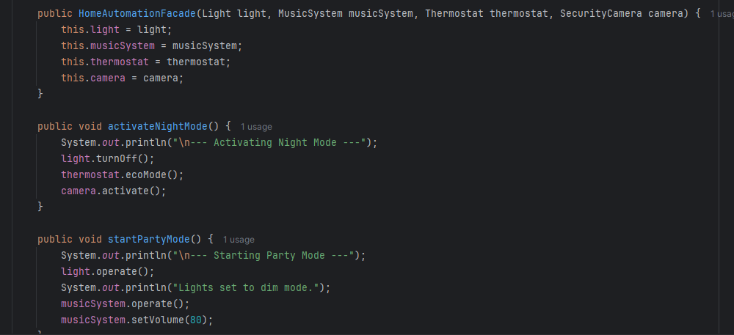

5. Class Overview
Class Name | Responsibility
Device | Interface representing all smart devices.
Light | Controls light (on/off).
MusicSystem | Controls music (play/stop).
Thermostat | Controls temperature.
SecurityCamera | Manages home surveillance.
DeviceDecorator | Abstract decorator for adding features to devices.
VoiceControlDecorator | Adds voice control feature.
EnergySavingDecorator | Adds energy-saving functionality.
RemoteAccessDecorator | Adds remote internet control.
Door | Represents the home’s main door (open/close/lock).
User | Stores username and password information.
AuthSystem | Verifies login credentials.
HomeAutomationFacade | Simplifies control of all devices and modes.
Main | Entry point; handles user interface and interaction logic.

6. How the System Works
- Authentication:
The program starts by asking for username and password.
If correct, the door automatically unlocks and opens.
- Control Selection:
The user can choose between:
  - Remote Control Menu – button-like options
  - Voice Control – text commands (simulated speech)
- Device Interaction:
  - The user can turn lights and music on/off, change thermostat temperature, or activate pre-set modes.
  - The system prints responses showing the state of each device.
- Exiting the System:
When the user leaves home, the door locks, lights turn off, music stops, and security camera activates.

7. Key Benefits
- Modular design – each class handles one clear responsibility.
- Scalable structure – new devices or features can be added easily using decorators.
- Readable code – logical class separation makes maintenance simple.
- Pattern practice – demonstrates real-life use of two major design patterns.

8. Example Output
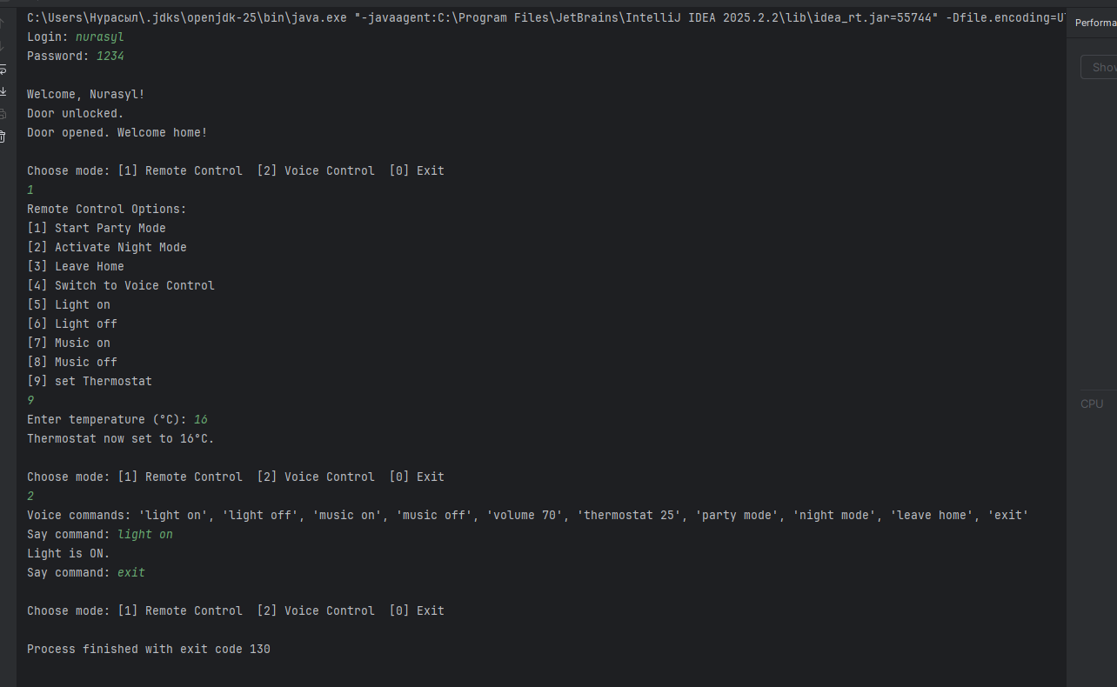

9. Conclusion
This project successfully demonstrates how object-oriented programming and design patterns can be used to build a modular, extendable smart home system.
The Decorator Pattern provides flexibility to add features dynamically, and the Facade Pattern simplifies complex operations for end-users.
Through login, door control, and dual-mode interfaces, the system closely simulates real-world smart home behavior.

