ASTANA IT UNIVERSITY
School of Software Engineering · Group SE-2413

DIPLOMA PROJECT
FIRST CHECKPOINT REPORT
Development of an Intelligent Voice Control System in the Kazakh Language Based on Neural Networks
Russian title: Разработка интеллектуальной системы голосового управления на казахском языке на основе нейронных сетей
Kazakh title: Нейрондық желілер негізінде қазақ тіліндегі дауыстық басқарудың интеллектуалды жүйесін әзірлеу
Student | Status of assigned focus
Myrzatay Alan Abayuly | ML/ASR study and research (proposed)
Temirgali Nurislam Kairatuly | Backend developer (confirmed)
Abdigali Nurassyl Zhandosuly | Frontend and QA (proposed; confirm with supervisor)

Supervisor: Turarova Marzhan Kabdikalievna
Date: 22 October 2026 | Target deadline: 24 October 2026, 18:00 (Astana local time)
DRAFT STATUS. This report contains planned design and literature research. Interview evidence, approved team allocation, real Git/YouTrack activity, and supervisor feedback must be added before final submission.

Executive summary
This report lays out a feasible design and evaluation plan for an intelligent Kazakh-language voice-command system. The proposed minimal demonstrator accepts controlled voice requests, uses neural speech recognition to create a transcript, identifies one of a limited set of safe intents, and displays a corresponding action outcome. The intended outcome is not merely a speech-to-text demo: users should be able to perform reproducible commands in Kazakh while the team can quantify recognition errors, intent errors, end-to-end latency, and failure behavior. At this checkpoint the team is expected to substantiate the problem, architecture, technologies and next steps; a complete application is not required.
Evidence convention: VERIFIED = backed by a citation or dated evidence; PROPOSED = plan awaiting approval; TODO = user/team must add actual evidence. Claimed model quality, fieldwork, Git activity and supervisor sign-off are not fabricated.

1. Project proposal

1.1 Problem and motivation
Kazakh speech technology is actively researched, including dedicated speech corpora and multilingual training, but existence of a general ASR model does not prove that a Kazakh voice-control interface reliably executes a particular command set under realistic noise, accents and code-switching conditions [S1, S2, S4]. The engineering problem is to connect speech recognition with constrained intent detection, safe action execution, an inspectable backend/API, and reproducible testing.

1.2 Target users, aim and scope
PROPOSED target audience: Kazakh-speaking users who prefer hands-free interaction with a web-based demonstrator; final personas must be validated by genuine stakeholder discussions. Aim: design, integrate and evaluate a safe prototype of neural-network-based Kazakh voice control.
- Collect actual stakeholder evidence and derive user-command priorities.
- Compare Kazakh-capable ASR models and document technology trade-offs.
- Define API, safe actions, component boundaries, and input/output behavior.
- Build a small web demonstrator with a limited, testable intent vocabulary.
- Evaluate ASR quality, command accuracy, latency, errors and privacy controls.
PROPOSED included: audio upload/recording (later), transcript, command inference, allow-listed UI actions, confidence/error handling, metrics. Excluded for MVP: arbitrary OS commands, financial actions, access to real smart-home devices, always-on listening, uncontrolled cloud sharing, and unsupported languages.

1.3 Expected deliverables
Deliverables include a maintained Git repository, traceable project tasks, a documented API, neural ASR integration, web UX, tests, benchmark notebook/scripts, evaluation tables and a final diploma project report. Acceptance at this checkpoint focuses on approved scope, reviewable diagrams, requirements and feasibility, not a completed model.

2. Evidence of relevance — NOT YET VERIFIED
The checkpoint requires 3–5 stakeholder discussions or substantive agreement with a real client. None of the materials available here establish that these have occurred. Do not submit invented transcripts, interview dates or approvals. The team must add real notes to docs/relevance-interview-log-TEMPLATE.md and identify the source of each requirement.
Evidence ID | Stakeholder / method | Verified finding | Impact on specification
INT-01 | TODO: real conversation | TODO | TODO
INT-02 | TODO: real conversation | TODO | TODO
INT-03 | TODO: real conversation | TODO | TODO
INT-04/05 | Optional as appropriate | TODO | TODO

Suggested interview focus: preferred app to control, common Kazakh commands, noisy environments, acceptable false activations, language switching, privacy and confirmation before an action. Separate stakeholder statements from team assumptions. If there is a client, document the substantive agreement and scope decisions instead.

3. Critical literature review
Ten scientific publications and five primary technical documentation sources have been selected for meaningful use. Most research sources are from 2021–2024; the 2020 wav2vec 2.0 work is retained for foundational methodology. The matrix below summarizes core relevance, but the team should read the full scientific papers before final claim-by-claim synthesis.

3.1 Synthesis
Kazakh-focused corpora (KSC, KSC2) demonstrate the feasibility of training and evaluating Kazakh ASR, including code-switched material [S1, S2]. Turkic multilingual transfer [S4] and broader cross-lingual pretraining [S6, S7] motivate alternative models, yet published gains cannot be transferred to this specific command corpus without direct experiments. Whisper [S5] offers an accessible multilingual neural baseline, whereas wav2vec 2.0 [S10] explains a family of self-supervised approaches. FLEURS [S8] informs controlled testing but does not replace a speaker-disjoint sample of voice commands. KazakhTTS2 [S9] matters only if spoken responses are included: ASR and TTS should not be conflated.

3.2 Structured literature matrix
ID / year | Source (short) | Contribution to project | Important caveat
S1 / 2021 | A Crowdsourced Open-Source Kazakh Spe | Kazakh ASR data; KSC (~332 h). | Mostly prepared speech; command-domain/noise generalization needs testing.
S2 / 2022 | KSC2: An Industrial-Scale Open-Source | Larger Kazakh ASR corpus (~1.2k h), including code-switching. | Licensing, size, domain balance and test leakage require review.
S3 / 2022 | A study of transformer-based end-to-e | Kazakh-specific transformer-based ASR study. | Reported accuracy depends on corpus and settings; not directly comparable.
S4 / 2023 | Multilingual Speech Recognition for T | Joint multilingual Turkic ASR; language transfer. | Multilingual gains may differ for a constrained command set.
S5 / 2023 | Robust Speech Recognition via Large-S | Whisper multilingual weakly supervised ASR. | Compute/latency and Kazakh command accuracy must be measured.
S6 / 2022 | XLS-R: Self-supervised Cross-lingual | Cross-lingual pretrained speech representations. | Fine-tuning/data and compute effort may exceed MVP budget.
S7 / 2024 | Scaling Speech Technology to 1,000+ L | MMS multilingual ASR framework. | Language availability does not imply domain-level reliability.
S8 / 2022 | FLEURS: Few-shot Learning Evaluation | Multilingual held-out benchmark with speech tasks. | Read-speech data differ from voice commands.
S9 / 2022 | KazakhTTS2: Extending the Open-Source | Kazakh speech synthesis and speech data resources. | TTS is not ASR; indirect relevance until spoken feedback is planned.
S10 / 2020 | wav2vec 2.0: A Framework for Self-Sup | Self-supervised pretraining in limited-label settings. | Pre-2021 foundational reference, not recent state-of-art proof.

3.3 Research/design gap
The project-specific gap is not proving that Kazakh ASR exists; it is showing whether a selectable neural recognizer plus constrained intent parsing achieves reliable voice control in a scoped domain, including safe fallback behavior. The final result must report test counts and measured metrics rather than rely on external papers’ accuracy.

4. Existing-system comparison
The systems below are compared against a common set of criteria: scope, Kazakh readiness, offline behavior, action integration, extensibility, privacy/local mode, maintenance status, and relevance. “Not confirmed” reflects a verification gap, not proof that a system cannot support Kazakh. Based on documented product descriptions [D2–D5].

4.1 Comparison matrix A (four shared criteria)
System | Functional domain | Kazakh support | Offline mode | Intent/action integration
Home Assistant Assist | Yes / smart home | Conditional; language pipeline must be tested | Yes, configurable | Home automation
OpenVoiceOS | Yes / general assistant | Not confirmed end-to-end | Yes, component-dependent | Skills/plugins
Rhasspy | Yes / bounded commands | Not listed as turnkey Kazakh profile | Yes | Intent events (HTTP/MQTT/WS)
Picovoice Rhino | Speech-to-intent / bounded | Not in public support list | On-device | Intent/slots

4.2 Comparison matrix B (four further criteria)
System | Customisable | Local/privacy | Maintenance | Fit to Kazakh MVP
Home Assistant Assist | Yes | Yes | Active | High for automation; outside chosen web-demo scope
OpenVoiceOS | Yes | Yes | Active project | High flexibility; integration burden
Rhasspy | Yes | Yes | Archived 2025 | Good reference; maintenance risk
Picovoice Rhino | SDK-based | SDK-based | Commercial SDK | Low immediate language fit

Differentiation (proposed): focus tightly on a measurable Kazakh command set with explicit transcript→intent→safe action traceability, rather than promise a general assistant. Rhasspy is included as an informative comparable pipeline but its repository was archived in 2025 [D5].

5. Technology comparison and provisional decisions
The following are options to be experimentally or architecturally assessed, not established winners. Final selection should account for the available team skills/hardware, model licensing, empirical Kazakh performance, privacy, and maintainability.
Decision | 2–3 alternatives | Provisional choice | Basis and further verification
Neural speech recognition | Whisper multilingual / Vosk Kazakh / XLS-R fine-tuning | Whisper for first benchmark; Vosk offline comparison; XLS-R optional adapted model | Compare held-out Kazakh WER, latency, memory and license; no winner claimed before experiments.
Backend platform | Go (Gin) / Python (FastAPI) / Node.js (Express) | Go (Gin) API gateway plus Python ML service (provisional) | Matches backend ownership and separates model dependencies; adds inter-service complexity.
Storage | PostgreSQL / SQLite / MongoDB | PostgreSQL only if diagnostic metadata persistence is approved; start without storing raw audio | Relational audit metadata if required; no premature collection of voice recordings.
Component interaction | REST/JSON / WebSocket / gRPC | REST/JSON for short clips; WebSocket considered for streaming | Simple client integration now; streaming upgrade measurable later.

Model-quality decision rule: first build the same held-out evaluation set and test at least two runnable candidate recognizers; then compare WER/CER, exact command accuracy, p95 latency, memory, installation effort, and data/license constraints before selecting a production candidate.

6. Requirements specification
Must = essential acceptance; Should = expected if time permits; Could = future. Functional and non-functional requirements are given testable acceptance criteria. The chosen command taxonomy is provisional pending stakeholder review.
ID | Priority | Requirement | Acceptance criterion
FR-01 | Must | Accept Kazakh speech input | Given a supported audio file (WAV 16kHz mono OR documented codec), system accepts upload and returns job/result or validation error.
FR-02 | Must | Recognize text with neural ASR | For valid Kazakh audio, response contains transcript and ASR model identifier; no hardcoded sample response in backend.
FR-03 | Must | Identify supported command intent | From transcript, map to one of a versioned list of intents or UNKNOWN.
FR-04 | Must | Execute safe allow-listed demo actions | Only OPEN_SECTION / SET_THEME / SHOW_HELP / CANCEL can change UI state; unsupported actions do nothing.
FR-05 | Must | Present result and errors | Client shows recognized text, intent, action outcome, and understandable error states.
FR-06 | Must | Protect data and handle permissions | No microphone access before explicit consent; no raw audio saved by default.
FR-07 | Should | Maintain traceable request diagnostics | Store timestamp, model version, latency and outcome without recording sensitive audio (opt-in logs only).
FR-08 | Should | Allow text command fallback | Text input invokes intent handler without invoking ASR.
FR-09 | Could | Provide spoken Kazakh feedback | Optional TTS only after core command loop is validated.
NFR-01 | Must | Evaluation reproducibility | Freeze dataset split, model version, command taxonomy and evaluation script. Metrics reproducible given fixed seed.
NFR-02 | Must | Measured latency | Report p50 and p95 end-to-end latency on named machine; target p95 <= 5 seconds for <= 5 s clips (hypothesis, not achieved).
NFR-03 | Must | Reliability under invalid input | Malformed/oversize audio yields client error and no server crash; allow-list blocks unsafe execution.
NFR-04 | Must | Privacy and security | Credentials in environment variables; audio size limits; consent for any collected recordings.
NFR-05 | Should | Kazakh command recognition quality | Evaluate exact-intent accuracy and WER on held-out speakers; targets chosen after baseline pilot.
NFR-06 | Should | Maintainability | Model adapter exposes a stable interface; API contract documented with sample requests/responses.

7. Architecture and diagrams
The design separates presentation, backend orchestration, neural model inference, intent/action control and optional minimal metadata storage. This enables model replacement without changing the UI protocol and provides a fail-closed action boundary. Implementation not claimed at this stage.

7.1 System context diagram
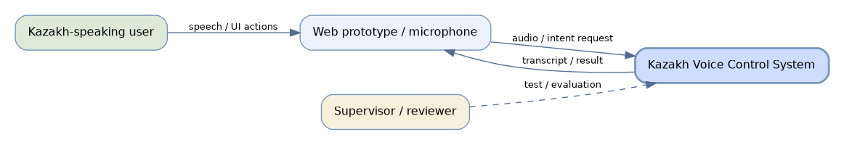
Editable source: diagrams/01-system-context.dot; image export: .svg and .png

7.2 Use case diagram (concept)
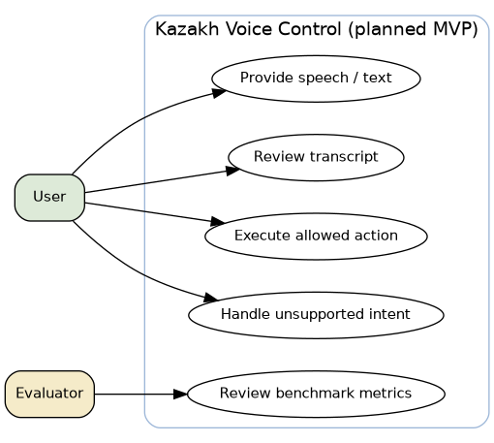
Editable source: diagrams/02-use-cases.dot; image export: .svg and .png

7.3 Draft component diagram
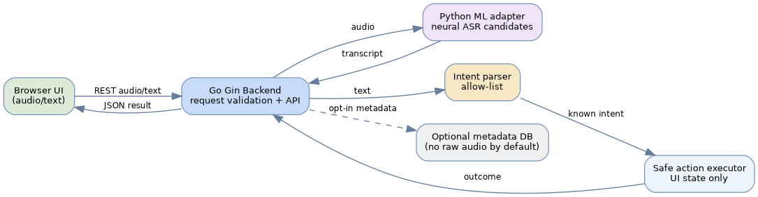
Editable source: diagrams/03-component-diagram.dot; image export: .svg and .png

7.4 Proposed interface contract
POST /api/v1/commands/audio accepts a validated short audio file and returns structured JSON containing transcript, intent, action/result, and model information. POST /api/v1/commands/text isolates intent logic during testing. /health reports service readiness. Invalid formats, oversized audio and model unavailability must have explicit error responses. The detailed examples are in docs/API_CONTRACT_draft.md.

8. UX / prototype
An editable HTML wireframe is included at prototype/index.html. It demonstrates a planned UI flow: enter a sample Kazakh command, show interpreted intent and a safe UI-only effect. The HTML interaction is intentionally mocked. It does NOT record audio or call a neural model yet; it is a UX deliverable, not implementation evidence.

8.1 Concept screen: text-driven static mock
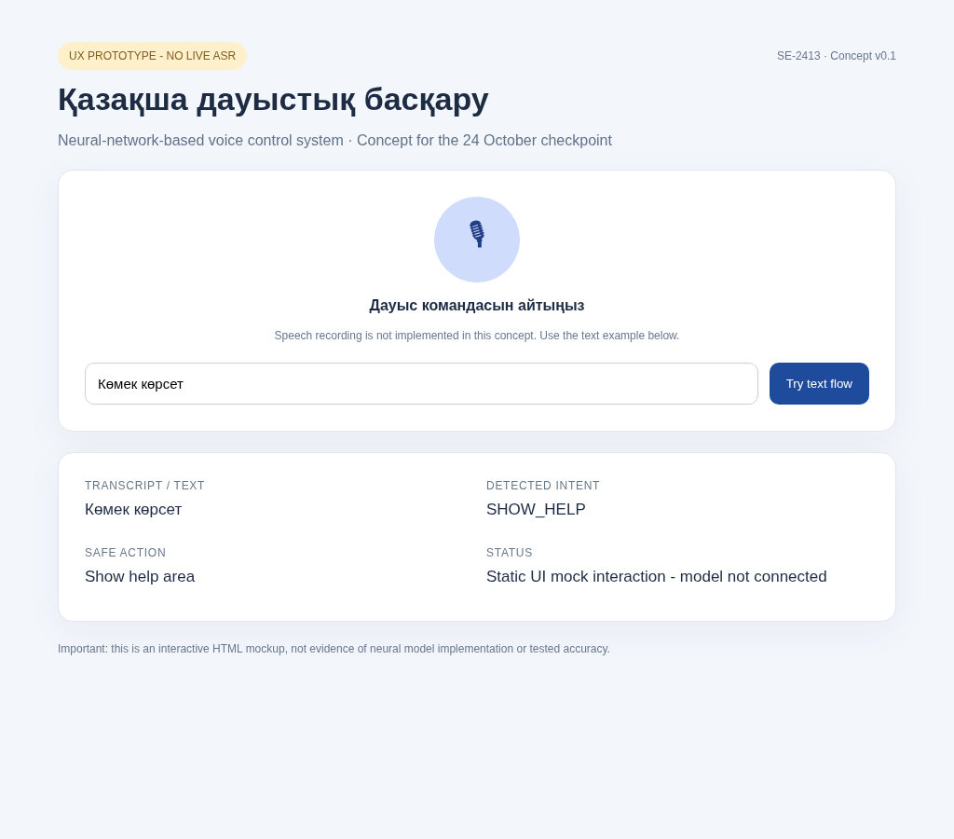
Figure: browser HTML UX mock screenshot. NOT a functioning speech-recognition service.

8.2 Key user flow
- User opens web page and sees permission/privacy note.
- User supplies audio after consent or uses fallback text input.
- System validates input and invokes recognizer (future implementation).
- User sees transcript, recognized intent, feedback and safe action.
- Unknown intent or model error produces a clear message; no unrestricted command executes.

8.3 Prototype acceptance for checkpoint
A reviewer can open the HTML file, input a Kazakh text command, and inspect consistent UI states (supported intent, UNKNOWN, safe theme toggle). A live microphone recording and ASR demonstration are explicitly future development tasks.

9. Verification and evaluation plan

9.1 Protocol
Use consented/duly licensed Kazakh speech clips with documented speaker-disjoint train/development/test separation. Start with public datasets (license verified) and collect a compact domain-specific command evaluation set with consent if approved. Include quiet, background-noise and mixed-language conditions; do not reuse training utterances in held-out test. Maintain fixed model versions and normalization rules.

9.2 Metrics and baseline
Metric | Definition / method | Baseline and status
Word Error Rate (WER) | (S+D+I) / reference words on fixed test clips | Compare candidate models and optional Vosk baseline; NOT measured
Character Error Rate (CER) | Edit distance / reference characters | Track agglutinative Kazakh variations; NOT measured
Intent accuracy | Correct predicted intents / total evaluated commands | Compare keyword/rule baseline to neural-enhanced approach; NOT measured
False action rate | Unsupported commands triggering an action / unsupported commands | Aim zero for known negative cases; NOT measured
Latency p50/p95 | End-to-end wall time under named CPU/GPU conditions | Target exploratory p95 <=5 s for <=5 s clips; NOT validated
Robustness | Rate of clean error handling on malformed/empty/oversize input | Acceptance tests to implement; NOT measured

9.3 Planned test cases
Test | Scenario | Expected outcome / coverage
TC-01 | Valid Kazakh voice clip | Successful ASR + supported action result [FR-01..05]
TC-02 | Russian/Kazakh code-switched clip | Transcript produced, controlled UNKNOWN fallback if ambiguous [FR-02..04]
TC-03 | Unsupported phrase | UNKNOWN; no action executed [FR-03..04]
TC-04 | Empty/corrupted audio | 4xx validation; no server crash [FR-01,NFR-03]
TC-05 | Oversized payload | 413 or documented 4xx; no processing [NFR-03]
TC-06 | Malformed intent from ML service | Fail closed; no unsafe action [FR-04,NFR-03]
TC-07 | Microphone access denied | UI error and text fallback path [FR-06,FR-08]
TC-08 | Latency test (>= 30 clips) | p50/p95 measured on declared environment [NFR-02]
TC-09 | Speaker-disjoint evaluation | WER/CER and intent accuracy by subgroup [NFR-01,NFR-05]

Analysis plan: report total clips, distinct speakers, per-condition samples, metrics for each model under identical conditions, 95% confidence intervals where statistically defensible, error examples, and observed limitations. No claimed performance without real runs.

10. Project management, dependencies and risks

10.1 Team responsibilities — subject to confirmation
Member | Proposed / confirmed focus | Traceable expected artifacts
Nurislam | CONFIRMED backend | API contract, integration design, backend comparison, interface/error specification, model adapter integration later
Alan | PROPOSED ML and literature | Stakeholder evidence coordination, literature matrix, model research/benchmark design
Nurassyl | PROPOSED frontend and QA | UX wireframe, test matrix, user flow, test setup and frontend integration later

Do not use this assignment as a claim of completed work. Actual individual contributions and task activity must be corroborated by members’ real commits, issue links and reviewed PRs.

10.2 Near-term milestones
Date | Checkpoint action | Definition of done
22 Oct | Confirm scope; create repo and YouTrack | All member access granted; initial tasks genuinely assigned
23 Oct | Evidence, literature and design review | Real interviews/client evidence; supervisor feedback recorded; corrections tracked
24 Oct before 18:00 | Freeze and submit checkpoint | All 11 sections complete; two PDFs; public or approved private links; one Forms response

10.3 Risk register
Risk | Likelihood / impact | Mitigation
R1 Kazakh ASR quality inadequate for natural accents/noise | High / High | Pilot KSC2/FLEURS + original consented test; measure WER and intent accuracy
R2 Not enough genuine stakeholder evidence before checkpoint | High / High | 3–5 real interviews or documented client agreement; log dates and approvals
R3 End-to-end latency too high | Medium / High | Benchmark two model sizes; record p50/p95 CPU/GPU
R4 Scope creep into OS-level device control | Medium / High | Explicit limited action allow-list; out-of-scope list and acceptance tests
R5 Accidental exposure of audio/credentials | Medium / High | Opt-in data capture, retention policy, .gitignore, code review
R6 Missing YouTrack/commit evidence at review | High / High | Create real issues, connect PRs, assign owners; stage progress with authentic dates
R7 Supervisor has not reviewed materials | High / High | Schedule review and record exact comments and fixes

10.4 Traceability obligations
Real GitHub or GitLab (GitHub accepted): recognizable individual accounts, README, source/editable diagrams, progressive documentation commits, task-ID branches and peer-reviewed PRs, as required by the checkpoint instructions. Real YouTrack: assigned/priority/deadline tasks, criteria, link to commit/PR, completed only when acceptance criteria met. The accompanying CSV is an IMPORT TEMPLATE; IDs shown there are not genuine YouTrack IDs.

11. Supervisor feedback — NOT YET VERIFIED
Supervisor: Turarova Marzhan Kabdikalievna. The university requests meaningful review of key outputs and evidence that the team responded to comments. This document contains no verified review meeting or written feedback; the table below must be completed from actual communication.
Date | Deliverable reviewed | Exact feedback | Revision / linked evidence
TODO | TODO | TODO | TODO
TODO | TODO | TODO | TODO

Supervisor confirmation to obtain: approve scope and user population; select MVP action domain and ASR short list; comment on architecture and evaluation; validate responsibilities and repository access.

Submission & integrity checklist
- Finalize stakeholder evidence and separate facts from assumptions.
- Confirm team roles and actual GitHub usernames/individual contributions.
- Have supervisor genuinely inspect artifacts and document comments/revisions.
- Create / populate actual GitHub and YouTrack, ensuring reviewer access.
- Export a separate REAL YouTrack board+task screenshot PDF (not supplied here).
- Replace remaining TODO markers; finalize a single report PDF and submit form once for team before 24 Oct 18:00.

References
[S1] Khassanov et al. (2021). A Crowdsourced Open-Source Kazakh Speech Corpus and Initial Speech Recognition Baseline. https://aclanthology.org/2021.eacl-main.58/
[S2] Mussakhojayeva et al. (2022). KSC2: An Industrial-Scale Open-Source Kazakh Speech Corpus. https://www.isca-archive.org/interspeech_2022/mussakhojayeva22_interspeech.html
[S3] Orken et al. (2022). A study of transformer-based end-to-end speech recognition system for Kazakh language. https://www.nature.com/articles/s41598-022-12260-y
[S4] Mussakhojayeva et al. (2023). Multilingual Speech Recognition for Turkic Languages. https://doi.org/10.3390/info14020074
[S5] Radford et al. (2023). Robust Speech Recognition via Large-Scale Weak Supervision. https://proceedings.mlr.press/v202/radford23a.html
[S6] Babu et al. (2022). XLS-R: Self-supervised Cross-lingual Speech Representation Learning at Scale. https://arxiv.org/abs/2111.09296
[S7] Pratap et al. (2024). Scaling Speech Technology to 1,000+ Languages. https://www.jmlr.org/beta/papers/v25/23-1318.html
[S8] Conneau et al. (2022). FLEURS: Few-shot Learning Evaluation of Universal Representations of Speech. https://arxiv.org/abs/2205.12446
[S9] Mussakhojayeva et al. (2022). KazakhTTS2: Extending the Open-Source Kazakh TTS Corpus With More Data, Speakers, and Topics. https://aclanthology.org/2022.lrec-1.578/
[S10] Baevski et al. (2020). wav2vec 2.0: A Framework for Self-Supervised Learning of Speech Representations. https://papers.nips.cc/paper_files/paper/2020/hash/92d1e1eb1cd6f9fba3227870bb6d7f07-Abstract.html
[D1] Vosk/Alpha Cephei (n.d.). Vosk offline speech recognition API and models. https://alphacephei.com/vosk/models
[D2] Home Assistant (n.d.). Assist voice assistant overview. https://www.home-assistant.io/voice_control/
[D3] OpenVoiceOS (n.d.). OpenVoiceOS technical manual. https://openvoiceos.github.io/beta-technical-manual/
[D4] Picovoice (n.d.). Rhino Speech-to-Intent documentation. https://picovoice.ai/docs/rhino/
[D5] Rhasspy (2025 archive). Rhasspy GitHub README. https://github.com/rhasspy/rhasspy

Source and status note
This draft was prepared using the AITU checkpoint requirements supplied by the student and the AITU methodology file. Scientific and technical references above provide research context; architecture, acceptance thresholds and proposed roles are proposed project plans, not measured outcomes or supervisor-endorsed facts. The AITU full-thesis guideline regarding length and formatting is separate from this checkpoint submission and should be followed for the final thesis.

