**Soal ACC Kelas 3A**

**Nama : Hernanda Hafidz Wijaya**

**NIM : 180631100012**

**Gelombang : 1**

1. **Jelaskan apa yang dimaksud gerbang logika OR dan tuliskan tabel kebenarannya!**
2. **Tuliskan tabel kebenaran dari rangkaian berikut:**

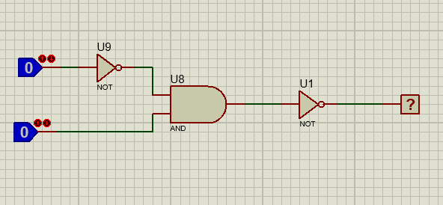

1. **Tuliskan tabel kebenaran dari rangkaian berikut:**

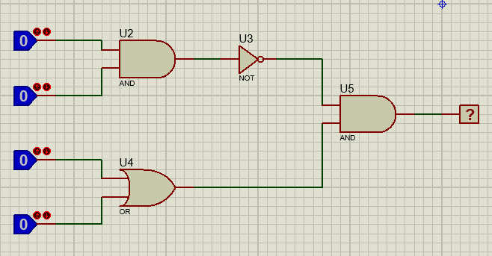

**Jawab:**

1. **Gerbang or ialah gerbang yang memiliki 2 input untuk menghasilkan 1 keluaran input. Jika salah satu input 1 atau keduanya 1 maka keluarannya akan bernilai 1. Jika kedua inputnya 0 maka inputnya 0.**

|  |  |  |
| --- | --- | --- |
| **INPUT** | | **OUTPUT** |
| **0** | **0** | **0** |
| **0** | **1** | **1** |
| **1** | **0** | **1** |
| **1** | **1** | **1** |

**2.**

|  |  |  |  |  |
| --- | --- | --- | --- | --- |
| **A (U9)** | **Out.A** | **B** | **Output AND (Out A+B)** | **OR U1 Output** |
| **0** | **1** | **0** | **0** | **1** |
| **1** | **1** | **0** |
| **1** | **0** | **0** | **0** | **1** |
| **1** | **0** | **1** |

**3.**

|  |  |  |  |  |  |  |  |
| --- | --- | --- | --- | --- | --- | --- | --- |
| **A** | **B** | **C** | **D** | **X (AND A+B U2)** | **Y (OR C+B)** | **Z (NOT X)** | **ZX (AND Z+Y)** |
| **0** | **0** | **0** | **0** | **0** | **0** | **1** | **0** |
| **0** | **0** | **0** | **1** | **0** | **1** | **1** | **1** |
| **0** | **0** | **1** | **0** | **0** | **1** | **1** | **1** |
| **0** | **0** | **1** | **1** | **0** | **1** | **1** | **1** |
| **0** | **1** | **0** | **0** | **0** | **0** | **1** | **0** |
| **0** | **1** | **0** | **1** | **0** | **1** | **1** | **1** |
| **0** | **1** | **1** | **0** | **0** | **1** | **1** | **1** |
| **0** | **1** | **1** | **1** | **0** | **1** | **1** | **1** |
| **1** | **0** | **0** | **0** | **0** | **0** | **1** | **0** |
| **1** | **0** | **0** | **1** | **0** | **1** | **1** | **1** |
| **1** | **0** | **1** | **0** | **0** | **1** | **1** | **1** |
| **1** | **0** | **1** | **1** | **0** | **1** | **1** | **1** |
| **1** | **1** | **0** | **0** | **1** | **0** | **0** | **0** |
| **1** | **1** | **0** | **1** | **1** | **1** | **0** | **0** |
| **1** | **1** | **1** | **0** | **1** | **1** | **0** | **0** |
| **1** | **1** | **1** | **1** | **1** | **1** | **0** | **0** |