**MODULE 1**

**Networks Affect our Lives**

In today’s world, through the use of networks, we are connected like never before. People with ideas can communicate instantly with others to make those ideas a reality. The creation of online communities for the exchange of ideas and information has the potential to increase productivity opportunities across the globe. The creation of the cloud lets us store documents and pictures and access them anywhere, anytime.

**Network Components**

All computers that are connected to a network and participate directly in network communication are classified as hosts. Hosts can be called end devices. Some hosts are also called clients. Many computers function as the servers and clients on the network. This type of network is called a peer-to-peer network. An end device is either the source or destination of a message transmitted over the network. Intermediary devices connect the individual end devices to the network and can connect multiple individual networks to form an internetwork. Intermediary devices use the destination end device address, in conjunction with information about the network interconnections, to determine the path that messages should take through the network. The media provides the channel over which the message travels from source to destination.

**Network Representations and Topologies**

Diagrams of networks often use symbols to represent the different devices and connections that make up a network. A diagram provides an easy way to understand how devices connect in a large network. This type of “picture” of a network is known as a topology diagram. Physical topology diagrams illustrate the physical location of intermediary devices and cable installation. Logical topology diagrams illustrate devices, ports, and the addressing scheme of the network.

**Common Types of Networks**

Small home networks connect a few computers to each other and to the internet. The small office/home office (SOHO) network allows computers in a home office or a remote office to connect to a corporate network, or access centralized, shared resources. Medium to large networks, such as those used by corporations and schools, can have many locations with hundreds or thousands of interconnected hosts. The internet is a network of networks that connects hundreds of millions of computers world-wide. The two most common types of network infrastructures are Local Area Networks (LANs), and Wide Area Networks (WANs). A LAN is a network infrastructure that spans a small geographical area. A WAN is a network infrastructure that spans a wide geographical area. Intranet refers to a private connection of LANs and WANs that belongs to an organization. An organization may use an extranet to provide secure and safe access to individuals who work for a different organization but require access to the organization’s data.

**Internet Connections**

SOHO internet connections include cable, DSL, Cellular, Satellite, and Dial-up telephone. Business internet connections include Dedicated Leased Line, Metro Ethernet, Business DSL, and Satellite. The choice of connection varies depending on geographical location and service provider availability. Traditional separate networks used different technologies, rules, and standards. Converged networks deliver data, voice, and video between many different types of devices over the same network infrastructure. This network infrastructure uses the same set of rules, agreements, and implementation standards. Packet Tracer is a flexible software program that lets you use network representations and theories to build network models and explore relatively complex LANs and WANs.

**Reliable Networks**

The term network architecture refers to the technologies that support the infrastructure and the programmed services and rules, or protocols, that move data across the network. As networks evolve, we have learned that there are four basic characteristics that network architects must address to meet user expectations: Fault Tolerance, Scalability, Quality of Service (QoS), and Security. A fault tolerant network is one that limits the number of affected devices during a failure. Having multiple paths to a destination is known as redundancy. A scalable network expands quickly to support new users and applications. Networks are scalable because the designers follow accepted standards and protocols. QoS is a primary mechanism for managing congestion and ensuring reliable delivery of content to all users. Network administrators must address two types of network security concerns: network infrastructure security and information security. To achieve the goals of network security, there are three primary requirements: Confidentiality, Integrity, and Availability.

**Network Trends**

There are several recent networking trends that affect organizations and consumers: Bring Your Own Device (BYOD), online collaboration, video communications, and cloud computing. BYOD means any device, with any ownership, used anywhere. Collaboration tools, like Cisco WebEx give employees, students, teachers, customers, and partners a way to instantly connect, interact, and achieve their objectives. Video is used for communications, collaboration, and entertainment. Video calls are made to and from anyone with an internet connection, regardless of where they are located. Cloud computing allows us to store personal files, even backup an entire drive on servers over the internet. Applications such as word processing and photo editing can be accessed using the cloud. There are four primary types of Clouds: Public Clouds, Private Clouds, Hybrid Clouds, and Custom Clouds. Smart home technology is currently being developed for all rooms within a house. Smart home technology will become more common as home networking and high-speed internet technology expands. Using the same wiring that delivers electricity, powerline networking sends information by sending data on certain frequencies. A Wireless Internet Service Provider (WISP) is an ISP that connects subscribers to a designated access point or hot spot using similar wireless technologies found in home wireless local area networks (WLANs).

**Network Security**

There are several common external threats to networks:

* Viruses, worms, and Trojan horses
* Spyware and adware
* Zero-day attacks
* Threat Actor attacks
* Denial of service attacks
* Data interception and theft
* Identity theft

These are the basic security components for a home or small office network:

* Antivirus and antispyware
* Firewall filtering

Larger networks and corporate networks use antivirus, antispyware, and firewall filtering, but they also have other security requirements:

* Dedicated firewall systems
* Access control lists (ACL)
* Intrusion prevention systems (IPS)
* Virtual private networks (VPN)

**The IT Professional**

The Cisco Certified Network Associate (CCNA) certification demonstrates that you have a knowledge of foundational technologies and ensures you stay relevant with skill sets needed for the adoption of next-generation technologies. Your CCNA certification will prepare you for a variety of jobs in today’s market. At [www.netacad.com](http://www.netacad.com/) you can click the Careers menu and then select Employment opportunities. You can find employment opportunities where you live by using the Talent Bridge Matching Engine. Search for jobs with Cisco as well as Cisco partners and distributors seeking Cisco Networking Academy students and alumni.

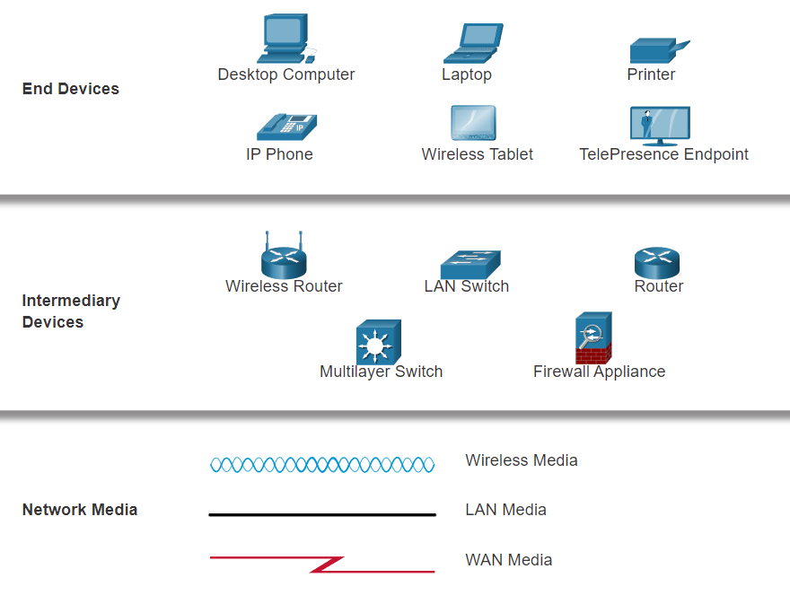

**MODULE 2**

All end devices and network devices require an operating system (OS). The user can interact with the shell using a command-line interface (CLI) to use a keyboard to run CLI-based network programs, use a keyboard to enter text and text-based commands, and view output on a monitor.

As a security feature, the Cisco IOS software separates management access into the following two command modes: User EXEC Mode and Privileged EXEC Mode.

Global configuration mode is accessed before other specific configuration modes. From global config mode, the user can enter different subconfiguration modes. Each of these modes allows the configuration of a particular part or function of the IOS device. Two common subconfiguration modes include: Line Configuration Mode and Interface Configuration Mode. To move in and out of global configuration mode, use the **configure terminal** privileged EXEC mode command. To return to the privileged EXEC mode, enter the **exit** global config mode command.

Each IOS command has a specific format or syntax and can only be executed in the appropriate mode. The general syntax for a command is the command followed by any appropriate keywords and arguments. The IOS has two forms of help available: context-sensitive help and command syntax check.

The first configuration command on any device should be to give it a unique device name or hostname. Network devices should always have passwords configured to limit administrative access. Cisco IOS can be configured to use hierarchical mode passwords to allow different access privileges to a network device. Configure and encrypt all passwords. Provide a method for declaring that only authorized personnel should attempt to access the device by adding a banner to the device output.

There are two system files that store the device configuration: startup-config and running-config. Running configuration files can be altered if they have not been saved. Configuration files can also be saved and archived to a text document.

IP addresses enable devices to locate one another and establish end-to-end communication on the internet. Each end device on a network must be configured with an IP address. The structure of an IPv4 address is called dotted decimal notation and is represented by four decimal numbers between 0 and 255.

IPv4 address information can be entered into end devices manually, or automatically using Dynamic Host Configuration Protocol (DHCP). In a network, DHCP enables automatic IPv4 address configuration for every end device that is DHCP-enabled. To access the switch remotely, an IP address and a subnet mask must be configured on the SVI. To configure an SVI on a switch, use the **interface vlan 1 global configuration** command. Vlan 1 is not an actual physical interface but a virtual one.

In the same way that you use commands and utilities to verify a PC host’s network configuration, you also use commands to verify the interfaces and address settings of intermediary devices like switches and routers. The **show ip interface brief** command verifies the condition of the switch interfaces. The **ping** command can be used to test connectivity to another device on the network or a website on the internet.

## Module Quiz - Basic Switch and End Device Configuration

**MODULE 3  
The Rules**

All communication methods have three elements in common: message source (sender), message destination (receiver), and channel. Sending a message is governed by rules called *protocols*. Protocols must include: an identified sender and receiver, common language and grammar, speed and timing of delivery, and confirmation or acknowledgment requirements. Common computer protocols include these requirements: message encoding, formatting and encapsulation, size, timing, and delivery options. Encoding is the process of converting information into another acceptable form, for transmission. Decoding reverses this process to interpret the information. Message formats depend on the type of message and the channel that is used to deliver the message. Message timing includes flow control, response timeout, and access method. Message delivery options include unicast, multicast, and broadcast.

**Protocols**

Protocols are implemented by end-devices and intermediary devices in software, hardware, or both. A message sent over a computer network typically requires the use of several protocols, each one with its own functions and format. Each network protocol has its own function, format, and rules for communications. The Ethernet family of protocols includes IP, TCP, HTTP, and many more. Protocols secure data to provide authentication, data integrity, and data encryption: SSH, SSL, and TLS. Protocols enable routers to exchange route information, compare path information, and then to select the best path to the destination network: OSPF and BGP. Protocols are used for the automatic detection of devices or services: DHCP and DNS. Computers and network devices use agreed-upon protocols that provide the following functions: addressing, reliability, flow control, sequencing, error-detection, and application interface.

**Protocol Suites**

A protocol suite is a group of inter-related protocols necessary to perform a communication function. A protocol stack shows how the individual protocols within a suite are implemented. Since the 1970s there have been several different protocol suites, some developed by a standards organization and others developed by various vendors. TCP/IP protocols are available for the application, transport, and internet layers. TCP/IP is the protocol suite used by today’s networks and internet. TCP/IP offers two important aspects to vendors and manufacturers: open standard protocol suite, and standards-based protocol suite. The TCP/IP protocol suite communication process enables such processes as a web server encapsulating and sending a web page to a client, as well as the client de-encapsulating the web page for display in a web browser.

**Standards Organizations**

Open standards encourage interoperability, competition, and innovation. Standards organizations are usually vendor-neutral, non-profit organizations established to develop and promote the concept of open standards. Various organizations have different responsibilities for promoting and creating standards for the internet including: ISOC, IAB, IETF, and IRTF. Standards organizations that develop and support TCP/IP include: ICANN and IANA. Electronic and communications standards organizations include: IEEE, EIA, TIA, and ITU-T.

**Reference Models**

The two reference models that are used to describe network operations are OSI and TCP/IP. The OSI model has seven layers:

7 - Application

6 - Presentation

5 - Session

4 - Transport

3 - Network

2 - Data Link

1 - Physical

The TCP/IP model has four layers:

4 - Application

3 - Transport

2 - Internet

1 - Network Access

**Data Encapsulation**

Segmenting messages has two primary benefits:

* By sending smaller individual pieces from source to destination, many different conversations can be interleaved on the network. This is called *multiplexing*.
* Segmentation can increase the efficiency of network communications. If part of the message fails to make it to the destination only the missing parts need to be retransmitted.

TCP is responsible for sequencing the individual segments. The form that a piece of data takes at any layer is called a *protocol data unit (PDU)*. During encapsulation, each succeeding layer encapsulates the PDU that it receives from the layer above in accordance with the protocol being used. When sending messages on a network, the encapsulation process works from top to bottom. This process is reversed at the receiving host and is known as *de-encapsulation*. De-encapsulation is the process used by a receiving device to remove one or more of the protocol headers. The data is de-encapsulated as it moves up the stack toward the end-user application.

**Data Access**

The network and data link layers are responsible for delivering the data from the source device to the destination device. Protocols at both layers contain a source and destination address, but their addresses have different purposes:

* **Network layer source and destination addresses** - Responsible for delivering the IP packet from the original source to the final destination, which may be on the same network or a remote network.
* **Data link layer source and destination addresses** - Responsible for delivering the data link frame from one network interface card (NIC) to another NIC on the same network.

The IP addresses indicate the original source IP address and final destination IP address. An IP address contains two parts: the network portion (IPv4) or Prefix (IPv6) and the host portion (IPv4) or Interface ID (IPv6). When the sender and receiver of the IP packet are on the same network, the data link frame is sent directly to the receiving device. On an Ethernet network, the data link addresses are known as Ethernet Media Access Control (MAC) addresses. When the sender of the packet is on a different network from the receiver, the source and destination IP addresses will represent hosts on different networks. The Ethernet frame must be sent to another device known as the router or default gateway. Изображение выглядит как текст

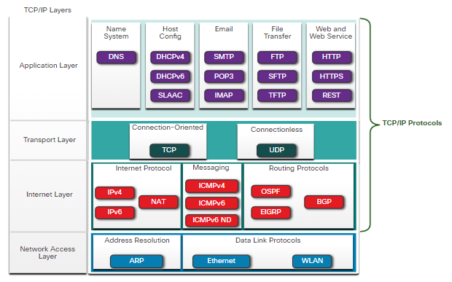

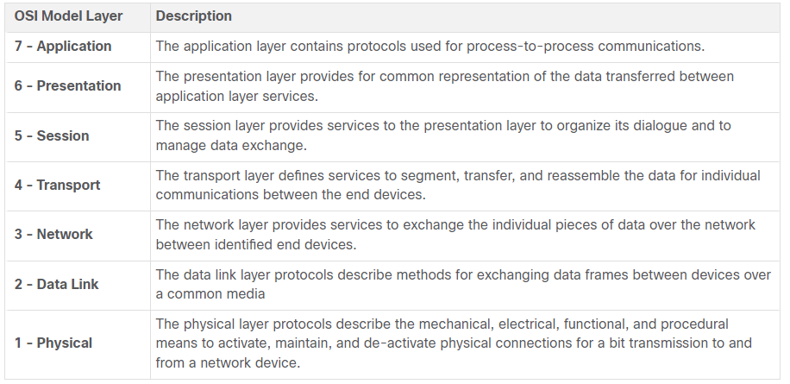

| TCP/IP Model LayerDescription4 - ApplicationRepresents data to the user, plus encoding and dialog control.3 - TransportSupports communication between various devices across diverse networks.2 - InternetDetermines the best path through the network.1 - Network AccessControls the hardware devices and media that make up the network. | |
| --- | --- |
| **TCP/IP Model Layer** | **Description** |
| **4 - Application** | Represents data to the user, plus encoding and dialog control. |
| **3 - Transport** | Supports communication between various devices across diverse networks. |
| **2 - Internet** | Determines the best path through the network. |
| **1 - Network Access** | Controls the hardware devices and media that make up the network. |

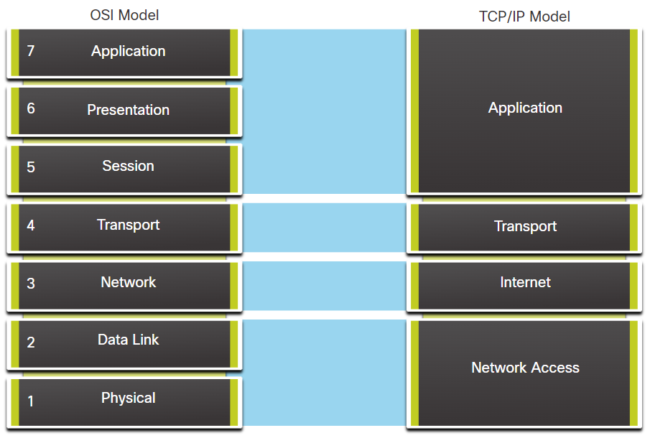

## Module Quiz - Protocols and Models

