**--LAB 4  
--EX 1**  
**--A**/*  
 1. PRE-design or conceptual design - starts from analysing of requirements.  
When every data requirement is stored and analyzed, the next thing that we need to do is creating a conceptual database plan.  
You can make design everywhere where you can write or draw. We have some websites for drawing design of database.  
Also, you can draw in usual paper :)  
  
 2. Logical Design - where is logic?  
The logical phase of database design is also called the data modeling mapping phase.  
This phase gives us a result of relation schemas. The basis for these schemas is the ER or the Class Diagram.  
To create the relation schemas is mainly mechanical operation. There are rules for transferring the ER model  
or class diagram to relation schemas.  
  
 3. Normalization - is it really necessary?  
Normalization is, in fact, the last piece of the logical design puzzle.  
The main purpose of normalization is to remove superfluity and every other potential anomaly during the update.  
Normalization in database design is a way to change the relation schema to reduce any superfluity.  
  
 4. Physical Design - let's create!  
The last phase of database design is the physical design phase. In this phase, we implement the database design.  
Here, a DBMS (Database Management System) must be chosen to use.  
Also, the indexes and the integrity constraints (rules) are defined in this phase.  
And finally the data is added and the database can finally be tested.  
*/  
  
**--B**/* **ER - Entity-Relationship**  
 Using ER we can take some table like "Entity" and make relations between other Entities. So we can make easier  
 designing and pondering of database. First three steps of designing we can take as steps of ER modeling.  
 Nowadays, we use Crow's foot notation in designs.  
*/

**EX 2 A**

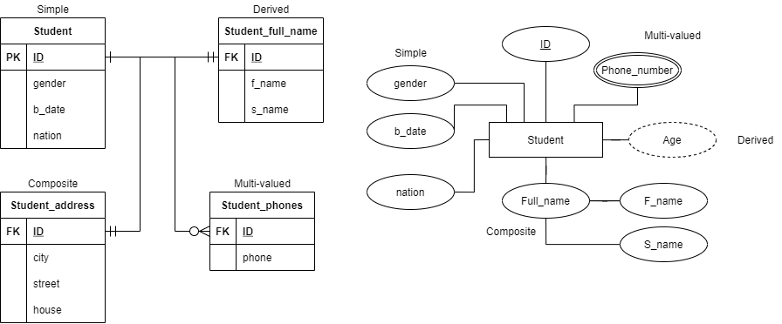

**EX 2B and 4**

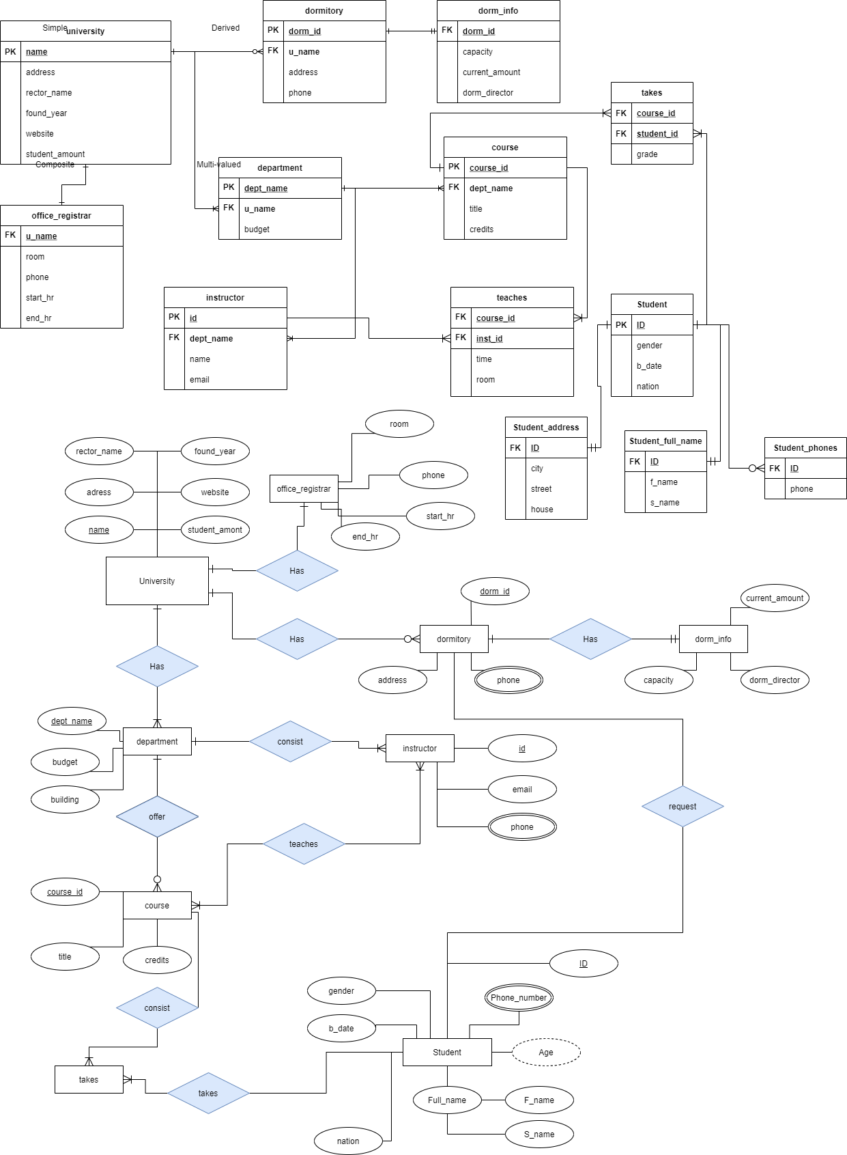

**EX 3**

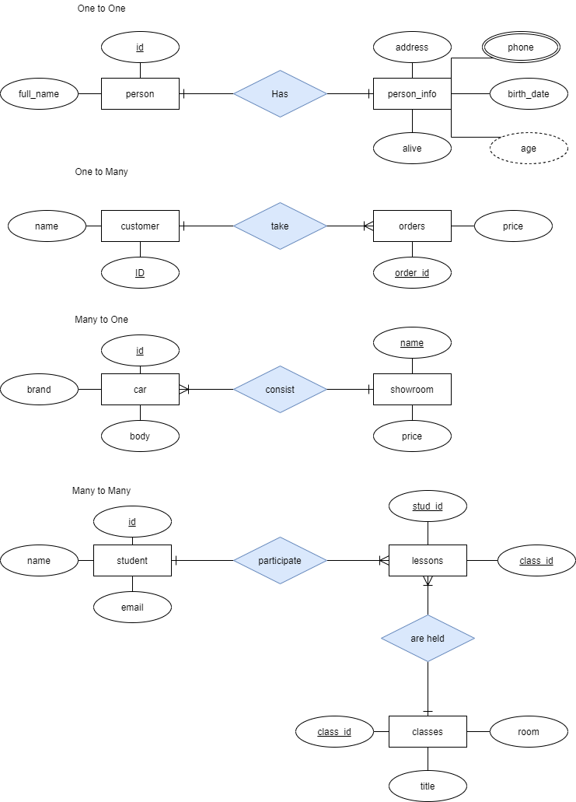

**EX 5**

