 | SR UNIVERSITY  Campus Warangal
 | Program: II - B. Tech (CS& AI) Batch: 12
 | Name: Nura Ram Charan Reg. No: 2503A52337
 | Department: Computer Science and AI Semester: I
 | AI Assisted Coding-Assignment Date: 21-Sep-2026

TASK 1 – Tree: Hospital Department Hierarchy

Problem
A hospital has a hierarchical structure. Represent the following using a Tree:
Hospital
├── Cardiology
│ ├── ICU
│ └── General Cardiology
├── Neurology
│ ├── Stroke Unit
│ └── Neuro ICU
└── Orthopedics

Requirements
- Create tree nodes.
- Add child departments.
- Display the hierarchy.
- Search for a department.
- Count total departments.
- Test at least three search cases.

Prompt
Create a Python tree structure to represent a hospital department hierarchy. Implement adding child nodes, displaying the hierarchy, searching for a department, and counting nodes. Explain how a tree is different from a list and provide test cases.

Code
class DepartmentNode:
def __init__(self, name):
self.name = name
self.children = []

class HospitalDepartmentTree:
"""Tree representing the hospital's parent-child department hierarchy."""

def __init__(self, root_name):
self.root = DepartmentNode(root_name)

def add_department(self, parent_name, department_name):
"""Add a department below the first matching parent department."""
parent = self.search(parent_name)
if parent is None:
raise ValueError(f"Parent department not found: {parent_name}")
if self.search(department_name) is not None:
raise ValueError(f"Department already exists: {department_name}")
parent.children.append(DepartmentNode(department_name))

def search(self, department_name):
"""Return the matching node, or None when it is not in the tree."""
if self.root.name == department_name:
return self.root

stack = list(reversed(self.root.children))
while stack:
current = stack.pop()
if current.name == department_name:
return current
stack.extend(reversed(current.children))
return None

def count_departments(self):
"""Return the total number of departments, including the root."""
count = 0
stack = [self.root]
while stack:
current = stack.pop()
count += 1
stack.extend(current.children)
return count

def display(self):
"""Print the hierarchy with indentation for each tree level."""
def print_branch(node, level):
print(f"{' ' * level}{node.name}")
for child in node.children:
print_branch(child, level + 1)

print_branch(self.root, 0)

def main():
hospital = HospitalDepartmentTree("Hospital")
hospital.add_department("Hospital", "Cardiology")
hospital.add_department("Cardiology", "ICU")
hospital.add_department("Cardiology", "General Cardiology")
hospital.add_department("Hospital", "Neurology")
hospital.add_department("Neurology", "Stroke Unit")
hospital.add_department("Neurology", "Neuro ICU")
hospital.add_department("Hospital", "Orthopedics")

assert hospital.count_departments() == 8
assert hospital.search("Hospital") is hospital.root
assert hospital.search("ICU").name == "ICU"
assert hospital.search("Stroke Unit").name == "Stroke Unit"
assert hospital.search("Unknown") is None

print("Hospital department hierarchy:")
hospital.display()
print(f"\nTotal departments: {hospital.count_departments()}")
print("All tree tests passed.")

if __name__ == "__main__":
main()

Output
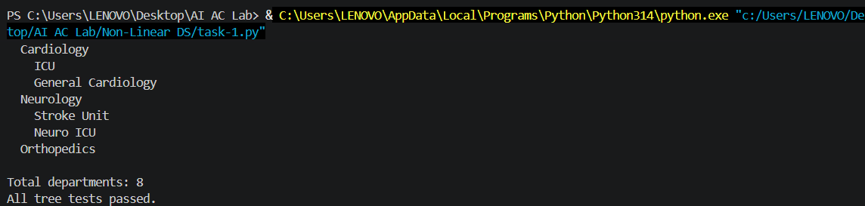

Observation
The hospital department hierarchy was successfully represented using a tree data structure. The hospital acts as the root node, while departments such as Cardiology, Neurology, and Orthopedics are child nodes. Sub-departments like ICU, General Cardiology, Stroke Unit, and Neuro ICU are placed below their respective parent departments.
The tree structure clearly shows the parent-child relationship between departments. A search operation was implemented to locate a department anywhere in the hierarchy. The program also counts the total number of departments, including the hospital root. The test cases successfully searched for existing departments such as ICU and Stroke Unit, and correctly returned no result for an unknown department. A tree is suitable for this problem because the data naturally follows a hierarchical structure.

-------------------------------------------------------------------------------------------------------------------------------

TASK 2 – Graph: Hospital Route Finder

Problem
Represent hospital locations as a Graph. Each location is a node and each connection is an edge.
Reception ─── Pharmacy
│ │
│ │
ICU ─────── Emergency
│
Laboratory

Requirements
- Add hospital locations as nodes.
- Add connections as edges.
- Display the graph using an adjacency list.
- Check whether two locations are connected.
- Find a route using BFS or DFS.
- Test at least three source-destination pairs.

Prompt
Create a Python graph representing hospital locations. Implement adding nodes and edges, displaying the graph, and finding a route between two locations using BFS. Explain BFS step by step and provide test cases.

Code
from collections import deque

class HospitalGraph:
"""Undirected graph of hospital locations and their connections."""

def __init__(self):
self.adjacency_list = {}

def add_location(self, location):
"""Add a location as a node if it does not already exist."""
if location not in self.adjacency_list:
self.adjacency_list[location] = []

def add_connection(self, first_location, second_location):
"""Add a two-way connection between two hospital locations."""
self.add_location(first_location)
self.add_location(second_location)

if second_location not in self.adjacency_list[first_location]:
self.adjacency_list[first_location].append(second_location)
if first_location not in self.adjacency_list[second_location]:
self.adjacency_list[second_location].append(first_location)

def display(self):
"""Print the graph as an adjacency list."""
for location, connections in self.adjacency_list.items():
neighbours = ", ".join(connections) if connections else "None"
print(f"{location}: {neighbours}")

def bfs_route(self, start, destination):
"""Return the shortest route from start to destination using BFS."""
if start not in self.adjacency_list or destination not in self.adjacency_list:
return None

queue = deque([(start, [start])])
visited = {start}

while queue:
current, route = queue.popleft()
if current == destination:
return route

for neighbour in self.adjacency_list[current]:
if neighbour not in visited:
visited.add(neighbour)
queue.append((neighbour, route + [neighbour]))

return None

def dfs_route(self, start, destination):
"""Return a route from start to destination using DFS."""
if start not in self.adjacency_list or destination not in self.adjacency_list:
return None

stack = [(start, [start])]
visited = set()

while stack:
current, route = stack.pop()
if current in visited:
continue
visited.add(current)

if current == destination:
return route

for neighbour in reversed(self.adjacency_list[current]):
if neighbour not in visited:
stack.append((neighbour, route + [neighbour]))

return None

def print_route(graph, start, destination, search_name, search_function):
route = search_function(start, destination)
result = " -> ".join(route) if route else "No route found"
print(f"{search_name}: {start} to {destination}: {result}")

def main():
hospital = HospitalGraph()

for location in ("Reception", "Pharmacy", "ICU", "Emergency", "Laboratory"):
hospital.add_location(location)

hospital.add_connection("Reception", "Pharmacy")
hospital.add_connection("Reception", "ICU")
hospital.add_connection("Pharmacy", "Emergency")
hospital.add_connection("ICU", "Laboratory")
hospital.add_connection("Emergency", "Laboratory")

assert hospital.bfs_route("Reception", "Laboratory") == [
"Reception", "ICU", "Laboratory"
]
assert hospital.bfs_route("Reception", "Emergency") == [
"Reception", "Pharmacy", "Emergency"
]
assert hospital.dfs_route("Reception", "Laboratory") is not None
assert hospital.bfs_route("ICU", "Unknown") is None

print("Hospital adjacency list:")
hospital.display()

print("\nRoute test cases:")
print_route(hospital, "Reception", "Laboratory", "BFS", hospital.bfs_route)
print_route(hospital, "Reception", "Emergency", "BFS", hospital.bfs_route)
print_route(hospital, "Reception", "Laboratory", "DFS", hospital.dfs_route)
print_route(hospital, "ICU", "Unknown", "BFS", hospital.bfs_route)

if __name__ == "__main__":
main()

Output
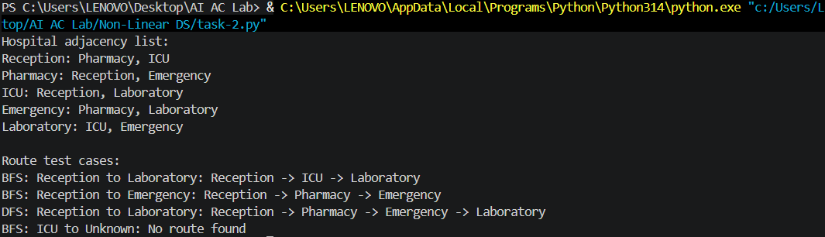

Observation
The hospital route finder was implemented using an undirected graph and an adjacency list. Hospital locations such as Reception, Pharmacy, ICU, Emergency, and Laboratory were represented as nodes. The connections between locations were represented as edges.
Breadth-First Search was used to find the shortest route between two locations. BFS explores all nearby locations before moving to locations farther away, making it appropriate for finding the shortest path in an unweighted graph. The program also includes DFS for comparison. The test cases successfully found routes from Reception to Laboratory and Reception to Emergency. It also correctly handled a destination that did not exist by reporting that no route was found. A graph is appropriate because hospital rooms may have multiple connections rather than a fixed parent-child relationship.

TASK 3 – Heap: Emergency Patient Priority

Problem
In an emergency department, patients are treated according to severity rather than simple arrival order. Implement a Priority Queue using a Heap.
Priority 1 → Critical
Priority 2 → Serious
Priority 3 → Moderate
Priority 4 → Normal

Requirements
- Add a patient with a priority value.
- View the highest-priority patient.
- Remove/serve the highest-priority patient.
- Display waiting patients.
- Handle at least one tie in priority appropriately.
- Test insertion and removal operations.

Prompt
Create a Python program for an emergency department that manages patients according to the seriousness of their condition. Use a heap-based priority queue, where priority 1 represents a critical patient, priority 2 represents a serious patient, priority 3 represents a moderate case, and priority 4 represents a normal case. The program should allow the user to add patients with their priority, view the patient who should be treated next, serve and remove the highest-priority patient, and display all waiting patients. If two patients have the same priority, serve the patient who arrived first. Include test cases for adding patients, checking the next patient, removing patients, and handling patients with equal priorities.

Code
import heapq

class EmergencyPriorityQueue:
"""Min-heap priority queue for emergency department patients."""

def __init__(self):
self._heap = []
self._arrival_order = 0

def add_patient(self, name, priority):
"""Add a patient, where priority 1 is the most urgent."""
if priority not in (1, 2, 3, 4):
raise ValueError("Priority must be 1, 2, 3, or 4")

patient = (priority, self._arrival_order, name)
heapq.heappush(self._heap, patient)
self._arrival_order += 1

def view_highest_priority(self):
"""Return the next patient without removing them."""
if not self._heap:
return None
priority, _, name = self._heap[0]
return name, priority

def serve_patient(self):
"""Remove and return the highest-priority waiting patient."""
if not self._heap:
return None
priority, _, name = heapq.heappop(self._heap)
return name, priority

def display_waiting_patients(self):
"""Return patients ordered by service priority without changing the heap."""
return [
(name, priority)
for priority, _, name in sorted(self._heap)
]

def main():
queue = EmergencyPriorityQueue()
queue.add_patient("Aisha", 3)
queue.add_patient("Ben", 1)
queue.add_patient("Chen", 2)
queue.add_patient("Dina", 1)

print("Waiting patients by priority:")
print(queue.display_waiting_patients())

# Priority 1 patients come first, and the tie is resolved by arrival order.
assert queue.view_highest_priority() == ("Ben", 1)
assert queue.display_waiting_patients() == [
("Ben", 1),
("Dina", 1),
("Chen", 2),
("Aisha", 3),
]
assert queue.serve_patient() == ("Ben", 1)
assert queue.serve_patient() == ("Dina", 1)
assert queue.serve_patient() == ("Chen", 2)
assert queue.serve_patient() == ("Aisha", 3)
assert queue.serve_patient() is None

print("All priority queue tests passed.")

if __name__ == "__main__":
main()

Output
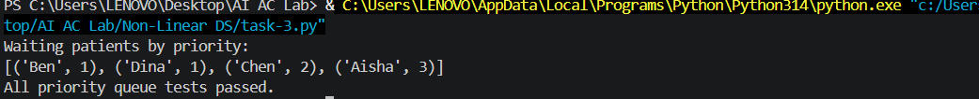

Observation
The emergency patient system was implemented using a min-heap priority queue. Each patient was stored with a priority value, where priority 1 represents the most serious case and priority 4 represents a normal case. The heap ensures that the most urgent patient remains available at the top of the structure.
The program supports adding patients, viewing the highest-priority patient, serving or removing a patient, and displaying all waiting patients in service order. A tie-handling mechanism was also included. When two patients have the same priority, the patient who arrived first is served first. This provides fair treatment while still respecting medical severity. The tests confirmed that Ben and Dina, both with priority 1, were served in their arrival order. A heap is suitable because insertion and removal take O(logn) time, while viewing the highest-priority patient takes O(1)O(1) time.

-------------------------------------------------------------------------------------------------------------------------------

TASK 4 – Trie: Medical Word / Drug Search

Problem
A hospital application needs an autocomplete feature. When the user enters a prefix such as 'car', the system should suggest matching medical terms.
Input prefix: "car"
Possible output:
cardiology
cardiac
carcinoma
care

Requirements
- Create a Trie.
- Insert medical words.
- Search for an exact word.
- Check whether a prefix exists.
- Display/autocomplete words beginning with a prefix.
- Test at least three different prefixes.

Prompt
Implement a Trie in Python for medical-word autocomplete. Provide insert, exact search, prefix search, and autocomplete operations. Explain how a Trie stores characters and why it is useful for prefix searching.

Code
class TrieNode:
def __init__(self):
self.children = {}
self.is_word = False

class MedicalTrie:
"""Trie for exact medical-word search and prefix autocomplete."""

def __init__(self):
self.root = TrieNode()

def insert(self, word):
"""Insert a medical word into the trie."""
word = self._normalize(word)
current = self.root

for character in word:
if character not in current.children:
current.children[character] = TrieNode()
current = current.children[character]
current.is_word = True

def search(self, word):
"""Return True when the complete word exists."""
node = self._find_node(word)
return node is not None and node.is_word

def prefix_exists(self, prefix):
"""Return True when at least one word starts with the prefix."""
return self._find_node(prefix) is not None

def autocomplete(self, prefix):
"""Return all stored words beginning with the prefix."""
prefix = self._normalize(prefix)
node = self._find_node(prefix)
if node is None:
return []

matches = []

def collect(current, suffix):
if current.is_word:
matches.append(prefix + suffix)
for character in sorted(current.children):
collect(current.children[character], suffix + character)

collect(node, "")
return matches

def _find_node(self, text):
text = self._normalize(text)
current = self.root

for character in text:
if character not in current.children:
return None
current = current.children[character]
return current

@staticmethod
def _normalize(text):
if not isinstance(text, str):
raise TypeError("Medical words and prefixes must be strings")
return text.strip().lower()

def main():
medical_words = [
"cardiology",
"cardiac",
"carcinoma",
"care",
"diabetes",
"diagnosis",
"medication",
"medicine",
]
trie = MedicalTrie()

for word in medical_words:
trie.insert(word)

# Exact search distinguishes complete words from prefixes.
assert trie.search("cardiology")
assert not trie.search("card")

# Test at least three different prefixes and one missing prefix.
assert trie.prefix_exists("car")
assert trie.autocomplete("car") == [
"carcinoma",
"cardiac",
"cardiology",
"care",
]
assert trie.autocomplete("dia") == ["diabetes", "diagnosis"]
assert trie.autocomplete("med") == ["medication", "medicine"]
assert not trie.prefix_exists("xyz")
assert trie.autocomplete("xyz") == []

print('Autocomplete for "car":')
for word in trie.autocomplete("car"):
print(word)
print("All trie tests passed.")

if __name__ == "__main__":
main()

Output
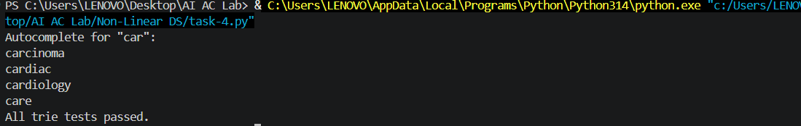

Observation
The medical autocomplete feature was implemented using a Trie. Each character of a medical word is stored as a node, allowing words with common prefixes to share the same path. Words such as cardiology, cardiac, carcinoma, and care all share the prefix car.
The program supports inserting medical terms, searching for an exact word, checking whether a prefix exists, and displaying all words that begin with a particular prefix. The test cases used the prefixes car, dia, and med, along with a missing prefix xyz. The results confirmed that the correct matching terms were returned. Exact search also correctly distinguished between a complete word and a prefix. A Trie is more suitable than a simple list for repeated prefix searches because it avoids scanning every stored word and organizes terms by their characters.

TASK 5 – AI Decision Challenge: Choose the Correct Structure
For each hospital-software scenario, choose the most appropriate non-linear data structure: Tree, Graph, Heap, or Trie.
Scenario | Your Choice + Reason
Hospital department hierarchy
Finding a route between hospital rooms
Emergency patients based on severity
Autocomplete medical terms
Frequently finding the highest-priority task

Student Activity
- Choose the data structure.
- Explain why it is appropriate.
- Identify the main operation.
- State the expected/typical Big-O complexity where appropriate.
- Ask AI for a recommendation.
- Compare your choice with AI's recommendation.
- If you disagree with AI, explain why.

Prompt
Create a simple Python program that helps choose the best non-linear data structure for different hospital software situations. The program should consider scenarios such as organizing hospital departments, finding routes between rooms, managing emergency patients by severity, providing autocomplete for medical terms, and handling high-priority tasks. For each situation, select the most suitable structure from Tree, Graph, Heap, or Trie, and explain why it is appropriate. Also include the main operation and expected Big-O time complexity. Finally, compare the selected choices with AI recommendations and display whether they agree.

Code
from dataclasses import dataclass

@dataclass(frozen=True)
class StructureDecision:
scenario: str
structure: str
reason: str
main_operation: str
complexity: str

DECISIONS = (
StructureDecision(
"Hospital department hierarchy",
"Tree",
"Departments form parent-child levels, such as hospital -> surgery -> ICU.",
"Traverse parent-child relationships",
"O(n) traversal/search",
),
StructureDecision(
"Finding a route between hospital rooms",
"Graph",
"Rooms are nodes and corridors are edges; one room can connect to many others.",
"BFS/DFS route search",
"O(V + E)",
),
StructureDecision(
"Emergency patients based on severity",
"Heap",
"The most urgent patient must be available quickly as priorities change.",
"Insert and remove highest priority",
"O(log n); peek O(1)",
),
StructureDecision(
"Autocomplete medical terms",
"Trie",
"Words share prefixes, allowing fast lookup of every term starting with typed letters.",
"Prefix search/autocomplete",
"O(p + k)",
),
StructureDecision(
"Frequently finding the highest-priority task",
"Heap",
"A heap keeps the minimum or maximum priority at the root for fast repeated access.",
"Peek and remove highest priority",
"O(1) peek; O(log n) removal",
),
)

AI_RECOMMENDATIONS = {
"Hospital department hierarchy": "Tree",
"Finding a route between hospital rooms": "Graph",
"Emergency patients based on severity": "Heap",
"Autocomplete medical terms": "Trie",
"Frequently finding the highest-priority task": "Heap",
}

def display_decisions(decisions=DECISIONS):
"""Display the completed worksheet table."""
headings = ("Scenario", "Choice", "Main operation", "Complexity", "Reason")
print(" | ".join(headings))
print("-" * 120)
for decision in decisions:
print(
f"{decision.scenario} | {decision.structure} | "
f"{decision.main_operation} | {decision.complexity} | {decision.reason}"
)

def compare_with_ai(decisions=DECISIONS):
"""Return whether each selected structure agrees with the AI recommendation."""
return [
(
decision.scenario,
decision.structure,
AI_RECOMMENDATIONS[decision.scenario],
decision.structure == AI_RECOMMENDATIONS[decision.scenario],
)
for decision in decisions
]

def main():
assert len(DECISIONS) == 5
assert all(result[3] for result in compare_with_ai())
assert DECISIONS[1].complexity == "O(V + E)"
assert DECISIONS[3].structure == "Trie"

print("Hospital software data-structure decisions:\n")
display_decisions()
print("\nComparison with AI recommendations:")
for scenario, student_choice, ai_choice, agrees in compare_with_ai():
status = "Agrees" if agrees else "Disagrees"
print(f"{status}: {scenario} -> student: {student_choice}, AI: {ai_choice}")
print("\nAll decision guide tests passed.")

if __name__ == "__main__":
main()

Output
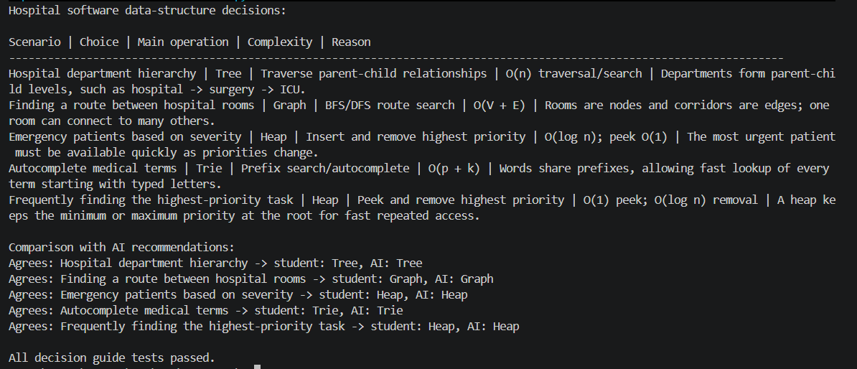

Observation
The data-structure decision activity showed that each structure is appropriate for a different type of hospital application. A Tree was selected for the department hierarchy because departments have parent-child relationships. A Graph was selected for finding routes because rooms and corridors form a network of connected locations.
A Heap was selected for emergency patients and frequently accessed priority tasks because it provides efficient access to the highest-priority item. A Trie was selected for medical autocomplete because it is designed for prefix-based searching. The comparison with the AI recommendations showed that all selected structures matched the expected choices.
Overall, the activities demonstrated that data structures should be selected according to the relationship between the data and the operations required. Trees are useful for hierarchy, graphs for networks, heaps for priority management, and Tries for prefix searching. The programs executed successfully, and the test cases confirmed that the main operations worked as expected.

THE END

