REPORT: Assignment #1 — Builder Pattern
Course: Software Design Patterns (ShP-2216)
Topic: Car Builder Implementation
Language: Java (JDK 17)

1. Introduction
When constructing complex objects such as a Car, using traditional constructors often leads to the "Telescoping Constructor" anti-pattern or long parameter lists that make the code unreadable and prone to errors (e.g., passing parameters in the wrong order).
The Builder Pattern was chosen for the Car domain because:
- A car consists of multiple configurable parts (type, engine, seating capacity, transmission, GPS navigation).
- Different types of cars (e.g., high-performance sports cars vs. standard city cars) require specific constraint checks and build sequences.
- The Builder pattern decouples complex object construction logic from representation, providing a step-by-step fluent API for object creation.

2. UML Class Diagram
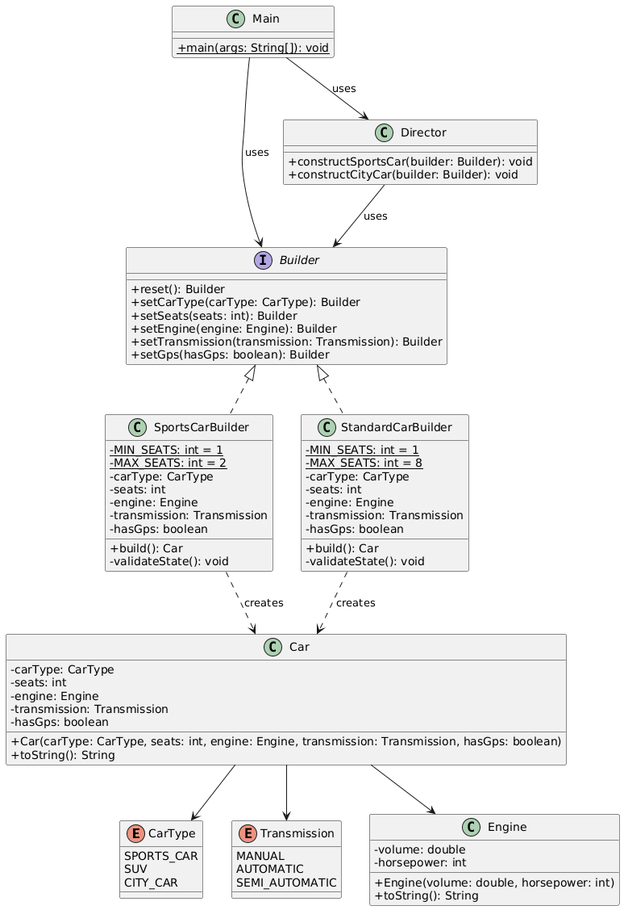

3. Clean Code Principles Applied
Pursuant to Chapter 3 of Clean Code by Robert C. Martin, the following 5 principles were applied in the implementation:

Principle 1: Eliminating Magic Numbers
- Explanation: Raw numeric literals in conditional checks lower readability and complicate maintenance. They were replaced with explicit private static final constants.
- Code Excerpt:
Java
// BEFORE (Bad Practice):
if (seats < 1 || seats > 2) {
throw new IllegalStateException("Invalid seats");
}

// AFTER (Applied Clean Code):
private static final int MIN_SEATS = 1;
private static final int MAX_SEATS = 2;

private void validateState() {
if (seats < MIN_SEATS || seats > MAX_SEATS) {
throw new IllegalStateException("Sports car seats must be between " + MIN_SEATS + " and " + MAX_SEATS);
}
}

Principle 2: Small, Single-Responsibility Functions (SRP)
- Explanation: A function should perform one task cleanly. Object validation logic was extracted into a dedicated helper method validateState() instead of bloating build().
- Code Excerpt:
Java
// BEFORE (Bad Practice - mixing validation with instantiation):
public Car build() {
if (seats < 1 || seats > 8) throw new IllegalStateException();
if (engine == null) throw new IllegalStateException();
return new Car(carType, seats, engine, transmission, hasGps);
}

// AFTER (Applied Clean Code):
public Car build() {
validateState();
return new Car(carType, seats, engine, transmission, hasGps);
}

private void validateState() {
if (seats < MIN_SEATS || seats > MAX_SEATS) {
throw new IllegalStateException("Seats out of valid bounds.");
}
if (engine == null) {
throw new IllegalStateException("Engine is required.");
}
}

Principle 3: Intention-Revealing Naming
- Explanation: Method and class names should clearly declare their purpose and abstraction level without requiring extra inline comments.
- Code Excerpt:
Java
// BEFORE (Unclear names):
class CBuilder {
public void setG(boolean g) { ... }
public Car make() { ... }
}

// AFTER (Applied Clean Code):
class SportsCarBuilder implements Builder {
@Override
public SportsCarBuilder setGps(boolean hasGps) { ... }

public Car build() { ... }
}

Principle 4: Don't Repeat Yourself (DRY)
- Explanation: Instead of repeating construction step calls throughout client code, standard build configurations are centralized inside the Director class.
- Code Excerpt:
Java
// AFTER (Applied Clean Code in Director):
class Director {
public void constructSportsCar(Builder builder) {
builder.reset()
.setCarType(CarType.SPORTS_CAR)
.setSeats(2)
.setEngine(new Engine(3.0, 450))
.setTransmission(Transmission.SEMI_AUTOMATIC)
.setGps(true);
}
}

Principle 5: Validated State / Defensive Programming
- Explanation: Objects should never be created in an invalid or incomplete state. The builder enforces strict state validation prior to instance creation and throws an explicit IllegalStateException on failure.
- Code Excerpt:
Java
private void validateState() {
if (engine == null) {
throw new IllegalStateException("Engine is required");
}
}

4. Conclusion

Pros Experienced:
- Step-by-step Construction: Flexibly build objects using method chaining without requiring giant constructors.
- Encapsulation of Constraints: Validation logic (e.g., sports cars allowing max 2 seats) is safely contained inside concrete builders.
- Reusability: The Director centralizes standard vehicle configurations, reducing code duplication across the client layer.

Cons Experienced:
- Increased Class Count: Requires introducing multiple boilerplate classes (Builder, SportsCarBuilder, StandardCarBuilder, Director), which increases project complexity for smaller domain models.

5. Repository Link
GitHub Repository: https://github.com/NuraliKalmakhanbet/Cars_Builder_Pattern.git

