Nama : Nurani Istiaen

NIM : 20210040085

Kelas : TI21A

Mata Kuliah : Pemrograman Berorientasi Objek

**Praktikum Inheritance**

**Percobaan 1**

|  |
| --- |
| class Parent {  public int x = 5;  }  class Child extends Parent {  public void Info(int x) {  System.out.println("Nilai x sebagai parameter = " + x);  System.out.println("Data member x di class Child = " + this.x);  System.out.println("Data member x di class Parent = " + super.x);  }  }  public class NilaiX {  public static void main(String args[]) {  Child tes = new Child();  tes.Info(20);  }  } |

Output :

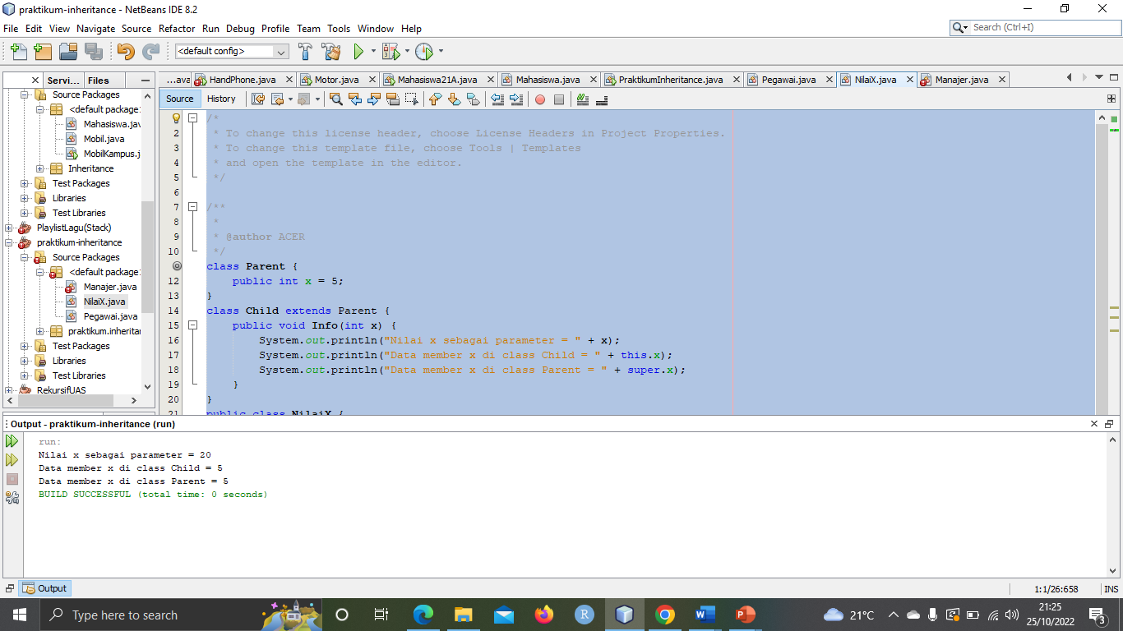

**Percobaan 2 :**

**Percobaan 5 :**

|  |
| --- |
| public class MoodyObject {  protected String getMood(){  return "moody";  }  public void speak(){  System.out.println("I am : "+getMood());  }  }  public class SadObject extends MoodyObject{    protected String getSad(){  return "sad";  }  public void cry(){  System.out.println("Hoo hoo : "+ getSad());  }  }  public class HappyObject extends MoodyObject{    protected String getHappy(){  return"happy";  }  public void laugh(){  System.out.println("Hahaha : " + getHappy());  }  }  public class MoodyTest {  public static void main(String[] args) {  MoodyObject m = new MoodyObject();  SadObject Sad = new SadObject();  HappyObject Happy = new HappyObject();    m.speak();  Sad.cry();  Happy.laugh();  }  } |

Output :

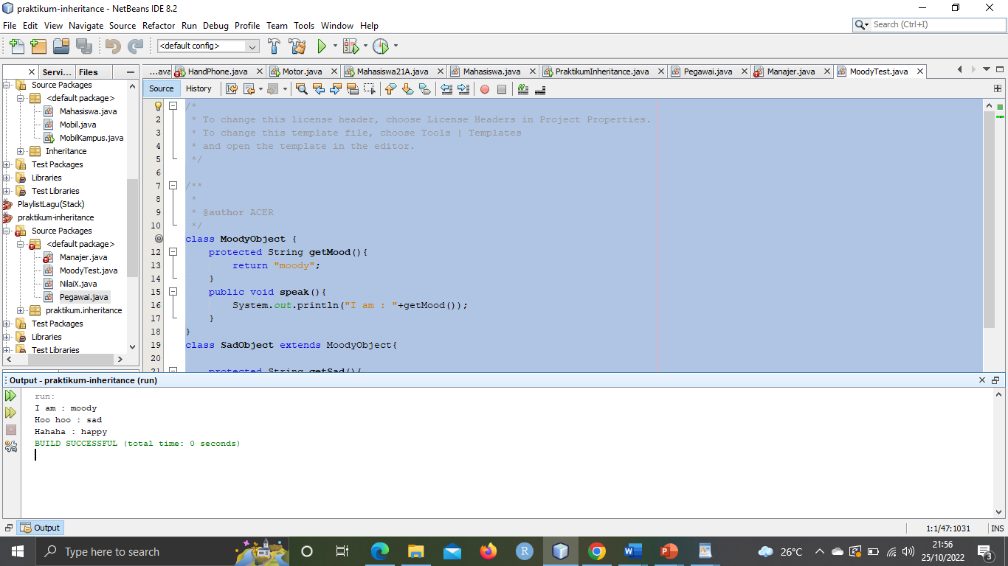

**Percobaan 6 :**