Retrieval-Augmented Generation for Multi-Source Scientific Literature Synthesis
Assignment 4 | Evidence-based final report draft | 8 November 2026
  - Status: computational experiment and exports completed; claim-level human agreement documented; consensus adjudication, judge-versus-consensus validation, and external submission evidence remain pending.

Executive summary
The study evaluated eight retrieval settings for scientific literature synthesis. The corpus contained 50 arXiv papers and 863 indexed chunks. The test benchmark contained 20 questions (16 answerable and four unanswerable) under eight conditions, producing 160 logged main generations; 16 ablation runs were separate. Main automatic-judge results show the highest descriptive completeness for BM25-5 (0.5385), whereas dense k10 achieved high gold-paper recall (0.9375) but low completeness (0.1500). These differences were not statistically significant in the registered Holm-adjusted tests. Citation compliance was approximately 4/759 claims (0.53%); citation-based unsupported-claim metrics must not be interpreted as factual hallucination rates.

1. Research design and methodology
Conditions: no_retrieval, random5, bm25_5, dense k1, k3, k5, k10, and a single-paper five-passage control. The generator was Qwen2.5-1.5B-Instruct, retrieval used a BGE-based embedding index and FAISS, and an automated judge produced claim- and keypoint-level scores. The frozen configuration and protocol are retained in final_config.json and protocol_freeze.json. The study reports answerable-question metrics separately from unanswerable abstention cases.
Metrics: completeness (keypoint coverage), claim-level correctness/accuracy on scoreable answered cases, gold-paper recall, citation compliance, false abstention, token volume and latency. Missing or judge-invalid scores were not zero-imputed. Six answerable scoring records were judge_invalid; all 160 main generations were logged with generation status ok.

2. Main results (exploratory automated scoring)
Condition | Valid / 16 | Completeness | 95% CI | Accuracy | Gold recall
no_retrieval | 16/16 | 0.362 | [0.250, 0.487] | 0.397 | 0.000
random5 | 15/16 | 0.493 | [0.360, 0.613] | 0.350 | 0.089
bm25_5 | 13/16 | 0.538 | [0.369, 0.692] | 0.414 | 0.897
k1 | 16/16 | 0.388 | [0.263, 0.525] | 0.445 | 0.302
k3 | 15/16 | 0.307 | [0.173, 0.467] | 0.313 | 0.689
k5 | 16/16 | 0.375 | [0.225, 0.525] | 0.305 | 0.792
k10 | 16/16 | 0.150 | [0.037, 0.300] | 0.160 | 0.938
control | 15/16 | 0.400 | [0.240, 0.573] | 0.458 | 0.300
The answerable main table has 128 planned observations, of which 122 have valid judge scores. Thirty-two unanswerable observations are summarized separately. No-retrieval has no supplied passages by design. Judge-derived accuracy and unsupported-claim results remain exploratory pending validated judge-versus-consensus comparisons.

3. Statistical analysis
Friedman completeness: χ²=8.8584, p=0.0647 (15 complete pairs), Kendall’s W=0.1476. Friedman accuracy: χ²=7.7526, p=0.1011 (11 complete pairs). The paired k5–k10 completeness difference was +0.225, with reported bootstrap CI [0.075, 0.375], but Holm-adjusted p=0.0562, hence not significant at 0.05. The ablation completeness difference (without minus with) was −0.050, p=0.7197. Hallucination-rate Friedman statistics were undefined because of near-constant values. None of these tests establishes superiority at corrected α=0.05.

4. Human validation and inter-rater agreement
The project team reports that Reviewer A and Reviewer B each manually reviewed 144 claim-level items. The two files match by claim_id. Earlier records described Reviewer B’s work as Codex-assisted; the team subsequently confirmed manual review, but the new label set was unchanged. The present report records the team’s attestation without claiming that the files independently prove an unaided or blinded process.
Excluding nine Reviewer B “unclear” labels, 135 binary comparisons yielded 90 agreements (66.67%) and Cohen’s κ=0.3034. Including “unclear” as a third category yielded 90/144 agreements (62.50%) and κ=0.2770. Binary disagreements comprise 42 Reviewer A=yes / Reviewer B=no and three Reviewer A=no / Reviewer B=yes. These are modest agreement results, not high reliability. A consensus sheet with 54 unresolved items has been prepared; original ratings are preserved.
The human–human comparison does not validate the automated judge. Judge-versus-human correctness agreement, judge-versus-consensus validation and evidence-support adjudication should be presented separately once aligned consensus labels exist.

5. Citation grounding and measurement validity
Only four of 759 extracted claims carried a recognized source citation (~0.53%). The automatic UNCITED verdict was widespread, so a reported unsupported/hallucination rate near 1.0 is largely a consequence of citation syntax and the scoring definition, not evidence that nearly all scientific claims are false. Citation compliance, valid citation-to-passage grounding, semantic evidence support by any supplied passage, and factual correctness are distinct constructs. The proposed semantic support analysis is a protocol deviation, not a silent replacement of the original metric.

6. Error analysis
Step 25b confirmed 30 fully populated records, all tagged E1_retrieval_miss. These were purposively selected examples of missing gold papers. The observed 100% E1 share applies only to these selected records; it is not an estimate of the prevalence of E1 among all 949 candidates or of the distribution across E1–E7. No E2–E7 frequency can be inferred from this appendix.

7. Subgroups, cost and efficiency
All answerable test items belong to the multi_source_synthesis question type, so no substantive between-type comparison is possible. BM25-5 reached mean completeness 0.667 when all gold papers were retrieved (n=9) versus 0.250 with some gold papers (n=4). For k10, 13 cases retrieved all gold papers yet averaged completeness 0.185. Median input tokens increased from 702 (k1) to 5729 (k10). k10 had median latency 9.73 seconds but median output length only 46 tokens; shorter responses and abstentions confound direct efficiency interpretation.

8. Discussion and hypotheses
The descriptive evidence does not show that increasing dense retrieval depth improves synthesis quality. High gold-paper recall is insufficient when the generator fails to integrate or cover the evidence. BM25-5 has the strongest descriptive completeness, but unequal valid counts and nonsignificant corrected tests preclude claims of confirmed superiority. Human review suggests judge reliability needs improvement. Negative and inconclusive findings are reported rather than suppressed.

9. Protocol deviations and limitations
- Seven benchmark key-point wording changes were recorded after the original freeze; instructor approval has not been independently verified.
- The control used five passages from one top-ranked paper, not five distinct papers.
- Six judge_invalid cases remain explicitly excluded from affected metrics; original outputs must be preserved.
- Citation-based grounding and semantic evidence support answer different questions.
- The reviewer provenance is team-attested; adjudication and judge-versus-consensus validation are not complete.
- The E1-only purposive error sample cannot represent all error types.
- Independent reproduction, GitHub release tag, Moodle submission receipt and source-data redistribution permissions remain unverified.

10. Conclusion
The experiment, ablation, statistical analyses, charts, and reproducibility export were executed and documented. The principal substantive finding is a lack of demonstrated improvement from increasing dense retrieval depth in this benchmark. BM25-5 achieved the highest descriptive completeness, while k10 retrieved more gold papers but produced less complete answers. These are exploratory results until consensus-based validation and remaining external reproducibility/submission requirements are addressed.

Appendices and deliverables
Appendix A: condition-level results and confidence intervals (results/main_results_DRAFT_not_for_submission.csv). Appendix B: purposive E1 cases (results/appendix_B_error_analysis.csv). Appendix C: reproduction template and manifest. Separate files: HUMAN_VALIDATION_FINAL_CONFIRMED.md, PROTOCOL_DEVIATIONS_FINAL.md, FINAL_RESULTS_AUDIT_VERIFIED.md, and Assignment4_Consensus_Adjudication_PENDING.csv.
Prepared from project artifacts available in the connected Google Drive on 8 November 2026. Unverified real-world steps are explicitly identified rather than marked complete.

Addendum — Post-discussion reconciliation (8 November 2026)
The team reports that, after discussion, 39 of the 54 initially disputed or unclear claim annotations were resolved and 15 remained contested. This 39/15 split is a team-reported aggregate, not a row-level verified consensus. The submitted claims_FINAL_144.csv contains values in its final column for all 144 claims but does not identify which 15 cases remain contested. Accordingly, final labels are treated as proposed adjudications, not a certified consensus reference standard.
The initial inter-rater coefficients are retained unchanged: binary Cohen’s κ = 0.3034 on 135 yes/no pairs (90 agreements); three-category κ = 0.2770 on all 144 items. The 15 unresolved items are not erased to increase apparent reliability. Disagreements may reflect different interpretations of factual correctness versus answer completeness or the evidentiary threshold, but the reason for each item requires documented review.
Judge-versus-consensus accuracy and kappa cannot be defensibly calculated for a certified consensus set until the disputed item IDs and decision provenance are established. The exploratory automated metrics and statistical results are therefore unchanged. The repository includes the executed notebook, source configuration, analysis tables, and figures; GitHub publication and external reproduction remain unverified.

Updated conclusion and submission status
The experiment and descriptive analysis have been completed. The principal result is that greater gold-paper recall did not correspond to greater answer completeness in the tested conditions; no Holm-adjusted comparison established superiority at α=0.05. The human review provides a transparent initial reliability estimate, while the 15 unresolved adjudications and incomplete judge validation limit stronger claims. This report is ready for team review, not certified as a fully validated final submission.
Figure A1. Metrics by retrieved passage count
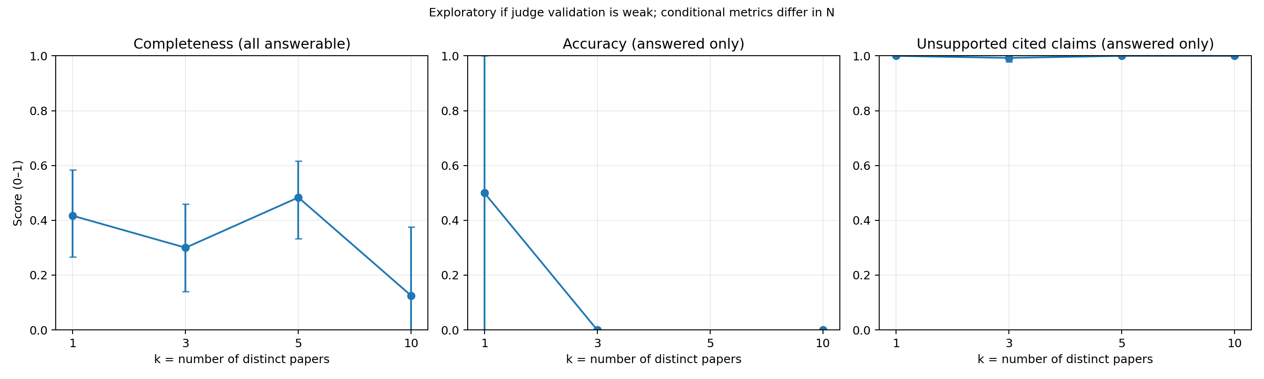
Figure A2. Main metrics by retrieval condition
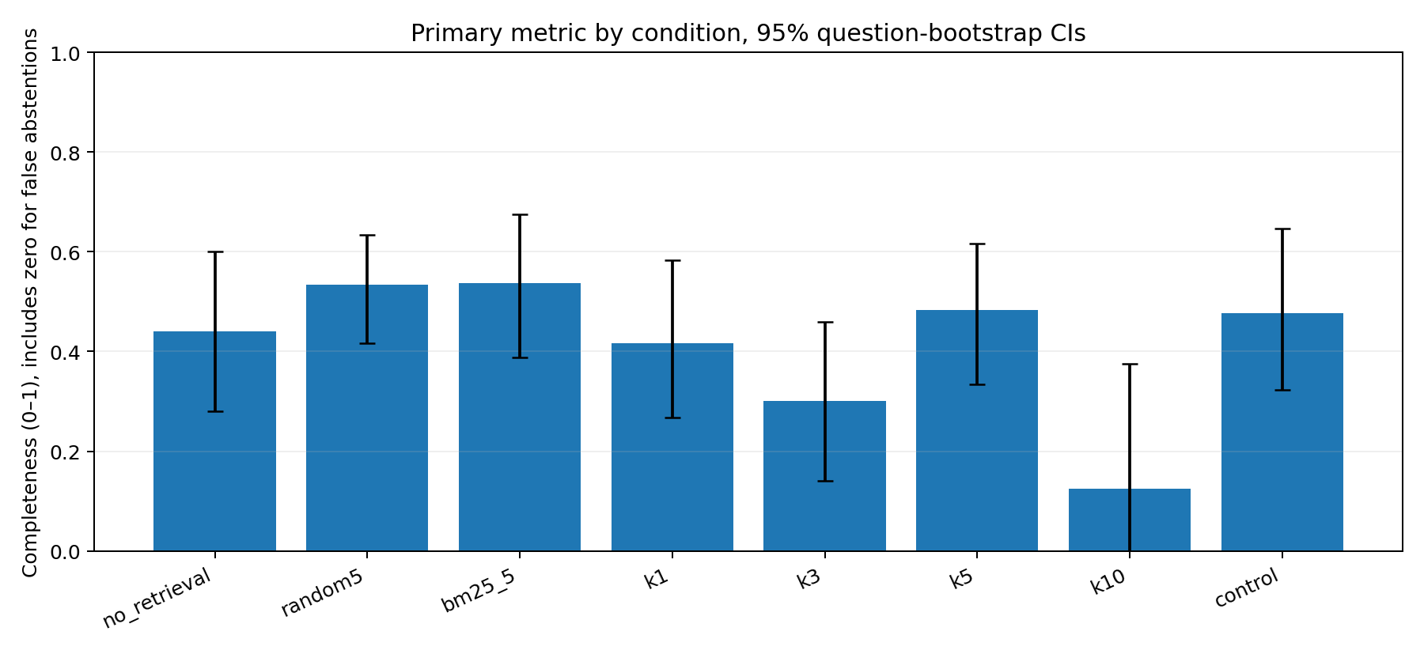
Figure A3. Gold-paper recall and completeness
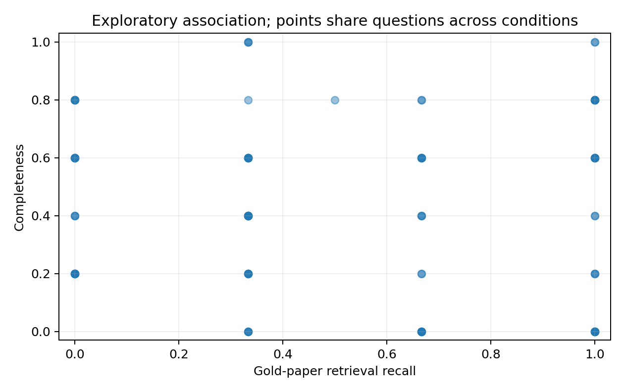
Figure A4. Input token volume


