AZERBAIJANI TECHNICAL UNIVERSITY

Faculty of Information Technologies and Telecommunications
Department of Cybersecurity

Discipline: “Python for cybersecurity”

Report for Laboratory Work № 4
« Creating a script for working with JSON »

Performed by:Nuray Beydullayeva
Student of group “6424e ”

Accepted by:
Instructor: Najafli Javad Vagif oglu

Baku
2025

- Create a simple Python application that reads a to-do list from a JSON file, allows the user to add new tasks, and saves the updated list back to the JSON file.
The purpose of this lab was to create a simple Python application that manages a to-do list using a JSON file. The program demonstrates how to read data from a JSON file, modify it in Python, and then save the updated data back to the same file.
First, a JSON file named todo.json was created to store the list of tasks. This file initially contains an array of tasks under a key called "tasks".
The program performs three main operations:
- Read existing tasks from the JSON file using the load_tasks() function. This function opens the file, loads the JSON data, and returns the list of tasks. If the file does not exist, it returns an empty list.
- Add a new task entered by the user. The user is prompted to type a new task, which is then appended to the current list.
- Save the updated list back to the JSON file using the save_tasks() function. This function overwrites the existing file with the new list, properly formatted using json.dump().
The main part of the program (main() function) first displays the existing tasks, asks the user to add a new one, and then confirms that the task has been added and saved successfully.
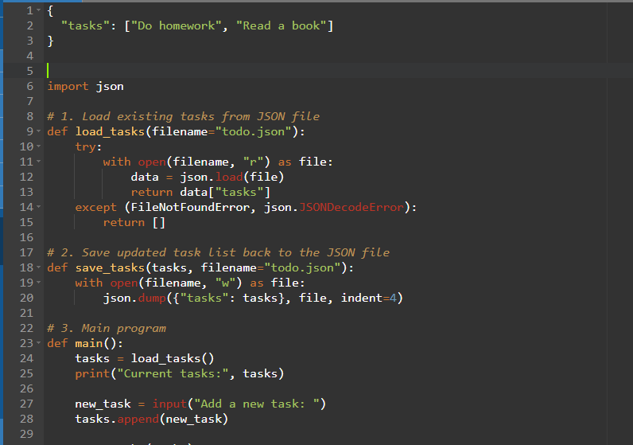
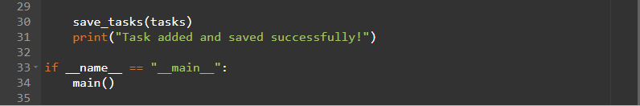

After execution, the todo.json file contains the newly added task along with the previous ones, showing that the program successfully performs file reading, data manipulation, and writing operations.
This lab demonstrates basic file handling, JSON manipulation, and user interaction in Python, which are fundamental concepts for building simple data-driven applications.
