Kazakh-British Technical University
Data Collection & Preparation
STUDENTS' INDEPENDENT STUDY (SIS) No. 1
Population and Area of Countries
API collection, static scraping and exploratory analysis
Full Name: Tursyn Nurbolat
ID: 23B031468
Format: Individual project
09.10.2026
Almaty

Aim, sources and preparation
Research question: How is population associated with country/economy surface area? The World Bank V2 API supplies country metadata and population (SP.POP.TOTL) for 2024. Scrape This Site supplies area from static country cards. Scope includes economies and territories, not only sovereign countries.
requests checks HTTP status and the two-part JSON schema, then collects every API page. World Bank aggregates are removed. BeautifulSoup parses country names, flag codes, capitals, population and area after robots.txt allows the page. Text, missing values, duplicates and numeric types are checked. Missing capital values stay missing; population is not imputed.
Datasets are merged one-to-one using two-letter codes. Norway’s damaged HTML flag class is repaired through a unique exact API name. All unmatched codes and differing name pairs are printed. Only rows with positive area and nonmissing positive API population enter EDA. Density = population / area; log10 values support scale-aware comparisons.

Coverage and descriptive results
Source / sample | Records | Notes
World Bank API | 217 | 6 missing cells
Static webpage | 250 | 8 missing cells
Code-matched EDA | 216 | 1 API / 34 web unmatched
Within the matched sample, India has the largest 2024 population (1,450,935,791); Russian Federation has the largest webpage area (17,100,000 km²). Median population is 6,751,308 and median area is 95,755 km². Monaco has the highest approximate density (19,810.8 people/km²). Kazakhstan has 20,592,571 people and an approximate density of 7.58 people/km².
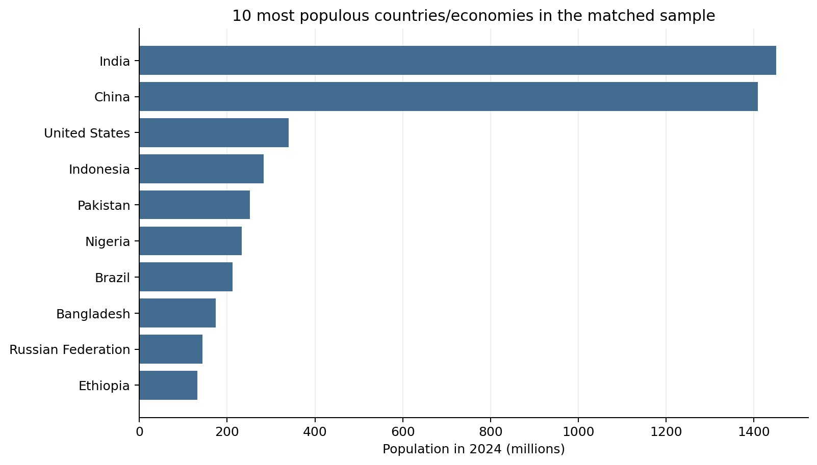
SIS 1 | Population and Area of Countries 2

Area, association and interpretation
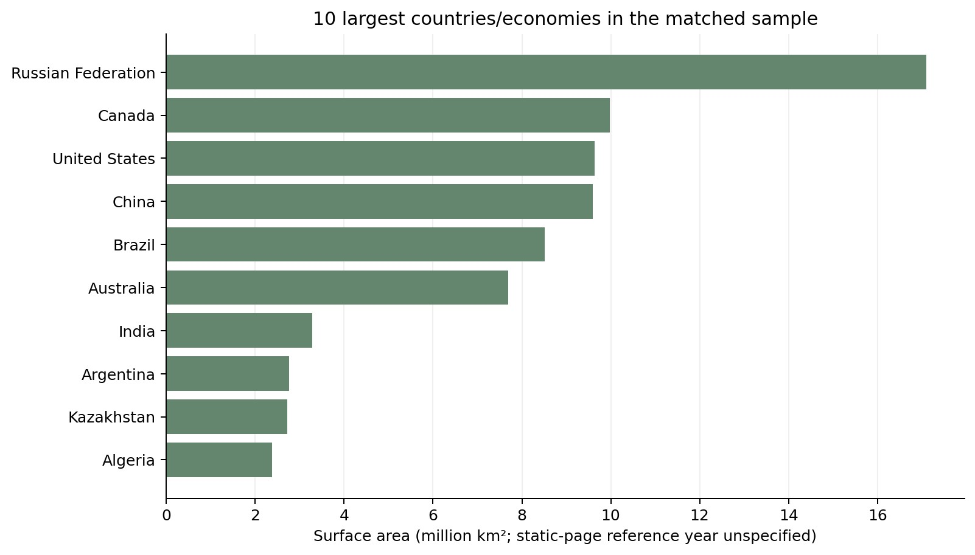
Population–area correlation (n=216): Pearson = 0.444; Spearman = 0.836; Pearson on log10 values = 0.869. Raw Pearson is sensitive to very large observations; Spearman compares ranks. These measures summarize association and do not establish causation.
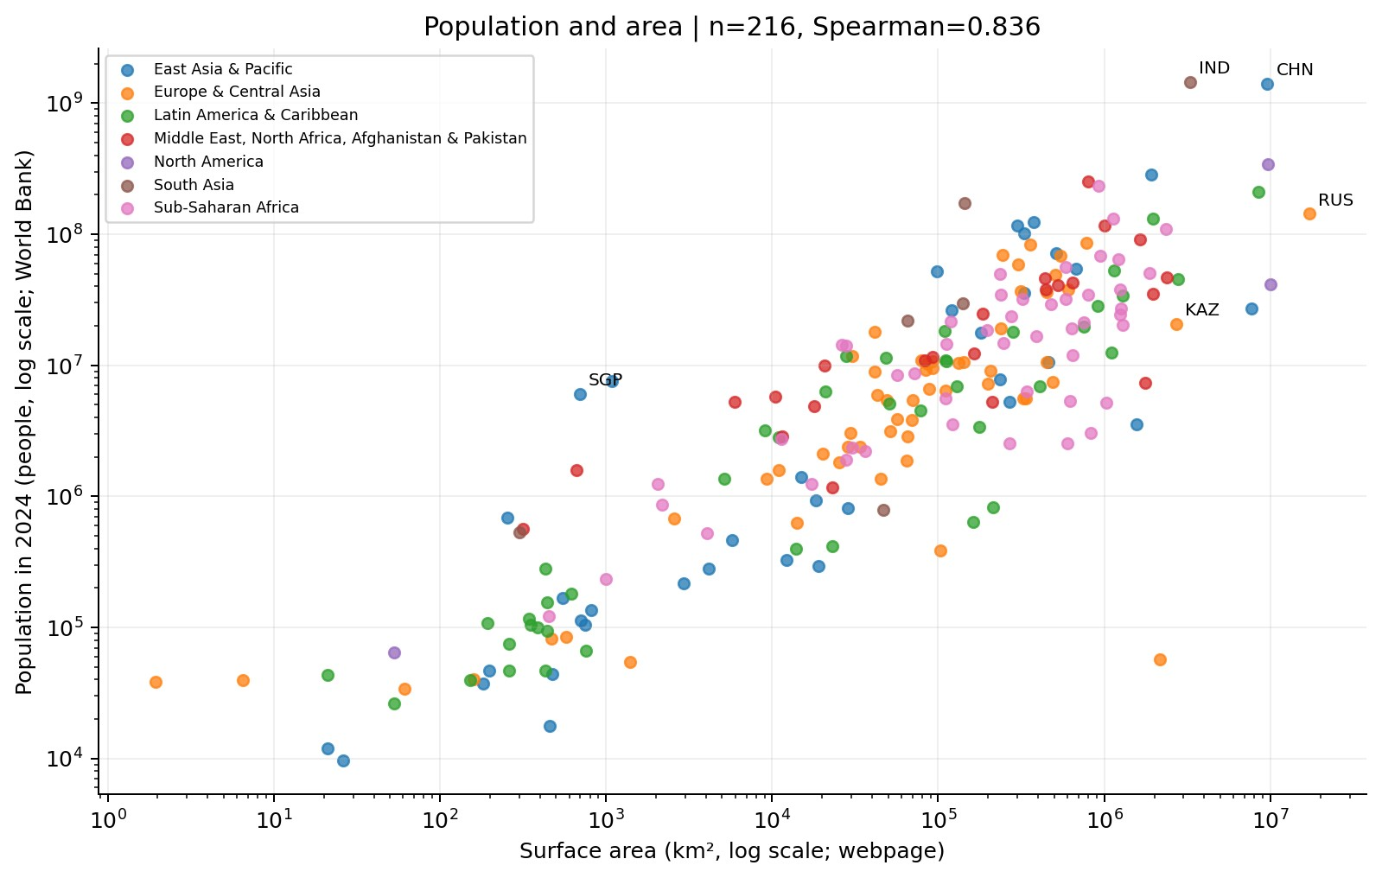
Limitations: the webpage gives no reference year or area methodology. Density therefore mixes 2024 population with a static area snapshot and is approximate. Coverage is the intersection of sources. Tiny territories can dominate density; code-based joins still require checking entity definitions. The webpage population is collected for review but is not used for the main numerical analysis.
Reproducibility: the executed notebook saves raw JSON/HTML snapshots, collection timestamps and hashes, cleaned CSVs, merge audits, statistics, correlations and four plots. LIVE=False explicitly replays snapshots. Complete pagination, unique keys, positive denominators and CSV round trips were validated.
Sources: api.worldbank.org/v2/country; api.worldbank.org/v2/country/all/indicator/SP.POP.TOTL?format=json&date=2024; www.scrapethissite.com/pages/simple/. API documentation: datahelpdesk.worldbank.org/knowledgebase/articles/898581-api-basic-call-structures.
SIS 1 | Population and Area of Countries 3

