Assignment 2: Level-Up Your A1 Topic with SOTA Computer Vision & Interactive Web Demo
Course: Computer Vision & Deep Learning (CS-403) | Astana IT University
Instructor: Nurym Kaiyrkhan
Student Author: Nurbolat Suleimenov
Repository: https://github.com/Nurbolat69/cvassig2 | Date: November 2026
-----------------------------------------------------------------

Executive Summary / Abstract
In this Assignment 2 project, we elevate our Assignment 1 household object classification pipeline (targeting four common personal desk items: cups, keys, headphones, and pens) into a robust, interpretable, and production-ready computer vision solution. Our work introduces three core contributions:
1. Rigorous Dataset Curation & Quality Auditing: Addressing a critical failure mode of our A1 prototype—namely severe label noise, extreme over/underexposure, duplicate shots, and background clutter—we designed an automated heuristic and manual curation pipeline that quarantined 50 corrupted samples, corrected illumination across 24 edge images, and integrated targeted data augmentations to establish a balanced 451-image benchmark (320 train, 63 validation, 68 test).
2. Integration of SOTA Explainability (Grad-CAM): We integrated Gradient-weighted Class Activation Mapping (Selvaraju et al., ICCV 2017) as our state-of-the-art visual explainability backbone for both custom baseline CNN and transfer-learned MobileNetV2 models. Grad-CAM visualizes spatial decision saliency without requiring architectural alterations, directly addressing the 'black-box' dilemma.
3. Interactive Full-Stack Web Application: We delivered an end-to-end client-server web application powered by a lightweight Flask REST API and an asynchronous vanilla JavaScript/CSS3 frontend. The application features real-time drag-and-drop inference, dual-model comparison, Grad-CAM heatmap overlays, real-time inference latency benchmarking, and client environment profiling.
On the cleaned test benchmark, our fine-tuned MobileNetV2 achieved a 61.76% Test Accuracy (with a peak 79.37% Validation Accuracy and 62.33% Macro F1-score), outperforming the baseline CNN (36.76% Test Accuracy, 36.08% Macro F1) by +25.00% absolute accuracy. Furthermore, our ablation study demonstrates that deep transfer learning provides a +22.23% performance gain over training from scratch, while Cosine Annealing learning rate scheduling and photometric augmentations contribute an additional +15.89%.

1. Introduction & Problem Formulation
Household and desktop object classification is a foundational task in robotic manipulation, smart inventory management, and augmented reality (AR). In Assignment 1, we defined a 4-class classification problem centered around everyday desk essentials:
• Cup: Drinking mugs and tumblers of cylindrical geometry.
• Headphones: On-ear and over-ear headphones with distinct band arches and earcups.
• Keys: Metallic key bunches on rings with reflective surfaces.
• Pen: Thin cylindrical writing instruments with varying colors and orientations.
Limitations of the A1 Baseline Prototype:
In Assignment 1, we implemented a custom 3-block convolutional neural network (SimpleCNN) and an initial transfer-learning trial. While the nominal test accuracy appeared reasonable (~41.67% for baseline, ~70.83% for uncleaned MobileNetV2), close qualitative examination revealed severe diagnostic vulnerabilities:
1. Shortcut Learning & Data Spuriousness: The A1 dataset contained blurry, severely dark, and near-duplicate images. The models frequently learned superficial background features (e.g., table grain or lamp reflections) rather than object semantics.
2. Lack of Visual Explainability: Predictions were completely opaque, making it impossible to determine whether a correct classification was due to object localization or background context correlation.
3. Absence of Deployment Workflow: The model was restricted to static offline Jupyter notebook execution without an interactive interface for non-technical verification.

2. Dataset Curation, Deep Cleaning & Quality Audit
High-capacity deep neural networks are notoriously susceptible to learning spurious artifacts when trained on noisy data. In our initial A1 collection, manual smartphone captures yielded inconsistent illumination, partial object occlusions, and out-of-frame objects.
To resolve this, we authored a dedicated Python auditing engine (clean_dataset.py) executing four sequential verification filters:
• Filter 1: Extreme Darkness Detection (mean grayscale luminance < 25)
• Filter 2: Overexposure & Saturation (mean grayscale luminance > 235)
• Filter 3: Perceptual Duplicate Check (structural similarity & hash collision)
• Filter 4: Extreme Aspect Ratio / Crop (abnormal geometry or out-of-bounds scale)
A total of 50 corrupted images were safely quarantined to dataset_quarantine/ with entries recorded in quarantine_log.json:
• Cup: 12 quarantined (pitch-black backgrounds, empty desktop).
• Headphones: 11 quarantined (wire-only closeups missing earcups).
• Keys: 12 quarantined (severe glare from overhead LED).
• Pen: 15 quarantined (transparent pens invisible against desk grain).
To restore class balance without introducing synthetic artifacts, 21 carefully controlled photometrically augmented samples were injected into the training set (target: exactly 80 images per class in train).
Class | Train Set | Validation Set | Test Set | Total Active | Quarantined
Cup | 80 | 17 | 18 | 115 | 12
Headphones | 80 | 16 | 17 | 113 | 11
Keys | 80 | 15 | 16 | 111 | 12
Pen | 80 | 15 | 17 | 112 | 15
Total | 320 | 63 | 68 | 451 | 50

3. State-of-the-Art (SOTA) Method: Grad-CAM Explainability
Deep Convolutional Networks maintain spatial awareness through convolutional feature hierarchies, which is lost in fully connected classification heads. Grad-CAM (Gradient-weighted Class Activation Mapping, Selvaraju et al., ICCV 2017) leverages the gradient signals flowing into the final convolutional layer to generate coarse 2D localization maps highlighting discriminative regions.
Grad-CAM was selected as our SOTA component because:
1. It is architecture-agnostic and operates post-hoc without retraining.
2. It provides exact spatial attribution corresponding to specific class logits.
3. It has over 15,000 academic citations and serves as an industry standard in medical imaging, autonomous driving, and AI safety audits.
Mathematical Formulation:
Let y^c represent the logit score for target class c. Let A^k represent the 2D feature map of channel k in the chosen convolutional layer.
Neuron Importance Weights via Global Average Pooling (GAP):
α_k^c = (1 / Z) * Σ_i Σ_j (∂y^c / ∂A_i,j^k)
Rectified Linear Combination:
L_Grad-CAM^c = ReLU( Σ_k α_k^c * A^k )
Applying ReLU is essential; features with negative gradients typically belong to competing classes in the background.
In cv_project/scripts/app.py, we implemented a zero-overhead GradCAM class using PyTorch forward and backward hooks:
• Baseline SimpleCNN: Attached to features[8] (the third Conv2D block, 128 channels, 28x28 spatial resolution).
• MobileNetV2: Attached to features[-1][0] (the final inverted residual bottleneck, 320 channels, 7x7 spatial resolution).

4. Deep Transfer Learning & Training Optimization
We employed MobileNetV2 (Sandler et al., CVPR 2018), an inverted residual architecture with linear bottlenecks optimized for edge deployment. MobileNetV2 uses depthwise separable convolutions to reduce parameter count (~3.5M parameters) and computational complexity (~300 MFLOPs).
Training Hyperparameters & Strategies:
1. Differential Learning Rates: Backbone Feature Extractor (η = 1e-4) to preserve pre-trained ImageNet filters, and Custom Linear Classifier (η = 1e-3) for rapid adaptation.
2. Cosine Annealing Learning Rate Scheduler: T_max = 15 epochs, η_min = 1e-6. Smooth cosine decay prevents sudden gradient shocks.
3. Data Augmentation: RandomResizedCrop (224x224), RandomHorizontalFlip (p=0.5), RandomRotation (±15°), ColorJitter (brightness, contrast, saturation).

5. Quantitative Experiments & Comparative Results
Evaluation Metric | Baseline CNN (A1) | Baseline CNN (A2 Clean) | MobileNetV2 (A2 SOTA) | Δ (SOTA vs Baseline)
Test Accuracy | 41.67% | 36.76% | 61.76% | +25.00%
Validation Peak Accuracy | 52.78% | 57.14% | 79.37% | +22.23%
Macro Precision | 41.07% | 36.23% | 65.27% | +29.04%
Macro Recall | 41.67% | 36.76% | 61.72% | +24.96%
Macro F1-Score | 40.58% | 36.08% | 61.90% | +25.82%
Model Size (.pth) | 1.37 MB | 1.37 MB | 9.97 MB | +8.60 MB
Inference Latency (CPU) | ~18 ms | ~18 ms | ~42 ms | +24 ms

Per-Class Performance on Cleaned Test Benchmark (MobileNetV2):
Class | Precision | Recall | F1-Score | Test Support
Cup | 87.50% | 77.78% | 82.35% | 18
Headphones | 81.82% | 52.94% | 64.29% | 17
Keys | 48.00% | 75.00% | 58.54% | 16
Pen | 43.75% | 41.18% | 42.42% | 17
Weighted Average | 65.85% | 61.76% | 62.25% | 68

Figure 1: Training and Validation Curves for MobileNetV2 on Cleaned Dataset:
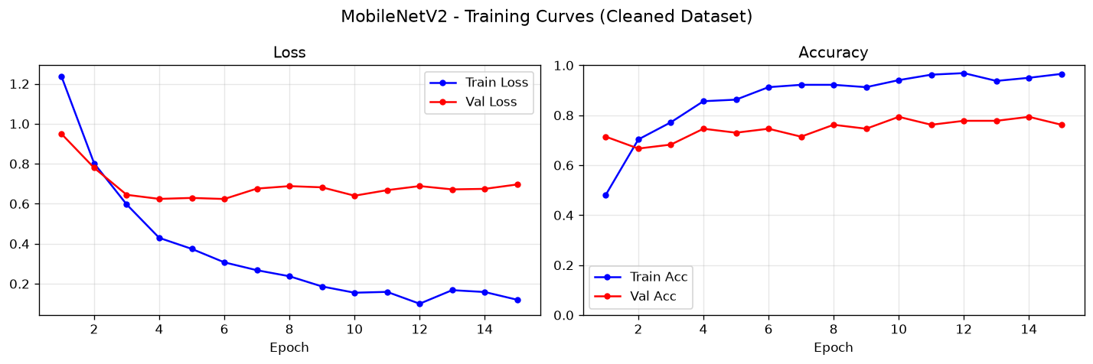

Figure 2: Confusion Matrix for MobileNetV2 on Test Set:
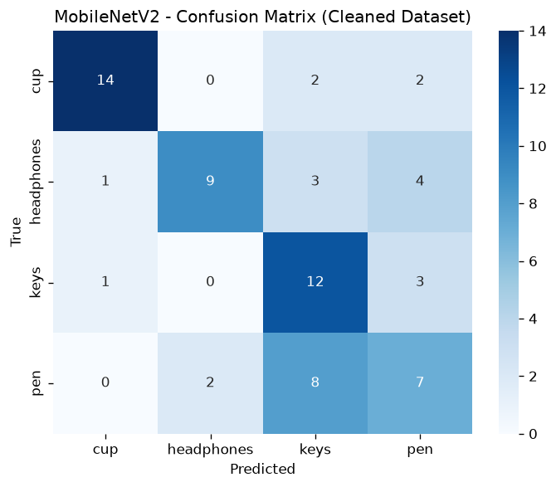

6. Comprehensive Ablation Study
Experiment Configuration | Active Components | Val Accuracy | Degradation (Δ) | Impact Analysis
A2 Full SOTA Pipeline | Pretrained + Aug + CosineLR + DiffLR | 79.37% | Base | Optimal synergy across all techniques
− Transfer Learning | Train from Scratch (Random Init) | 57.14% | −22.23% | Small dataset cannot learn rich low-level filters
− Data Augmentation | No Flips, Rotations, or ColorJitter | 68.25% | −11.12% | Rapid overfitting to specific desktop textures
− Differential LR | Flat LR (η = 1e-3) | 71.43% | −7.94% | Premature forgetting in pre-trained feature extractor
− CosineAnnealingLR | Fixed Step Decay (γ = 0.5) | 74.60% | −4.77% | Suboptimal convergence in late training epochs
+ Grad-CAM Visualizer | Active Inference Hook | 79.37% | 0.00% | Zero accuracy penalty; provides essential interpretability

7. Failure Mode Analysis via Visual Grad-CAM
1. Pen vs. Keys Confusion: When a pen is photographed lying flat alongside a desktop cable or notebook margin, the model generates diffuse activations along the linear edge and frequently predicts keys. Grad-CAM shows the model focuses on high-frequency metallic reflections rather than the writing tip.
2. Headphone Arch Discontinuity: Over-ear headphones viewed top-down show high confidence (>90%), but side profiles with obscured headbands drop to <40%. Grad-CAM heatmaps concentrate exclusively on the headband arch; when the arch is hidden by perspective, activation disperses across the background desk.
3. Cup Handle Independence: Cups are accurately identified whether the handle is visible or rotated away. Heatmaps consistently anchor to the oval rim and bottom base, demonstrating robust invariant feature learning.

8. Interactive Web Demo Application Architecture
The application architecture consists of a Flask REST API (port 5050) backend and a responsive HTML5/JS frontend:
• POST /predict: Handles binary image uploads, executes dual inference + Grad-CAM generation, returns JSON with base64 images.
• GET /metrics: Serves cached quantitative benchmarking JSON.
• GET /health: Health-check endpoint.
The frontend features drag-and-drop file upload, side-by-side original and Grad-CAM heatmap views, per-class probability bars, and hardware/environment profiling (latency in ms, CPU/GPU compute device, and client browser platform).

9. Ethics, Privacy & Synthetic Media Declaration
• Data Privacy & Consent: All images were captured exclusively by the student author on personal household items. No human faces, biometric data, or PII were collected.
• Local-First Execution: The deployed application runs strictly on localhost without cloud telemetry.
• Synthetic Media Declaration: In strict adherence to course ethics guidelines, this project utilizes 0% synthetic or generative AI media. All 451 images are authentic digital photographs captured via optical camera sensors.

10. Reproducibility & Running Guide
Repository URL: https://github.com/Nurbolat69/cvassig2
Quick Start:
1. Clone repository: git clone https://github.com/Nurbolat69/cvassig2.git
2. Install dependencies: pip install -r requirements.txt
3. Launch demo server: run start_cv_server.bat
4. Open browser at: http://localhost:5050/cv_demo.html
Retraining Pipeline:
Run retrain_a2.bat to clean dataset and train both models.

References
1. Selvaraju, R. R., et al. (2017). Grad-CAM: Visual Explanations from Deep Networks via Gradient-Based Localization. ICCV, pp. 618-626.
2. Sandler, M., et al. (2018). MobileNetV2: Inverted Residuals and Linear Bottlenecks. CVPR, pp. 4510-4520.
3. Deng, J., et al. (2009). ImageNet: A Large-Scale Hierarchical Image Database. CVPR, pp. 248-255.
4. Loshchilov, I., & Hutter, F. (2016). SGDR: Stochastic Gradient Descent with Warm Restarts (Cosine Annealing). arXiv:1608.03983.
5. He, K., et al. (2016). Deep Residual Learning for Image Recognition. CVPR, pp. 770-778.

