LABORATORY WORK #2
Normalization and DDL
In this lab I worked with database normalization and DDL commands. I first normalized the booking receipt table and then created the airport database tables and relationships.

PART I. NORMALIZATION

1. What normal form is violated?
The original table is:
Booking_receipt(booking_id, passenger_full_name, passenger_passport_number, flight_number, departure_airport_name, departure_city, arrival_airport_name, arrival_city, airline_name, seat_numbers, ticket_price)
The main problem is with 1NF. The column seat_numbers can contain several values in one cell, for example "12A, 12B". In 1NF one cell should contain only one value. Because of this, the table is not in 1NF.
There is also repeated passenger information when one booking has several passengers. After fixing 1NF, this problem will be handled when we move to 2NF and 3NF.
Problem | Column | Why it is a problem
1NF | seat_numbers | Several seat values can be stored in one cell.
Repeated data | passenger_full_name, passenger_passport_number | The same passenger data can be repeated for one booking.
Later normalization | flight_number, airport data, airline_name | These attributes describe the flight, airport or airline and should be stored separately.

2. Normalization step by step

Step 1 - 1NF
To get 1NF, I changed seat_numbers into a single seat_number value. If a booking has two seats, I use two rows instead of putting both seats into one cell.
booking_id | passport_number | passenger_name | flight_number | departure_airport | departure_city | arrival_airport | arrival_city | airline | seat_number | ticket_price
B001 | P1001 | Ayan Karimov | KC101 | Almaty International Airport | Almaty | Astana International Airport | Astana | Kazakhstan Airlines | 12A | 45000.00
B001 | P1002 | Dana Karimova | KC101 | Almaty International Airport | Almaty | Astana International Airport | Astana | Kazakhstan Airlines | 12B | 45000.00
B002 | P1003 | Madi Sarsenov | DV210 | Almaty International Airport | Almaty | Aktau Airport | Aktau | FlyStep | 8C | 38000.00
B003 | P1004 | Aliya Nur | DV210 | Almaty International Airport | Almaty | Aktau Airport | Aktau | FlyStep | 8D | 38000.00
B004 | P1005 | Timur Bek | FS305 | Astana International Airport | Astana | Shymkent Airport | Shymkent | SkyNomad | 4A | 32000.00

Primary key idea for this example: (booking_id, passport_number). Every seat value is now atomic.

Step 2 - 2NF
For 2NF I remove partial dependencies. Passenger name depends on passport_number. Flight number and price depend on booking_id. So I separate passenger data and booking data.
Table | Attributes
Passenger | passport_number, passenger_name
Booking | booking_id, flight_number, ticket_price
BookingPassenger | booking_id, passport_number, seat_number

Here BookingPassenger connects a booking with a passenger. The two key columns are foreign keys to Booking and Passenger.

Step 3 - 3NF
For 3NF I remove transitive dependencies. Flight number determines the airport route and airline. Airport id determines airport information. Airline id determines airline information. Because of this, I make separate Flight, Airport and Airline tables.
3NF table | Attributes / keys
Booking | booking_id, flight_number (FK), ticket_price
Passenger | passport_number, passenger_name
BookingPassenger | booking_id (FK), passport_number (FK), seat_number
Flight | flight_number, departure_airport_id (FK), arrival_airport_id (FK), airline_id (FK)
Airport | airport_id, airport_name, city
Airline | airline_id, airline_name

After this split, the same airport or airline information does not have to be written in every booking row. This is the main reason for using 3NF.

3. Functional dependencies
Step | Functional dependency | Meaning
1NF | (booking_id, passport_number) -> seat_number | A seat is connected to one passenger inside one booking.
2NF | booking_id -> flight_number, ticket_price | The booking determines its flight and price.
2NF | passport_number -> passenger_name | Passport number identifies the passenger.
3NF | flight_number -> departure_airport_id, arrival_airport_id, airline_id | A flight determines its route and airline.
3NF | airport_id -> airport_name, city | Airport id identifies airport information.
3NF | airline_id -> airline_name | Airline id identifies the airline.

4. Is Flights in 3NF?
In my airport database the primary key of Flights is flight_id.
flight_id -> sch_departure_time, sch_arrival_time, departing_airport_id, arriving_airport_id, departing_gate, arriving_gate, airline_id, act_departure_time, act_arrival_time, created_at, updated_at
Flights is in 3NF. The columns departing_airport_id, arriving_airport_id and airline_id are foreign keys. They are used to get data from Airport and Airline tables. Flights does not also store airport_name, city or airline_name, so there is no extra transitive dependency between non-key columns inside Flights.
Therefore I consider Flights to be in 3NF.
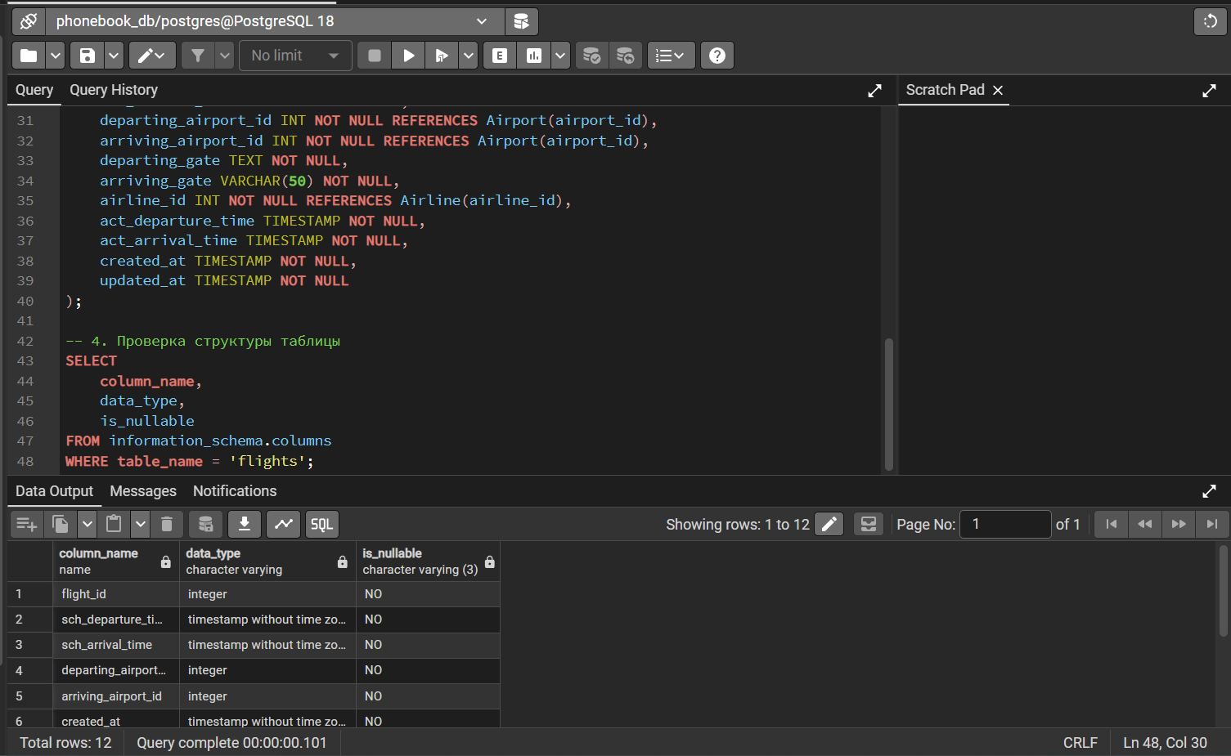

Task 5: Implementing 3NF Tables and Inserting Data
In this task, I implemented the 3NF tables designed in Task 2 using SQL CREATE TABLE statements.

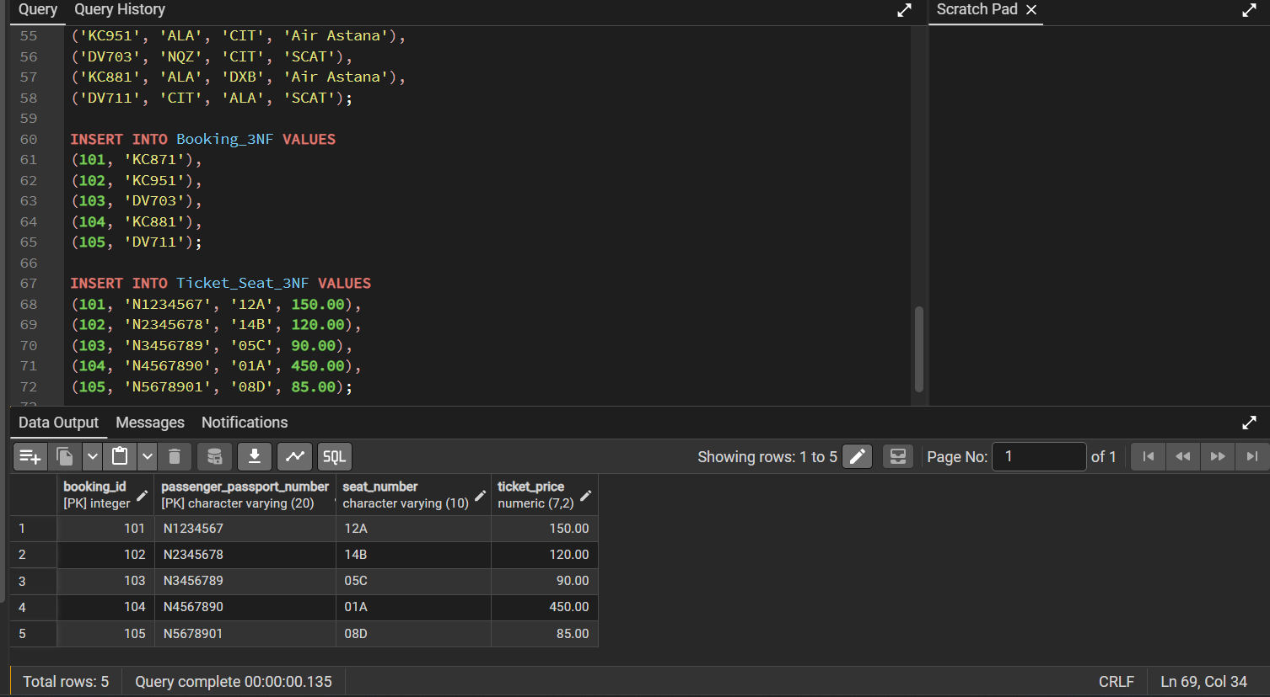

PART II. DDL

1-4. CREATE TABLE, PRIMARY KEY and NOT NULL
Below is the SQL that I used. First I create all requested tables. Every attribute from the task is NOT NULL and every table has a primary key.
CREATE TABLE airline_info (
airline_id INT NOT NULL PRIMARY KEY,
airline_code VARCHAR(30) NOT NULL,
airline_name VARCHAR(50) NOT NULL,
airline_country VARCHAR(50) NOT NULL,
created_at TIMESTAMP NOT NULL,
updated_at TIMESTAMP NOT NULL,
info VARCHAR(50) NOT NULL
);
CREATE TABLE airport (
airport_id INT NOT NULL PRIMARY KEY,
airport_name VARCHAR(50) NOT NULL,
country VARCHAR(50) NOT NULL,
state VARCHAR(50) NOT NULL,
city VARCHAR(50) NOT NULL,
created_at TIMESTAMP NOT NULL,
updated_at TIMESTAMP NOT NULL
);
CREATE TABLE passengers (
passenger_id INT NOT NULL PRIMARY KEY,
first_name VARCHAR(50) NOT NULL,
last_name VARCHAR(50) NOT NULL,
date_of_birth DATE NOT NULL,
gender VARCHAR(50) NOT NULL,
country_of_citizenship VARCHAR(50) NOT NULL,
country_of_residence VARCHAR(50) NOT NULL,
passport_number VARCHAR(20) NOT NULL,
created_at TIMESTAMP NOT NULL,
updated_at TIMESTAMP NOT NULL
);
CREATE TABLE flights (
flight_id INT NOT NULL PRIMARY KEY,
sch_departure_time TIMESTAMP NOT NULL,
sch_arrival_time TIMESTAMP NOT NULL,
departing_airport_id INT NOT NULL,
arriving_airport_id INT NOT NULL,
departing_gate VARCHAR(50) NOT NULL,
arriving_gate VARCHAR(50) NOT NULL,
airline_id INT NOT NULL,
act_departure_time TIMESTAMP NOT NULL,
act_arrival_time TIMESTAMP NOT NULL,
created_at TIMESTAMP NOT NULL,
updated_at TIMESTAMP NOT NULL
);
CREATE TABLE booking (
booking_id INT NOT NULL PRIMARY KEY,
flight_id INT NOT NULL,
passenger_id INT NOT NULL,
booking_platform VARCHAR(50) NOT NULL,
created_at TIMESTAMP NOT NULL,
updated_at TIMESTAMP NOT NULL,
status VARCHAR(50) NOT NULL,
price DECIMAL(7,2) NOT NULL
);
CREATE TABLE booking_flight (
booking_flight_id INT NOT NULL PRIMARY KEY,
booking_id INT NOT NULL,
flight_id INT NOT NULL,
created_at TIMESTAMP NOT NULL,
updated_at TIMESTAMP NOT NULL
);
CREATE TABLE baggage_check (
baggage_check_id INT NOT NULL PRIMARY KEY,
check_result VARCHAR(50) NOT NULL,
created_at TIMESTAMP NOT NULL,
updated_at TIMESTAMP NOT NULL,
booking_id INT NOT NULL,
passenger_id INT NOT NULL
);
CREATE TABLE baggage (
baggage_id INT NOT NULL PRIMARY KEY,
weight_in_kg DECIMAL(4,2) NOT NULL,
created_at TIMESTAMP NOT NULL,
updated_at TIMESTAMP NOT NULL,
booking_id INT NOT NULL
);
CREATE TABLE boarding_pass (
boarding_pass_id INT NOT NULL PRIMARY KEY,
booking_id INT NOT NULL,
seat VARCHAR(50) NOT NULL,
boarding_time TIMESTAMP NOT NULL,
created_at TIMESTAMP NOT NULL,
updated_at TIMESTAMP NOT NULL
);
CREATE TABLE security_check (
security_check_id INT NOT NULL PRIMARY KEY,
check_result VARCHAR(20) NOT NULL,
created_at TIMESTAMP NOT NULL,
updated_at TIMESTAMP NOT NULL,
passenger_id INT NOT NULL
);

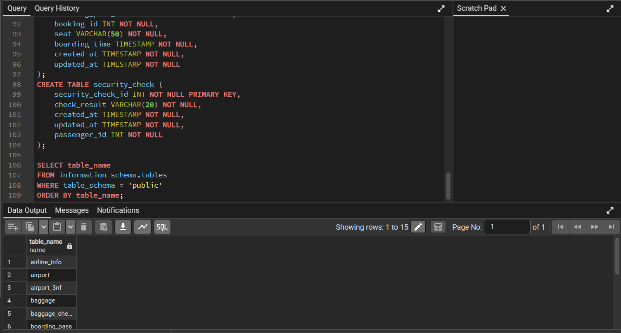

5-8. Required ALTER TABLE commands
ALTER TABLE airline_info RENAME TO airline;
ALTER TABLE booking RENAME COLUMN price TO ticket_price;
ALTER TABLE flights ALTER COLUMN departing_gate TYPE TEXT;
ALTER TABLE airline DROP COLUMN info;
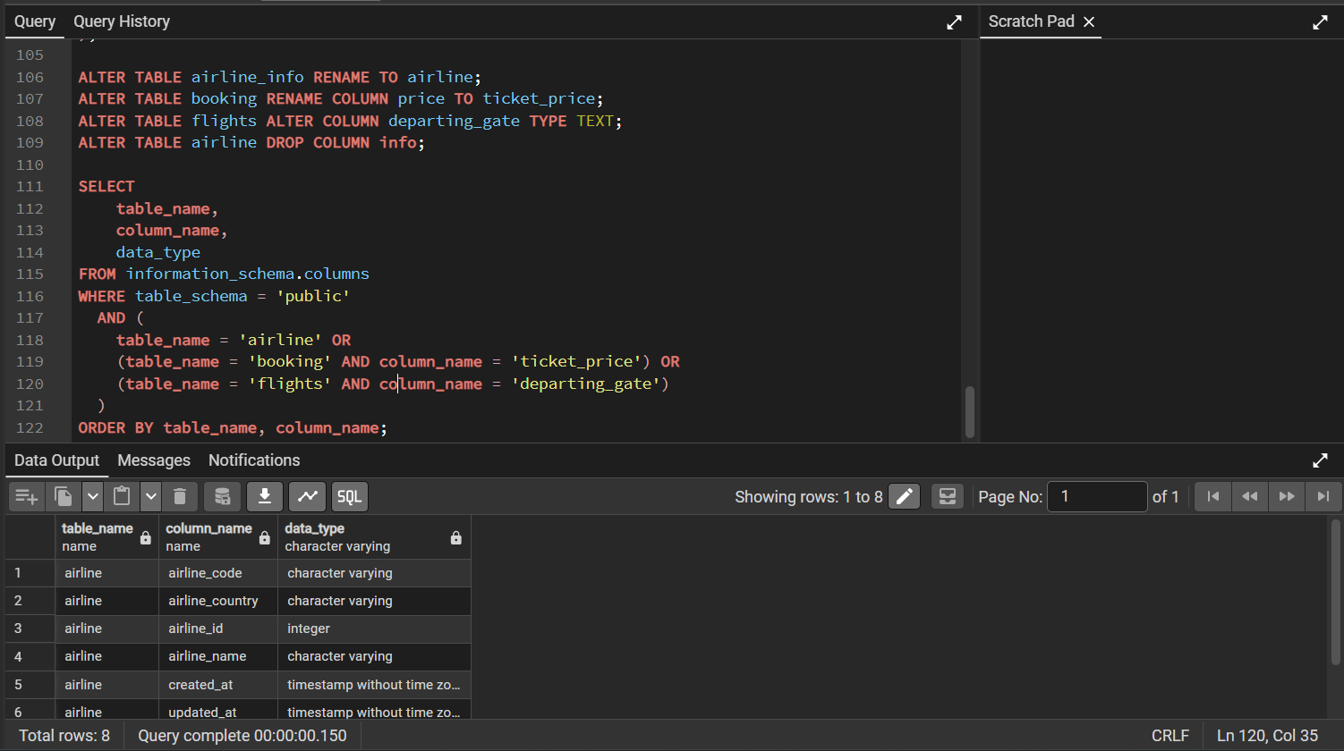

9. Foreign keys / relationships
I added the relationships after creating the tables. Airport is connected to Flights two times, because a flight has both a departure airport and an arrival airport.
ALTER TABLE security_check
ADD CONSTRAINT fk_security_check_passenger
FOREIGN KEY (passenger_id) REFERENCES passengers(passenger_id);
ALTER TABLE booking
ADD CONSTRAINT fk_booking_passenger
FOREIGN KEY (passenger_id) REFERENCES passengers(passenger_id);
ALTER TABLE baggage_check
ADD CONSTRAINT fk_baggage_check_passenger
FOREIGN KEY (passenger_id) REFERENCES passengers(passenger_id);
ALTER TABLE baggage_check
ADD CONSTRAINT fk_baggage_check_booking
FOREIGN KEY (booking_id) REFERENCES booking(booking_id);
ALTER TABLE baggage
ADD CONSTRAINT fk_baggage_booking
FOREIGN KEY (booking_id) REFERENCES booking(booking_id);
ALTER TABLE boarding_pass
ADD CONSTRAINT fk_boarding_pass_booking
FOREIGN KEY (booking_id) REFERENCES booking(booking_id);
ALTER TABLE booking_flight
ADD CONSTRAINT fk_booking_flight_booking
FOREIGN KEY (booking_id) REFERENCES booking(booking_id);
ALTER TABLE booking_flight
ADD CONSTRAINT fk_booking_flight_flight
FOREIGN KEY (flight_id) REFERENCES flights(flight_id);
ALTER TABLE booking
ADD CONSTRAINT fk_booking_flight
FOREIGN KEY (flight_id) REFERENCES flights(flight_id);
ALTER TABLE flights
ADD CONSTRAINT fk_flights_departing_airport
FOREIGN KEY (departing_airport_id) REFERENCES airport(airport_id);
ALTER TABLE flights
ADD CONSTRAINT fk_flights_arriving_airport
FOREIGN KEY (arriving_airport_id) REFERENCES airport(airport_id);
ALTER TABLE flights
ADD CONSTRAINT fk_flights_airline
FOREIGN KEY (airline_id) REFERENCES airline(airline_id);

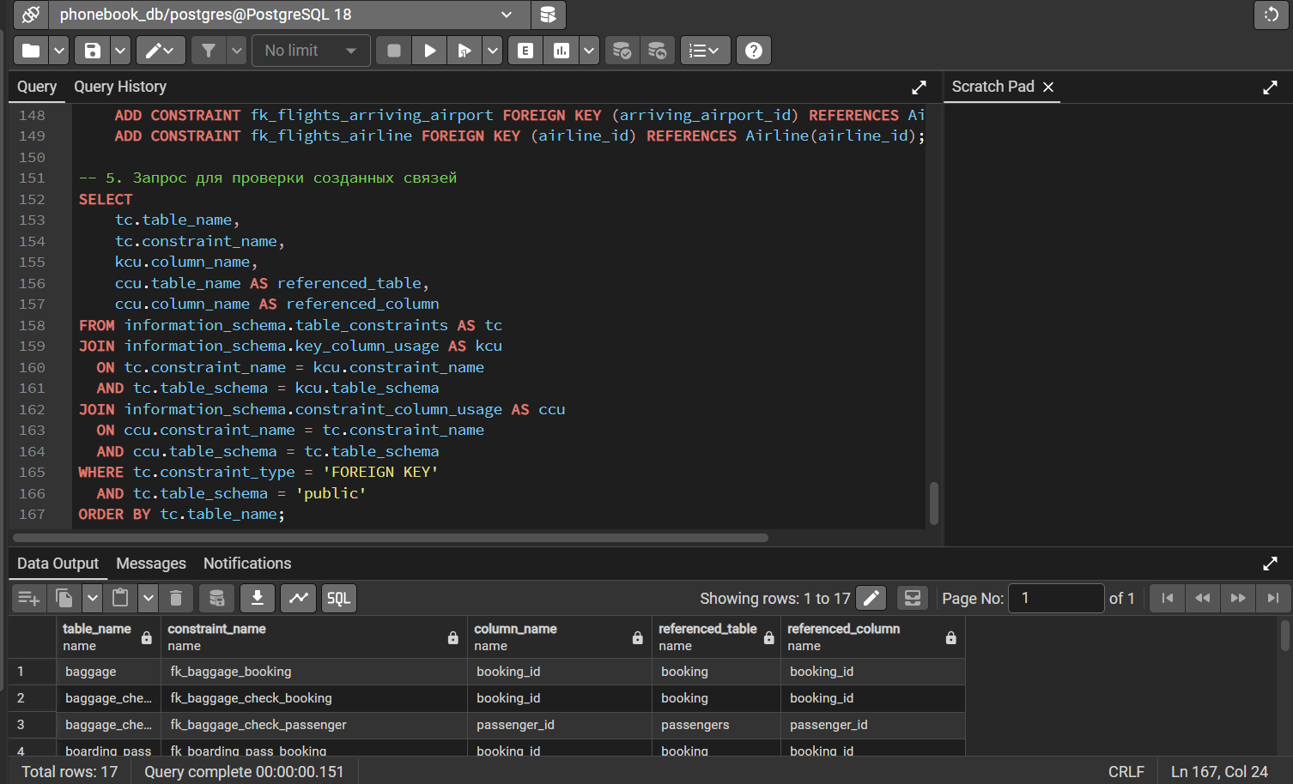

PART III. DML - SAMPLE DATA
I used a small sample dataset with 5 rows in the main tables. The idea is that the data can be inserted after the tables and foreign keys are created.

Airline
INSERT INTO airline (airline_id, airline_code, airline_name, airline_country, created_at, updated_at)
VALUES
(1, 'KZ1', 'Kazakhstan Airlines', 'Kazakhstan', '2026-09-15 10:00:00', '2026-09-15 10:00:00'),
(2, 'FS2', 'FlyStep', 'Kazakhstan', '2026-09-15 10:00:00', '2026-09-15 10:00:00'),
(3, 'SN3', 'SkyNomad', 'Kazakhstan', '2026-09-15 10:00:00', '2026-09-15 10:00:00'),
(4, 'TL4', 'Turkic Line', 'Turkey', '2026-09-15 10:00:00', '2026-09-15 10:00:00'),
(5, 'AT5', 'Asia Travel Air', 'Uzbekistan', '2026-09-15 10:00:00', '2026-09-15 10:00:00');

Airport
INSERT INTO airport (airport_id, airport_name, country, state, city, created_at, updated_at)
VALUES
(101, 'Almaty International Airport', 'Kazakhstan', 'Almaty', 'Almaty', '2026-09-15 10:00:00', '2026-09-15 10:00:00'),
(102, 'Astana International Airport', 'Kazakhstan', 'Astana', 'Astana', '2026-09-15 10:00:00', '2026-09-15 10:00:00'),
(103, 'Aktau Airport', 'Kazakhstan', 'Mangystau', 'Aktau', '2026-09-15 10:00:00', '2026-09-15 10:00:00'),
(104, 'Shymkent Airport', 'Kazakhstan', 'Turkistan', 'Shymkent', '2026-09-15 10:00:00', '2026-09-15 10:00:00'),
(105, 'Tashkent International Airport', 'Uzbekistan', 'Tashkent', 'Tashkent', '2026-09-15 10:00:00', '2026-09-15 10:00:00');

Passengers
INSERT INTO passengers (passenger_id, first_name, last_name, date_of_birth, gender, country_of_citizenship, country_of_residence, passport_number, created_at, updated_at)
VALUES
(1, 'Ayan', 'Karimov', '2005-01-15', 'Male', 'Kazakhstan', 'Kazakhstan', 'P1001', '2026-09-15 10:00:00', '2026-09-15 10:00:00'),
(2, 'Dana', 'Karimova', '2006-03-20', 'Female', 'Kazakhstan', 'Kazakhstan', 'P1002', '2026-09-15 10:00:00', '2026-09-15 10:00:00'),
(3, 'Madi', 'Sarsenov', '2004-11-11', 'Male', 'Kazakhstan', 'Kazakhstan', 'P1003', '2026-09-15 10:00:00', '2026-09-15 10:00:00'),
(4, 'Aliya', 'Nur', '2005-06-18', 'Female', 'Kazakhstan', 'Kazakhstan', 'P1004', '2026-09-15 10:00:00', '2026-09-15 10:00:00'),
(5, 'Timur', 'Bek', '2003-08-09', 'Male', 'Kazakhstan', 'Kazakhstan', 'P1005', '2026-09-15 10:00:00', '2026-09-15 10:00:00');

Flights
INSERT INTO flights (flight_id, sch_departure_time, sch_arrival_time, departing_airport_id, arriving_airport_id, departing_gate, arriving_gate, airline_id, act_departure_time, act_arrival_time, created_at, updated_at)
VALUES
(1001, '2026-10-01 08:00:00', '2026-10-01 09:20:00', 101, 102, 'A12', 'B04', 1, '2026-10-01 08:05:00', '2026-10-01 09:25:00', '2026-09-15 10:00:00', '2026-09-15 10:00:00'),
(1002, '2026-10-02 10:00:00', '2026-10-02 13:00:00', 101, 103, 'A08', 'C11', 2, '2026-10-02 10:02:00', '2026-10-02 13:04:00', '2026-09-15 10:00:00', '2026-09-15 10:00:00'),
(1003, '2026-10-03 14:00:00', '2026-10-03 15:10:00', 102, 104, 'B07', 'D02', 3, '2026-10-03 14:00:00', '2026-10-03 15:12:00', '2026-09-15 10:00:00', '2026-09-15 10:00:00'),
(1004, '2026-10-04 16:00:00', '2026-10-04 17:30:00', 104, 101, 'D05', 'A10', 4, '2026-10-04 16:10:00', '2026-10-04 17:40:00', '2026-09-15 10:00:00', '2026-09-15 10:00:00'),
(1005, '2026-10-05 18:00:00', '2026-10-05 19:45:00', 101, 105, 'A03', 'E01', 5, '2026-10-05 18:00:00', '2026-10-05 19:43:00', '2026-09-15 10:00:00', '2026-09-15 10:00:00');

Booking
INSERT INTO booking (booking_id, flight_id, passenger_id, booking_platform, created_at, updated_at, status, ticket_price)
VALUES
(5001, 1001, 1, 'Web', '2026-09-15 11:00:00', '2026-09-15 11:00:00', 'CONFIRMED', 45000.00),
(5002, 1001, 2, 'Web', '2026-09-15 11:05:00', '2026-09-15 11:05:00', 'CONFIRMED', 45000.00),
(5003, 1002, 3, 'Mobile', '2026-09-15 11:10:00', '2026-09-15 11:10:00', 'CONFIRMED', 38000.00),
(5004, 1002, 4, 'Mobile', '2026-09-15 11:12:00', '2026-09-15 11:12:00', 'CONFIRMED', 38000.00),
(5005, 1003, 5, 'Agency', '2026-09-15 11:15:00', '2026-09-15 11:15:00', 'CONFIRMED', 32000.00);

Booking_flight
INSERT INTO booking_flight (booking_flight_id, booking_id, flight_id, created_at, updated_at)
VALUES
(9001, 5001, 1001, '2026-09-15 11:00:00', '2026-09-15 11:00:00'),
(9002, 5002, 1001, '2026-09-15 11:05:00', '2026-09-15 11:05:00'),
(9003, 5003, 1002, '2026-09-15 11:10:00', '2026-09-15 11:10:00'),
(9004, 5004, 1002, '2026-09-15 11:12:00', '2026-09-15 11:12:00'),
(9005, 5005, 1003, '2026-09-15 11:15:00', '2026-09-15 11:15:00');

Baggage_check
INSERT INTO baggage_check (baggage_check_id, check_result, created_at, updated_at, booking_id, passenger_id)
VALUES
(7001, 'PASSED', '2026-09-15 12:00:00', '2026-09-15 12:00:00', 5001, 1),
(7002, 'PASSED', '2026-09-15 12:01:00', '2026-09-15 12:01:00', 5002, 2),
(7003, 'PASSED', '2026-09-15 12:02:00', '2026-09-15 12:02:00', 5003, 3),
(7004, 'PASSED', '2026-09-15 12:03:00', '2026-09-15 12:03:00', 5004, 4),
(7005, 'PASSED', '2026-09-15 12:04:00', '2026-09-15 12:04:00', 5005, 5);

Baggage
INSERT INTO baggage (baggage_id, weight_in_kg, created_at, updated_at, booking_id)
VALUES
(8001, 12.50, '2026-09-15 12:10:00', '2026-09-15 12:10:00', 5001),
(8002, 15.00, '2026-09-15 12:11:00', '2026-09-15 12:11:00', 5002),
(8003, 9.80, '2026-09-15 12:12:00', '2026-09-15 12:12:00', 5003),
(8004, 18.20, '2026-09-15 12:13:00', '2026-09-15 12:13:00', 5004),
(8005, 7.40, '2026-09-15 12:14:00', '2026-09-15 12:14:00', 5005);

Boarding_pass
INSERT INTO boarding_pass (boarding_pass_id, booking_id, seat, boarding_time, created_at, updated_at)
VALUES
(6001, 5001, '12A', '2026-10-01 07:20:00', '2026-09-15 12:20:00', '2026-09-15 12:20:00'),
(6002, 5002, '12B', '2026-10-01 07:20:00', '2026-09-15 12:21:00', '2026-09-15 12:21:00'),
(6003, 5003, '8C', '2026-10-02 09:20:00', '2026-09-15 12:22:00', '2026-09-15 12:22:00'),
(6004, 5004, '8D', '2026-10-02 09:20:00', '2026-09-15 12:23:00', '2026-09-15 12:23:00'),
(6005, 5005, '4A', '2026-10-03 13:20:00', '2026-09-15 12:24:00', '2026-09-15 12:24:00');

Security_check
INSERT INTO security_check (security_check_id, check_result, created_at, updated_at, passenger_id)
VALUES
(3001, 'PASSED', '2026-09-15 12:30:00', '2026-09-15 12:30:00', 1),
(3002, 'PASSED', '2026-09-15 12:31:00', '2026-09-15 12:31:00', 2),
(3003, 'PASSED', '2026-09-15 12:32:00', '2026-09-15 12:32:00', 3),
(3004, 'PASSED', '2026-09-15 12:33:00', '2026-09-15 12:33:00', 4),
(3005, 'PASSED', '2026-09-15 12:34:00', '2026-09-15 12:34:00', 5);

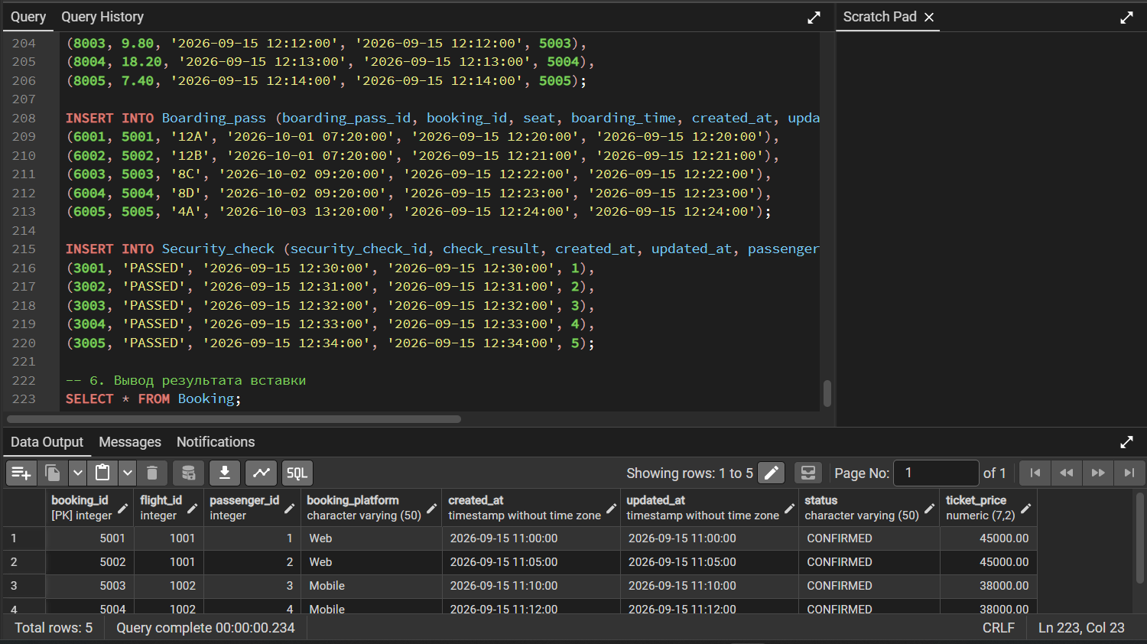

Conclusion
In this lab I learned how 1NF, 2NF and 3NF are different. First I made all values atomic, then I removed partial dependencies and finally I separated data with transitive dependencies. After that I used DDL commands to create the airport database, change the tables and add foreign keys. The final database structure has less duplicated data and is easier to maintain.

