**Graph Theory (Use AdjacencyList representation (where Map is used))**

Implement generic graph classes (Undirected and directed). You can create one class for both or two separate classes. Using these classes solve next problems:

1. Use Strings to represent cities. Add these cities to graph. You task is to find if we can pass from city A to city B. Answer is Yes or No. For example in the graph below you can pass from any city to any other. But if you remove edges *{Astana Aktobe}* and *{Astana Aktau}* then you can not pass from Almaty to Atyrau for example.

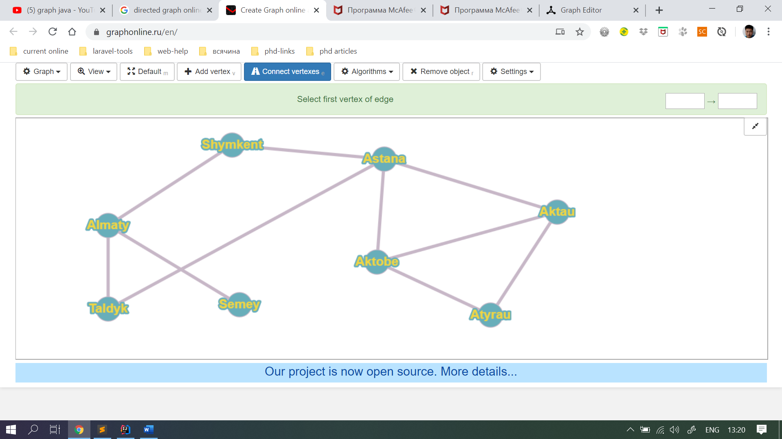

1. Do the same task but now with the directed graph. Just think that some roads now are one way only. And also try to go from city A to city B. Below you can not pass from Aktau to anywhere, or from Atyrau to any city except Akrau.

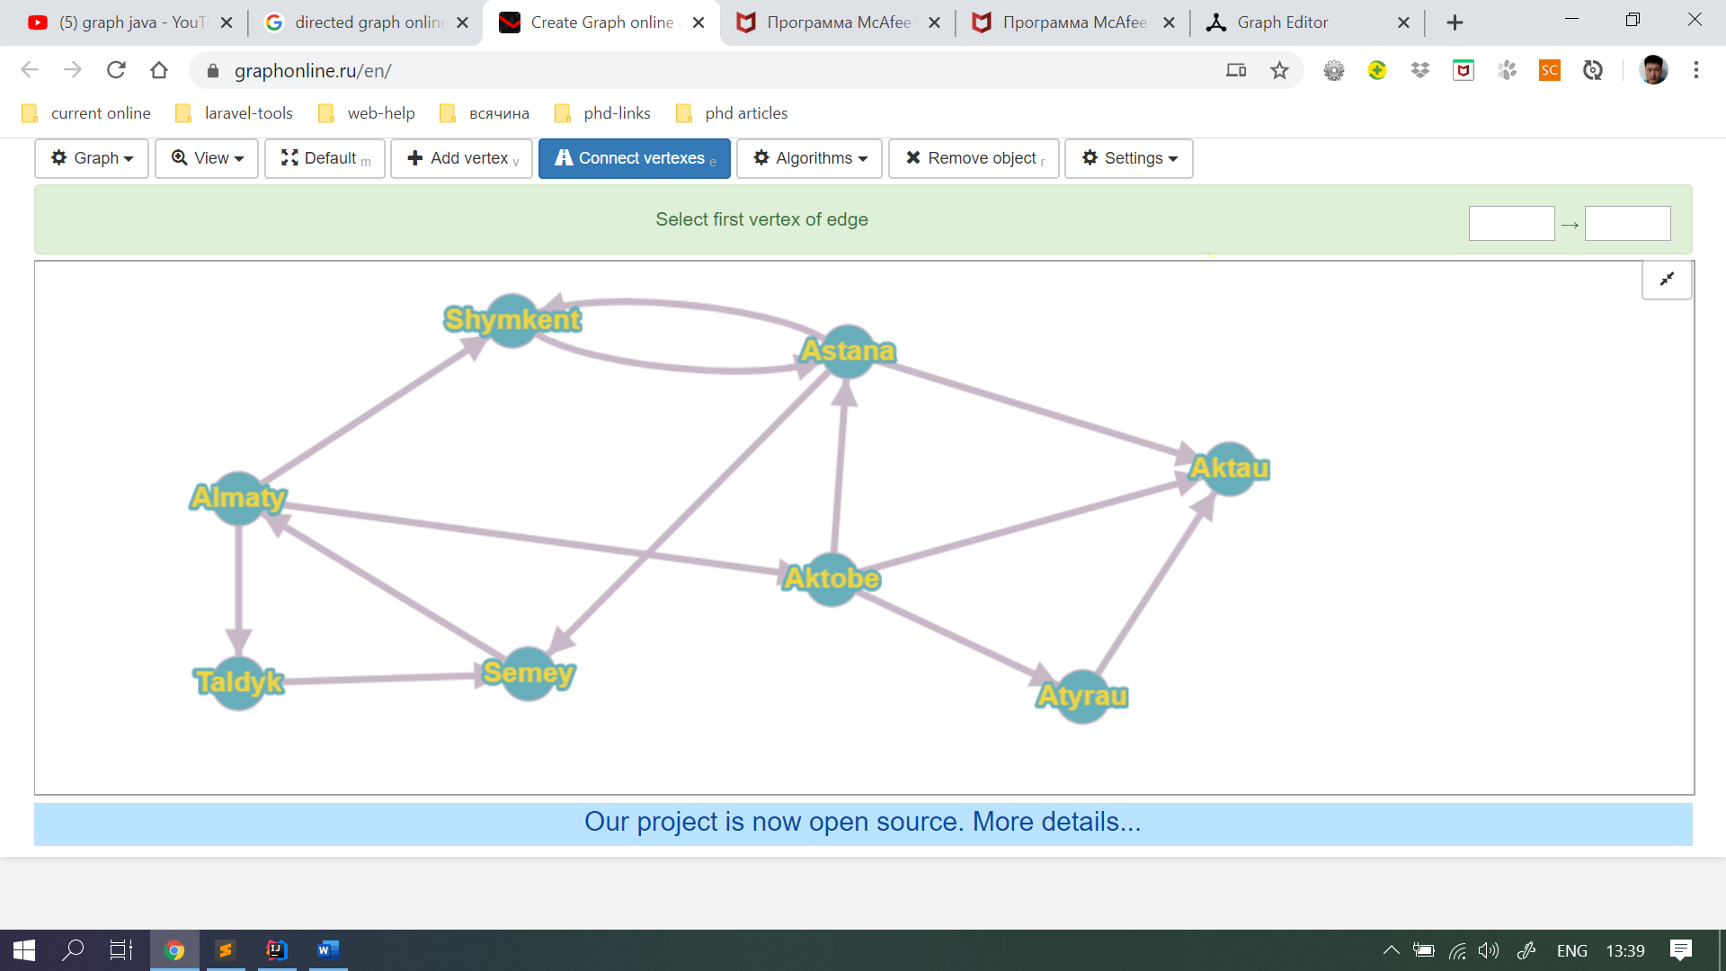

1. Use Strings to represent friendship among several people. As you know in Instagram there is a service that finds friends of your friends and suggests you to add or follow these people. Do the same task. For example(see picture below): Azamat has three friends (Ergali, Sabina and Musa). So if I enter Azamat service must show me:

* Shyngys(3 common friends)
* Ivan (2 common friends)
* Erik (2 common friends)
* Ilyas
* Erlan

You see it also must sort them by common friends decreasingly.

