**Graphs (Weigthed Graphs)**

Build weighted graph data structure to implement next tasks:

1. We have Instagram network, where people are connected(subscribed). All accounts have number of subscribed people. The graph shows only close friends(not all subscribed people).

Task is to find an account where we can put a commercial so that all subscribed people will see and also the account owner will ask its closer friends to repost and their subscribers also will see our commercial. So find someone to show our commercial to maximum number of people.

In the example below it is **meirzhan** account: 985 + 250 + 344 + 215 + 235 + 879 is maximum number of people.

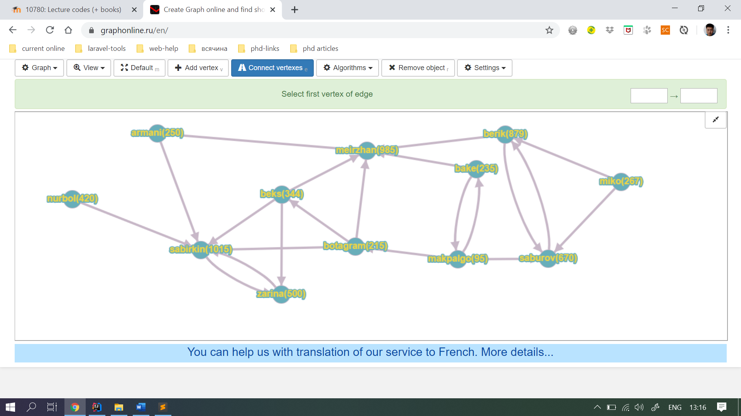

1. You have connected cities and distances between them. In each city there are some number of ill people. Also you are given city to start from and number of km you can travel. Your task is to find **path** where you can cure maximum number of people. Also you have to show the number of people that are healthy after you travel.

In the example below: if you are given city **Shymkent** to start from and you can go only 15 km. So your path will be Shymkent->Turkistan->Qyzylorda->Aktau and peoples to be cured are: 50+45+105+76 => is maximum.

