

American International University-Bangladesh (AIUB)

Faculty of Science and Technology (FST)
Department of Computer Science (CS)

SDPM Group Project, Spring 2025-26

Project Title: Affordable Car & Motorbike Subscription

Section : A

Submitted by

Name | ID
Md. Nafiun Ahmed Ovi | 22-46453-1
Nuren Tasnim Risha | 22-48474-3
Maisha Faria | 22-48478-3
Aritri Roy Priota | 23-51531-1

- Introduction
Owning a personal vehicle in Dhaka, Bangladesh, is often challenging due to high costs and practical limitations, which has created a growing demand for flexible and affordable transportation solutions. Our company is a Dhaka-based mobility service provider that focuses on addressing these challenges by offering car and motorbike rental and subscription services. We aim to make vehicle access easier and more affordable through a modern digital platform that allows users to subscribe to vehicles with manageable payments instead of large upfront costs. By integrating secure payment systems, GPS tracking, digital contracts, and driver hiring options, we ensure a safe, reliable, and user-friendly experience. Our goal is to transform urban mobility in Dhaka by providing convenient, cost-effective, and secure transportation solutions for all.

- Project Title
Affordable Car & Motorbike Subscription

- Objective:
Main Objective:
The primary objective of this project is to develop a robust, scalable, and user-centric digital platform that provides affordable and flexible access to cars and motorbikes in Dhaka through a subscription-based model. By shifting away from the traditional high-cost vehicle ownership model, the platform aims to make personal mobility accessible to a wider audience, reduce the financial burden of upfront payments, and ensure safety, convenience, and reliability for all users. The system will combine automation, real-time monitoring, and streamlined operations to deliver a seamless experience for both subscribers and the service provider.
Sub-Objectives:
- Accessibility & Affordability: Provide a range of subscription plans for cars and motorbikes, enabling users to select the vehicle type and plan that fits their budget, eliminating the need for large upfront payments or long-term loans.
- Process Digitization: Automate key operational processes, including user registration, e-KYC verification, digital contract signing, and subscription management, creating a paperless, efficient, and user-friendly experience.
- Real-Time Vehicle Security: Integrate advanced IoT-enabled tracking systems, including GPS monitoring, geofencing, and real-time alerts, to ensure the security of the vehicles and give subscribers peace of mind.
- Seamless Financial Transactions: Implement a secure, automated payment system capable of handling recurring billing, invoices, and payment reminders, ensuring transparency, reliability, and hassle-free financial operations.
- Resource & Maintenance Management: Develop an administrative dashboard to monitor the health and maintenance schedule of each vehicle, track active subscriptions, and manage driver availability, optimizing resource utilization and reducing operational overhead.
- On-Demand Driver Services: Provide an integrated feature for hiring professional drivers on-demand, allowing users to choose between self-driving or chauffeured services without leaving the platform.
- User Engagement and Notifications: Enhance the user experience with real-time notifications for upcoming payments, vehicle availability, service alerts, and subscription updates to keep users informed and engaged.
- Scalability and Multi-Platform Accessibility: Design the system to accommodate future growth, including the addition of new vehicles, service areas, and user load, while ensuring full accessibility through both mobile (Android/iOS) and web platforms.
- Actionable Analytics and Reporting: Generate reports and dashboards for both users and administrators, offering insights into vehicle usage, subscription trends, revenue streams, and system performance to enable informed decision-making and continual improvement.

4.0 Justification
The Affordable Car & Motorbike Subscription Platform offers a modern, automated solution designed to address the challenges of personal vehicle ownership in Dhaka. By combining a subscription-based approach with real-time monitoring, digital contracts, and optional driver services, the system helps users access reliable transportation while streamlining operations and enhancing overall urban mobility. Below are the comprehensive benefits, broken down into user, business, societal, and operational advantages.
User Benefits:
- Effortless Vehicle Access with Real-Time Updates: Users can subscribe to cars or motorbikes and manage their subscriptions through a digital platform. Automated updates ensure they are always informed about upcoming payments, vehicle availability, or contract renewals, making personal mobility simple and seamless.
- Proactive Vehicle and Asset Monitoring: The system continuously tracks vehicle location via GPS and geofencing, providing alerts for unauthorized movements or potential issues. This proactive monitoring ensures safety and prevents misuse or theft.
- Transparent and Paperless Experience: e-KYC verification and digital contract generation simplify registration, onboarding, and subscription management, reducing administrative burden and saving time.

Business Benefits:
- Maximize Operational Efficiency through Automation: Fleet and subscription management are centralized, reducing manual administrative tasks and allowing staff to focus on high-priority activities.
- Optimize Resource Allocation to Reduce Costs: Real-time monitoring of vehicles, subscriptions, and drivers enables efficient use of resources, reducing downtime, maintenance delays, and operational waste.
- Data-Driven Decisions with Actionable Insights: Detailed analytics on subscription trends, vehicle usage, and payment patterns provide insights for operational improvements and strategic planning.
Societal Benefits:
- Enhanced Urban Mobility: The platform reduces dependency on private vehicle ownership, making transportation accessible, flexible, and convenient for a broader population.
- Economic Opportunities: Integration of driver-hiring services creates employment opportunities while enabling more efficient use of vehicles.
- Financial Inclusion: Affordable subscription tiers allow residents from different economic backgrounds to access vehicles without large upfront costs.
Operational Benefits:
- Scalability for Future Growth: The platform is designed to accommodate more vehicles, users, and service areas as demand increases.
- Streamlined Payment and Billing Processes: Integrated payment gateways automate recurring billing, invoicing, and reminders, reducing errors and improving cash flow.
- Security and Reliability: GPS tracking, geofencing, and digital contracts ensure assets are protected and operations run smoothly, fostering trust among users and drivers

- Systems Overview: (Includes Use case diagram)

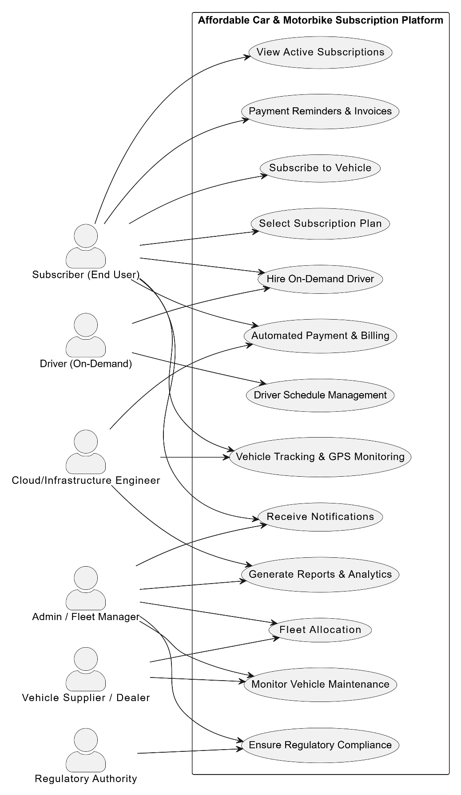

6.0 Project Stakeholders:

Stakeholder | Role | Responsibilities | Expectations | Communication Method | Stakeholder Type
Project Sponsor | Executive, Client Decision Maker | Approves project direction, budget, and timelines. Reviews final deliverables. | Timely progress updates, alignment with business goals, cost-effective solution. | Meetings, Emails, Reports | Primary
Timely progress updates, alignment with business goals, cost-effective solution. | Oversees the Project Execution | Manages the team, timelines, and deliverables. Handles risks and ensures project completion. | Clear objectives, successful project completion within the defined timeline. | Weekly Progress Meetings, Emails | Primary
Clear objectives, successful project completion within the defined timeline. | System Development and Coding | Design, develop, and implement the web and mobile applications, integrate APIs (GPS, payment, driver module). | Clear task assignments, well-defined requirements, smooth collaboration. | Daily Stand-ups, Code Reviews | Primary
Clear task assignments, well-defined requirements, smooth collaboration. | Design User Interface and Experience | Creates wireframes and designs for web and mobile platforms, ensuring an intuitive and visually appealing interface. | Feedback on design iterations, a user-centric approach. | Meetings, Design Reviews | Primary
Feedback on design iterations, user-centric approach. | Testing and Quality Control | Conduct unit, integration, system, and user acceptance testing to identify bugs and ensure quality standards. | Clear testing guidelines, collaboration with developers for bug fixes. | Bug Tracking System, Meetings | Primary
Cloud/Infrastructure Engineer | Cloud Service Setup and Management | Ensures system architecture is secure, scalable, and running efficiently on the cloud. | Reliable uptime, scalability, and performance optimization. | Emails, Monitoring Tools | Primary
Customer Support Team | Support for Users | Provides ongoing assistance to subscribers, resolving issues related to app usage, payments, or driver requests. | Prompt issue resolution, effective communication with users. | Support Tickets, Phone, Email | Primary
End Users (Subscribers) | Vehicle Subscribers | Use the platform to subscribe to vehicles, track payments, and optionally hire drivers; provide feedback. | Easy-to-use interface, reliable vehicle access, secure payment | App Notifications, Email, Feedback Surveys | Primary
Drivers (Professional / On-Demand) | Chauffeur Services | Provide driver services as requested via the platform, ensuring safety and timely pickups. | Clear schedules, timely notifications, smooth integration with app. | Mobile App Notifications, SMS Alerts | Primary
Vehicle Suppliers / Dealers | Vehicle Providers | Supply cars and motorbikes, assist with maintenance, and ensure fleet availability. | Timely communication, adherence to vehicle quality standards. | Emails, Phone, Admin Portal | Secondary
Regulatory Authorities | Compliance and Oversight | Ensure the platform complies with transportation, digital, and financial regulations. | Compliance with laws and timely updates on regulatory changes. | Reports, Email, Meetings | Secondary

7.0 Feasibility Study
The feasibility study for the Affordable Car & Motorbike Subscription Platform evaluates both the technical and financial viability of developing and deploying the system in Dhaka. The purpose of this assessment is to ensure that the project is realistic, sustainable, and capable of delivering the intended benefits to all stakeholders.
Technical Feasibility:
The proposed system is technically feasible due to the availability of modern tools, frameworks, and infrastructure required for its development and operation.
- Platform Development: The system will be developed as a cross-platform solution using React Native or Flutter for mobile applications and React.js or Vue.js for the web dashboard, ensuring compatibility with Android, iOS, and web browsers.
- Backend & Database: The backend will use Node.js, Django, or Laravel, with PostgreSQL/MySQL for structured data and MongoDB/Redis for real-time tracking. This ensures scalability, reliability, and efficient handling of high volumes of transactions and vehicle tracking data.
- Vehicle Tracking & Security: Integration of GPS tracking, geofencing, and IoT-enabled devices ensures real-time monitoring of vehicles, enhancing asset security and operational reliability.
- Payment Gateway Integration: Local payment systems such as bKash, Nagad will be incorporated for secure recurring subscription payments.
- Infrastructure: Cloud hosting on platforms like AWS, Google Cloud will support scalability, high uptime, and disaster recovery.
- Human Resources: Skilled developers, QA testers, UI/UX designers, fleet managers, and support staff are available to deliver and maintain the system.
The combination of mature technologies, available expertise, and existing infrastructure makes the system highly technically feasible.
Financial Feasibility:
The project has been evaluated for financial viability, including initial development costs, recurring operational expenses, and projected revenue.
- Development Budget: The total estimated cost is $15,000, covering planning, development, integration, testing, and deployment.
- Operational Savings and Revenue: Automation of subscription management, billing, fleet tracking, and driver services is projected to generate $8,000–10,000 annually in operational savings and revenue.
- Return on Investment (ROI): Based on projected revenue, the break-even point is expected within 18–22 months, making the investment sustainable and profitable.
- Cost Efficiency: Centralized maintenance, automated billing, and efficient resource allocation reduce overhead costs, while scalability allows for growth without significant additional capital investment.

8.0 System Components
The Affordable Car & Motorbike Subscription Platform is designed as a modular, digital ecosystem to streamline vehicle subscription, fleet management, and user engagement. Breaking the system into components allows scalability, security, and operational efficiency.
Modules:
1. Subscription & Vehicle Booking Module:
- Purpose: Manages user registration, vehicle selection, subscription plans, and booking confirmation.
- Key Features:
  - e-KYC verification ensures compliance and security.
  - Users can select vehicles, subscription tiers, and duration.
  - Real-time confirmation of vehicle availability and conflict resolution.
- Interactive Benefit: Users can monitor active subscriptions, upcoming payments, and vehicle locations in a dashboard.
2. Driver Management Module:
- Purpose: Coordinates on-demand driver services.
- Key Features:
  - Assigns drivers based on availability and location.
  - Tracks driver performance, shift completion, and user ratings.
- Interactive Benefit: Drivers receive task notifications, while admins monitor schedules and performance.
3. Vehicle Tracking & Security Module:
- Purpose: Monitors fleet in real-time and ensures asset safety.
- Key Features:
  - GPS tracking, geofencing, and automated alerts for unauthorized movement.
  - Remote immobilization in case of theft or misuse.
- Interactive Benefit: Admins and users can track vehicles and receive instant alerts.
4. Maintenance & Resource Management Module:
- Purpose: Manages vehicle maintenance, fleet resources, and operational tasks.
- Key Features:
  - Tracks service schedules and maintenance history.
  - Monitors resource usage (fuel, parts, tools) to reduce waste.
- Interactive Benefit: Fleet managers generate reports to optimize vehicle utilization and maintenance planning.
5. Payment & Billing Module:
- Purpose: Automates subscription payments and digital contract management.
- Key Features:
  - Integrates local payment gateways for recurring billing.
  - Generates invoices and sends reminders to users.
- Interactive Benefit: Users track payments in real-time; admins have visibility over revenue.
6. Analytics & Reporting Module:
- Purpose: Provides actionable insights for users and administrators.
- Key Features:
  - Tracks subscription trends, fleet utilization, revenue, and driver performance.
  - Generates dashboards for decision-making.
- Interactive Benefit: Admins and users can analyze usage patterns and optimize fleet performance.
7. Customer Portal:
- Purpose: Central interface for subscription management and feedback.
- Key Features:
  - Booking management, service requests, and feedback collection.
- Interactive Benefit: Users interact with the platform, submit queries, and track issue resolution.
8. Mobile & Web Access Module:
- Purpose: Ensures multi-platform accessibility.
- Interactive Benefit: Users, admins, and drivers can access data and updates on mobile or desktop anywhere.

9.0 Process Model to be Followed
The project will adopt the Agile Iterative Development Model, which is well-suited for software projects requiring flexibility, frequent stakeholder feedback, and incremental delivery of functionality. This approach aligns with the PM3 Process & Phases concepts from the slides and ensures the system can adapt to evolving user needs while minimizing risks during development.

Justification for Agile Iterative Model
- Incremental Releases:
  - The Agile model allows the system to be delivered in small, functional increments. Each module (e.g., subscription management, vehicle tracking, driver services) is developed and tested independently, providing tangible outputs at the end of each sprint.
  - Users and stakeholders can interact with early versions, validate requirements, and suggest improvements, which reduces the likelihood of major redesigns later.
- Frequent Feedback & Adaptation:
  - Agile emphasizes continuous communication between developers, testers, admins, and end-users.
  - Feedback from each iteration is incorporated immediately into the next sprint, allowing the project to adapt quickly to new requirements or changes in business priorities.
- Risk Reduction through Progressive Integration:
  - By integrating and testing modules progressively, the Agile approach ensures that potential issues are detected early.
  - For example, GPS tracking integration, payment gateway setup, and subscription automation can be individually tested before full system deployment.
- Enhanced Collaboration Across Teams:
  - Agile promotes close collaboration among frontend and backend developers, UI/UX designers, QA testers, and project managers.
  - Cross-functional team coordination ensures consistent design, coding standards, and user experience across web and mobile platforms.

Workflow of the Agile Iterative Model
- Requirement Gathering:
  - Collect detailed functional and non-functional requirements from stakeholders, including users, drivers, fleet managers, and administrators.
  - Document specifications for each module: subscription, booking, driver services, vehicle tracking, and payment processing.
- Sprint Planning:
  - Break down the project into short sprints (1–2 weeks each).
  - Prioritize features and modules based on business needs, technical dependencies, and risk factors.
  - Assign tasks to development, QA, and design teams.
- Module Development:
  - Develop each module independently within a sprint:
    - Subscription & Booking
    - Driver Management
    - Vehicle Tracking & Security
    - Payment & Billing
    - Maintenance & Resource Management
  - Implement unit tests during development to catch errors early.
- Testing & Quality Assurance (QA):
  - Conduct iterative testing after each sprint, including:
    - Unit Testing – individual components
    - Integration Testing – module interactions
    - System Testing – end-to-end workflows
    - User Acceptance Testing (UAT) – validate features against requirements
  - Document defects and feedback for next iteration.
- Feedback & Iteration:
  - Review testing outcomes and user feedback after each sprint.
  - Modify requirements, improve functionality, and fix defects.
  - Prepare the next sprint with updated priorities based on feedback.
- Deployment:
  - Deploy tested and verified modules to production in stages.
  - Conduct final system integration, performance testing, and user training.
  - Launch the platform with full functionality and monitor post-deployment performance.
Advantages of Agile Iterative Model for This Project:
- Flexibility to accommodate changes in user requirements (e.g., adding new subscription plans, driver features).
- Faster detection and resolution of technical issues through incremental testing.
- Improved user engagement and satisfaction, as stakeholders see visible progress after each sprint.
- Streamlined coordination across multiple teams, ensuring high-quality delivery.

10.0 Effort Estimation
The Effort Estimation is based on the technical complexity of modules, required infrastructure, and available human resources. Using the WBS (Work Breakdown Structure) methodology, each module of the system is evaluated for development time, required programmers, and dependencies. This ensures accurate planning for resources and scheduling.
- Requirement Analysis: 5 days, 2 members
- System Design: 7 days, 2 members
- Module Development:
  - Subscription & Booking: 10 days, 2 members
  - Driver Management: 8 days, 1 member
  - Vehicle Tracking & Security: 10 days, 2 members
  - Maintenance & Resource Management: 8 days, 1 member
  - Payment & Billing: 6 days, 1 member
  - Analytics & Reporting: 6 days, 1 member
  - Customer Portal: 6 days, 1 member
  - Mobile & Web Access: 10 days, 2 members
- Integration & Testing: 10 days, 3 members
- Deployment: 3 days, 2 members
- Training & Documentation: 3 days, 2 members
Total: 94 person-days, 3–4 developers with QA and UI/UX support

11.0 Activity Network diagram

ID | Activity | Duration (Days) | Predecessor(s) | ES (Early Start) | EF (Early Finish) | LS (Late Start) | LF (Late Finish) | Slack (Days)
A | Requirement Analysis | 5 | - | 0 | 5 | 0 | 5 | 0
B | System Design | 7 | A | 5 | 12 | 5 | 12 | 0
C1 | Subscription & Booking | 10 | B | 12 | 22 | 12 | 22 | 0
C2 | Driver Management | 8 | B | 12 | 20 | 16 | 24 | 4
C3 | Vehicle Tracking & Security | 10 | B | 12 | 22 | 12 | 22 | 0
C4 | Maintenance & Resource Mgmt | 8 | B | 12 | 20 | 16 | 24 | 4
C5 | Payment & Billing | 6 | B | 12 | 18 | 18 | 24 | 6
C6 | Analytics & Reporting | 6 | B | 12 | 18 | 18 | 24 | 6
C7 | Customer Portal | 6 | B | 12 | 18 | 18 | 24 | 6
C8 | Mobile & Web Access | 10 | B | 12 | 22 | 12 | 22 | 0
D | Integration & Testing | 10 | All C1-C8 | 22 | 32 | 22 | 32 | 0
E | Deployment | 3 | D | 32 | 35 | 32 | 35 | 0
F | Training & Documentation | 3 | E | 35 | 38 | 35 | 38 | 0

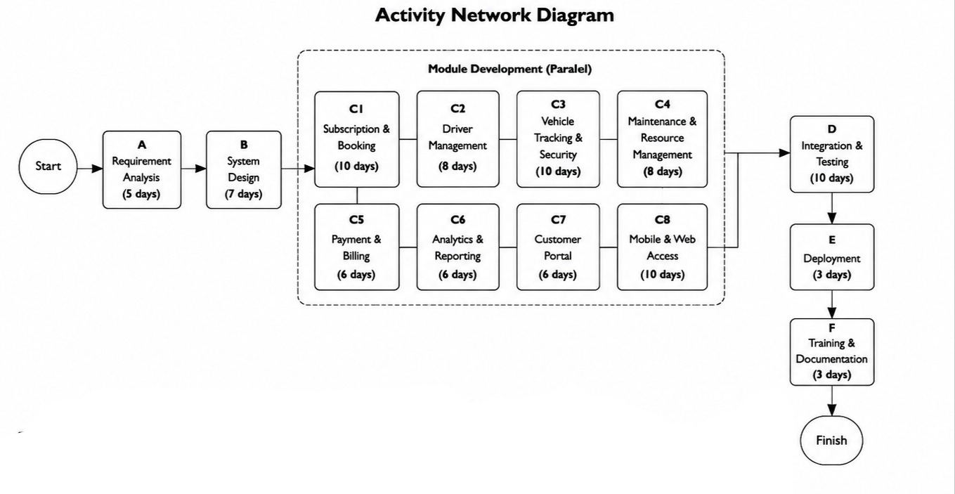
Critical path is: System Design -> Subscription & Booking -> Vehicle Tracking & Security ->Mobile & Web Access ->Integration & Testing ->Deployment->Training & Documentation.
Total project duration 38 days.

12.0 Activity Network diagram

Technical Risks
Risk | Description | Likelihood | Impact | Mitigation Strategy
GPS/IoT Integration Failure | GPS or IoT devices may fail to transmit accurate data or face network issues | Medium | High | Use tested hardware, implement redundant tracking systems, perform rigorous pre-deployment testing
Payment Gateway Failure | bKash/Nagad payment system may experience downtime or transaction errors | Medium | High | Integrate multiple payment options and fallback mechanisms; monitor payment processing
Software Bugs | Code errors in backend, frontend, or mobile apps affecting functionality | High | Medium | Agile iterative testing, unit and integration testing, regular code reviews
Operational Risks
Risk | Description | Likelihood | Impact | Mitigation Strategy
Vehicle Maintenance Delays | Vehicles may face unplanned maintenance or breakdowns | Medium | High | Implement predictive maintenance via analytics and proactive scheduling
Driver Availability | On-demand driver module may experience staff shortage | Medium | Medium | Maintain a pool of trained drivers and flexible scheduling

Financial Risks
Risk | Description | Likelihood | Impact | Mitigation Strategy
Budget Overrun | Project costs exceeding the $15,000 budget | Low | High | Monitor expenses continuously, allocate contingency funds, review vendor contracts
Revenue Shortfall | Lower than projected subscription uptake | Medium | High | Conduct market analysis, adjust pricing or promotions, enhance marketing

Security Risks
Risk | Description | Likelihood | Impact | Mitigation Strategy
Data Breach | Unauthorized access to user or financial data | Low | High | Implement strong encryption, secure cloud infrastructure, regular security audits
Project Management Risks
Risk | Description | Likelihood | Impact | Mitigation Strategy
Delays in Development | Modules not delivered as per planned sprints | Medium | Medium | Agile methodology, clear task allocation, daily stand-ups, milestone tracking
Stakeholder Miscommunication | Misalignment between project team and stakeholders | Low | Medium | Frequent updates, clear documentation, review meetings

13.0 Resource Requirements and Budget

i. Project Resources
- Team: 1 Project Manager, 1 Cloud Architect, 2 Backend Developers, 1 Frontend Developer, 1 QA/Security Analyst, 1 DevOps/SRE.
- Tools & Infrastructure: IDEs, frameworks (React, Flutter, Node.js/Django/Laravel), databases (PostgreSQL/MySQL, MongoDB/Redis), cloud hosting (AWS/Google Cloud), GPS/IoT devices.
- Devices: Smartphones for testing, desktops/laptops for development.

ii. Client Resources
- Devices: Smartphone (Android/iOS), Desktop/Laptop.
- Software & Connectivity: Web browser, mobile app, stable internet connection, GPS-enabled device if needed.

Budget
- Development: 5,00,000 BDT (includes all modules and integration).
- Maintenance & Support: 1,00,000 BDT/year.
- Cloud & Hosting: 20,000–50,000 BDT/month.
- Optional Integrations: Payment gateways, SMS, mapping services.
- Mobile App: 50,000–1,50,000 BDT if separate iOS/Android development.
- Contingency: 10% of total.
Estimated Total Initial Cost: 5,00,000–6,00,000 BDT (excluding optional and contingency).
14.0 Conclusion
The Affordable Car & Motorbike Subscription Platform is a comprehensive digital solution designed to transform urban mobility in Dhaka by offering flexible, cost-effective, and reliable vehicle access. Through subscription-based plans, automation of processes, real-time tracking, and integrated driver services, the system addresses the challenges of high vehicle costs, traffic congestion, and maintenance complexities. The project leverages modern technologies, cloud infrastructure, and a well-defined cross-functional team to ensure technical feasibility, scalability, and operational efficiency. Risk analysis, resource planning, and budget estimation confirm that the system is both sustainable and economically viable. By providing a user-friendly interface for subscribers, efficient fleet management tools for administrators, and secure operations, the platform promises to enhance transportation accessibility, improve client satisfaction, and create opportunities for economic growth. Overall, the project represents a significant step toward smarter, safer, and more sustainable urban mobility solutions in Dhaka.

