

**Mobile Applications Development**

Year 2 (2019/20), Semester 3

Year 3 (2019/20), Semester 5

***SCHOOL OF INFOCOMM TECHNOLOGY***

Diploma in Financial Informatics

Diploma in Information Technology

**ASSIGNMENT**

**Duration :**  1 July 2019 to 29 July 2019

**Weightage :** 30% of total coursework

**Individual/Team :** Team (3 students)

**Format :** Stage 1 (20%)

Stage 2 (80%)

**Cut-Off Date/Time: Monday, 29 July 2019, 9 AM** (week 16)

**Penalty for late submission**: 10 marks per day (including Sunday and public holiday)

No report will be accepted after **5 Aug 2019, 9 AM**.

|  |  |  |  |
| --- | --- | --- | --- |
| **Tutorial Group:** | P03 | **Team Number:** | 6 |
| **Members** | **Student No.** | **Student Name** | **Grade** |
| S10189886D | Dicco Neoh Hyu Hang |  |
| S10189288F | Nur Izni Nadhira Binte Zailani |  |
| S10187123D | Nurhannanis Binte S.Zulkifli |  |
|  |  |  |

**Lobang Finder**

Lobang Finder is an application created with the intention of helping users to find fun shopping areas based on their location. The application is named like this because it knows all the good places the users are sure to enjoy themselves at.

**Roles & Responsibilities**

For this project, we have equally assigned each member with respective areas of managements. Dicco handles the creation of storyboard, the designing of logo and the general layout. Izni handles the data storage in Firebase, inputting necessary data for the app as well as the research for the codes required on displaying the collected data into android studio. Hannanis manages the coding for all the pages on the android studio.

**Features of the app**

The features of Lobang Finder are the implementation of Google map. The app is able to display the user’s current location on the map. It also has a recyclerview of the nearest fun spots according to the one nearest to the user’s location. The areas implemented are of Clementi, Jurong, Bukit Batok, Orchard and Bukit Panjang.

* Responsive Layout
* Manifest Customization
* Intents
* Google Map implemented
* Use of Adapter for recyclerview
* Own design of logo

**App Design**

Lobang Finder has a rather simple and basic design as not to complicate the codes and to meet the minimum requirements. The screenshots of the app will be displayed below.

**First Page:**  **Second Page:**

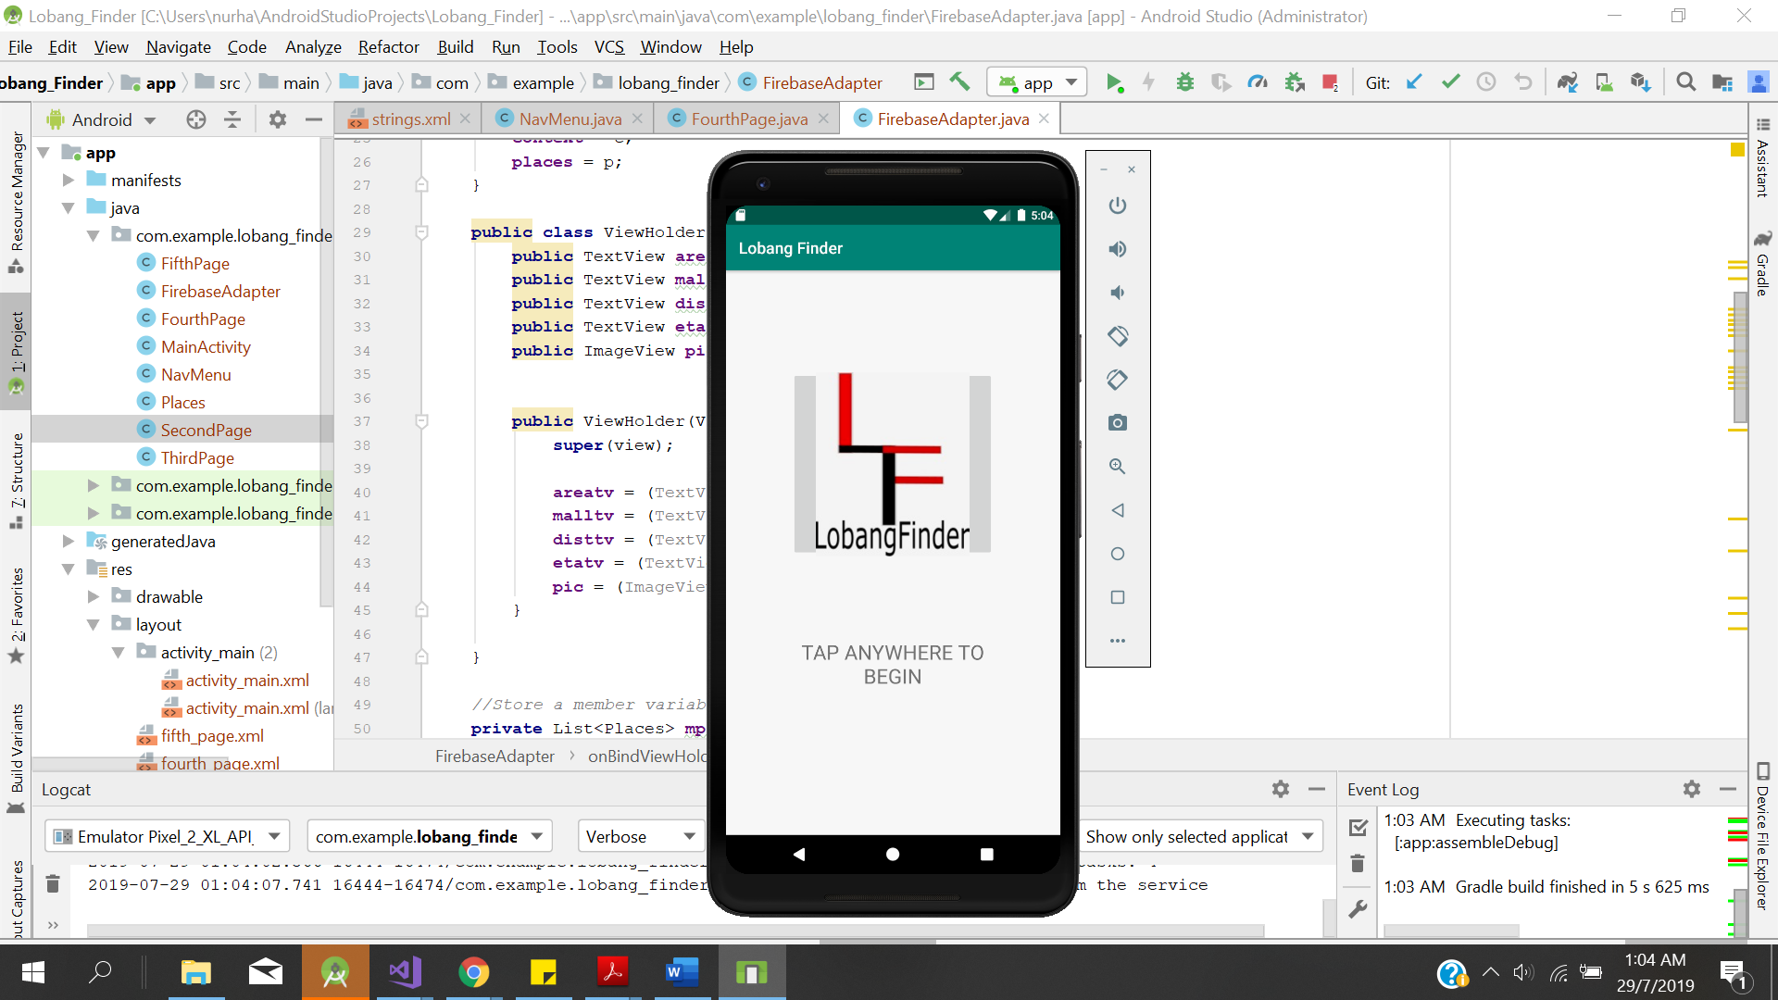 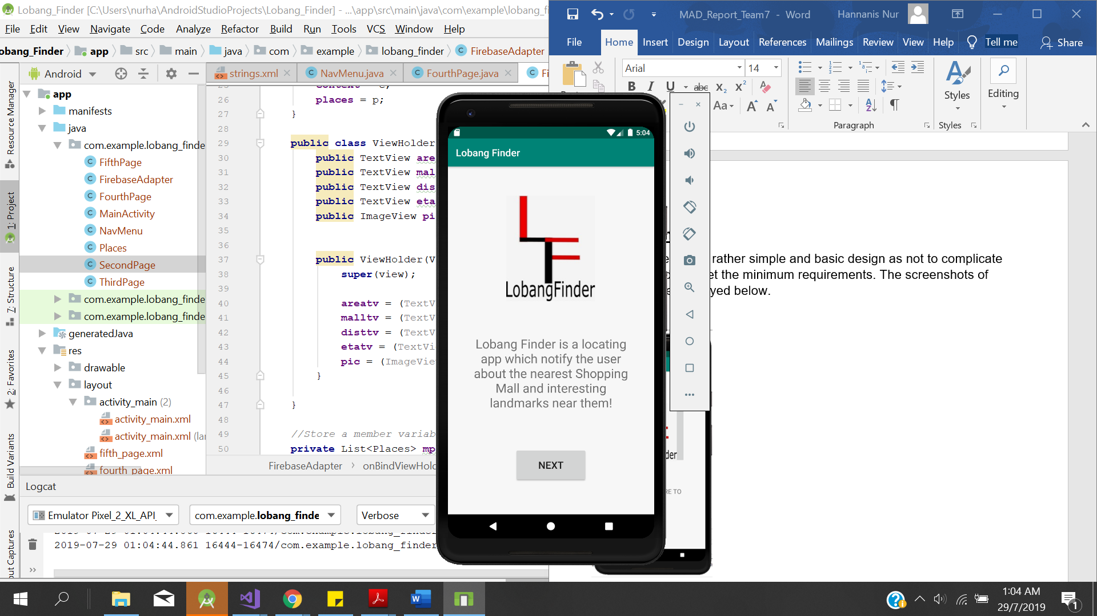

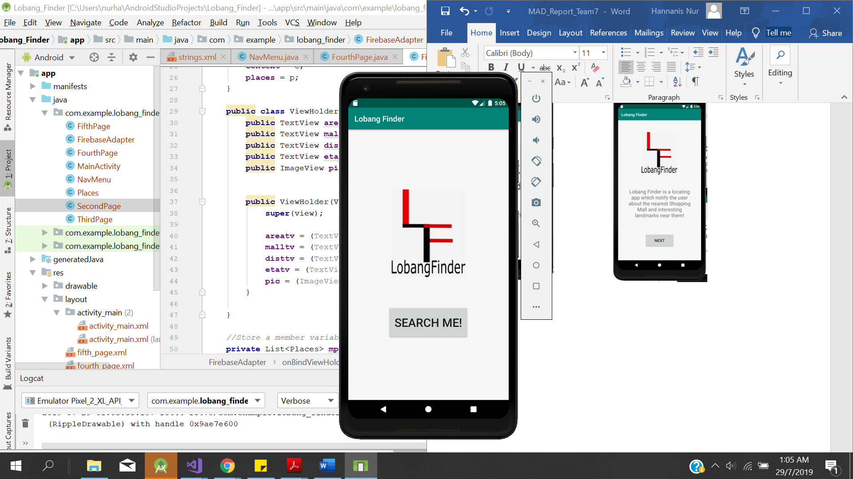 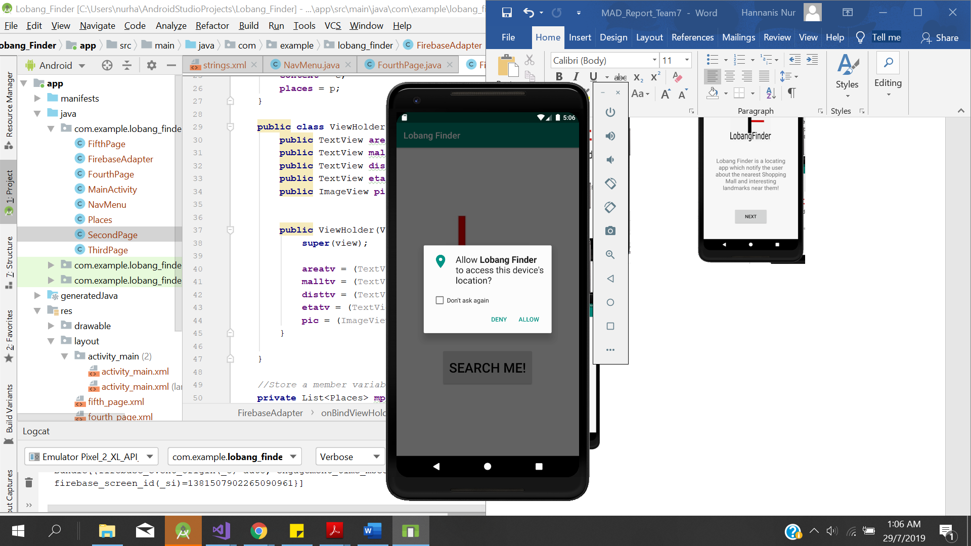

**Fourth Page:**

**Third Page:**

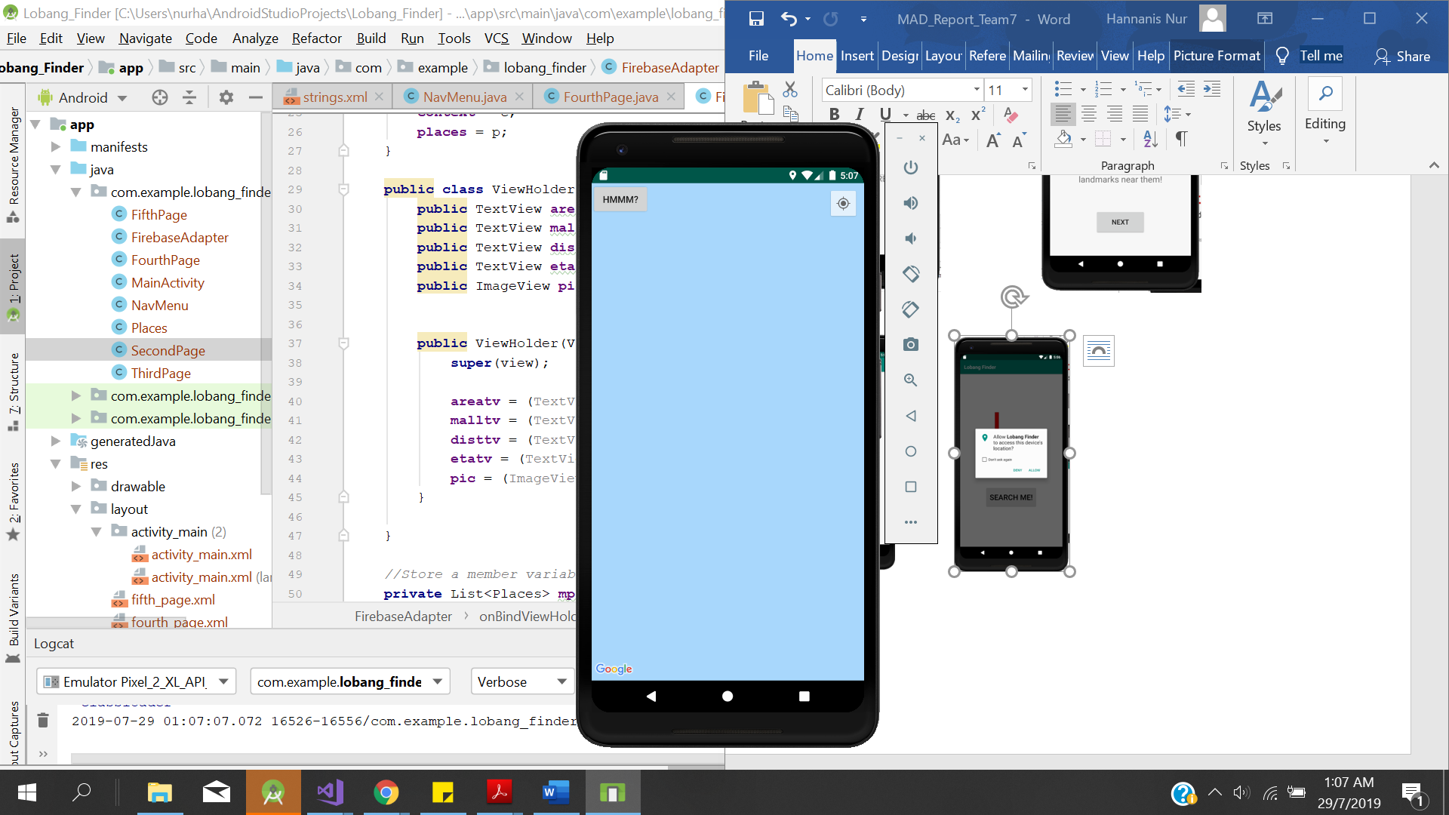 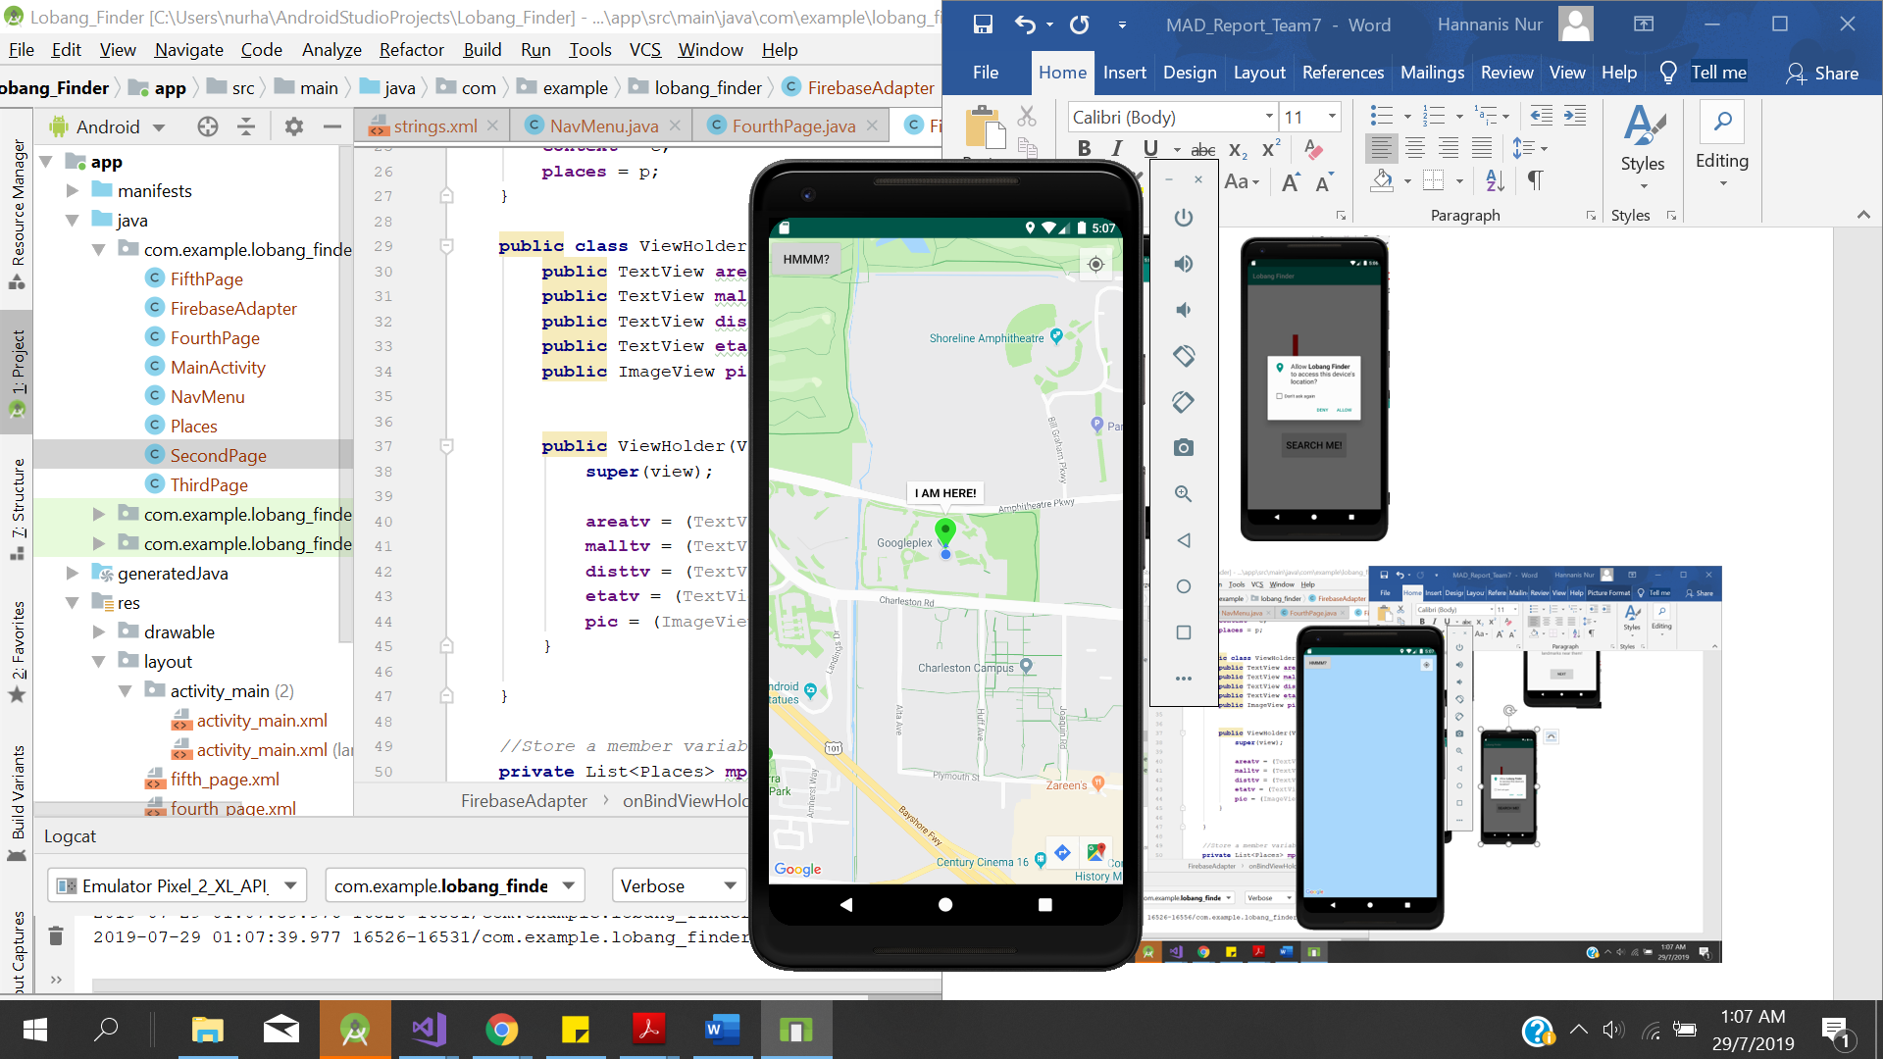

**Sixth Page:**

**Fifth Page:**

**Error Page:**

**Seventh Page:**

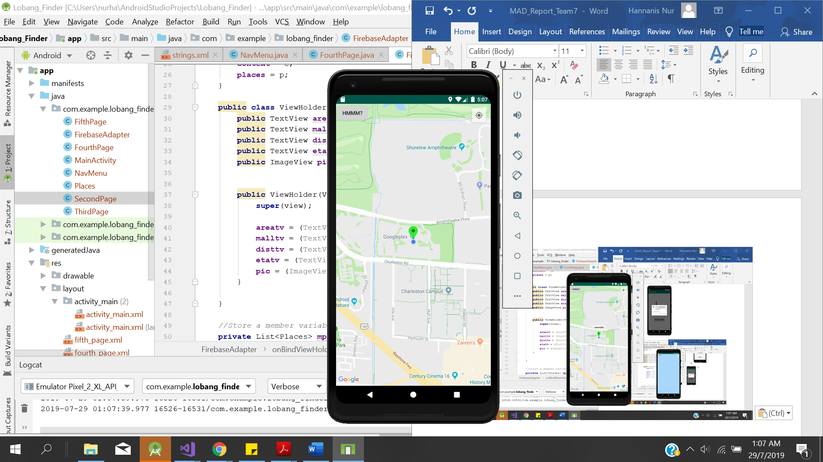 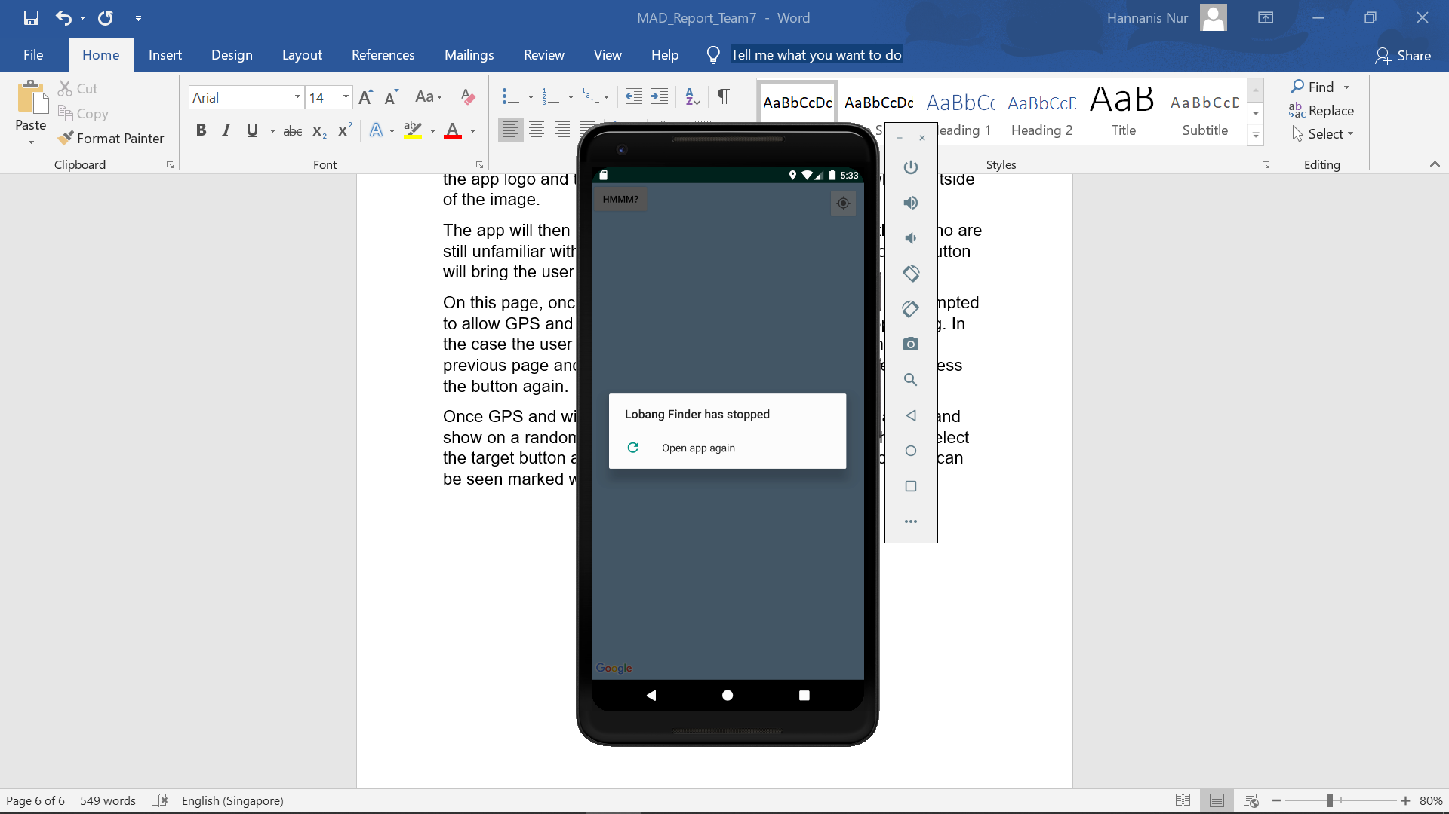

**User Guide**

Lobang Finder is an easy app to navigate through for users. It has only the necessary functions for users to toggle with.

Starting off, the user opens the app to see the first interface. It displays the app logo and the user can proceed on by tapping anywhere outside of the image.

The app will then show a short introduction of the app, for those who are still unfamiliar with the main intention of the app. Pressing of the button will bring the user to the next page.

On this page, once the user selects “Search Me” button, they will be prompted to allow GPS and internet as to allow the app to continue operating. In the case the user denies the permission, the app will return to the previous page and will prompt the same thing if the user tries to press the button again.

Once GPS and wi-fi is enabled, a Google Map display will launch and show on a random spot. To know where the user is, they should select the target button at the top right of the screen. The user’s location can be seen marked with a green marker with “I AM HERE!”

If user selects the “Hmm” button, a list of the nearest shopping malls and fun places will be displaced according to the nearest to the user’s location.