**How to incorporate the quantitative trait data model + integration with trait ontologies into the phenopacket model?**

As a new phenopacket building blog:

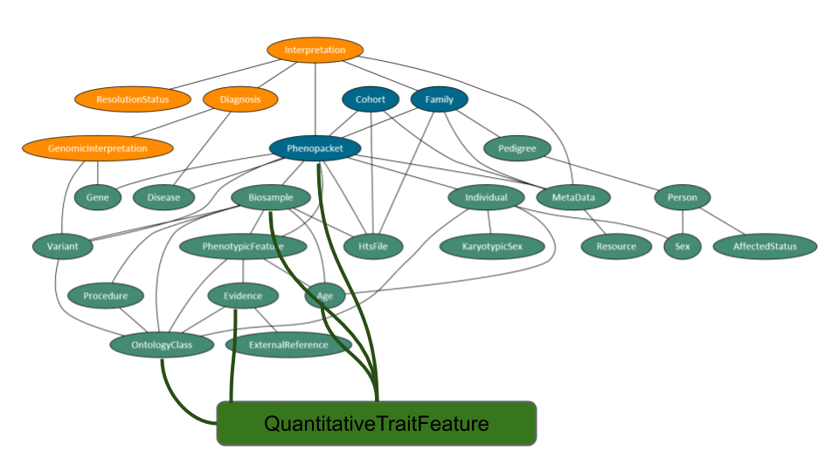

**Quantitative_trait_feature**

This is a list of quantitative traits as clinical signs and laboratory findings observed in the subject. See below for further information.

**QuantitativeTraitFeature**

This element is intended to be used to describe a quantitative trait that characterizes the subject of the Phenopacket. For medical use cases the subject will generally be a patient or a proband of a study, and the quantitative traits will be clinical or laboratory measurements described by an ontology such as the Clinical Measurement Ontology. The word quantitative trait mean An individual trait feature, observed as either present or absent (negated), with possible onset, modifiers and frequency.

**Data model**

|  |  |  |  |
| --- | --- | --- | --- |
| **Field** | **Type** | **Status** | **Description** |
| description | string | optional | human-readable verbiage **NOT** for structured text |
| type | OntologyClass | required | term denoting the quantitative trait feature |
| negated | boolean | optional | defaults to false |
| value | string | required | Measurement value |
| unit | OntologyClass | required | term denoting the unit of measurement |
| assay | OntologyClass | optional | Term denoting the assay type |
| onset | [Age](https://phenopackets-schema.readthedocs.io/en/latest/age.html#rstage) OR [AgeRange](https://phenopackets-schema.readthedocs.io/en/latest/age.html#rstagerange) | recommended | Age at which the feature was first observed |
| biosample | [Biosample](https://phenopackets-schema.readthedocs.io/en/latest/biosample.html) | recommended | Unit of biological material from which the substrate for analyses are extracted |
| evidence | [Evidence](https://phenopackets-schema.readthedocs.io/en/latest/evidence.html) | recommended | the evidence for an assertion of the observation of a type (ECO) |

Example

{

"type": {

"id": "CMO:0000015",

"label": "Body temperature"

},

"Value": “37.5”,

"unit": {

“id”: “UO:0000027”,

“label”: "Degrees Celsius",

}

}

**Description**

This element represents a free-text description of the quantitative trait.

**Type**

This element represents the primary ontology class which describes the quantitative trait, e.g. Temperature (CMO:0000015).

**Negated**

This element is a flag to indicate whether the quantitative trait was measured or not.

**Value**

This element is a string that describes the magnitude measured of the trait.

**Unit**

This element is an ontology class that describes the unit label of measurement.

**Assay**

This element is an ontology class that describes the type of assay.

**Onset**

This element is recommended to describe the age at which the quantitative trait feature was first noticed.

**Biosample**

This element is recommended to describe the unit of biological material from which the substrate for analyses are extracted.

**Evidence**

This element is recommended and contains one or more [Evidence](https://phenopackets-schema.readthedocs.io/en/latest/evidence.html#rstevidence) elements that specify how the trait was determined.

**Data model OBSOLETE**

|  |  |  |  |
| --- | --- | --- | --- |
| **Field** | **Type** | **Status** | **Description** |
| description | string | optional | human-readable verbiage **NOT** for structured text |
| type | OntologyClass | required | term denoting the quantitative trait feature |
| negated | boolean | optional | defaults to false |
| quantity* | OntologyClass | required |  |
| severity | OntologyClass | optional | description of the severity of the feature described in type ( representing [HP:0012824](https://hpo.jax.org/app/browse/term/HP:0012824)? Or PATO as appropriate) |
| modifier | List of OntologyClass | optional | representing one or more terms (from [HP:0012823](https://hpo.jax.org/app/browse/term/HP:0012823)? Or PATO as appropriate) |
| onset | OntologyClass | optional | Age at which the features was first observed, e.g. [HP:0011462](https://hpo.jax.org/app/browse/term/HP:0011462) ? |
| evidence | Evidence | recommended | the evidence for an assertion of the observation of a type (ECO?) |

*QUDT model: https://qudt.org/

Example

{

"type": {

"id": "CMO:0000015",

"label": "Temperature"

},

"quantity": {

“id”: “qud:Quantity”

"value": {

“id”: “qud:QuantityValue”,

“magnitude”: "40.1"

},

"Kind": {

“id”: “qud:QuantityKind”,

“label”: "Temperature"

},

"unit": {

“Id”: “qud:Unit”,

“label”: "Celsius Degrees",

“system”: {

“id”: “OntologyClass”,

“label”: “metric”

},

},

},

"severity": {

id": "OntologyClass",

"label": "Severe"

},

"modifier": {

id": "OntologyClass",

"label": "Increased"

}

}

**Description**

This element represents a free-text description of the quantitative trait.

**Type**

This element represents the primary ontology class which describes the quantitative trait, e.g. Temperature (CMO:0000015).

**Negated**

This element is a flag to indicate whether the quantitative trait was measured or not.

**Quantity**

This element is an ontology class that describes the quantity measured of the trait.

**Severity**

This element is an ontology class that describes the severity of the condition.

**Modifier**

This element is a list of ontology class elements that can be empty or contain one or more ontology terms that are intended to provide more expressive or precise descriptions of a quantitative trait feature, including attributes such as positionality and external factors that tend to trigger or ameliorate the feature. Terms can be taken from the hierarchy of Clinical modifier in the HPO (noting that severity should be coded in the severity element).

**Onset**

This element can be used to describe the age at which the quantitative trait feature was first noticed. For many medical use cases, either the Age sub-element or an ontology class (e.g., from the HPO Onset (HP:0003674) terms) will be used.

**Evidence**

This element is recommended and contains one or more [Evidence](https://phenopackets-schema.readthedocs.io/en/latest/evidence.html#rstevidence) elements that specify how the phenotype was determined.