Lion algorithm: Overview, modifications and applications

Saman M. Almufti
Computer Science, Nawroz University, Kurdistan-Region, Iraq
saman.almofty@gmail.com

A B S T R A C T |  | A R T I C L E I N F O
The increasing complexity of real-world problems motivated computer scientists and researchers to seek more efficient problem-solving strategies. Because of their ability to adapt to a wide range of conditions, Natural Inspired, Bio Inspired, Metaheuristics based on evolutionary computation, and Swarm Intelligence algorithms have been widely used for solving complex, real-world optimization problems. This paper presents a swarm based algorithm that is based on the cooperative behaviors between Loin’s, it is called Lion Algorithm (LA) algorithm. This paper provides a review of these algorithms, with a particular emphasis on the Lion algorithm. Lion Algorithm is based on lions' unique social behavior, which makes them the world's strongest animal. Loin Algorithm, like Genetic Algorithm, includes generation, mutation, crossover, and so on. The lion's territorial defense and territorial takeover behavior distinguishes this algorithm from others. |  | Received : June 14, 2022  Revised : June 22, 2022  Accepted : July 21, 2022  K E Y W O R D S  Evolutionary  algorithm, Lion Algorithm (LA), Metaheuristic, Optimization,  Swarm intelligent
Suggested Citation (APA Style 7th Edition):

Almufti, S.M. (2022). Lion optimization algorithm: Overview, modifications and applications. International Research Journal of Science, Technology, Education, and Management, 2(2), 176-186. https://doi.org/10.5281/zenodo.6973555

Introduction

In computer science and engineering fields, it is typically very difficult to solve various optimization problems. Over the past few decades, different algorithms are designed to deal with these complex problems. In these problems, search space grows exponentially with the problem size. Therefore, the traditional algorithms do not afford a suitable solution for them. Hence, many metaheuristic methods have been designed to solve those difficult optimization problems (Yazdani & Jolai, 2016).

Metaheuristic algorithms are a collection of techniques that inspires their ideologies from nature’s concept of characteristics, appearance, evolutions, and behaviors. These algorithms typically follow metaheuristics principles.
Generally, metaheuristic algorithms describe as a "master strategy that guides and modifies other heuristics to produce solutions beyond those that are normally generated in a quest for local optimality" (Marqas, Almufti, Ahmed, & Asaad, 2021). Metaheuristic algorithms use a certain alteration, modifications, randomization and local search to obtain a near-optimal solution for difficult optimization problems in a reasonable time, nevertheless, those algorithms do not guarantee the finding of optimal solutions (Mirjalili, Mirjalili, & Lewis, 2014). In 2017, a survey paper listed about 200 algorithms that fit in metaheuristic algorithms, most well-known metaheuristic algorithms include Artificial Bee Colony (ABC), Cat Swarm Optimization (CSO), Ant Colony Optimization (ACO), Fish Swarm Algorithm (FSA), Lion Algorithm (LA), Elephant Search Algorithm (ESA), Grey Wolf Optimization (GWO), Particle Swarm Optimization (PSO), and other optimization algorithms (Almufti S. M., 2017).

In this paper, a Metaheuristic algorithm based on lion's behavior called Lion Algorithm (LA) is introduced. The basic (LA) was firstly introduced by Rajakumar In 2012, it was called as Lion’s Algorithm (LA), which inspired the raw inspirations of lion’s unique social behaviour Mating and Territorial (Rajakumar B. , 2012). But additionally, to mating and territorial, lions have many other behaviors such as migration, territorial marking, unique style of prey capturing, roaming, moving to a safe place, and other behaviors. So, during the past decent, various algorithms has been proposed based on the basic Loin’s Algorithm for solving problems related to numerous fields. After introducing the basic Loin’s Algorithms, this paper high-light the new Algorithms that inspired the behaviors of Lain’s and the fields and applications that are used in.

Metaheuristics algorithm

The majority of meta-heuristics are stochastic algorithms. When deterministic algorithms are inefficient, they are used to find feasible solutions to a given optimization problem (almufti, 2022). According to the "No Free Lunch Theorem", no algorithm can always outperform the others in all possible optimization problems on average. However, in some cases, an algorithm's performance can be improved. As a result, a specific meta-heuristic may be better suited to a specific type of optimization problem. One algorithm may perform better for some optimization problems, but it may perform worse for other types of optimization problems. However, the set of all optimization problems is so large that finding the best algorithm for each of them is impossible. As a result, it is important to introduce and apply a new optimization algorithm if it can be demonstrated that it performs well in certain types of optimization problems (Ihsan, Almufti, Ormani, Asaad, & Marqas, 2021). Metaheuristics algorithms are classified into various categories as shown in figure 1.

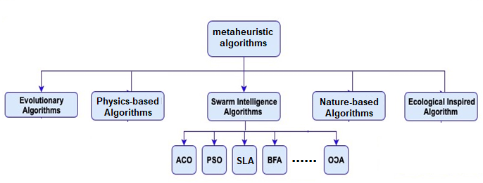
Figure 1. Metaheuristics algorithm classifications

Swarm intelligence is the field of designing intelligent interactive multi-agent systems that cooperate to achieve a specific goal (Almufti S. M., Using Swarm Intelligence for solving NP-Hard Problems, 2017). Swarm intelligence is defined by Dorigo M as “The emergent collective intelligence of groups of simple agents” (Salim, Almufti, & Asaad, 2019). Generally all Swarm-based algorithms are inspired from behaviors of social living beings that live to gather in a group or colonies such as insects or animals. Several optimization techniques based on SI principles inspired from real collective behavior systems in the nature, swarm intelligence consists of a collection of algorithms including Ant Colony Optimization (ACO) by Marco Dorigo in 1992, Particle Swarm Optimization (PSO) by Kennedy and Eberhart in 1995, Artificial Bee Colony (ABC) by Karaboga in 2005, Artificial Immune System (AIS) by Farmer in 1980, Bat Algorithm (BA) by Xin-She Yang in 2010, social spider optimization (Almufti S. M., The novel social spider optimization algorithm: overview, modifications, and applications, 2021), Grey wolf optimizer, Bacterial Foraging, Stochastic diffusion search, Glowworm Swarm Optimization, Gravitational search algorithm, Cat Swarm Optimization, and other optimization algorithms (Almufti S. M., 2015).

Lion’s social behaviour

In nature, lions belong to cat species and they have an exciting social behaviour to preserve the pried member stronger in every generation. Lions are social animals, unlike most other members of the cat family, living in a pride (family group) with between 20 and 30 members. Some prides have just one male, others up to four. Lions are strongly territorial and will fight off any strange male who tries to enter their territory. A cub (lion child) requires 2-4 years to reach the maturity age, during that time the territorial lion have to defend for the territory. In between these 2-4 years, nomadic lions out of pride may try to attack the pride and leads to a war between the territorial and nomadic lions, which is called territorial defence. The lions that belong to a pride together work to defeat the nomadic lion. In the defeating agents the nomadic lions, if the territorial lose the war may be either killed or driven out of the pride. The nomadic lion becomes the territorial lion by killing the cubs of old territorial lion. And the new territorial lion forces the female lion on the pride to oestrus and copulate to give birth to their own cubs (Bauer, de, & Silvestre, 2003). After the cubs get matured, they take over the territorial lion a war occur between the old territorial male and new territorial male. If they seem to be stronger than the territorial lion to take over the pride, the territorial lion may be either killed or driven out of the pride.

Standard Lion Algorithm (LA)

Rajakumar presented the basic stander Lion Algorithm as a searching algorithm in 2012 (Rajakumar B. , 2012) as an inspiration for the lion behaviours. Following this, the algorithm was modified and reconstructed with some improvements. Thus, many other algorithms were developed based on the principles of the stander lion algorithm. The standard LA passes throw Six steps: (1) pride generation, (2) fertility evaluation, (3) mating, (4) territorial defence, (5) territorial takeover, and (6) termination. It is illustrated in Fig. 2
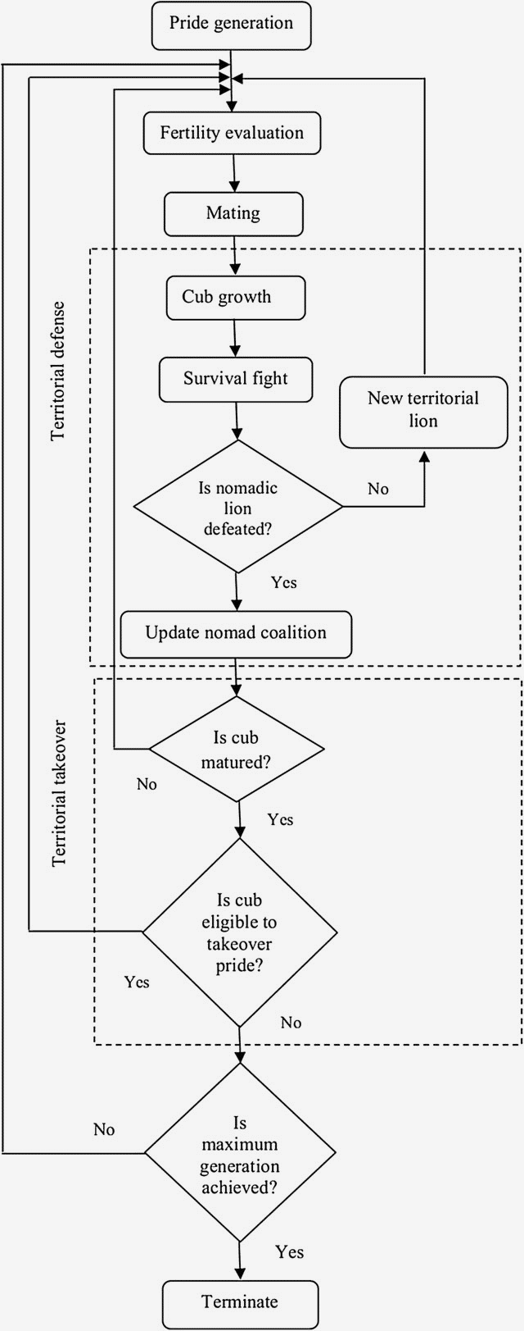

Figure 2. Standard lion algorithm flowchart

Pride creation is the first stage of the Lion Algorithm, which is similar to many other swarm-based and evolution-based algorithms in that it initializes all male, female, nomadic lions, and the objective model. After the initialization (Pride creation stage) is completed, the mating step is initiated to create cubs from the natal pride, which involves the periodic fertility evaluation, which is regarded as the most amazing process among the entire processing steps (Rajakumar B. R., 2020). The territorial-defense and territorial-takeover stages, which demonstrate the social behavior of pride, distinguish themselves from the other optimization algorithms. These two procedures are regarded as the primary functions for directing the algorithm in the search process and so determining the best result. The termination criteria of LA are determined by the problem model and may be processed based on the optimality of the obtained solution or on the number of iterations/generations. The pseudo-code in Algorithm 1 explains the stepwise functioning of standard LA.

- Pride generation

According to the definition of pride (Chintalapalli & Ananthula, 2018) and Eq. (1) A territorial lion Xmale, its lioness Xfemale, and a nomadic lion Xnormal form the foundation of the pride. Despite the fact that its generation is discussed in the pride generation process, the wandering lion is not a member of the pride. The lions representation is as close to the solution vector representation as it gets. When n > 1 (search with real encoding), the vector elements of Xmale, Xfemale, and Xnomad, i.e., xmale l, xfemale l, and xnomad l, are arbitrary numbers within the minimum and maximum limits, where l = 1, 2,..., L. L indicates the lion's length, which may be calculated as follows:
$$L=\left\{\begin{aligned}n; n>1 \\ m; otherwise\end{aligned}\right.$$ | (1)

where, n and m consider two integers that corresponds the length of lions. In case of n = 1, the algorithm will search for a binary encoded lion and so the vector-elements are either be generated as 1 or 0, to satisfy the constraints in Eqs. (1) and (3).
$$g\left(xl\right)⋴\left(x_{l}^{min},x_{l}^{max}\right)$$ | (2)
$$m\%2=0,$$ | (3)
Where
$$g\left(x_{l}\right)=\sum_{l=1}^{L}{x_{l}2^{\left(\frac{L}{2}-l\right)}}$$ | (4)

LA uses Eq. (2) and (4) for ensuring that the generated binary lion is inside the solution space, whereas the Eq. (6) for keeping an equal number of binary bits on both sides of the decimal point. The generated Xnomad is placed into one of the two nomadic lion positions. Assuming there are two nomadic lions, and they are trying to invade territory. The other lion will only be initialized when it is needed for territorial defense. For now, the position remains null and Xnomad will be represented by Xnomad 1.

b. Fertility evaluation

In the sequential process of the lion algorithm, every territorial lion and lioness gradually age or sometimes become infertile. This can make the lion seem slow or sluggish when it comes to fighting for its own survival or taking over territory. If Xmale and Xfemale were to get enough of their fitness, they would either reach global optima or local optima from which they could not lead us to better solutions. Fertility evaluation can help you find local solutions that are optimal for you. In this process, Xmale is found to slow down and its deceleration rate Lr is increased by one if f(Xmale) is greater than fref, which is the reference fitness. When the Lr limit is reached, a territorial defense response occurs. This is helped along by the fertility rate of the X-female, which is increased by one after crossover. If Sr exceeds the tolerance Smax r, then female X will undergo updating as given in the equation. I think you may be misunderstanding me. I don't think you are understanding me correctly. When the updated female Xfemale+ is considered to be equal to the original female Xfemale, the mating process can be performed. On the contrary, the update continues until the number of female gc generation reaches gmax c. If there is no Xf female + to replace X female throughout the modernization process, it can be determined that X female is still reproductive enough to produce better cubs [11].

$$x_{l}^{female+}=\left\{\begin{aligned}x_{l}^{female+}; if l=k \\ x_{l}^{female}; otherwise\end{aligned}\right.$$ | (5)
$$x_{k}^{female+}=min\left[x_{k}^{max},max\left(x_{k}^{min}-∇_{k}\right)\right]$$ | (6)
$$∇_{k}=\left[x_{k}^{female}+\left(0.1r_{2}-0.05\right)\left(x_{k}^{male}-r_{1}x_{k}^{female}\right)\right]$$ | (7)

where x female+ l and x female+ k are the Xfemale+ vector elements l and k, respectively, k is a random integer generated within the interval [1, L], ∇ is the female update function, and r1 and r2 are random integers generated within the interval [0, 1].

c. Mating

Mating is divided into two primary steps and one additional step in the lion algorithm. Crossover and mutation are seen to be the primary phases of evolution, whereas gender clustering is thought to be a supplementary step. Many papers have been written about the role of crossover and mutation operations in evolution algorithms. These operations inspire us, therefore we incorporated them into our algorithm. They develop cubs by crossing diverse elements between Xmale and Xfemale. Cubs are solutions made up of both Xmale and Xfemale parts. The natural littering rate of four cubs in a lioness pregnancy is monitored. As a result, four cubs are born. Figure 3 depicts the suggested crossover process for generating one cub. An Xcub of an Xmale and an Xfemale is the sum of the Hadamard products of the crossover mask and Xmale and the Hadamard product of the complement of the same crossover mask and Xfemale, assuming that the crossover mask is simply a binary vector with Cr L binary ones. The B mask is changed to construct each cub, for example, the pth Bp mask is utilized to generate Xcubs (p). These four cubs are also mutated to generate four new cubs; henceforth, we refer to the cubs obtained through the cross as "Xcubs," and the cubs obtained via the mutation as "Xnew." These eight cubs are from the cub pool.

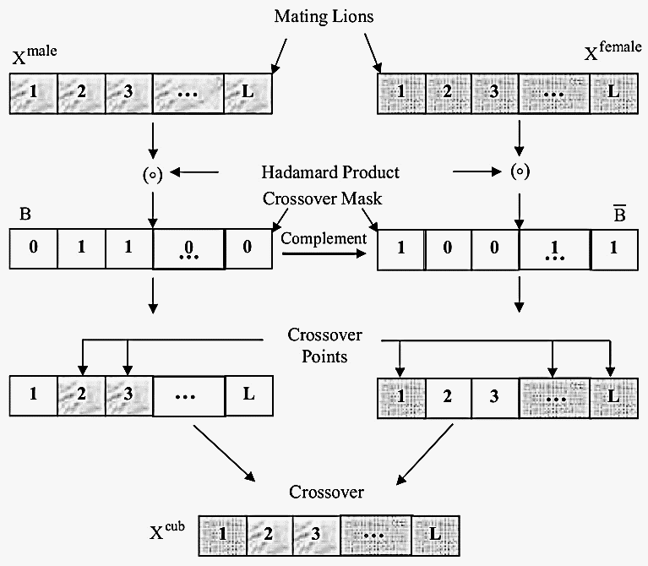
Fig. 2. Mating in LA

d. Lion operators

Territorial defense not only allows for a broad search of the solution space, but also helps the algorithm in avoiding the local optimal point and recognizing multiple solutions with equal fitness. The territorial defense can be divided into three stages: forming a nomad coalition (Yazdani & Jolai, 2016).fighting for survival and finally updating the nomad coalition. The winner-take-all strategy is used to identify $x^{e-nomad}$, which simplifies the nomad coalition process. Following that, if the requirements in Eqs. (8)–(10) are met, $x^{e-nomad}$ is chosen.
$$f\left(x^{e-nomad}\right)<f\left(x^{male}\right)$$ | (8)
$$f\left(x^{e-nomad}\right)<f\left(x^{m_cub}\right)$$ | (9)
$$f\left(x^{e-nomad}\right)<f\left(x^{f_cub}\right)$$ | (10)

When Xmale is defeated, pride is updated, but when Xe nomad is defeated, nomad coalition is updated. The pride updating process involves replacing Xmale with Xe nomad, whereas updating a nomad coalition entails selecting only one Xnomad with Enomad greater than or equal to the exponential of unity (see theorem 2 in Appendix), with the other position being filled only at the time of the next territorial defense. If $x^{m_cub}$and $x^{f_cub}$are matured, i.e. when the age of the cubs surpasses the maximum age for cub maturity Amax, territorial takeover leads the algorithm to update $x^{male}$ and $x^{female}$

e. Termination

When at least one of the following two termination criteria is met, the algorithm execution is terminated.
$$N_{g}>N_{g}^{Max}$$ | (11)
$$\left|f\left(x^{male}\right)-f\left(x^{Optimal}\right)\right|≤e_{t}$$ | (12)
where, $N_{g}$ is the number of generations, which is initialized as zero, when a territorial takeover occurs it gradually incremented by one, $N_{g}^{Max}$ represents the maximum number of generations and error threshold denoted by $e_{t}$. In Eq. (12) second criterion can be considered only when the target minimum f ( $x^{Optimal}$) (or maximum) is known and f ( $x^{Optimal}$) does not mean that $x^{Optimal}$is known.

Standard lion algorithm pseudocode

In this section the pseudocode of Standard Lion Algorithm are illustrated in algorithm 1
Algorithm 1: Standard Lion Algorithm pseudocode
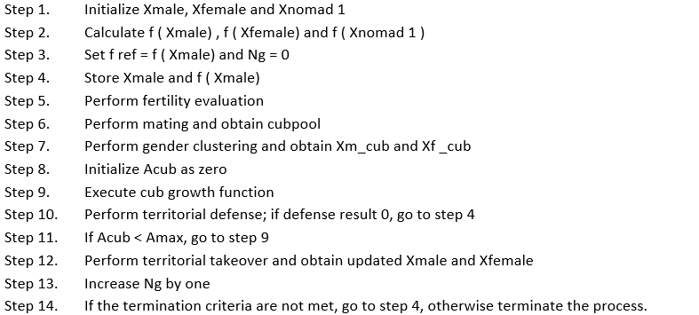

Modifications of LA

In general, all metaheuristics algorithms undergo several adjustments and enhancements after their initial appearance, so that they can be utilized to tackle a variety of issues (Almufti, 2021b; Wen et al., 2015). After the appearance of STANDARD LION ALGORITHM (LA) in 2012. Many adjustments have been made to the original LA to increase the performance of the suggested algorithm in order to meet the needs of real-world problems. Some of the adjustments and enhancements to the LA algorithm are listed and arranged in this part by development year, as indicated in Table (1).

Table 1. LA based algorithms

# | Abbr. | Name | Author | Year | Ref.
 | MO-ADDOFL | Multi-objective-based adaptive dynamic directive operative fractional lion algorithm | Satish Chander | 2017 | (Satish, P., & Praveen, 2017)
 | ALF-TOHIP | Fractional Lion Topology-Hiding Multipath Routing Protocol | Ambekar Kolekar | 2017 | (RK & UD, 2017)
 | FLA | Fractional LA | Satish Chander | 2018 | (Chander, Vijaya, & Dhyani, 2018)
 | ADDOFL | Adaptive Dynamic Directive Operative Fractional Lion | Ranjan N, Prasad R | 2018 | (Ranjan & Prasadb)
 | LFNN | lion fuzzy neural network-based | Ranjan N, Prasad R | 2018 | (Ranjan & Prasadb)
 | KLOA | K-Lion Optimization Algorithm | Jagatheesh kumar | 2018 | (G & brunda, 2018)
 | IKLOA | Improved K-Lion Optimization Algorithm | Jagatheesh kumar | 2018 | (G & brunda, 2018)
 | M-LionWhale | Multi-Lion whale optimisation algorithm | Chintalapalli & Ananthula | 2018 | (Chintalapalli & Ananthula, 2018)

LA applications

Over the years, the Standard Lion Algorithm (La) algorithm and its modifications have demonstrated high performance in solving various real-world problems, and it has been used to solve unconstrained, constrained, multi-objective, and NP-Hard problems in engineering, medicine, and the environment, as summarized in Table 2.

Table 2: GWO applications

# | Application | Discussion | Ref.
 | nonlinear system identification | The accuracy of the system identification process is improved by using global optimization techniques in nonlinear system identification, specifically bilinear system identification. To achieve precise system characteristics, the LA is used in bilinear system identification. (BR, 2014) | (BR, 2014)
 | Data clustering | Clustering is a data partitioning technique that groups homogeneous data into one cluster and divides heterogeneous data into interclusters. It's a method of determining the cluster centroid, which represents the whole cluster. It's an optimization problem that can be solved. The Adaptive Dynamic Directive Operative Fractional Lion (ADDOFL) algorithm, a version of LA, has been documented in the literature to select the centroids that can cluster the data more successfully. | (Chander, Vijaya, & Dhyani, 2018)
 | Wireless sensor network (WSN) | in WSN, Clustering of sensor nodes and selection of cluster heads, which are the heads of sensor clusters, are part of the hierarchical routing process. The choice of cluster heads is critical because it determines the network's lifespan and energy efficiency. The cluster head selection problem is handled by fractional lion (FLION) [36], resulting in a longer network lifetime. | (RK & UD, 2017)
 | Feature selection | Feature selection is a data processing approach that selects the optimal subset of features based on a set of assessment criteria and reduces the number of unnecessary characteristics. To get the highest level of classification accuracy, the optimal feature selection is required. LA has handled this issue successfully by introducing a greedy search technique into territorial defense. | (KC, JC, & JT, 2018)
 | Mobile Ad hoc Network (MANET) | The Mobile Ad hoc Network is the most well-known means of data transfer (MANET). The primary issue with MANET is selecting the most efficient routing path. AFL-TOHIP is a modified LA called fractional LA that is implemented into the TOHIP (Topology-Hiding Multipath Routing Protocol) protocol for better solution search (RK & UD, 2017). To construct a programming model, the M-LionWhale hybrid optimization technique is employed, which incorporates the LA into the Whale Optimization Algorithm (WOA) for secure routing. (Chintalapalli & Ananthula, 2018) | (RK & UD, 2017),  (Chintalapalli & Ananthula, 2018)
 | Text classification | Text classification is one of the text mining tasks that categorizes texts based on their features and user demands. One of the most important challenges in text categorization is the dimensionality of the search space. The dimensionality curse has a direct impact on it. The optimization principle is used here to obtain the ideal weights of a fuzzy neural network using the LA.. (Prasadb & Ranjan) | (Ranjan & Prasadb)
 | Vehicular Ad hoc Networks (VANETs) | VANETs are said to be part of Mobile Ad hoc Networks (MANETs), which provide reliable road safety. Because the routing process evaluates multiple parameters such as Quality of Service (QoS) limits, congestion parameters, and many more, an optimization strategy is the best solution. Because it has been proven for benchmark problems, the LA has been used to address the route finding difficulty in VANET. | (MB & N, 2018)
 | Social network analysis | Social networks are information networks that allow people to communicate and share common interests. Community discovery is considered as an optimization problem in this social network study. As a result, LA is used to determine how many user communities should remain in social networks. | (Y, Y, & M, 2018)

Conclusions

The Standard Lion Algorithm (La) is a Swarm-based metaheuristic algorithm that was proposed in 2012. Many improvements have been offered to it since its inception, and it has been used to solve many problems in various fields. This work initially addressed the original LA method and then provided some of its modifications in detail. Finally, several of its applications were reviewed, including parameter adjustment, alternate approaches for feature selection and classification, and hybridized forms. Applications in various sectors, such as engineering, medicine, power distribution, and reliability optimization, were considered.

References

Almufti, S.M. (2015). U-Turning Ant Colony Algorithm powered by Great Deluge Algorithm for the solution of TSP Problem. Retrieved from Hdl.handle.net
Almufti, S.M. (2017). Historical survey on metaheuristics algorithms. International Journal of Scientific World, 7(1), 1-12. doi:https://doi.org/10.14419/IJSW.V7I1.29497
Almufti, S.M. (2017). Using Swarm Intelligence for solving NP-Hard Problems. Academic Journal of Nawroz University, 6(3), 46-50. doi:https://doi.org/10.25007/ajnu.v6n3a78
Almufti, S.M. (2021). The novel social spider optimization algorithm: overview, modifications, and applications. ICONTECH international journal of surveys, engineering, technology, 5(2), 35-51.
Almufti, S.M. (2022). Hybridizing Ant Colony Optimization Algorithm for Optimizing Edge-Detector Techniques. Academic Journal of Nawroz University, 11(2), 135-145. doi:https://doi.org/10.25007/ajnu.v11n2a1320
Bauer, H., de, I.H., & Silvestre, I. (2003). Lion (Panthera leo) social behaviour in the West and Central African savannah belt. Mammalian Biology, 68(4), 239-243. doi:https://doi.org/10.1078/1616-5047-00090
BR, R. (2014). Lion algorithm for standard and large scale bilinear system identification: a global optimization based on lion’s social behavior. IEEE congress on evolutionary computation (CEC), 2116–2123.
Chander, S., Vijaya, P., & Dhyani, P. (2018). Multi kernel and dynamic fractional lion optimization algorithm for data clustering. Alexandria Engineering Journal, 57(1), 267-276. doi:https://doi.org/10.1016/j.aej.2016.12.013
Chintalapalli, R.M. & Ananthula, V.R. (2018). M-LionWhale: multi-objective optimisation model for secure routing in mobile ad-hoc network. IET Communications, 12(12), 1406-1415. doi:10.1049/iet-com.2017.1279
G, J. & brunda, S.S. (2018). An Improved K-Lion Optimization Algorithm With Feature Selection Methods for Text Document Cluster. International Journal of Computer Sciences and Engineering, 6(7), 245-251.
Ihsan, R.R., Almufti, S.M., Ormani, B.M., Asaad, R.R., & Marqas, R.B. (2021). A Survey on Cat Swarm Optimization Algorithm. Asian Journal of Research in Computer Science, 10(2), 22-32. doi:10.9734/AJRCOS/2021/v10i230237
KC, L., JC, H., & JT, W. (2018). Feature selection with modified lion’s algorithms and support vector machine for high-dimensional data. Appl Soft Comput 68.
Marqas, R.B., Almufti, S.M., Ahmed, H.B., & Asaad, R.R. (2021). Grey wolf optimizer: Overview, modifications and applications. International Research Journal of Science, Technology, Education, and Management, 1(1), 44-56. doi: https://doi.org/10.5281/zenodo.5195644
MB, W. & N,G. (2018). Route discovery for vehicular Ad hoc networks using modified lion algorithm. Alexandria Eng J 57.
Mirjalili, S., Mirjalili, S. M., & Lewis, A. (2014). Grey Wolf Optimizer. Advances in Engineering Software.
Rajakumar, B.R. (2012). The Lion's Algorithm: A New Nature-Inspired Search Algorithm. Procedia Technology, 6, 126-135. doi:https://doi.org/10.1016/j.protcy.2012.10.016
Rajakumar, B.R. (2020). Lion Algorithm and Its Applications. In M. Khosravy, N. Gupta, N. Patel, & T. Senjyu, Frontier Applications of Nature Inspired Computation (pp. 100-119). Springer Nature Singapore. doi:https://doi.org/10.1007/978-981-15-2133-1_5
Ranjan, N. M. & Prasadb, R. S. (n.d.). lion fuzzy neural network-based evolutionary model for text classification using context and sense based features. Applied Soft Computing. doi:https://doi.org/10.1016/j.asoc.2018.07.016
RK, A. & UD, K. (2017). AFL-TOHIP Adaptive fractional lion optimization to topology-hiding multipath routing in mobile Ad hoc network. International conference on ISMAC. doi:10.1109/I-SMAC.2017.8058274
RK, A. & UD, K. (2017). AFL-TOHIP: Adaptive fractional lion optimization to topology-hiding multi-path routing in mobile Ad hoc network. 727–732.
Salim, B.W., Almufti, S.M., & Asaad, R.R. (2019). Review on elephant herding optimization algorithm performance in solving optimization problems. International Journal of Engineering & Technology, 7(4), 6109-6114. doi:10.14419/ijet.v7i4.23127
Satish, C., P., V., & Praveen, D. (2017). Multi-objective-based adaptive dynamic directive operative fractional lion algorithm for data clustering. International Conference on Infocom Technologies and Unmanned Systems (Trends and Future Directions). doi:10.1109/ICTUS.2017.8286066
Y, L., Y, H., & M, Z. (2018). Short-term load forecasting for electric vehicle chargingstation based on niche immunity lion algorithm and convolutional neural network. Energies.
Yazdani, M. & Jolai, F. (2016). Lion Optimization Algorithm (LOA): A nature-inspired. Journal of Computational Design and Engineering, 3(1). doi:https://doi.org/10.1016/j.jcde.2015.06.003

