STUDENT TECHNICAL REPORT / SUBMISSION RECORD
Assignment 4 — Distributed Stream Processing
AITU Research Event Analytics with Kafka and Spark
This section is a formal submission and acceptance record. Complete all applicable fields and attach evidence from your own implementation. The common synthetic scenario and dataset do not make student submissions interchangeable.

1. Student and Submission Information
Required field | Student entry
Student full name | Kaziyev Nurassyl
Student ID | 242125
Group / cohort | BDA-2401
Instructor | Serek Azamat
Submission date | 30/10/2026
Individual variant / task code
Git repository / project link | https://github.com/Nurikoks/RTDA_Assignments/tree/main/Assignment_4_Kafka_Spark
Python / tool versions | Python 3.13.5, Apache Kafka 4.3.2 (KRaft, Scala 2.13), confluent-kafka 2.16.1 (librdkafka 2.16.0), PySpark 4.2.1 with spark-sql-kafka-0-10 4.2.1, Java 21.0.6, pandas 2.3.2, matplotlib 3.10.6, psutil 7.1.3

2. Work Record
Item | Student entry
Work start date | 30/10/2026
Work completion date | 30/10/2026
Main libraries / technologies | Apache Kafka 4.3.2 (single broker, KRaft mode), confluent-kafka (Producer, Consumer, AdminClient), Spark Structured Streaming 4.2.1 with the Kafka source, pandas, matplotlib, psutil, Java 21 (javac)
Source files / notebook | producer.py, consumer.py, stream_common.py, create_topic.py, spark_streaming_job.py, winfs/aitu/NoPermLocalFileSystem.java, winfs/aitu/NoPermLocalFs.java, start_kafka.ps1, data/research_events.csv, README.md, requirements.txt
Test / experiment files | load_test.py, scaling_test.py, make_figures.py, producer.py --inject-invalid (validation test). Logs and results in outputs/: consumer_run.log, consumer_run_v1_global_watermark.log, validation_consumer.log, spark_run.log, spark_live_run.log, partE_load_results.csv, partE_scaling_results.csv, consumer_group_lag.txt
Final repository commit/version | ____________________________________________

3. Report Structure to Complete
For each section, provide a concise technical explanation and cite your own code, calculation, experiment, plot, log, screenshot, configuration, or other artifact. Generic copied explanations without individual evidence are insufficient.

3.1 Streaming Architecture
Provide and explain your Kafka architecture with producers, topic, partitions, consumer group, Python processor, aggregation layer, and monitoring. Discuss failure and scaling considerations.
Required evidence | Student response / reference
Technical explanation | Three producer processes, one for each research group (producer.py --group G01, G02, G03), send JSON events to one Kafka 4.3.2 broker in KRaft mode. The topic aitu.research.jobs has 3 partitions and the message key is research_group, so all events of one group stay in order in one partition. The consumer group aitu-analytics runs the Python processor (consumer.py). It checks the schema, sends broken events to the topic aitu.research.jobs.dlq and keeps the counts, averages and 5-second windows (aggregation layer, results in outputs/*.csv). Spark Structured Streaming reads the same topic as a second processor with its own group. Monitoring looks at consumer lag, throughput, latency, CPU and failure rate per window. For failures: the producer is idempotent with acks=all, offsets are committed only after processing (at-least-once), and after a crash the data is read again from Kafka. For scaling: producers can be added at any time, consumers in one group only up to the number of partitions (3).
Code / file / function / configuration reference | create_topic.py: NewTopic('aitu.research.jobs', num_partitions=3, replication_factor=1, retention.ms = 7 days) and NewTopic('aitu.research.jobs.dlq', 1 partition). stream_common.py: BOOTSTRAP = localhost:9092, TOPIC, DLQ_TOPIC, CONSUMER_GROUP = aitu-analytics. Broker: start_kafka.ps1 and aitu-server.properties (auto.create.topics.enable=false). Diagram: figures/partA_architecture.png (make_figures.py, architecture()).
Result / calculation / experiment evidence | outputs/create_topic.log: aitu.research.jobs partitions=3, leaders=[1, 1, 1], replicas=[1, 1, 1]. Producer delivery logs: G01 went to partition 2 (offsets 0 to 3), G02 to partition 1 (0 to 2), G03 to partition 0 (0 to 2), so the 3 keys did not collide. outputs/consumer_group_lag.txt after the run: committed offsets 3, 3, 4 and lag 0 on all 3 partitions. The diagram is shown below this table.
Student-specific decision or observation | I chose 3 partitions because there are 3 research groups, so up to 3 consumers can work in parallel. Replication factor 1 is only because there is one local broker. In production I would use 3 brokers, RF = 3 and min.insync.replicas = 2. I turned off automatic topic creation after the producers created the topic with only 1 partition in my first run.
Completed table for Part A: components of the streaming architecture.
Component | Purpose | Failure/scale consideration
Producer | Reads the job events of one research group, turns them into JSON and sends them with key = research_group. | acks=all and enable.idempotence=true, so a retry does not create a duplicate. If the broker is down, events wait in the local buffer. Producers keep no state, more can be added at any time.
Kafka topic | aitu.research.jobs keeps all job events as an ordered log for 7 days and separates producers from consumers. Broken events go to aitu.research.jobs.dlq. | One broker with RF = 1 is a single point of failure here. For production: 3 brokers, RF = 3, min.insync.replicas = 2. The retention period allows replay after a consumer failure.
Partition | 3 partitions. The key keeps all events of one group in one partition, so the order per group is kept (G01 in partition 2, G02 in 1, G03 in 0). | Order is guaranteed only inside a partition. The number of partitions limits parallel consumers to 3. Key skew: with 6 groups in the load test the partitions got 50 %, 33 % and 17 % of the events.
Consumer group | aitu-analytics shares the partitions between its members and stores the committed offsets. | If a member stops, its partitions go to the others (rebalance) and they continue from the last committed offset. A 4th member would be idle. Spark uses its own group, so it does not take partitions away.
Processor | consumer.py: schema check, completed/failed counts, average duration by job_type, average CPU by group, 5 s event-time windows. Spark job: window and job_type aggregation. | The state is in memory. After a crash it is rebuilt by reading Kafka again (at-least-once, so a duplicate is possible). Spark keeps its state in a checkpoint. One Python consumer reaches its limit at about 60,000 events/s (CPU).
Monitoring | Consumer lag, throughput, end-to-end latency, CPU, failure rate per window and number of DLQ events. | Alert when the lag keeps growing (consumers too slow) or when the failure rate of a window is above 30 %. Tools used: Kafka ConsumerGroupCommand (lag), load_test.py logs.
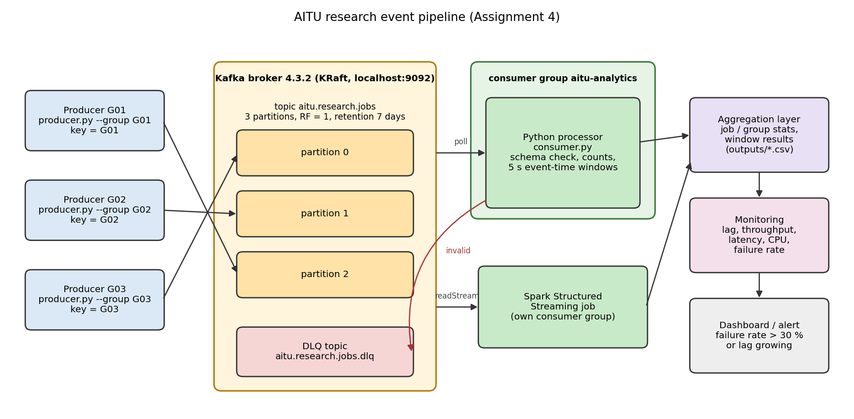
Figure for Part A: Kafka architecture of the pipeline (figures/partA_architecture.png). The arrows from the producers show the real partition of each key from the delivery logs.

3.2 Kafka Producer and Consumer
Document producer/consumer implementation, schema validation, completed/failed job counts, average duration by job type, and average CPU by research group. Reference the exact code and output.
Required evidence | Student response / reference
Technical explanation | producer.py reads data/research_events.csv, adds the assumed date 2026-10-30 to the time and sends every event as JSON with key = research_group (confluent-kafka, acks=all, enable.idempotence=true, linger.ms=5). I started 3 producers at the same time, one per group, with 1 s between events. consumer.py joins the group aitu-analytics with auto commit off, reads batches of up to 100 messages and commits after each batch. validate_event() checks that all 7 fields exist, their types, the timestamp format, the allowed job_type and status values, duration_sec > 0 and cpu_pct between 0 and 100. A broken event goes to the DLQ topic with the error text in a header. A valid event updates the completed/failed counts and the duration list per job_type and the CPU list per research group.
Code / file / function / configuration reference | producer.py (main, on_delivery), consumer.py (main loop, status_count, duration, cpu), stream_common.py (validate_event, csv_row_to_event). Logs: outputs/producer_G01.log, producer_G02.log, producer_G03.log, consumer_run.log, validation_consumer.log. Tables: outputs/partB_job_types.csv, partB_cpu_by_group.csv.
Result / calculation / experiment evidence | consumer_run.log: valid events 10, invalid 0, completed 8, failed 2. Average duration: ml (42 + 51 + 64) / 3 = 52.33 s, image (75 + 88 + 70) / 3 = 77.67 s, text (18 + 22) / 2 = 20.00 s, simulation (95 + 120) / 2 = 107.50 s. Average CPU: G01 (61 + 38 + 81 + 94) / 4 = 68.50 %, G02 (74 + 68 + 44) / 3 = 62.00 %, G03 (92 + 89 + 78) / 3 = 86.33 %. Validation test with 3 broken events: X001 unknown job_type 'audio', X002 missing field cpu_pct, X003 wrong type for duration_sec. All 3 went to the DLQ and the counts did not change.
Student-specific decision or observation | One producer per research group simulates separate worker nodes. Because of this the consumer gets the events grouped by partition (all G01 events first), not in time order, which matters for Part C. I commit after the batch is processed, not before, so a crash can repeat an event but can not lose it.
Completed table for Part B: job counts and average duration (seconds) by job type. Total: 8 completed, 2 failed.
Job type | Completed | Failed | Average duration
ml | 2 | 1 | 52.33
image | 3 | 0 | 77.67
text | 2 | 0 | 20.00
simulation | 1 | 1 | 107.50
Average CPU utilization by research group (Part B, step 5).
Research group | Events | Average CPU %
G01 | 4 | 68.50
G02 | 3 | 62.00
G03 | 3 | 86.33

3.3 Windowed Stream Processing
Complete the 5-second event-time windows and calculate event count, failure rate, and average CPU. Explain window boundaries and processing logic.
Required evidence | Student response / reference
Technical explanation | Tumbling 5-second windows on event time, closed at the start and open at the end: [start, end). So the event at 14:00:05 belongs to 14:00:05-14:00:10 and the event at 14:00:10 to the third window. Window start = floor(seconds / 5) * 5. For each window the consumer keeps the event list, the number of failed jobs and the CPU sum. Failure rate = failed / count, average CPU = CPU sum / count. A window is closed when the watermark passes its end. Watermark = the minimum over the partitions of the latest event time in that partition, minus 2 s allowed lateness. Windows that are still open when the stream is idle for 5 s are flushed.
Code / file / function / configuration reference | consumer.py: window_start(), class WindowAggregator (add, watermark, close_ready), ALLOWED_LATENESS = 2 s. Output: outputs/partC_windows.csv and consumer_run.log. First wrong run: outputs/consumer_run_v1_global_watermark.log. Figure: figures/partC_windows.png.
Result / calculation / experiment evidence | 14:00:00-14:00:05: E001 to E004, 1 failed (E004), failure rate 1 / 4 = 25 %, CPU (61 + 74 + 38 + 92) / 4 = 66.25. 14:00:05-14:00:10: E005 to E009, 1 failed (E007), 1 / 5 = 20 %, CPU (68 + 81 + 89 + 44 + 94) / 5 = 75.20. 14:00:10-14:00:15: only E010, 0 %, CPU 78.00. The log shows that window 1 was closed when E007 arrived (watermark 14:00:05). The other two were flushed at the end.  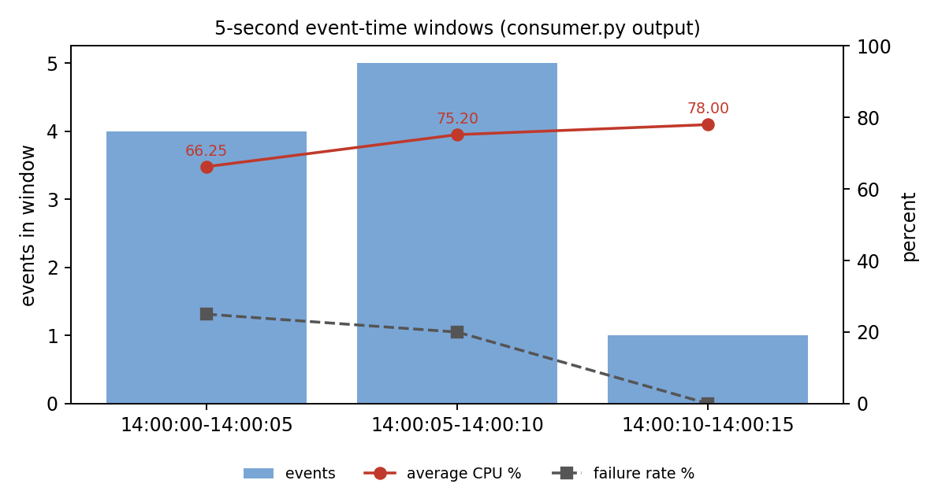
Student-specific decision or observation | My first version used one global watermark (latest event time minus 2 s). The consumer read partition 2 (G01) first, the watermark jumped to 14:00:07 and E002 and E004 were dropped as late, so window 1 had 2 events instead of 4. Kafka keeps the order only inside one partition, so I changed it to a watermark per partition. After that no event was late.
Completed table for Part C: 5-second event-time windows [start, end).
Window | Events | Count | Failure rate | Average CPU
14:00:00–14:00:05 | E001, E002, E003, E004 | 4 | 25.0 % (1 of 4) | 66.25
14:00:05–14:00:10 | E005, E006, E007, E008, E009 | 5 | 20.0 % (1 of 5) | 75.20
14:00:10–14:00:15 | E010 | 1 | 0.0 % (0 of 1) | 78.00

3.4 Spark Structured Streaming
Document the equivalent Spark transformation and the output fields window, job_type, count, and avg_duration. Reference the exact code/configuration used.
Required evidence | Student response / reference
Technical explanation | spark_streaming_job.py reads the topic with readStream.format('kafka') from the earliest offset, parses the value with from_json and a fixed schema, turns timestamp into event_time with to_timestamp and drops rows that break the same rules as validate_event(). Then it runs groupBy(window(event_time, '5 seconds'), job_type) with count('*') and round(avg(duration_sec), 2). The query uses complete output mode and foreachBatch, which saves the result table. The default trigger is availableNow (read everything and stop). With --live 45 it runs with a 2 s processing-time trigger. Spark 4.2.1, master local[2], 3 shuffle partitions, session time zone UTC.
Code / file / function / configuration reference | spark_streaming_job.py: EVENT_SCHEMA, build_query(), save_batch(), kafka_jars(), windows_fs_jar(). winfs/aitu/NoPermLocalFileSystem.java and NoPermLocalFs.java (set as spark.hadoop.fs.file.impl and fs.AbstractFileSystem.file.impl). Outputs: outputs/partD_spark_schema.txt, partD_spark_output.csv, spark_run.log, spark_live_run.log.
Result / calculation / experiment evidence | Batch run: 10 input rows, 9 output rows, trigger time 8158 ms (addBatch 6132 ms). Window 14:00:05-14:00:10, ml: count 2, avg_duration (51 + 64) / 2 = 57.5. The counts per window (4, 5 and 1) are the same as in Part C. Live run: micro-batch 1 had 3 rows, micro-batch 2 had 8 rows and micro-batch 3 all 9, so the result was updated while the producers were still sending.
Student-specific decision or observation | Complete mode is fine for 9 rows, but its state grows all the time. For a long stream I would add withWatermark('event_time', '10 seconds') and use append or update mode. Spark needs 6 to 8 s per micro-batch on my laptop, so for 10 events the Python consumer is much faster. Spark makes sense when the volume is large. To run Spark on Windows without winutils.exe I wrote a small Hadoop file system class that skips chmod and readlink.
Completed table for Part D: output schema of the Spark query (outputs/partD_spark_schema.txt).
Output field | Type | Transformation
window | struct<start: timestamp, end: timestamp> | window(col('event_time'), '5 seconds'): tumbling 5 s window, event_time = to_timestamp(timestamp), start included, end excluded
job_type | string | field from from_json(value), only simulation / ml / image / text are kept, group key
count | long (bigint) | count('*') per window and job_type
avg_duration | double | round(avg(duration_sec), 2) per window and job_type
Spark output (outputs/partD_spark_output.csv), 9 rows from the 10 events.
window | job_type | count | avg_duration
14:00:00-14:00:05 | image | 1 | 75.0
14:00:00-14:00:05 | ml | 1 | 42.0
14:00:00-14:00:05 | simulation | 1 | 95.0
14:00:00-14:00:05 | text | 1 | 18.0
14:00:05-14:00:10 | image | 1 | 88.0
14:00:05-14:00:10 | ml | 2 | 57.5
14:00:05-14:00:10 | simulation | 1 | 120.0
14:00:05-14:00:10 | text | 1 | 22.0
14:00:10-14:00:15 | image | 1 | 70.0

3.5 Throughput and Latency
Report measurements at 10, 100, and 500 events/s, including observed throughput, average latency, CPU, and bottleneck. Explain scalability and one optimization.
Required evidence | Student response / reference
Technical explanation | load_test.py runs the producer and the consumer as 2 separate processes on my laptop (6 cores / 12 threads, 15.2 GB RAM) with the local broker. The producer sends synthetic events at a fixed rate for 20 s (200, 2,000 and 10,000 events) to a new 3-partition topic. Every event has the send time sent_ns. The consumer does the same work as consumer.py and measures latency = processing time - sent_ns. Throughput = events received / time from the first to the last received event. CPU % = process CPU time / wall time (100 % = one core), system CPU is the whole machine. The baseline consumer settings are the same as in consumer.py: batch of 100, batch timeout 1 s, async commit per batch.
Code / file / function / configuration reference | load_test.py (run_producer, run_consumer, one_run) and scaling_test.py. Results: outputs/partE_load_results.csv, partE_load_baseline.log, partE_load_experiments.log, partE_scaling_results.csv. Figure: figures/partE_load.png.
Result / calculation / experiment evidence | All events were received at every rate. Latency was about 0.5 s at 10 and 100 events/s, because consume(100, timeout=1.0) waits until 100 messages arrive or 1 s passes. At 500 events/s the batch fills in 0.2 s, so latency falls to 110.5 ms. With a batch timeout of 0.05 s the average latency became 59.3, 40.6 and 39.9 ms. Without a rate limit one consumer processed 61,601 events/s at 114 % CPU.  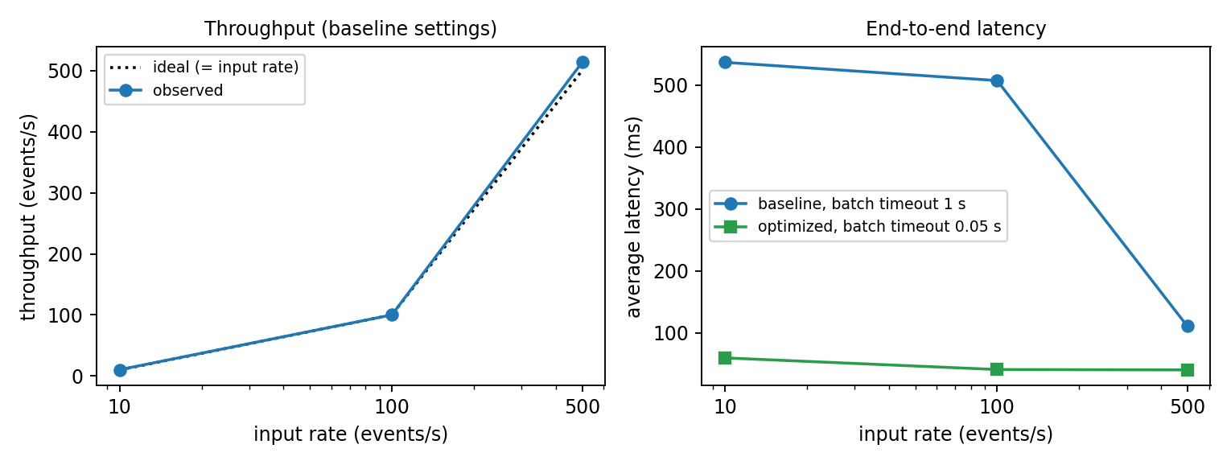
Student-specific decision or observation | The system scales well enough for this load: 500 events/s uses only 6 % of one core and the maximum is about 120 times higher. My optimization is a batch timeout of 0.05 s instead of 1 s. It gives 12 times lower latency at 100 events/s with almost the same CPU. A synchronous commit after every message had the lowest latency at 500 events/s (median 6.9 ms), but its maximum fell to 1,466 events/s, so I kept the batch commit.
Completed table for Part E: baseline settings (batch 100, batch timeout 1 s, commit per batch), 20 s per rate. CPU % of one core.
Input rate (events/s) | Observed throughput | Average latency (ms) | CPU % | Bottleneck
10 | 10.4 events/s (200 of 200 received) | 536.63 (p95 994.63) | consumer 0.8, producer 0.5, system 10.8 | Consumer batch wait: consume(100, timeout 1 s) waits for a full batch. CPU is not a limit.
100 | 100.1 events/s (2,000 of 2,000) | 507.19 (p95 953.55) | consumer 2.1, producer 6.6, system 13.1 | Same batch wait, a batch of 100 is still not full within 1 s.
500 | 513.4 events/s (10,000 of 10,000) | 110.50 (p95 198.70) | consumer 6.1, producer 14.3, system 16.0 | Batch fills in 0.2 s, so the wait is shorter. Not saturated, the next limit is Python processing (about 61,600 events/s).
Additional measurements: optimization, maximum load and consumer group scaling (outputs/partE_load_results.csv, outputs/partE_scaling_results.csv).
Experiment | Throughput (events/s) | Avg latency (ms) | CPU % | Observation
Batch timeout 0.05 s, 10 events/s | 10.3 | 59.33 | consumer 1.0 | 9 times lower latency than baseline
Batch timeout 0.05 s, 100 events/s | 102.8 | 40.55 | consumer 2.6 | 12 times lower latency
Batch timeout 0.05 s, 500 events/s | 511.9 | 39.92 | consumer 8.2 | almost the same CPU as baseline
No rate limit, 50,000 events | 61,601 (producer 56,391) | 579.64 | consumer 113.6, producer 142.7 | consumer is CPU bound, events wait in Kafka
Commit after every message, 500 events/s | 513.3 | 18.93 (median 6.90) | consumer 23.4 | low latency, but 4 times more CPU
Commit after every message, no limit | 1,466 | 7,256 | consumer 50.3 | every commit waits for the broker
1 consumer, 200,000 preloaded events | 66,046 |  | 104.7 | reads all 3 partitions
2 consumers in the group | 75,879 |  | 65.5 (average) | split 166,870 / 33,130 events
3 consumers in the group | 111,357 |  | 73.1 (average) | 1.69 times faster, partitions 100,001 / 66,869 / 33,130

3.6 Engineering Interpretation
State the main architectural bottleneck, explain behavior under increasing event volume, and justify the optimization using measured evidence.
Required evidence | Student response / reference
Technical explanation | The main architectural bottleneck is the single Python consumer process. At about 60,000 events/s it uses more than one full core (JSON parsing and validation in Python), while the broker still has free capacity. At low rates the limit is not throughput but the latency added by batching. With growing volume: up to 500 events/s nothing is saturated and throughput equals the input rate. Without a limit the producer sends faster than the consumer reads, events wait in Kafka and latency grows to 580 ms (consumer lag). More consumers help only up to the number of partitions, and only if the keys are spread evenly over the partitions.
Code / file / function / configuration reference | load_test.py, scaling_test.py, consumer.py (batch size and timeout in consume()). outputs/partE_load_results.csv and outputs/partE_scaling_results.csv.
Result / calculation / experiment evidence | Maximum: 61,601 events/s with consumer CPU 113.6 %. Scaling with 200,000 preloaded events: 1 consumer 66,046 events/s, 2 consumers 75,879, 3 consumers 111,357 (1.69 times faster). Partition sizes were 100,001, 66,869 and 33,130 events, so the consumer of partition 0 had half of all events and decided the total time. Batch timeout changed from 1 s to 0.05 s: 507 ms to 41 ms at 100 events/s.
Student-specific decision or observation | For a campus load of hundreds of events per second the needed change is the smaller batch timeout, not more hardware. For a much higher load I would first add partitions (for example 12), so that the group keys spread more evenly, and then add consumers. With 6 keys on 3 partitions my test got an uneven split of 50 %, 33 % and 17 %.

4. Individual Work and Anti-Plagiarism Record
Students may work from the same assignment statement and synthetic data. However, each submission must contain independently produced implementation evidence. Copying another student's source code, tables, calculations, plots, screenshots, logs, API responses, architecture, wording, or conclusions is not acceptable.
- Use the assigned individual variant/task code in the report, README, and repository.
- Provide the exact Kafka topic/partition configuration and source filenames used.
- Include execution-generated consumer output and window results.
- Include measured performance evidence, not estimated values.
- Document one scaling/design decision made by you and why.
- Record one implementation or configuration problem you personally solved.
- Be prepared to explain or modify one Kafka/Spark component during oral defense.
Individual evidence | Student entry
My unique technical/design decision | One producer per research group with key = research_group on 3 partitions, and a watermark per partition (minimum over partitions minus 2 s) for the event-time windows, so a partition that is read early can not make events from other partitions late.
My own test/experiment | 1) Schema test with 3 broken events, all went to the DLQ. 2) Load test at 10, 100, 500 events/s and without a limit, with batch timeout 1 s and 0.05 s and with a commit after every message. 3) Consumer group test with 1, 2 and 3 consumers on 200,000 preloaded events. 4) Live Spark run while the producers were sending.
Problem/bug I personally encountered and solved | The global watermark dropped E002 and E004 as late (window 1 had 2 events instead of 4). I printed the partition and watermark for every event, saw that partition 2 was read first and changed to a watermark per partition. Windows problems: the producers auto-created the topic with 1 partition (I disabled auto.create.topics.enable), deleting a topic crashed the broker with AccessDeniedException (now I reset the data folder instead), and Spark needed winutils.exe (I wrote NoPermLocalFileSystem.java).
Exact code/repository/commit reference | RTDA4 folder: producer.py, consumer.py (WindowAggregator), spark_streaming_job.py, load_test.py, scaling_test.py, create_topic.py, stream_common.py, start_kafka.ps1. Topic aitu.research.jobs, 3 partitions, RF 1, group aitu-analytics. Repository: https://github.com/Nurikoks/RTDA_Assignments/tree/main/Assignment_4_Kafka_Spark
One limitation of my implementation | One broker with replication factor 1, so a broker failure stops the pipeline and can lose data. All measurements were made on one laptop, where producer, broker and consumer share the CPU. At-least-once delivery means that after a crash an event can be counted twice.
One improvement I propose | 3 brokers with RF = 3, more partitions (for example 12) for an even key spread, alerts on consumer lag, and writing window results with a key (window + group) so that a repeated event does not change the output.

5. Evidence and Submission Checklist
- ☐ Technical report completed
- ☐ Source code / notebook submitted
- ☐ Required tables and calculations completed
- ☐ Required diagrams / plots / dashboard evidence included
- ☐ Execution logs or reproducible experiment evidence included
- ☐ README and run instructions included where required
- ☐ Data/schema/configuration files included where required
- ☐ Performance / analytical results included where required
- ☐ Oral defense / demonstration completed

6. Student Declaration of Originality
I confirm that this submission represents my own work. I have not copied another student's source code, calculations, tables, architecture, plots, screenshots, logs, results, or written explanations. Any external material or reused code has been identified. I understand that the instructor may request a live demonstration, code modification, reproduction of calculations, or explanation of any submitted component.
Role | Name | Signature | Date
Student / Executor | ________________ | ________________ | ____________
Instructor / Accepted by | ________________ | ________________ | ____________

7. Instructor Acceptance Record
Verification item | Status / comment
Report structure completed | ☐ Yes ☐ No __________________________________________
Required artifacts submitted | ☐ Yes ☐ No __________________________________________
Evidence is reproducible/sufficient | ☐ Yes ☐ No __________________________________________
Individual contribution is identifiable | ☐ Yes ☐ No __________________________________________
Oral defense / demonstration completed | ☐ Yes ☐ No __________________________________________
Final status | ☐ Accepted ☐ Revision required

