APILA: AI-Powered Indonesian Law Assistent

Focus Area: Knowledge, Skills, & Learning
Beneficiary: All Indonesian Citizens (278+ Million People)

1. Problem Statement
Indonesia is a state governed by law (negara hukum), yet a profound irony persists: its citizens' legal literacy remains critically low. Data from the Ministry of Law and Human Rights (BPHN) reveals that only 6.9% of all villages and districts across Indonesia have been officially recognised as "Law-Aware" (Desa/Kelurahan Sadar Hukum) meaning more than 93% of all residential areas lack a baseline standard of legal awareness.
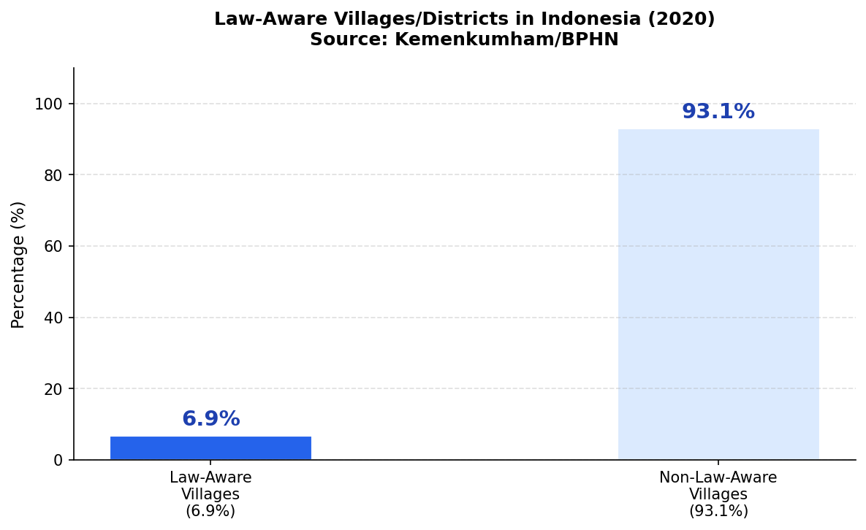
Figure 1. Law-Aware Villages/Districts in Indonesia (Source: BPHN/Kemenkumham, 2020)
Research from Universitas Padjadjaran (2022) identifies the root causes as a lack of awareness about applicable regulations and the near-absence of accessible information channels for ordinary citizens. The consequences are tangible: a survey by Lembaga Survei Indonesia (LSI) found that 31% of the public rates law enforcement as poor, while only 27.9% consider it good. Low-income communities, micro-enterprises (UMKM), and citizens in remote regions suffer the most they cannot afford paid legal counsel, do not understand contracts they sign, and do not know where to turn when their rights are violated. This challenge directly aligns with two of Google.org's core focus areas: (1) quality education access and (2) economic empowerment.
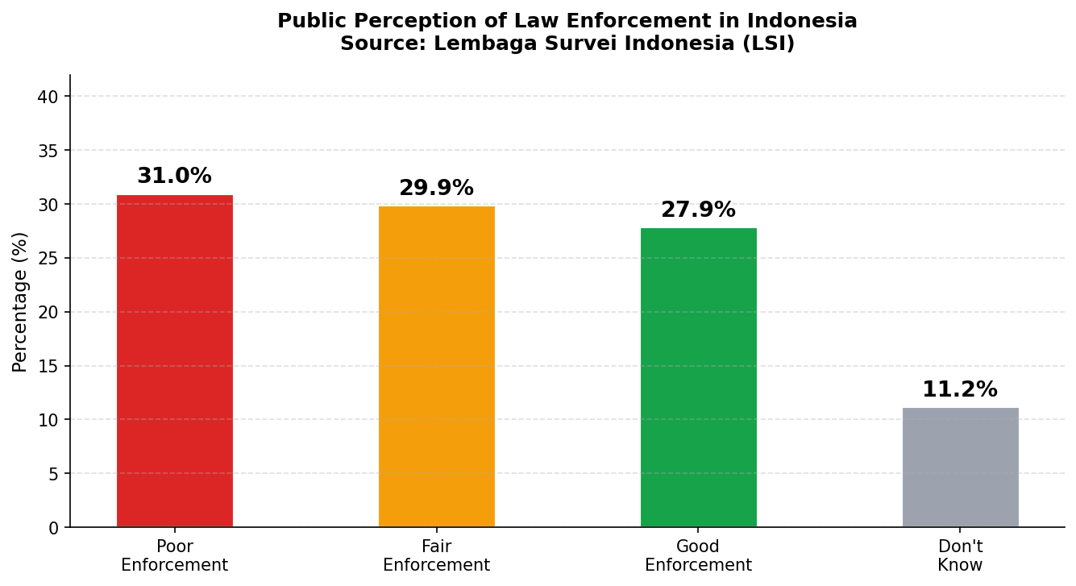
Figure 2. Public Perception of Law Enforcement in Indonesia (Source: LSI)

2. Target Beneficiaries & Coverage
With a population of 278.7 million people, Indonesia offers transformative scale of impact. APILA primary beneficiaries include: (1) low- and middle-income citizens without access to paid legal services; (2) UMKM operators requiring guidance on contracts, licensing, and employment law; (3) youth and students seeking to understand their fundamental civic rights; (4) victims of criminal acts, domestic violence, or land disputes who do not know how to proceed; and (5) citizens in remote 3T regions (Frontier, Outermost, and Underdeveloped areas) unreachable by conventional legal aid services.
The opportunity to reach them is exceptional. APJII 2024 reports that 221.5 million Indonesians (79.5%) are now connected to the internet, with consistent year-on-year growth. More strikingly, demand for legal content has surged: consumption of "Political, Social, Legal & Human Rights" content online jumped from 24.73% (2023) to 40.56% (2024) a 64% rise in a single year confirming a massive unmet need.
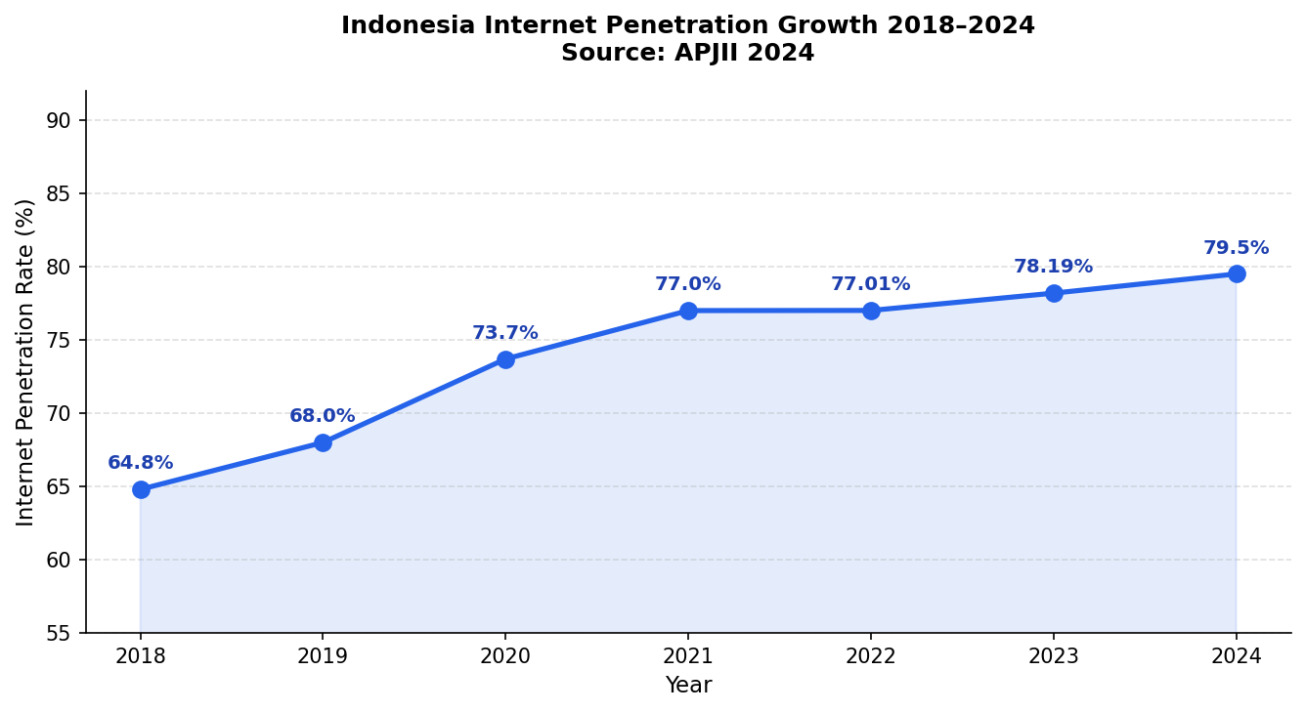  Figure 3. Internet Penetration Growth 2018–2024 | 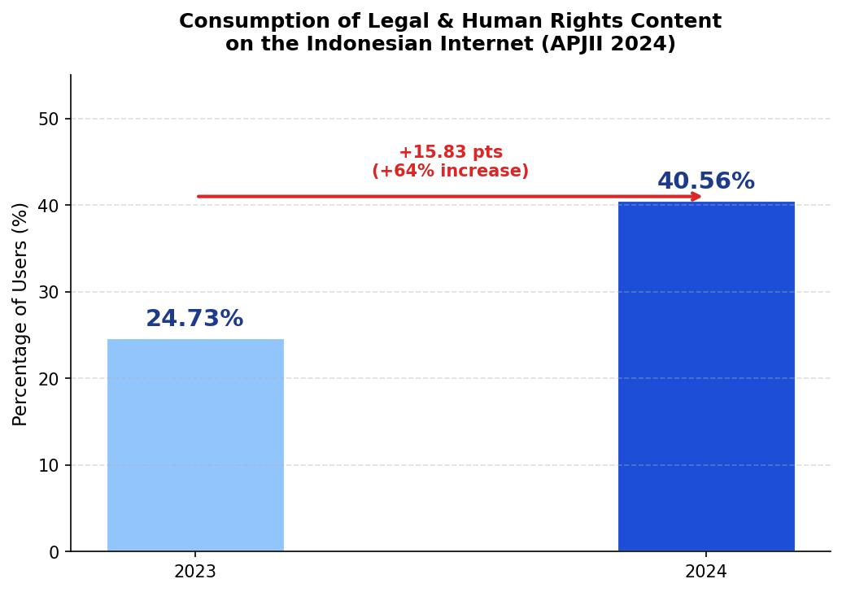  Figure 4. Surge in Legal Content Consumption

3. AI-Based Solution: HukumAI Indonesia

3.1 How the System Works

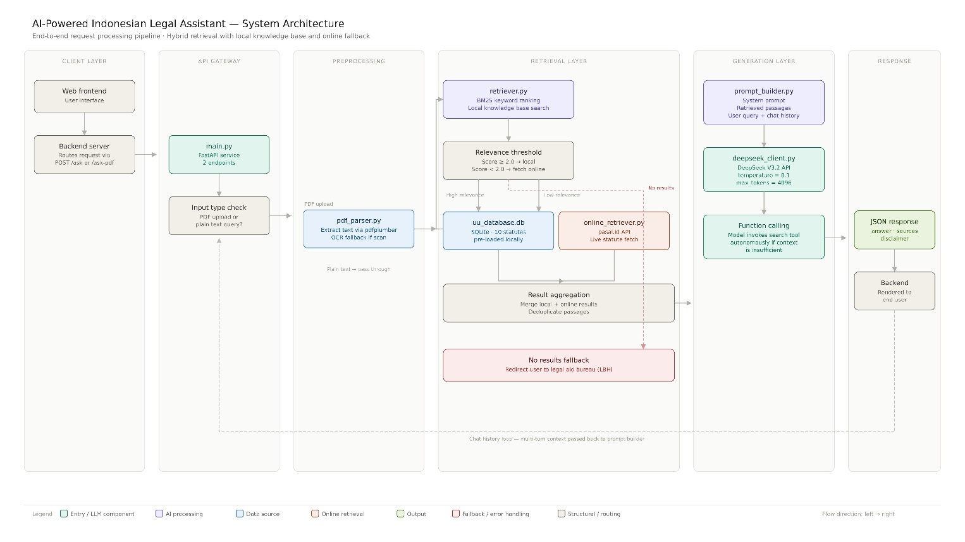
• Step 1 User Input: The user submits a legal question via a web form or uploads a PDF document through the frontend interface. The request is forwarded to the main backend via a REST API call.
• Step 2 Input Routing: The AI Service receives the request and checks whether a PDF file is attached. If yes, pdf_parser.py is invoked to extract the full text from the document before proceeding. If no document is uploaded, the pipeline continues directly with the user's text query.
• Step 3 Legal Retrieval: The query enriched with any extracted PDF text is passed to retriever.py, which performs a BM25 keyword search against the local legal database, a curated SQLite database containing 10 Indonesian statutes. The system then evaluates whether the retrieved results are sufficiently relevant to the query.
• Step 4 Adaptive Source Selection: If the local database results are deemed relevant, they are used directly. If the local results are insufficient, online_retriever.py is triggered to fetch real-time legal articles from the pasal.id API, ensuring the response is always grounded in up-to-date statutory provisions. Results from both sources are then merged.
• Step 5 Prompt Construction: The merged retrieval results combined with the original question, any PDF content, and the ongoing chat history are assembled into a structured prompt containing a system instruction, the retrieved legal documents as context, and the user's query.
• Step 6 LLM Response Generation: The fully constructed prompt is sent to DeepSeek V3.2 (temperature = 0.1) to ensure deterministic, factually grounded answers. If no relevant content is found from either source, the system triggers a fallback response that redirects the user to consult a Legal Aid Institute (LBH).
• Step 7 Structured Output: The final response is returned as a JSON object containing the answer, the cited legal sources, and a mandatory disclaimer clarifying that the response constitutes preliminary legal information, not formal legal advice. Chat history is preserved across turns to support multi-turn conversations.

3.2 Why AI Is the Right Approach
AI is not merely relevant it is the only approach capable of addressing this challenge at a national scale:
- Unlimited scalability a single system can serve millions of concurrent users at negligible marginal cost, unlike human legal consultants limited by time and capacity.
- 24/7 accessibility available at any time across all Indonesian time zones, including remote areas beyond the reach of conventional legal aid.
- Natural language understanding (NLP) citizens can ask questions in everyday language without mastering technical legal terminology.
- RAG-grounded accuracy every answer is directly sourced from verified legal documents, minimising the risk of AI hallucination.
- Low cost & sustainable built entirely with open-source tools: Python, open-source LLMs, and the locally available pasal.id API.

3.3 Responsible AI Principles
APILA Indonesia is developed with a full commitment to ethical AI. The system explicitly displays a disclaimer clarifying that responses constitute preliminary legal information not formal legal opinion and encourages users to consult a licensed advocate for complex matters. User data is processed under strict privacy standards and is never stored without explicit consent.

4. Feasibility
The solution is built entirely on open-source components: Python 3.11+ with LangChain/LlamaIndex for the RAG pipeline; SQLite as the vector database; the pasal.id API as the primary, always-updated legal data source; and a lightweight responsive web interface deployable via Google Cloud or Railway no expensive commercial licenses required.
Phase | Timeline | Key Deliverables
Phase 1 | Weeks 1–2 | RAG pipeline development, legal database curation, pasal.id API integration
Phase 2 | Weeks 3–4 | Chatbot UI, document upload feature, internal testing & LBH validation
Phase 3 | Weeks 5 | Soft launch, onboard 1,000+ early users, iterate based on feedback
Table 1. APILA Indonesia Implementation Roadmap

5. Scalability & Impact
Within the first 12 months, APILA targets 10,000 active users and over 50,000 legal queries processed. Over the medium and long term, the impact spans three levels:
- Community level: improved understanding of civic rights at the grassroots, reducing unresolved land disputes and labour conflicts.
- National level: supporting the government's target of expanding Law-Aware Villages through a scalable, measurable digital channel.
- ASEAN regional level: the APILA model can be adapted for other Southeast Asian nations facing similar legal literacy gaps Myanmar, Cambodia, and the Philippines with localised legal databases and language support.

6. Community Outreach Plan (1,000+ Members)
- Social media campaigns (Instagram, TikTok, YouTube): short-form legal education content targeting Gen Z and Millennials, who represent 64% of Indonesian internet users (APJII 2024).
- Google Student Ambassador network: direct outreach to university communities nationwide via the Google Developer Student Clubs (GDSC) ecosystem.
- Free workshops & webinars: in collaboration with local Legal Aid Institutes (LBH) and local governments to educate communities on fundamental legal rights.

