Problem Statement
Patrick F. Taylor Hall (PFT) is one of the largest and most frequently visited buildings on the LSU campus, which is used daily by students, staff, and visitors for classes, labs, offices, advising, and events. However, navigating inside PFT is often confusing and time-consuming, especially for people who use it for the first time or those who are occasional visitors. Our team is trying to solve the problem of inefficient and stressful indoor wayfinding in PFT by exploring how a digital indoor navigation experience could better support people in finding rooms and services, e.g., classrooms, faculty offices, restrooms, accurately and with less effort. This project is guided by a formative, semi-structured interview plan that focuses on where people get stuck in places like hallways, floor transitions, room areas, what cues they rely on, e.g., signage, room numbers, landmarks, and what features they would want in a future indoor navigation system, e.g., estimated time arrival (ETA), step-by-step directions, rerouting, landmarks, and accessibility support. Many people cannot efficiently navigate inside PFT due to the following problems:
- Room-finding failures: People struggle to locate a specific room or office, as they are not sequential in number.
- Confusing building structure: Similar-looking hallways and unclear floor transitions (stairs/elevators) can make it hard to know where you are.
- Insufficient or inconsistent cues: Signage, room numbering patterns, and directories do not provide enough guidance.
- Accessibility barriers: People may need an elevator, ramps or less crowded routes, but they cannot easily identify accessible paths or preferred routes inside the building.

Indoor navigation issues create real costs and frustrations. People often waste time, arrive late to classes/meetings, and experience stress when they cannot find their destination. This situation is harmful in high-pressure contexts such as exams, interviews, advising appointments, or conferences. Users with mobility constraints, injuries, or heavy loads may require accessible routes, but uncertainty about routes can make the building feel less usable. Improving indoor wayfinding can reduce cognitive load, increase confidence, and make PFT more welcoming for everyone, including visitors who do not have local knowledge of the building.
Current local solutions available in PFT are signs, room numbers, and wall directories. These are helpful, but they often fail when a user needs step-by-step decisions, e.g., which hallway to take, which stairwell leads to the right side of the floor. Static information also cannot adapt when someone takes a wrong turn or chooses a different route preference (elevator vs stairs). Asking people for help sometimes works, but it is inconsistent and adds social burden. Outdoor navigation apps (e.g., Google Maps/Apple Maps) are useful for getting to the building but typically do not provide reliable indoor, multi-floor turn-by-turn guidance inside a complex venue. Commercial platforms like MazeMap, Mappedin, and Anyplace often require significant setup and maintenance. Research also explores approaches like AR-based indoor navigation models of indoor spaces. These research systems require specialized data collection, and they may not be deployed long-term in a campus building with real maintenance constraints, adoption barriers, and trust concerns.
We want to solve this problem because it is a high-impact, real-world HCI challenge that affects everyday campus life. Small design improvements can save time, reduce frustration, and improve access for diverse users. Our goal is not only to propose “an app,” but also to understand the lived navigation experience through formative interviews and translate those insights into practical design requirements. We aim to propose a more usable and context-aware indoor navigation concept for PFT.
Formative Study

A. Instrument: To understand users’ experiences navigating inside PFT Hall, we conducted a qualitative formative study using semi-structured interviews supported by a brief demographic and technology-usage questionnaire. Interviews were selected over a large-scale survey because indoor navigation experiences are contextual and experiential. This approach allowed us to explore participants’ navigation strategies, confusion points, emotional responses, and expectations for digital support in depth.
B. Participants: We conducted semi-structured interviews with eight participants who had prior experience navigating inside PFT. The sample was selected to cover a continuum of familiarity with the building. Table 1 is a brief description of the demographics and experience of the interviewees.

Table 1 : Demographic data of the participants of the indoor navigation system formative study
Participant  ID | Age | Gender | Role | Education Level, Year | Frequency of PFT Visits | Smartphone Ownership | Outdoor Navigation Tool Usage
P1 | 32 | Female | Graduate Student | PhD, 2nd | Daily | Yes | Occasionally
P2 | 31 | Male | Graduate Student | PhD, 1st | Daily | Yes | Frequently
P3 | 35 | Female | Graduate Student | PhD, 3rd | Weekly | Yes | Frequently
P4 | 36 | Female | Graduate Student | PhD, 4th | Weekly | Yes | Frequently
P5 | 25 | Male | Graduate Student | PhD, 3rd | Daily | Yes | Frequently
P6 | 25 | Male | Graduate Student | PhD, 1st | Daily | Yes | Occasionally
P7 | 24 | Female | Graduate Student | PhD, 1st | Daily | Yes | Frequently
P8 | 24 | Male | Graduate Student | PhD, 1st | Weekly | Yes | Occasionally

The participants were all graduate students (4 females and 4 males; mean age 29 years). Recruitment was conducted through word-of-mouth, and then snowball sampling was used to find more interviewees. The sample only included PhD students who represented different fields. All participants (8/8) also indicated that they visited the PFT building on a daily (5/8) or weekly (3/8) basis, which means that they are somewhat familiar with the setting. All participants frequently use outdoor navigation apps like Google Maps (5/8), Apple Maps (2/8), and Waze (1/8). However, none of the participants were using any specific indoor navigation system before, which also shows a considerable difference between the wayfinding practices outdoors and indoors.

C. Procedure: The interview was carried out online through Zoom. The individual study sessions were split into two separate parts: (1) a short questionnaire that covered demographic data and technology use, and (2) a semi-structured interview that enquired about navigation behaviors and related difficulties. At the beginning of each session, the researchers obtained verbal informed consent from the participants and explained the purpose and procedures of the study. In the first part of the session, participants completed a short questionnaire that took about three minutes. The questionnaire asked for basic information such as age, gender, role, level of education, how often they visited the PFT building, whether they owned a smartphone, and whether they used any outdoor navigation tools. The second measure consisted of a semi-structured interview that lasted an average of 16.57+-2.45 minutes. The interviewees were asked to share certain experiences of disorientation or confusion experienced during their navigation through the PFT building. The interview was extended to ask about their role in the building, their familiarity with the building, and the areas they tend to want to visit regularly, e.g., classrooms, office, or department. The additional questions covered the general experiences of the participants in terms of navigation, the experience of getting lost, recovery strategies, and the perceived usefulness or confusion of the environmental features in terms of signage or landmarks, with the aim of determining the salient pain points and cognitive wayfinding cues. Mobility needs were also discovered through the preference of routes and accessibility difficulties by the participants in the interview. Lastly, the participants were asked whether they are using outdoor navigation tools and whether they would consider using a similar indoor system, which would evaluate openness and what they would want such a system to possess. The study was purely voluntary with no monetary rewards being provided.

D. Data Collection & Analysis: The study was carried out through audio recording and transcription of the Zoom sessions. We conducted an inductive thematic analysis using the six-step framework of Braun and Clarke. The transcripts were first open-coded by one researcher in Excel, and the corresponding segments were identified in relation to navigation difficulties, spatial disorientation, emotional reactions, and digital expectations (such as ‘All the hallways look the same’ was coded under layout similarity). Then, two researchers discussed and axially coded the codes. The refined codes were then grouped into wider categories, and candidate themes were verified against the whole dataset. The research group finally condensed four themes into three discussion sessions: (1) Navigation Goals and Wayfinding Strategies; (2) Building Layout and Signage Challenges; (3) Navigation Errors and Emotional Impact, and (4) Familiarity, Learning, and System Adoption.

E. Results: The inductive thematic analysis identified four main themes. These themes reflect what people are trying to do, the challenges they face in the building, how navigation affects them emotionally, and what they expect from possible digital support.
- Navigation Goals and Wayfinding Strategies: Participants usually entered PFT with a specific purpose, such as finding a classroom or an office. They mostly relied on wall signs, memory from previous visits, or simple trial and error. As P5 said, "I usually just follow the room numbers and hope they increase in order." This suggests that many users navigate reactively rather than with a clear plan.
- Environmental and Structural Navigation Barriers: Many participants described the building layout as confusing. Signage was often described as limited or unclear. P2 mentioned, "All the hallways look the same, and I lose my sense of direction." These structural features often led to wrong turns and extra walking.
- Emotional Impact and User Experience: Navigation problems were not only practical but also emotional. Participants reported feeling stressed, especially when they were running late. P1 explained, "When I'm late and can't find the room, I get really stressed." This shows that indoor navigation issues affect both efficiency and overall experience.
- Familiarity, Learning, and System Adoption: Over time, participants became more familiar with certain parts of the building, but even regular users struggled in less familiar areas. Several participants expressed interest in having some form of digital indoor navigation support. For example, P4 said, "If there was an app that showed me exactly where to go, I would definitely use it." This suggests openness to a tool that could provide clearer guidance inside the building.
Personas & Tasks

Persona 1: Emily Carter - University Student (Frequent User)
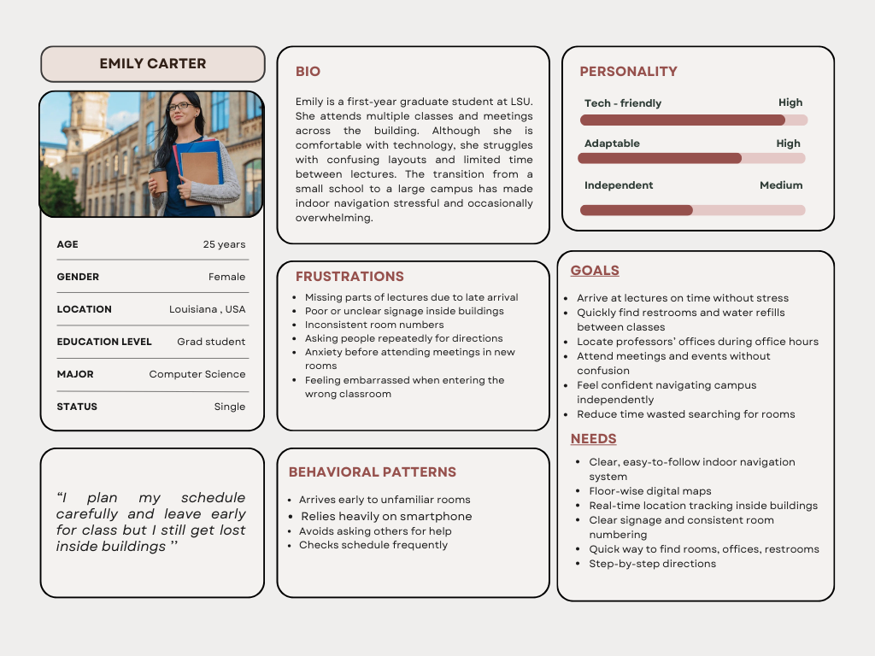
Figure 1 Primary Persona- Emily Carter, Frequent campus user
Emily Carter represents first-year graduate students who frequently move between large, multi-floor academic buildings but still experience confusion due to unclear signage and inconsistent room numbering. Even though she is comfortable with technology, she finds it difficult to rely on memory alone when navigating unfamiliar sections of the building. She often worries about being late to classes or meetings, especially when rooms are located on different floors. Her habit of checking her phone and arriving early to new locations reflects her desire to avoid stress and embarrassment. Designing with Emily in mind highlights the importance of reducing confusion, supporting time-sensitive transitions, and helping frequent users feel more confident navigating campus spaces.
Persona 2: John Summers - Visitor (Infrequent User)
John Summers represents visitors who come to campus for short-term purposes such as meetings or professional events. Because he is unfamiliar with the building layout and does not visit regularly, he lacks a clear mental model of how the space is organized. Under time pressure, unclear signage and complex floor maps increase his anxiety. Although he is moderately comfortable using technology, he prefers straightforward guidance that does not require effort to understand. His main objective is to reach his destination smoothly without relying on strangers for help. Designing for John emphasizes clarity, simplicity, and support for first-time users who need efficient navigation without unnecessary complexity.
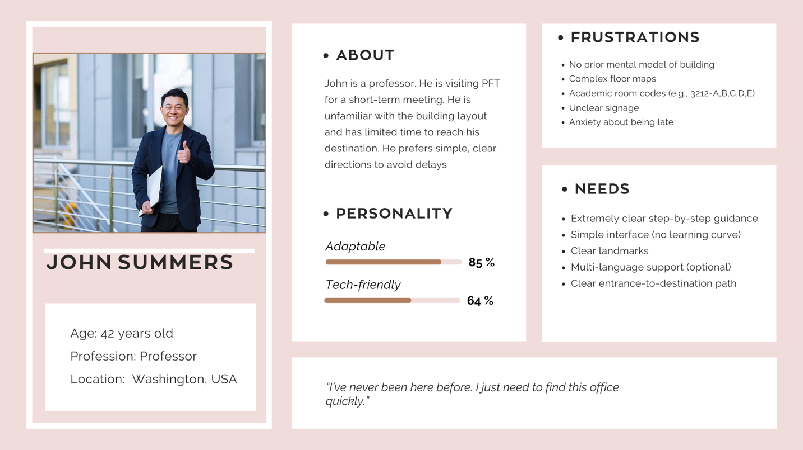
Figure 2 Secondary Persona - John Summers
Task Example 1: Navigating Between Back-to-Back Classes (Routine Task)
Emily is a first-year PhD student with two consecutive classes scheduled in different rooms within the same building. After finishing her first seminar on the first floor, she has only ten minutes to reach her next class in Room 2220 on the second floor. Although she attends PFT regularly, she is still unfamiliar with certain sections of the building.
Her goal is to move between classrooms quickly without getting lost or arriving late. Because hallways look similar and room numbers do not always follow a predictable order, she must pay attention to floor transitions and signage. The short break between classes increases pressure and leaves little room for error. The task begins when she exits her first classroom and ends when she locates and confirms the correct room for her second class. Completing this task helps her stay on schedule and reduces stress during busy academic days.
Task Example 2: First-Time Professional Visit to Meeting Room (Infrequent but important)
John is visiting the building to attend a scheduled professional meeting in Room 2212. He arrives shortly before the meeting begins and has never navigated the building before. Without prior familiarity, he must interpret the building layout, determine the correct floor, and follow room numbering to locate the meeting space.
His objective is to reach the room efficiently while maintaining a professional impression. Because he is under time constraints, wrong turns or unclear directions could increase stress. The task starts when he enters the building and ends when he confirms the meeting room and arrives prepared. Completing this task successfully allows him to participate confidently in the meeting without unnecessary delays.
Participation:
Sl | Participants | Email | Contribution Areas
1 | Tania Khatun | tkhatu1@lsu.edu | Wrote Problem Statement, Conducted Interviews of 2 persons
2 | FNU Nurjahan | nurja1@lsu.edu | Designed the Interview questions, wrote the formative study part, and conducted interviews with 2 persons
3 | Nushrat Jahan Ria | nria1@lsu.edu | Designed the Interview questions, wrote the formative study part, and conducted interviews with 2 persons
4 | Sidhi Kumari Yadav | SidhiKumari.Yadav@lsu.edu | Wrote Personas, Conducted Interviews of 1 person
5 | Ming Li | Ming.Li@lsu.edu | Wrote Task Examples, Conducted Interviews of 1 person

