**NIO Inc**.

**1) Business Description**: NIO Inc., established in 2014, is a prominent Chinese electric vehicle manufacturer specializing in the design, production, and distribution of high-end electric vehicles. Our core business model revolves around the production and promotion of electric SUVs, coupled with cutting-edge battery-as-a-service (BaaS) solutions and advancements in autonomous driving Technologies(nio.com).

**2) Sector Overview**: The electric vehicle market is characterized by stiff competition, and NIO is in direct competition with industry giants like Tesla (TSLA) and Li Auto (LI) for market dominance. The electric vehicle sector has witnessed significant growth over the past years, driven by increasing consumer demand for environmentally friendly transportation. Specially, NIO exhibited impressive revenue and earnings growth, reflecting strong demand for its electric SUVs, particularly the NIO ES6 and ES8 models(electrek.co,2023). This growth instilled confidence in investors about the company's financial stability and future profitability.

**3) Price Action Analysis**: NIO gained significant international recognition and popularity on the exchange in the second half of 2020 and into 2021. This period was marked by a rapid increase in NIO's stock price and market capitalization, driven by the positive impact of growing interest in electric vehicle (EV) companies (Ilaria Mazzocco, 2023).

**Table**:1

As can be seen from table 1, the lowest line prices were in 2023-05. In April and May NIO, delivered 6,658 and 6,155 vehicles, respectively (fool.com, Jun 2023). This was a weaker indicator when we looked at other competitors (fool.com, Sep 2023). Therefore, these processes had an impact on the Stock market prices.

**Table**:2

**4) Future Catalysts**: A year ago, demand for electric vehicles due to high gas prices from the war in Ukraine sent prices on an upward swing. Now, more sector competition, higher inventory and incentives are pushing prices back down(cnbc.com). Regardless of some setbacks, I believe NIO's stock will continue to be impacted by product launches, delivery numbers, and global expansion efforts. One of the important events in the next 6 months could be the launch of a new electric vehicle model (EC6) or updates to existing models. Possible scenarios for the stock during this event include increased investor interest if the new model receives positive reviews and higher sales estimates.

* 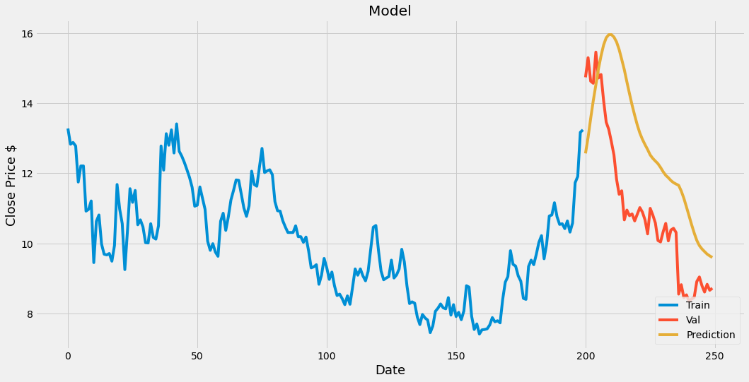

**Table**:3

**Source**

<https://finance.yahoo.com/quote/NIO/history?p=NIO>

<https://csis-website-prod.s3.amazonaws.com/s3fs-public/2023-08/ts230821_Ilaria_Mazzocco_Testimony.pdf?VersionId=tUdJCkDwKrw3u7Snq_fTsEnvKkEsyGiW>

<https://electrek.co/2023/08/21/nio-cranking-out-300-es6-electric-suvs-per-day/>

<https://www.fool.com/earnings/call-transcripts/2023/06/09/nio-nio-q1-2023-earnings-call-transcript/>

<https://www.nio.com/news/all-new-EC6-launch>

<https://www.cnbc.com/2023/07/26/new-and-used-ev-prices-have-dropped-but-dont-rush-to-buy.html>