ASSIGNMENT 4–5 REPORT

Incident Response Simulation and
Infrastructure as Code Implementation

MicroShop — Containerized Microservices System

Introduction to SRE | 2026

GitHub: https://github.com/Nurlybek-Nurzhan/Assignment_4-5_SRE

System Overview
MicroShop is a containerized e-commerce platform built to demonstrate SRE practices. It consists of five independent FastAPI microservices, a PostgreSQL database, an Nginx frontend acting as a reverse proxy, Prometheus for metrics collection with three alert rules, and Grafana with an auto-provisioned dashboard. All components run in Docker containers orchestrated by Docker Compose on a shared internal bridge network (microshop-net).
Architecture
- Auth Service (port 8001) — JWT authentication with bcrypt password hashing; crashes on startup if JWT_SECRET not set
- Product Service (port 8002) — product catalog, persisted to a Docker volume via JSON file
- Order Service (port 8003) — order management, PostgreSQL backend, Histogram latency metrics; crashes if DB_PASS or JWT_SECRET not set
- User Service (port 8004) — user profile management with JWT token verification; crashes if JWT_SECRET not set
- Chat Service (port 8005) — messaging with JWT token verification; crashes if JWT_SECRET not set
- PostgreSQL — persistent database used exclusively by the Order Service
- Prometheus (port 9090) — scrapes /metrics from all five services; three alert rules defined
- Grafana (port 3000) — auto-provisioned datasource and dashboard on startup
- Nginx (port 80) — serves the frontend, proxies /api/* routes to backend services
Observability and Metrics
All five services expose Prometheus Counter metrics for request counts. The Order Service additionally exposes a Histogram metric — order_request_duration_seconds — with nine latency buckets (5ms to 2.5s). This enables p50, p95, and p99 latency queries in Grafana, which are the primary signals used in production SLO monitoring.
Three Prometheus alert rules are defined in monitoring/alert_rules.yml:
- OrderServiceErrors — fires when order_errors_total increases (DB connection broken)
- ServiceDown — fires when any scrape target returns up=0 (process crashed)
- OrderServiceHighLatency — fires when p95 latency exceeds 1 second for 1 minute
Security Hardening
- All credentials stored in .env file, never hardcoded in source
- Passwords hashed with bcrypt — plaintext never stored
- Real JWT tokens (HS256) issued on login; Chat, User services validate on every request
- Services crash at startup with RuntimeError if JWT_SECRET or DB_PASS env vars are missing
- All containers have enforced memory and CPU limits (mem_limit / cpus top-level keys)
- Docker healthchecks on all services — Docker knows if app is ready, not just started
- terraform.tfstate excluded from git — contains sensitive AWS resource IDs
- allowed_ssh_cidr has no default in variables.tf — terraform apply fails if not explicitly set
Known Limitations (Assignment Scope)
- Auth service uses two hardcoded users defined in .env — no user registration flow
- Chat messages are in-memory only — reset on container restart (no chat DB)
- User list is a static in-memory list — no persistence across restarts
- Order Service opens a new psycopg2 connection per request — no connection pooling
- allowed_ssh_cidr is set to 0.0.0.0/0 in terraform.tfvars for demo purposes — must be restricted to a specific IP in production
Running System
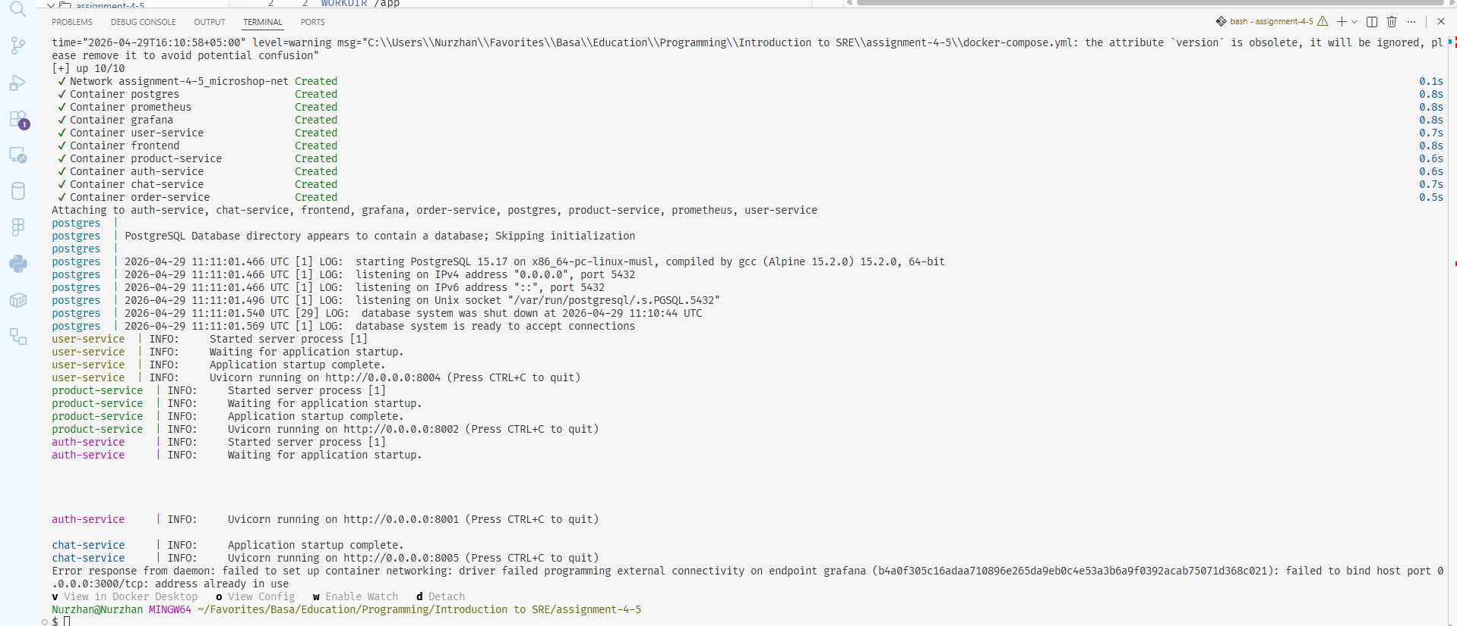
Figure: docker compose up — all 9 containers started successfully
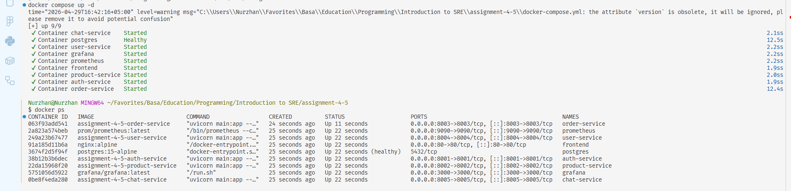
Figure: docker ps — all containers running with correct port mappings
Frontend Dashboard
The MicroShop Dashboard shows real-time health of all five services with green/red status dots. The header includes a login form — entering credentials calls the Auth Service and receives a real JWT token which is then used for authenticated Chat and User Service calls.
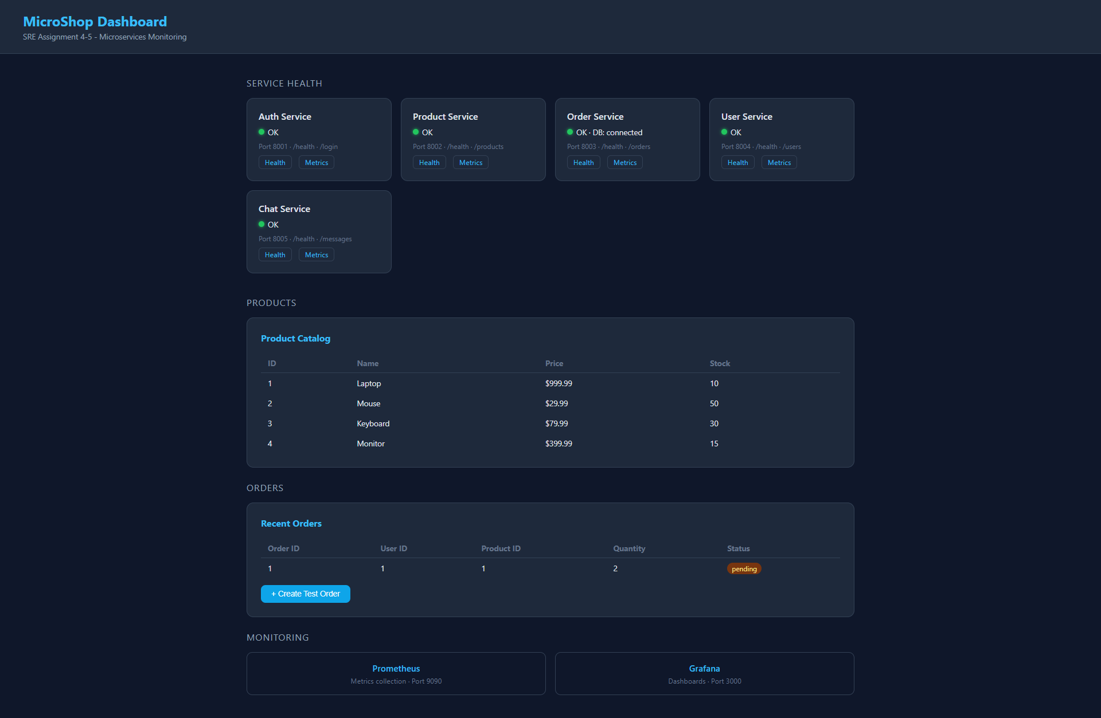
Figure: MicroShop Dashboard — all 5 services healthy, login form in header
Monitoring
Prometheus scrapes all five services every 15 seconds. Grafana loads the Prometheus datasource and MicroShop dashboard automatically on startup via provisioning files — no manual configuration needed. The dashboard includes panels for service health, per-service request rates, order error rate, total error count, and order latency percentiles.
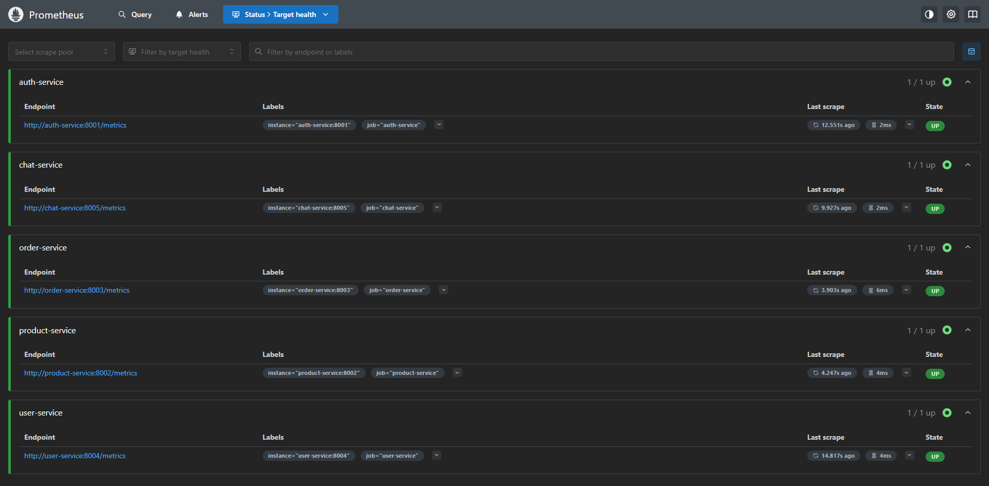
Figure: Prometheus — all 5 service targets showing UP
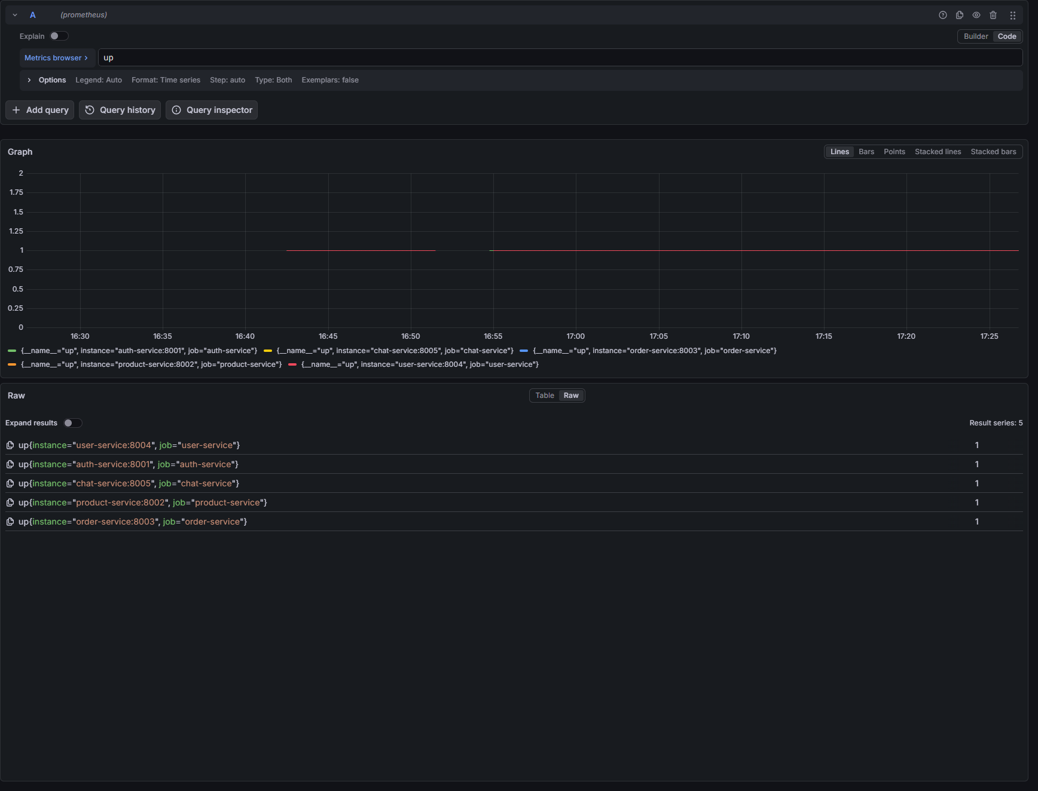
Figure: Grafana — auto-provisioned dashboard with health, request rate, and error panels

ASSIGNMENT 4 — Incident Report
1. Incident Summary
On 2026-04-29, a production-level incident was simulated in the MicroShop Order Service by deliberately misconfiguring the DB_HOST environment variable from 'postgres' to 'wrong-host'. After restarting the container with this broken configuration, the Order Service lost all database connectivity and returned HTTP 503 on every request. All four other services remained fully operational throughout the incident, demonstrating correct fault isolation.
2. Impact Assessment
- Order Service: 100% unavailable — /orders (GET and POST) and /health all returned HTTP 503
- Frontend dashboard: Order Service card showed 'Unreachable' with red status dot
- Users could not view existing orders or create new ones
- Auth, Product, User, and Chat services: fully operational — fault isolation confirmed
- Data integrity: no data lost — PostgreSQL remained healthy throughout
- Prometheus showed order-service as up=1 — the process was running but functionally broken
3. Severity Classification
Severity: SEV-2 (Major) — a critical business function (order processing) was completely unavailable.
Classified SEV-2 rather than SEV-1 because the failure was isolated to one service. Authentication, product browsing, and other features remained functional.
4. Timeline of Events
Time | Event
T+00:00 | DB_HOST changed from 'postgres' to 'wrong-host' in docker-compose.yml
T+00:05 | Order Service restarted: docker compose up -d --force-recreate order-service
T+00:10 | Frontend dashboard detected Order Service as 'Unreachable'
T+00:15 | /api/orders/orders returned HTTP 503 Service Unavailable
T+00:20 | order_errors_total counter began incrementing in Prometheus
T+00:25 | /health returned 503: 'DB connection failed: could not translate host name wrong-host'
T+00:30 | docker logs confirmed repeated psycopg2 DNS resolution failures
T+01:00 | Root cause confirmed: incorrect DB_HOST environment variable
T+01:05 | DB_HOST corrected back to 'postgres' in docker-compose.yml
T+01:10 | Order Service restarted with corrected configuration
T+01:15 | /health returned HTTP 200: {status: ok, db: connected}
T+01:20 | Frontend dashboard confirmed all services green — full recovery

5. Root Cause Analysis
Root cause: misconfigured DB_HOST environment variable. Docker Compose services resolve each other by container name through Docker's internal DNS. The hostname 'postgres' resolves correctly on the microshop-net network. The value 'wrong-host' has no DNS record, so every call to psycopg2.connect() immediately raised an OperationalError at the DNS resolution step before attempting any TCP connection.
Key SRE observation: Prometheus showed order-service as up=1 throughout the incident. Prometheus scrapes /metrics, which does not touch the database and always responds. The service process was alive but functionally broken. This is the critical SRE distinction: process liveness does not equal service health. The /health endpoint correctly returned 503 with the exact error message. The order_request_duration_seconds Histogram also showed latency spikes before failures, which would have triggered the OrderServiceHighLatency alert in a real environment.
Incident Evidence
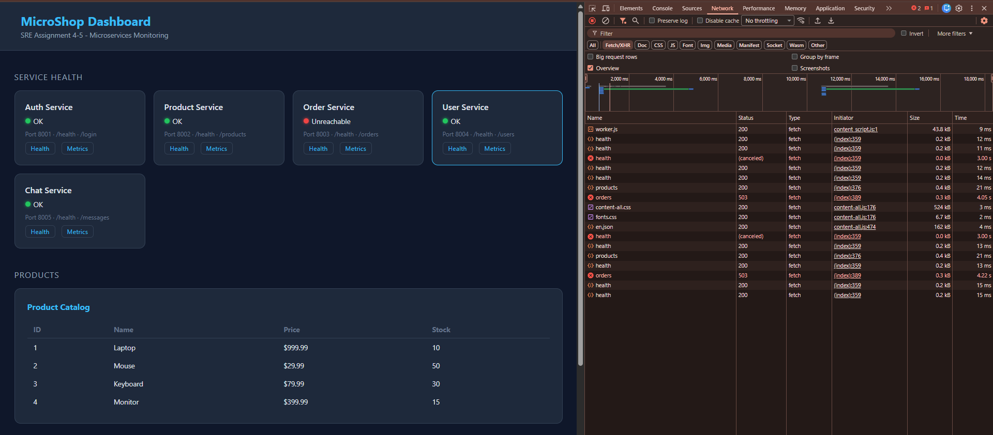
Figure: Dashboard during incident — Order Service 'Unreachable', 503 errors in Network tab
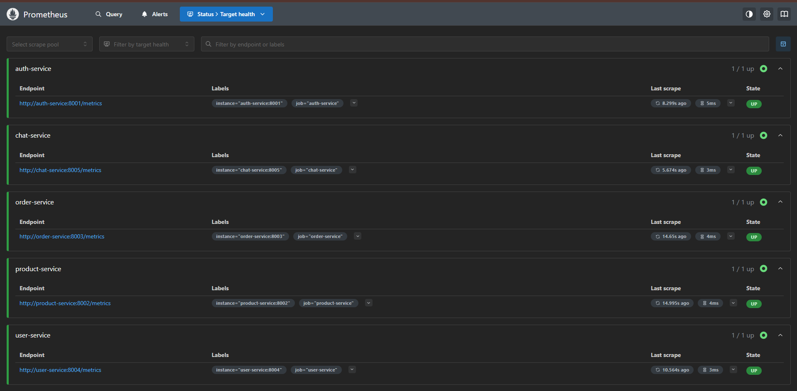
Figure: Prometheus during incident — up=1 for all services. Process alive but DB broken. Real signal: order_errors_total incrementing.
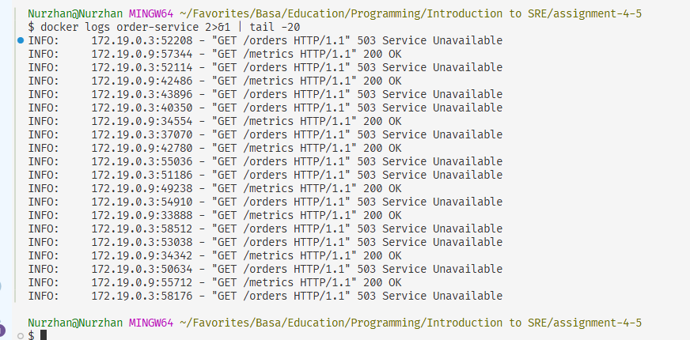
Figure: Docker logs — GET /orders returns 503, GET /metrics returns 200. Confirms service running but every DB request fails.
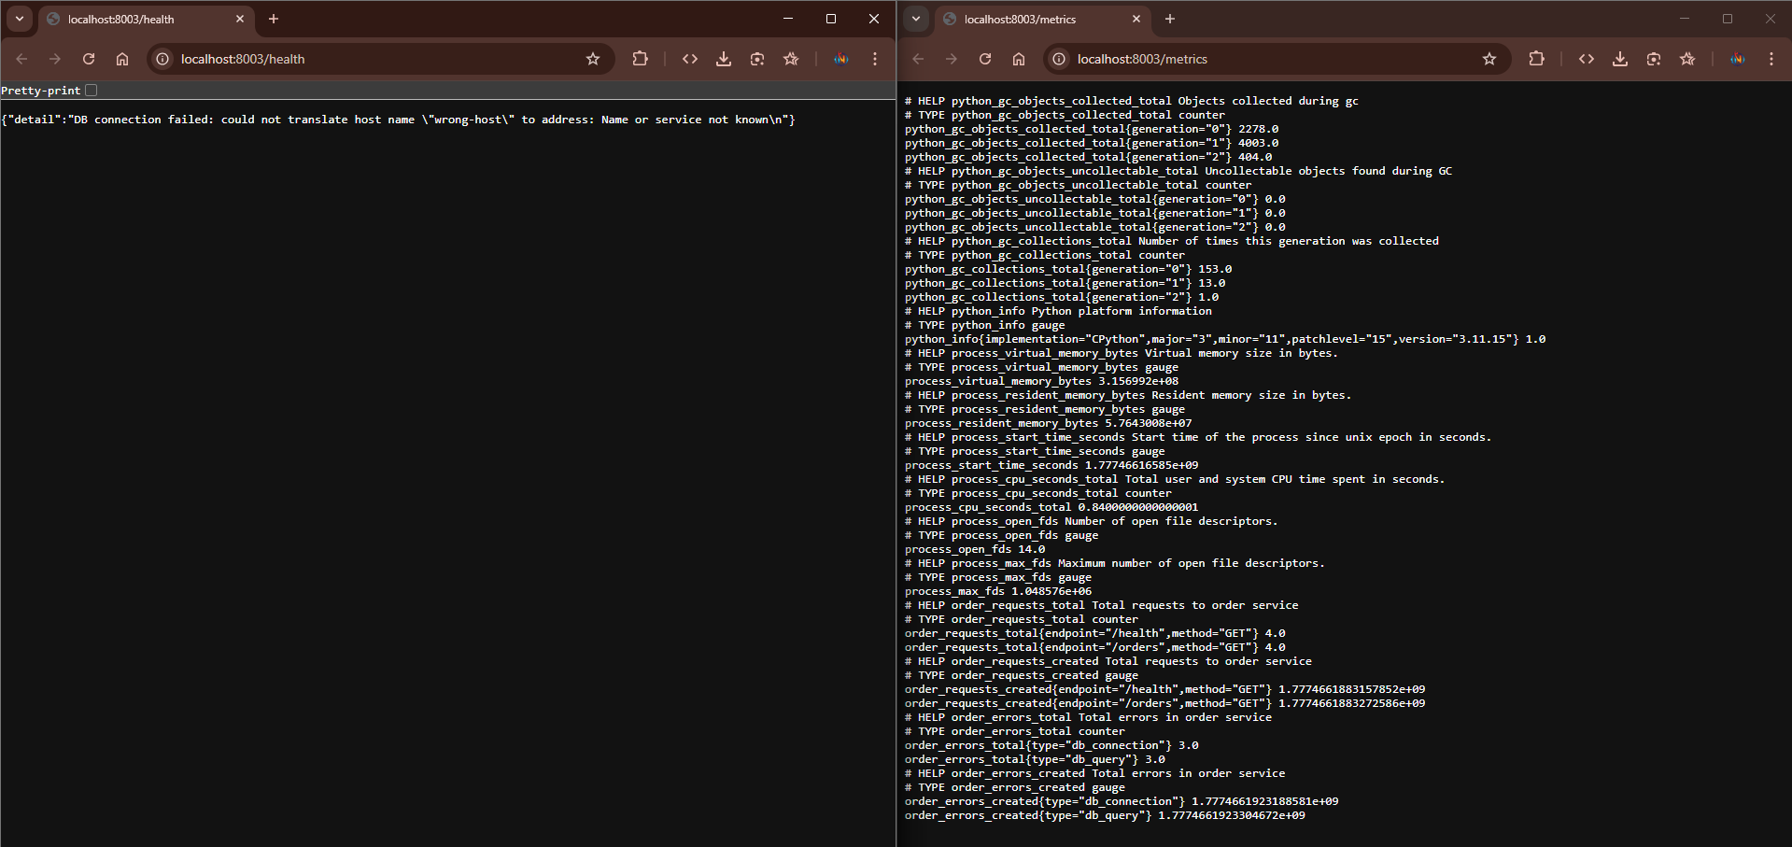
Figure: /health returning 503 with exact error: 'could not translate host name wrong-host' — root cause evidence.
6. Mitigation Steps
- Step 1 — docker logs order-service showed repeated 503 on /orders
- Step 2 — /health endpoint returned exact error with the bad hostname 'wrong-host'
- Step 3 — Inspected docker-compose.yml: DB_HOST was set to 'wrong-host'
- Step 4 — Changed DB_HOST back to 'postgres'
- Step 5 — Restarted only the affected container: docker compose up -d --force-recreate order-service
- Step 6 — Verified: /health returned 200 with db: connected
- Step 7 — Confirmed via dashboard: all services green
7. Resolution Confirmation
Full recovery achieved within approximately 70 seconds of applying the fix. /health returned HTTP 200, the dashboard showed all five services green, and the order_errors_total counter stopped incrementing. No data was lost.
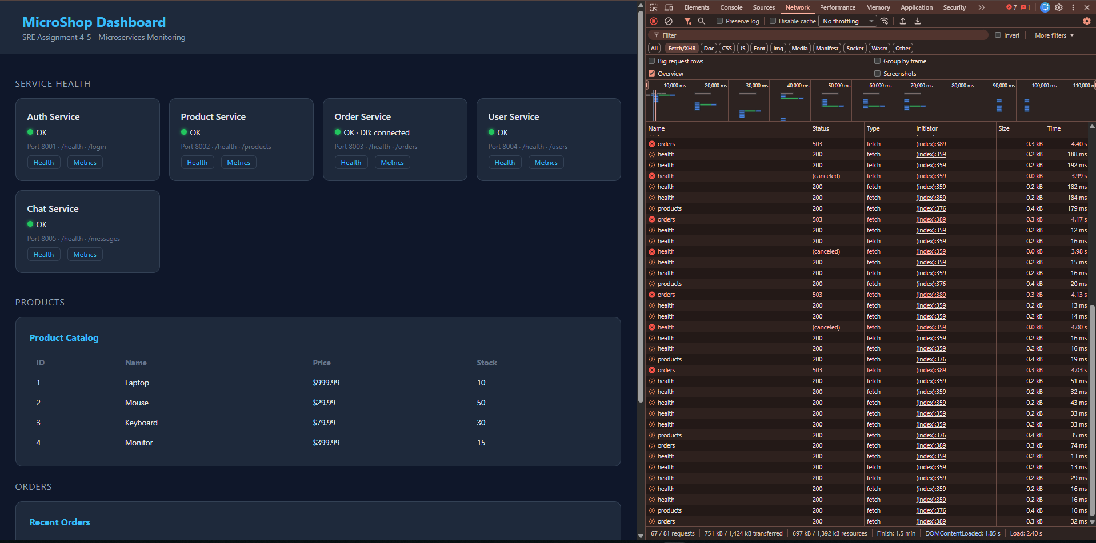
Figure: Recovery — all services green, Order Service showing DB: connected
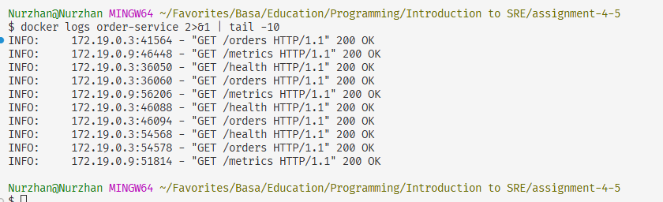
Figure: Recovery logs — HTTP 200 responses confirmed after fix
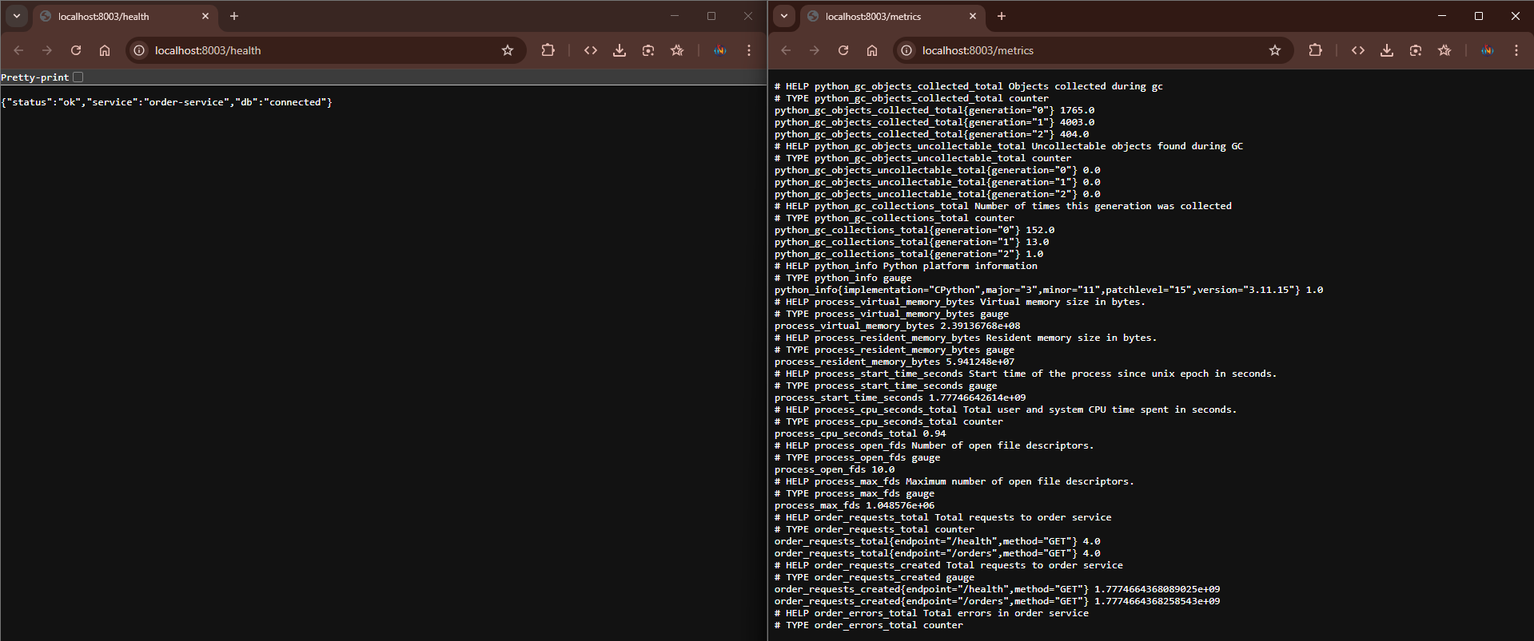
Figure: /health returning 200 with db: connected

Postmortem Analysis
1. Incident Overview
On 2026-04-29, the MicroShop Order Service became fully unavailable for approximately 70 seconds due to an incorrect database hostname in the service environment configuration. The incident was intentionally introduced as part of Assignment 4 to simulate a realistic production failure and practice the complete incident response lifecycle.
2. Customer Impact
- 100% of order-related requests failed with HTTP 503 during the incident window
- Order viewing and creation were completely unavailable
- Product browsing, authentication, user profiles, and chat were fully unaffected
- No data loss — PostgreSQL remained healthy and all existing orders were preserved
3. Root Cause Analysis
The DB_HOST environment variable was manually changed to a non-existent hostname. Docker Compose services discover each other via Docker's internal DNS using container names. Setting DB_HOST='wrong-host' caused immediate DNS failure on every database operation. The service had no retry logic — each request attempted a fresh connection, failed instantly, incremented order_errors_total, and returned HTTP 503.
4. Detection and Response Evaluation
Detection was fast — the frontend dashboard showed the failure within 10 seconds. The /health endpoint was the critical diagnostic tool: it returned the exact bad hostname in the error message, making root cause identification immediate.
Gap identified during incident: Prometheus showed up=1 throughout because it only checks process liveness via /metrics. The OrderServiceErrors alert rule fires on error counter increases, and the new OrderServiceHighLatency alert fires on p95 latency exceeding 1 second — both would catch functional failures that process liveness misses.
5. Resolution Summary
A single configuration change (correcting DB_HOST to 'postgres') followed by a container restart fully restored the service in under 2 minutes. No code changes, no data recovery, no other service required intervention.
6. Lessons Learned
- Environment variables are a frequent source of misconfiguration in containerized systems
- Process liveness (up=1) does not mean a service is functionally healthy — dependency checks in /health are essential
- Histogram metrics (p95/p99 latency) provide earlier warning signals than counters alone
- Microservices fault isolation worked correctly — one broken service did not cascade to others
- Services now crash at startup if critical env vars are missing — fail fast beats silent wrong behavior
7. Action Items
- DONE — OrderServiceErrors alert: fires when order_errors_total increases
- DONE — ServiceDown alert: fires when any Prometheus target goes down
- DONE — OrderServiceHighLatency alert: fires when p95 latency exceeds 1 second
- DONE — Histogram metrics added to Order Service (order_request_duration_seconds)
- DONE — Services crash at startup if JWT_SECRET or DB_PASS not set
- DONE — allowed_ssh_cidr has no default — terraform apply requires explicit value
- TODO — Add DB connection retry with exponential backoff
- TODO — Configure Grafana notification channel (email/Slack) for alert delivery
- TODO — Restrict allowed_ssh_cidr to specific IP in production deployment

ASSIGNMENT 5 — Infrastructure as Code (Terraform + AWS)
Overview
The cloud infrastructure for MicroShop was provisioned using Terraform with the AWS provider. Terraform is a declarative IaC tool — the entire infrastructure is described in .tf files and created, updated, or destroyed with single commands. This makes infrastructure reproducible, version-controlled, and auditable.
Implementation: Two Phases
During development, Terraform was first configured with a local Docker provider (kreuzwerker/docker) to validate the configuration structure locally. This phase is visible in screenshots 13_terraform_apply_*. After the professor confirmed that cloud deployment was required, the configuration was migrated to the AWS provider. The final AWS deployment is shown in screenshots 14_terraform_apply_after_AWS_implementation_*. The code in the repository reflects the final AWS configuration only.
Note: AWS apply created: EC2 instance at 34.238.137.187 (us-east-1), security group sg-0091acf407323802f.
Terraform Files
main.tf
Defines two AWS resources. aws_security_group opens inbound ports for SSH (22), HTTP (80), Grafana (3000), and Prometheus (9090). SSH and monitoring ports use the allowed_ssh_cidr variable — this variable has no default, so terraform apply fails if not explicitly set. aws_instance provisions a t3.micro EC2 VM with Amazon Linux 2. The user_data script installs Docker, git, and docker-compose on first boot. key_name accepts an optional SSH key pair via the ssh_key_name variable.
variables.tf
Declares five variables: aws_region, instance_type, ami_id, allowed_ssh_cidr (no default — forces explicit security decision), and ssh_key_name (optional, empty = no SSH key). Removing the default from allowed_ssh_cidr was a deliberate security hardening step — it prevents accidental open-internet deployments.
terraform.tfvars
Provides actual values: us-east-1, t3.micro, Amazon Linux 2 AMI, and allowed_ssh_cidr = 0.0.0.0/0 for this assignment demo. t3.micro was chosen because t2.micro was rejected by AWS as not free-tier eligible. The 0.0.0.0/0 value is intentional for demo access and documented with a comment explaining it must be restricted in production.
outputs.tf
Outputs after apply: instance_public_ip, instance_public_dns, grafana_url, prometheus_url, and security_group_id — making deployed services accessible without manually looking up the IP in the AWS Console.
Terraform Screenshots
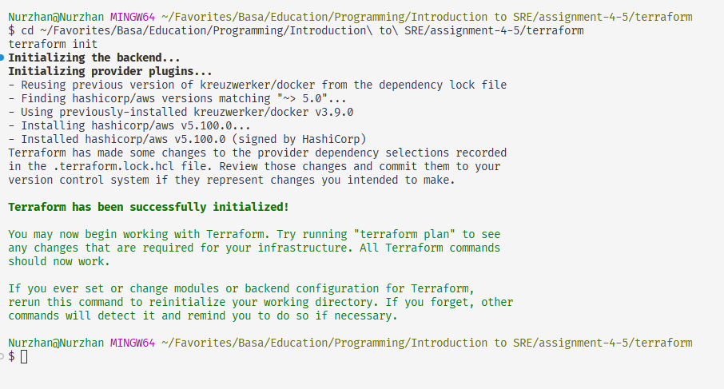
Figure: terraform init — AWS provider downloaded successfully
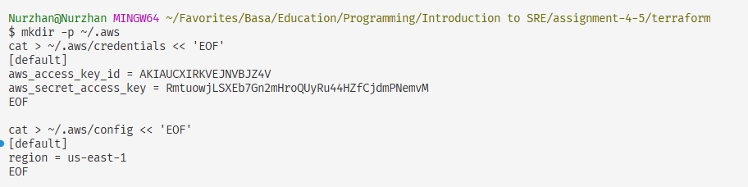
Figure: AWS IAM credentials configured for Terraform authentication
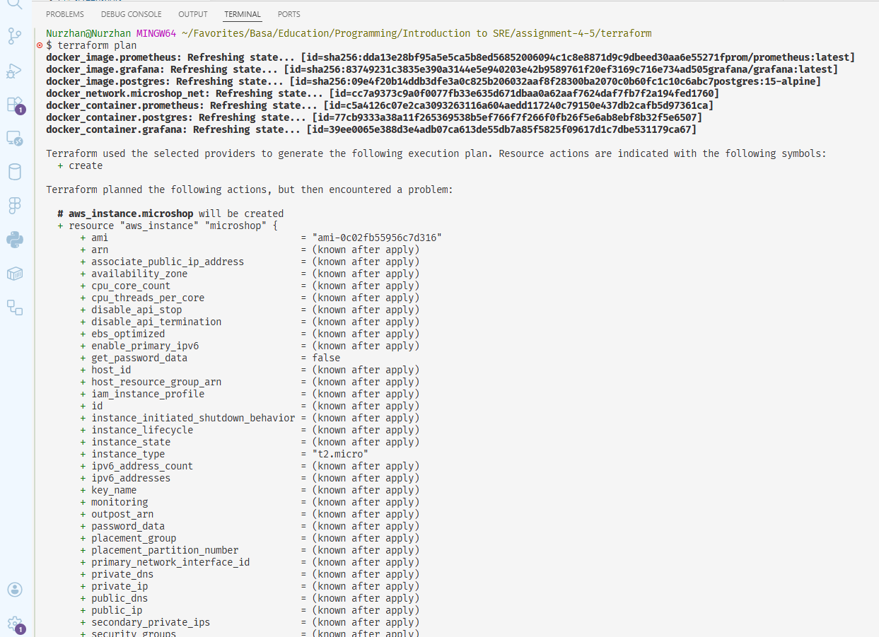
Figure: terraform plan — aws_security_group and aws_instance to be created
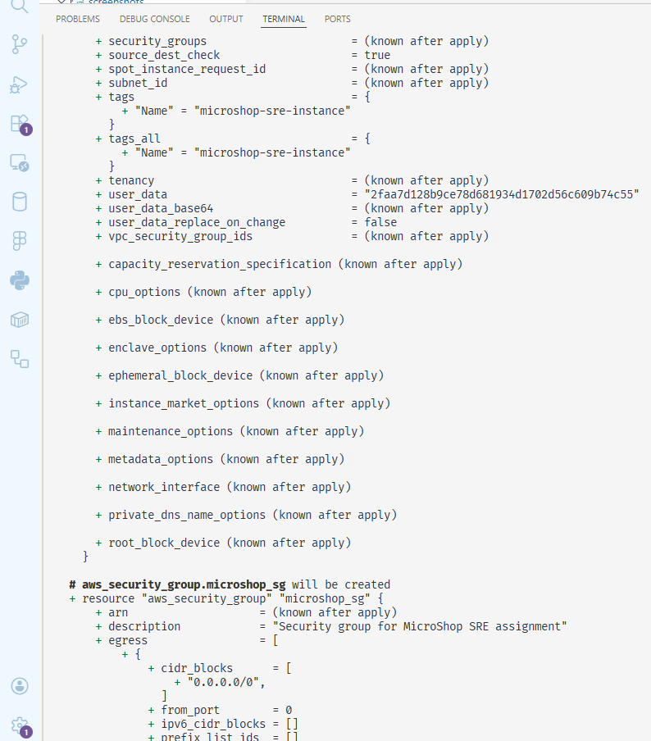
Figure: terraform plan — EC2 instance configuration detail
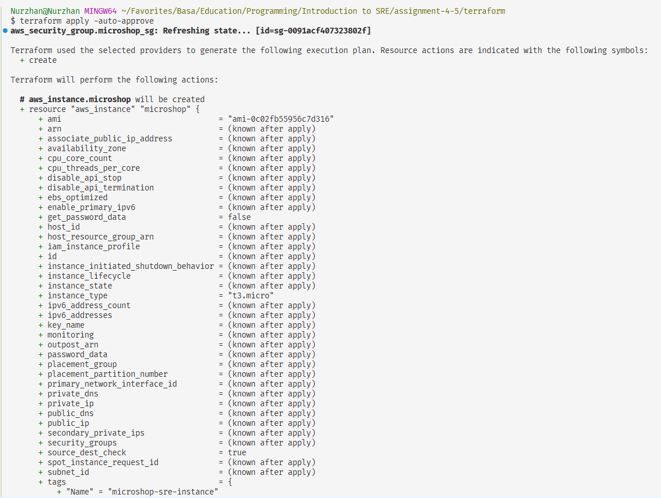
Figure: terraform apply — EC2 instance creation in progress
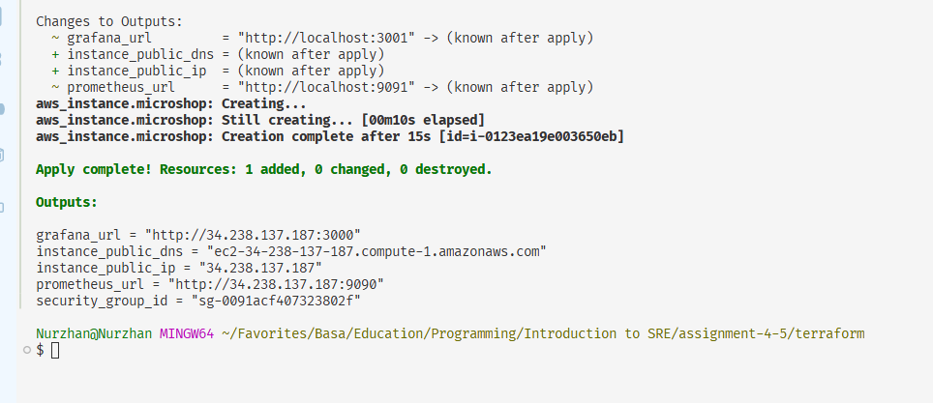
Figure: terraform apply — security group created
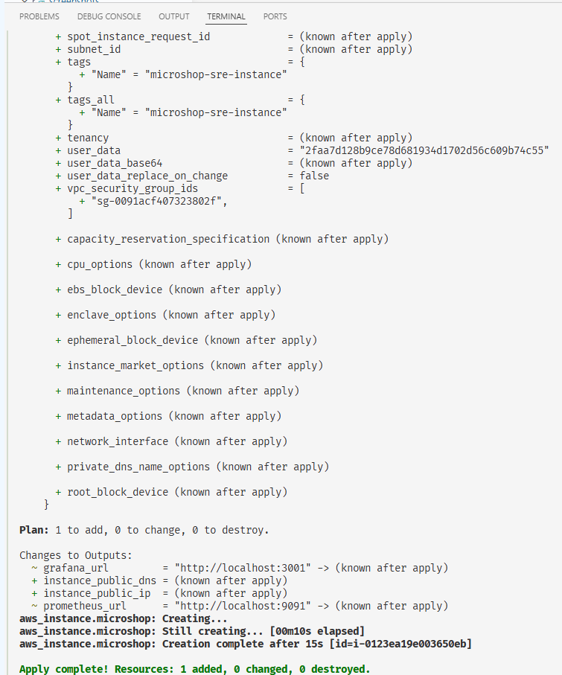
Figure: terraform apply — outputs: public IP 34.238.137.187
Why Terraform over Manual AWS Console
- Reproducible — identical infrastructure on every terraform apply
- Version controlled — infrastructure changes tracked in git
- Self-documenting — .tf files describe exactly what exists and why
- Automated — no manual clicking, no missed steps
- Destroyable — terraform destroy removes everything, preventing surprise AWS charges

Deployment Guide
Prerequisites
- Docker Desktop installed and running
- Terraform >= 1.0 installed
- AWS account with IAM user (AdministratorAccess, access key + secret key)
- Git
1. Clone and Configure
git clone https://github.com/Nurlybek-Nurzhan/Assignment_4-5_SRE.git
cd Assignment_4-5_SRE
cp .env.example .env # then edit .env with your secrets
2. Run Locally
docker compose up --build
Dashboard: http://localhost:80 | Prometheus: http://localhost:9090 | Grafana: http://localhost:3000
Login with credentials from .env (default: nurzhan / password123).
3. Provision AWS Infrastructure
cd terraform
Set allowed_ssh_cidr in terraform.tfvars to your IP (e.g. 203.0.113.5/32)
Configure credentials: edit ~/.aws/credentials with your IAM access key
terraform init && terraform plan && terraform apply
4. Simulate the Incident
In docker-compose.yml change DB_HOST: postgres → DB_HOST: wrong-host
docker compose up -d --force-recreate order-service
Watch dashboard, check /health, observe order_errors_total in Prometheus.
5. Recover
Restore DB_HOST: postgres in docker-compose.yml
docker compose up -d --force-recreate order-service
6. Clean Up AWS
cd terraform && terraform destroy

