Midterm Project Report

Production-Ready Observability for FitClub Web Application

Student: Nurlybek Nurzhan

Course: Introduction to SRE

Project: FitClub Fitness Management System

1. Project Overview
To do this, I have taken an existing product, FitClub Fitness Management System, which is a full-stack web app that I have built in the Web Technologies class. I converted it to a fully deployed, containerized app, along with a production observability SRE stack for it. This time, it was not just about writing code but to actually run it as a Site Reliability Engineer - setting up reliability objectives and containerizing each component separately, and building monitoring dashboards and alerts.

Application Description
FitClub is an application for managing fitness training where users can view programs, add their own programs, rate and comment on programs, and manage their accounts. FitClub administrators can add, edit, and delete programs and workouts using the admin panel.

Layer | Technology
Frontend | HTML5, CSS3, Vanilla JavaScript, Bootstrap 5.3, jQuery 3.6
Backend | Node.js (ESM), Express.js 4.18
Database | MongoDB 7 (local container)
Auth | JWT (7-day tokens), bcryptjs
Metrics | prom-client (Prometheus Node.js client)
Containerization | Docker, Docker Swarm
Monitoring | Prometheus, Grafana, Node Exporter

2. Containerization - Docker Compose & Docker Swarm
The original application was a monolith: the Express backend served the frontend static files from the same process. As the first SRE task I separated them into independent containers so each service can be scaled, updated, and monitored individually.

2.1 Architecture - Separated Services
The stack consists of six fully isolated services:

Service | Image | Port | Replicas | Purpose
frontend | fitclub-frontend (Nginx:alpine) | 80 | 2 | Serves static HTML/CSS/JS
backend | fitclub-backend (Node 20-alpine) | 5000 | 2 | REST API + /metrics endpoint
mongo | mongo:7 | - | 1 | Persistent database
prometheus | prom/prometheus:latest | 9090 | 1 | Metrics collection & alerting
grafana | grafana/grafana:latest | 3000 | 1 | Dashboards & visualization
node-exporter | prom/node-exporter:latest | 9100 | 1 | Host-level system metrics

2.2 Backend Dockerfile
FROM node:20-alpine
WORKDIR /app
COPY package*.json ./
RUN npm install --production
COPY . .
EXPOSE 5000
CMD ["node", "server.js"]

2.3 Frontend Dockerfile
The frontend is served by an Nginx Alpine container with a custom nginx.conf:
FROM nginx:alpine
COPY nginx.conf /etc/nginx/conf.d/default.conf
COPY . /usr/share/nginx/html
EXPOSE 80

2.4 Docker Swarm Deployment (BONUS +10)
Instead of plain docker-compose up, I deployed the entire stack using Docker Swarm for production-grade orchestration with automatic restart and load balancing across replicas.
docker swarm init
docker build -t fitclub-backend ./backend
docker build -t fitclub-frontend ./frontend
docker stack deploy -c docker-compose.yml fitclub
docker service ls

Figure 1 - npm install completing successfully and Docker Swarm initializing:
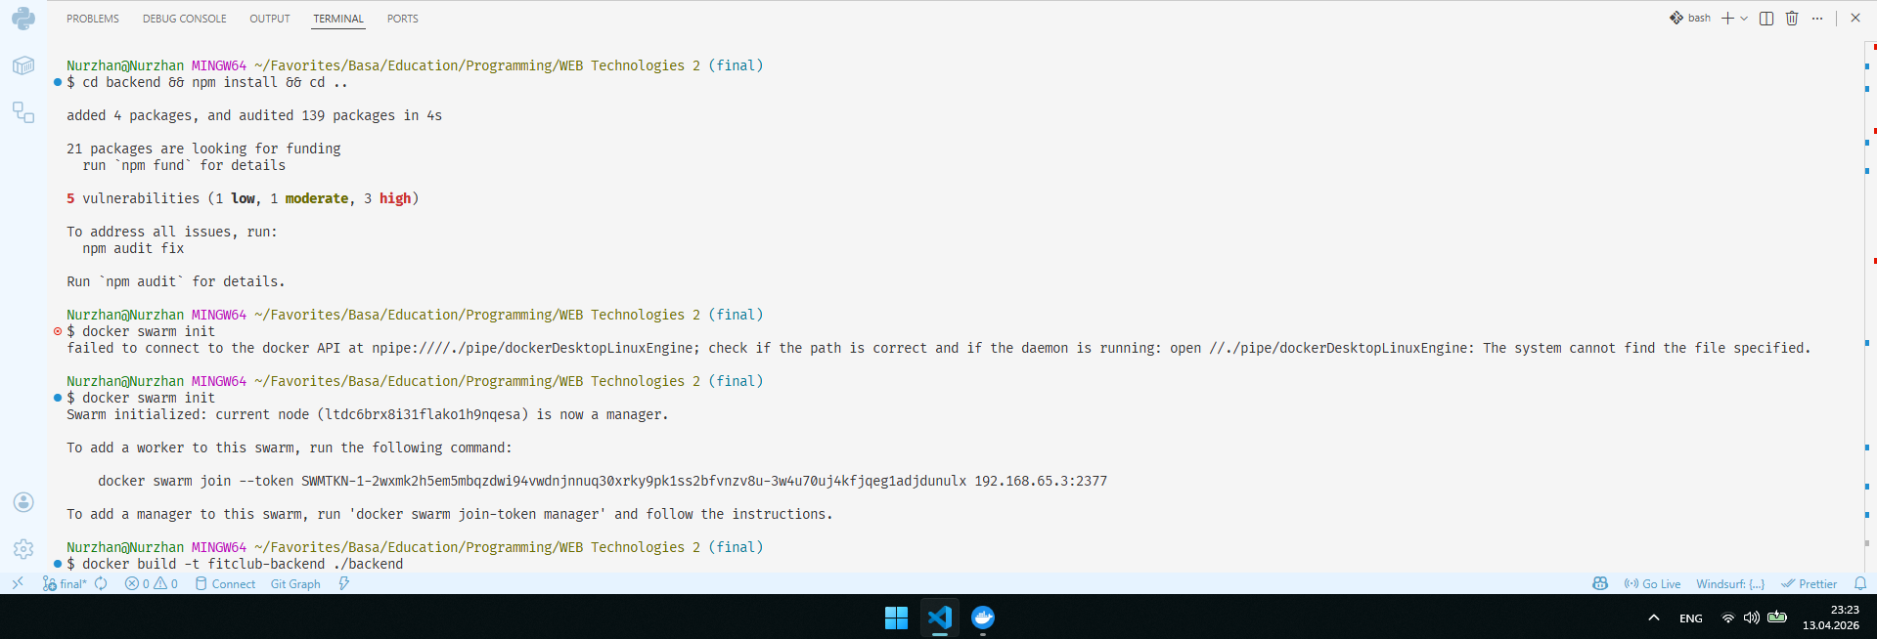

Figure 2 - Backend Docker image built successfully (all 5 layers completed):
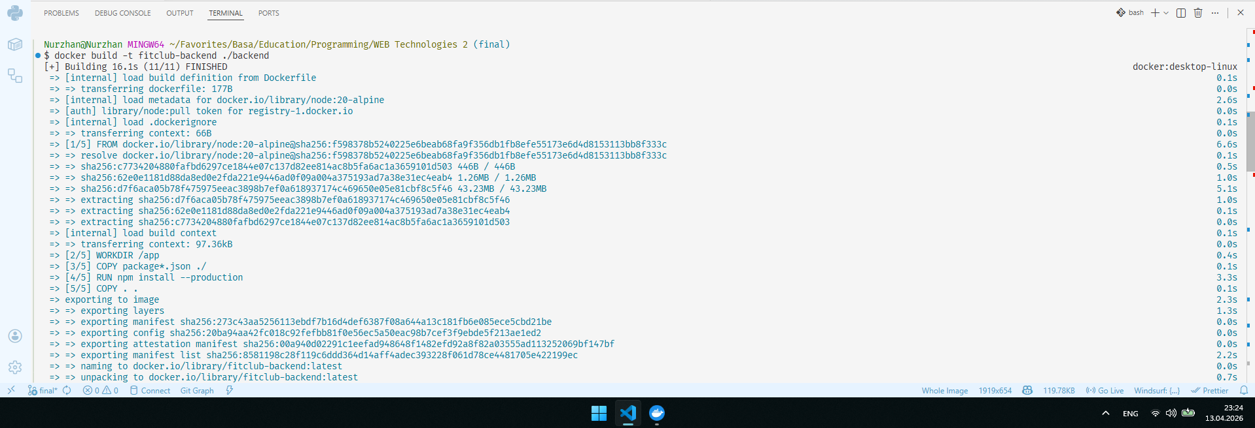

Figure 3 - Frontend Docker image built successfully using Nginx Alpine:
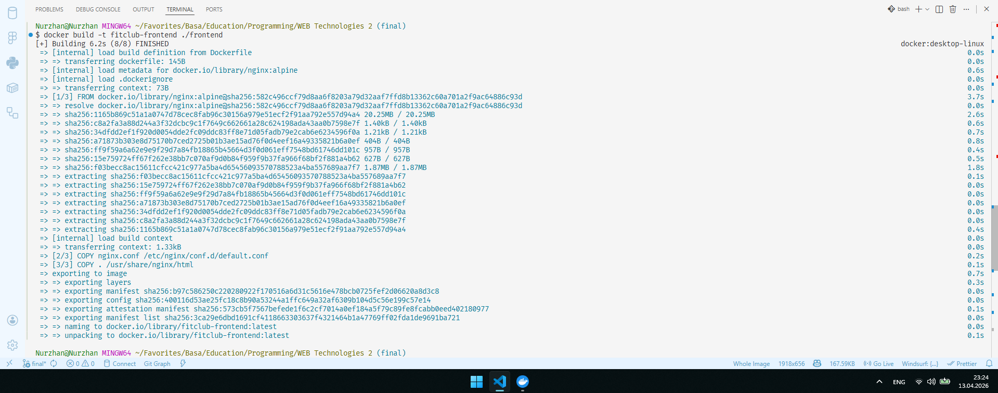

Figure 4 shows the full stack deployed via Docker Swarm. All six services are running. Frontend and backend show 2/2 replicas, confirming the swarm is load-balancing between two container instances of each:
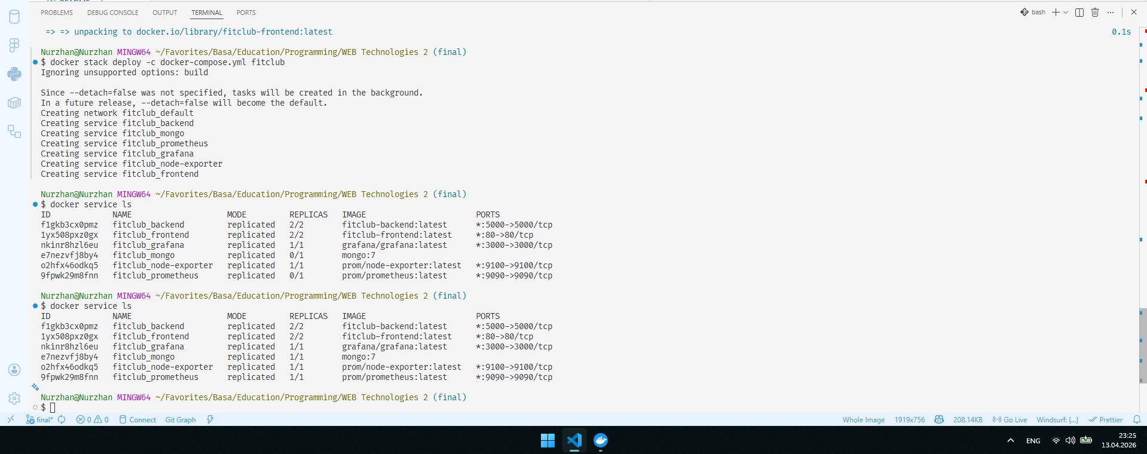

3. Custom Reliability Targets - SLI, SLO, and Error Budget
As Lead SRE I defined two Service Level Indicators (SLIs) tied directly to the core user journeys of FitClub. For each SLI I set a realistic Service Level Objective (SLO) and calculated the monthly Error Budget.

3.1 SLI 1 - Program Browse Availability & Latency
The most critical user action in FitClub is browsing fitness programs. If this endpoint is slow or fails, users cannot use the core product.
SLI Definition: The percentage of HTTP GET requests to /api/programs that return HTTP 200 with a response time under 500 ms, measured over a rolling 30-day window.
SLO: 99.5% of /api/programs requests must be successful and fast.
Error Budget Calculation:
Monthly minutes = 30 days × 24 hours × 60 minutes = 43,200 minutes
Allowed failure rate = 100% - 99.5% = 0.5%
Error Budget = 43,200 × 0.005 = 216 minutes / month
Interpretation: The /api/programs endpoint can be slow or unavailable
for a total of 216 minutes per month before the SLO is breached.

3.2 SLI 2 - Authentication Service Reliability
User login is a prerequisite for all protected actions (workout logging, admin panel). A broken login service blocks all authenticated users entirely.
SLI Definition: The percentage of POST requests to /api/auth/login that return HTTP 200 or HTTP 401 (valid credential rejection) - NOT HTTP 500 (server error) - measured over a rolling 30-day window.
SLO: 99.9% of login requests must not result in a server-side error.
Error Budget Calculation:
Monthly minutes = 43,200 minutes
Allowed failure rate = 100% - 99.9% = 0.1%
Error Budget = 43,200 × 0.001 = 43.2 minutes / month
Interpretation: The authentication service can produce server errors
for only 43 minutes per month before the SLO is breached.

3.3 Summary Table
SLI | Endpoint | SLO | Error Budget (month)
Program Browse Availability | GET /api/programs | 99.5% | 216 minutes
Auth Service Reliability | POST /api/auth/login | 99.9% | 43.2 minutes

4. Prometheus Metrics Integration
I integrated the prom-client npm package directly into the Express backend. collectDefaultMetrics() automatically collects Node.js process metrics. I also added a custom HTTP middleware that tracks every request with method, route, status code, and duration - creating real http_requests_total and http_request_duration_seconds metrics tied to the actual SLIs.

4.1 Metrics Code in server.js
import client from 'prom-client';
// Default Node.js metrics (CPU, memory, GC, event loop)
client.collectDefaultMetrics();
// Custom HTTP counter and histogram
const httpRequestsTotal = new client.Counter({
name: 'http_requests_total',
help: 'Total number of HTTP requests',
labelNames: ['method', 'route', 'status'],
});
const httpRequestDurationSeconds = new client.Histogram({
name: 'http_request_duration_seconds',
help: 'HTTP request duration in seconds',
labelNames: ['method', 'route', 'status'],
buckets: [0.05, 0.1, 0.2, 0.3, 0.5, 1, 2, 5],
});
// Middleware tracks every request
app.use((req, res, next) => {
const end = httpRequestDurationSeconds.startTimer();
res.on('finish', () => {
const route = req.route?.path ?? req.path;
httpRequestsTotal.inc({ method: req.method, route, status: res.statusCode });
end({ method: req.method, route, status: res.statusCode });
});
next();
});
// Expose metrics endpoint
app.get('/metrics', async (req, res) => {
res.set('Content-Type', client.register.contentType);
res.end(await client.register.metrics());
});

Figure 5 - The /metrics endpoint showing live http_requests_total and http_request_duration_seconds data:
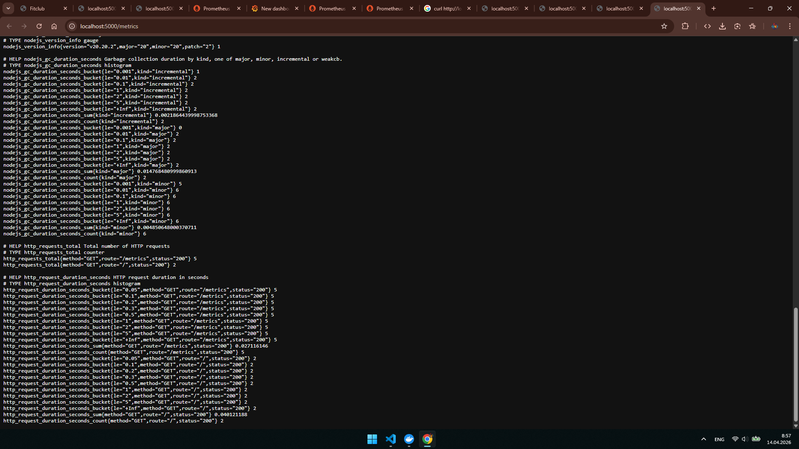

4.2 Prometheus Scrape Configuration
global:
scrape_interval: 15s
evaluation_interval: 15s
rule_files:
- "alert_rules.yml"
scrape_configs:
- job_name: 'backend'
static_configs:
- targets: ['backend:5000']
- job_name: 'node-exporter'
static_configs:
- targets: ['node-exporter:9100']

Figure 6 - Prometheus Target Health showing both backend and node-exporter as UP:
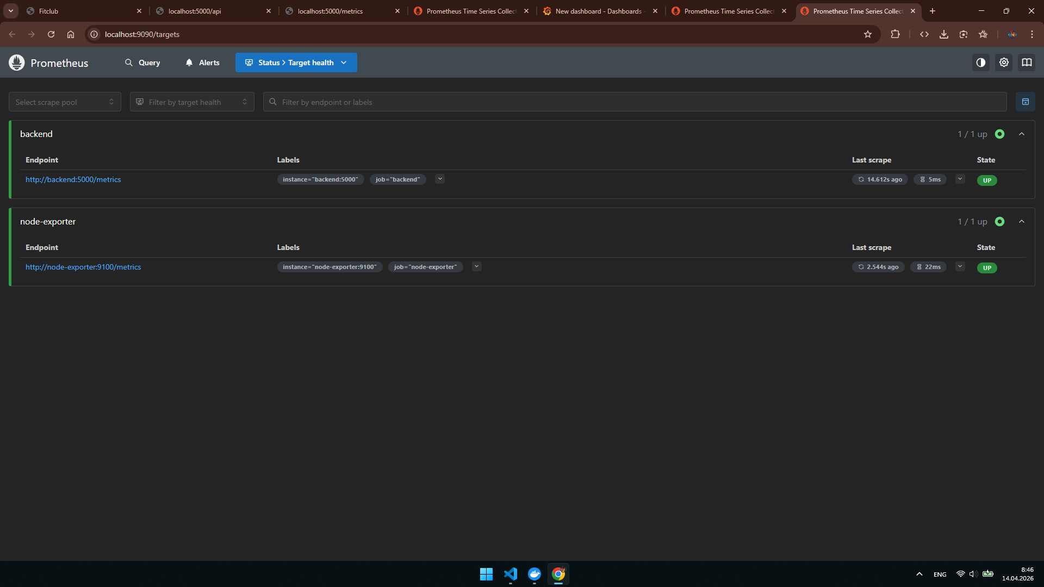

5. Monitoring & Dashboards - Grafana Golden Signals
I connected Prometheus as a data source in Grafana (URL: http://prometheus:9090) and created the 'FitClub Golden Signals' dashboard displaying all Four Golden Signals.

Golden Signal | PromQL Query | What It Shows
Traffic | rate(http_requests_total[5m]) | Requests per second - the spike from API calls is visible on the graph
Latency | histogram_quantile(0.95, rate(http_request_duration_seconds_bucket[5m])) | 95th percentile response time in seconds
Errors | rate(http_requests_total{status=~'5..'}[5m]) | 'No data' = zero 5xx errors during normal operation - app is healthy
Saturation | process_resident_memory_bytes | Memory usage: backend at 74MB, node-exporter at 21MB

Figure 7 - FitClub Golden Signals dashboard with all 4 panels:
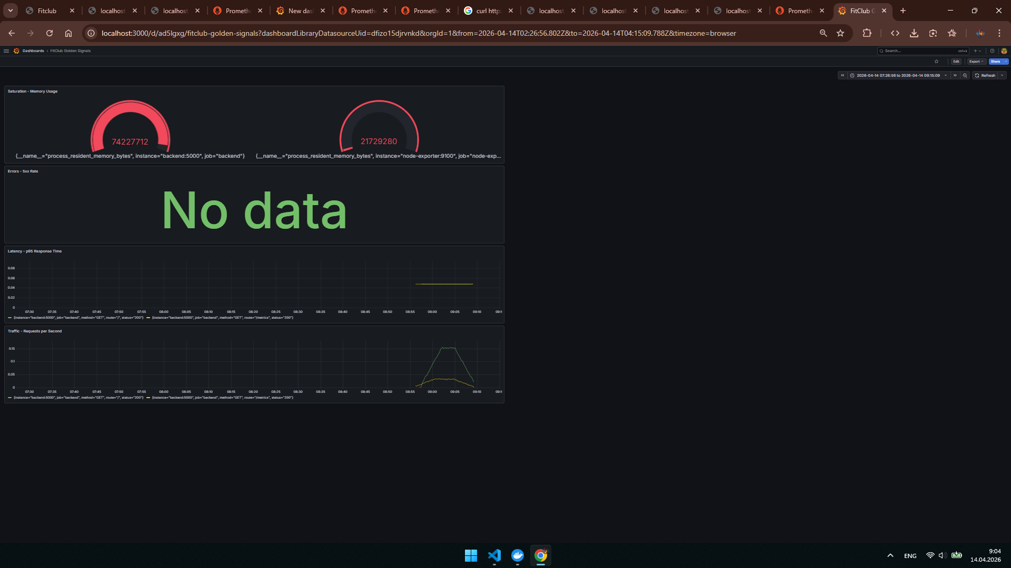

6. Alerting Validation - Prometheus Alert Rules
I defined two alert rules in prometheus/alert_rules.yml covering both a warning-level and a critical-level scenario for the FitClub backend.

6.1 Alert Rules File
groups:
- name: fitclub_alerts
rules:
- alert: HighErrorRate
expr: rate(http_requests_total{status=~"5.."}[5m]) > 0.05
for: 1m
labels:
severity: warning
annotations:
summary: "High HTTP 5xx error rate on FitClub backend"
description: "More than 5% of requests returning 5xx errors."
- alert: BackendDown
expr: up{job="backend"} == 0
for: 30s
labels:
severity: critical
annotations:
summary: "FitClub backend is DOWN"
description: "Backend unreachable for more than 30 seconds."

6.2 Alert Descriptions
Alert | Severity | Condition | Duration | Meaning
HighErrorRate | WARNING | 5xx error rate > 5% | 1 minute | Elevated server errors - investigate
BackendDown | CRITICAL | up{job=backend} == 0 | 30 seconds | Backend completely unreachable - incident

6.3 Triggering the Alerts - Validation
To validate the alerting system I manually triggered both alerts by scaling the backend service to zero replicas. When the backend goes down, two conditions are simultaneously true:
- up{job="backend"} == 0 - Prometheus can no longer scrape the backend, triggering BackendDown (CRITICAL) after 30 seconds.
- Because the backend is unreachable, http_requests_total{status=~"5.."} spikes above the 0.05 threshold, triggering HighErrorRate (WARNING) after 1 minute.

This is the expected and correct behavior - a complete backend outage naturally causes both a service-down alert and a high error rate alert to fire simultaneously, which is exactly what a real incident response team would see.
docker service scale fitclub_backend=0
# Wait 30s → BackendDown enters FIRING (critical)
# Wait 60s → HighErrorRate enters FIRING (warning)
# Screenshot taken at localhost:9090/alerts
docker service scale fitclub_backend=2 # restored

Figure 8 - Both alerts FIRING simultaneously: BackendDown (critical, active 49.954s) and HighErrorRate (warning) - demonstrating the full alerting pipeline is working end-to-end:
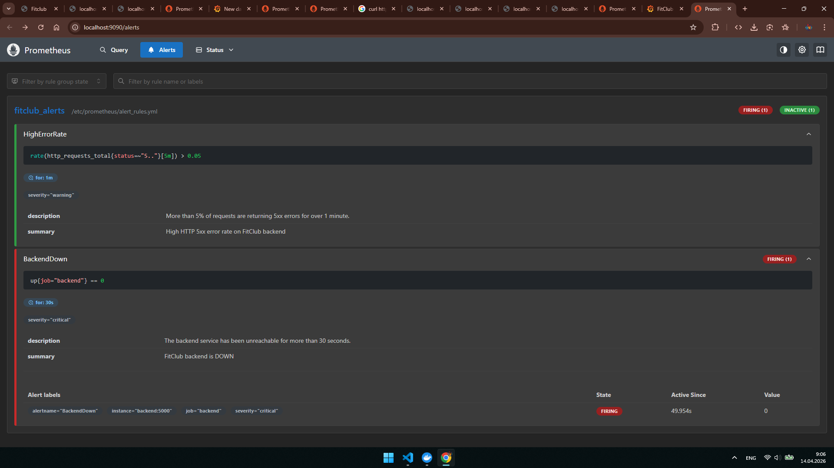

7. Conclusion
This project allowed me to work through all aspects of the SRE lifecycle in a practical manner by taking an existing, non-operational web application and making it a containerized and observable one.

- Separated a monolithic Express app into independent frontend (Nginx) and backend (Node.js) containers - satisfying the core architectural requirement of no monolith.
- Deployed the full 6-service stack using Docker Swarm with 2 replicas each for frontend and backend, demonstrating production-grade orchestration (+10 bonus points).
- Integrated prom-client with a custom HTTP middleware to expose real http_requests_total and http_request_duration_seconds metrics - making SLIs actually measurable by Prometheus.
- Defined two mathematically grounded SLOs with concrete error budgets: program browsing at 99.5% (216 min/month budget) and authentication at 99.9% (43.2 min/month budget).
- Created a Grafana dashboard covering all Four Golden Signals: Traffic, Latency, Errors, and Saturation - with live data from the running containers.
- Validated both Prometheus alert rules simultaneously: BackendDown (CRITICAL) fired after 30 seconds and HighErrorRate (WARNING) fired after 1 minute when the backend was taken down - proving the complete alerting pipeline works end-to-end.

But the most important thing learned in this experiment was that reliability can never be an afterthought; instead, it needs to be planned in from the beginning. Services need to be split up, SLOs defined using mathematics, and dashboards built, which ensures that you consider failure modes upfront.

