Template Final Exam

|  |  |  |
| --- | --- | --- |
| # | Full Name | Group |
| 1 | Yeshankul Nurmukhammed | CS – 2113 |
| 2 | Kurman Beksultan | CS – 2113 |
| 3 | Sadvakasov Temirlan | CS – 2113 |
| 4 | Mukatay Ilyas | CS – 2113 |

|  |
| --- |
| Link to the repository: https://github.com/Nurma03/OPS_final |

Step-by-step task completion:

Task 1:

The command is shown below in the correct order:

* **sudo -i** # to enter as root
* **adduser student** # to add new user
* **passwd student** # to put a password on new user
* **(password: 12345)** # student password
* **login** # to login another user
* **student** # to enter student user
* **12345** # student password to enter student user
* **whoami** # to show which user is used

Screenshots of the code compilation result:

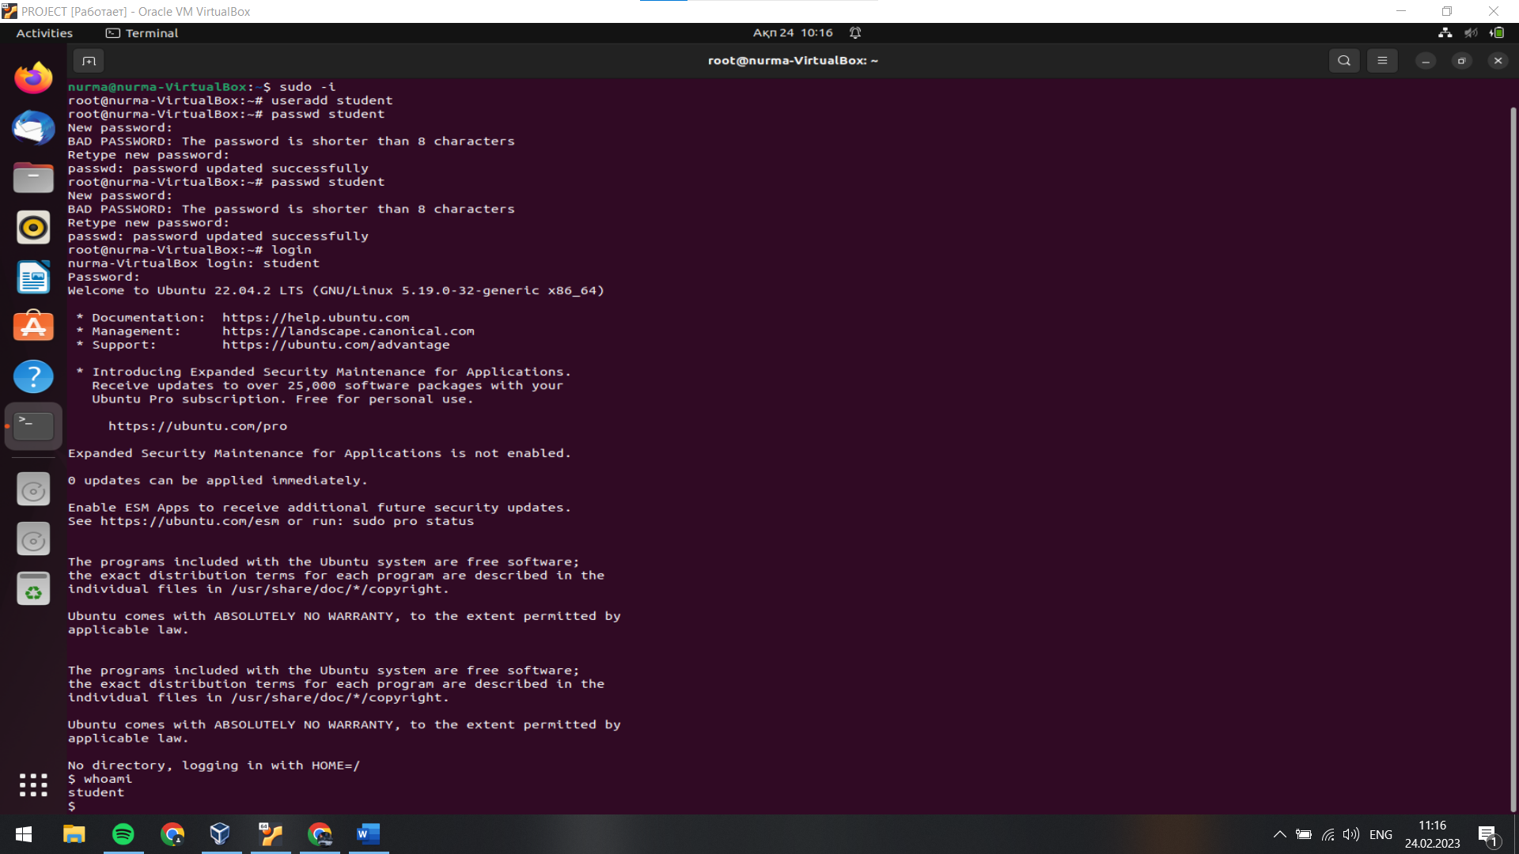

Task 2:

The command is shown below in the correct order:

* **sudo apt-get install network-manager** # to install the Network-Manager package
* **sudo apt-get install dhcpcd** # to install the DHCP client package
* **ip link show** # to display information about the network interfaces
* **ping Instagram.com** # to test the connectivity between two networked devices
* **sudo iptables –vnL –t nat** # to list the rules of the NAT table

all network-manager19:31

Screenshots of the code compilation result:

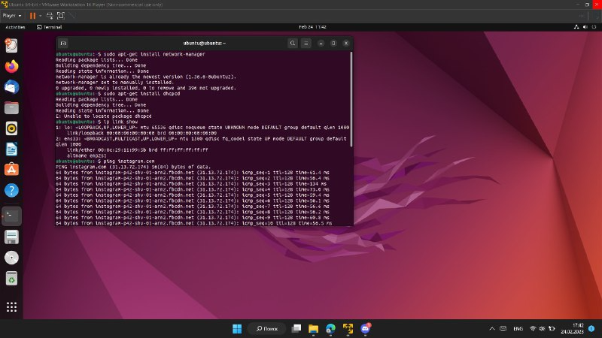 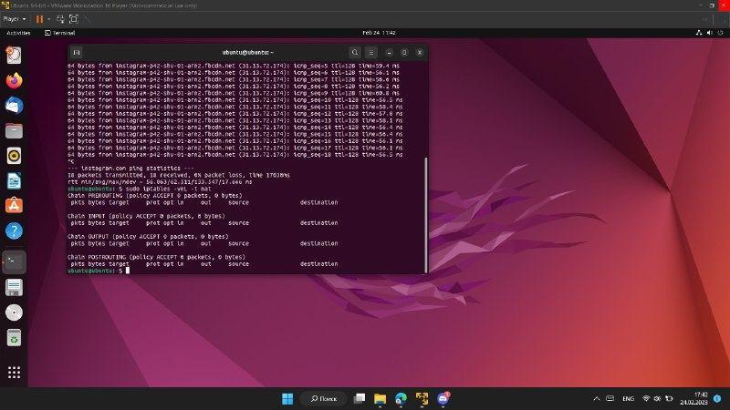

Task 3:

The command is shown below in the correct order:

* **mkdir project** # to create ‘project’ folder
* **cd project** # to create file in the ‘project’ folder
* **touch mod.c** # to create ‘mod.c’ file
* **touch makefile** # to create ‘makefile’ file
* **sudo insmod mod.ko** # to install module ‘mod.ko’
* **sudo dmesg | tail** # to check the kernel logs
* **sudo rmmod mod** # to remove module ‘mod.ko’
* **sudo dmesg | tail** # to check the kernel logs

Screenshots of the code compilation result:



