Measurement of some physical quantity means its comparison with the unit of appropriate physical quantity. Two kinds of measurements exist: direct and indirect measurements. In the process of direct measurement we simply measure a physical quantity of our interest. When we find it from known relationship with other directly measured physical quantities we deal with indirect measurement of this quantity. No measurement made can be ever exact. The accuracy(correctness) and precision(number of significant figures) of a measurement are always limited by the degree of refinement of the apparatus used, by the skill of the observer, and by the basic physics in the experiment.

We must also give a range of possible true values based on our limited number of measurements.  
We use the synonymous terms uncertainty, error, or deviation to represent the variation in measured data. Two types of errors are possible. Systematic error is the result of a miscalibrated device, or a measuring technique. The least count is the smallest division that is marked on the instrument. Thus a meter stick will have a least count of 1.0 mm. The instrument limit of error, ILE for short, is the precision to which a measuring device can be read.

The Instrument Limit of Error is generally taken to be the least count or the half (1, 1/2) of the least count. If the scale divisions are closer together, you may only be able to estimate to the nearest 1/2 of the least count, and if the scale divisions are very close you may only be able to estimate to the least count. The word random indicates that they are inherently unpredictable and uncontrollable.

Random error is caused by unpredictable fluctuations in the readings of a measurement apparatus, or in the experimenter's interpretation of the instrumental reading;.

he higher the precision of a measurement instrument, the smaller the variability (standard deviation) of the fluctuations in its readings.

There is one more type of errors called blunder which is a big mis-take made as a result of lack of care. One may easily avoid a blunder being careful in the process of measurements

Suppose we repeat a measurement several times and record the different values. We can then find the average value, here denoted by a symbol between angle brackets, <>, and use it as our best estimate of the reading.

Let the readings obtained in the process of measurement of some physical quantity XbeX1, X2,...,Xi,...Xn,where. Xi is the result of the i-th measurements of X. The mean value of X obtained in n measurements is:

<X> = (X1+X2 +X3+...+ Xn)/n

If n approaches to infinity, <X> approaches to the true value of X0.The difference between <X>and Xi is called absolute error of the i-th measurement and may be positive or negative:

ΔXi = <X> -Xi ,(1.2)

The standard deviation value is given by

σ n=)3.1(,1)(2−−∑nXXiφπ

The standard deviation value represents the average distance of a set of scores from the mean. Knowing the standard deviation helps create a more accurate picture of the distribution along the normal curve. A smaller standard deviation represents a data set where scores are very close in value to the mean; a smaller range. A data set with a larger standard deviation has scores with more variance; a larger range. It is convenient to measure the spread of a set of n observations X I, around their mean value <X>. When n approaches infinity standard deviation approaches to a constant limit-σ. The value of σ2 is called dispersion of the results of the measurements.

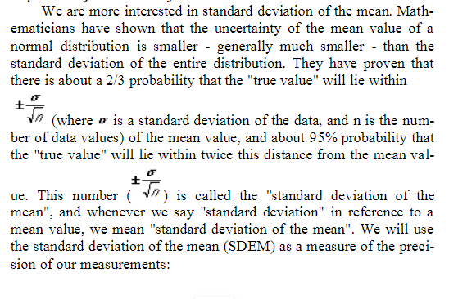

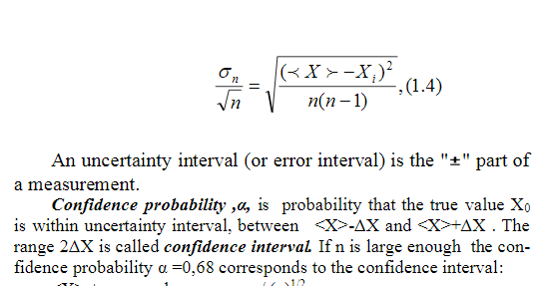

Confidence probability ,α,is probability that the true value X0is within uncertainty interval, between <X>-ΔX and <X>+ΔX . The range 2ΔX is called confidence interval. If n is large enough the confidence probability α=0,68 corresponds to the confidence interval: <X>±σ<X>, where σ<X> =σ/(n)1/2, α=0.95 corresponds to the confidence interval <X> ± 2 σ<X>,

Confidence interval (or absolute error for n measurements) is found by:ΔX=tsS

(1.5)The final result is written in the form

X= <X>± ΔX

for a specified confidence probability α. Relative error is ratio of the absolute error to the mean value:

ε= ΔX/<X>