# Table of Contents

Contents

Table of Contents 1

Working with restaurant dataset 2

Creating Spark ETL JOB session 2

Read restaurant_csv dataset 2

Get Nulls in dataset. Also I defined geocode UDF in order to geocode missing coordinates. 3

Applying Geocode UDF 4

Save dataframe 4

Applying Geohash 5

Working with Weather dataset 6

Reading Weather dataset and applying geohash UDF 6

Deleting duplicated rows 7

Saving weather cleaned dataset 7

Joining Restaurant and Weather Datasets 8

Join Restaurant and Weather datasets 8

Cleaning joined dataset from Nulls 8

Further Manipulations with joined dataset. 9

Leave joined dataset as it is. 9

Droping duplicates for geohash and wthr_date together. 9

Saving datasets. 10

# Working with restaurant dataset

Install Spark locally using one of the methods described [here](https://spark.apache.org/downloads.html) or in Docker.

Create a Spark ETL job to read data from a local storage. You can find the data in the Spark Practice—Dataset file on the page with the task description.

## Creating Spark ETL JOB session

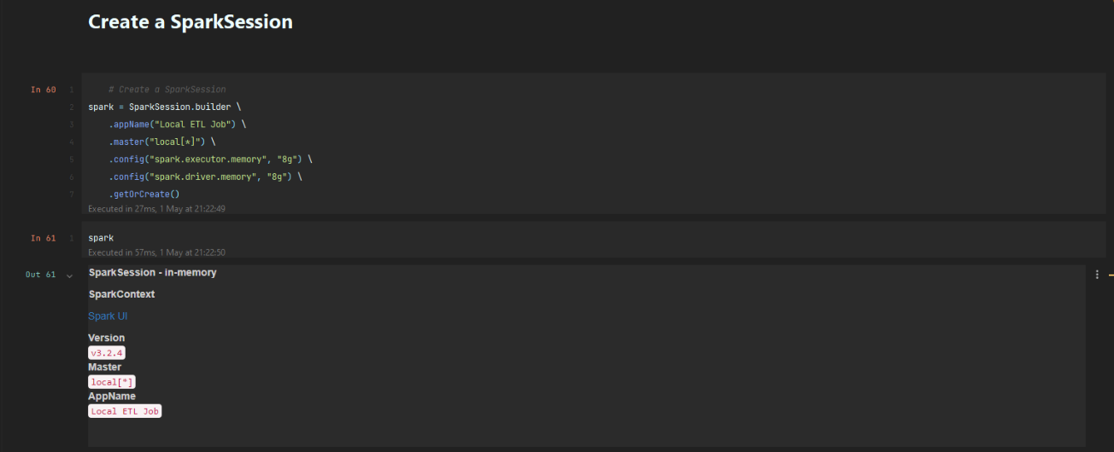

## Read restaurant_csv dataset

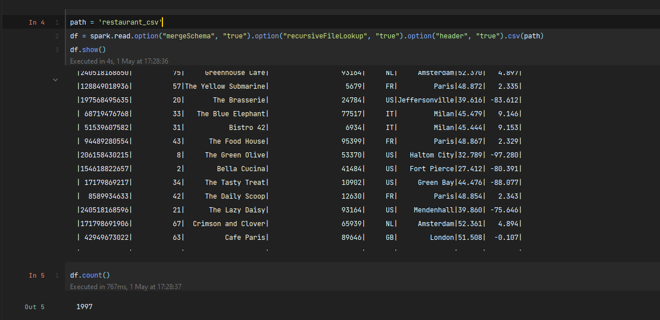

## Get Nulls in dataset. Also I defined geocode UDF in order to geocode missing coordinates.

## Applying Geocode UDF

After applying we can see that there is no Nulls in lat and lng.

## Save dataframe

I saved dataframe before applying hash, in order to make easier if something goes wrong

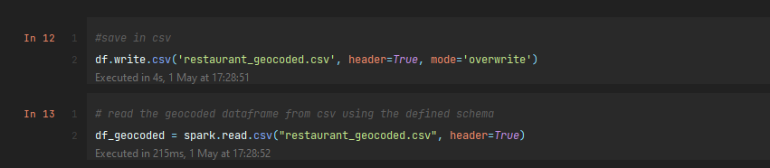

## Applying Geohash

I also created geohash UDF in order to hash my geocode.

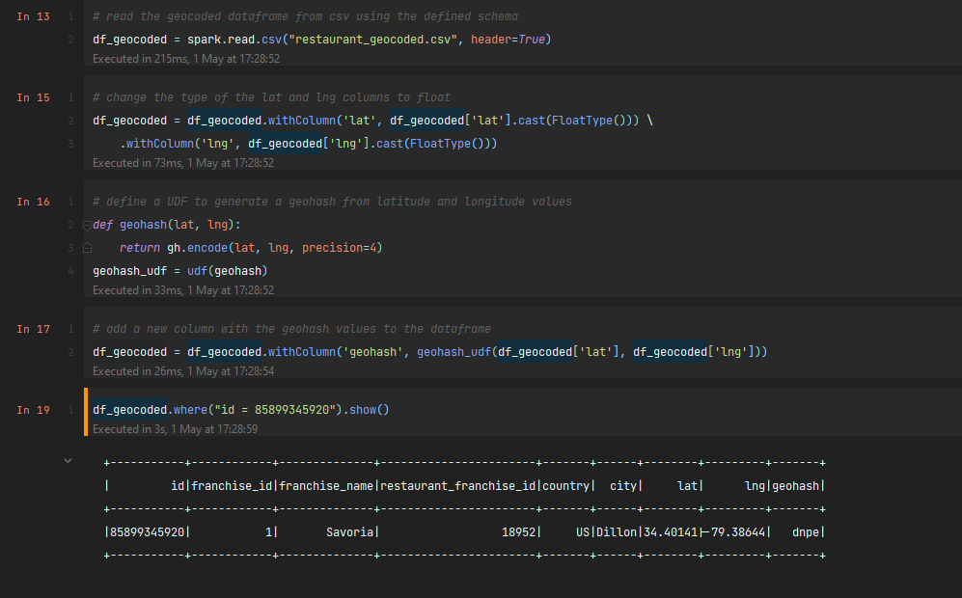

# Working with Weather dataset

## Reading Weather dataset and applying geohash UDF

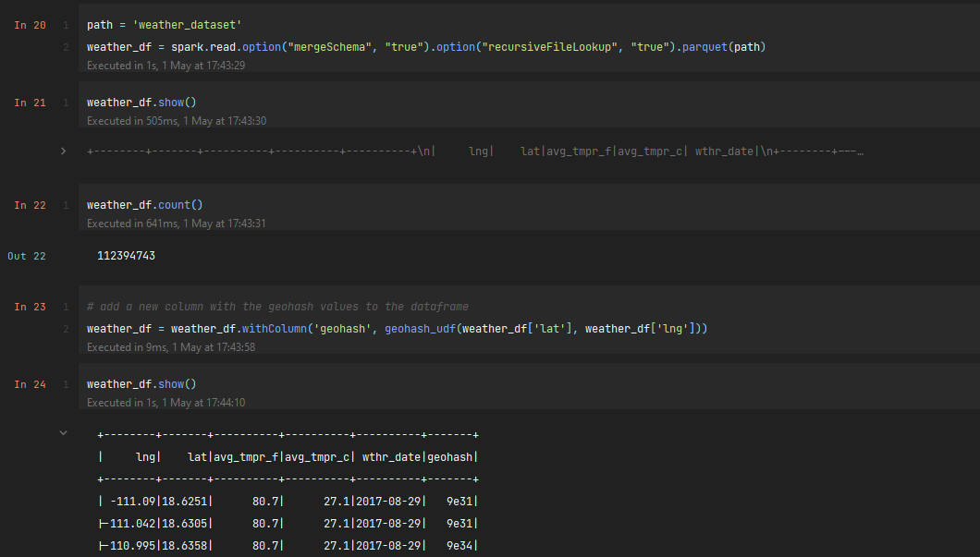

## Deleting duplicated rows

I took wthr_date and geohash as unique together. After cleaning duplicates we can see that there is only unique value for wthr_date and geohash together

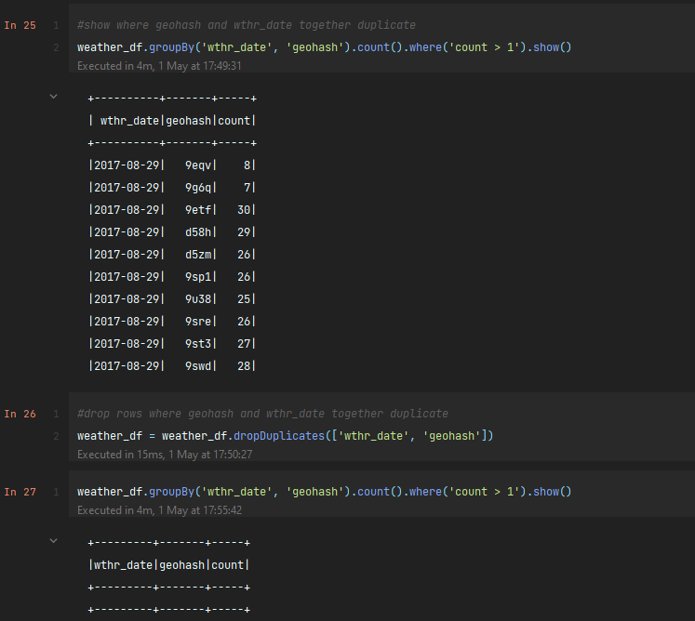

## Saving weather cleaned dataset

I saved cleaned dataset. Then read it again from file in order to make easier further steps

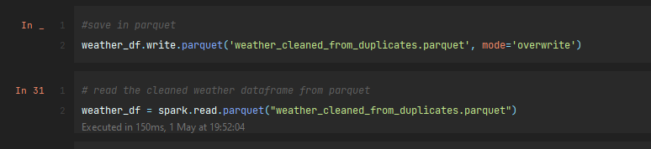

# Joining Restaurant and Weather Datasets

## Join Restaurant and Weather datasets

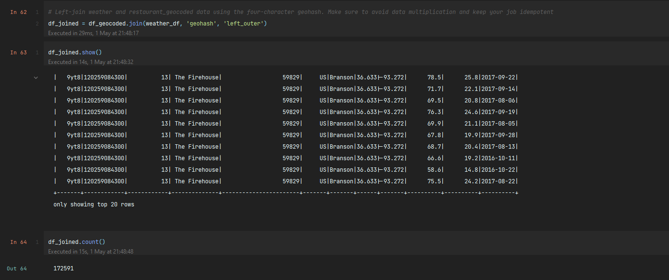

## Cleaning joined dataset from Nulls

After dropping null are NaN counts changed from 122 to 0

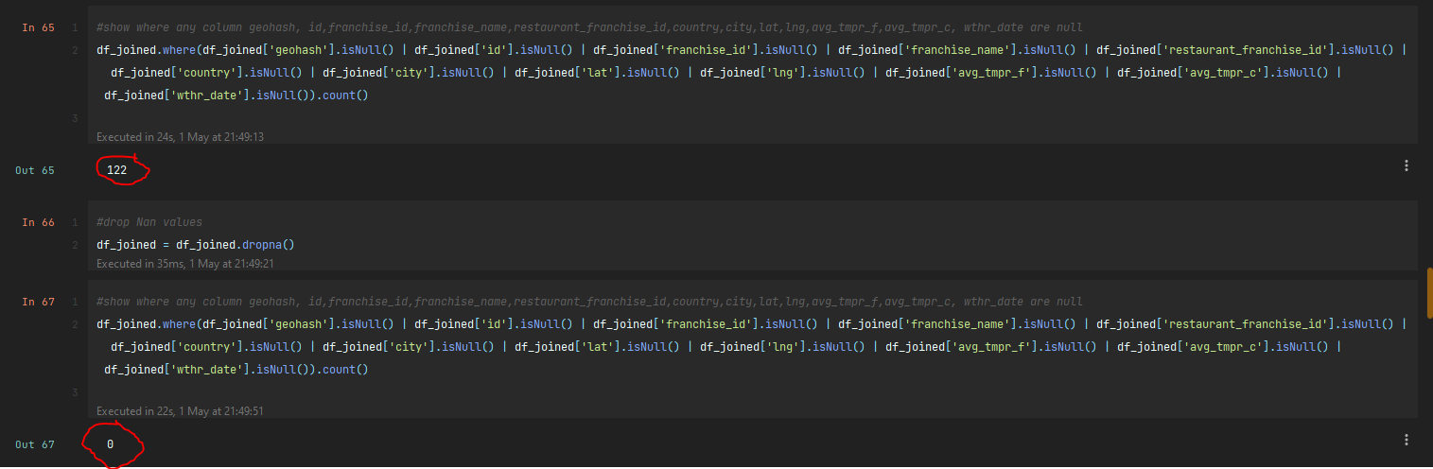

## Further Manipulations with joined dataset.

### Leave joined dataset as it is.

Then we will have same geohash and weather but different franchise.

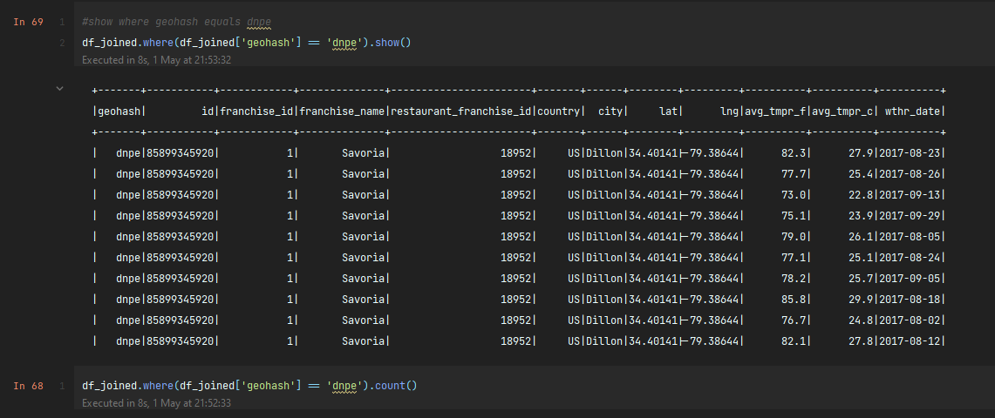

### Droping duplicates for geohash and wthr_date together.

In that case I will have 92 positions for each geohash

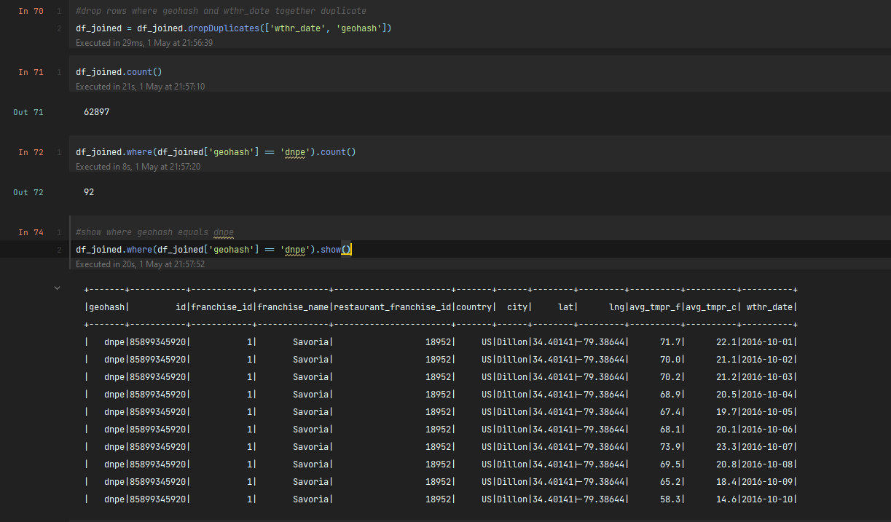

## Saving datasets.

I saved datasets in two variants:

1. Where I DID NOT DROPPED duplicates for wthr_date and geohash.
2. Where I DROPPED duplicates for wthr_date and geohash.

