NUTRISMART
Probation Period — Unified Academic Report
Development of an intelligent system for monitoring and analyzing dietary intake
Astana IT University | 24 October 2026
Student: Abdikarim Nurmukhammed | Group: SE-2430
Supervisor: Bakayeva Bakyt | Individual project

Submission status and evidence boundaries
This document compiles existing work and draft project evidence. The interactive browser prototype and the YouTrack board are demonstrable. A native Android application and actual AI food recognition are future work, not completed functions.
User evidence: an exploratory Google Forms survey of five respondents; no completed individual interviews are claimed. The literature review includes candidate sources and requires final full-text and bibliographic cross-checks.
Supervisor feedback: requested; no response or approval is claimed in this report. Replace the pending record with actual dated comments after receipt.
GitHub repository: https://github.com/Nurmukhammed070/intelligent-nutrition-system | YouTrack: https://nurmukhammedabdikarim.youtrack.cloud | Submission tag prob-period-1: NOT VERIFIED at document generation time.
Note: existing system feature claims, scientific references, and acceptance criteria require independent verification before being marked fully complete.

Report structure
1. Project proposal and scope
2. Evidence of relevance and user research
3. Critical literature review
4. Existing-system comparison
5. Technology alternatives
6. Functional and non-functional requirements
7. Architecture and editable diagram evidence
8. UX prototype
9. Verification and evaluation plan
10. Project management, progress and risks
11. Supervisor feedback status
Appendix A. Diagram exports and YouTrack board evidence

1. Project proposal

NUTRISMART
  - Project Proposal and Scope | Probation Period

Development of an intelligent system for monitoring and analyzing dietary intake

Executive Summary
NutriSmart is a proposed mobile-first intelligent system for monitoring and analyzing dietary intake. It is intended to simplify recording meals, estimating calories and macronutrients, viewing intake history, and generating understandable informational insights. A future image-assisted workflow will propose food items from a photograph and ask the user to confirm ingredients and portion sizes before calculating nutritional values.

1. Project Identification
Diploma project: Development of an intelligent system for monitoring and analyzing dietary intake.
Working product name: NutriSmart.
Student: Abdikarim Nurmukhammed (individual project).
Supervisor: Bakayeva Bakyt.
GitHub repository: https://github.com/Nurmukhammed070/intelligent-nutrition-system
Academic group: to be confirmed by student.

2. Problem Statement
Manual food logging requires users to identify ingredients, estimate portions, and search for nutritional values. These repetitive steps may reduce the convenience of continuous tracking. Image-assisted estimation can shorten the process, but food classification, portion estimation and nutrient calculations have distinct sources of error. An application must make estimates transparent and correctable.

3. Intended Users
Primary users: adults who wish to maintain a personal food diary and review estimated calorie and macronutrient intake without specialized nutrition knowledge. Secondary stakeholder: academic supervisor and evaluators reviewing functionality, usability, architecture, and measurement methods. The initial scope excludes clinical diagnosis and nutrition treatment.

4. Aim
To design, develop and evaluate a mobile-oriented intelligent nutrition monitoring system that supports structured and convenient food recording, transparent nutritional calculations and explainable analysis, with a researched path toward photograph-assisted food identification.

5. Objectives
1. Investigate relevant scientific and technical approaches to dietary tracking, food-image recognition, portion estimation and usability.
2. Gather and analyze potential user needs through real discussions and clearly distinguish evidence from assumptions.
3. Compare existing nutrition products and alternative technology stacks.
4. Define measurable functional and non-functional requirements, architecture and data model.
5. Implement and test food search, meal logging, nutrient calculation, goals and historical summaries.
6. Evaluate an image-assisted workflow, including recognition uncertainty and user confirmation, before claiming automatic estimation.
7. Measure correctness and usability using documented tests and a repeatable baseline.

6. Proposed Scope
In scope for initial implementation: responsive prototype, food catalogue/search, user-confirmed servings, calories and macronutrients, food diary, local persistence, goals, basic rule-based insights, testing and documentation.
Research/next stage: mobile Android integration, authoritative food data source, real vision model/API, portion estimation evaluation, persistent server database, authentication and synchronization.
Out of scope for the current checkpoint: validated clinical recommendations, guaranteed calorie estimation from images and completed production-grade mobile application.

7. Engineering Approach
Initial client: Kotlin with Jetpack Compose for native Android; responsive HTML/CSS/JavaScript UX prototype remains an independent usability demonstrator. Backend direction: Node.js REST services; storage options (Room/SQLite vs PostgreSQL) require the documented architectural choice. Proposed image pipeline: acquire photo -> recognize candidate foods -> estimate/confirm portions -> retrieve nutrient values with provenance -> calculate totals -> user review -> save. No photo estimate should be presented as exact.

8. Expected Deliverables
Source code and a runnable prototype; requirements and acceptance criteria; system context, use-case and component diagrams (editable sources and readable exports); research evidence and critical literature review; existing-system and technology comparisons; test and evaluation plan; risk register; project-management traceability; supervisor feedback with revisions; probation-stage tagged repository state.

9. Status at the Probation Checkpoint
An interactive browser-based prototype has been developed and manually checked by the student, including fixes to contrast and photograph removal. Earlier versions include food logging, nutritional calculations and diary features. Claims concerning the latest backend, automated tests, Android runtime, or real AI image recognition must be reverified against the specific repository commit before submission. User-study results, completed scientific review, source-backed competitor comparison, YouTrack history and supervisor feedback are not yet verified.

10. Main Risks and Mitigations
Food recognition uncertainty: require confirmation and evaluate accuracy against measured samples. Portion uncertainty: never infer weight from a single photograph without qualification. Nutrition provenance: select a documented source and store source metadata. Privacy: use local-first storage initially; obtain explicit consent for any future photo uploads. Time/scope: prioritize evidence, demonstrable features and honest limitations for the probation checkpoint.

11. Success Criteria
The prototype can demonstrate an end-to-end meal-entry flow; calorie/macronutrient calculations are checked against known arithmetic cases; major requirements map to verification methods; diagrams agree with the implemented architecture; usability feedback is recorded from actual participants; future image-recognition performance is assessed separately from the photo-upload demonstration.

2. Evidence of relevance — exploratory survey

NutriSmart
  - USER RELEVANCE RESEARCH | INITIAL SURVEY FINDINGS
Diploma project: Development of an intelligent system for monitoring and analyzing dietary intake
Student: Abdikarim Nurmukhammed • Supervisor: Bakayeva Bakyt
Evidence source: screenshots of Google Forms response summaries provided by the student on 24 October 2026. Counts below reflect only what is visible in these screenshots.

1. Method and scope
An exploratory online questionnaire was administered using Google Forms. The screenshots show five responses to the main multiple-choice questions. Some open-ended questions received only three or four responses. Sampling method and respondent demographics were not provided. Therefore, findings should be treated as early user feedback, not representative population estimates.
Important distinction: five completed questionnaires are NOT documented as five individual interviews. The university requirement mentioning 3–5 discussions with user representatives should be addressed by conducting and recording actual follow-up conversations or by obtaining supervisor approval for an alternative method.

2. Quantitative findings (n = 5, where indicated)
Question / measure | Observed answers | Interpretation
Prior use of food tracking apps | 3 yes (60%); 2 no (40%) | Participants have mixed prior experience.
Food tracking frequency | Daily: 1 (20%); a few times/week: 2 (40%); occasionally: 1 (20%); never: 1 (20%) | Use patterns vary; avoid assuming continuous daily tracking.
Difficulties with logging (multiple choices) | Manual entry: 3 (60%); understanding nutrition values: 3 (60%); portion estimation: 2 (40%); finding food: 1 (20%); staying consistent: 1 (20%) | Reduce manual effort and explain nutrition values.
Preferred input method | Take photo: 3 (60%); type a meal: 1 (20%); all methods: 1 (20%); food search: 0 | Photo entry should be prominent, with editable alternatives.
Usefulness of automatic calorie/macro calculation (1–5) | 1: 0; 2: 1; 3: 1; 4: 1; 5: 2 | 3/5 rated it 4–5; small, mixed sample.
Would review AI photo suggestions | Yes: 2 (40%); maybe: 2 (40%); no: 1 (20%) | Offer confirmation and editing, never force acceptance.
Most valuable features (multiple choices) | Goals: 4 (80%); recommendations: 4 (80%); daily diary: 3 (60%); photo suggestions: 2 (40%); food search: 1 (20%); charts: 1 (20%); export history: 1 (20%) | Goals, explanations and diary deserve prominent navigation.
Willing to join follow-up discussion | Yes: 2 (40%); no: 3 (60%) | Two respondents indicated willingness; their participation is not yet confirmed.

3. Qualitative feedback
Four respondents answered what would make them distrust a food estimate. The answers concerned actual food weight, lack of independent verification, incorrect data, and hidden or complex ingredients. These are separate responses rather than a ranked frequency distribution.
Three respondents answered the privacy question. One expressed detailed concern about dietary data sharing and possible secondary uses; other answers broadly emphasized privacy and safety. These answers motivate clear data-processing disclosures and cautious handling of food photos.
Four respondents answered what to improve in existing apps. Suggestions included greater accuracy and access to specialist/AI assistance, while two answers expressed no specific improvement. These comments do not establish a validated demand for professional consultation features.

4. Requirements informed by the observations
Question / measure | Observed answers | Interpretation
UR-01 | Fast entry | Manual input was a frequent difficulty | Prioritize photo-first workflow alongside editable text and search.
UR-02 | Visible calculations | Nutrition comprehension and accuracy concerns | Show portion mass, nutrient values per 100 g, data source, and formula.
UR-03 | Human confirmation | Four of five selected yes/maybe for review | Let users correct recognized foods and portions before saving.
UR-04 | Goals and insights | Goals and recommendations each selected by four | Offer adjustable targets and explainable, non-medical insights.
UR-05 | Privacy controls | Privacy concerns raised in free-text answers | Specify whether photos are processed locally or uploaded; provide deletion.

5. Limitations
- Small convenience sample (five responses), with no demographic breakdown supplied.
- Open-ended items have different response counts; no missing answers were invented.
- The screenshots do not show completion of interviews, user testing sessions, or supervisor validation.
- Reported preferences do not measure actual usability or model accuracy.
- Future photo recognition needs separate evaluation of food classification, portion estimation, nutrient lookup, and uncertainty.

6. Next validation step: real conversations
Invite the two respondents who selected “Yes” to the follow-up question, if contact was collected with consent. Recruit 1–3 additional willing potential users independently. Hold short 10–15 minute conversations and document dates, participant codes, consent, actual responses, design implications, and prototype feedback. Do not backdate or invent sessions. Confirm the approach with the supervisor.

7. Submission evidence checklist
- Preserve the original response summary screenshots or export charts from Google Forms.
- Export anonymized response summaries (do not disclose names or sensitive information).
- Add this report to docs/research/ in the existing repository.
- After real discussions, append a factual interview-log table with dates and results.
- Record supervisor comments and any changes made to requirements.
Status: initial survey evidence collected; interview/discussion requirement still requires verification.

3. Critical literature review — working research draft

Critical Literature Review
  - Development of an intelligent system for monitoring and analyzing dietary intake
Student: Abdikarim Nurmukhammed | Supervisor: Bakayeva Bakyt | 24 October 2026
RESEARCH DRAFT — Source metadata and accessible abstracts checked for selected records. Full-text methodological verification remains necessary for the entire set. Do not describe this document as a completed systematic review.

1. Scope and method
This focused narrative review evaluates mobile dietary recording, food-image recognition, portion estimation, nutrient inference and validation. Thirteen scholarly candidates were retained from an earlier project matrix. This update checks publication metadata and expands the synthesis while distinguishing peer-reviewed evidence from engineering assumptions. It is not a systematic search: database search dates, complete search strings and screening flow were not recorded. The university requires 12 meaningfully used sources, at least eight scientific publications.

2. Synthesis of evidence

2.1 User burden, app data quality and privacy
König et al. [3] review 117 publications and 129 smartphone tools; the mix of photo, portion, free-text and food-database functions indicates that no single input mode solves every recording problem. Gioia et al. [4] compared 11 diet apps and evaluated time stamps, usability, privacy, and nutrient estimates; their example food records revealed discrepancies relative to a dietitian/reference-database comparison. NutriSmart will provide text/search as a dependable fallback, allow users to correct records, and document data handling. Unlike these studies, the five-person NutriSmart survey measures stated preferences rather than real logging accuracy.

2.2 Recognition is not portion measurement
Dalakleidi et al. [2] review image-based food-recognition systems, while Konstantakopoulos et al. [1] emphasize the relationship and separation of visual recognition and volume estimation. The Mediterranean-food imaging system [9] illustrates an approach dependent on a particular capture workflow; Schenk et al. [13] investigate 3D images and food descriptions rather than unconstrained single photos. Therefore NutriSmart will treat recognized labels as editable candidates and will not infer precise mass from a casual image without measured validation.

2.3 Datasets, models and generalization
Nutrition5k [10] provides dish images with weight/nutrition references, enabling evaluation of the whole nutritional-estimation pipeline. Zhao et al. [12] combine segmentation and regression and report a percentage mean absolute error of 17.06% for evaluated nutrition components in their reported setup. Those outcomes are research-specific; neither establishes accuracy for home-cooked Kazakh foods, different cameras, or lighting. NutriSmart must record food coverage, collect suitable examples, and evaluate performance on a held-out local test set.

2.4 Validation, reliability and explainability
Shonkoff et al. [6] reviewed 52 image-based AI studies; differing datasets and reporting prevented meta-analysis. Zheng et al. [5] provide a broader scoping review of AI assessment workflows. Cofre et al. [11] review validation evidence and discuss risk of bias. Consequently, NutriSmart should separately evaluate classification (top-1/top-3), portion mass (MAE in grams) and nutritional totals (MAE in kcal/grams), against weighed portions and documented food composition values. A confidence value without calibration must not be shown as a guarantee.

2.5 Usability and practical deployment
MyDietCam [7] documents a mobile-app design and usability context, supporting iterative review with actual users rather than assuming that photo input is effortless. The dietary-data collection review candidate [8] additionally raises questions about collection burden. Compared with model-only research, NutriSmart will evaluate task completion and time-to-log across manual entry and future photo-assisted entry. Privacy consent and image retention will be explicit.

3. Critical comparison and design implications
Approach | Value | Limitation | NutriSmart response
Manual text/search [3,4,8] | User confirms items and grams | High input burden; database matching errors | Minimum viable baseline; timed usability tasks
Image recognition [1,2,5] | May generate food candidates quickly | Similar-looking foods and hidden ingredients | Editable candidates; top-1/top-3 evaluation
Vision + 3D/portion [9,13] | Potential quantity estimation | Capture and scale requirements | Do not promise photo-only exact mass
End-to-end nutrient models [10,12] | Direct nutrient prediction | Dataset transfer and compounded errors | Separate food match, portion, nutrient source
AI assessment reviews [6,11] | Evaluation methods and limitations | Heterogeneous outcomes and risk of bias | Use weighed ground truth and absolute error

4. Source audit and evidence matrix
Status: A = publicly indexed metadata and summary checked in this review; B = present in prior matrix, with full-text and/or bibliographic checks outstanding. A does not mean complete full-text critical reading.
[1] Konstantakopoulos et al. (2024). A Review of Image-Based Food Recognition and Volume Estimation Artificial Intelligence Systems. [B] Distinguish identification from volume estimation; check review inclusion and limitations.
https://pubmed.ncbi.nlm.nih.gov/37276096/
[2] Dalakleidi et al. (2022). Applying Image-Based Food-Recognition Systems on Dietary Assessment: A Systematic Review. [A] Survey mobile image-recognition methods; heterogeneous recognition/portion pipelines.
https://doi.org/10.1093/advances/nmac078
[3] König et al. (2022). Characteristics of smartphone-based dietary assessment tools: a systematic review. [A] 117 publications, 129 tools; modalities and completeness vary.
https://doi.org/10.1080/17437199.2021.2016066
[4] Gioia et al. (2023). Mobile Apps for Dietary and Food Timing Assessment: Evaluation for Use in Clinical Research. [A] 11 apps; usability, privacy, time stamps, and estimates assessed.
https://doi.org/10.2196/35858
[5] Zheng et al. (2024). Artificial Intelligence Applications to Measure Food and Nutrient Intakes: Scoping Review. [B] Pipeline stages and heterogeneity; verify full methods.
https://www.jmir.org/2024/1/e54557
[6] Shonkoff et al. (2023). AI-based digital image dietary assessment methods compared to humans and ground truth: a systematic review. [A] 52 studies; varied datasets; no meta-analysis; report absolute error.
https://doi.org/10.1080/07853890.2023.2273497
[7] MyDietCam study (2023). MyDietCam: Development and Usability Study. [B] UX research example; confirm full formal citation and protocol.
https://pubmed.ncbi.nlm.nih.gov/36644664/
[8] Dietary data collection review (2022). Improving dietary data collection tools for better nutritional assessment. [B] Review candidate; publisher access limited; verify complete record.
https://www.sciencedirect.com/science/article/pii/S2666990022000180
[9] Mediterranean food image study (2023). An Automated Image-Based Dietary Assessment System for Mediterranean Foods. [B] Food recognition with constrained imaging / stereo estimation.
https://pmc.ncbi.nlm.nih.gov/articles/PMC10202193/
[10] Thames et al. (2021). Nutrition5k: Towards Automatic Nutritional Understanding of Generic Food. [B] Benchmark dataset with weight and nutrient annotation.
https://openaccess.thecvf.com/content/CVPR2021/html/Thames_Nutrition5k_Towards_Automatic_Nutritional_Understanding_of_Generic_Food_CVPR_2021_paper.html
[11] Cofre et al. (2025). Validity and Accuracy of Artificial Intelligence-Based Dietary Intake Assessment Methods: A Systematic Review. [B] Validation methods and risk of bias; verify results.
https://pubmed.ncbi.nlm.nih.gov/40207441/
[12] Zhao et al. (2024). Visual nutrition analysis: leveraging segmentation and regression for food nutrient estimation. [A] Segmentation and regression; reported PMAE 17.06% in study setting.
https://doi.org/10.3389/fnut.2024.1469878
[13] Schenk et al. (2024). The Use of Three-Dimensional Images and Food Descriptions from a Smartphone Device Is Feasible and Accurate for Dietary Assessment. [A] 3D imaging with food descriptions; not directly equivalent to one photo.
https://doi.org/10.3390/nu16060828

5. Remaining checks before submission
- Read accessible full texts and capture methods/sample/dataset/metrics for each chosen paper.
- Verify complete author lists, DOI, venue, volume, and publication years for references marked B.
- Use at least 12 sources substantively in the text with consistent referencing, not just in a list.
- Distinguish study-reported results from planned NutriSmart performance.
- Seek supervisor feedback; document revisions in NUT-3 and preserve the final evidence matrix.

4–11. Design, requirements, evaluation and project management
NUTRISMART
Criteria 4–10: Evidence-based Design & Preparation
Development of an intelligent system for monitoring and analyzing dietary intake
Student: Abdikarim Nurmukhammed | Supervisor: Bakayeva Bakyt | Individual project
DOCUMENT STATUS — Working draft for supervisor review. Do not present pending interviews, unreviewed scientific papers, mock photo recognition, or uncreated YouTrack issues as completed results.

4. Existing system comparison
Method: four contemporary food-tracking products were selected. Features below are taken from official support pages available on 24 October 2026. “Not verified” means the capability was not established from the sources reviewed, NOT that the product lacks it. NutriSmart column describes project scope, not a claim of feature parity.
Criterion | MyFitnessPal | Cronometer | YAZIO | Lose It! | NutriSmart
Food diary | Supported [MFP] | Supported [CR] | Supported [YA] | Supported [LI] | Interactive browser prototype
Photo-assisted logging | Meal Scan; Premium, English [MFP] | Photo Logging; Gold [CR] | AI calorie tracker; Pro [YA] | Snap It; Premium [LI] | UI workflow only; AI not connected
Can edit detected foods / portions | Yes [MFP] | Yes [CR] | Yes [YA] | Yes [LI] | Demo candidate / portion edit
Automated kcal / nutrition from photo | Suggested food linked to DB [MFP] | Matched foods / energy summary [CR] | Rough nutrition estimate [YA] | Suggested foods and servings [LI] | Not implemented
Food search / manual input | Supported [MFP] | Supported [CR] | Supported [YA] | Supported [LI] | Prototype has catalog/text input
Macronutrients | Supported [MFP] | Supported [CR] | Supported [YA] | Supported [LI] | Prototype calculation
Language / access caveats | Meal Scan English, OS and Premium limits [MFP] | Gold for photo [CR] | Photo AI in Pro [YA] | Snap It English/Premium [LI] | English UI; local prototype
Source / transparency | Verified database described [MFP] | Nutrient-source list [CR] | AI results called rough [YA] | Verified-food system [LI] | Planned source+confidence disclosure

Analysis: camera-assisted food tracking already exists in leading apps, so NutriSmart must not claim originality merely for adding a camera. A defensible project focus is an auditable nutrition pipeline, human corrections, measurable uncertainty, and a transparent comparison with manual logging. A comparative user test is still pending.
Official sources (read/accessed 24 October 2026):
[MFP] https://support.myfitnesspal.com/hc/en-us/articles/360045761612-How-to-use-the-Meal-Scanner
[CR] https://support.cronometer.com/hc/en-us/articles/39013533811092-Mobile-Photo-Logging
[YA] https://help.yazio.com/hc/en-us/articles/39137901903889-What-is-the-AI-Calorie-Tracking-Feature-and-how-does-it-work
[LI] https://loseit.zendesk.com/hc/en-us/articles/47771695186580-How-to-Use-Snap-It
[CR-data] https://cronometer.com/features/photo-voice-logging.html
[LI-manual] https://loseit.zendesk.com/hc/en-us/articles/49210381551380-How-to-Log-Food-in-Lose-It

5. Technology comparison
The selected mobile direction is Kotlin + Jetpack Compose with a local Room/SQLite datastore. The working browser prototype remains a UX demonstration and is not evidence of a production Android release.
Decision | Alternative | Advantages | Trade-offs | Choice
Mobile app | Kotlin + Compose | Native Android; type safety; Android Studio available | Android-only | Selected
Mobile app | Flutter | Cross-platform UI | New Flutter installation, another language/toolchain | Deferred
Mobile app | SwiftUI | Native iOS | No Android delivery without another client | Not selected
Data persistence | Room / SQLite | Offline-first; simple prototype deployment | Local-device only | Selected MVP
Data persistence | PostgreSQL + REST API | Relational model, multi-device scaling | Deployment/auth/security work | Future stage
Data persistence | Firebase | Managed auth/sync | Provider dependency and privacy evaluation | Alternative
Image analysis | On-device model | Offline; potentially privacy-friendly | Model size, accuracy, integration, evaluation | Candidate
Image analysis | Cloud vision/food API | Fast prototype integration | Cost, image privacy, network and vendor constraints | Candidate
Image analysis | Custom trained model | Research control | Dataset, ML expertise, evaluation cost | Research option
Food value source | Curated static catalog | Deterministic demo | Limited coverage; illustrative values | Existing prototype
Food value source | USDA FoodData Central | Source-based nutrient lookup | Coverage/mapping and API integration | Evaluate
Food value source | Regional/national database | Potential local-dish coverage | Availability/license/quality | Evaluate

Decision rationale: keep the first production Android slice local-first and testable; separate photo classification, serving estimation and nutrient lookup. Before adopting a vision provider, measure classification accuracy, kcal/portion error, latency, privacy, and operating costs.

6. Requirements traceability
ID | Requirement | Priority | Acceptance criterion | Test ID | Status
FR-01 | Record food from catalog/text with portion | P0 | Entry stored and nutritional totals update | T-01,T-02 | Prototype: available
FR-02 | Automatic kcal/P/F/C calculation | P0 | 200 g multiplies per-100g values by 2 | T-01 | Prototype: available; values illustrative
FR-03 | Remove/edit entry | P0 | Diary recalculates after deletion | T-03 | Delete: available; editing verify
FR-04 | Browse diary by date | P0 | Date selection changes visible entries | T-04 | Prototype: available
FR-05 | Set daily goals | P0 | Goals persist and progress updates | T-05 | Prototype: verify
FR-06 | Select/remove photo | P0 | Remove clears preview; repeat upload works | T-06 | Prototype: user checked v0.6
FR-07 | Real food recognition from photo | P2 | Accuracy evaluated on labelled meals; editable predictions | T-09 | Not implemented
FR-08 | Estimate portion size from photo | P2 | Mass error tested against weighed ground truth | T-10 | Not implemented
FR-09 | Save diary in persistent Android database | P1 | Room records persist across restarts | T-07 | Android starter unverified
FR-10 | Explainable nutrition insights | P1 | Shows trigger, source and calculation | T-08 | Concept/partial prototype

Non-functional: NFR-01 offline local diary; NFR-02 contrast and keyboard/mobile usability; NFR-03 clear distinction between measured, user-entered, and AI-estimated values; NFR-04 no secret/API key in Git; NFR-05 no medical diagnosis; NFR-06 photo consent and retention documentation; NFR-07 API error handling/latency tests.

7. Architecture and diagrams
The editable DOT diagram sources and rendered PNGs are included under diagrams/. Diagrams depict a staged target architecture: solid lines are baseline interactions; dashed lines indicate future integrations. The browser prototype does not yet connect to a production Android backend.
System Context — see diagrams/system-context.dot (editable) and diagrams/system-context.png (export).
Use Cases — see diagrams/use-cases.dot (editable) and diagrams/use-cases.png (export).
Components — see diagrams/components.dot (editable) and diagrams/components.png (export).

8. UX / prototype
The user-verified responsive browser prototype includes overview, calorie/macronutrient summary, food logging, date-aware diary, goal settings, photo upload/removal, CSV export and a planned photo-analysis interaction. It must be clearly labelled a browser UX prototype, not a native Android production application. Real image-based nutrition inference is not yet implemented.
Demo scenarios: (1) search Rice → adjust grams → confirm values → save; (2) change date → review diary; (3) upload photo → remove → upload a different photo; (4) update daily goal → review dashboard; (5) export local CSV.

9. Verification and evaluation plan
Baseline: manual food logging and explicit user-entered portion measurements. AI-assisted logging (when implemented) will be measured against the same meals using weighed ingredient/portion ground truth. Do not count test files as passed tests without a recent test run.
Test | Method | Metric | Pass condition
T-01 | 200 g food with 130 kcal/100 g | kcal absolute error | Result = 260 kcal
T-02 | Add entries from food catalogue | Completion / calculation | Saved entry shown; totals correct
T-03 | Delete logged meal | Data consistency | Removed everywhere, totals updated
T-04 | Switch diary date | Date accuracy | Only selected date shown
T-05 | Set new daily goals | Persistence / UI | Reload preserves goal
T-06 | Upload, remove, upload again | UI / state reset | Old preview and stale response absent
T-07 | Restart native Android app | Persistence | Room records survive restart
T-08 | Trigger insight | Explainability | Rule and input values displayed
T-09 | Future photo classification | Top-1/top-3 accuracy | Target established with supervisor
T-10 | Future image portion estimates | Mass MAE / kcal MAE | Compare to weighed food

Formative usability plan: 3–5 user discussions, timed manual-entry tasks, completion/error rates, post-task difficulty rating and qualitative concerns. No interviews or participant results are claimed here. For scientific evaluation report confidence intervals where practical and disclose the sample limitations.

10. Project management and risks
Repository to retain: https://github.com/Nurmukhammed070/intelligent-nutrition-system. Git tag for Microsoft Forms: prob-period-1. These URLs do not prove the repository has been populated or tagged; verify on GitHub.
Issue template | Deliverable | Acceptance | Priority | Owner
Project proposal | Reviewed proposal | Scope and aim approved or feedback logged | High | Abdikarim Nurmukhammed
User study | 3–5 discussions + optional Google Form | Real responses and findings/assumptions separated | High | Abdikarim Nurmukhammed
Literature | 12 used sources, 8 scientific | Critical synthesis with complete citations | High | Abdikarim Nurmukhammed
Competitor analysis | 4 systems × 8 criteria | Source-backed matrix | High | Abdikarim Nurmukhammed
Architecture | 3 diagrams + files | Editable DOT and exported diagrams | High | Abdikarim Nurmukhammed
UX tests | Screenshots + findings | Repeatable user flows and results | High | Abdikarim Nurmukhammed
Supervisor review | Comment/decision record | Actual feedback and response documented | High | Abdikarim Nurmukhammed
Checkpoint packaging | README/PDF/screenshots/tag | Matches version and is accessible | High | Abdikarim Nurmukhammed

Do not paste invented YouTrack IDs. Create tasks in YouTrack, then append real IDs, links, branch/commit references and deadlines. Link evidence only after it exists.
Risk | Impact | Mitigation
Photo cannot reveal exact mass | Misleading calorie numbers | Require portion confirmation, disclose error
Food data gaps and regional dishes | Low coverage | Track source, allow manual override
Uploaded meal images may be sensitive | Privacy concern | Consent, minimal retention and server policy
Limited time at checkpoint | Incomplete evidence | Prioritize mandatory research and verified docs
Unreviewed decisions | Supervisor may reject scope | Request tracked feedback and revise

11. Supervisor review — pending
Supervisor: Bakayeva Bakyt. Send the proposal, this dossier, working prototype/screenshots, and the literature evidence list. Ask for scope and technology approval, whether Google Forms + 3–5 interviews meets the relevance requirement, and the minimum expected photo-AI feature at this checkpoint. Record the actual date, remarks, decisions and changes in the accompanying feedback log. Do not mark approved until the supervisor responds.

Submission readiness
Before submitting Microsoft Forms: (1) finish interview evidence and literature full-text analysis; (2) create real YouTrack tasks/screenshots; (3) put the current project and docs in the existing GitHub repository; (4) link tasks to real commits; (5) verify access; (6) create prob-period-1 at final checked commit; (7) ensure PDF artifacts match the tag. University documentation also lists later tags pre-defense-1, pre-defense-2 and final-pre-defense; those are separate milestones.

Appendix A. Required diagrams and board evidence

A1. System context diagram
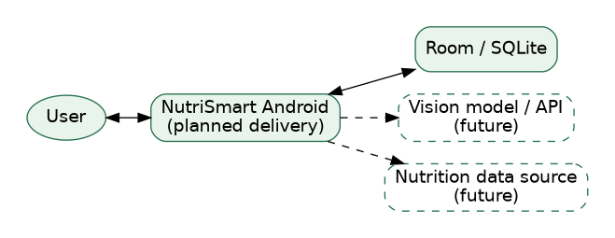
Diagram export from the current architecture materials. Maintain editable source files in the project repository.

A2. Use case diagram
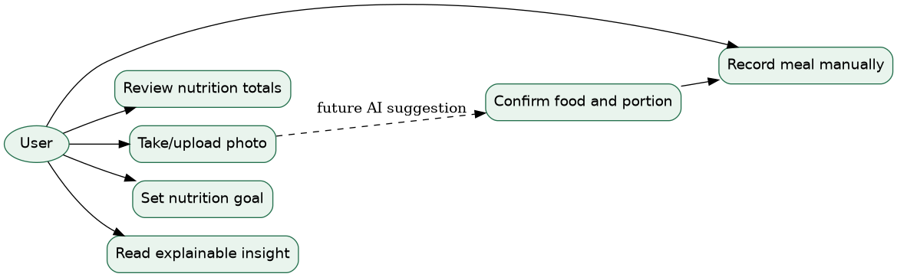
Diagram export from the current architecture materials. Maintain editable source files in the project repository.

A3. Component diagram
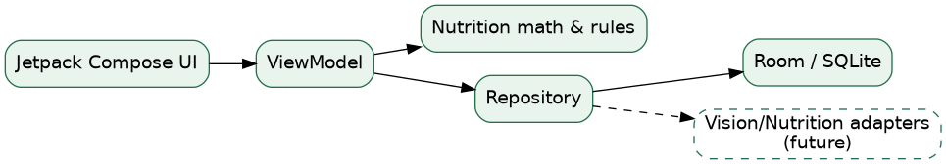
Diagram export from the current architecture materials. Maintain editable source files in the project repository.

A4. YouTrack project management evidence
15 issues created (NUT-1 to NUT-15): Backlog 6, Development 1, Review 8, Test 0 as seen on 24 October 2026. Screenshots are also provided as a separate required PDF. This document does not assert that all acceptance criteria are met.
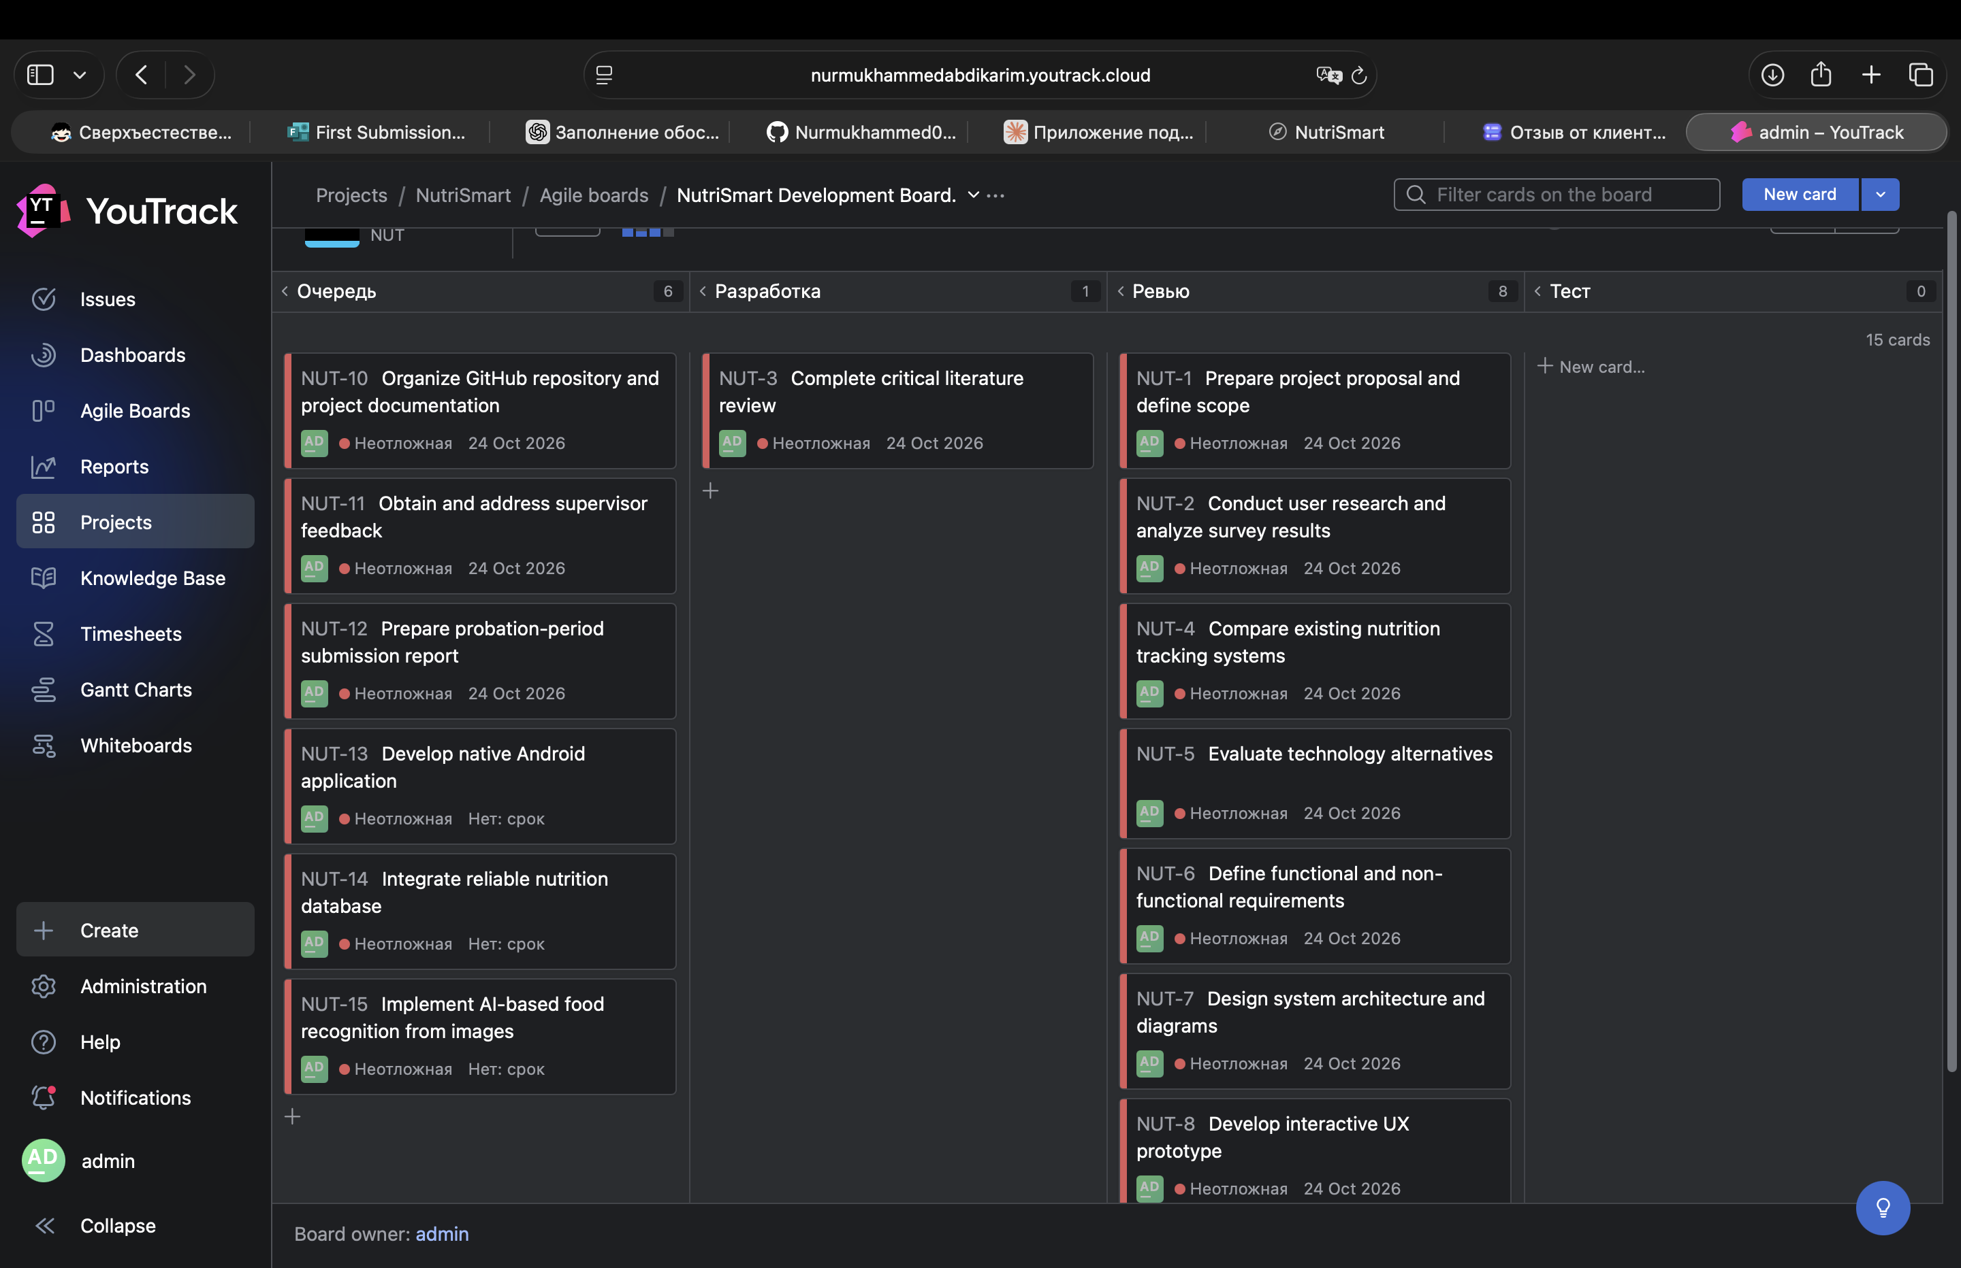

Supervisor review record
Status: awaiting response from Bakayeva Bakyt. No comments or approval received and incorporated as of preparation of this version. This is an outstanding checkpoint requirement.

Submission checklist — verify before Microsoft Forms
[ ] GitHub contains uploaded final report, editable sources and prototype
[ ] Repository contains meaningful commits referencing actual NUT issue IDs
[ ] GitHub tag prob-period-1 exists and opens on the intended commit
[ ] Supervisor and committee have required access to GitHub and YouTrack
[ ] Separate YouTrack PDF uploaded in its designated field
[ ] This unified report PDF uploaded in its separate designated field
[ ] Individual contribution includes real commit URLs; no fabricated links
[ ] Supervisor feedback status is reported accurately

