**Nurnabi Islam**

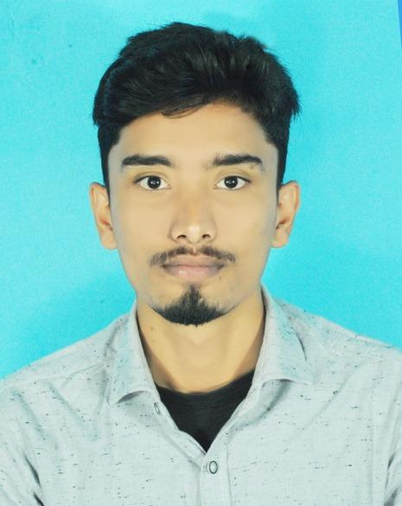

[Saronislam72766@gmail.com] |

[01785377951] |

[ Char Chara Bari,Bahalipara-5300] |

[Nilphamari] |

[[LinkedIn](https://www.linkedin.com/in/nurnabi-islam-0595a434b)] |

**Professional Summary**

A dedicated professional with a strong academic foundation in Physics Honours. Equipped with hands-on training experience in computer fundamentals and office applications. Passionate about leveraging technical expertise and teaching skills to foster learning and innovation.

**Education**

**Bachelor of Science (BSc) in Physics**  
Nilphamari Govt. College  
Year: 2025

**HSC in Science**   
Domar Govt. College  
Year: 2018

**Training Experience**

**Computer Fundamentals and Office Applications Training**

Organized by CDT, BRUR Funded by World Bank

* Conducted training sessions on computer basics and office productivity tools for diverse groups of learners.
* Delivered practical demonstrations and hands-on exercises to enhance learner engagement and understanding.
* Designed course materials and assessments tailored to different skill levels.

**Technical Skills**

* **Office Applications**: Microsoft Word, Excel, PowerPoint
* **Programming Fundamentals**: [Add any relevant programming languages you know]
* **Computer Fundamentals**: Hardware and software basics, troubleshooting

**Certifications (if any)**

[Computer Fundamental and Office Application EDGE.]

**Languages**

[ English,Bengali.]