Lab 10. Configuring NGINX

NGINX is a high-performance, open-source web server, reverse proxy, and load balancer. It is designed for handling high concurrency with low memory usage. NGINX is widely used for serving static content, proxying requests to application servers, and distributing traffic efficiently. It supports features like SSL termination, caching, and API gateway functionality.
NGINX is used for:

- Web Server – Serves static and dynamic content efficiently.
- Reverse Proxy – Forwards client requests to backend servers.
- Load Balancer – Distributes traffic across multiple servers.
- API Gateway – Manages API requests and authentication.
- SSL Termination – Handles HTTPS encryption to offload backend servers.
- Caching – Stores responses to improve performance.
- Rate Limiting – Controls request rates to prevent abuse.

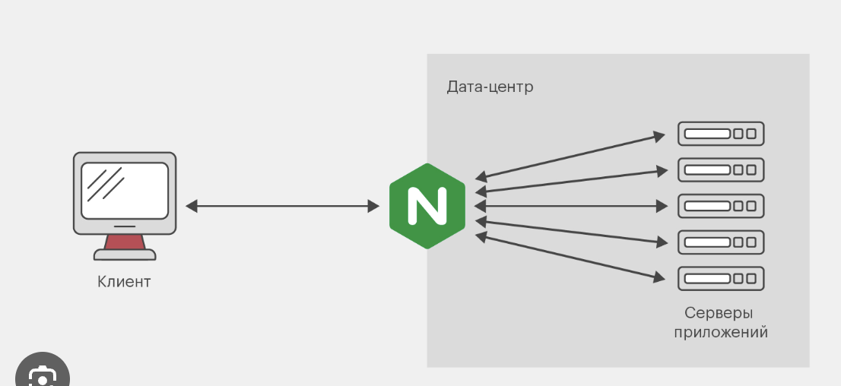

Configuring Nginx server

- Install nginx
sudo apt update
sudo apt install nginx
- Create configuration file
NGINX configuration files define server behavior, manage virtual hosts, enable load balancing, set security rules, handle logging, optimize performance, and configure reverse proxy settings.
The default location of the Nginx configuration file in Ubuntu is /etc/nginx/nginx.conf. This file contains the main configuration settings for Nginx. Additionally, other configuration files, such as site-specific configurations, are typically found in /etc/nginx/sites-available/ and /etc/nginx/sites-enabled/.
For adding your own configuration, it is best practice to create a new configuration file within the /etc/nginx/sites-available/ directory. You can name the file according to the site or application you are configuring. Then, create a symbolic link to that file in the /etc/nginx/sites-enabled/ directory to enable it.
sudo nano /etc/nginx/sites-available/my_site
Paste this code:
server {
listen 8000;
server_name localhost;
root /var/www/html; # Path to your HTML file where it is located
index my_site.html; # The default file to serve
location / {
try_files $uri $uri/ =404;
}
}
Create HTML file in specified directory:
nano /var/www/html/my_site.html
and paste this code, but you can write any HTML code:
<div>My site on 8000</div>

- Create a symbolic link in /etc/nginx/sites-enabled/:
sudo ln -s /etc/nginx/sites-available/my_site /etc/nginx/sites-enabled/

- Reload Nginx:
sudo nginx -t
sudo systemctl reload nginx

- Nginx configuration errors
Check the configuration before restarting:

bash
Copy
Edit
sudo nginx -t
If there are errors, fix them in the /etc/nginx/nginx.conf file or in the site configuration files (/etc/nginx/sites-enabled/).

- (sudo tail -f /var/log/nginx/error.log)
If there are any errors, fix them and restart Nginx

- Open your browser on localhost:8000. It should open your HTML page.

In conclusion, Nginx can be used for:

- Serving Static Websites: Nginx is commonly used to serve static websites, such as blogs, portfolios, or personal sites. It efficiently handles HTML, CSS, JavaScript, and image files.
- Reverse Proxy: Nginx acts as a reverse proxy to forward requests from clients to backend application servers, such as those running Node.js, PHP, or Python, allowing the server to handle dynamic content.
- Load Balancing: Nginx distributes incoming traffic across multiple servers to balance the load and improve performance and reliability of web applications.
- SSL/TLS Termination: Nginx can manage secure connections by terminating SSL/TLS, handling HTTPS requests on behalf of backend servers to offload encryption/decryption tasks.
- URL Rewriting and Redirects: Nginx can rewrite URLs or set up redirects for SEO purposes or to route users to new locations when content changes or URLs are updated.

Task: explore Nginx proxy_pass parameter to allow sending requests to your running API

