1

**DDL:**  
DDL is Data Definition Language which is used to define data structures. For example: create table, alter table are instructions in SQL.

Basic command present in DDL are CREATE, DROP, RENAME, ALTER etc

DDL does not use WHERE clause in its statement.

**DML:**  
DML is Data Manipulation Language which is used to manipulate data itself. For example: insert, update, delete are instructions in SQL.

BASIC command present in DML are UPDATE, INSERT, MERGE etc.

While DML uses WHERE clause in its statement.

2

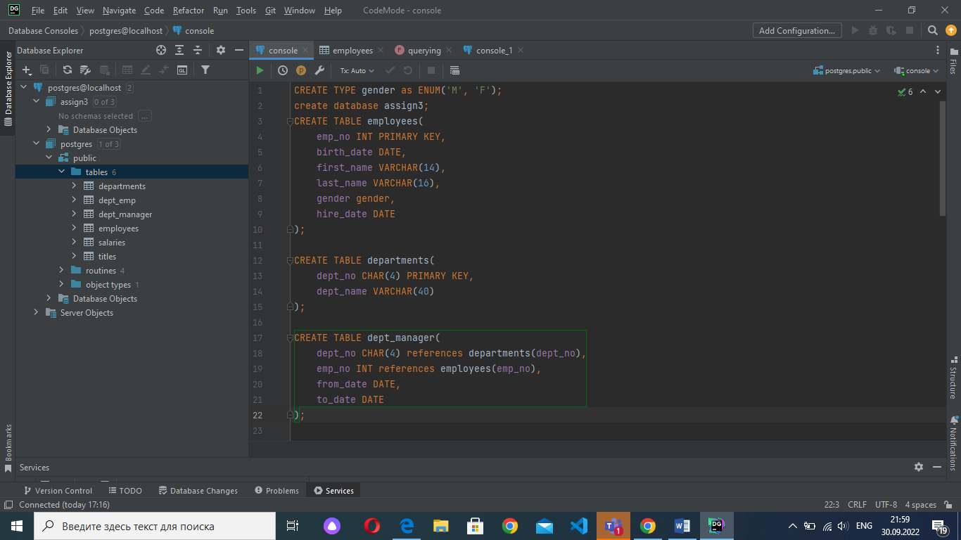

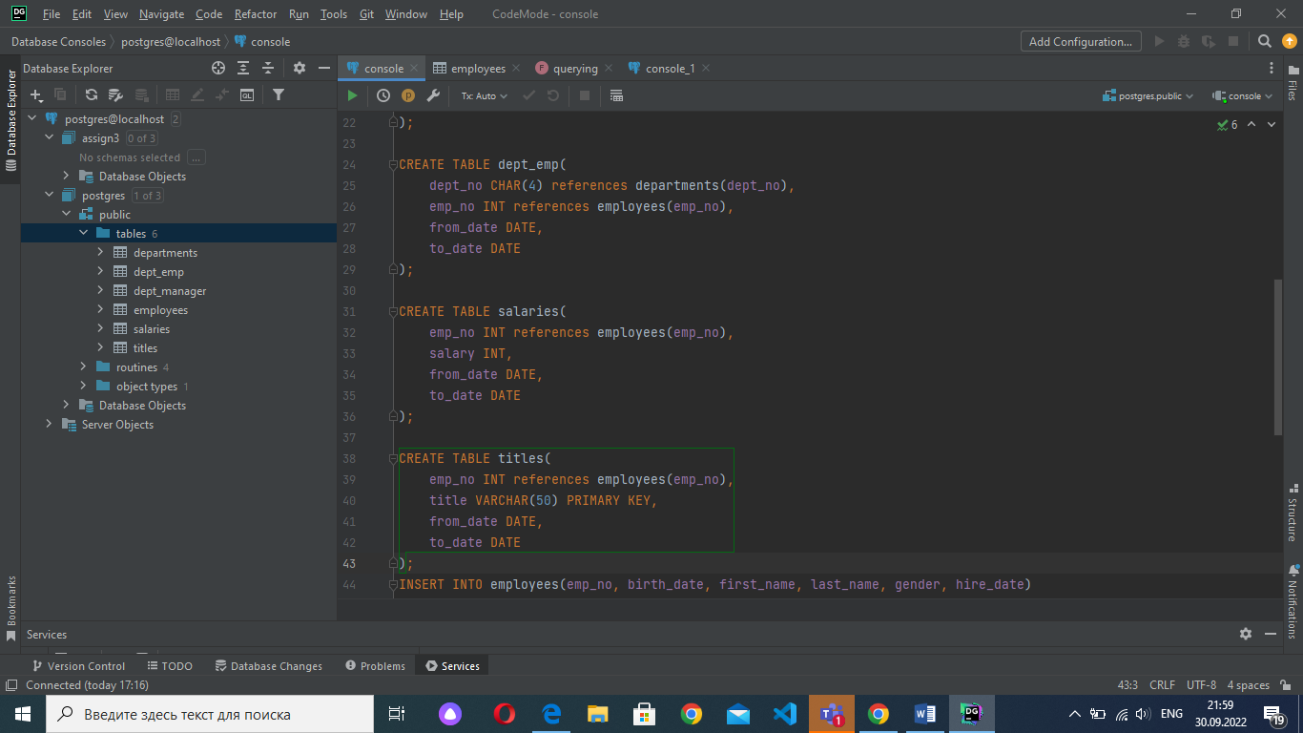

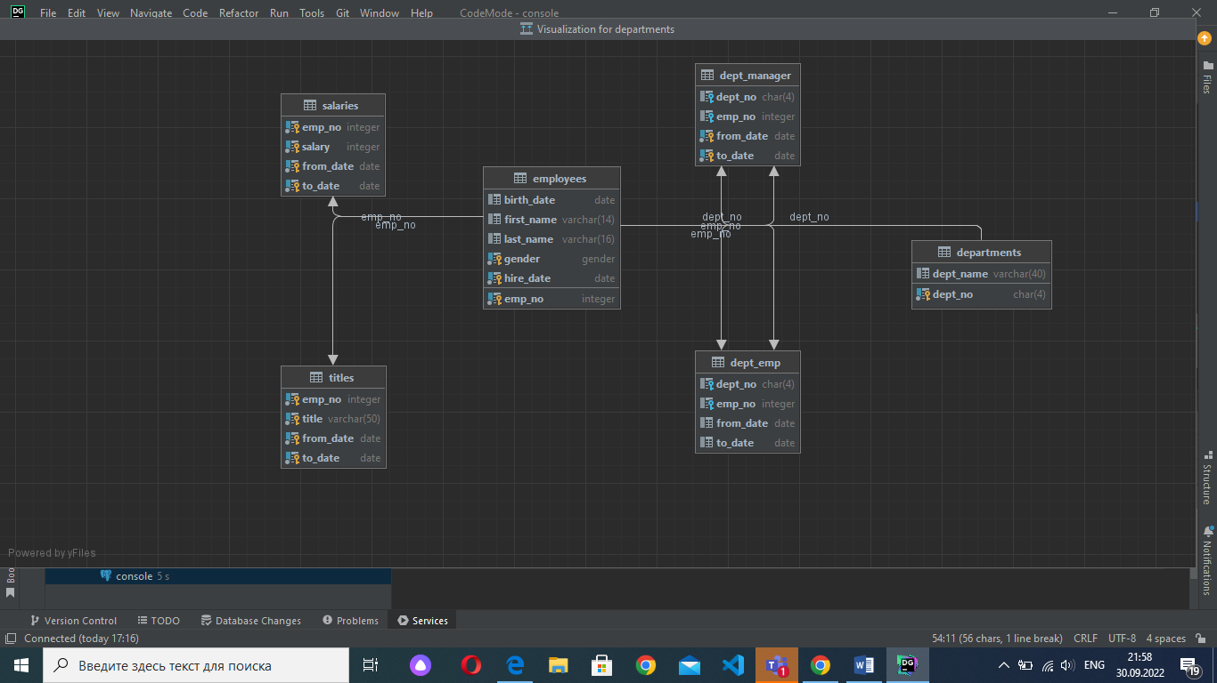

3

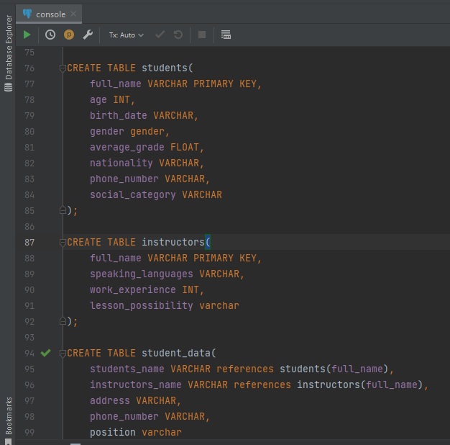

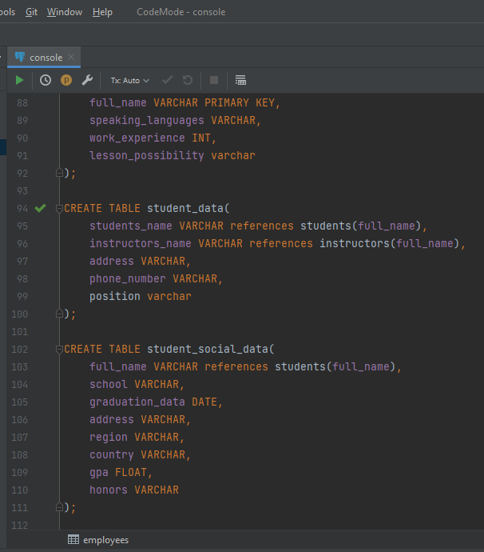

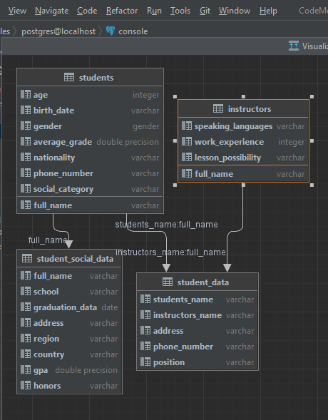

4

INSERT

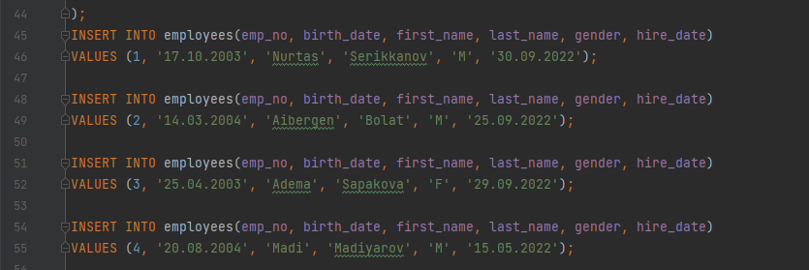

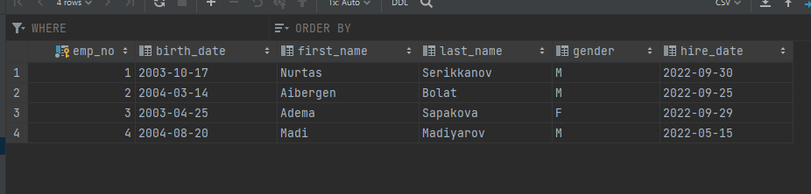

UPDATE

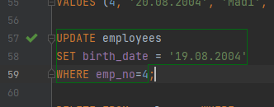

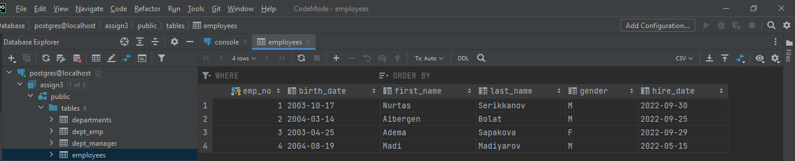

DELETE

C:\Users\Lenovo\Downloads\2022-10-01_14-15-11.png

