Software Requirements Specification
for
NurtureOrphan
Version 1.0 approved
Prepared by-
Aaina Bhawnani
Amritansh Kr.Verma
Naali Moksha
Swamy Reddy
- Thirumala Reddy
Ojasi Lavanya
Aryan Kaushik Vora
KIIT Deemed University

08-10-2023
Table of Contents
Table of Contents
Revision History
1. | Introduction |  | 1
 | 1.1 | Purpose | 1
 | 1.2 | Document Conventions | 1
 | 1.3 | Intended Audience and Reading Suggestions | 1
 | 1.4 | Product Scope | 1
 | 1.5 | References | 1
2. | Overall Description |  | 2
 | 2.1 | Product Perspective | 2
 | 2.2 | Product Functions | 2
 | 2.3 | User Classes and Characteristics | 2
 | 2.4 | Operating Environment | 2
 | 2.5 | Design and Implementation Constraints | 2
 | 2.6 | Assumptions and Dependencies | 2
3. | External Interface Requirements |  | 3
 | 3.1 | Web User Interface(Web UI) | 3
 | 3.2 | Data Input and Output | 3
4. | System Features |  | 4
 | 4.1 | Orphan Home Information Collection | 4
 | 4.2 | Donation Application | 4
 | 4.3 | Food waste Reduction and Distribution | 4
 | 4.4 | Food Donation | 4
 | 4.5 | Grocery Donation | 4
5. | Other Nonfunctional Requirements |  | 5
 | 5.1 | Performance Requirements | 5
 | 5.2 | Safety Requirements | 5
 | 5.3 | Software Quality Attributes | 5

6. | Other Requirements | 6
Appendix A: Glossary |  | 6
Appendix B: Analysis Models |  | 6
Appendix C: To Be Determined List |  | 6

Introduction

Purpose
The purpose of this document is to outline the requirements and specifications for Nurture Orphan website aims to facilitate support for orphan homes and promote the welfare of underprivileged children by providing a platform that connects users with various applications dedicated to specific causes related to orphan homes.
The website aims to simplify and enhance the process of supporting orphan homes. It serves as a central hub where users can access information about various orphan homes and discover diverse opportunities to contribute to their well-being.The website actively promotes the overall welfare of underprivileged children. It offers a range of dedicated applications, each addressing specific causes closely related to the needs of orphan homes.Through its various applications, the website addresses a multitude of causes related to orphan homes. Users can engage in financial support, combat food wastage, contribute home-cooked meals, and provide essential items such as medicine and groceries. The multiplicity of causes allows individuals to support in ways that resonate with them personally.

Document Conventions
Document Structure: The SRS document aims to ensure clarity, consistency and professionalism in communicating the requirements and specifications for the Nurture Orphan website. Clear and consistent headings are used to organize different sections of the document. The sections are categorized by the purposes and perspective of the website, requirements of the website, UML designs constraints and interfaces of Nurture Orphan.
Formatting: The entire document contains legible font style and size (Headings- Times New Roman, 14pt; Content- Tomes New Roman, 12pt).
Styling: The SRS is written in a clear and concise style. This means avoiding technical jargon and using plain language whenever possible.

Intended Audience and Reading Suggestions
Philanthropists and Donors:
Individuals or organizations looking to contribute financially to orphan homes and support the welfare of underprivileged children.

Volunteers:
People interested in actively participating in causes related to orphan homes, such as offering their time, skills, or services.

Community Organizations:
Non-profits, community groups, and organizations interested in partnering with or supporting orphan homes.

Families and Individuals Interested in Adoption:
Those considering adoption or looking for information about the adoption process and orphanages.

Local Businesses:
Businesses interested in corporate social responsibility (CSR) and contributing to causes related to orphan homes.

Educational Institutions:
Schools, colleges, and universities interested in engaging students in community service or supporting educational initiatives for orphaned children.

Government Agencies:
Agencies responsible for social welfare and child services that may find opportunities to collaborate or support specific initiatives.

Media and Influencers:
Journalists, bloggers, and social media influencers interested in promoting and raising awareness about the welfare of underprivileged children.

Reading Suggestions:

Homepage Overview:
Provide a clear and concise introduction to the website's mission and objectives. Highlight the key features and benefits of the platform.

How to Contribute:
Clearly outline the various ways individuals or organizations can contribute, whether through financial donations, volunteering, or other means.

Applications Overview:
Detail the dedicated applications available on the platform, specifying how each addresses specific needs of orphan homes. Include success stories or case studies.

User Stories and Testimonials:
Share stories of individuals or organizations that have benefited from the platform, showcasing the impact of contributions.

Volunteer Opportunities:
Provide information on how individuals can get involved as volunteers, including the application process, training, and ongoing support.

Adoption Resources:
For families interested in adoption, offer comprehensive information on the adoption process, legal requirements, and links to relevant resources.

Corporate Partnership Opportunities:
Outline how businesses can partner with the platform for CSR initiatives, including sponsorship opportunities, employee engagement, and joint campaigns.

Educational Initiatives:
Highlight any educational programs or initiatives supported by the platform, encouraging educational institutions to get involved.

Media Kit:
Provide a media kit with press releases, images, and other resources for media outlets and influencers interested in covering or promoting the website.

FAQ Section:
Address common questions users might have about the platform, its operations, and how their contributions make a difference.

Contact Information:
Clearly display contact information for inquiries, support, and collaboration opportunities.

Social Media Integration:
Encourage users to follow the platform on social media for updates, success stories, and community engagement.

Product Scope
Overall, this project has the potential to make a significant impact on the society and the lives of orphans. The website will consist of multiple interconnected modules, each serving a 21specific purpose related to orphan home support and welfare promotion. This document will define the functional and non-functional requirements for each module.
It also has the potential to prevent food wastage and help in the connecting the dots towards sustainability.

1.5 References

Overall Description

2.1 Product Perspective
- This is a new product based on the idea of supporting the live of people who need help.
- This product aims to prevent food wastage and works towards sustainability
- This platform will connect users with a wide options for donation

2.2 Product Functions
The product will help its users to donate as per the needs by the orphanages highlighted in the website. An easy to understand UI will be in play and the users will be able to know the need for the donation.

2.3 User Classes and Characteristics
- Regular Users: Consumers looking for helping orphans and trying to be a hope of light in their lives
- Admin Users: Responsible for content management

2.4 Operating Environment
The product is a web application that can be run on any modern web browser without the need of any new software, however the internet connection should be stable for updates.

2.5 Design and Implementation Constraints
- Compliance with web standards (HTML5, CSS3, JavaScript)
- Use of responsible web design for various devices

2.6 Assumptions and Dependencies
- Availability of machine learning models
- Stable hosting and database services

External Interface Requirements
3.1 Web User Interface (Web UI):
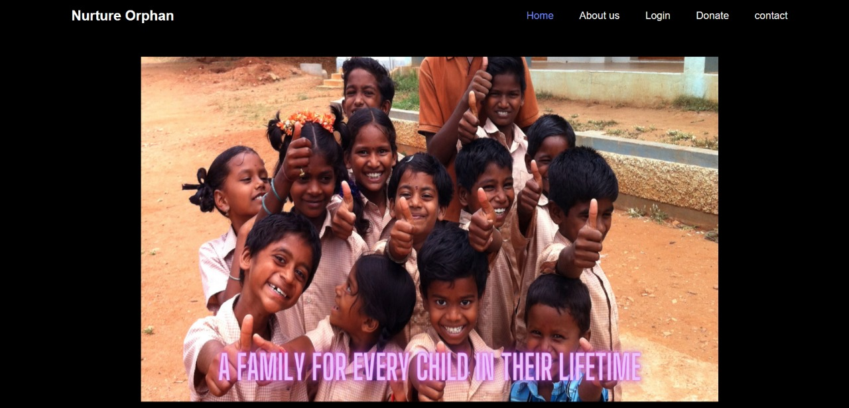

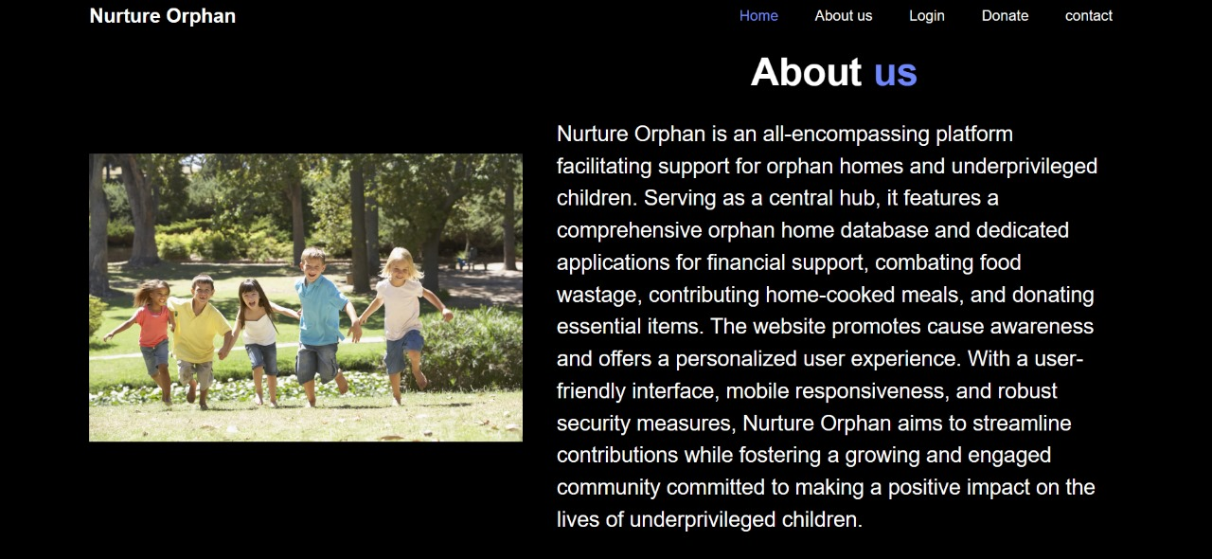
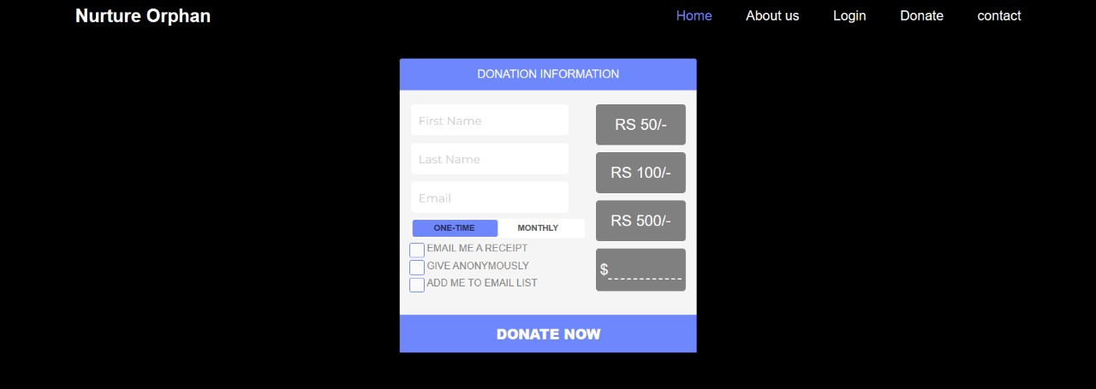
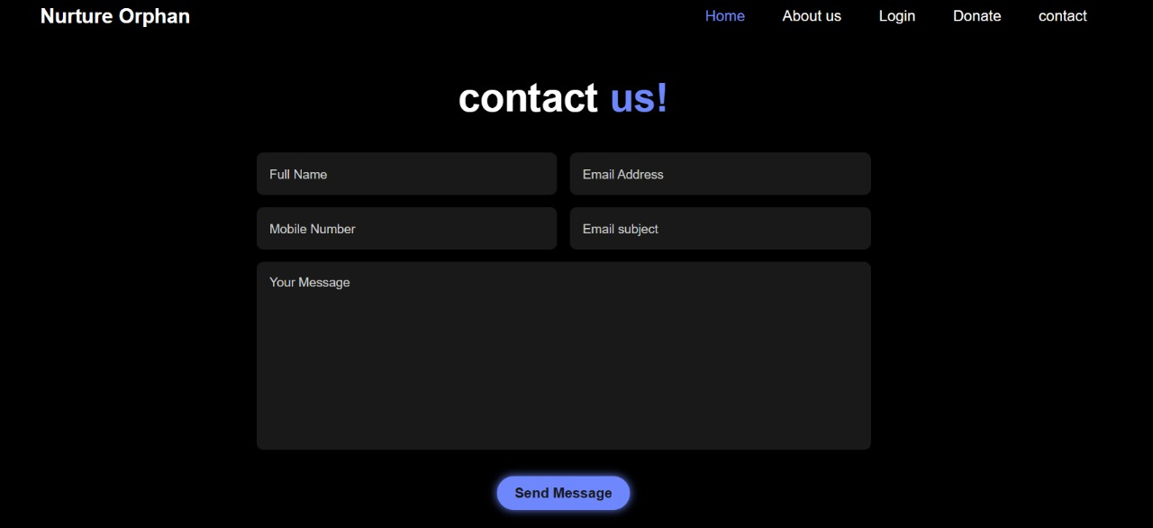

3.2. Data Input and Output:

Users will input data through input fields. Data output will include search results, product details, user profiles, and reports, presented in a clear and readable format.

ER Diagram:

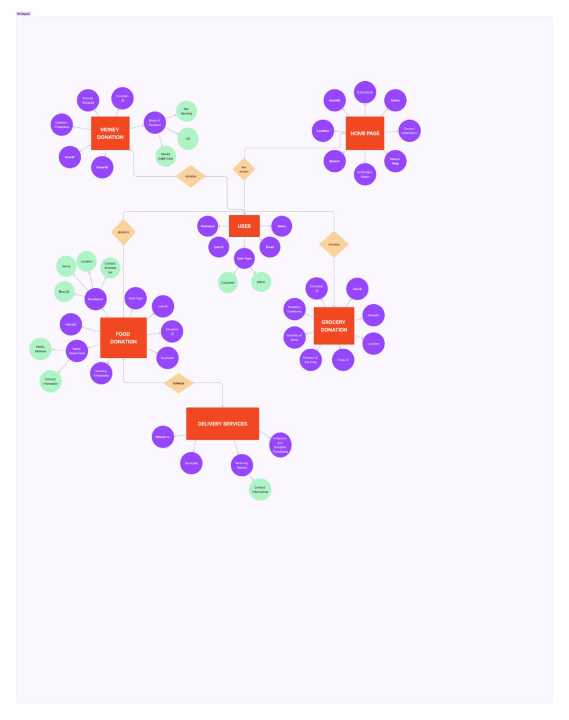

Use Case Diagram:
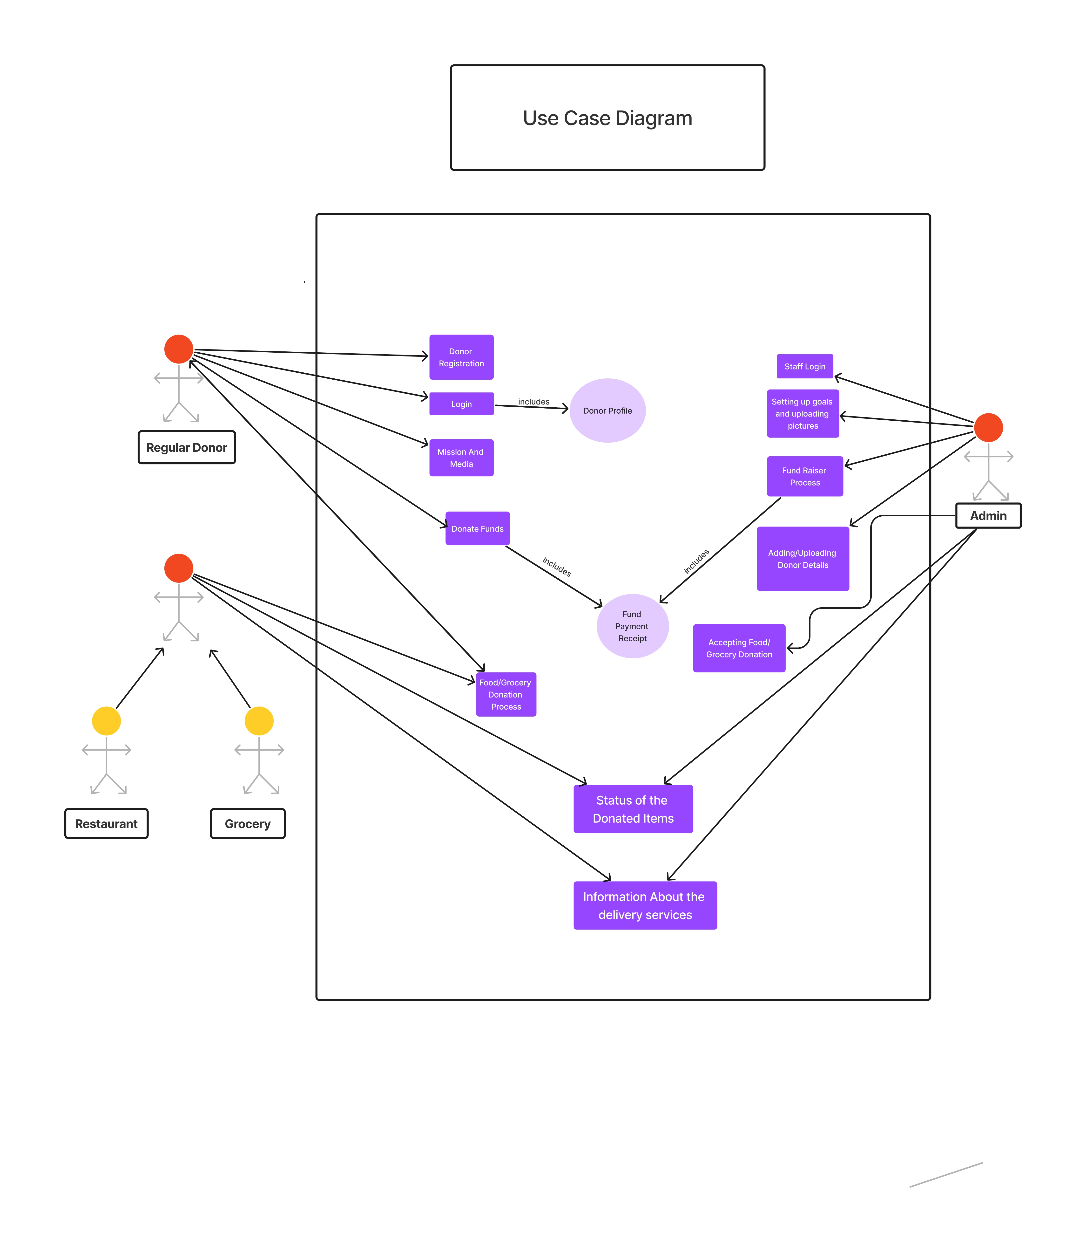

CLASS Diagram:
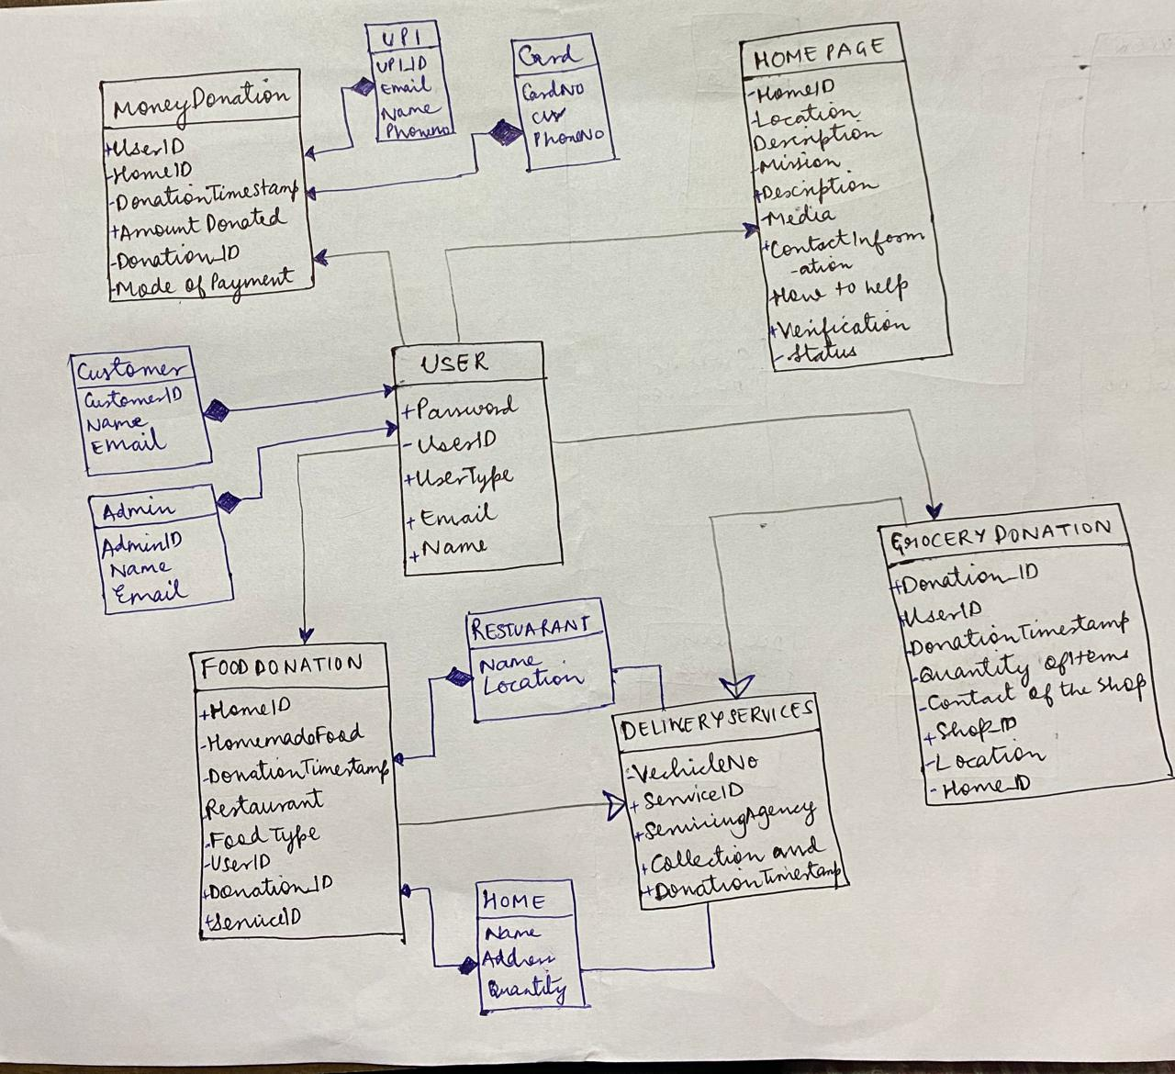

SEQUENCE Diagram:

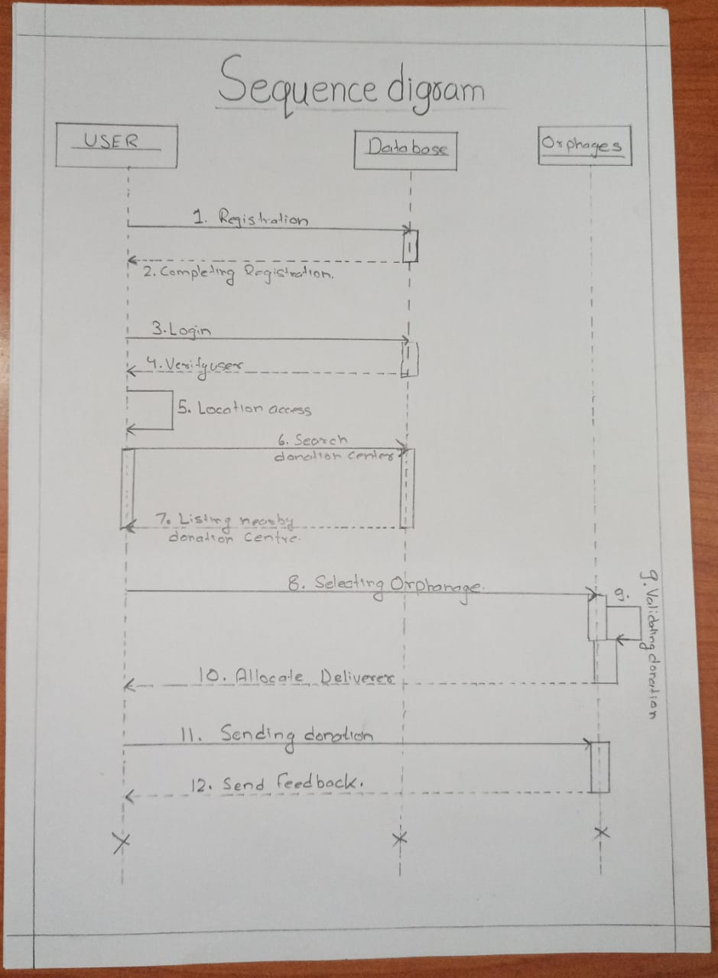

System Features
4.1 Orphan Home Information Collection

User Registration
- Users must register or log in to access the website features.
- User registration requires basic information such as name, email, and password.

Orphan Home Listing
- The app will compile information about verified orphan homes.
- Users can browse and search for orphan homes by location and other criteria.
- Details about each orphan home, including its history, mission, and contact information, will be available.

4.2 Donation Application
4.2.1 Select Orphan Home
- Users can select an orphan home from the list of verified homes.
- Users can view the specific needs and requirements of each home.
4.2.2 Donation Process
- Users can donate money directly through the app.
- The donation process will be secure and transparent, with options to select donation amounts.

4.3 Food Waste Reduction and Distribution
4.3.1 Restaurant Collaboration
- The app will list restaurants willing to donate surplus food.
- Restaurant owners can register their willingness to participate.

4.3.2 Food Pickup and Delivery
- A designated delivery service will collect surplus food from restaurants daily.
- The app will schedule and coordinate food deliveries to different orphan homes.

4.4 Food Donation
4.4.1 User Food Donation
- Users can request a pickup service to collect excess or leftover food from their homes.
- Collected food will be delivered to orphan homes in need.

4.5 Grocery Donation
4.5.1 Donating Essential Items
- Users can donate grocery and medicines products directly through the app.
- The app will coordinate the collection and delivery of these items to orphan homes.

Other Nonfunctional Requirements

Performance Requirements
5.1.1. Response Time

- The system should respond to user interactions
- The web application's pages should load in under 3 seconds on standard internet
connections.

5.1.2. Mobile Responsiveness:

The web application should provide an optimized user experience on mobile devices, with pages loading within 3 seconds on 4G or equivalent mobile networks.

5.1.3. Error Handling

- Error messages should be informative and user-friendly, helping users understand and resolve issues.
- Error pages should load quickly.

Safety Requirements
5.2.1. Orphanage/Donator Verification

- Implement a robust verification process for orphanages and donators.
- Regularly review and update the list of verified orphanages and donators to maintain trust with users.

5.2.2. Ethical Standards Compliance
Ensure that the system promotes and adheres to ethical standards related to donations and environmentally responsible practices.

5.2.3. User Education
Provide educational resources about donation practices and their environmental impact to help users make informed choices.

5.2.4. Feedback Mechanism
Implement a feedback mechanism to allow users to report ethical concerns, issues with
functions, or problems with the platform's functionality.

5.2.5. Compliance with Legal Regulations
Ensure that the platform complies with all relevant legal regulations related to donation, user data protection, and ethical advertising practices.

Software Quality Attributes

5.1. Usability
- The system should have a user-friendly and intuitive interface, making it easy for users to find orphanage for donation.
- Ensure that navigation is straightforward, and the layout is visually appealing.

5.3.2. Performance

- Response times should be fast to provide users with a smooth and responsive experience.
- Pages should load quickly, and search results should be returned promptly.

5.3.3. Availability
- Ensure that the system is available 24/7, with minimal scheduled maintenance windows.
- Implement monitoring and alerting to detect and address issues proactively.

5.3.4. Compatibility:
- The web application should be compatible with various web browsers
- Ensure cross-browser and cross-platform compatibility.

5.3.5. Maintainability:

- Ensure that the code base is well-organized, modular, and documented to facilitate future
- maintenance and updates.
- Implement version control and a structured development process.

5.3.6. Testability:
- Develop the application with testability in mind, making it easy to create and execute tests
- for various components.
- Implement unit testing, integration testing, and user acceptance testing.

Other Requirements
Appendix A: Glossary
Appendix A: Glossary
1. Monetary Donations:
The orphanage welcomes financial contributions to support the well-being and development of the children under its care. Donors can make monetary donations through the following channels:
a. Online Transfers: Bank details will be provided upon request.
b. Cheques: Payable to Tapovan Orphange , with contact information on the back.
c. In-Person: Visit our office during business hours for on-site donations.
2. Food Donations:
To ensure the health and nutrition of the children, the orphanage accepts non-perishable food items. Donors are encouraged to provide items such as:
a. Canned Goods: Soups, vegetables, fruits, etc.
b. Dry Goods: Rice, pasta, beans, lentils, and similar staples.
c. Snacks: Nutritious snacks suitable for children.
3. Donation Drop-off Points:
Donors can drop off their contributions at designated locations, including:
a. Orphanage Main Office
b. Local Partner Organizations
4. Acknowledgment and Reporting:
All donors will receive a formal acknowledgment of their contribution. Additionally, the orphanage will provide periodic reports on the utilization of donations to maintain transparency.
5. Contact Information:
For any inquiries or to coordinate donations, please contact:
Nurture Orphan Orphanage
127/578 W-1 Saket Nagar, Bhubaneswar, Odisha
tapovanodisha@gmail.com
8604235239
Appendix B: Analysis Models
<Optionally, include any pertinent analysis models, such as data flow diagrams, class diagrams, state-transition diagrams, or entity-relationship diagrams.>
Appendix C: To Be Determined List
<Collect a numbered list of the TBD (to be determined) references that remain in the SRS so they can be tracked to closure.>

