**CAT404 – Software Engineering Major Project**

**Project Proposal   
Event Planner System (Subsystem 3: Orders Subsystem)  
SE22230064**

[Nurul Adila Binti Abdul Mukti] , [Dr. Mohd Nadhir Bin Ab Wahab]  
[[nrladilamukti@student.usm.my](mailto:nrladilamukti@student.usm.my)] , [[mohdnadhir@usm.my](mailto:mohdnadhir@usm.my)]

School of Computer Sciences, Universiti Sains Malaysia  
11800 USM, Penang, Malaysia

**Abstract**

Organizing events would be much easier when everything is just one click away. Most of the services provided on the online platform are scattered. The user will need to go through each of those individual platforms for booking and even to make survey for the best packages will be very tiresome for some. Moreover, the user is also exposed to service scam or even the vendor is unprotected as they also might face last minute booking cancellation. Therefore, Order subsystem of Event Planner System (EPS) has come into the way to help in reducing the effort and make organizing activity more hassle-free and organize. This subsystem will be implemented using agile methodology fulfilling all the six phases of Software Development Life Cycle (SDLC). This subsystem is made up of four modules which are the cart module for keeping track all the interested service, the payment module for managing the payment transaction, the review module to provide testimonial for future user and collect user experience on delivered service and lastly the booking module that will help in tracking the service or order progress. By the end of the development, this system is expected to ensure client get the promised service as agreed through service receive confirmation, prevent vendor from experiencing total financial loss through cancellation fee and help save users time in keeping every interested service on one application.

*Keywords: Online platform, Order Subsystem, Modules*

# **Project Background**

E-commerce has become one of the important industries and sectors nowadays especially after the covid hit the world. More people start to put their preference higher towards using ecommerce platform in managing their daily needs. Event Planner System (EPS) is an ecommerce platform that provides centralized variety of service choices from different talented vendors. This web-based system is aimed at helping people manage events in a more efficient way and hassle-free. Besides being able to have wider choices for a service, the client does not have to spend more time navigate from one service website to another just to compare the packages provided. Instead, they can only search based on the categories provided through the system to get the list of service packages for the required service then make a choice based on their preferred budget.

Other than being able to make bookings anytime in 24 hours, they can also refer to the review provided by the previous clients in helping them make the right choice and avoid scamming issues. By reviewing the review provided, the client will be able to know the quality level of service provided by the vendor. Not just that, the payment transaction will also be secured as the money will not be released to the vendor until the client confirmed the service is delivered as agreed. Moreover, the vendor will also be protected from the need to face total financial loss in the event of a last-minute booking cancellation by the client.

In overview, this order subsystem will support three types of stakeholders which are the admin, the vendor, and the client. The client can add the interested service to cart, make payment once the service is confirmed, confirm the service status when received, review the service provided by the vendor and track the service progress whether accepted or rejected. Meanwhile the vendor will be able to track or decide whether to accept or reject the booking application of the client, receive reviews posted by the client and receive payment status. The admin will be able to manage the order data, cart data, review data and release payment to vendor once the client confirms the service is received.

# **Problem Statements**

A successful and smooth event is just a dream for every event’s organizer. To realize it, one must sacrifice part of their time and invest some effort to coordinate and organize everything carefully. All the expenses involved for the event should be within the range of the agreed budget so that any overspending issues can be avoided from occurring. Not just that, having a platform that could help in managing all the service booking at once, will help the organizer to be more efficient and able to use the remaining time to focus on other matters. Many people would be excited about having an event but not until the organizing part as this sometime would cause some headache if not being managed correctly and systematically. Moreover, if not lucky enough, some might be involved in a service scam where the service is not delivered accordingly as discussed although the payment had been made causing the client to bear a financial loss. Surveying process will be much easier if the user can directly put every packages detail in one place directly rather than jot down one by one, so later they can just come back to that shortlisted list and make comparison for the package that will serve the best value.

To accommodate those needs, this system will enable the user to have wider choices of a service where all services will be categorized according to their own respective type. Such example catering, photography, boutique etc. By choosing the intended category, a list of packages of the same service from different vendors will be shown. From there, the user will be able to directly review each post or offering and put the interested one into the cart for the second review process. The user will be able to scroll through the cart to revise all the interested services to choose the best package among those. Skipping the page-to-page navigation or jotting down process will help the user to be more organized, efficient, and systematic. Other than that, the user will be guaranteed on receiving the booked service as agreed or full payment will be refund back. Not just the user will be protected, the vendor will also be covered from facing last minute booking cancellation since the cancellation fee will be imposed to the user and the payment will not be refund fully to the user only, but some percentage of the payment will also be released to the vendor intended to cover the losses.

# **Motivation**

The Covid-19 hit had impact the shopping pattern in Malaysia. Many would prefer to make use of online platforms to ease their daily life rather than conventional ways. According to an article published by News Strait Times on 3 February 2022, almost 88% of Malaysian citizen are digital consumers and the high number of consumers are not just spent much of their time for making a choice before purchase but they also willing to spend their time to shop-hop across number of websites to opt for the best deals. From this number, it does show that ecommerce platforms have started to play a great role in society. At the moment, it is foreseen that for the service website, most of them would be stand-alone websites that would require some consumer’s effort and time to navigate from one site to another to make comparison between the same service. This has made it less efficient for the nowadays consumer that is always deemed to have faster and quicker transactions. Not just that, a safer platform for booking process is also become a necessity for every consumer to protect and avoid any scamming issues from happening. Therefore, it would be grateful to have a platform that could ease decision making in getting the best deal and protect from scamming issues.

# System Objective

The main objective of this system is to create an Event Planner System (EPS). This sub-system is focusing on order management. Therefore, the sub-system should be able to:

1. View, book and modify the services offered by the vendor in the cart.
2. Make a payment for the service selected.
3. Manage the booking and feedback review.

# Proposed Solutions

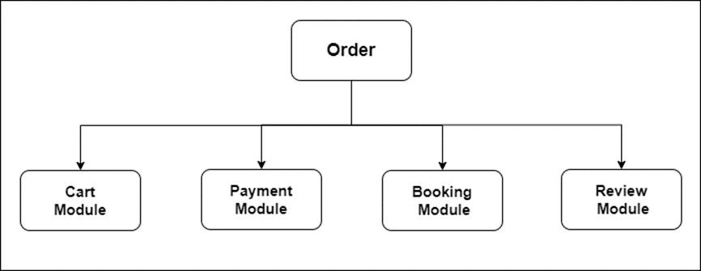

*Figure 1 shows the Module Diagram of the Order Subsystem*

This order subsystem will be made up of four modules as shown in the diagram above. Each module will have its own responsibility in contributing towards the meaningful overall solution. Starting with the cart module, the client will be able to add the interested service from post listing into the cart. Once added, the client will be able to come back and check for the interested service straight from the cart. They will be able to edit the quantity or remove items from the cart. The admin will be able to manage cart data. Next, in the payment module, the client will be able to make payment to vendor to book the service while the vendor will be able to receive the payment receive status made by the client once service receives is confirmed.

Furthermore, in this module, the admin will also be able to manage all payment data and approve the payment release to the vendor once the service confirmation is made by the client. The third module is booking module. In this module, the client will be able to check the booking status whether it is accepted or rejected by the vendor. The vendor will be able to view the book request from client and accept or reject the book request from client based on their availability. Lastly, in the review module, the client will be able to put their review upon the service received confirmation is made and the vendor will be able to view all the review received.

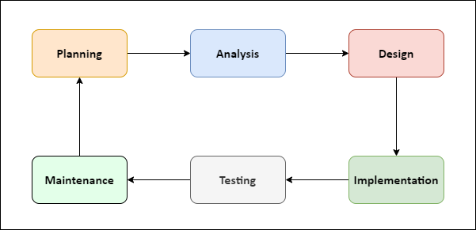

*Figure 2 shows the Software Development Life Cycle (SDLC)*

One criterion to have a successful workable system is by having the right project management. Software development life cycle that consist of six phases of planning, analysis, design, implementation, testing and maintenance will be fulfilled to ease the development process and reduce unnecessary cost. In the planning phase, the feasibility assessment will be conducted, and the creation of project plan will be initiated. In the analysis phase, the list of potential stakeholders of the system will be produced. The requirements will be elicited from the list of stakeholders through survey and brainstorming. The confirmed requirements then will be prioritized into three categories which are high, medium, and low priorities. Next in the design phase, the IT infrastructure that is suitable to the system will be decided based on the current specifications then proceed towards the system model design.

The fourth phase is the implementation phase. Here, the development of code and database for the system will be initiated according to the specifications made during previous phases. This system will be implemented using HTML, CSS and Reacts. The tools that will also be involved in implementation are Visual Studio Code, GitHub, Bootstrap and Firebase. Once the implementation process is done, the system will undergo a testing process to find bugs or defects that may exist in the code. The testing will be executed based on the written test cases by the tester. A number of testing will be involved such as unit testing, integration testing and functional testing. After validated and verified, the system is now ready to be deployed to the real environment. The last phase of maintenance will be focusing towards getting change requests from the user whether for enhancement or corrections after the system has been successfully deployed into the real environment.

1. **Benefits / Impact / Significance of Project**

Every solution provided must have its own impact whether small or big on the communities. The impact of this system can be divided into three main benefits. Firstly, the system is budget friendly. Through this system, the client can easily make comparisons between the same service offered by different vendors. Some might find that the packages offered by two vendors are just indistinguishable but at different prices. By comparing the prices and the quality level of service delivered to the client, one might be able to make the best decision based on their needs.

Next, this system also enables the user to experience safer booking transactions. Although the client still needs to pay for the overall price during the booking process, the money will still be on hold first before being released to vendor until the service is delivered to them as agreed. In this way, if the vendor cannot make it as in the agreement, full payment made in booking will be refunded to the client. Not only the client being protected, but the vendor will also be guaranteed from last minute booking cancellation. If that happens, the vendor will be entitled to receive some percentage of the booking payment made by the client to cover the losses. Thus, this system will help the client and vendor to have safer experiences in using online platforms.

Finally, the interested service can be added to cart directly with one button so that later it is easier to choose between the short listed one and proceed to the booking process. This will help the client to be more organized so that later the client does not need to miss any valuable service packages. Like before, the client will need to jot down from which party the service provided is interesting and once have been satisfied with their research through many websites that provide the same service, they will need to come back to the interested website to proceed with the next step. Some might forget to jot down and fully rely on their memory but then once they want to navigate to that website, they get confused and forget if that is the one that serve the best value making them to revisit back all the previous websites to make decision.

# **Uniqueness of Proposed Solutions**

This system has become more outstanding compared to other systems because it works as a one stop center in providing a variety of services to the client. Traditionally, each service will have their own website or social media causing them to be scattered in many platforms especially in Facebook, Instagram and WhatsApp. In order to view the packages provided, the client will need to manually navigate to each of those platforms causing them to spend a lot of time and effort just to conduct a survey for one service. If the client would like to organize a bigger event like a wedding, that will require more service provider, this will be very hectic to navigate through all the website and platform one by one. In order to make events being organized more seamlessly, this system will play a role in making service booking more efficient, organized and hassle-free.

Moreover, this system also provides more secure transactions to protect the client from being scammed by the vendor. Once the client makes the booking and pays for the service, the money will not go directly to the vendor and will be put on hold by the admin first. The payment will only be released to the intended vendor after the service confirmation is made by the client. If the client did not receive the booked service on the agreed date, the client will be able to raise the issue with the service and the full payment will be refunded back to the client. If the client did not confirm the service or raises any issue after a week of the agreed date, the money will be automatically released to the vendor considering that the service had been delivered successfully.

# **Expected Outcomes**

These are the expected outcomes of Order Subsystem by module:

**Cart Module**

* The client will be able to add the interested service to cart
* The client will be able to edit quantity or item in the cart
* The client will be able to remove the item in the cart
* The client will be able to see the item’s quantity and price in the cart.
* The admin will be able to manage all cart data.

**Payment Module**

* The client will be able to make payment to the vendor.
* The vendor will be able to receive the status of the payment made by the
* client.
* The admin will be able to approve the payment release to the vendor once the
* service confirmation is made by the client.

**Booking Module**

* The client will be able to check the status of booking progress.
* The vendor will be able to view the book request from client.
* The vendor will be able to accept or reject the book request from client.

**Review Module**

* The client will be able to provide a review once the service is confirmed.
* The vendor will be able to view all the reviews received.
* The admin will be able to manage all the review data.

# **Status of the Project**

This proposed system is fresh from the start and has never been developed or deployed before.

# **References**

1. Imam, A. (2021, February 24). Software development life cycle: The phases of SDLC. Retrieved November 2, 2022, from https://blog.testlodge.com/software-development-life-cycle/
2. System development life cycle. (n.d.). Retrieved November 2, 2022, from https://www.tutorialspoint.com/system_analysis_and_design/system_analysis_and_design_development_life_cycle.htm
3. Wedding planner system. (2022, August 31). Retrieved October 30, 2022, from https://www.myweddingplanner.com.my/
4. Our projects. (n.d.). Retrieved November 2, 2022, from https://www.moments.my/projects/
5. MUTHUSAMY, G., & KRISHNAN, R. (2022, February 3). Dont get carried away by online shopping | new straits times. Retrieved October 30, 2022, from https://www.nst.com.my/opinion/letters/2022/02/768268/dont-get-carried-away-online-shopping

# **Appendix**

