CSS3

Nurul Islam

(172002009)

**Inline CSS:**

<!DOCTYPE html>

< html >

<head>

<title>inline CSS</title>

</head>

<body>

<h1 style="Color:Green ; font-size:50px" align="center"> Bangladesh<h1>

<p style="color:red;font-size:20px">Paragraph with green color and font size is 20</p>

<p style="color:green;font-size:15px"> Paragraph with redcolor and font size is 15</p>

</body>

</ html >

**Internal CSS:**

<!DOCTYPE html>

< html >

<head>

<title>Internal CSS</title>

<style type="text/css">

h1

{

color:green;

align=center;

}

p

{

color:red;

}

</style>

</head>

<body>

<h1> Bangladesh<h1>

<h2> Bangladesh<h1>

<p>Paragraph with green color and font size is 20</p>

<p>Paragraph with redcolor and font size is 15</p>

</body>

</ html >

**External CSS**

* Create a .css file
* Add some required style
* Link the file with html file
* Use <link> tags and some related attributes inside of the tag

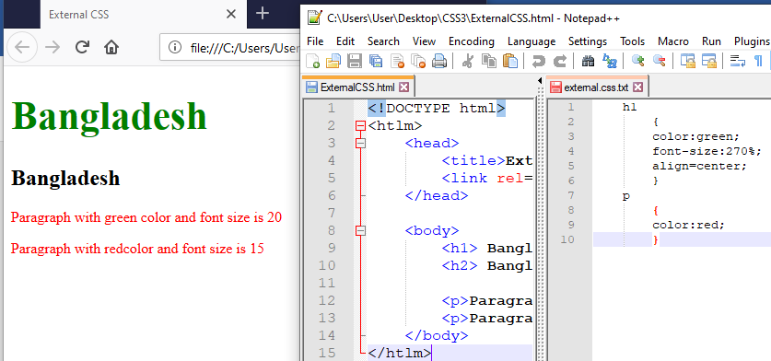

**HTML Code:**

<!DOCTYPE html>

< html >

<head>

<title>External CSS</title>

<link rel="stylesheet" type="text/css" href="external.css.txt">

</head>

<body>

<h1> Bangladesh</h1>

<h2> Bangladesh</h2>

<p> Paragraph with green color and font size is 20 </p>

<p> Paragraph with redcolor and font size is 15 </p>

</body>

</ html >

**CSS code(external.css.txt):**

h1

{

color:green;

font-size:270%;

align=center;

}

p

{

color:red;

}

Class and ID selector

Class:

* ( . ) is used before a class name to create a class( number is not used)
* Class is created inside <head> and <style> tag

Id:

* ( # ) is used before a ID name to create a ID( number is not used)
* ID is created inside <head> and <style> tag

Main difference between class and Id is- we can use class multiple time but Id is used just a single time.

Example:

<!DOCTYPE html>

< html >

<head>

<title>Class And ID Selector</title>

<style type="text/css">

.heading-style

{

color:red;

}

#Id-name

{

color:green;

}

</style>

</head>

<body>

<h1 class="heading-style"> Bangladesh</h1>

<h2 id="Id-name"> Bangladesh</h2>

<p class="heading-style">Paragraph with green color and font size is 20</p>

<p> Paragraph with redcolor and font size is 15</p>

</body>

</ html >

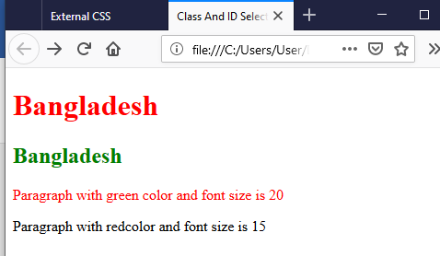

Example:

<!DOCTYPE html>

<html>

<head>

<title>Class And ID Selector</title>

<style type="text/css">

#Section1

{

background-color: green;

}

#Section1 h2

{

color: white;

}

#Section1 p

{

color: red;

font-size:190%;

}

</style>

</head>

<body>

<div id="Section1">

<h2>Heading 1</h2>

<p> Paragraph for division 1</p>

</div>

</body>

</html>

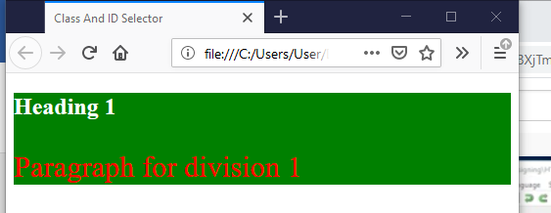

**Universal selector**

* ( * ) is used

**Decendent selector:**

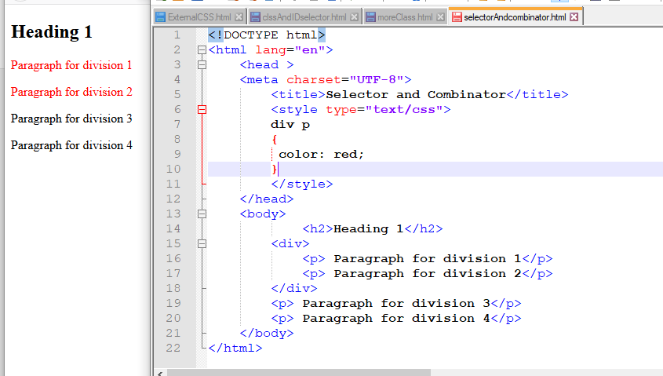

**Child Selector**

* ( > ) is used
* (+) is used for Adjacent sibling selectors , which select only immediate elements.
* (~) is used for general sibling selectors , which select only immediate elements.

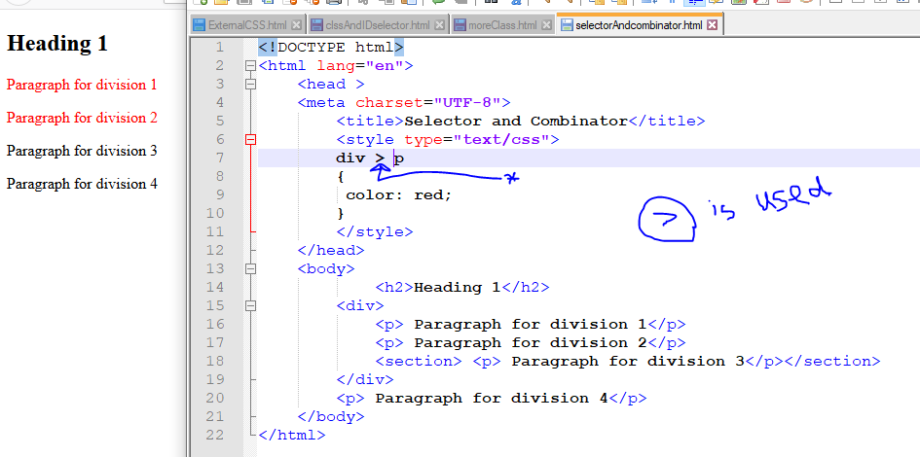

**Font**

* Create a font class
* Use font link from web site
* Use font family for that particular font

<!DOCTYPE html>

<html lang="en">

<head>

<meta charset="UTF-8">

<title>Font in CSS</title>

<link href="https://fonts.googleapis.com/css2?family=Itim&display=swap"

rel="stylesheet">

<style>

.my-style

{

font-size:150%;

**font-family: 'Itim', cursive;**

font-style:italic;

font-weight:bold;

}

</style>

</head>

<body>

<p class="my-style">This is a paragraph </p>

</body>

</html>

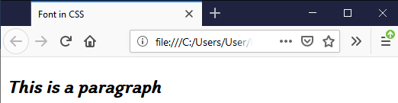

**Color**

* Create a class
* Hexadecimal color code can be used from color related web site but # sign must be there before color code

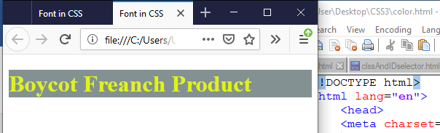

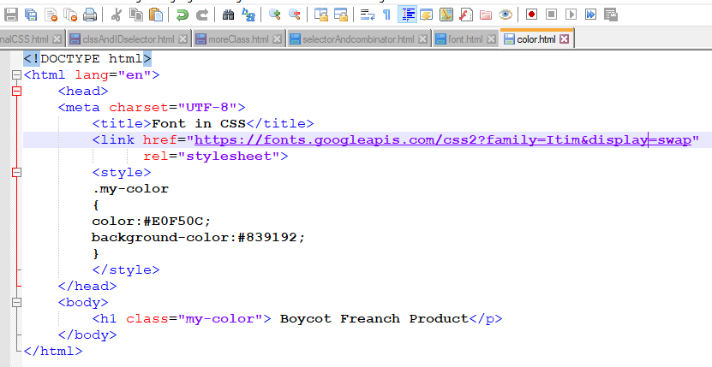

**Text Style**

* Align is used to format a text left, right or center
* Text decoration is used to decorate the text ..like underline, overline
* Text indent is used to create a space of first word
* Text transform is used to transform capital and small letter, upper-lower case can be used
* Text shadow is user to make the texts shadow

**Style Emoji**

* Go to the website: <https://unicode-table.com/en/>

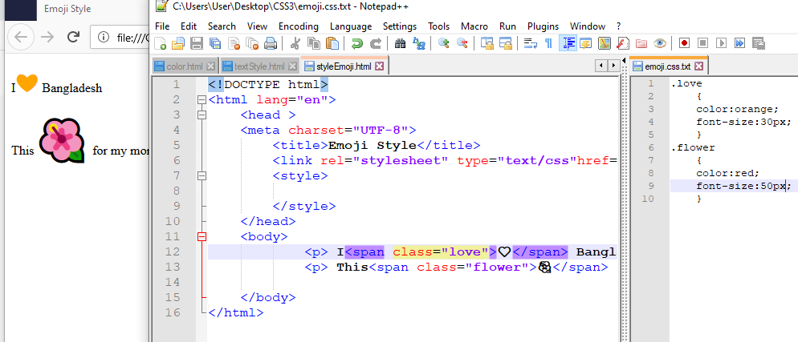

**Float**

ddf

**Margin:**

