**How to deploy Vue.js front end application (Mintari Web App).**

Prerequisites and system requirements:

Node JS version: v16.14.0.

NPM: v8.3.1

Nuxt: 2.15.8

Vue:2.6.14.

Please follow the below given step to deploy:

Step 1. Clone Repository.

Step 2. Go to the root folder. for ex: /mits2fe_aipl/.

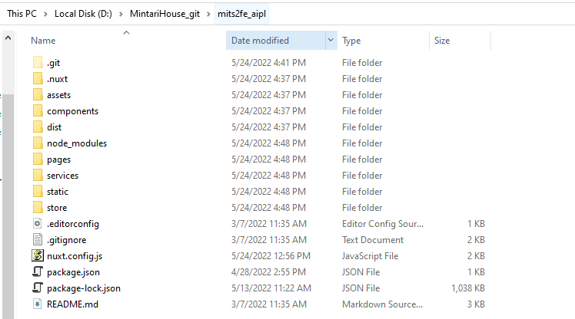

Step 3. Go to address bar of folder, type CMD and hit enter.

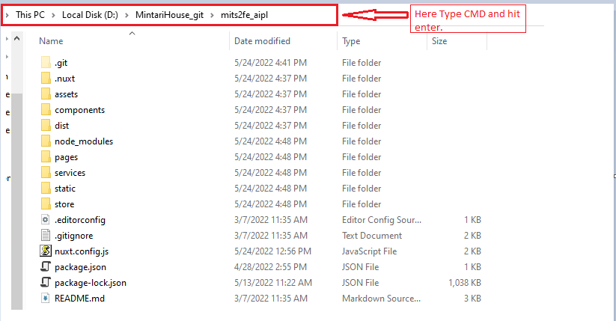

A new command prompt window will open as shown in the image below:

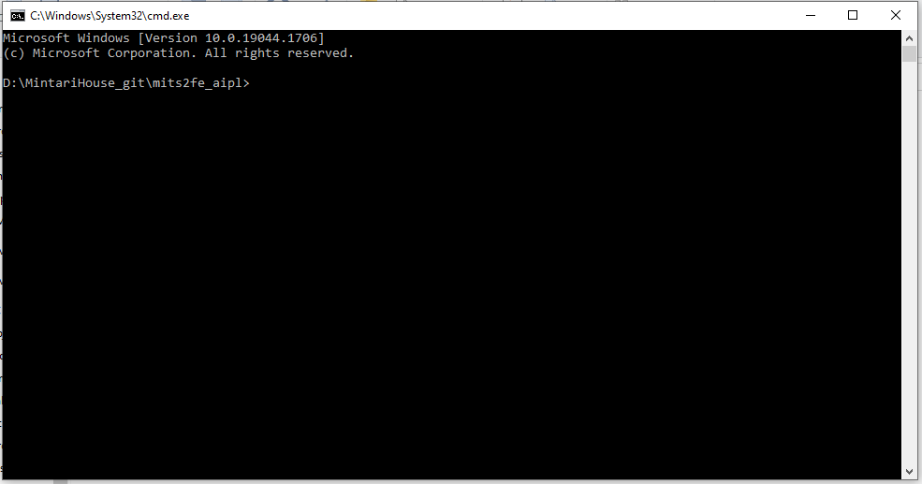

Step 4. Now type “npm i” or “npm install” in the command prompt to download all the necessary packages.

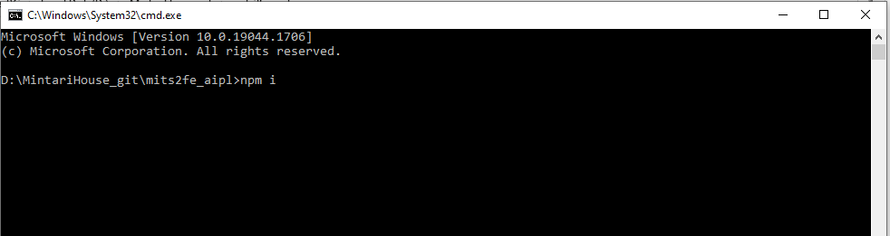

After the command processing has completed. Go to step 5.

Step 5. Please change the API base URL in the nuxt.config.js file under --> axios: {base URL: "http://122.176.47.222:85/mintari2/public/index.php/api/"} and save the file.

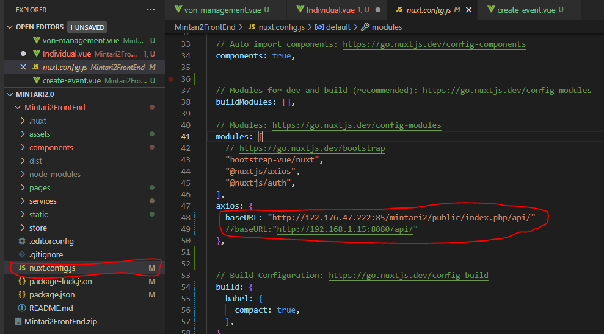

Step 6. Now go to the command prompt and type “npm run generate” to generate a deployment file.

Step 7. Once the command processing is finished, go to “dist” folder under your root project as shown in the image below:

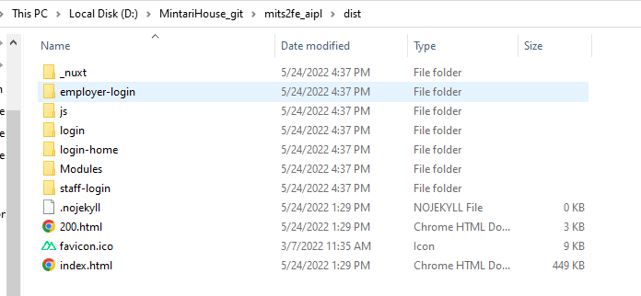

Step 8. Now Copy all the generated folders and files into your website root folder.