Task 1

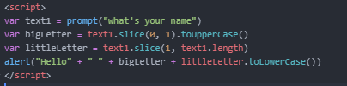

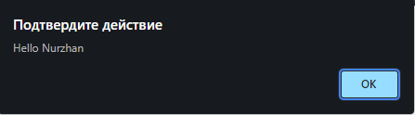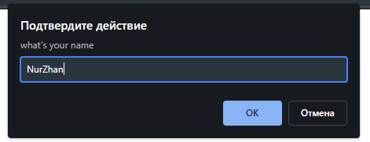

Task 2

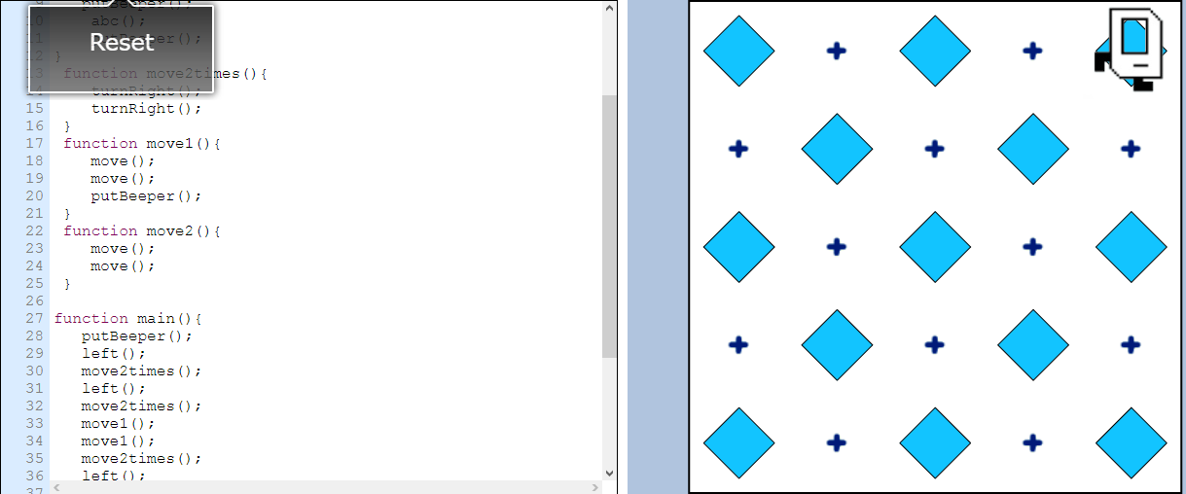

Code :

function abc(){

move();

turnLeft();

move();

}

function left(){

abc();

putBeeper();

abc();

putBeeper();

}

function move2times(){

turnRight();

turnRight();

}

function move1(){

move();

move();

putBeeper();

}

function move2(){

move();

move();

}

function main(){

putBeeper();

left();

move2times();

left();

move2times();

move1();

move1();

move2times();

left();

move2times();

left();

move2times();

move1();

turnRight();

move1();

move2();

turnRight();

move2();

}

Task 3

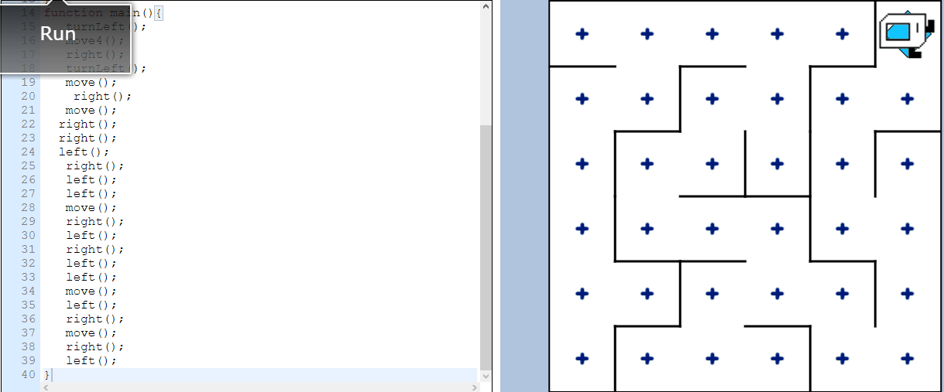  
function move4() {

repeat(4){

move();

}

}

function right(){

turnRight();

move();

}

function left(){

turnLeft();

move();

}

function main(){

turnLeft();

move4();

right();

turnLeft();

move();

right();

move();

right();

right();

left();

right();

left();

left();

move();

right();

left();

right();

left();

left();

move();

left();

right();

move();

right();

left();

}

Task 4

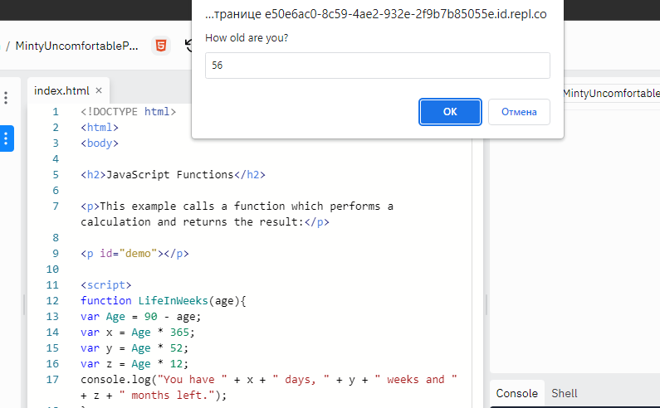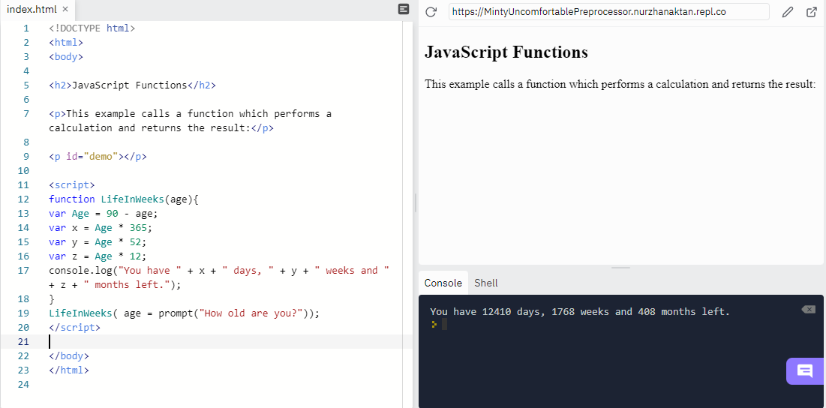

Code:

<!DOCTYPE html>

<html>

<body>

<h2>JavaScript Functions</h2>

<p>This example calls a function which performs a calculation and returns the result:</p>

<p id="demo"></p>

<script>

function LifeInWeeks(age){

var Age = 90 - age;

var x = Age \* 365;

var y = Age \* 52;

var z = Age \* 12;

console.log("You have " + x + " days, " + y + " weeks and " + z + " months left.");

}

LifeInWeeks( age = prompt("How old are you?"));

</script>

</body>

</html>

Task 6

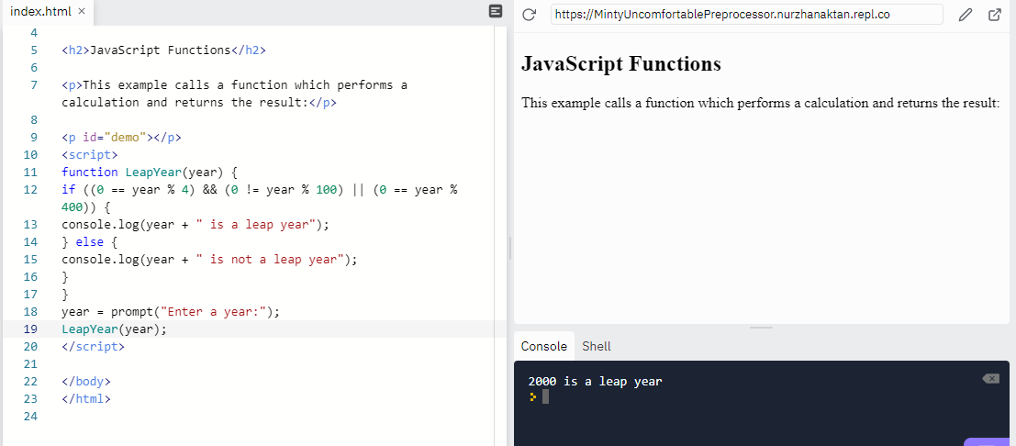

Code:

<!DOCTYPE html>

<html>

<body>

<h2>JavaScript Functions</h2>

<p>This example calls a function which performs a calculation and returns the result:</p>

<p id="demo"></p>

<script>

function LeapYear(year) {

if ((0 == year % 4) && (0 != year % 100) || (0 == year % 400)) {

console.log(year + " is a leap year");

} else {

console.log(year + " is not a leap year");

}

}

year = prompt("Enter a year:");

LeapYear(year);

</script>

</body>

</html>

Task 7

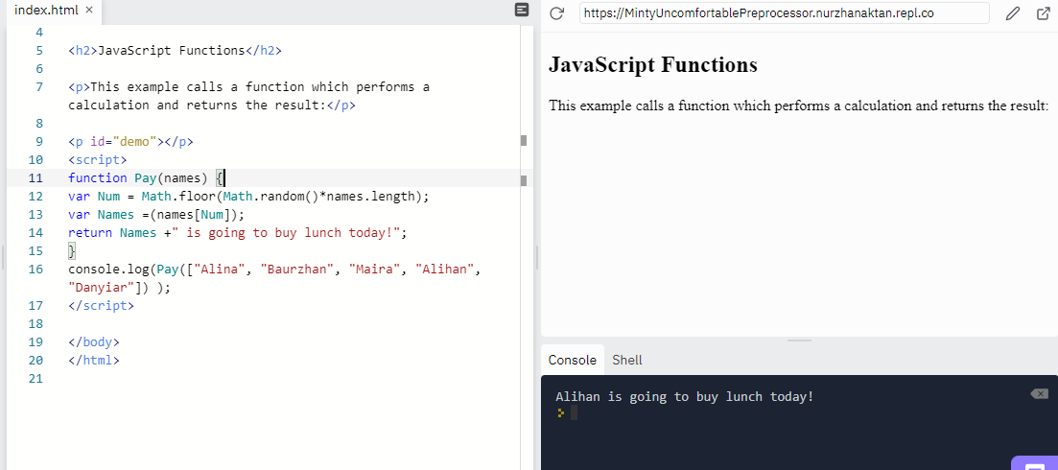

Code:

<!DOCTYPE html>

<html>

<body>

<h2>JavaScript Functions</h2>

<p>This example calls a function which performs a calculation and returns the result:</p>

<p id="demo"></p>

<script>

function Pay(names) {

var Num = Math.floor(Math.random()\*names.length);

var Names =(names[Num]);

return Names +" is going to buy lunch today!";

}

console.log(Pay(["Alina", "Baurzhan", "Maira", "Alihan", "Danyiar"]) );

</script>

</body>

</html>

Task 8

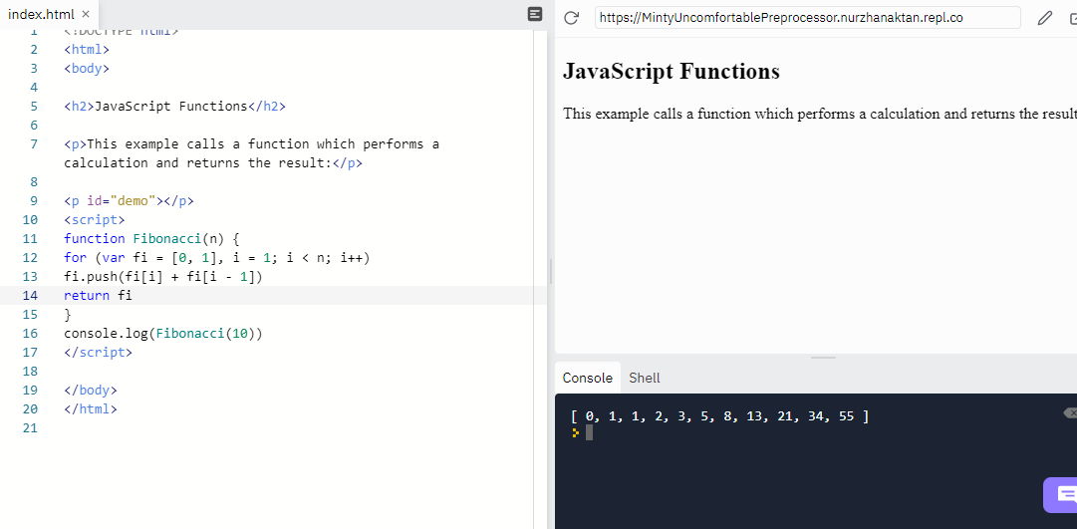

Code: <!DOCTYPE html>

<html>

<body>

<h2>JavaScript Functions</h2>

<p>This example calls a function which performs a calculation and returns the result:</p>

<p id="demo"></p>

<script>

function Fibonacci(n) {

for (var fi = [0, 1], i = 1; i < n; i++)

fi.push(fi[i] + fi[i - 1])

return fi

}

console.log(Fibonacci(10))

</script>

</body>

</html>