🖥️ SCREEN 1 — HERO

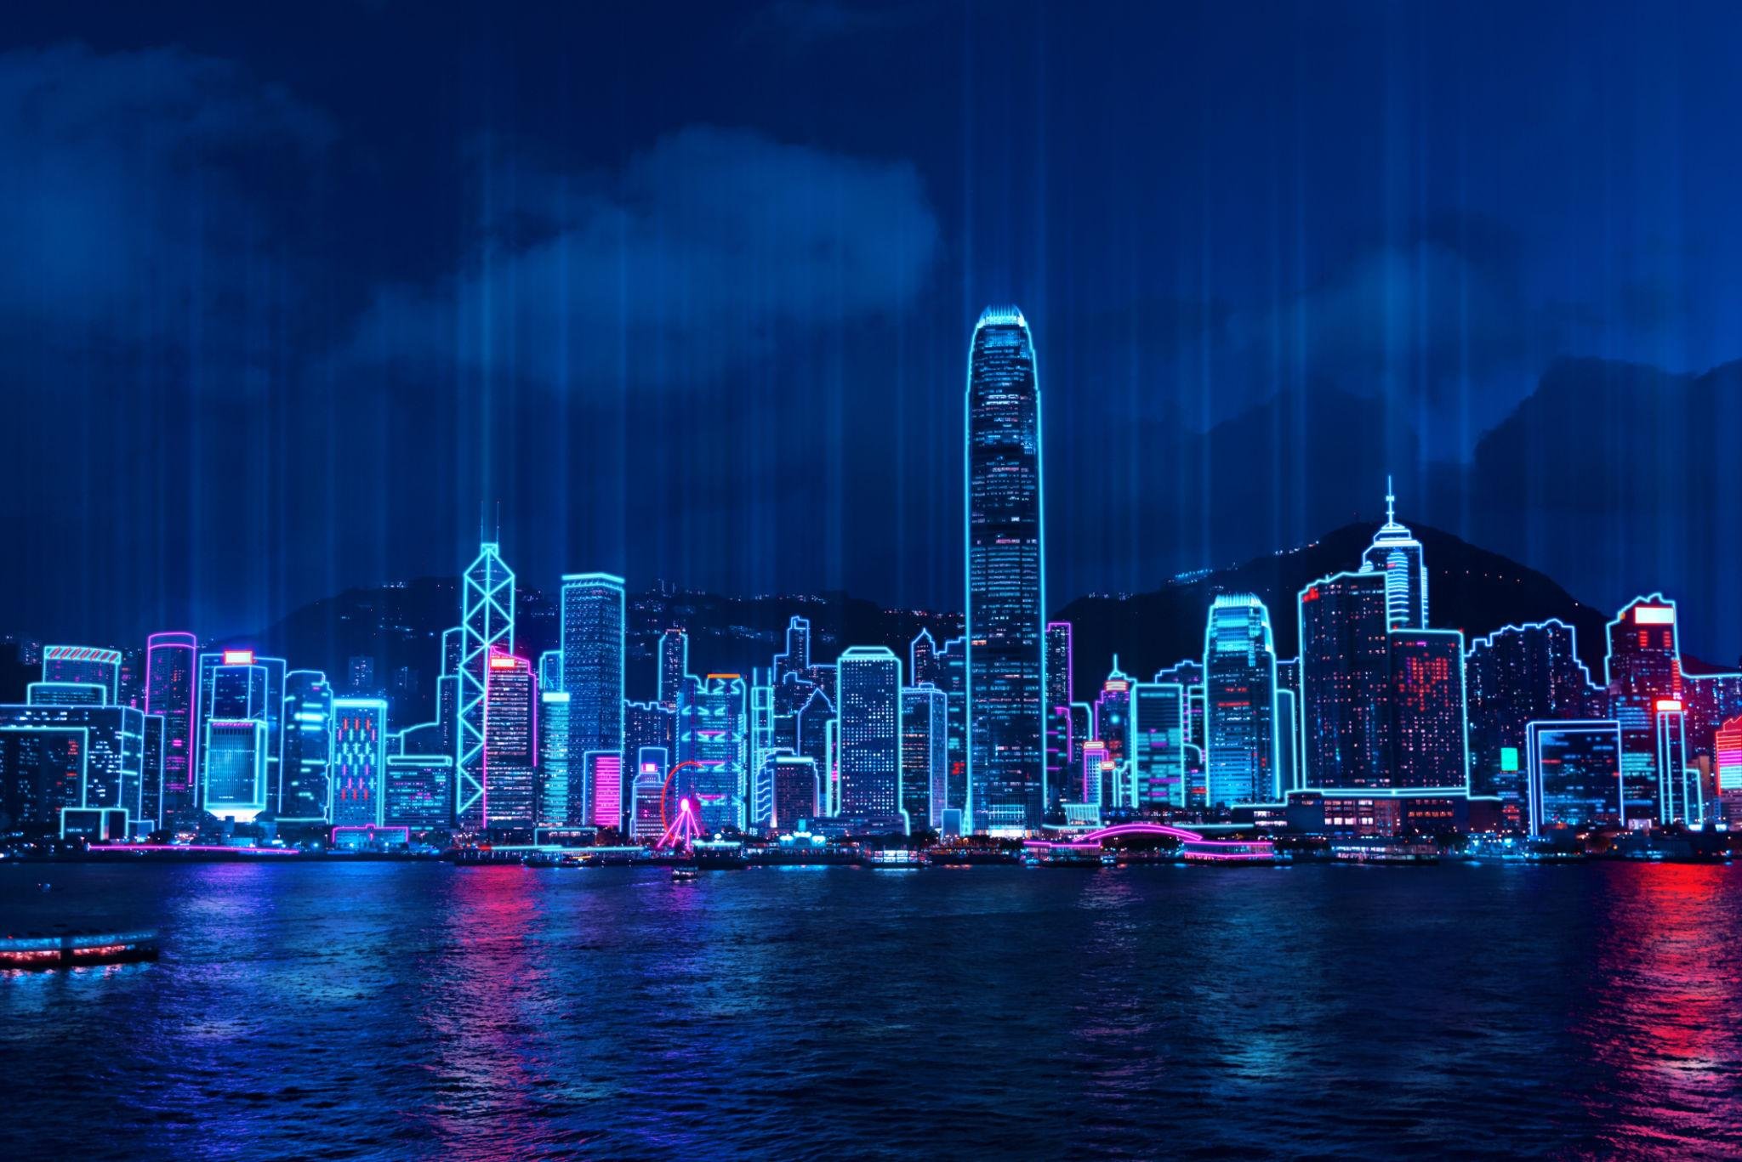
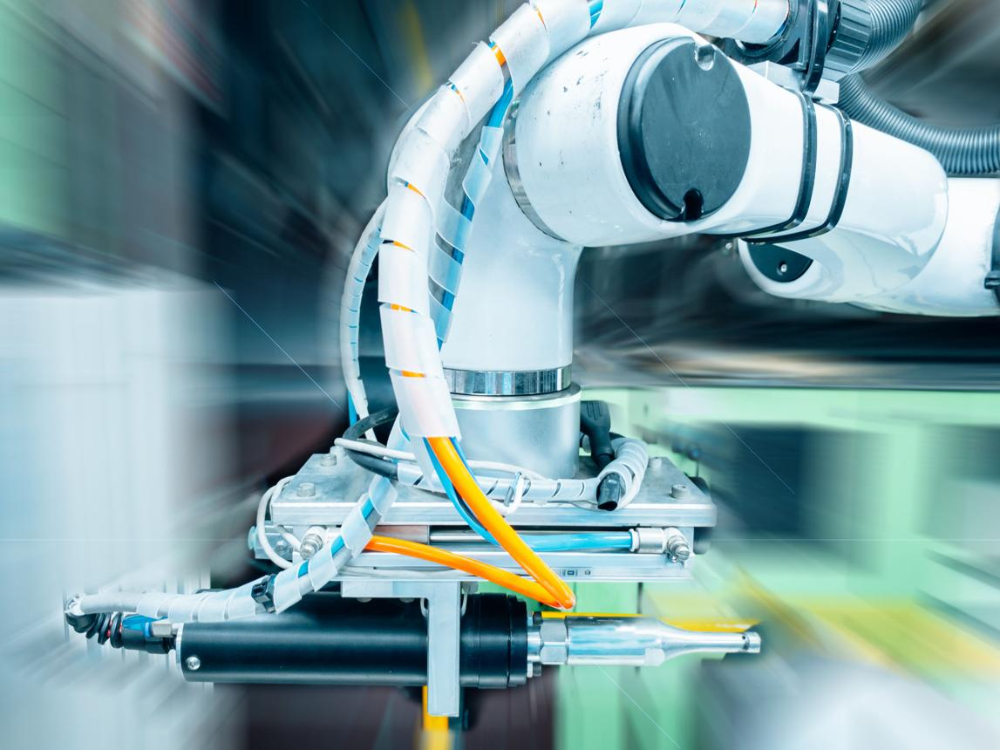
6

TEXT
Global Multi-Brand Industrial Supply

Subheading
Based in Hong Kong • Worldwide Sourcing & Distribution

Description
We supply original and replacement industrial equipment and spare parts from leading global brands.

✔ 1000+ Brands
✔ Global Sourcing Network
✔ Fast Response
✔ Competitive Pricing

Buttons:
Request Quote
Send Inquiry

🖥️ SCREEN 2 — QUICK RFQ


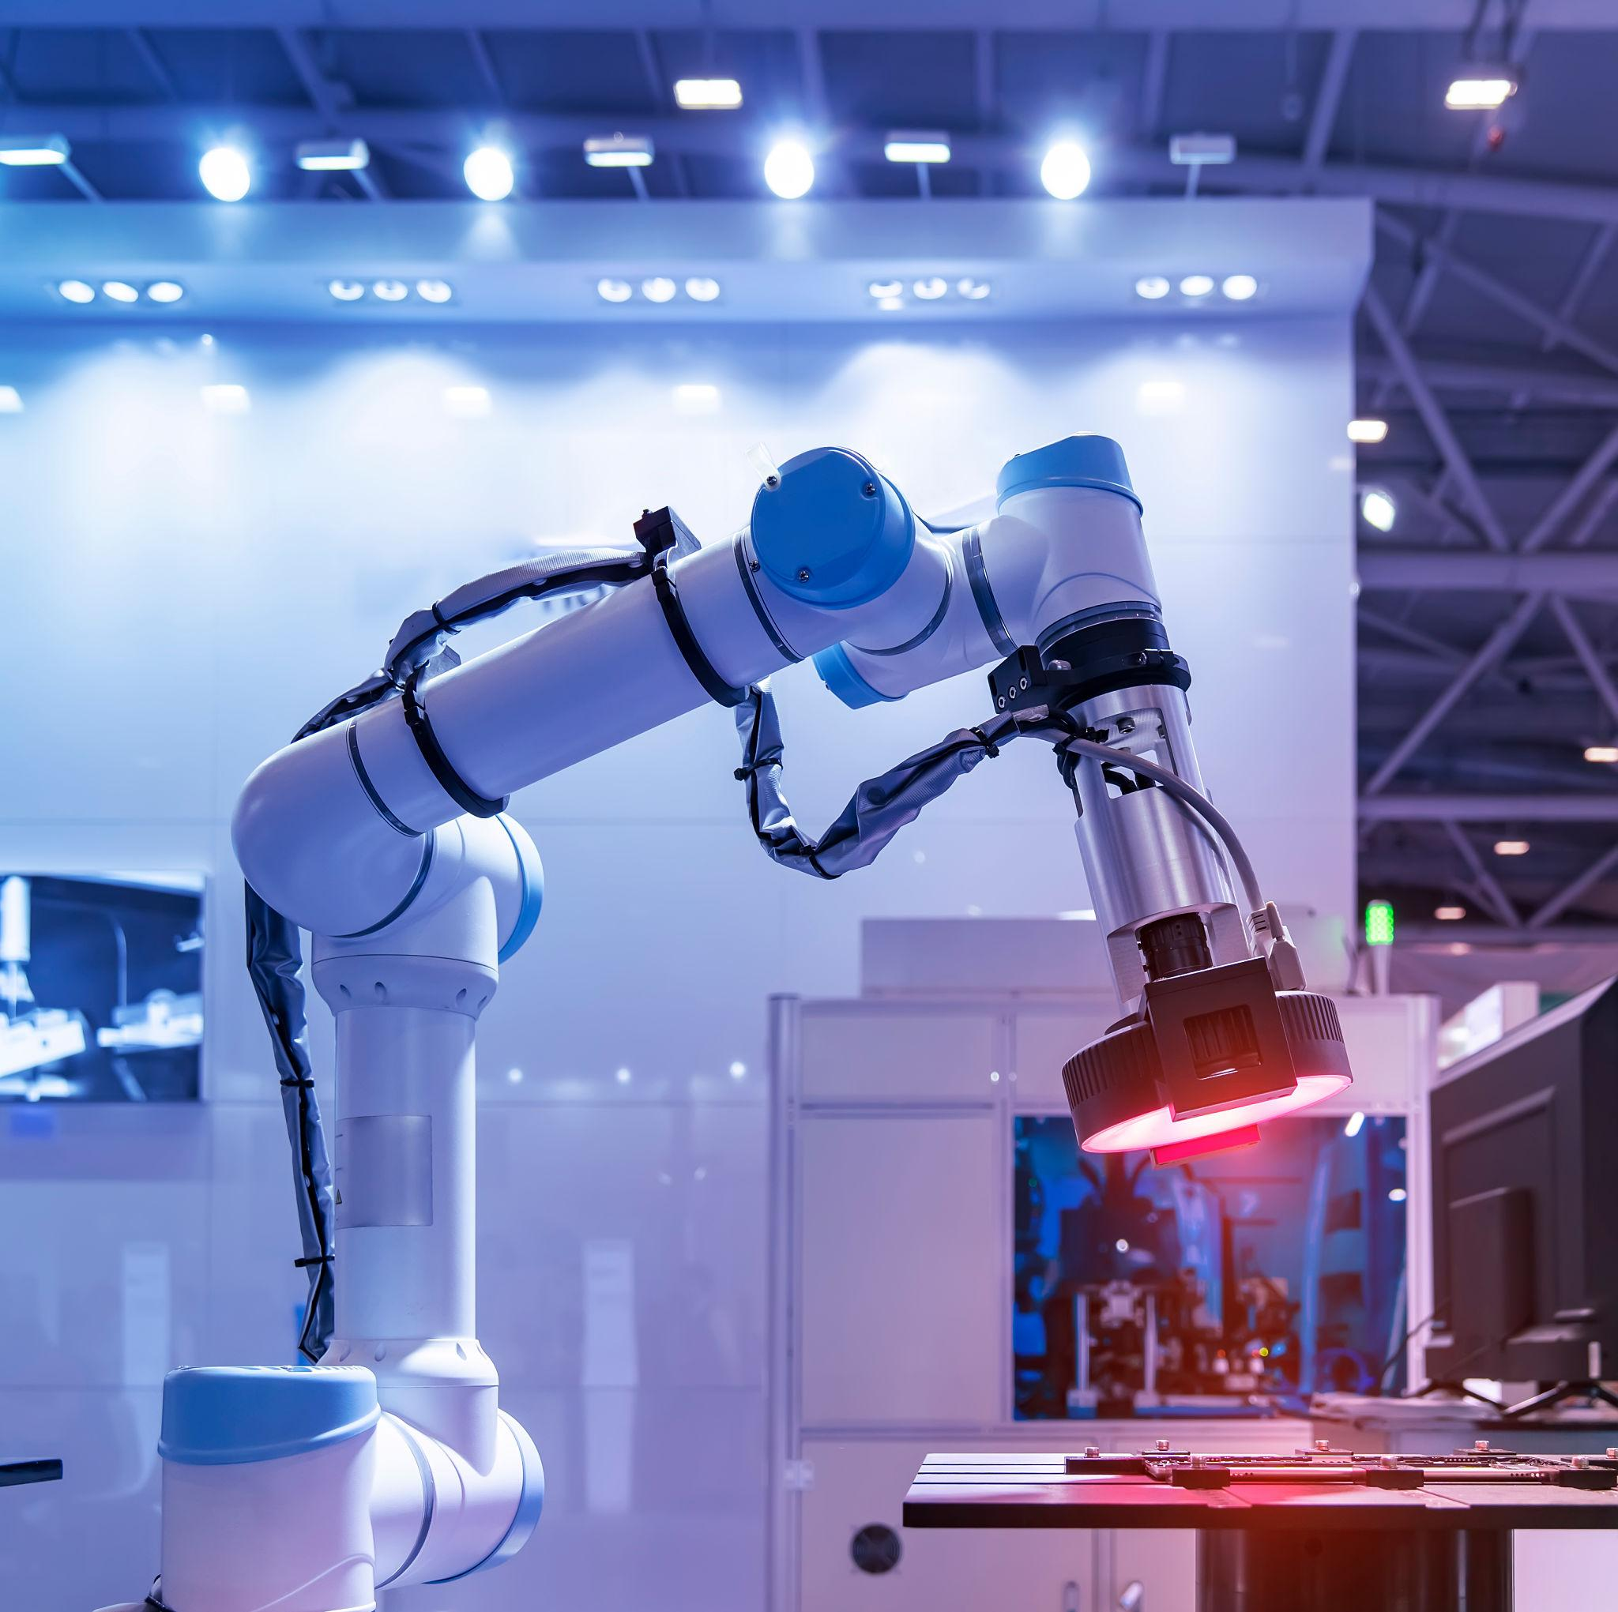

TEXT
Quick Inquiry
Send your part number and get a fast quotation.

Fields
- Part Number
- Brand
- Model
- Quantity
- Country
- Email
- Upload File
Button:
Get Quote

🖥️ SCREEN 3 — BRANDS (КЛЮЧЕВОЙ БЛОК)




TEXT
Brands We Supply
Siemens • ABB • Schneider • Mitsubishi • Omron • Fanuc • Allen-Bradley • Yaskawa • Delta • Honeywell • Bosch • Panasonic
(+ “and many more”)

👉 это самый важный блок для Китая

🖥️ SCREEN 4 — PRODUCT CATEGORIES

6

TEXT
Product Categories
- PLC & Controllers
- Servo Motors & Drives
- Sensors & Switches
- HMI & Panels
- Power Supplies
- Industrial Robots
- CNC Components
- Automation Spare Parts

Отдельный файл

🖥️ SCREEN 5 — APPLICATIONS

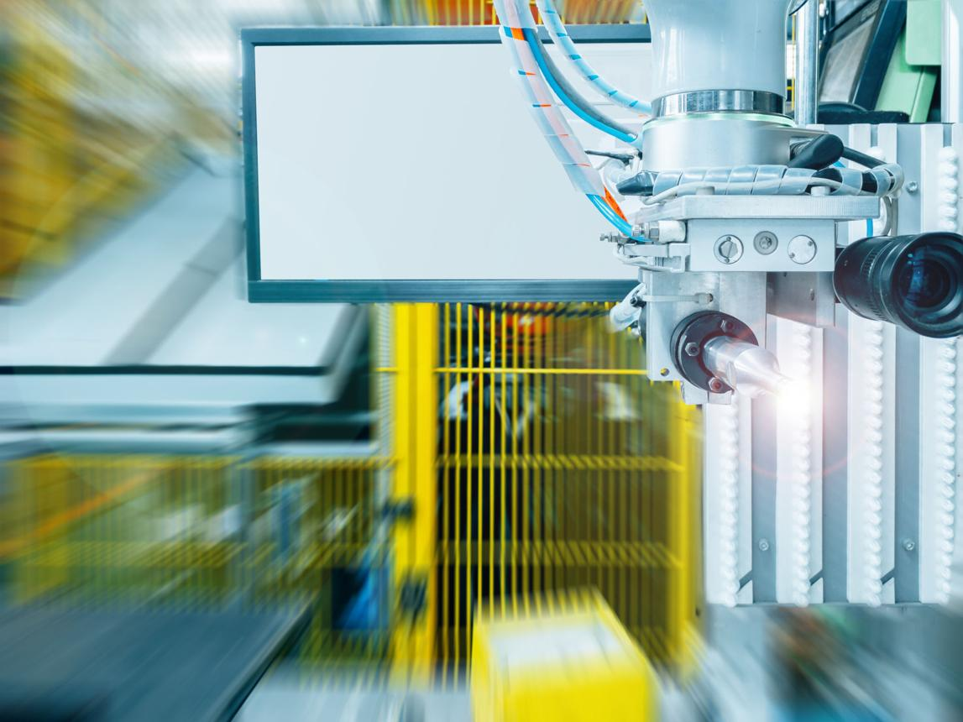
7

TEXT
Industries We Serve
- Manufacturing
- Automation
- Electronics
- Energy
- Oil & Gas
- Mining
- Marine
- Infrastructure

Отдельный файл

🖥️ SCREEN 6 — HOW IT WORKS

TEXT
How It Works
- Send your request
- We source globally
- We provide quotation
- Fast delivery worldwide

✔ Original Parts
✔ Replacement Options
✔ Competitive Prices


🖥️ SCREEN 7 — GLOBAL SUPPLY


8

TEXT
Global Supply Network
We deliver worldwide:
- Asia
- Europe
- Middle East
- Africa
- North America

✔ Air Freight
✔ Sea Freight
✔ Express Delivery

🖥️ SCREEN 8 — FINAL CTA
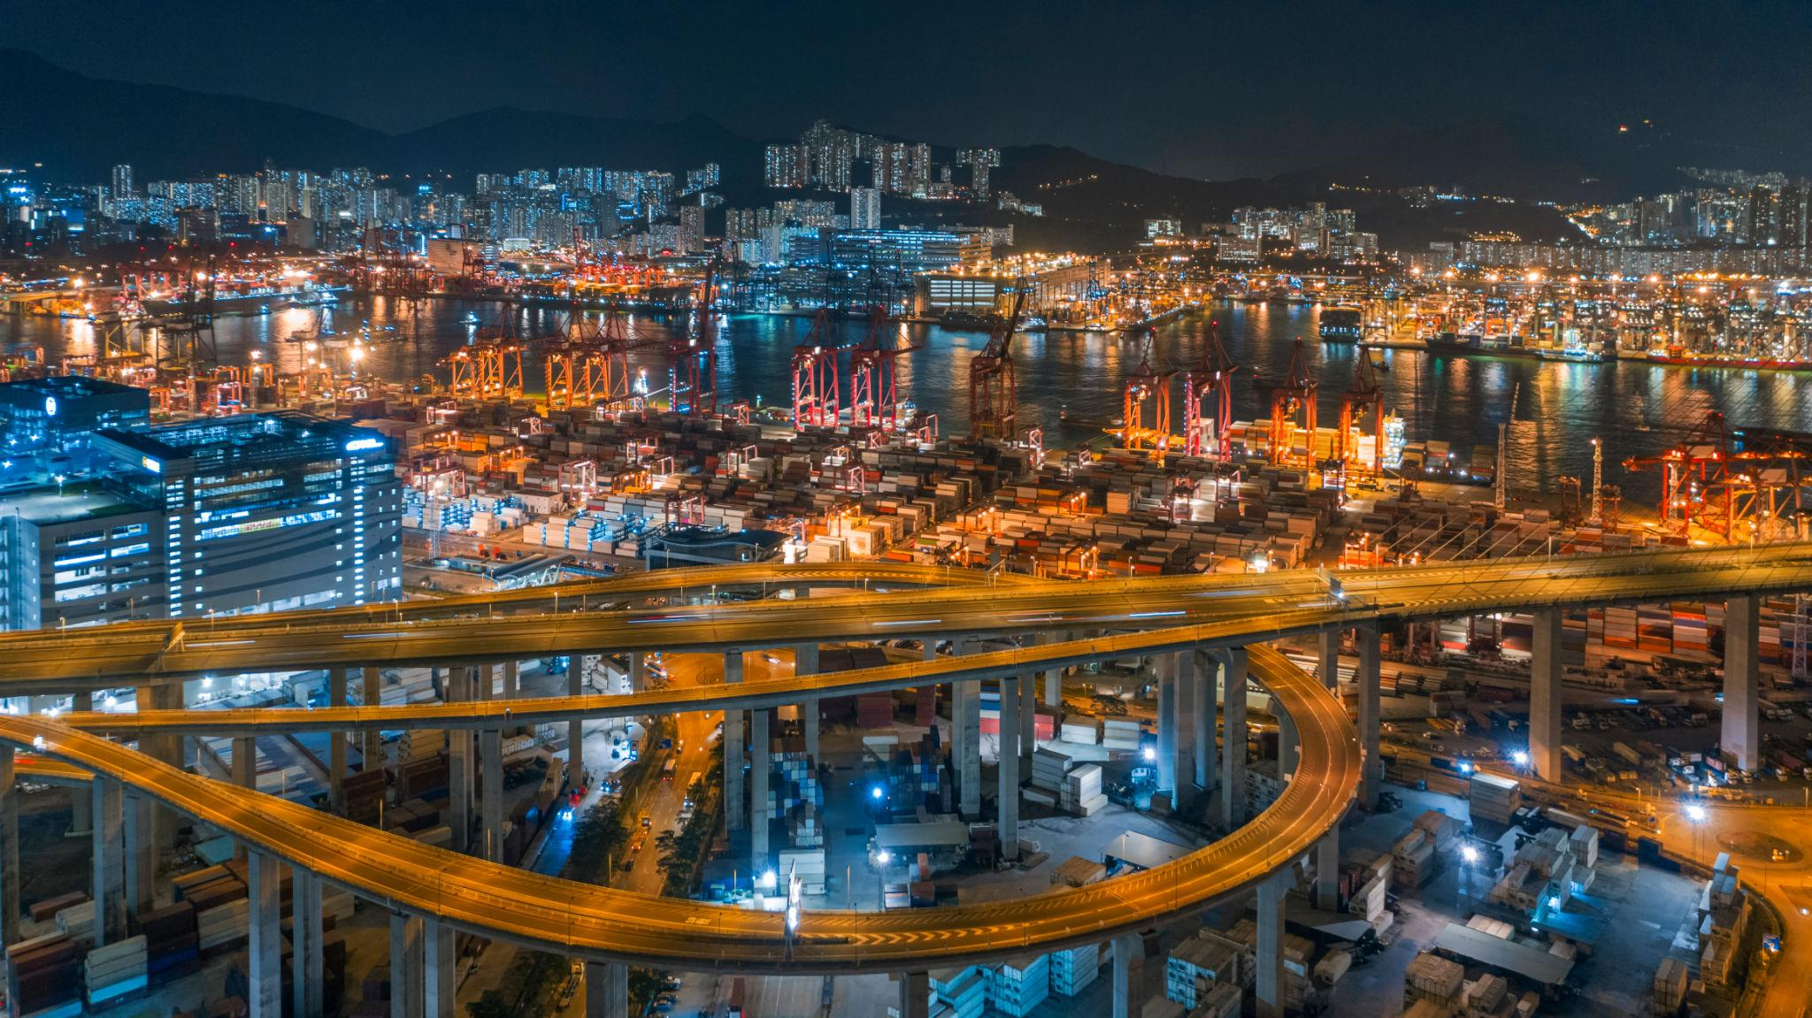

6

TEXT
Looking for Industrial Parts?
Send your request and get a fast quotation from our team.

Buttons:
Request Quote
Contact Us

🎨 ВИЗУАЛЬНЫЙ СТИЛЬ (КИТАЙ / HK)

Цвета
- белый
- синий
- красный (акцент)

Стиль
- tech
- clean
- немного “перегруженный”, но структурный

