**SPL-1 Project Report, 2022**

**BlockChainED**

**SE: 305**

Submitted by

***Nusrat Jahan Lia***

**BSSE Roll No. : 1306**

**BSSE Session: 2020-2021**

Supervised by

***Dr.Ahmedul Kabir***

**Designation: Associate Professor**

**Institute of Information Technology**



**Institute of Information Technology**

**University of Dhaka**

[21-05-2023]

Table of Contents

1. Introduction 3

1.1. Background Study 3

1.2. Challenges 3

2. Project Overview 3

3. User Manual 3

4. Conclusion 3

5. Appendix 3

References 3

# Introduction

BlockChainEd is an educational project that empowers users to create and explore their own

blockchain networks. With an intuitive app, users can easily generate wallets, conduct transactions,

assign miners, and examine decentralized information. The application validates transactions,

executes proof of work, and seamlessly integrates verified blocks into the blockchain. Additionally,

BlockChainEd offers a unique feature that allows users to simulate attacks on their blockchain,

enabling them to modify information within a valid block. However, the app promptly safeguards

against such attacks by recalculating hashes and breaking the chain from the corrupted block.

BlockChainEd serves as an interactive platform that not only educates users about blockchain

technology but also allows them to experience its practical implementation.

## Background Study

To implement the "BlockChainEd" project, I had to gather the following study and background

knowledge:

1. Blockchain Technology: Understanding the fundamental concepts and principles of

blockchain technology, including decentralized consensus mechanisms, distributed ledger

systems, blocks, and transactions.

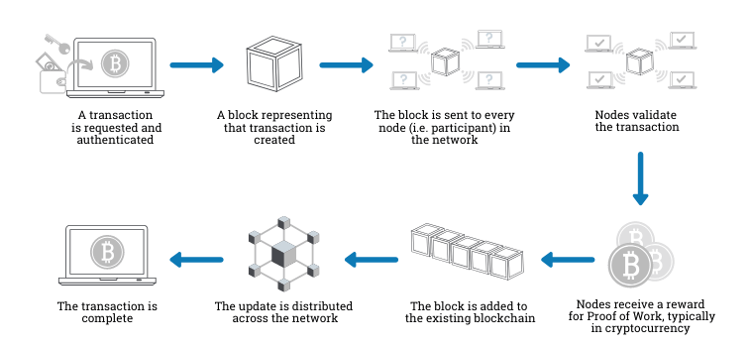

## 2. Cryptography: Knowledge of cryptographic techniques used in blockchain systems, such as public key cryptography, elliptic curve cryptography (ECC), and digital signatures. Understanding the concepts of private keys, public keys, and how they are used to secure transactions and wallets.

## 

Point addition in Elliptic Curve Cryptography

3. Wallet Creation: Learning about the process of generating public-private key pairs for wallet

addresses, creating wallets, and managing key pairs securely. Understanding how wallet

addresses are used to send and receive transactions.

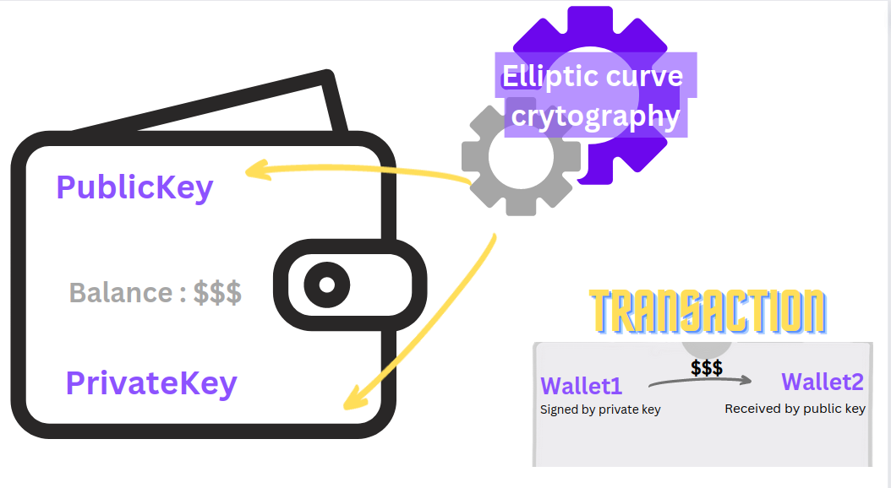

Wallets with ECC generated Keys

4. Transactions and Mining: Understanding how transactions are created, signed, and propagated in a blockchain network. Studying the process of appointing miners to validate transactions, perform proof-of-work (PoW) calculations, and add verified blocks to the blockchain.

5. Consensus Mechanisms: Researching different consensus mechanisms used in blockchain

networks, such as PoW or proof-of-stake (PoS). Understanding how consensus algorithms

ensure the agreement and security of the blockchain.

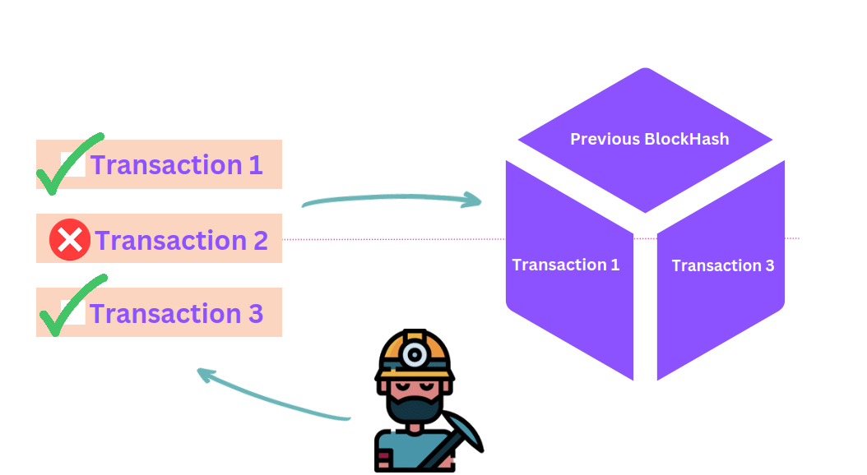

6. SHA-256 Hashing Algorithm: Learning about the SHA-256 algorithm used for hashing in

blockchain systems. Understanding how it ensures the integrity and security of transactions

and blocks.

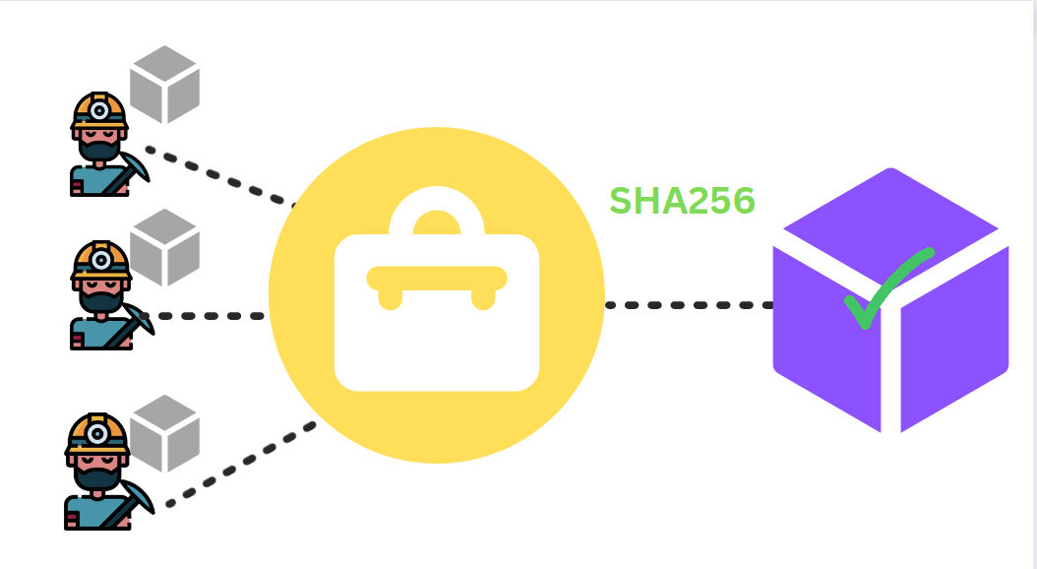

Miners going through proof-of-work algorithm to find valid hash of block

7. Blockchain Attacks: Researching various types of attacks that can occur in a blockchain network, such as double-spending attacks. Understanding the vulnerabilities and countermeasures to prevent such attacks.

8. Information Inspection: Exploring methods to inspect and retrieve information stored in a

decentralized environment. Understanding how to access and verify transaction details, block contents, and other relevant data.

By gathering the above study and background knowledge, one would have the necessary foundation

to implement the "BlockChainEd" project successfully.

## Challenges

Implementing the "BlockChainEd" project comes with several challenges:

1. Complexity: Blockchain technology involves intricate concepts like consensus algorithms,

cryptographic techniques, and decentralized data structures. Understanding and implementing

these concepts correctly can be challenging, especially for developers who are new to blockchain.

2. Security: Security is a crucial aspect of blockchain systems. Ensuring the secure generation

and storage of private keys, implementing robust authentication and encryption mechanisms,

and protecting against potential attacks require careful attention and expertise.

3. Performance and Scalability: As the blockchain grows in size and the number of transactions

increases, maintaining optimal performance and scalability becomes challenging. Efficient

transaction processing, block validation, and network scalability need to be considered during

the development process.

4. Consensus Mechanisms: Implementing a consensus mechanism, such as proof-of-work

(PoW) or proof-of-stake (PoS), involves addressing challenges related to block validation,miner selection, and network coordination. Each consensus algorithm has its own complexities that need to be understood and implemented correctly.

5. Blockchain Attacks: Anticipating and preventing various attacks, such as 51% attacks,

double-spending attacks, or Sybil attacks, requires a deep understanding of the vulnerabilities

and countermeasures specific to blockchain systems. Implementing robust security measures

to protect the integrity of the blockchain is crucial.

6. User Experience: Designing a user-friendly interface that allows users to create wallets,

make transactions, and inspect blockchain information intuitively can be a challenge. Balancing simplicity with the complex underlying technology is essential to ensure a positive user experience.

7. Testing and Debugging: Blockchain applications require thorough testing to identify and fix

potential bugs or vulnerabilities. Ensuring the reliability and stability of the application,

particularly in a decentralized environment, can be challenging and time-consuming.

8. Integration and Interoperability: Integrating the blockchain application with other systems or

platforms, such as cryptocurrency wallets or third-party services, may present challenges.

Ensuring compatibility and seamless interaction between different components can be

complex.

Overcoming these challenges requires a combination of deep technical knowledge, careful

planning, and continuous testing and improvement. It is important to stay updated with the latest

advancements and best practices in blockchain development to address these challenges effectively.

## Project Overview

BlockChainEd is an innovative project that I have been working on, aimed at empowering users to

create their own blockchain networks. With BlockChainEd, users have the ability to create wallets,

make transactions, and even appoint miners within their personalized blockchain environment. The

application incorporates various essential features such as transaction verification, proof of work,

and the seamless addition of verified blocks to the blockchain.

One of the key functionalities of BlockChainEd is the ability for users to inspect and explore the

information within their decentralized environment. This provides users with a comprehensive

understanding of the blockchain's inner workings and enhances their overall control over the

system.

To ensure the utmost security and privacy, BlockChainEd leverages public-key cryptography, with

a specific focus on Elliptic Curve Cryptography (ECC). This cryptographic technique enables

secure key generation, encryption, and digital signature operations, ensuring the integrity and

confidentiality of the user's transactions.

Furthermore, BlockChainEd implements the widely adopted SHA256 hashing algorithm. This

algorithm plays a vital role in verifying the integrity of the data stored within the blockchain bygenerating a unique hash for each block. This ensures that any modifications to the information

contained within a block will be immediately detected, safeguarding the integrity of the blockchain.

An intriguing feature of BlockChainEd is the ability for users to test the resilience of their own

blockchain by simulating an attack scenario. Users can attempt to change the information within a

valid block, but BlockChainEd actively defends against such attacks. The application achieves this

by recalculating the hash and subsequently breaking the chain from the corrupted block, ensuring

the security and immutability of the blockchain.

In summary, BlockChainEd is an ambitious project that allows users to create, manage, and explore

their own blockchain networks. By incorporating public-key cryptography using ECC and

implementing the SHA256 hashing algorithm, BlockChainEd offers a secure and robust

environment for users to engage in transactions while maintaining the integrity and privacy of their

data.

# User Manual

This user manual provides step-by-step instructions on how to obtain the BlockChainEd application

from GitHub and run the RunBlockChainEd.cpp file. Please follow the guidelines below:

Prerequisites:

1. C++ Compiler: Ensure that you have a C++ compiler installed on your system, such as GCC

or Clang.

2. Code Editor/IDE: Have a code editor or integrated development environment (IDE) installed

to open and edit the RunBlockChainEd.cpp file.

Instructions:

1. Visit the BlockChainEd repository on GitHub at

https://github.com/NusRAT-LiA/Blockchain_in_Cpp-SPL-1 .

2.On the GitHub repository page, click on the "Code" button and select the option to clone the

repository. Copy the provided repository URL.

3. Open the Terminal/Command Prompt: Launch your system's terminal or command prompt

to execute commands.

4.In the terminal or command prompt, navigate to the desired directory where you want to

clone the BlockChainEd repository. Use the following command to clone the repository:

git clone https://github.com/NusRAT-LiA/Blockchain_in_Cpp-SPL-1

5.Compile the RunBlockChainEd.cpp file using the C++ compiler. Open your terminal or

command prompt and navigate to the UserInterface directory where the

RunBlockChainEd.cpp file is located. Then, run the following command:

g++ RunBlockChainEd.cpp -o BlockChainEd

6.Select From the Options :

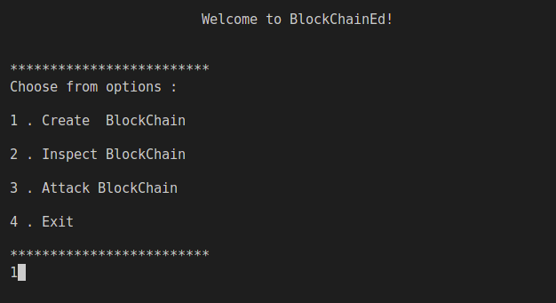

Selected 1 for creating a blockchain

7.Enter your desired name for the blockchain and add mining difficulty

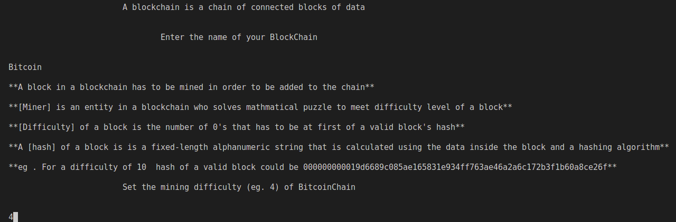

Chosen name for the chain is “Bitcoin” , mining difficulty is “4”

8.A blockchain is innitiated and genesis block is created .

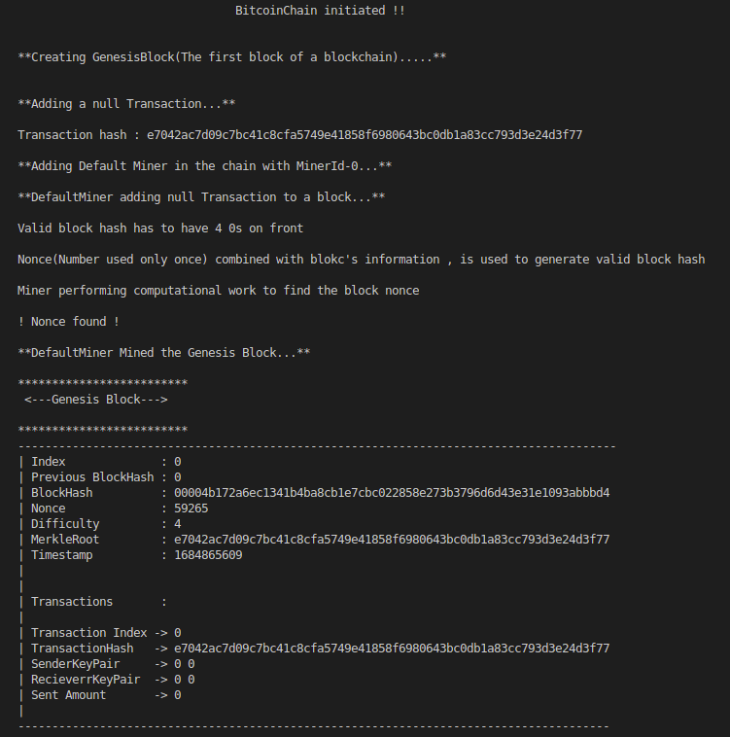

Step by step process of creating genesis block

9.Create some wallets , wallet’s key’s will be generated through Elliptic-Curve-Cryptgraphic functionalities

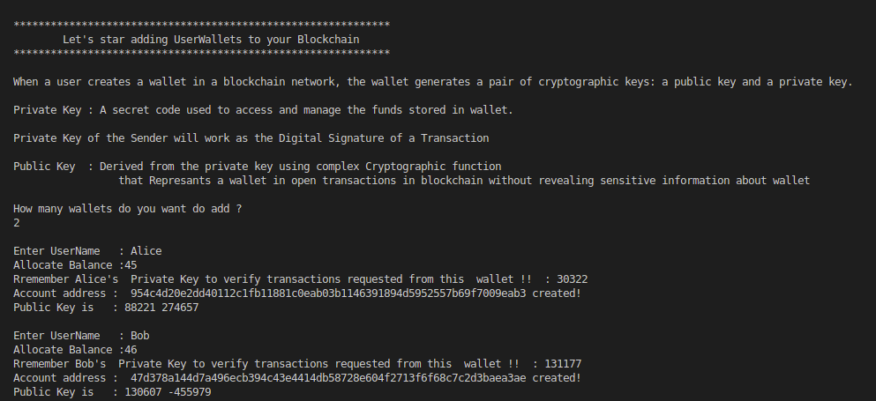

Two wallets created with the names of “Alice” and “Bob” with respective 45 and 46 balance allocated

10.Create transactions using wallet’s keys

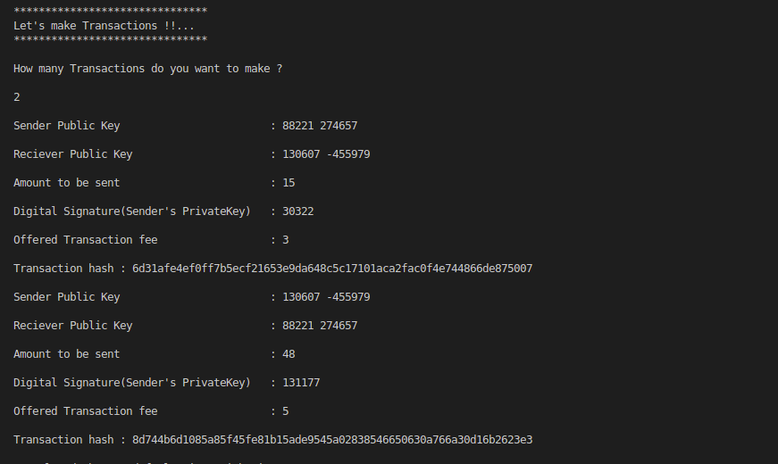 First transaction is from “Alice” to “Bob” ; Second transaction is from “Bob” to “Alice”

11.If you want , add more miners along with default miner

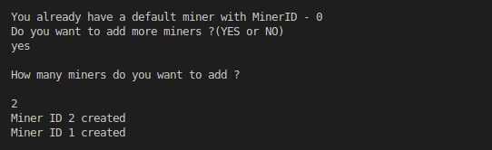

Two miners created

12.Appoint miner to mine Blocks , miner will remove unverified transactions

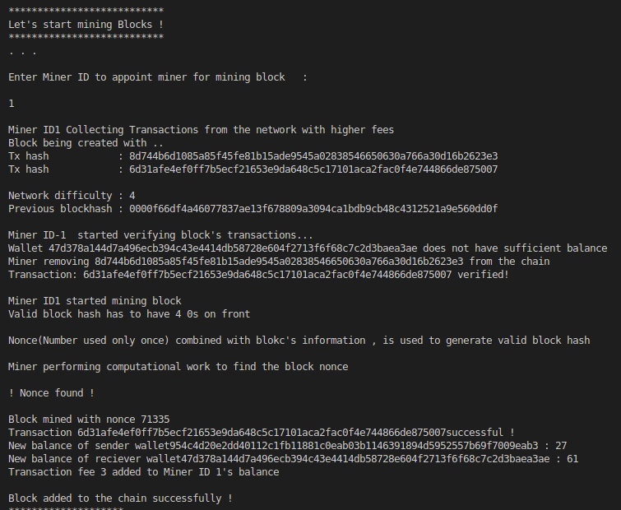

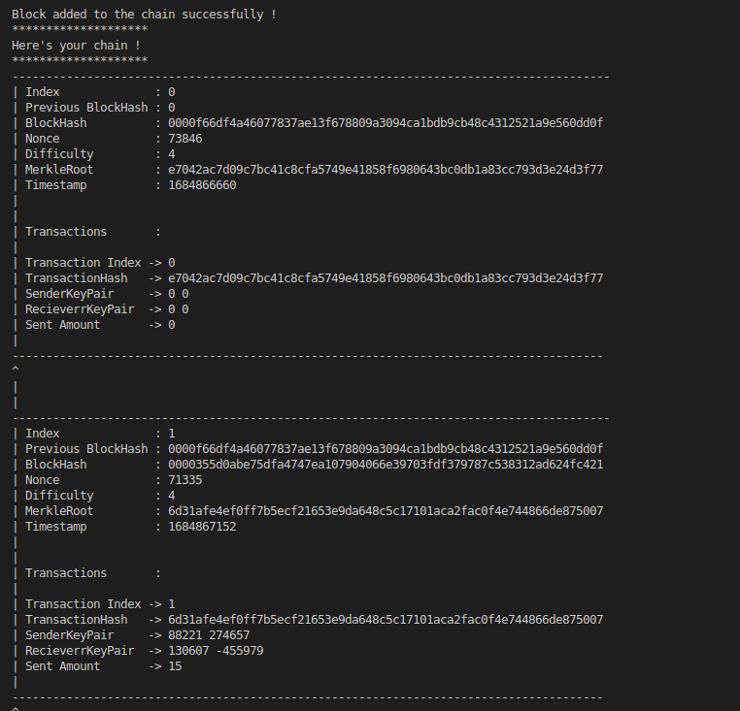

Mined block with verified transaction added to your blockchain

13.Either keep creating wallets ,transactions , blocks or move on to next options(inspection / attacking)

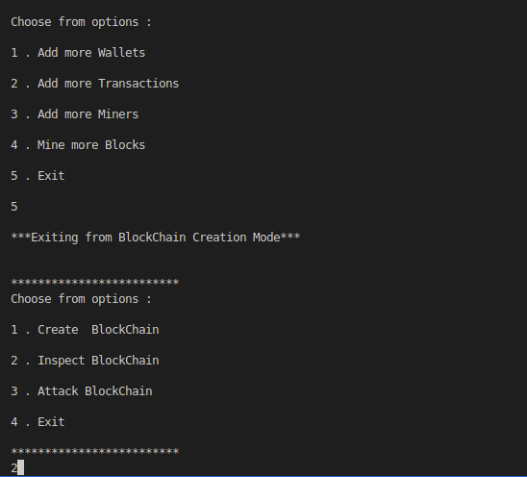

14 . Inspect elements of your blockchain

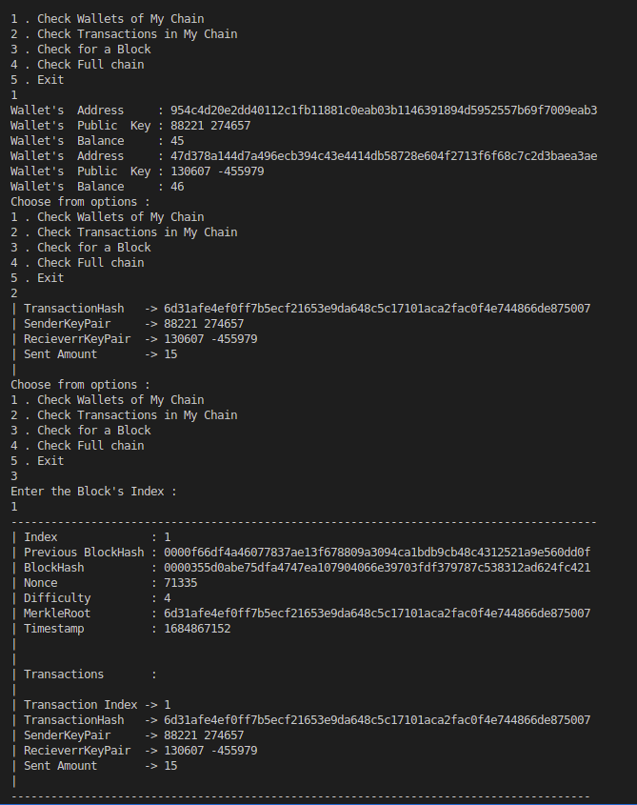 Wallets , Transactions and blocks the explored

15 . Generate an attack by changing transaction information

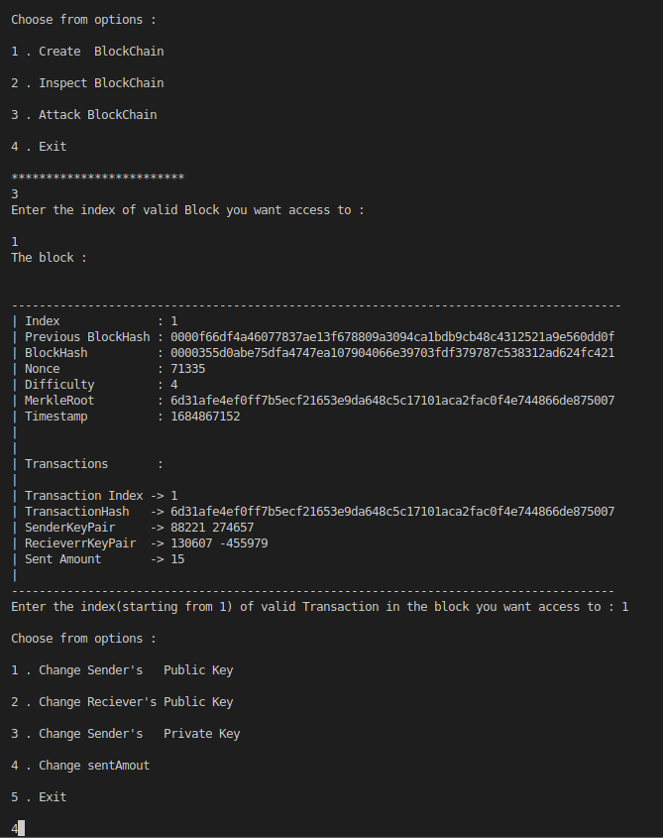 Access to Block no.1’s transaction no. 1 provided, because blockchain is a decentralized ledger

16 . Attack will be prevented and corrupted block will be removed

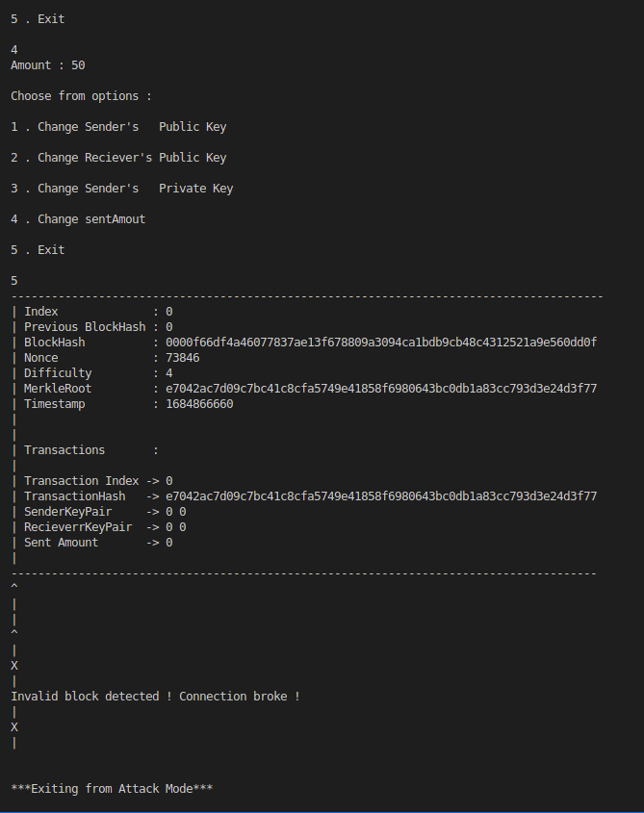 An attempt to make sent amount 50 instead of 15 is made , but change in verified data detected and prevented

Continue to explore !

# Conclusion

In conclusion, the "BlockChainEd" project is a complex and challenging endeavor that requires a

comprehensive understanding of blockchain technology, cryptography, consensus mechanisms, and

security measures. The implementation of functionalities such as wallet creation, transaction

handling, mining, block verification, and information inspection demands expertise in various

programming languages and software development skills.

Throughout the project, several hurdles need to be overcome. These challenges include grappling

with the intricacies of blockchain technology, ensuring robust security measures to protect againstattacks, addressing performance and scalability issues, designing a user-friendly interface, and conducting rigorous testing and debugging.

Despite these challenges, successfully implementing the "BlockChainEd" project can yield

significant benefits. Users will be empowered to create their own blockchain, perform transactions

securely through public key cryptography and ECC, and gain insights into decentralized

environments. By allowing users to simulate and prevent attacks on their blockchain, the project

facilitates a deeper understanding of blockchain vulnerabilities and countermeasures.

Overall, the "BlockChainEd" project serves as an educational tool, providing individuals with a

hands-on experience in blockchain development. By gathering the necessary study and background

knowledge and overcoming the associated challenges, developers can contribute to the

advancement and adoption of blockchain technology, a transformative force with the potential to

revolutionize various industries and foster a more decentralized and secure digital landscape.

# 

# References

1. W. Dai, "b-money," http://www.weidai.com/bmoney.txt, 1998.
2. Software Implementations and Applications of Elliptic Curve Cryptography, Kirill Kultinov/ Wright State University, 2019, 89
3. Bitcoin: A Peer-to-Peer Electronic Cash System ,Satoshi Nakamoto/2008
4. H. Massias, X.S. Avila, and J.-J. Quisquater, "Design of a secure timestamping service with

minimal trust requirements," In 20th Symposium on Information Theory in the Benelux, May 1999.

1. S. Haber, W.S. Stornetta, "How to time-stamp a digital document," In Journal of

Cryptology, vol 3, no 2, pages 99-111, 1991.

1. A. Back, "Hashcash - a denial of service counter-measure,"http://www.hashcash.org /papers/hashcash.pdf, 2002.
2. R.C. Merkle, "Protocols for public key cryptosystems," In Proc. 1980 Symposium on

Security and Privacy, IEEE Computer Society, pages 122-133, April 1980