

BANGLADESH UNIVERSITY OF PROFESSIONALS (BUP)

Project Report
Title: Automated Water Level Controller

- Group Members:
Student Name | Student ID
Shanjida Afrin | 2252421087
Paromita Chanda Joya | 2252421089
Nusrat Jahan | 2252421121
- Name of the Department/Office/Faculty: | Faculty of Science and Technology (FST)
- Place where the work will be performed:  - Name of the University:  - Name of the Department/Institute: | Bangladesh University of Professionals  Department of Computer Science and Engineering (CSE)

Table of Contents
CHAPTER 1 INTRODUCTION 3
1.1 Overview 3
1.2 Background 3
1.3 Problem Statement 4
1.4 Rational of Study 4
1.5 Objectives 5
1.6 Outline of This Research 5
CHAPTER 2 LITERATURE REVIEW 6
2.1 Overview 6
2.2 Literature Review 6
CHAPTER 3 METHODOLOGY 8
3.1 Overview 8
3.2 Methodology 8
3.3 Overall Model Description 12
3.4 Work Plan 13
CHAPTER 4 15
PERFORMANCE ANALYSIS OF THE 15
AUTOMATED WATER LEVEL CONTROLLER 15
4.1 Overview 15
4.2 Experimental Setup 15
4.3 Performance Analysis 16
CHAPTER 5 17
CONCLUSION 17
REFERENCES 18

CHAPTER 1 INTRODUCTION

1.1 Overview

In today’s water management landscape, the need for efficient control mechanisms is paramount. The Automated Water Level Controller project aims to address this need by revolutionizing traditional methods through automation. In this chapter, the objectives and significance of optimizing water usage and minimizing wastage will be discussed.

1.2 Background

Amid concerns over water scarcity and inefficient management, the Automated Water Level Controller emerges as a solution. Traditional manual methods fall short in addressing modern complexities, leading to waste and inefficiency. However, automation technology offers promise. By integrating sensors and advanced control systems, these controllers can revolutionize water management, reducing waste and improving efficiency. Furthermore, insights from social media can enhance effectiveness. Given rising water demand and climate challenges, such innovations are essential for sustainable water use.
According to research by UNICEF, Four billion people - almost two-thirds of the world’s population - experience severe water scarcity for at least one month each year. By 2030, we may face a 40% global gap between water supply and demand. [1]
Bangladesh is also not safe from this global crisis. Dhaka's growing population is straining the city's water supply. The water authority, DWASA (Dhaka Water Supply and Sewerage Authority), is struggling to keep up with the daily needs of residents. As the figure shows below, the gap between supply and demand is increasing rapidly. This problem is even worse in slums, where some people don't have access to clean drinking water. [2]
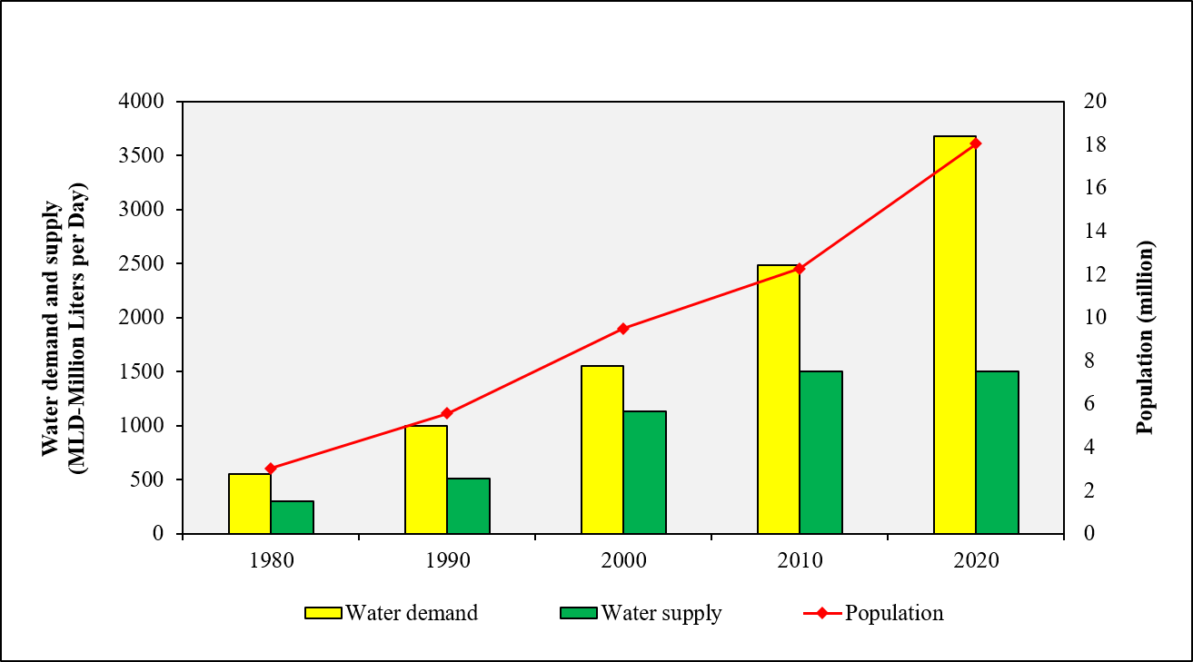
Fig 1.1: Scenario of Dhaka’s water demand and supply over the years

1.3 Problem Statement
In the realm of water management, the traditional methods of controlling water levels in reservoirs, tanks, and containers are plagued by inefficiencies and limitations. Manual monitoring and adjustment of water levels not only consume valuable time and resources but are also prone to errors and inaccuracies. This outdated approach often results in water wastage, suboptimal utilization, and increased operational costs.
Furthermore, in regions facing water scarcity or erratic supply, the need for reliable and efficient water level control becomes even more pronounced. Manual intervention may not be timely enough to prevent overflow or depletion, leading to potential environmental damage and economic losses.
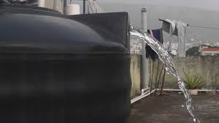
Fig 1.2: Water tank overflowing
Therefore, there is an urgent need for a modern and automated solution to address these challenges. An Automated Water Level Controller project aims to revolutionize water management by harnessing the power of technology to monitor and adjust water levels automatically. By overcoming the shortcomings of existing systems and offering a more efficient and reliable alternative, this project seeks to optimize water usage, minimize wastage, and ensure sustainable water management practices for the future.

1.4 Rational of the Study

In the modern landscape of technological advancement, the Automated Water Level Controller project emerges as a beacon of innovation, driven by the imperative to optimize water management in both residential and industrial domains. Its premise lies in the fusion of electronic components to create a system that autonomously detects and regulates water levels with precision and efficiency. By eliminating manual intervention and ensuring optimal resource utilization, the project not only enhances convenience but also underscores its significance in mitigating water wastage, minimizing risks of overflow or leakage, and enhancing operational efficiency. Along with serving all those purposes,this system is affordable as well. Beyond its immediate benefits, the project holds broader implications for sustainability efforts, contributing to the global discourse on water conservation and management. Through its integration of automation technology, the Automated Water Level Controller project exemplifies the transformative potential of innovation, offering a tangible solution to pressing challenges while paving the way for a more sustainable and resilient future.

1.5 Objectives

The main objective of the project is given below -
- To ensure efficient water usage and prevent wastage
- To minimize water-related expenses, including bills and maintenance by preventing overflow from tank

The project aims to revolutionize water management by implementing automation technology to optimize resource utilization, minimize wastage, and enhance operational efficiency, ultimately ensuring sustainable and effective control of water levels.

1.6 Outline of This Research

The research book follows the subsequent structure. Chapter 1 covers the introduction mentioning the importance of an automated system to prevent water wastage. In the next chapter a review of the existing work is provided. Chapter 3 covers the methodology, model description and work plan. The performance of an automated water level controller is provided in Chapter 4. Chapter 5 concludes the overall project. This chapter also presents recommendations for future enhancement.

CHAPTER 2 LITERATURE REVIEW

2.1 Overview

Because automated water level control systems are widely used in various fields, there is a substantial amount of research on them. The majority of research findings highlight the advantages of automated water pump systems over traditional manual systems, such as increased efficiency, lower energy consumption, better water management, and improved pump performance.

2.2 Literature review

An author's paper presented the design of an automatic water level controller. The design system uses a mercury flow switch. The system incorporates two contactors which are energized to provide a direct online start of the motor. An overload relay senses the presence of excess current and disconnects the supply while the mercury flow switch uses the Archimedes principle of flotation to provide electrical contact to switch the ON and OFF supply to the motor when the tank is empty or full, respectively. This system is relatively cheap but Mercury switches have a relatively slow operating rate, are highly toxic, and accumulate in any food chain[3]

Soumya Das and her colleagues designed a system that utilizes electrode resistive sensors to detect water levels by measuring conductivity. These sensors enable various actions like controlling water pumps or indicating water levels through LED displays, facilitated by comparators and microcontrollers [4]

Hemant Lenka and his team utilized a technique employing a Hall Effect Sensor to gauge the water flow rate in irrigation pipelines and enable accurate measurement of water in agricultural fields [5]

Anuj Pathak and his colleagues presented a design where the automatic level controller system and SMS system work synergistically. The controller operates on battery power. Whenever the system encounters an empty level and the status of load shedding, an SMS notification is sent to the user.[6]

Another study was done where the authors designed a water level sensor using a digital logic processing circuit, JK flip flop and a motor drive circuit controlled by a relay-based driver. The system first senses the amount of water available in the tank by the level detector part and then adjusts the state of the water pump according to the water level information [7]
Literature on automated water level control systems, encompassing diverse methodologies including mercury flow switches, electrode resistive sensors, Hall Effect Sensors, and integrated SMS notifications have been researched and reviewed in this chapter. Each study offers insights into improving efficiency, accuracy, and functionality in water management.

CHAPTER 3 METHODOLOGY

Overview

In this section, a brief description of the model is given. The overall Model Description includes components, a block diagram, a circuit diagram, an explanation of the working principle, and the weekly work plan.

Methodology

Components:

- 555 Timer IC
- Water level sensor
- Relay
- Resistors
- Capacitors
- Transistors
- Cables and Connectors
- Diodes
- Breadboard
- Water Pump

555 Timer IC:

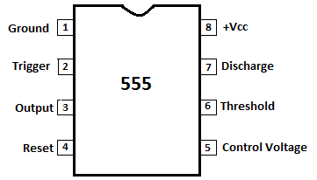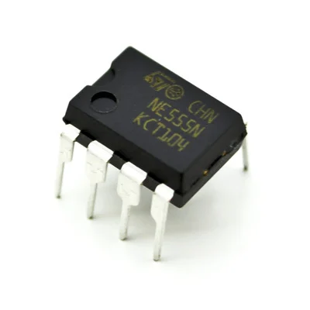

Fig 3.1: Pin diagram of 555 Timer IC Fig 3.2: 555 Timer IC

The 555 Timer IC is an integrated circuit which is used for various purposes such as timer, delay, oscillator applications, etc. It can be configured in various modes-astable (operates as oscillator), monostable (operates as one-shot pulse generator), bistable (operates as flip-flop or latch). The simplicity of this IC makes it a suitable fit for a lot of applications to generate timer pulses. In this project, it was used to generate square waves as output which were later fed to relay.

Water level sensor:

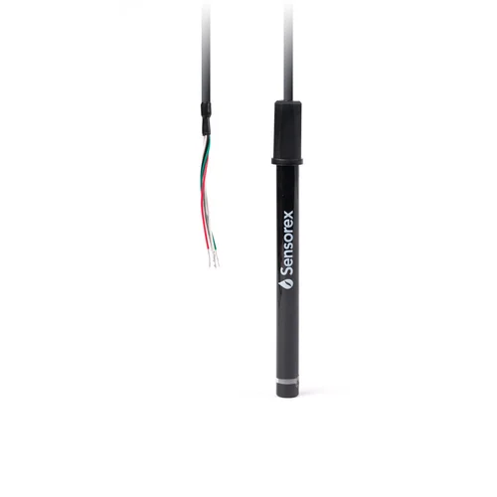
Fig 3.3: Conductive Probes (Water level sensor)

A water level sensor is used to sense low or high-water levels. There are different options such as ultrasonic sensors, capacitive sensors, float switches, or conductive probes. Ultrasonic or capacitive sensors might be an overkill for this project. Conductive probes are used in this project as it is simple, reliable, and inexpensive. These sensors have two electrodes placed at predetermined levels in the tank. When the tank is almost full and the water level rises to the level of electrodes, they signal a high level as contact is made. Similarly, the probe situated at the lower level tank signals when contact is lost.

Relay:

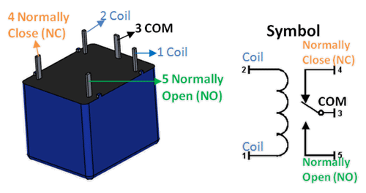

Fig 3.4: 12V Relay

Relay is an electromechanical switch which helps to control a high-powered load or circuit with a low-power signal. It has input terminals and a set of operating contact terminals for these signals. It is also used to make or break contact.
In this project, a 12V relay is used between IC555 and the water pump. The output power of the IC is low and the relay acts as a switch amplifying this low current to control the high-powered motor. It also provides isolation between these two and protects the control circuit (IC555).

Resistors:
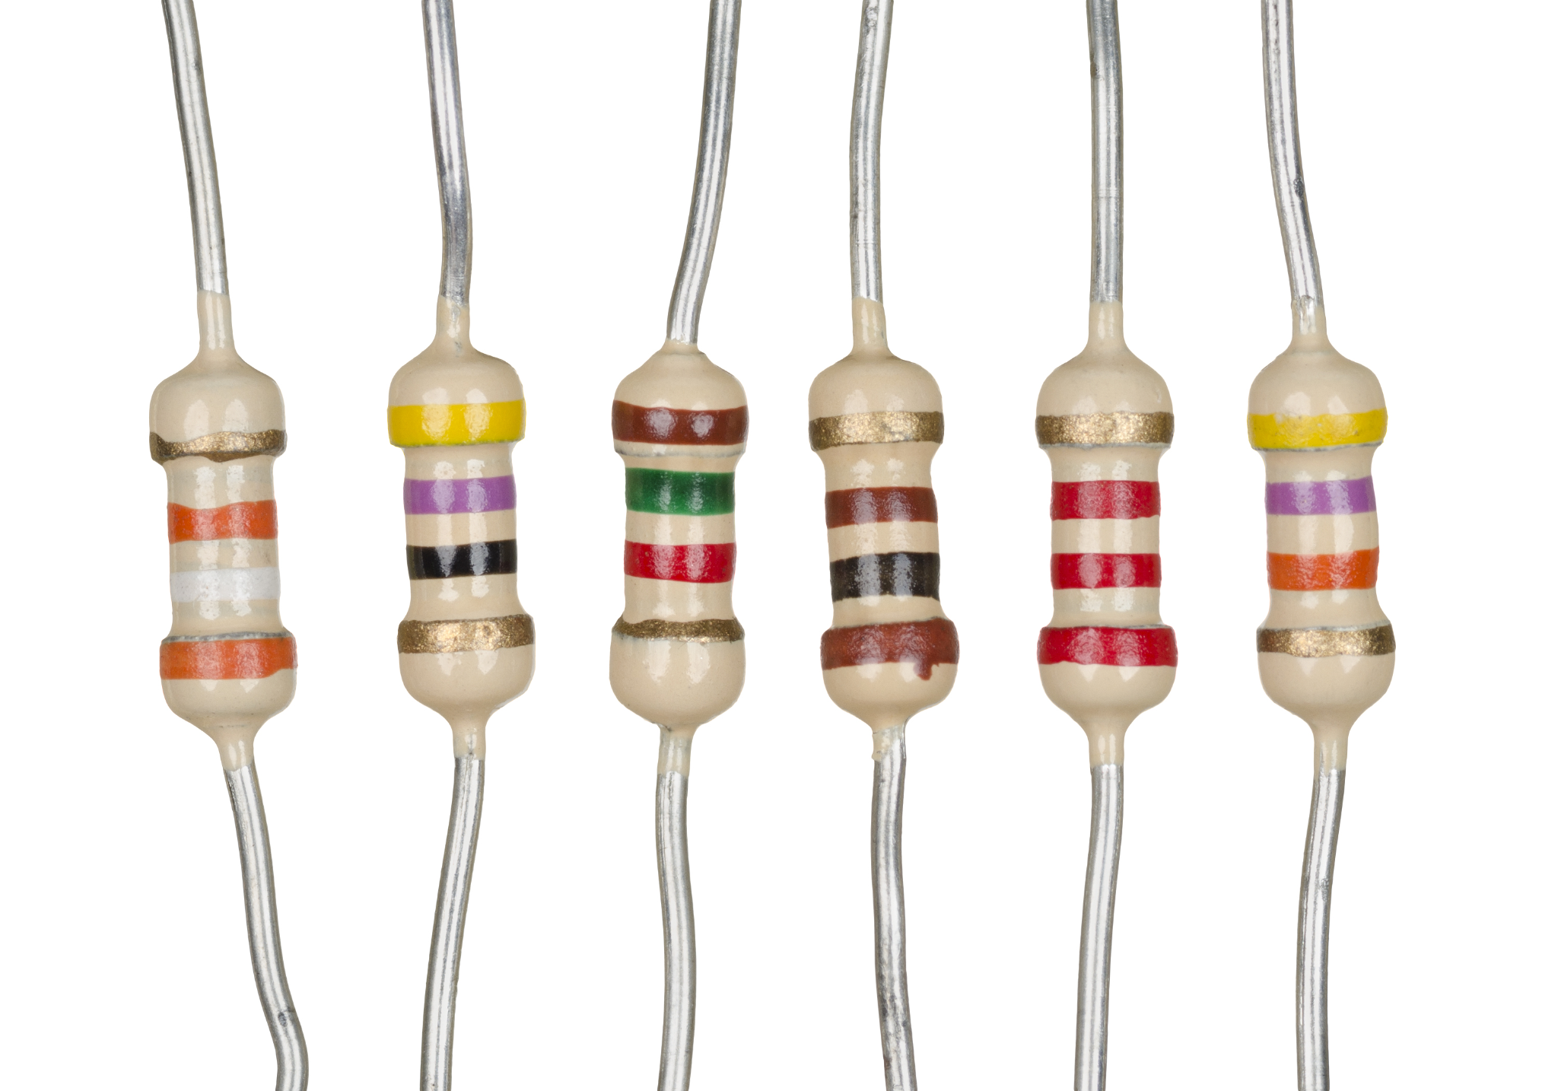
Fig 3.5: Resistors

Resistor is a widely used electronic component which regulates the flow of current through the circuit by acting as an obstacle. In this project, different types of resistors- 1K ohms, 220K ohms, 22M ohms, 1M ohms etc are used to control the current flow in the circuit.

Capacitors:
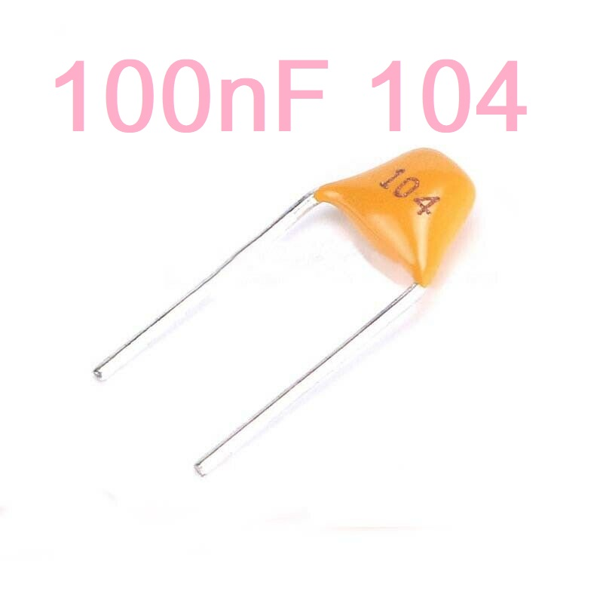

Fig 3.6: Capacitor

A capacitor is a device that stores electrical energy in an electric field. It is a two-terminal passive electronic component. The effect of a capacitor is known as capacitance. The capacitance of the capacitor is the charge stored in either one of the conductors to the potential difference between the conductors. In this project, we will be using a 100-microfarad capacitor.

Transistors:
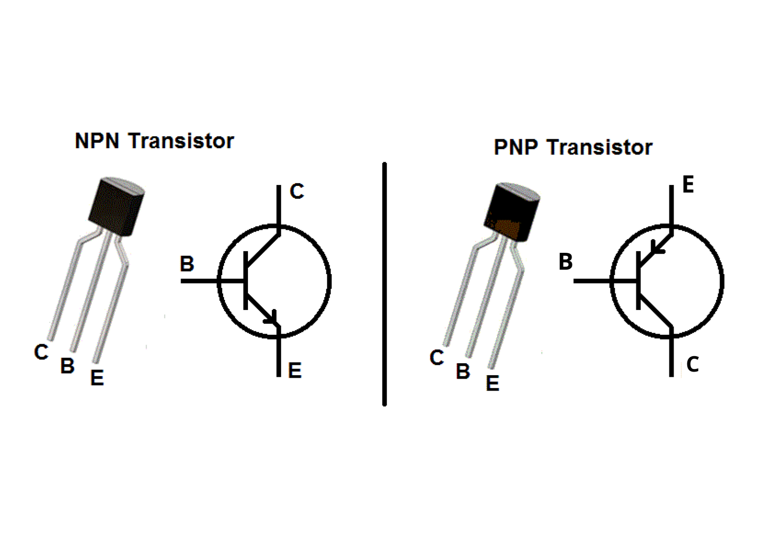
Fig 3.7: Transistor
Transistor is a basic semiconductor device used for amplifying or switching operations. It has 3 terminals-base, emitter and collector.
In this project, a general-purpose NPN transistor BC547 is used. The transistor acts like an amplifier and amplifies the output from IC555 making it suitable for driving the relay which requires a higher level current than the IC can provide.

Diodes:
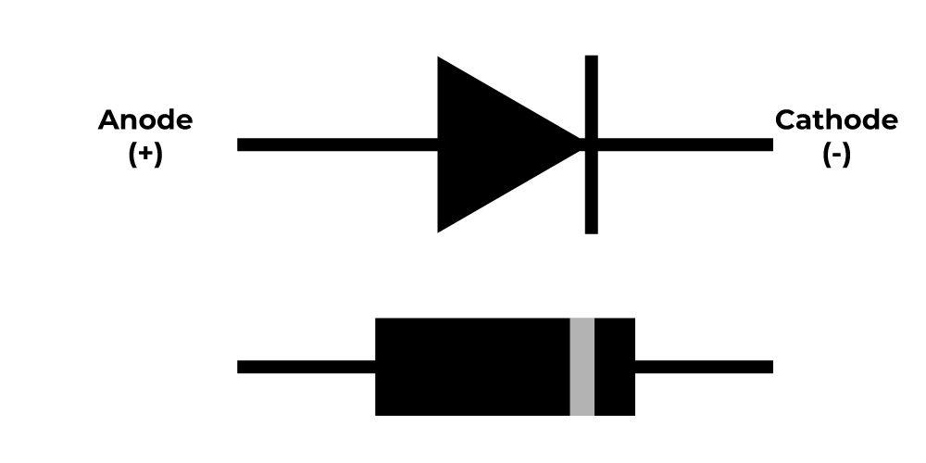

Fig 3.8: Diode

A diode is a semiconductor device that functions as a one-way current switch. It permits free current flow in one direction (referred to as the diode's forward direction) while severely restricting current flow in the opposite direction (the reverse direction).
Diodes can be used as rectifiers, signal limiters, voltage regulators, switches, signal modulators, signal mixers, signal demodulators, and oscillators. A diode's fundamental property is its ability to conduct electric current in only one direction.[8]
In this project, 1N4007 diode is used in parallel with the relay. It provides protection and prevents damage as it provides a path for voltage spike and back EMF to dissipate safely. Thus it protects the transistor and other components.

Breadboard:
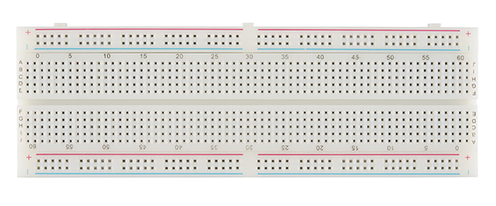
Fig 3.9: Breadboard

A breadboard is a simple device designed to let you create circuits without the need for soldering. There are two major types of breadboards; these are solder and solderless boards. Breadboard It has a bunch of holes. These holes let you easily insert electronic components to prototype (meaning to build and test an early version of) an electronic circuit.

Water Pump:
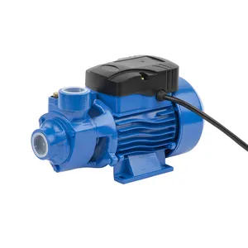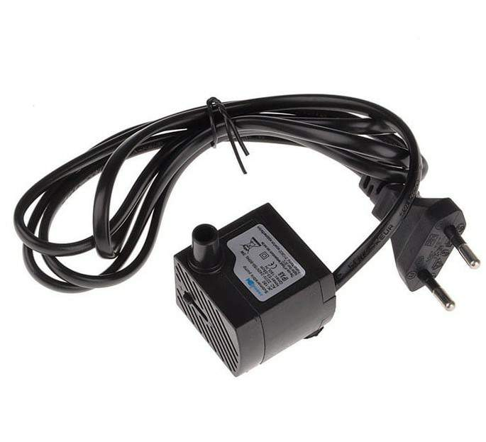
Fig 3.10: water pump used commercially Fig 3.11: Mini water pump

The water pump is the motor which moves water from one place to another. In this project, the water pump is used to fill the tank with water. The water pump is controlled by the relay in the circuit.

Overall Model Description

Block Diagram:

Power
Supply

IC 555
BC547 Transistor
1N4007
Diode
Relay
Motor / Pump
Water
Tank
Sensors

Fig 3.12: Block Diagram of Automatic Water level Controller

Explanation:

Initially, 12V DC is fed to the 555 timer IC as input. The conductive probes are placed in the water tank. The probe from the bottom level is attached to the IC’s trigger(2nd) pin and when it’s submerged its voltage is Vcc. When the water level is low it loses connection,2nd pin becomes separated from the water and it triggers IC to produce output. The output of the IC (a square wave) is connected to a BC547 Transistor. It amplifies the low-powered output from the IC and sends it to the Relay. The Relay turns the motor on.
When the water level rises, the top-level probe is submerged and the transistor turns on. The collector voltage becomes really low and the IC is reset by a low voltage in the fourth pin. The output of the IC becomes 0 volt and the motor will be turned off.[9]
Circuit Diagram:
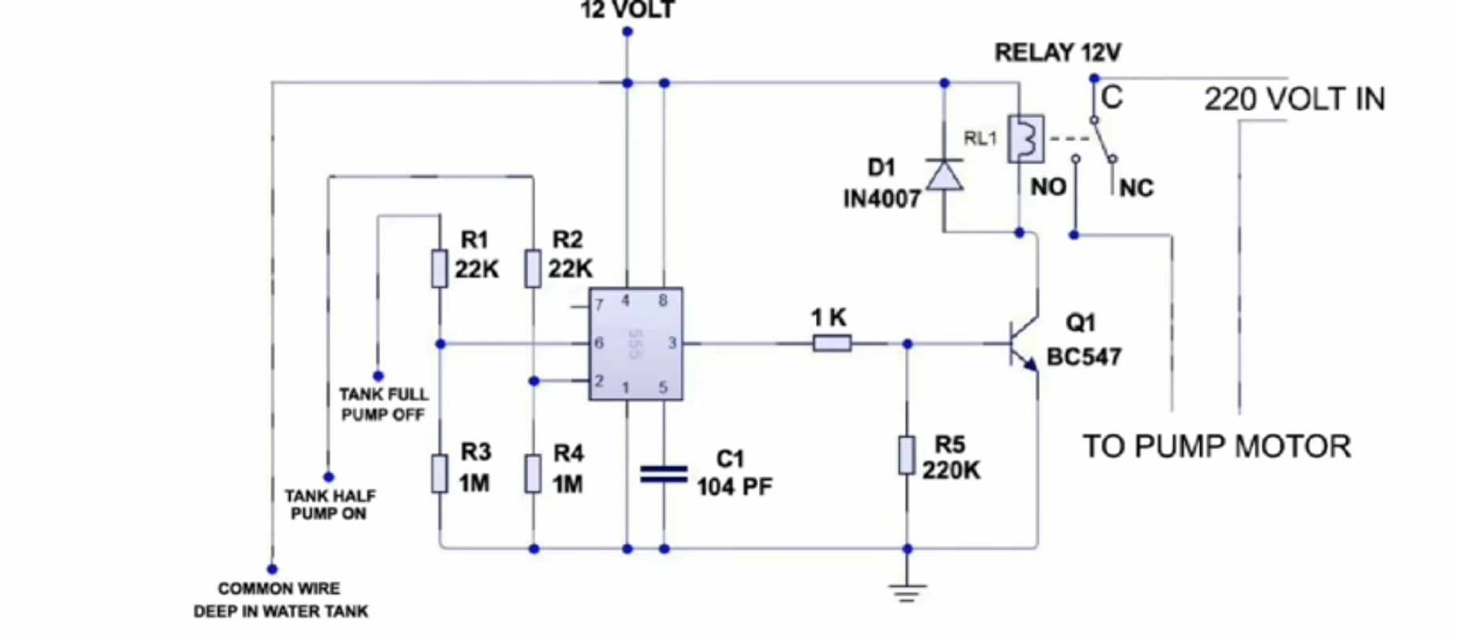

Fig 3.13: Circuit Diagram of Automatic Water Level Controller

Work plan

Description of the work plan:

This project is divided into multiple stages that are interrelated with each other in a top-down approach. In the first stage of the project, the data set will be collected using various sources from the internet. It will take approximately four weeks. In the next step, data cleaning will be done. Through group discussion, differentiation of correct and usable data from the pile and incorporation of new ideas are done. These two stages will take approximately two weeks. The most important part of the project is model formation. This will take approximately five weeks. After the development of the model, the results will be reported. The final preparation of the report may take one week.

Work Plan | 12 weeks (3 months)
Data Collection
Group Discussion and Data Cleaning
Model development and reporting results
Final report submission

In this chapter, we discussed the components used which are 555 Timer IC, Water level sensor, Relay, Resistors, Capacitors, Transistors, Cables and Connectors, Diodes, Breadboard, Water Pump, etc. The model and the working principle were also discussed which is basically the sensor sending signals to the IC application in triggering and reset allowing the other components to turn the motor on or off and preventing overflow in this process. A detailed work plan is also shown in this chapter.

CHAPTER 4

PERFORMANCE ANALYSIS OF THE

AUTOMATED WATER LEVEL CONTROLLER

4.1 Overview

In this chapter, the experimental setup utilized for implementing the Automated Water Level Controller will be detailed, outlining the key components and system configuration. Following the setup, a comprehensive performance analysis is conducted, evaluating various metrics such as accuracy, response time, reliability, and energy efficiency. The results of this analysis provide insights into the effectiveness and efficiency of the controller in managing water levels.

4.2 Experimental Setup

For our experimental setup of the controller, we utilized a range of components to construct a functional system capable of effectively managing water levels. Central to our setup is the 555 Timer IC, serving as the core component for controlling the timing and operation of the system. Alongside this, we employed a Water Level Sensor to accurately detect the water levels in the containers. A Relay (12V) was integrated into the circuit to control the submersible motor, allowing for precise regulation of water flow. Various resistors: 1KΩ, 22KΩ(2), 180KΩ, 1MΩ(2) and a 100nF(104) capacitor were strategically utilized to ensure optimal performance. Additionally, transistors, diodes, cables, and connectors were employed to facilitate connectivity and enhance the functionality of the system. The entire circuit was assembled on a Breadboard for ease of prototyping and testing.
To facilitate the physical water transfer process, we incorporated a submersible motor connected to a clear pipe. This motor, submerged in a pot filled with water, effectively pumps water from one container to another through the clear pipe. The system is designed to respond to the water levels sensed by the sensors in the receiving pot. When the water level falls below a certain threshold, the motor activates, transferring water until it reaches the high-level sensor, at which point the transfer halts. This setup ensures automated and precise control of water levels, optimizing resource utilization and minimizing the risk of overflow or wastage.

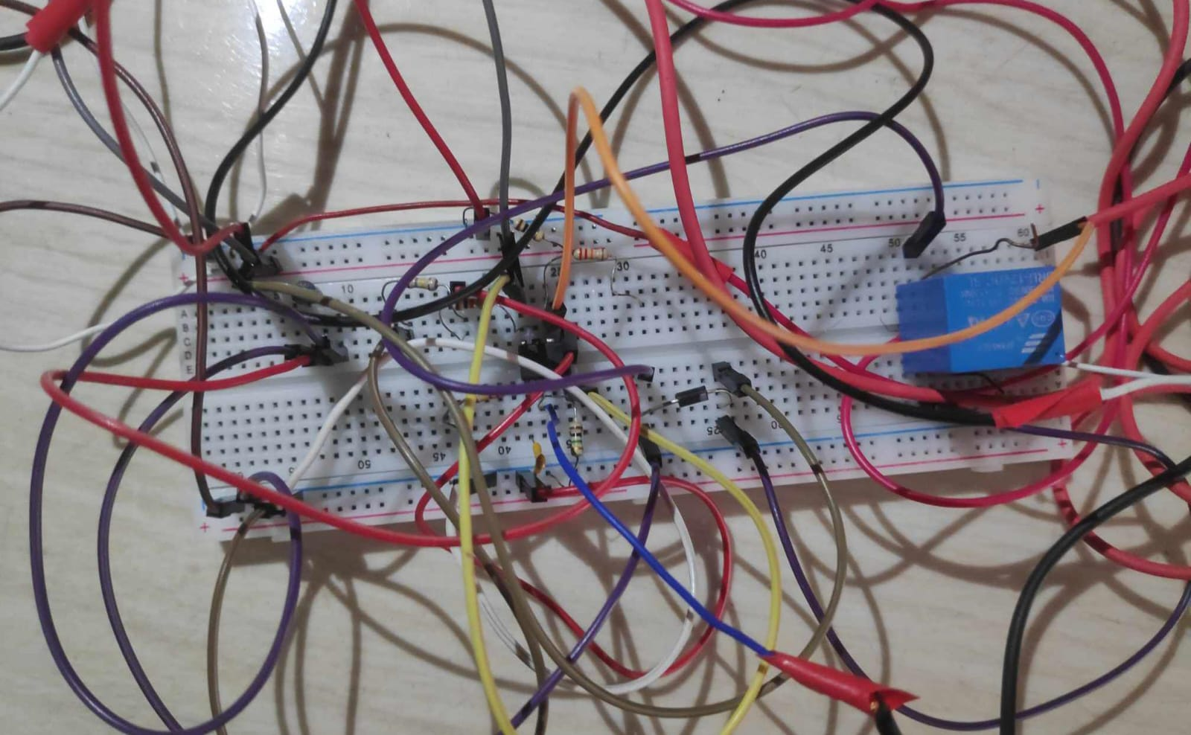 | 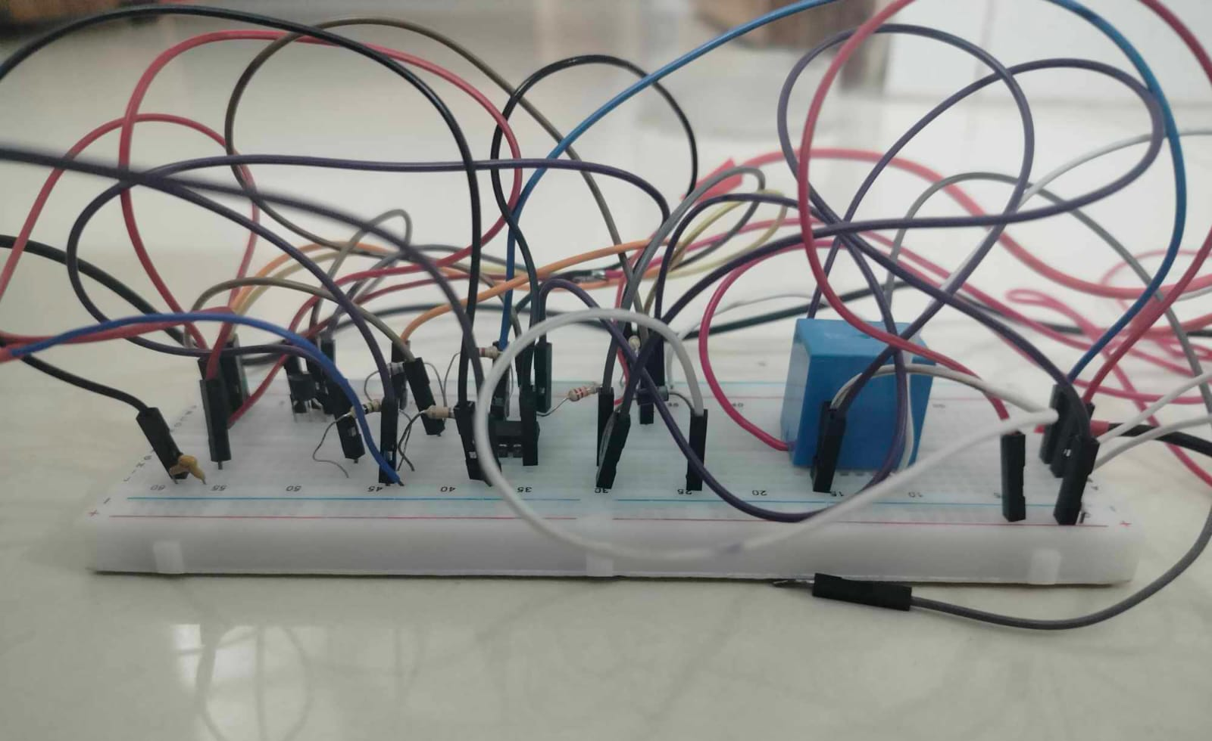 | 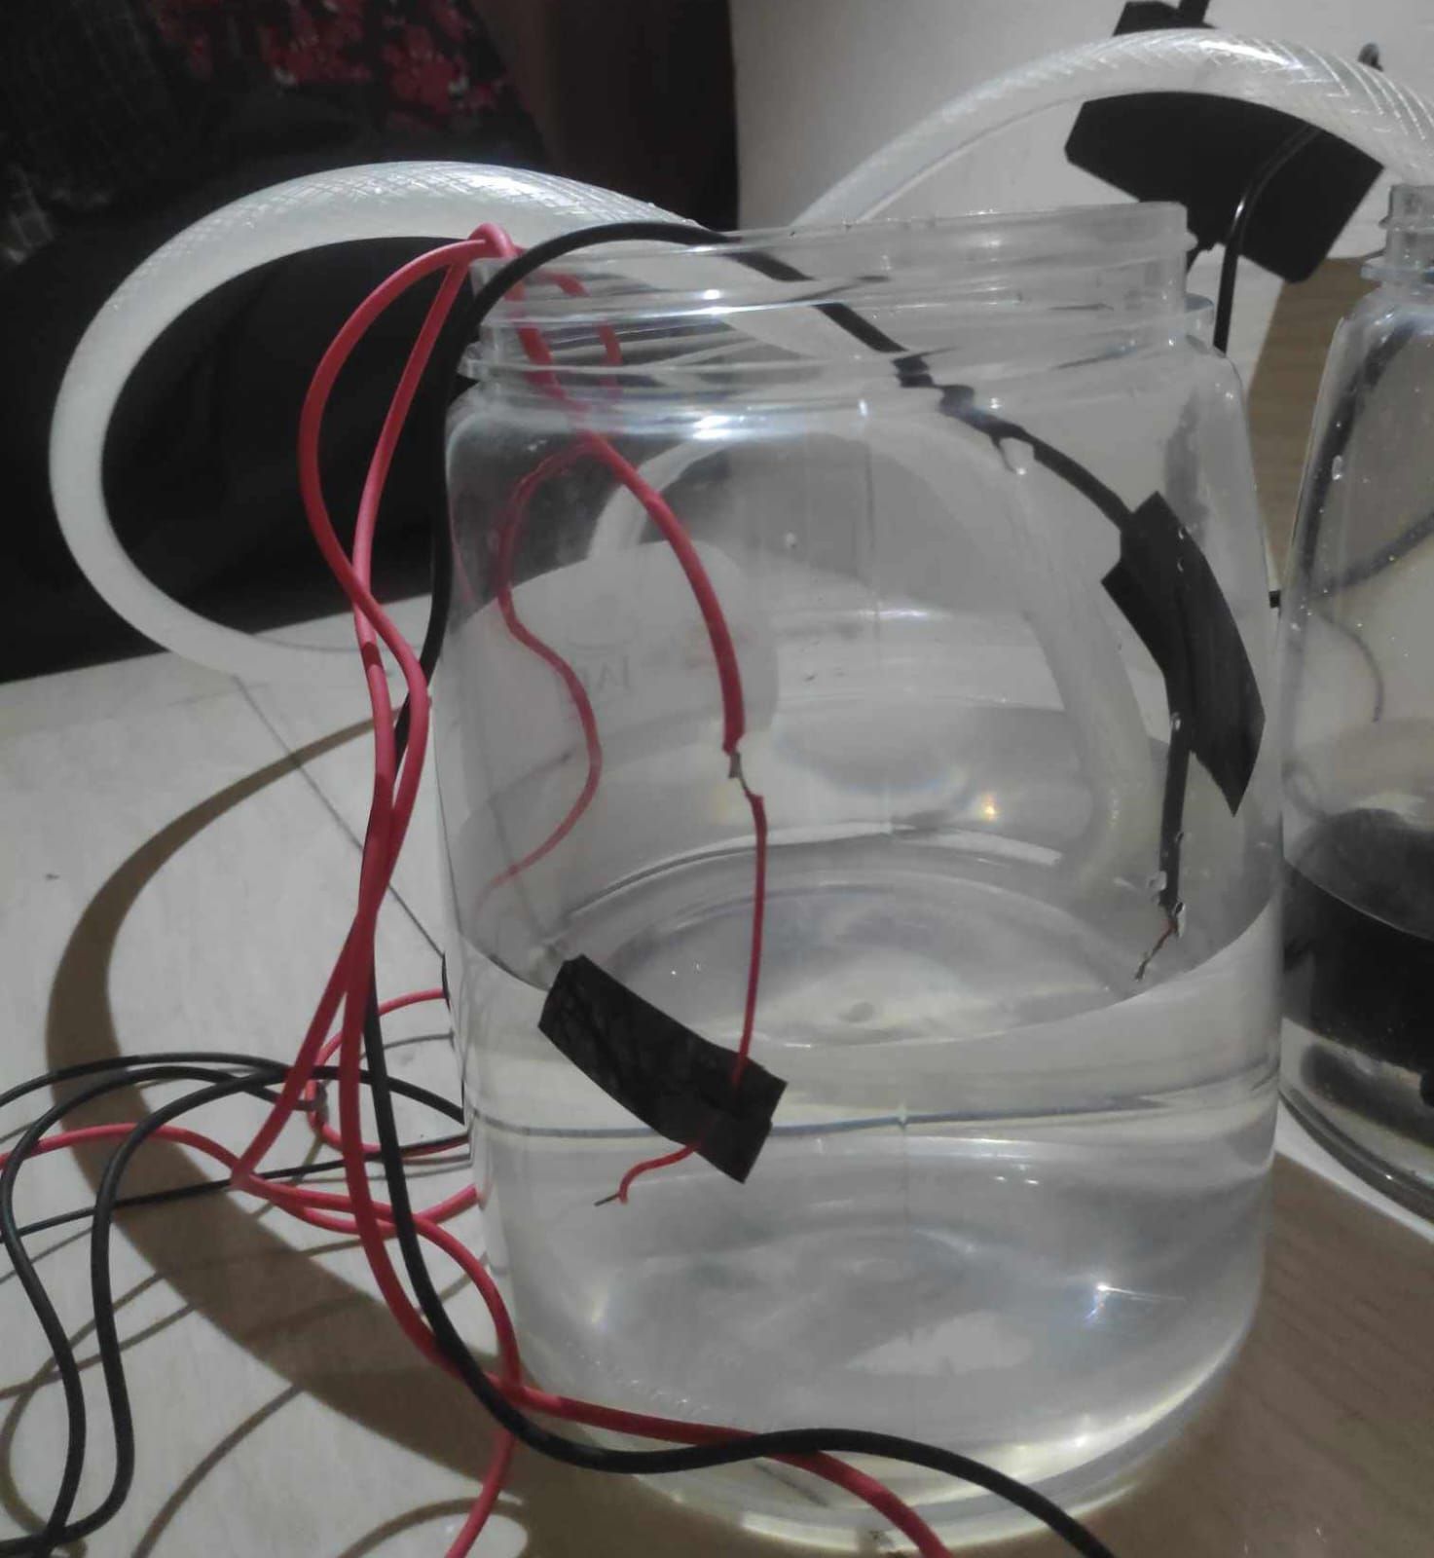
Fig 4.1: Implementation of Automated Water Level Controller

4.3 Performance Analysis
After analyzing the performance and results of the Automated Water Level Controller project, it can evaluated as follows:
- Accuracy and Precision: The system's ability to accurately detect and maintain water levels within predefined thresholds was assessed. This can be measured by comparing the actual water levels with the desired levels set by the sensors.
- Response Time: The system responds immediately to change the water levels which indicates a more efficient control mechanism.
- Reliability: The system continuously monitors and controls water levels over extended periods. This involves assessing its ability to operate consistently without failures or malfunctions.
- Wastage Reduction: Water wastage reduction is achieved by implementing the Automated Water Level Controller compared to manual methods or conventional systems.
- Cost-Benefit Analysis: In this system, we used an IC as the major component to cut the cost even more. So overall, the project is very affordable even if we use it in residential water tanks, swimming pools, spas, etc. As it is an automated system, the cost of labor and maintenance expenses can also be saved.
The experimental setup involved rigorous testing of the Automated Water Level Controller across various scenarios to evaluate its performance metrics, such as response time, accuracy, cost benefits, etc. By analyzing these performance metrics, the efficiency in maintaining precise water levels of the controller has been assessed.

CHAPTER 5

CONCLUSION

An automatic water level regulator was designed and constructed using available materials and successfully tested at the Bangladesh University of Professionals. The electronic circuitry was realized using available simple components such as 555 timer IC. Performance evaluation of the system indicated that it could regulate water level within a specific range, an indication that it can be applied for reducing energy and material losses in the process industry, small and medium scale enterprises as well as in farms, homes, etc.
The project was successful in achieving its objectives. The motor automatically turned off when the water reached the high level, preventing wastage and overflow. By implementing this project, we were able to build a system that is simultaneously automated and affordable.
In this project, we didn’t use Arduino to minimize the cost. But in the future, if we increase our budget to use Arduino, we can maximize its effectiveness. There is also future scope for integrating the project with IOT.

REFERENCES

- “Water Scarcity | UNICEF” 13 May. 2020, https://www.unicef.org/wash/water-scarcity. Accessed 2 May,2024.

- “Dhaka Megacity: How Uncontrolled Urbanization is Breaking the Walls of Water Security?” 19 Dec.2020,
https://internationalaffairsbd.com/dhaka-megacity-uncontrolled-urbanization-breaking-walls-water-security/
Accessed 2 May,2024.

- Band, E. J., & Anyasi, F. I. (2014). Design of an automatic water level controller using mercury float switch. IOSR Journal of Electronics and Communication Engineering, 9(2), 16-21

- Das, S., Dhar, S., Deb, P. B., & Mujamdar, P. S. (2017). Microcontroller Based Water Level Indicator and Controller. Asian Journal of Applied Science and Technology (AJAST), 1(5), 181-182

- Sood, R., Kaur, M., & Lenka, H. (2013). Design and development of automatic water flow meter. International journal of computer science, engineering and applications, 3(3), 49

- Pudasaini, S., Pathak, A., Dhakal, S., & Paudel, M. (2014). Automatic water level controller with short messaging service (SMS) notification. International Journal of Scientific and Research Publications, 4(9), 1-4.

- Getu, B.N.s & Attia, H.A. (2016 December). Automatic water level sensor and controller system. 5th International conference on electronic devices,Systems and Applications(ICEDSA)(pp. 1-4)IEEE

- Erick Gregersen, diode | Definition, Symbol, Types, & Uses - Encyclopedia Britannica.Mar 05,2018" https://www.britannica.com/technology/diode. Accessed 26 Apr. 2024.

- Dr. N.Sambasiva Rao, Dinesh Ramisetti, Rama Krishna Bathula.2023.Ic 555 timer-based automatic water level sensor and controller system.International Journal Of Advance Research And Innovative Ideas In Education.8(1)

