**Book_Api Load Testing Documentation**

Find out the actual TPS for if 10000 user can give load within 1 hour

Expected load: 10000 user, per hour

Actual load: what TPS?

**Here are some Jmeter UI screenshots and html report:**

**1.167 users for 60s (Throughput 2.8/sec)**

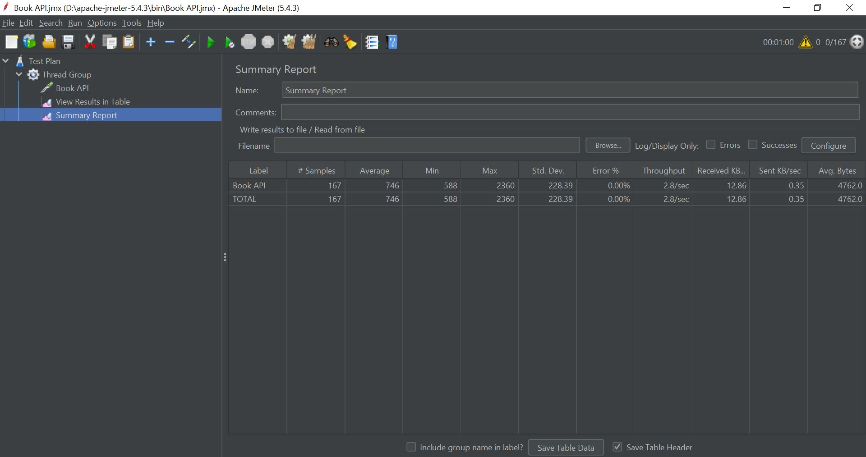

**Figure 1: 167 users for 60s UI**

**2. 834 users for 300s (Throughput 2.8/sec)**

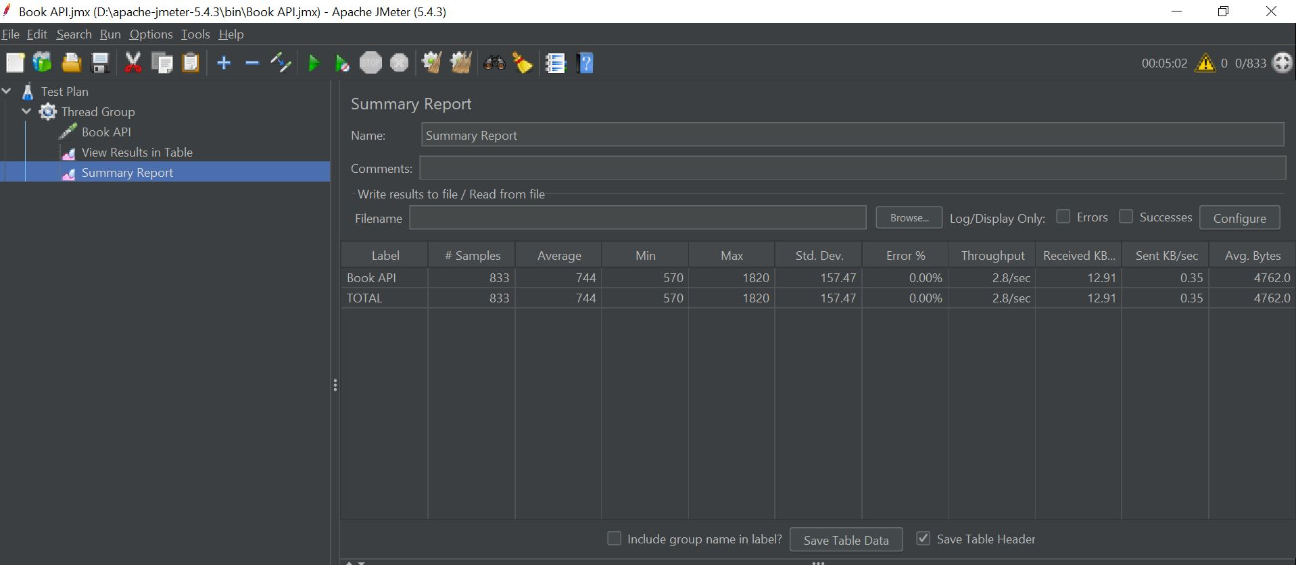

**Figure 2: 834 users for 300s UI**

**3. 1667 users for 600s (Throughput 2.8/sec)**

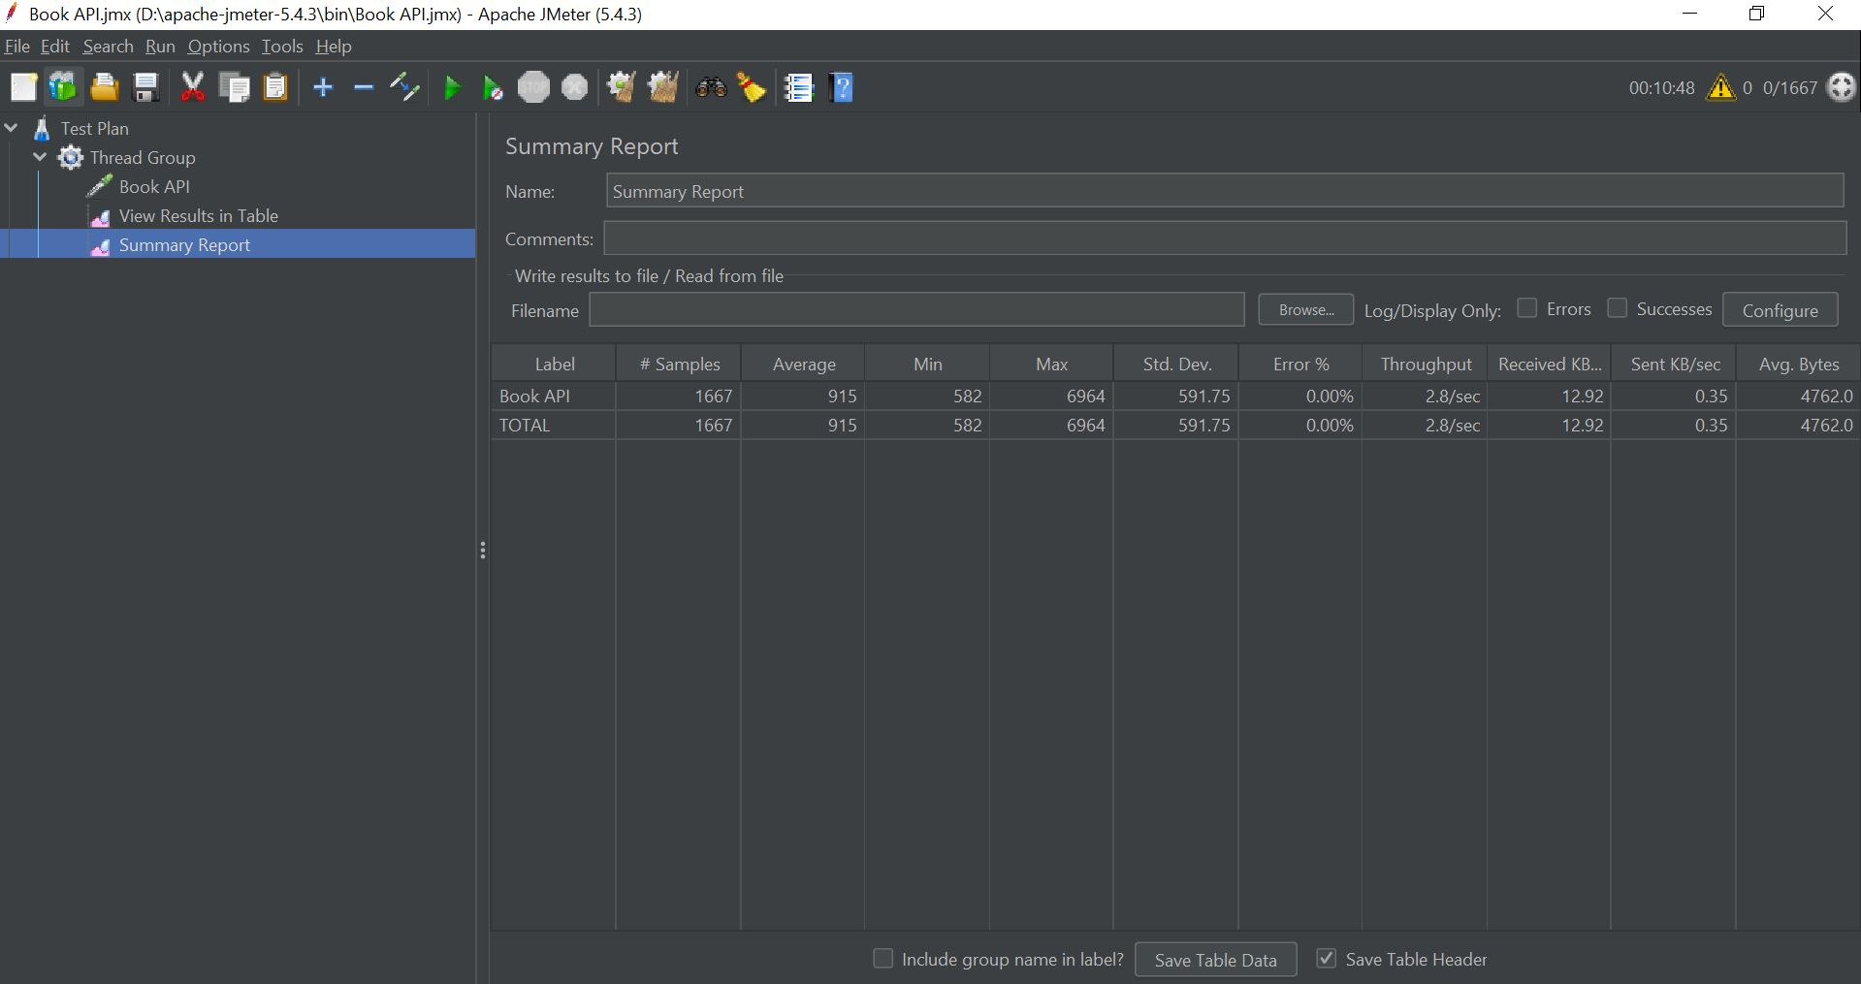

**Figure 3: 1667 users for 600s UI**

**4. 2500 users for 900s (Throughput 2.8/sec)**

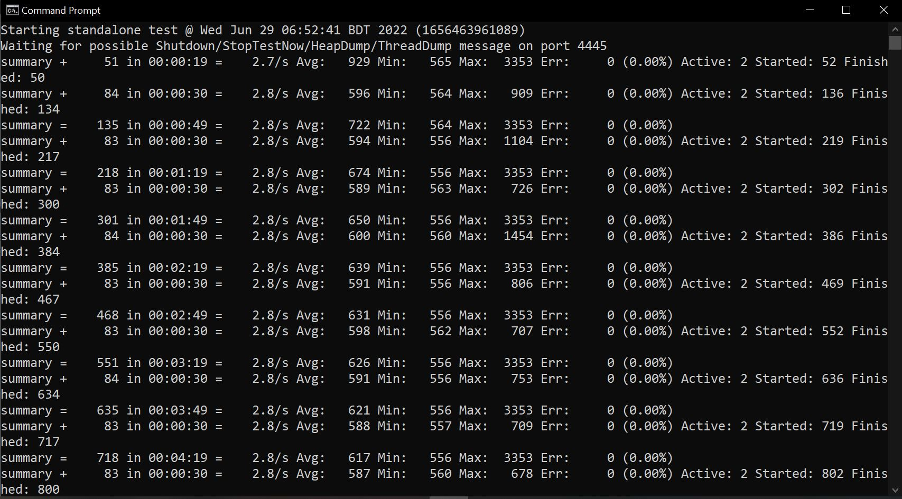

**Figure 4: 2500 Users For 900s Html Report**

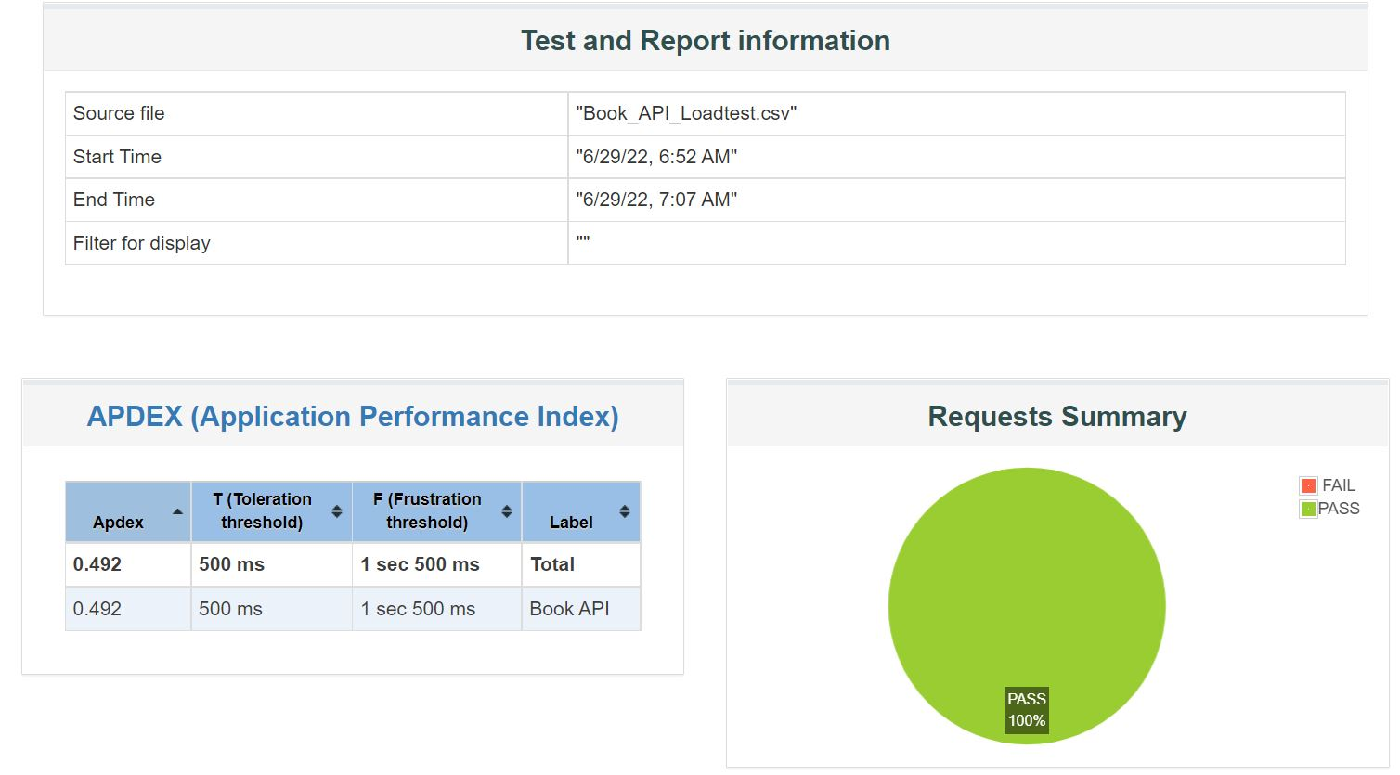

**Figure 5: 2500 Users For 900s Summary Report**